Team: C02

Members: Carter Hale and Jonathan Hagen

**CAR EVASION GAME**

**Project Description**

Our Project will be a simple video game designed around evading cars. This would be implemented using the VGA Output on the FPGA while controlling our vehicle with a Keyboard input. In terms of how the game works, the user would be in control of a car as other cars move towards it, creating obstacles for them to avoid. The user would be able to move left and right to switch lanes and avoid any collisions. If a collision occurred, the game would automatically restart. Initially, there will not be a scoring system, but we hope to expand on this core concept and include one.

Our Project would be based on first learning the basics of graphical output, and then, with hooking up an input device, such as a keyboard. With these understandings, we can then add the graphics for the cars and eventually the movement and collision logic to determine if the user loses. The photo below is a screenshot of an Online Flash game. The layout and general premise of our game is based off a similar idea, but without the jumping capability or the need to go forward as the user can only control horizontal motion in our proposed implementation.

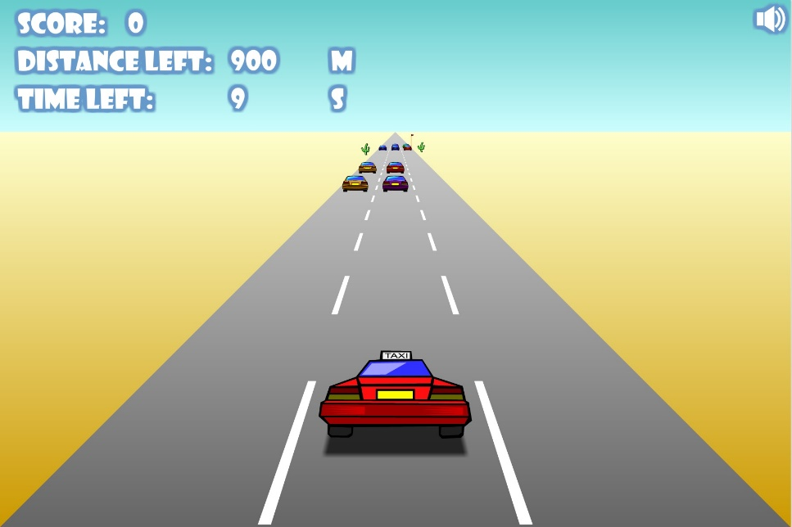

**Resources**

1. DE2-115 Board
2. Keyboard
3. Monitor

**Quartus Accessibility**

Carter Hale has Quartus up and running, however Jonathan Hagen has many issues with the Software and will likely use the Lab Computers instead.

**Project Task**

1. Basic Game working without: Random Encounters, a Score System, Any Controls Beyond ‘Left’ and ‘Right’. Regarding the specifics of our game, we will begin with 3 lanes for the car to drive in. The speed at which oncoming cars will ramp up as the user lasts longer without a collision.
2. Before implementing a scoring system, there will be no end to the game, as it would go on arbitrarily until the user fails and the game would then restart. However, we would like to expand and add a simple scoring system implemented around the game logic. Either added to the Monitor Output or through the 7-Segment displays provided on the Development Board.
3. For the pattern of the oncoming cars, we will start with a reoccurring pattern of obstacles and hopefully expand on this to generate random oncoming cars, which would increase difficulty for the user.
4. A perfectly polished game that performs well and does not contain any bugs. It would include all the necessary expansions like the scoring system, and random obstacle encounters.

**Project Schedule & Milestones**

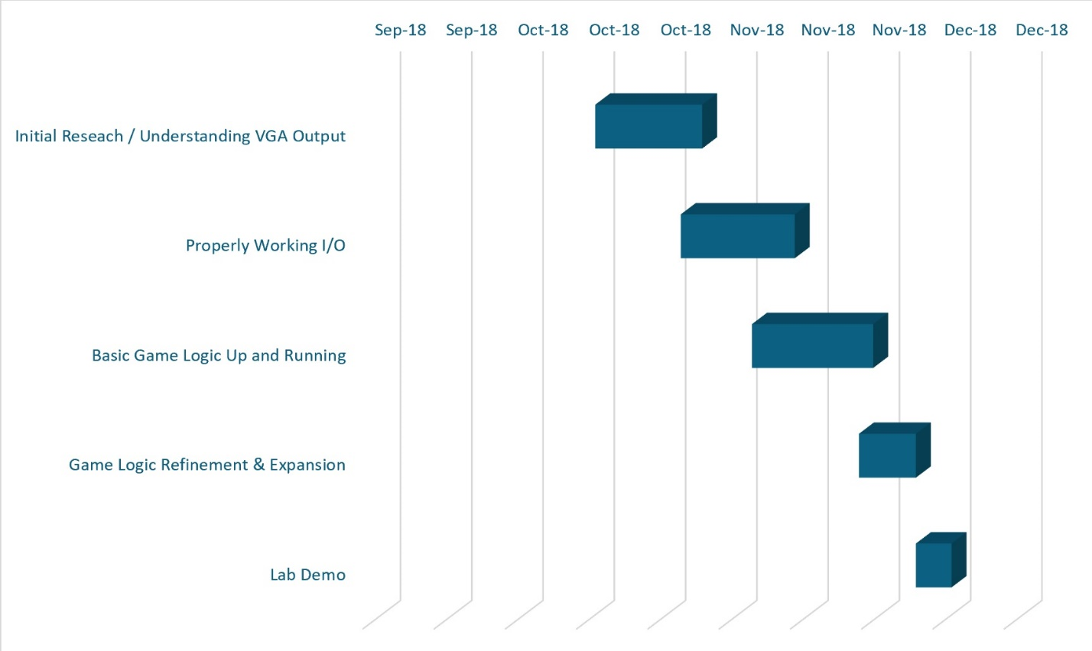

Sep-20 Sep-30 Oct-10 Oct-20 Oct-30 Nov-10 Nov-20 Nov-30 Dec-10 Dec-20

These Milestones do not leave much margin for error as we will aim to reach each step well in advance of our created deadlines. This will force us to not procrastinate as our deadlines do not allow us to get behind.

**Expected Challenges and Risks**

* Understanding VHDL Code for VGA Output
* Understanding VHDL Code for Keyboard Input
* Understanding Finite State Machines and Clocks
* Using VHDL for simple Graphic Design
* Time Management