**P1:**

1. What is our independent variable? What is our dependent variable?

* The independent variable is congruent vs. incongruent set of words
* The dependent variable is the color recognition time of each set of incongruent and congruent words.

1. What is an appropriate set of hypotheses for this task? What kind of statistical test do you expect to perform? Justify your choices.

* My hypothesis is: The mean color recognition time for congruent word is different from the incongruent ones.
  + H0: $μ_{C}-μ_{i}=0$ There is no difference between the mean color recognition time for these two populations
  + H1: $μ_{C}-μ_{i}≠0$ There is a difference between the mean color recognition time for these two populations

(Where $μ_{C}$ is the population mean for color recognition time of the congruent set of words and $μ_{i}$ is the population mean for color recognition time of the incongruent set of words)

* The recommended statistical test in order to reject or accept my hypothesis is the two-tailed T-test. I chose the T-test because we do not have the population means ($μ$). Ideally, the best option is to compare the population means ($μ$) directly to see if the differences between the mean color recognition times are because of the Stroop Effect or just by chance. Since the population means are unknown, we have to use the sample means ($\overline{X})$. Moreover, the sample size is relatively small (less than 30). Which makes the T-test more suitable option.
* The same population took both tests under two conditions, the test should be dependent T-test.
* There are also four assumptions for the T-test that should be satisfied in order to choose this test:
  + Interval or ratio scale of measurement (approximately interval)
  + Random sampling from a defined population
  + Samples or sets of data used to produce the difference scores are linked in the population through repeated measurement, natural association, or matching
  + Scores are normally distributed in the population; difference scores are normally distributed
* Ideally, we should compare the population means ($μ$) directly to see if the differences between the means of reading time are because of the Stroop Effect or just by chance. Since we do not have the population means, therefore we have to use the sample means ($\overline{X})$. Using the sample data that we have and a two-tailed T-test we can test our hypothesis.

1. Report some descriptive statistics regarding this dataset. Include at least one measure of central tendency and at least one measure of variability.

|  |  |  |  |
| --- | --- | --- | --- |
| **Measures** | | **Congruent** | **Incongruent** |
| **Central Tendency** | Mean | 14.051125 | 22.01591667 |
| Median | 14.3565 | 21.0175 |
| **Variability** | Variance | 12.66903 | 23.0117 |
| Standard Deviation | 3.559357 | 4.79705 |

1. Provide one or two visualizations that show the distribution of the sample data. Write one or two sentences noting what you observe about the plot or plots.

* Figure 1: This chart compares the time that took for the participants to finish each set of congruent and incongruent words. It shows while for all participants it took longer to read the incongruent ones, for some of them it took significantly longer than others.
* Figure 2 & 3: These two histograms shows that the two groups have significant difference in median times and range.

Figure

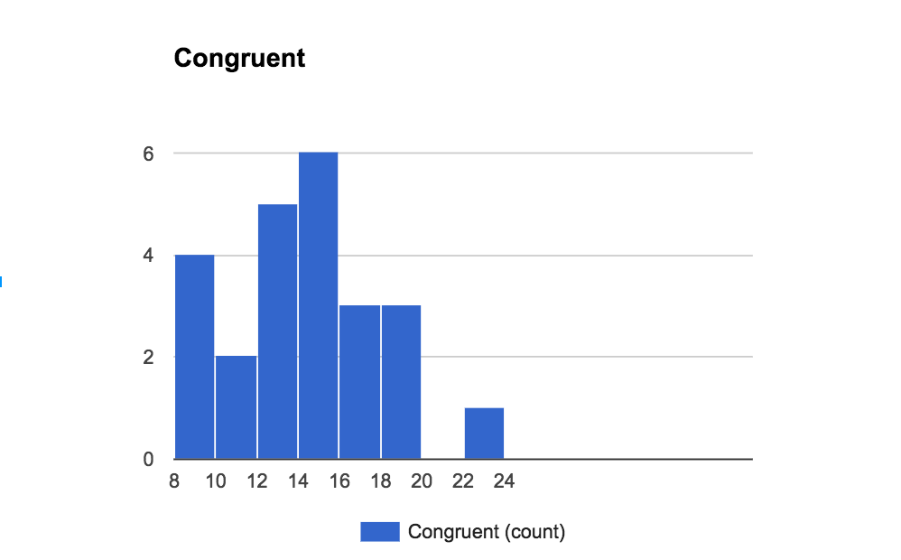

Figure

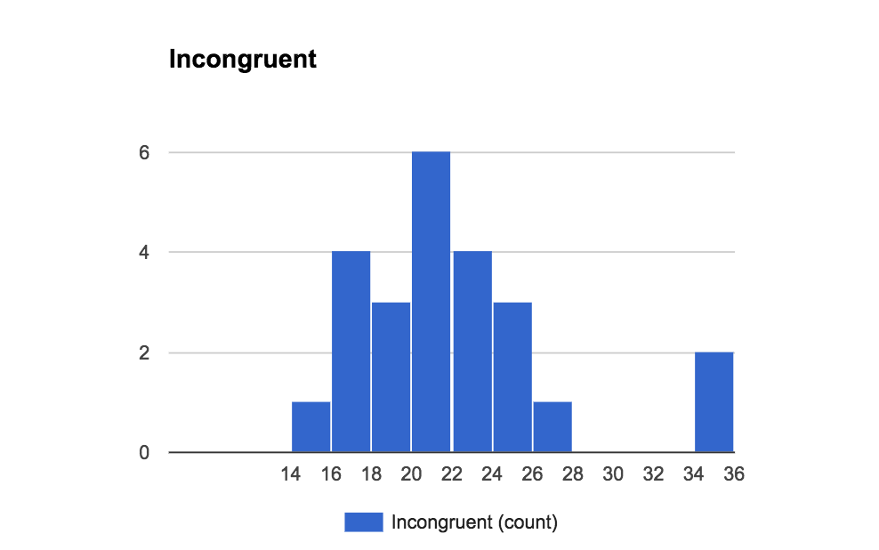

Figure

1. Now, perform the statistical test and report your results. What is your confidence level and your critical statistic value? Do you reject the null hypothesis or fail to reject it? Come to a conclusion in terms of the experiment task. Did the results match up with your expectations?

$$n_{c}=24$$

$$\overline{χ_{i}}=22.01591667$$

$$\overline{χ_{c}}=14.051125$$

$$\overline{χ_{c}}-\overline{χ_{i}}=-7.964791667$$

$$SD=4.86482691$$

$$statistic= \frac{\overline{χ_{c}}-\overline{χ_{i}}}{{SD}/{\sqrt[2]{n}}}=-8.020706944$$

$$Degree of freedom=n-1=23$$

$$95\% Confidence Level: α=0.05$$

Within 95% of confidence level and 23 degree of freedom we reject the null hypothesis: the means are different

Resources:

1. <https://faculty.washington.edu/chudler/words.html>
2. <http://www.psychology.emory.edu/clinical/bliwise/Tutorials/TOM/meanstests/assump.htm>
3. https://www.rit.edu/cla/gssp400/sbackground.html