**SVKM’s NMIMS**

**Mukesh Patel School of Technology Management & Engineering**

A.Y. 2022 - 23

**Course: Database Management Systems Project Report**

|  |  |  |
| --- | --- | --- |
| Program |  | |
| Semester |  | |
| Name of the Project: |  | |
|  | | |
| Details of Project Members |  |  |
| Batch | Roll No. | Name |
|  |  |  |
|  |  |  |
|  |  |  |
| Date of Submission: | | |

**Contribution of each project Members:**

|  |  |  |
| --- | --- | --- |
| Roll No. | Name: | Contribution |
|  |  |  |
|  |  |  |

**Note:**

1. Create a readme file if you have multiple files
2. All files must be properly named (I004_DBMSProject)
3. Submit all relevant files of your work ( Report, all SQL files, Any other files)
4. **Plagiarism is highly discouraged (Your report will be checked for plagiarism) Rubrics for the Project evaluation:**
   * Innovative Ideas and self learning (5 Marks) Idea should not be regular such as Hotel, Library Management system etc.
   * Implementation and Design (10 Marks) It includes ER model, Relational model and Normalization of tables.
   * Project Demonstration and Viva (5 Marks)

**Project Report Selected Topic**

**by**

**Student 1, Roll number: xx Student 2, Roll number: xx Student 3, Roll number: xx**

**Course: DBMS AY: 2022-23**

**Table of Contents**

|  |  |  |
| --- | --- | --- |
| **Sr no.** | **Topic** | **Page no.** |
| **1** | Storyline |  |
| **2** | Components of Database Design |  |
| **3** | Entity Relationship Diagram |  |
| **4** | Relational Model |  |
| **5** | Normalization |  |
| **6** | SQL Queries |  |
| **7** | Learning from the Project |  |
| **8** | Challenges you faced while doing the Project |  |
| **9** | Conclusion |  |

# Storyline

This section should describe the requirements for the chosen database topic. Form a storyline and describe in detail.

# Components of Database Design

Describe all entities along with their attributes here. Also, mention the primary keys for each entity.

Describe all relationships among various entities. Also, specify the cardinality and participation for all relationships.

# Entity Relationship Diagram

Draw the ER diagram here. An example is shown:

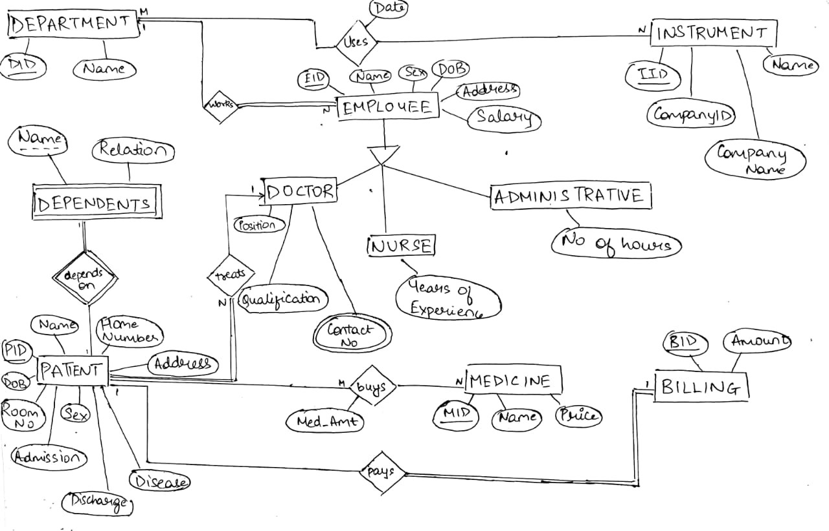

# Relational Model

Convert the ER diagram to the relational model using the concepts learned in the class. List the various tables obtained.

# Normalization

Perform normalization (1NF, 2NF, 3NF, BCNF) as applicable for the entire database.

# SQL Queries

Using a DBMS software (SQLite3 or MySQL or any other of your choice):

* Create the tables
* Populate the tables (insert some meaningful data, at least 10 tuples for each relation)
* Run SQL queries (minimum 15) covering **all concepts** learned in the class

This section should contain the question, SQL code, and the output snapshot for each query.

# Project demonstration

* Tools/software/ libraries used
* Screenshot and Description of the Demonstration of project ( If GUI is made)

# Learning from the Project

Include learning from the project:

* How this project helped you?
* What new aspects did you learn?

# Challenges Faced

1. **Conclusion**

* What are the key takeaways from the project?