**The SK Salon (website)**

**Technical Manual**

**for IT Support Services**

Prepared by: Haley Hardwick

**Revision Sheet**

|  |  |  |
| --- | --- | --- |
| **Release No.** | **Date** | **Revision Description** |
| Rev. 0 | 4/20/2017 | Technical Manual Created |
|  |  |  |
|  |  |  |
|  |  |  |
|  |  |  |
|  |  |  |

**TECHNICAL MANUAL**

**TABLE OF CONTENTS**

Page #

1.0 GENERAL INFORMATION 1-1

1.1 System Overview 1-1

1.2 Acronyms and Abbreviations 1-1

2.0 SYSTEM SUMMARY 2-1

2.1 Website Development 2-1

2.2 Database Overview 2-2

2.3 User Access Levels 2-3

3.0 GETTING STARTED 3-1

3.1 Setting up MySQL 3-1

3.2 Create the database 3-1

**1.0 GENERAL INFORMATION**

# GENERAL INFORMATION

## 1.1 System Overview

The SK Salon website was designed to be mobile- and computer-friendly. The main goals of this website included created a responsive, streamlined design to promote The SK Salon and get customers the most up-to-date information possible. A streamlined, easy-to-use interface was a must for both the customer and her clients.

The administrative portal utilizes two different interfaces for navigation: one for the website editing portion of the site and one for the inventory app side of the site in order to easily tell which interface the customer is working in. The administrative portal offers the ability to quickly and easily manipulate text and images on the website to keep it up to date. It also offers the ability to manage customers, sales, and inventory in the inventory app portion of the portal.

This system is designed with intentions of utilizing a virtual machine instead of a physical server. During development of this system the XAMPP (Apache distribution) package was used. NOTE: The XAMPP package is for developing purposes only.

**2.0 SYSTEM SUMMARY**

# SYSTEM SUMMARY

## 2.1 Website Development

The following were used in the development of the Nucor-Relay for Life website.

* XAMMP package 7.0.13 for Windows (utilizes Apache and MySQL servers for testing as localhost/)
* Bootstrap 3.3.7 (Carousel development)
* Project Zurb Components (Navigation bar)
* NotePad++ (for writing source files)
* GitHub (project repository)
* Languages – HTML, PHP, JavaScript, MySQLi, CSS, JQuery

## 2.2 Database Overview

The backend database was designed with MySQLi and the “phpmyadmin” application. The following ERD shows the entities, attributes and connectivity.

## 2.3 User Access Levels

**Machine/localhost**

There are three different types of users located in the image above. The customer, Sandee Kranz, will be the administrator of the website and have sole administrative privileges as far as managing inventory and creating new users is concerned. Ms. Kranz will have the option of creating new users as she sees fit, but they will not have the ability to create new users themselves. The general public will utilize the frontend of the website only and will have no access to the administrative portal from the front page.

**3.0 GETTING STARTED**

# GETTING STARTED

## 3.1 DOWNLOADING XAMMP AND SOURCE FILES

1. Begin by downloading the “XAMPP 7.0.13 package” for Windows from the XAMPP website.
2. After successful installation of XAMPP package, locate the “SK Salon” folder from CD/DVD and download content to the “htdocs” folder located inside “XAMMP” folder

## 3.2 Create the database

The following are steps for creating a database named “sk-salon”

1. Start by locating/opening the “XAMMP Control Panel”
2. Click the “Start” button of both the “Apache” and “MySQL” shown in pic

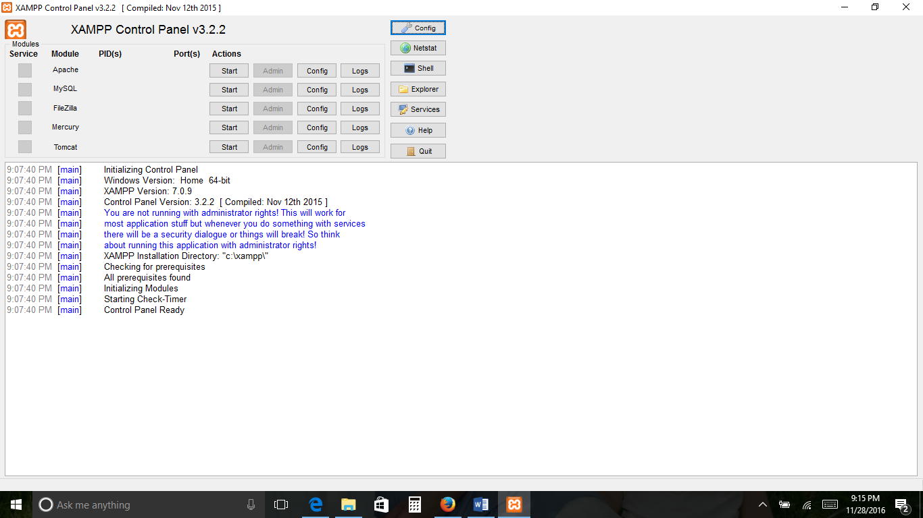

1. Open your favorite browser and type the following text “localhost/phpmyadmin” inside the address text box
2. This should launch the phpMyAdmin application, now click the “New” tab as circled below.

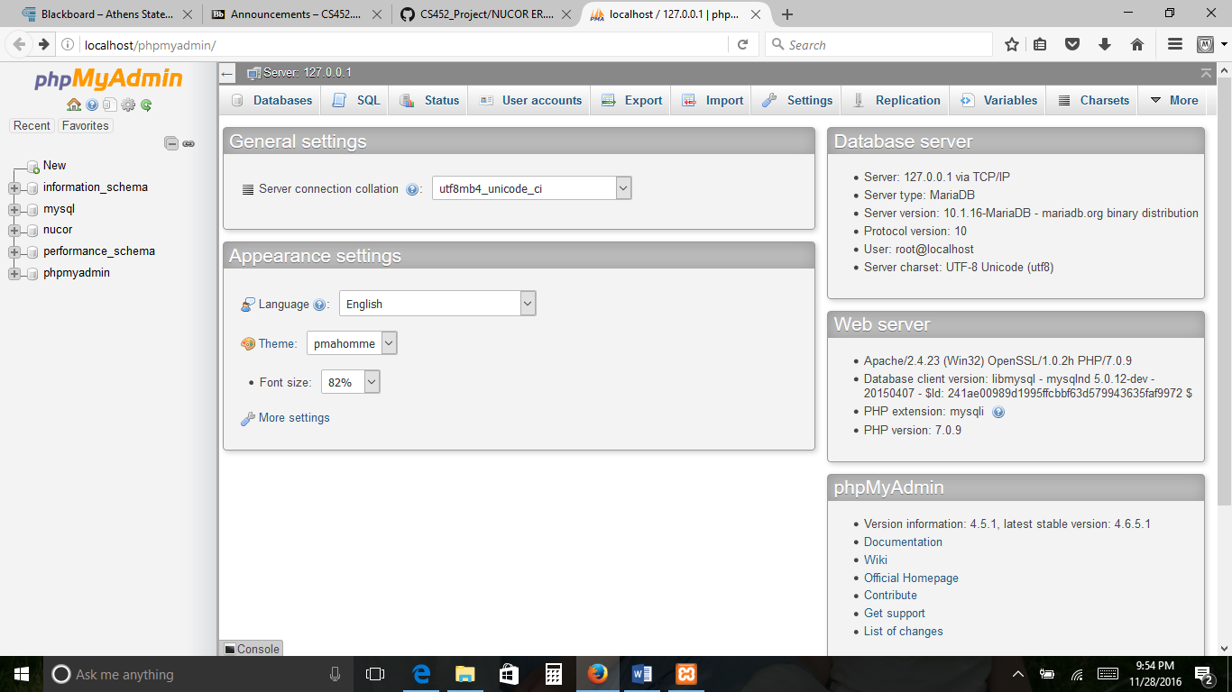

1. Create a new database in phpMyAdmin by clicking New and creating a database with the name “sksalon”. Click the Create button.
2. Locate the “SK_Salon.sql” file on the DVD in the folder labeled Admin.

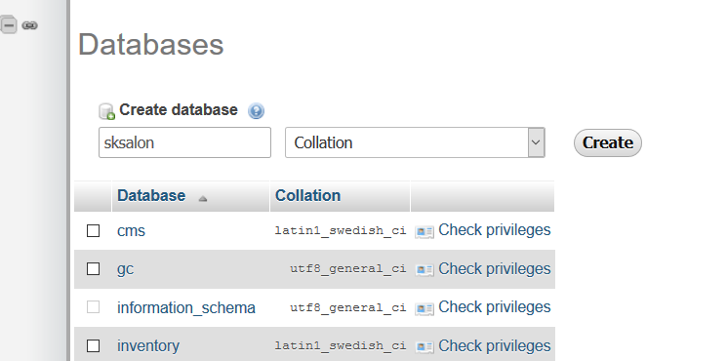

1. In the “phpMyAdmin” application from your browser click on the table name (the table you just created. Select Import from the menu above.
2. Select your SK_Salon.sql file you located before and push GO.
3. You should now have the needed tables for the backend.

