

*Corporate Social Responsibility Data set - Roche Data Science*

Project Leader: Yeibin Kang

Last updated: 2022-03-04

Team: 10X

Yeibin Kang

Ha Eun Kim

Heebin Lee

Hakyung Jeong

Yoonkyung Kim

TABLE OF CONTENTS

1. Problem analysis
   1. Problem statement
   2. Exploratory Data Analysis (EDA) for hospital bed numbers in OECD countries
      1. Canada
      2. Other OECD countries with highest or increasing number of hospital beds per population
         1. South Korea
         2. Japan
         3. Turkey
      3. Insights from EDA and research
2. Solution vision
   * 1. Introduce ‘Bedjustment’
     2. Urgency score calculation based on indicators - Example
3. Solution feasibility
   * 1. Target clients
     2. Economic aspects
     3. Technical aspects
4. Proof of concept
   * 1. UX/UI design
     2. Development plan
5. Conclusion
6. Project Analysis
   1. Problem Statement

Canada experiences a lack of hospital bed numbers which could lead to severe healthcare issues such as increasing the death rate, decreasing the accessibility to the healthcare service and population movement. Moreover, if another pandemic would happen, many Canadians will suffer from it because of the lack of hospital bed numbers. Our solution ‘Bedjustment’ will improve health care sustainability through ensuring better quality healthcare in Canada and help the Canadian government and health care industry reduce unexpected expenditure.

* + 1. Canada has fewer intensive care beds than almost anyone else in the developed world. Even before the Covid-19, Canada had 90% of hospital beds in use. Canada ranks near the bottom of OECD countries when it comes to hospital beds per capita. Canada has 1.97 acute care hospital beds per 100,000 residents, fewer than any other OECD country ([Source](https://nationalpost.com/news/canada/why-canadas-hospital-capacity-was-so-easily-overwhelmed-by-the-covid-pandemic)).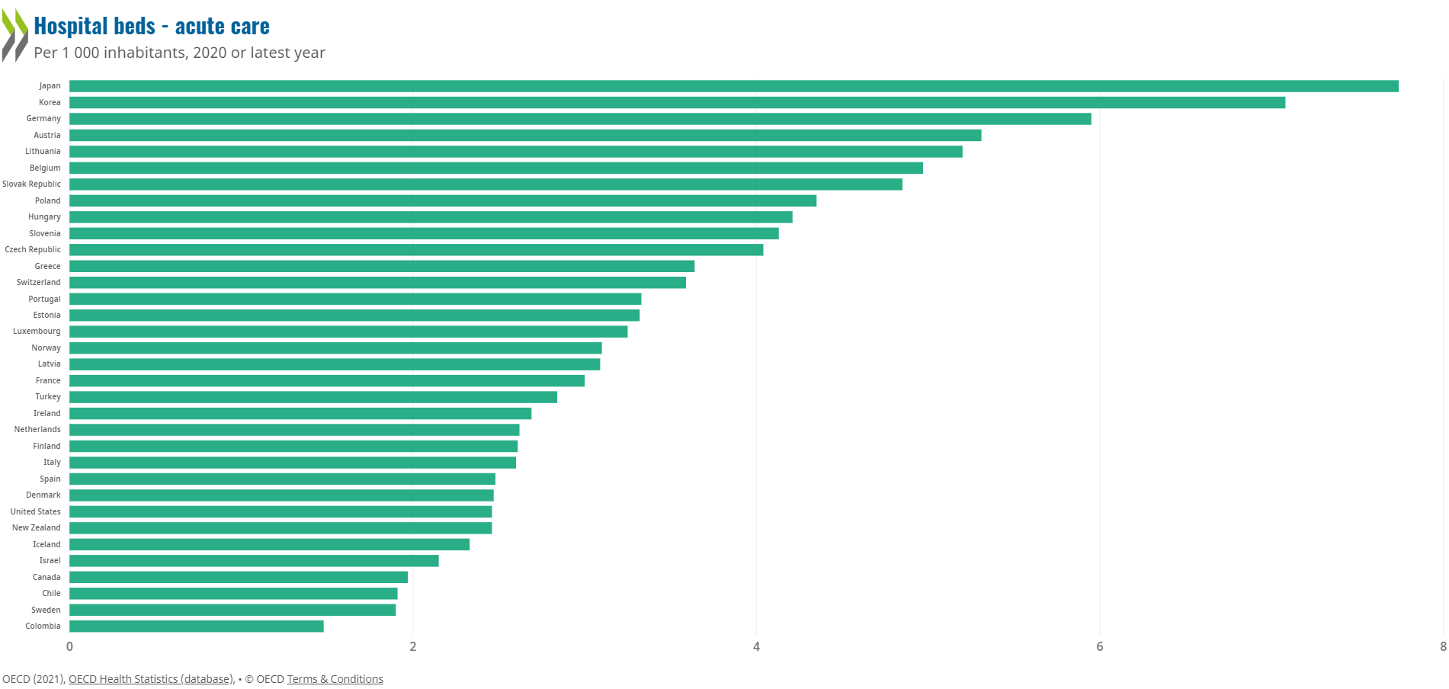
    2. The healthcare system in Canada is easily overwhelmed. For example, Brampton Civic Hospital, which opened in 2007, is home to one of Canada’s busiest emergency rooms and serves as the main full-service hospital for the city’s approximately 650,000 residents and there’s always a hospital capacity problem even before the pandemic. The government declared a healthcare emergency in Brampton for the lack of hospital beds ([Source](https://toronto.ctvnews.ca/there-s-always-been-a-hospital-capacity-problem-in-brampton-covid-19-made-it-worse-1.5755669)).
    3. Despite everything, Canada’s system is still one of the world’s priciest. According to the [Canadian Institute for Health Information](https://www.cihi.ca/en/oecd-interactive-tool-international-comparisons-peer-countries-canada), Canada spends US$4,812 per capita on health care each year. It’s less than half what the Americans spend (​​[Source](https://nationalpost.com/news/canada/why-canadas-hospital-capacity-was-so-easily-overwhelmed-by-the-covid-pandemic)).
  1. Exploratory Data Analysis (EDA) on the hospital bed numbers in OECD countries

Team 10X performed EDA using [OECD health data](https://stats.oecd.org/Index.aspx?ThemeTreeId=9) proposed by Roche to figure out the status of healthcare sustainability in Canada and gain insights from it. Team 10X used Python libraries, including Pandas and Matplotlib, Google Colaboratory, and Microsoft Excel for EDA through data visualization.

After looking at the change in the number of hospital beds in all OECD countries in the data, Team 10X selected a few countries and drew graphs based on the criteria below.

* Countries with the highest number of hospital beds
* Countries with a rapid increase in the number of hospital beds
* Countries where the number of hospital beds is slightly above average
* Countries where the number of hospital beds is below average
* Countries with a rapid decrease in the number of hospital beds

The graph below shows the change in the number of hospital beds per 1000 population from 2010 to 2020 in these countries. Japan maintains the largest number of hospital beds per 1000 population, Korea's number of beds is rapidly increasing, and Canada is well below the average.

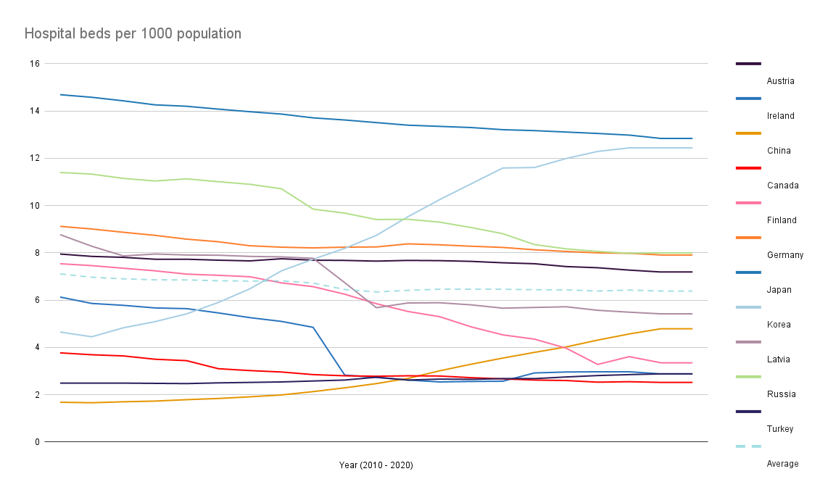

* + 1. Canada
* Background information:
  + - 1. Canada has a national health care system, governed and delivered by each provincial jurisdiction.
      2. Under each province’s regulation, citizens receive hospital and physician services without cost.
* EDA:
* The graph below shows that almost all hospital beds in Canada are located in publicly owned hospitals, and the proportion of curative (acute) care beds are also quite high.

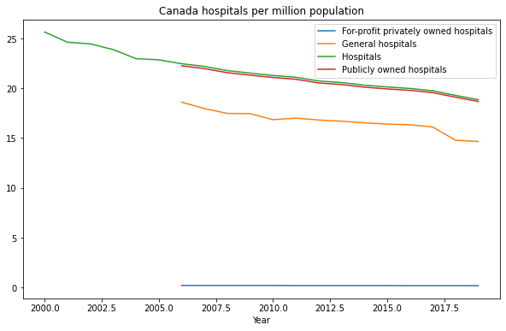

* The graph below that shows hospitals in Canada per million population supports the fact that almost all hospitals in Canada are publicly owned hospitals.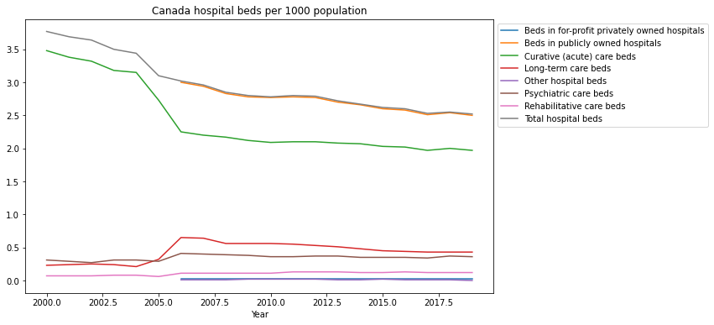
* The graph below shows the number of long-term care beds in Canada per 1000 population aged 65 years and over, and it can be seen that it increased sharply until around 2016, and then declined sharply after that. It suggests that Canada needs to increase its hospital beds.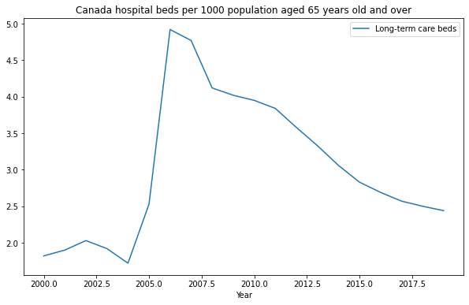
  + 1. Other OECD countries with highest or increasing number of hospital beds per population
* Team 10X selected countries where the number of hospital beds per capita was the highest or experienced the sharpest or slight increase to gain insight. Team 10X performed more EDA and conducted research on these countries: South Korea, Japan, and Turkey.
  + - 1. South Korea
         1. National healthcare insurance system: South Korea provides the National healthcare insurance system to Koreans. Taking up insurance is mandatory for most Koreans.
         2. Most of the hospitals in South Korea are run by private owners (94%) and 30 out of 43 university hospitals are run by private universities and 10 of them are operated by public universities.
* The following graph shows the ratio of hospital beds in Korea by their hospital type or their purpose of use.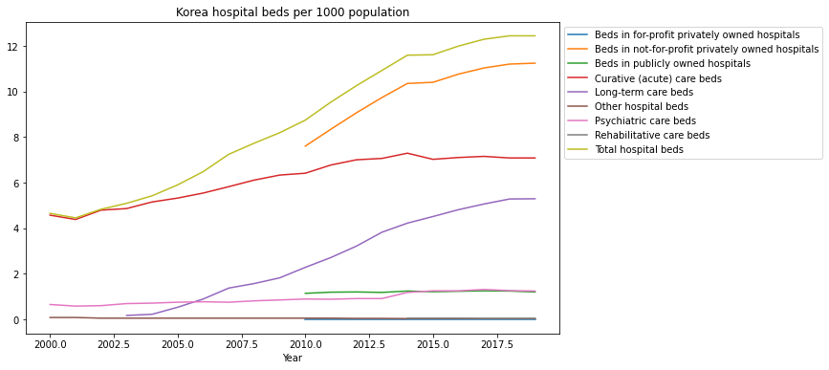

The following graph shows the ratio of hospitals in Korea by their type. As mentioned above that most of the hospitals are run by private owners, this graph also shows that not-for-profit privately owned hospitals account for a large proportion of Korean hospitals.

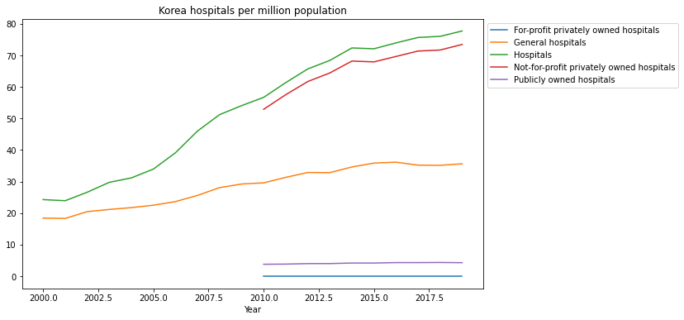

* + - * 1. South Korea is one of the world's fastest aging countries

The number of hospital beds has strongly increased in Korea (+164%), with a significant number of these dedicated to long-term care. Most of the hospital beds are dedicated to long-term care.

* The graph below supports the above.

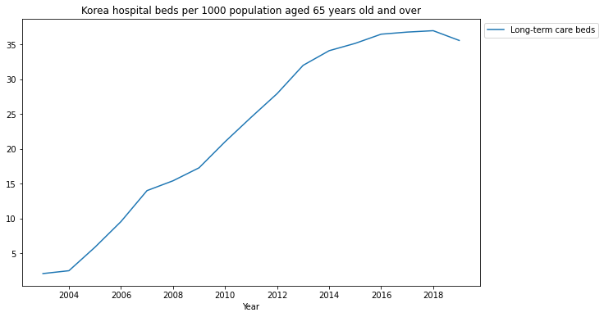

In Korea, life expectancy at birth was 82.7 years in 2017, higher than the OECD average of 80.8

* + - * 1. Since 2002, health spending in Korea has grown at nearly 8% each year, more than double the OECD annual average of 3.6%. That’s in large part due to an over-reliance on hospitals ([Source](http://www.koreabiomed.com/news/articleView.html?idxno=5780)).
      1. Japan

The below graph shows the amount of hospital beds is stable in most of the hospitals in Japan which enables Japan to keep the number of beds per population high. Also, acute beds occupied a large proportion of bed numbers.

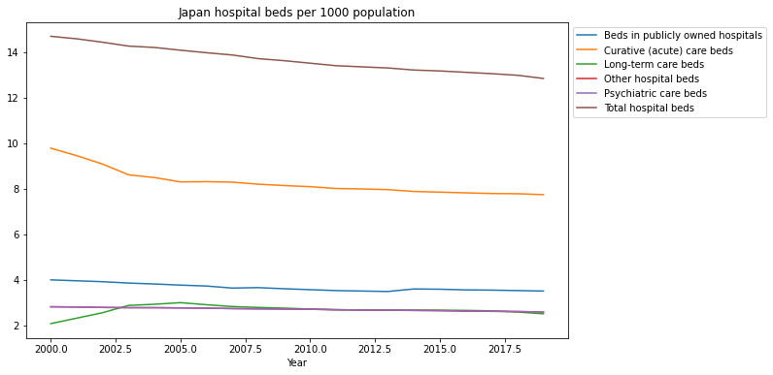

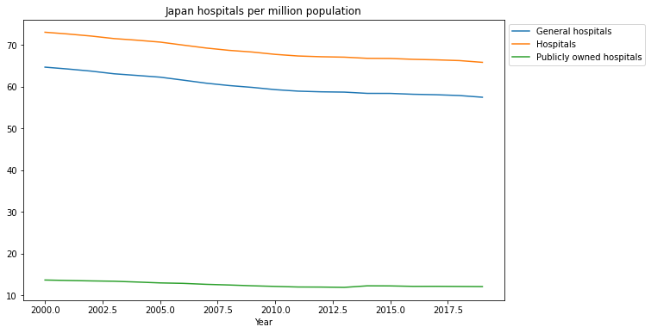

* + - * 1. Rapid aging country
        2. Systemic national healthcare system

70% of the cost of healthcare service is borne by the government and 30% by the nation. Taking up insurance is mandatory for people who are working.

Japan controls the price for healthcare services to provide for all of the nation.

* + - * 1. Up-to-date medical technology
      1. Turkey

What makes Turkey different from the other countries above is that it has a certain proportion of for-profit privately owned hospitals. Although the beds in publicly owned hospitals account for the largest proportion, the proportion of beds in for-profit privately owned hospitals is gradually increasing. For-profit privately owned hospitals themselves by population also account for a fairly large percentage. Another point is that acute care beds account for a large proportion and are increasing. Please check the graphs below:

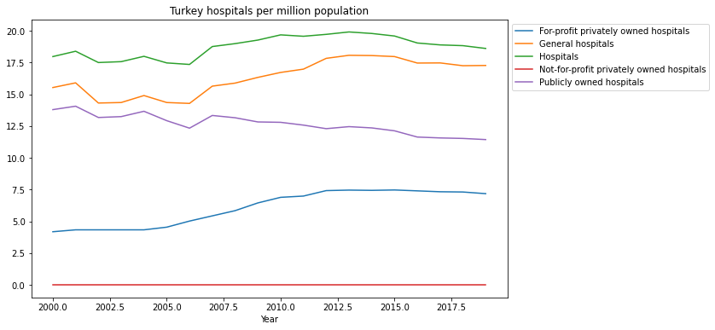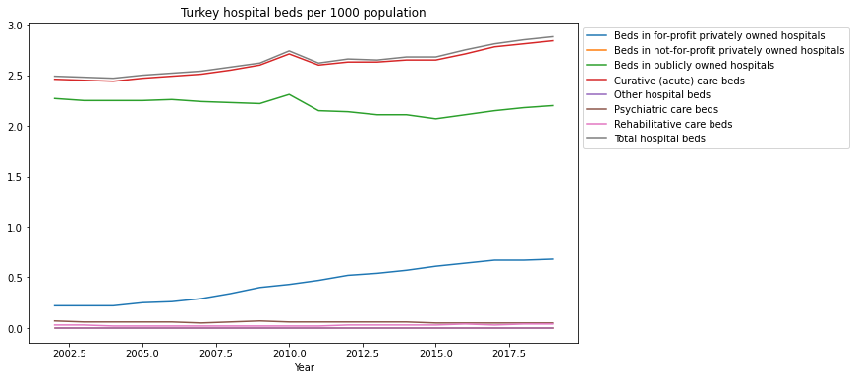

More background information:

* + - * 1. In 2003, Turkey started a universal health care system, Known as Universal Health Insurance *Genel Sağlık Sigortası*. It led to a satisfaction rate of healthcare service from 39.5% to 75.9% in 2011.
        2. Even though Turkey has a large private health service, many people prefer to use private healthcare services because the private healthcare service provides shorter waiting lists and higher quality. So it leads a medical tourism and healthcare accessibility inequality
    1. Insights from EDA and research:

Compared to OECD peer countries, including Korea, Japan, and Turkey, Canada needs to gradually increase the number of hospital beds, especially for the elderly. This is because the graph illustrates that the long-term care hospital beds per population are rapidly decreasing.

Team 10X have considered what would be the most efficient way to increase the number of hospital beds in Canada and concluded that Team 10X need to build a system to select areas where more hospital beds are urgently needed.

* To see the entire EDA: please refer to [this Google Colatoratory file](https://colab.research.google.com/drive/1S5o52xbXFh1BReh6uCgpg8Y7DVJl5jIK#scrollTo=ZSLUufsUvbVG)

1. Solution vision
   1. Introduce ‘Bedjustment’

‘Bedjustment’ recommends regions in Canada with the most urgent need for more hospital beds using Machine Learning.

* + 1. Hospital Bed distribution recommendation system using ML
       1. Team 10X will develop the hospital bed distribution recommendation system for users who plan to allocate more beds in Canada.
       2. Team 10X found 3 important factors for evaluating the need for more hospital beds in OECD stat data. The indicators will be Hospital bed numbers per population, the proportion of the aging population, and the average waiting time of hospitals in the region. Regions will get points for each factor, and the ML model will recommend three optimal regions to allocate more hospital beds based on the points.
    2. The system needs an algorithm to give an appropriate score based on the value of the indicator for each region
    3. Display the information
       1. The system will use a map to help users can see trend of hospital bed numbers near the area
       2. The system will display simple healthcare information for the recommended area which help users to choose the right area
  1. Urgency score calculation based on indicators - Example

|  |  |  |  |  |
| --- | --- | --- | --- | --- |
|  | Aging Population | Hospital beds per population | Waiting Time | Total |
| Ontario | 10 | 9 | 10 | 9.6 |
| Quebec | 9 | 10 | 1 | 6.6 |
| British Columbia | 8 | 8 | 2 | 6 |
| Alberta | 7 | 7 | 7 | 7 |
| Manitoba | 6 | 3 | 5 | 4.6 |
| Nova Scotia | 5 | 4 | 8 | 5.6 |
| Saskatchewan | 4 | 6 | 3 | 4.3 |
| New Brunswick | 3 | 2 | 6 | 3.6 |
| Newfoundland | 2 | 1 | 4 | 2.3 |
| P.E.I | 1 | 5 | 9 | 5 |

1. Solution feasibility  
   1. Target Clients
      1. Canada’s health care system: The health sector wants to improve the service they provide and is aware of hospital bed shortage
      2. Healthcare facilities and providers: Hospital bed shortage often leads to delay in discharging patients from ERs — which significantly costs healthcare facilities
   2. Economic aspect
      1. Low cost & high benefit: The major costs associated with Bedjustment is machine learning recommenders and data providers. The benefits it can bring to the healthcare industry is more significant than its cost.
      2. Investment from target clients: Aforementioned target clients are willing to solve hospital bed shortage, so they would be open to share their data and make investment.
      3. Less effort and cost in later stages: Once the business is on its track, Bedjustment does not require continuous inputs or resources. Automatic data ingestion and machine learning recommenders will maintain the system.
      4. Supply and Demand: Target clients can understand which areas need more hospital beds compared to other areas by using ‘Bedjustment’. This will resolve inequality problems in one of healthcare issues in Canada.

* 1. Technical aspects
     1. Accessibility for data: In order to analyze and recommend particular areas within provinces, access to more granular data is required.
     2. Implementation of a recommender system using ML: Team 10X needs to optimize ML model to analyze and combine different factors and recommend the best region.

1. Proof of concept
   1. UX/UI Design
      1. [Demo video](https://drive.google.com/file/d/1b2XJ3o9Lx74zHcFRrvPUa_mJ2jlqdIzk/view?usp=sharing)
      2. [Figma prototype](https://www.figma.com/proto/WvtuJ56HJo6TTDXwkKQAdw/Seneca-Hackathon?node-id=16%3A3&scaling=min-zoom&page-id=0%3A1&starting-point-node-id=16%3A3)
      3. Users will fill out the number of beds they are going to allocate and which provinces they are considering — they can select “Any provinces” if they are not constrained to certain provinces. When the click “Search” button, it will show the map and lists of the high-demand areas. Users can browse different areas by clicking them and short descriptions and factors of the area are displayed. Once they find the area they would like to allocate beds, they will click “View facilities” to see the lists of the hospitals and healthcare facilities in the area.
   2. Development plan
      1. Implementing optimized Machine Learning model for recommendation system: More research is required.
      2. Integrating ML model with the web app: Team 10X plan to use React for frontend and Flask for backend to connect the ML model to the frontend web application.

1. Conclusion

In conclusion, Team 10X expects to improve healthcare sustainability by solving especially a number of hospital beds issues in Canada. Also, Team 10X helps to predict and prevent the worst scenario in the Canadian healthcare industry by using ‘Bedjustment’, and Canadians will experience a better quality of healthcare services.