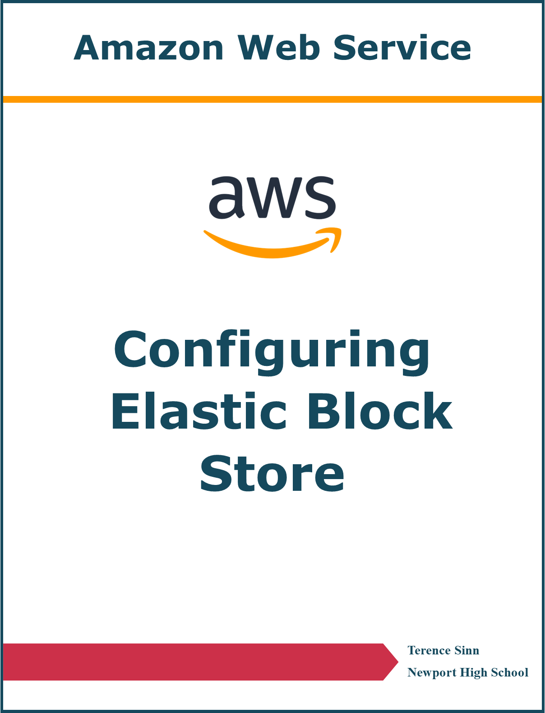

**Purpose**

When working with EC2 virtual machine instances, there might be times when the created virtual disk space is not enough. When running out of storage, AWS offers the Elastic Block Store service in order to create extra virtual disks on-demand to increase the storage of the EC2 instance. AWS also offers the ability to create snapshots, which are a backup of all files on the drive at a specific instant in time, which makes data recovery much easier. These tools expand the scalability and reliability of the AWS cloud computing service.

**Lab Summary**

A new virtual hard drive disk (called a volume) was added to a predefined EC2 virtual machine instance. The ability to SSH and configure the EC2 instance through the Linux terminal was utilized in order to mount the new volume into the operating system to be accessed. A snapshot of the volumes in the EC2 instance was also created in order to create backup and reload points.

**Creating and Attaching Volumes:**

1. In EC2 configuration, there is a predefined lab instance. Click onto volumes in the left menu.

2. Create a new volume with a size of 1 GiB and a tag of Name / My Volume.

3. In the volumes dashboard, select My Volume and click into actions and attach volume.

4. Select the volume to attach to the Lab EC2 instance.

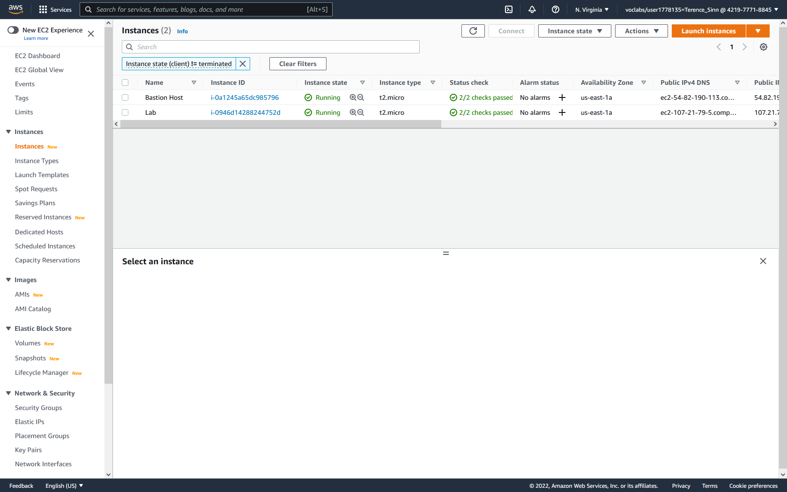

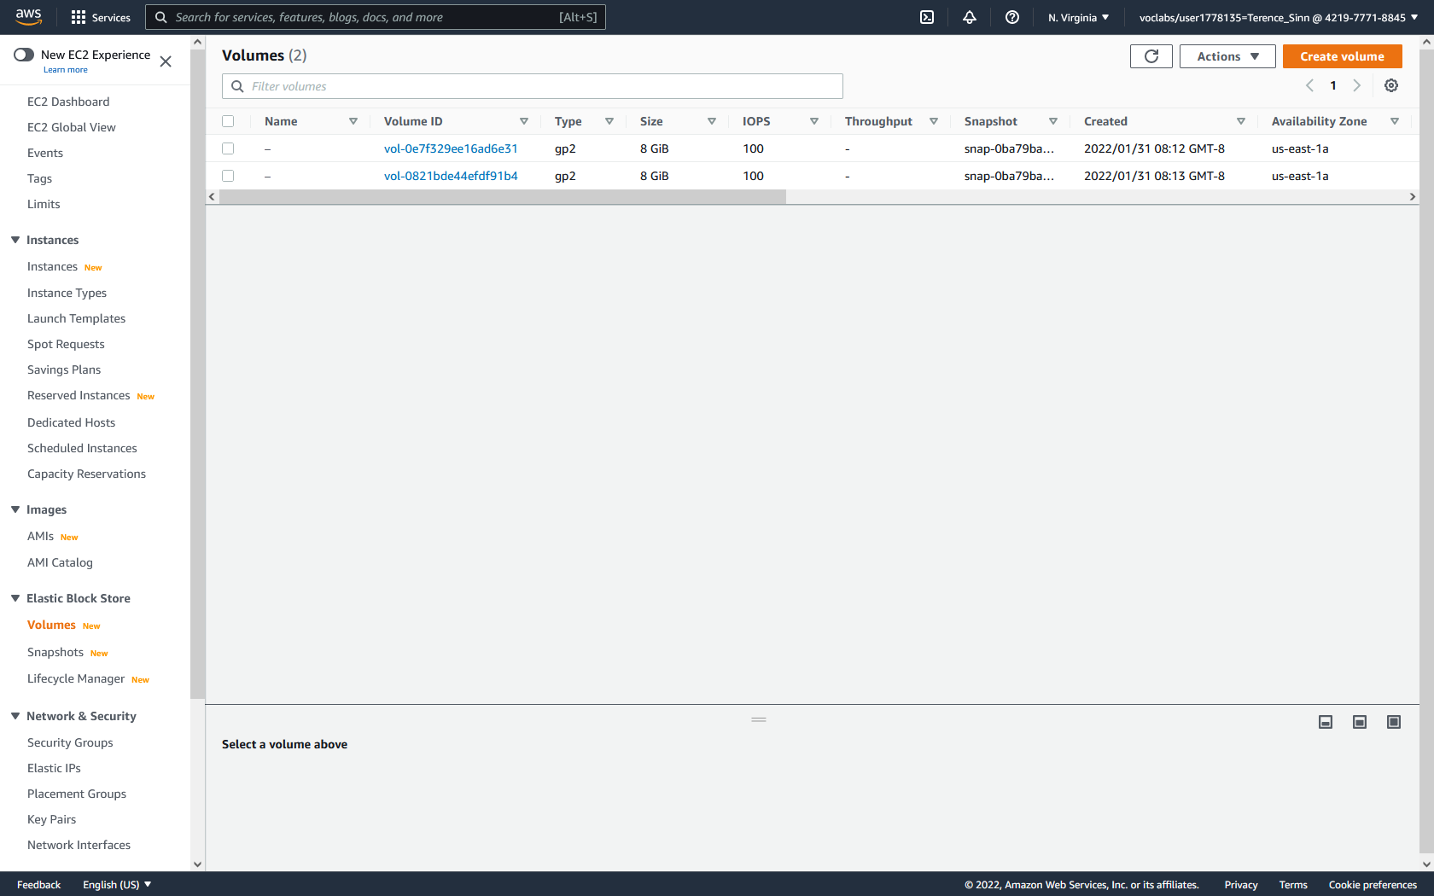

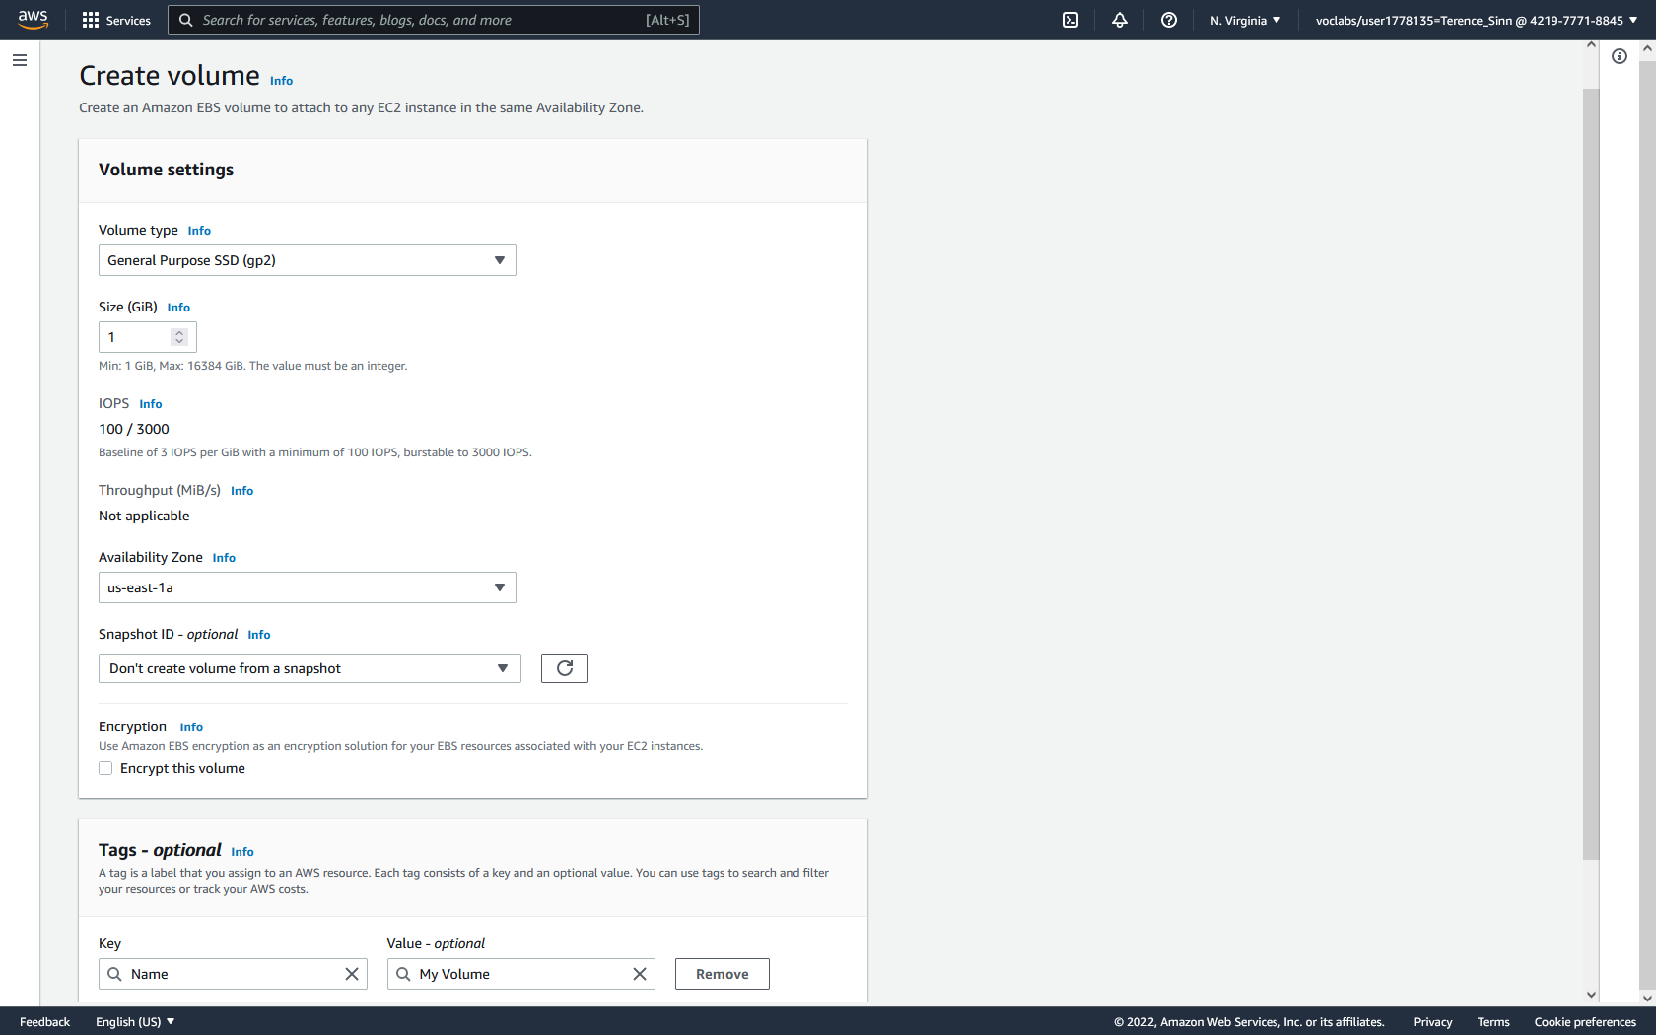

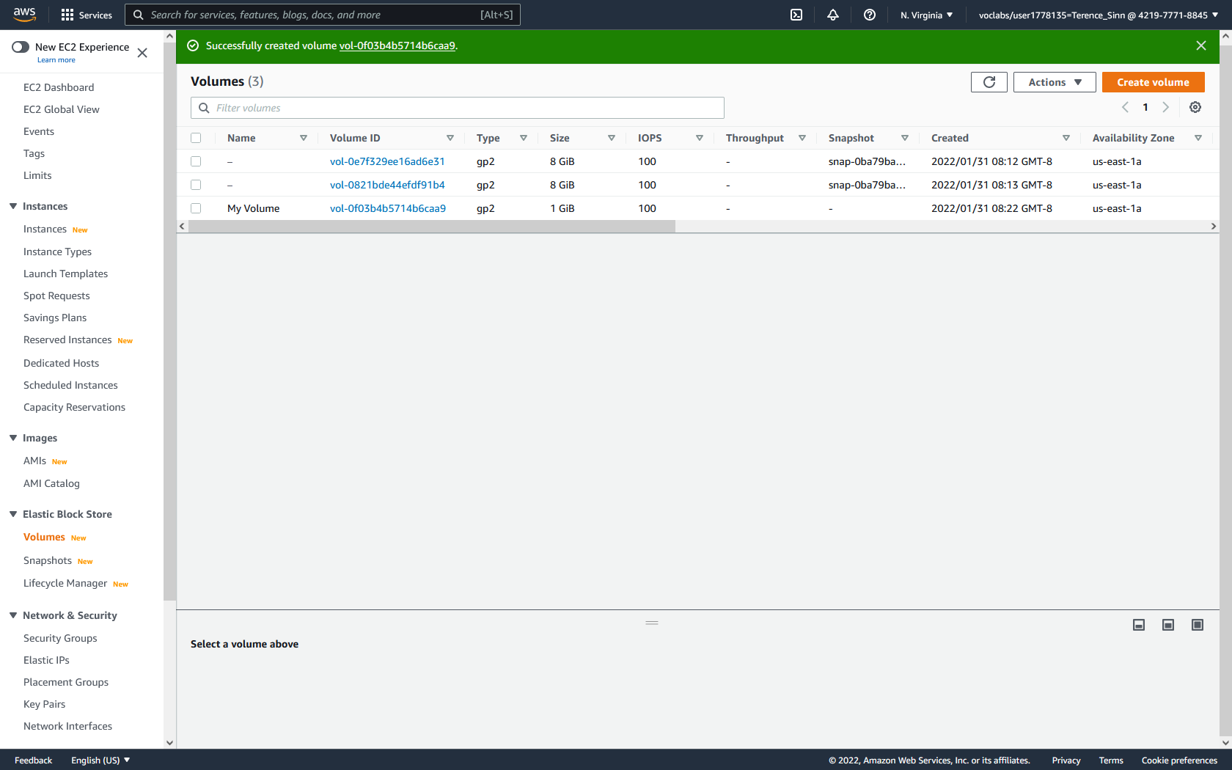

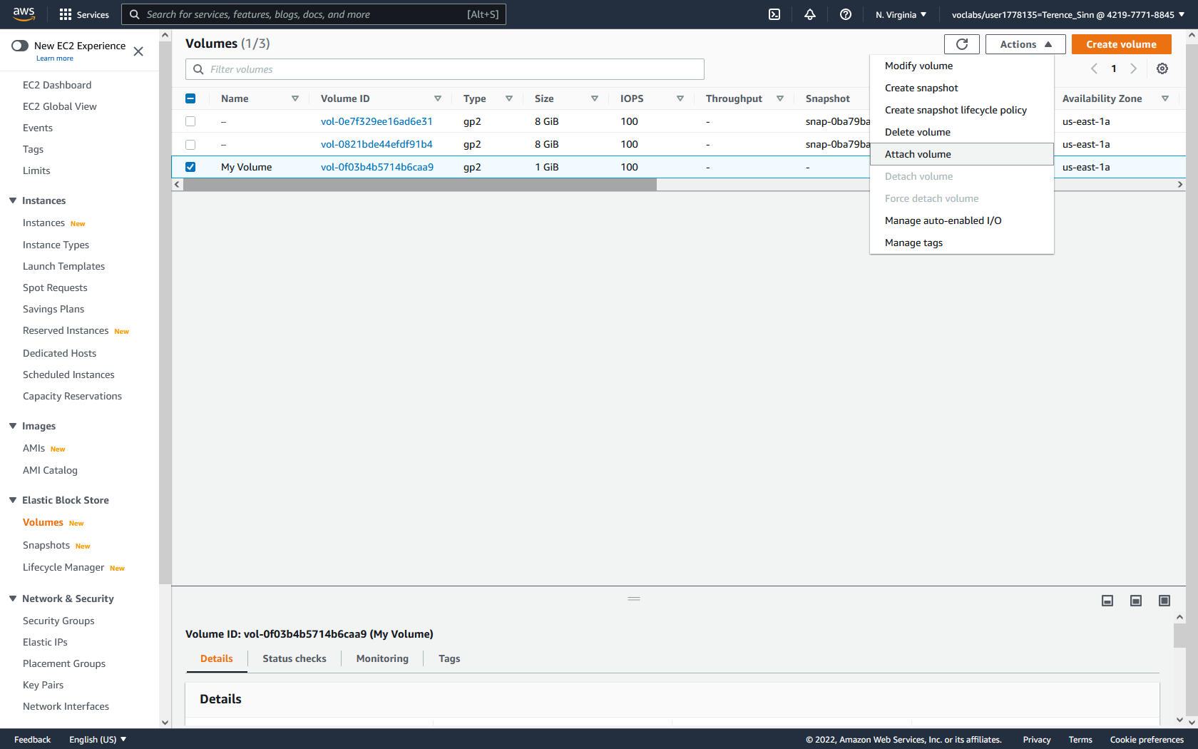

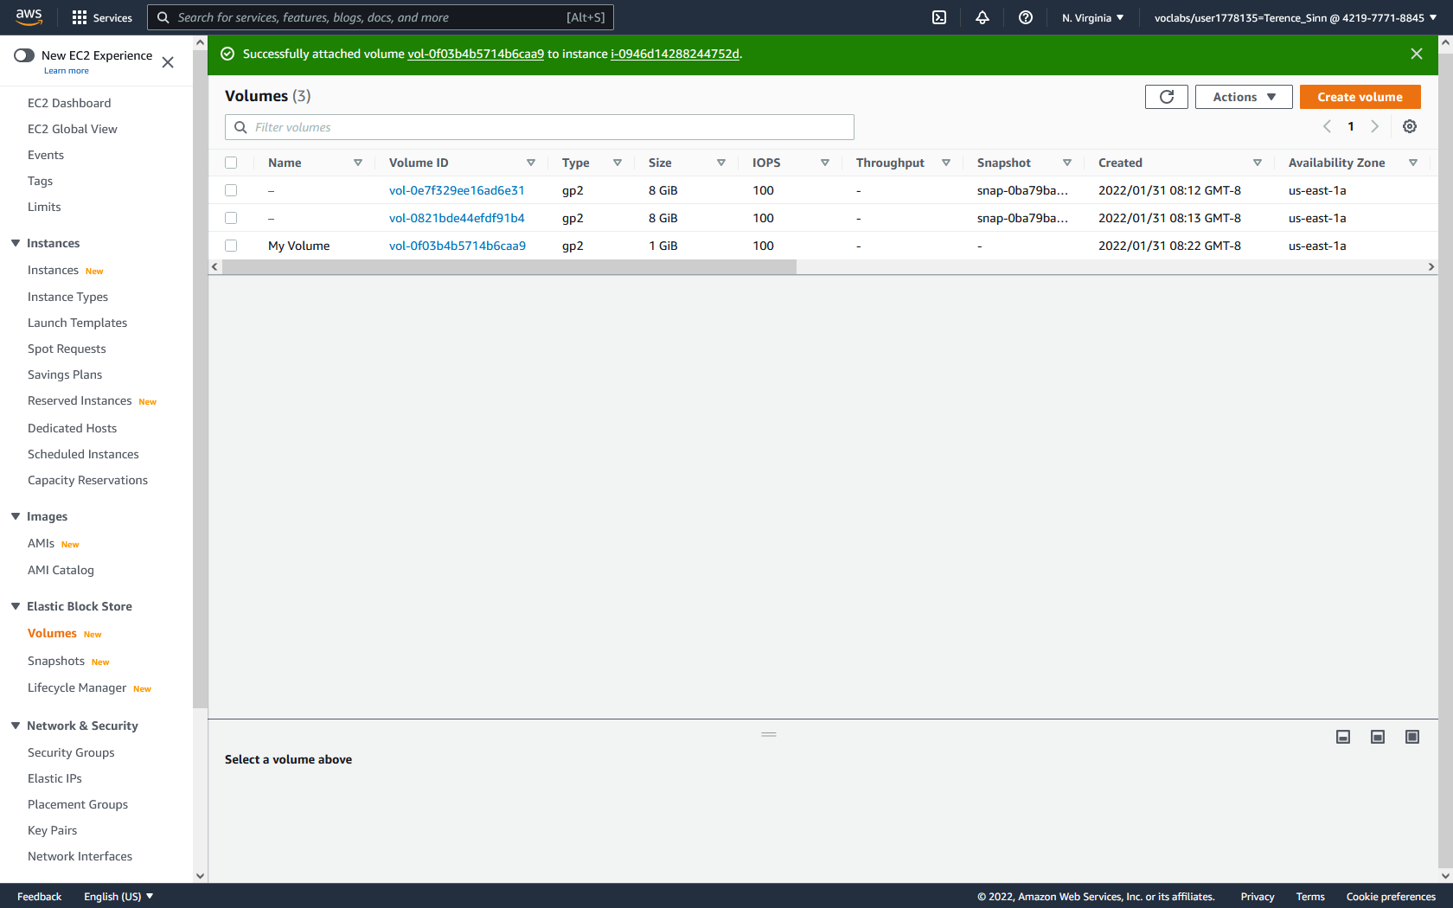

**SSH into the EC2 Instance:**

1. To SSH into the EC2 instance, you will need a private key. Normally, the private key is provided on creation of the EC2 instance. In this case, you will go to the AWS academy lab website, click details, and show. From here, download the PPK (for using PuTTY terminal emulator) or PEM (for normal SSH).

2. For the first access method using the PPK, open PuTTY terminal emulator.

3. Click onto the connection tab on the left menu. Then change the seconds between keepalives to 30 seconds. This will keep the console session from timing out.

4. Find the IPv4 address of the EC2 instance by going to the instance dashboard and clicking into the Lab Instance’s details. In PuTTY, click onto the session tab on the left menu and type in the IPv4 address under Hostname. Make sure it is using port 22 and SSH.

5. On the left menu under connections, expand SSH. Under SSH, click onto the Auth tab. Click browse and select the labsuser.ppk downloaded earlier. The click open. A new terminal window should appear.

6. Login with the user name ec2-user.

**OR**

2. Open the terminal (for MacOS and Linux users) or open the command prompt (requires the installation of OpenSSH and Linux subsystem packages).

3. Using the cd command and the correct file paths, navigate into the folder that holds the PEM file.

4. Type the command to make the private key read only:

chmod 400 labsuser.pem

5. SSH into the instance by typing the following command, using the appropriate IPv4 address. The -i option tells SSH to use a predefined private key in order to initiate authentication:

ssh -i labsuser.pem ec2-user@<IPv4 Address>

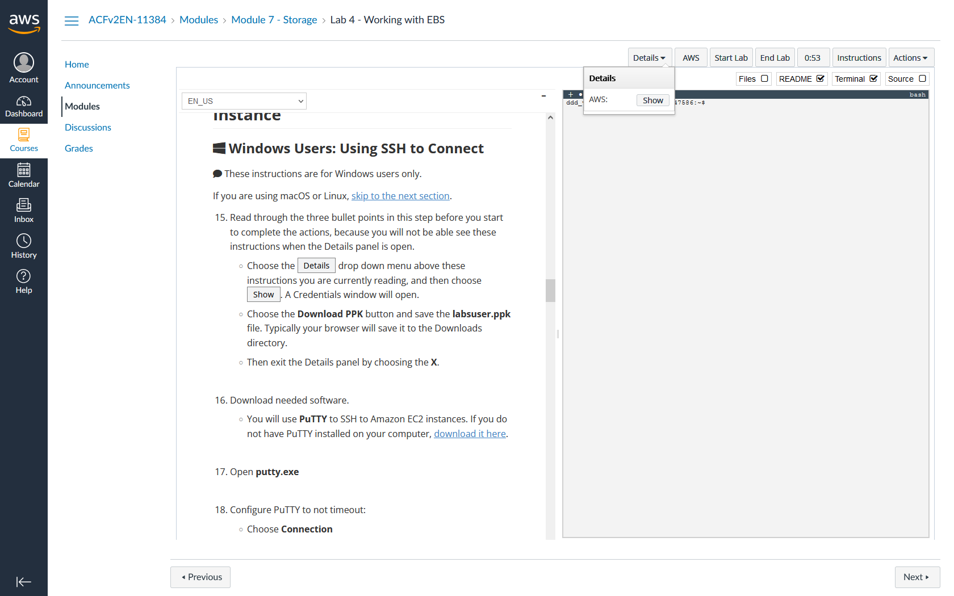

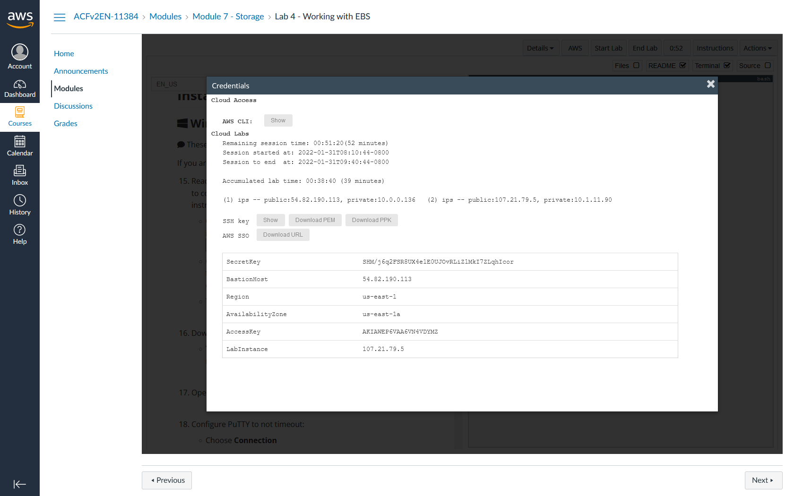

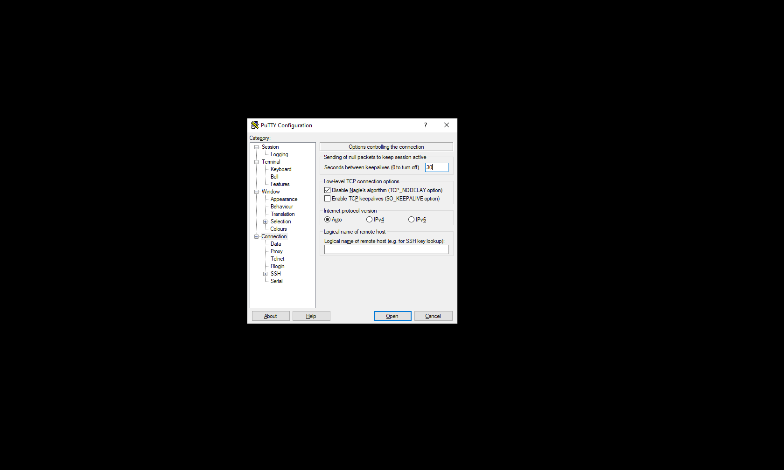

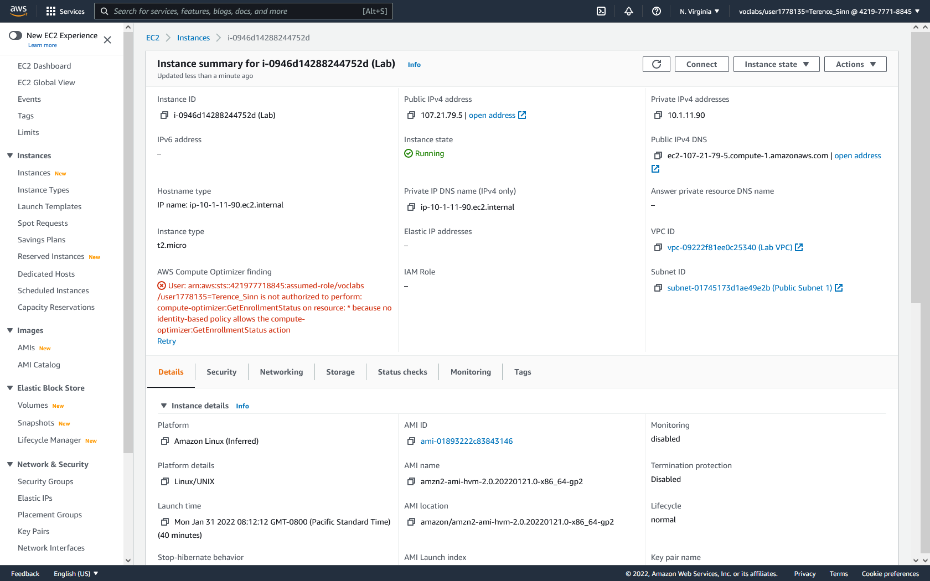

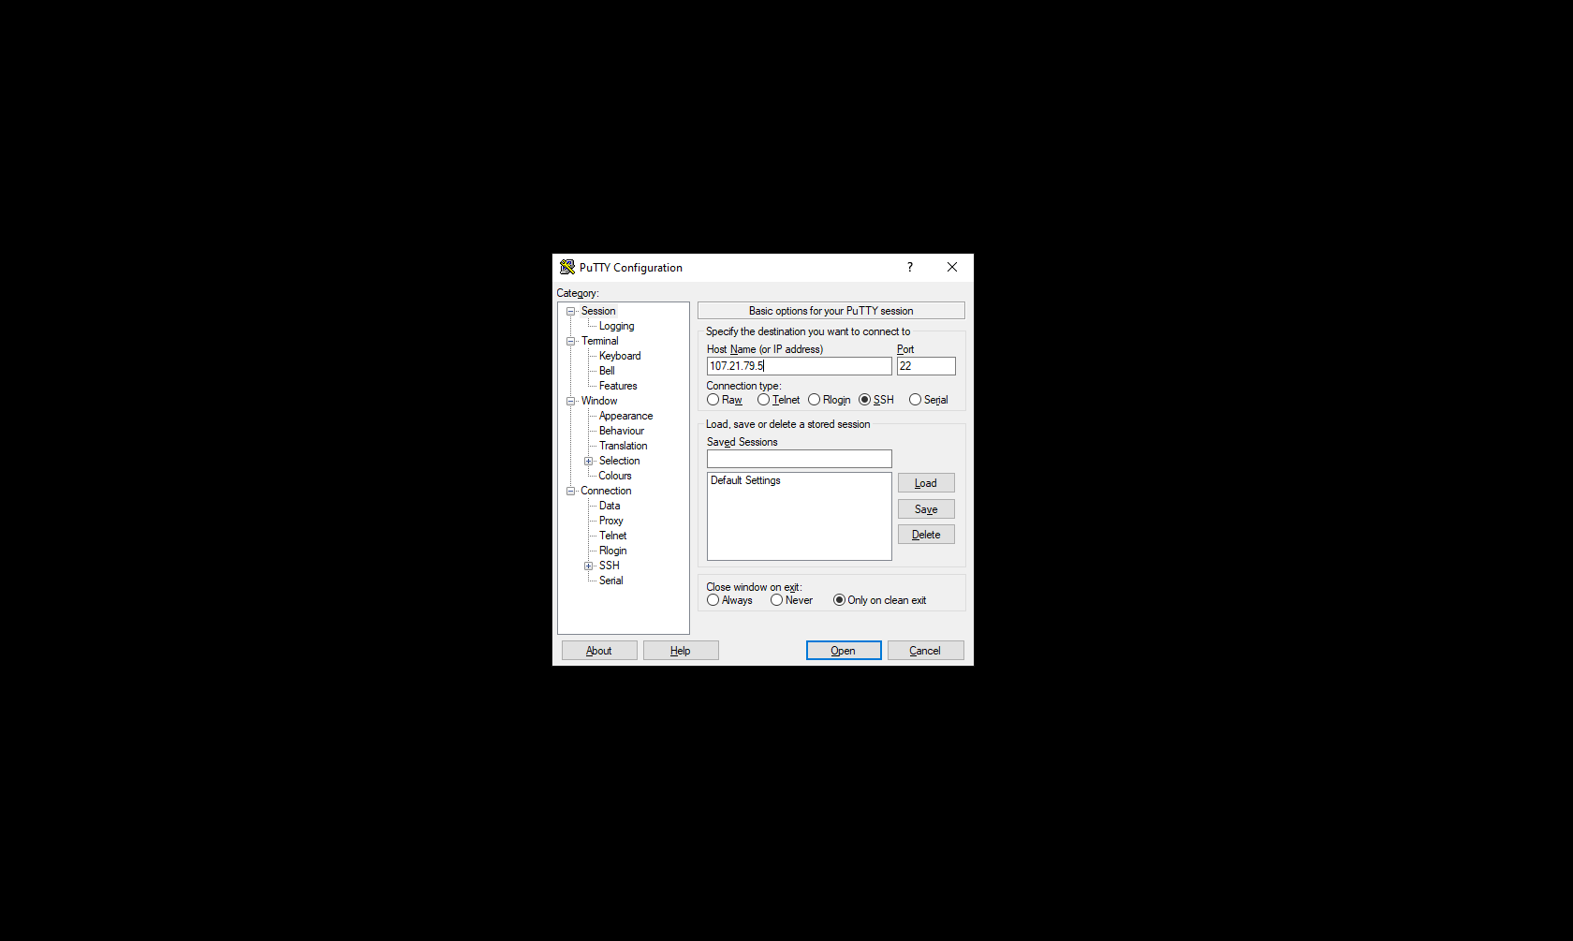

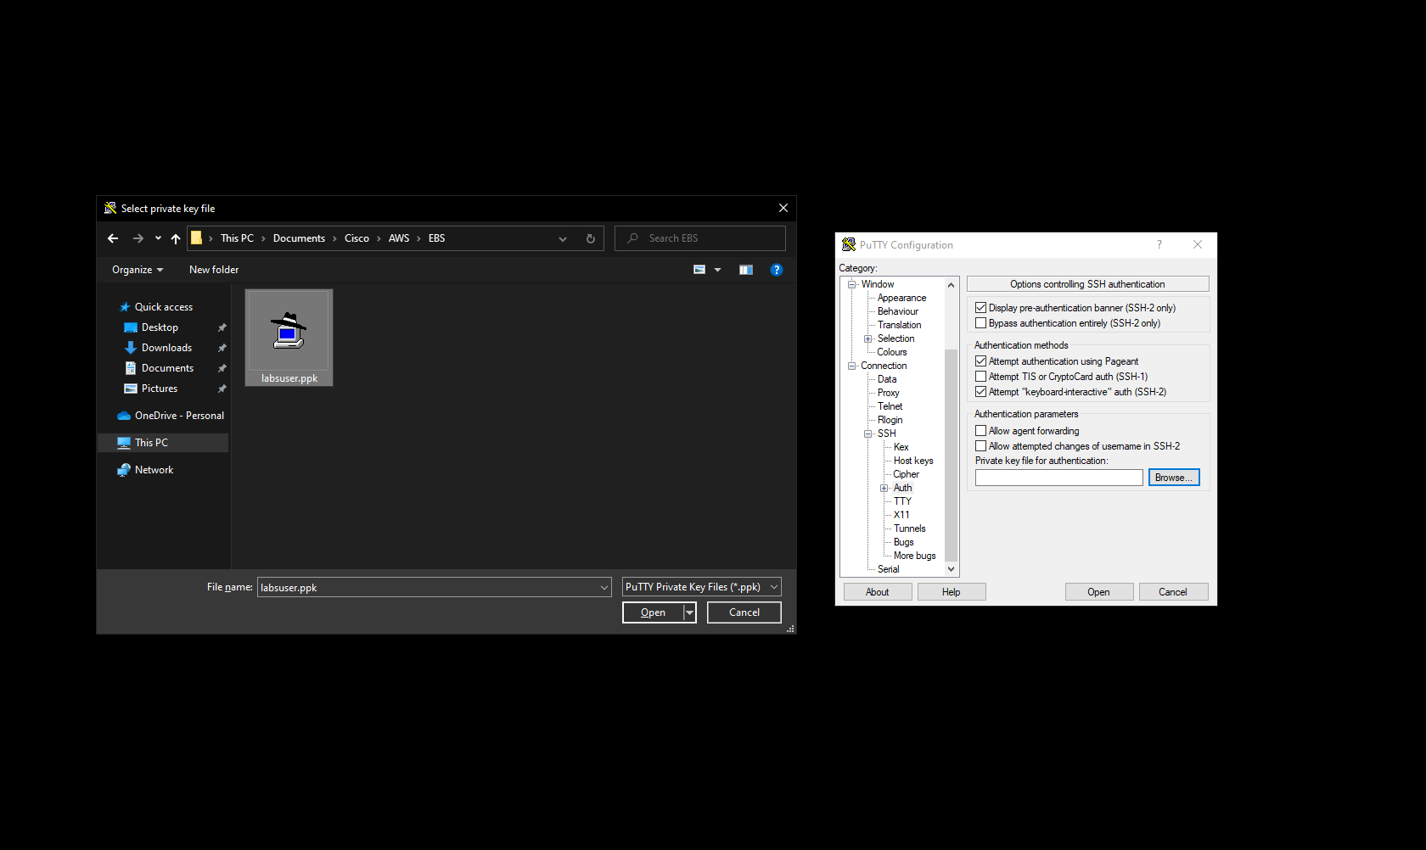

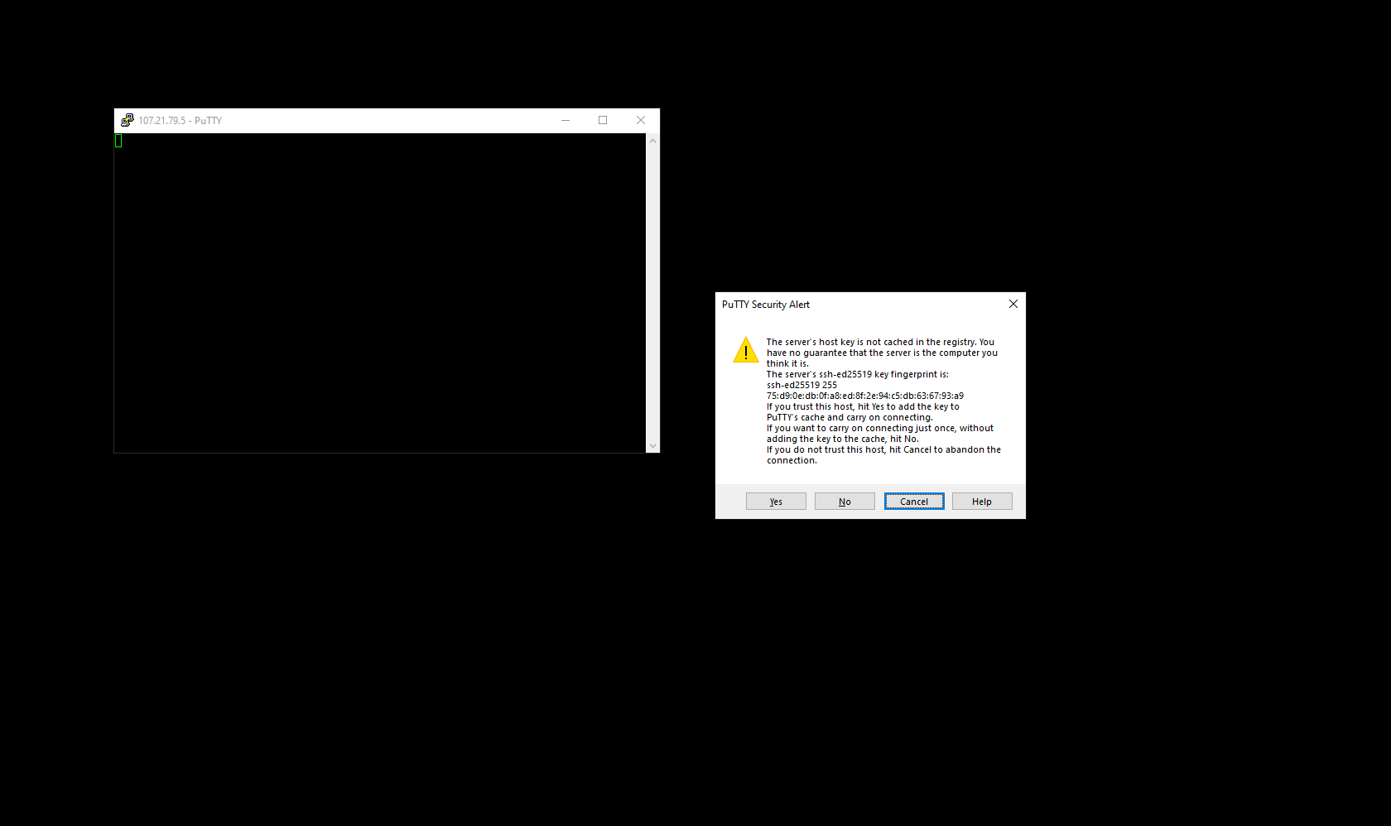

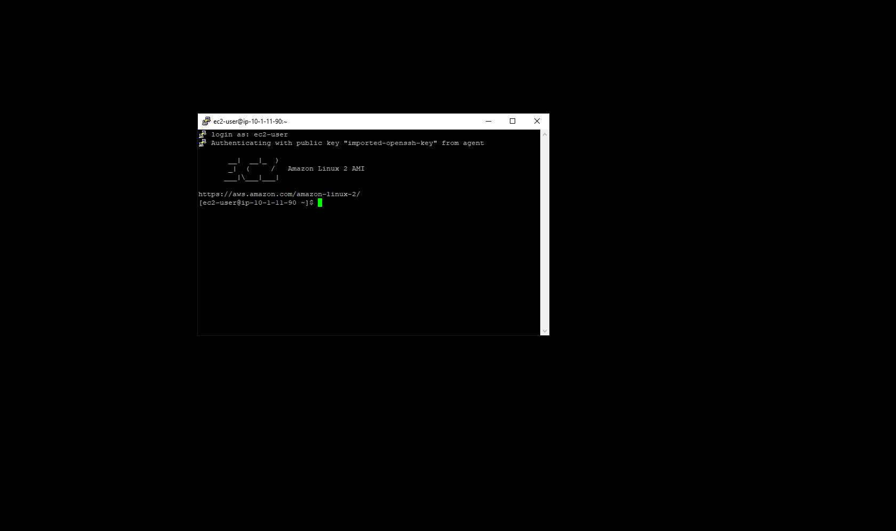

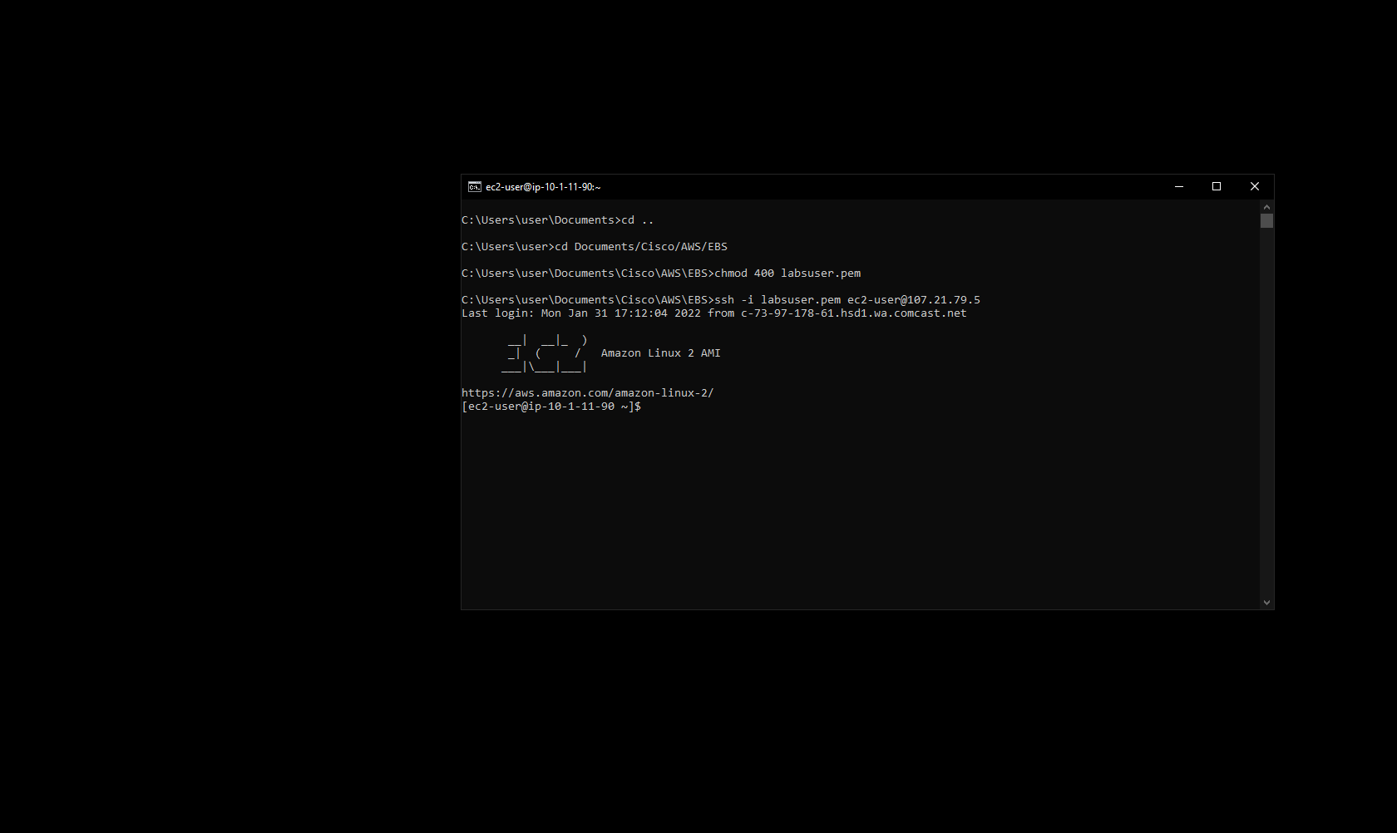

**Mounting:**

1. In the terminal, type the following command to see the active filesystems. Notice how there is no file system with the size of 1 GiB. This is because we haven’t mounted that volume yet:

df -h

2. Type the following command to create the file system. The -t ext3 determines the type of file system to be used as ext3. The /dev/sdf identifies the volume attached to the instance:

sudo mkfs -t ext3 /dev/sdf

3. Type the following command to create a directory in which the drive can be accessed:

sudo mkdir /mnt/data-store

4. Type the following command to mount the file system into the directory created:

sudo mount /dev/sdf /mnt/data-store

5. Type the following command to automatically mount the new file system when the instance is restarted. This adds an extra line to the fstab configuration file:

echo "/dev/sdf /mnt/data-store ext3 defaults,noatime 1 2" | sudo tee -a /etc/fstab

6. Check that the extra line has been added to the fstab configuration file by typing the following command:

cat /etc/fstab

7. Type the following command to verify that a file system with a size of 1 GiB has been mounted:

df -h

8. Type the following command to create a file in the new file system:

sudo touch /mnt/data-store/test.txt

9. Type the following command to verify that the file has been created in that directory:

ls /mnt/data-store

10. Type the following command to create a new file with some text in the new file system:

sudo sh -c "echo some text has been written > /mnt/data-store/file.txt"

10. Type the following command to view the text within the newly created file:

cat /mnt/data-store/file.txt"

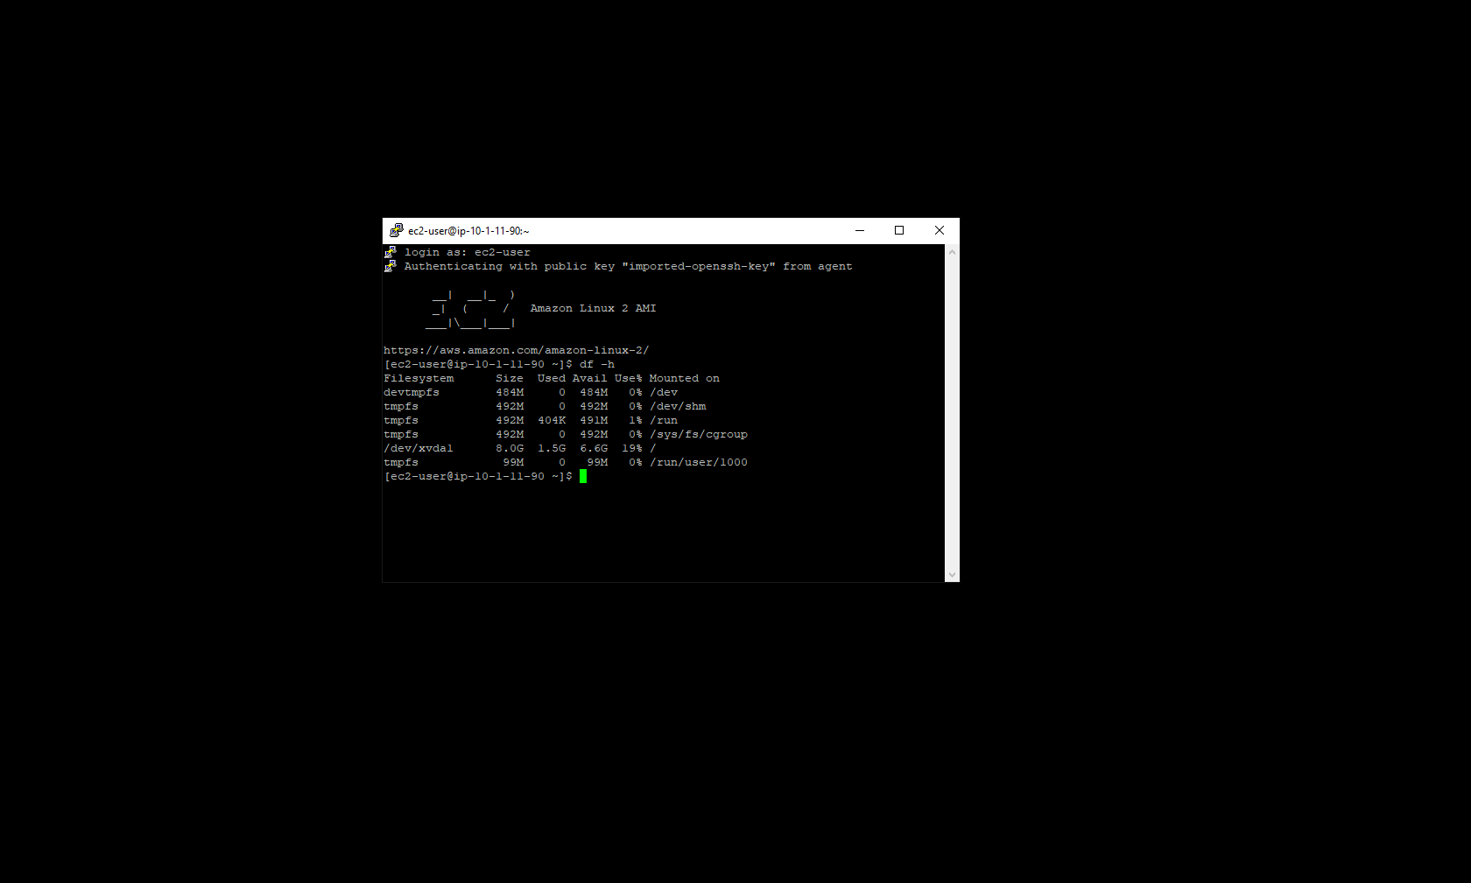

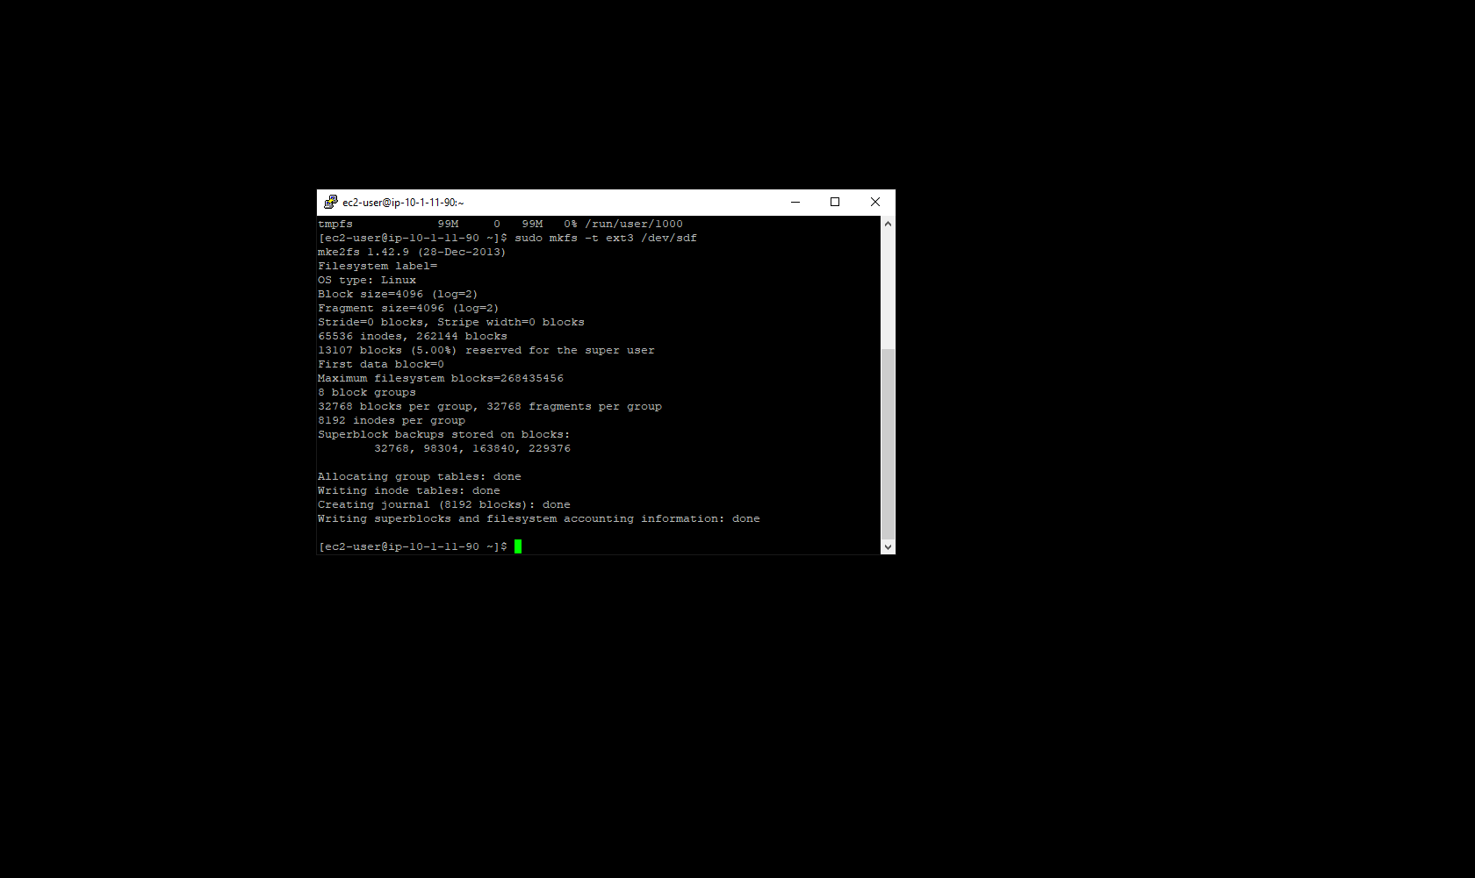

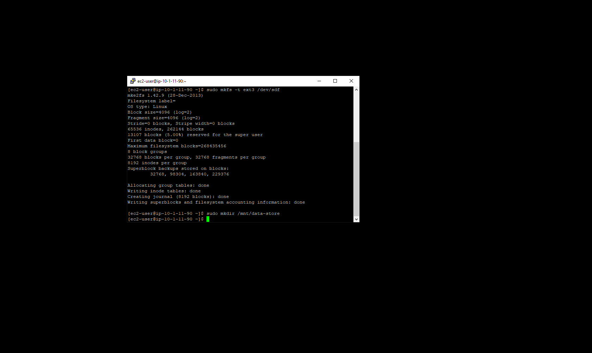

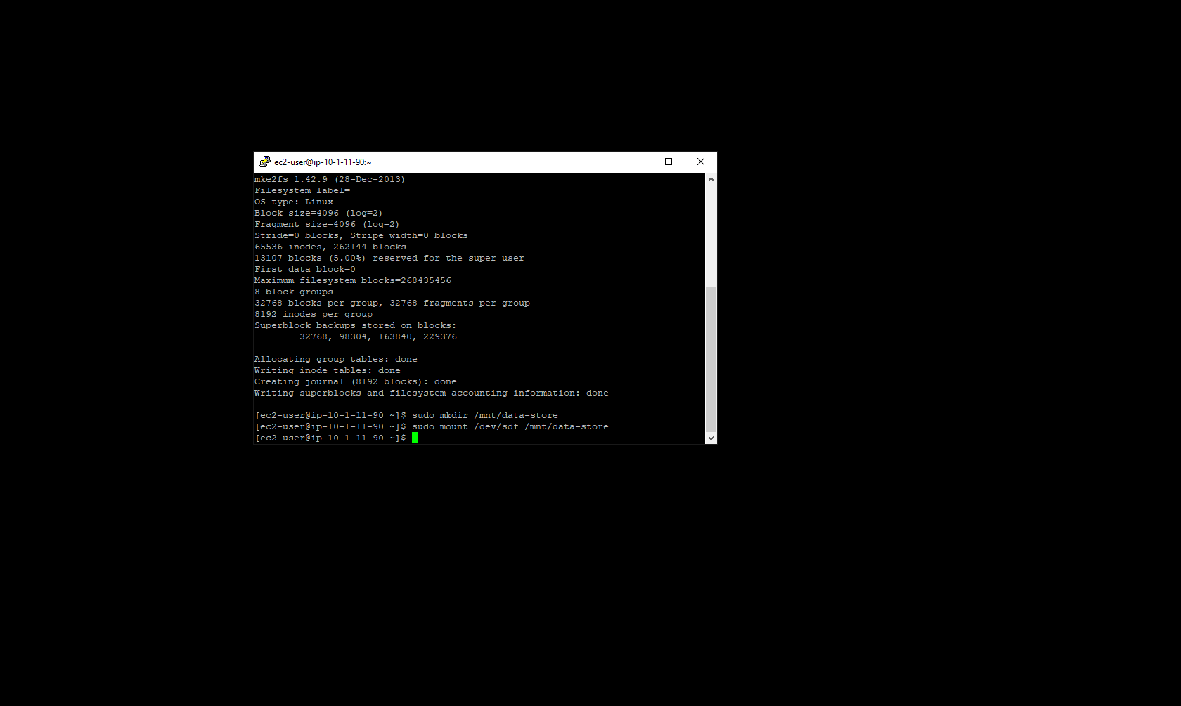

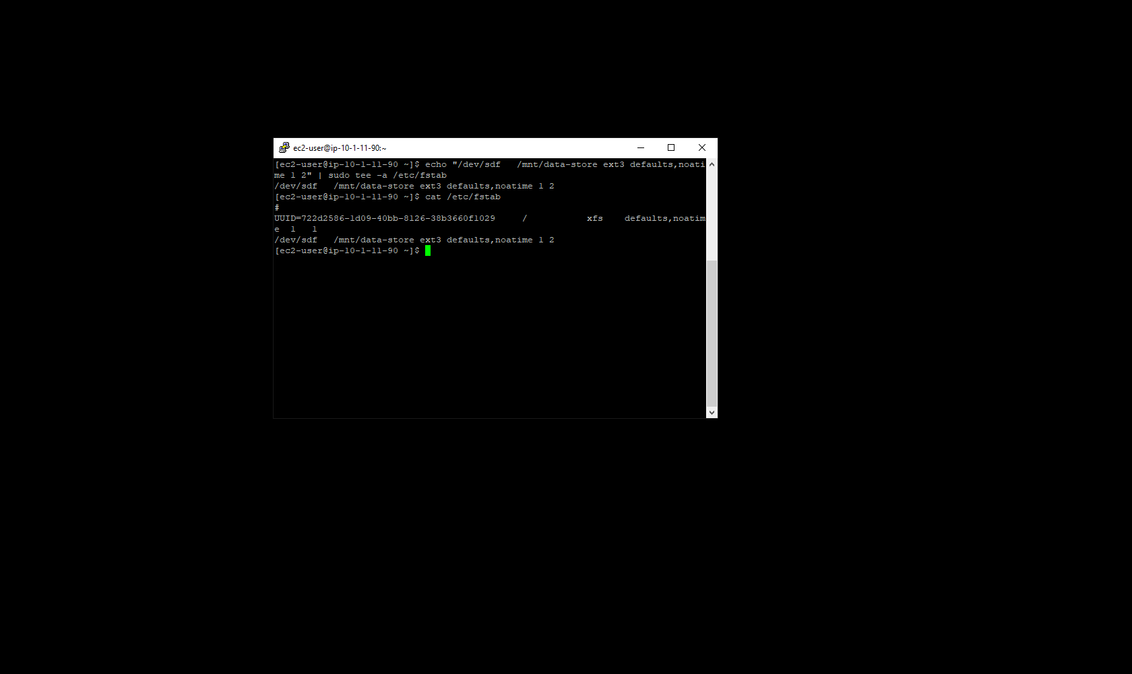

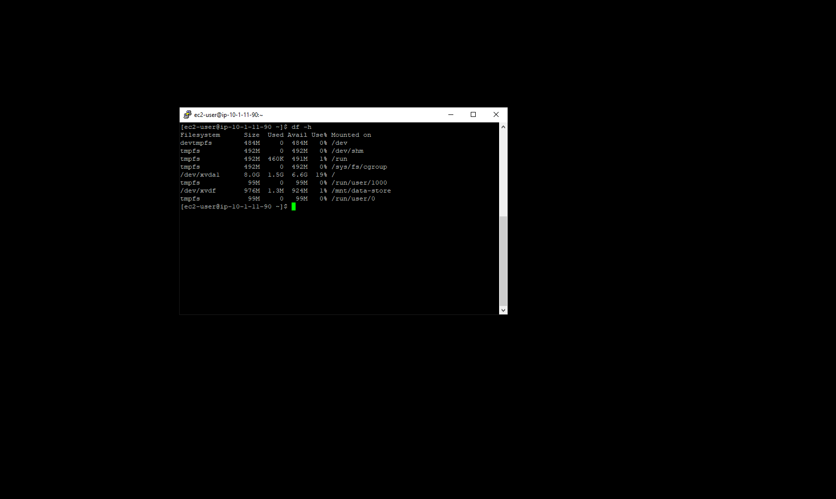

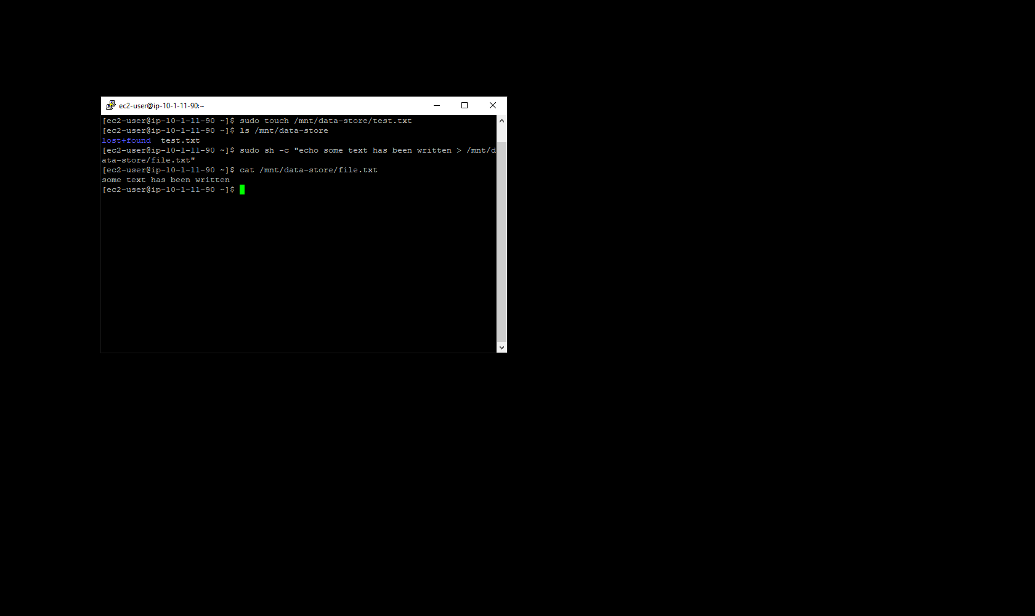

**Creating Snapshots:**

1. Back in the AWS Console, click into volumes in the left menu. Then click into My Volume to view further details.

2. Click actions and create snapshot in order to create a backup of the contents of the volume at that instant in time. Give the snapshot a the tag with Key / Value pair of Name / My Snapshot.

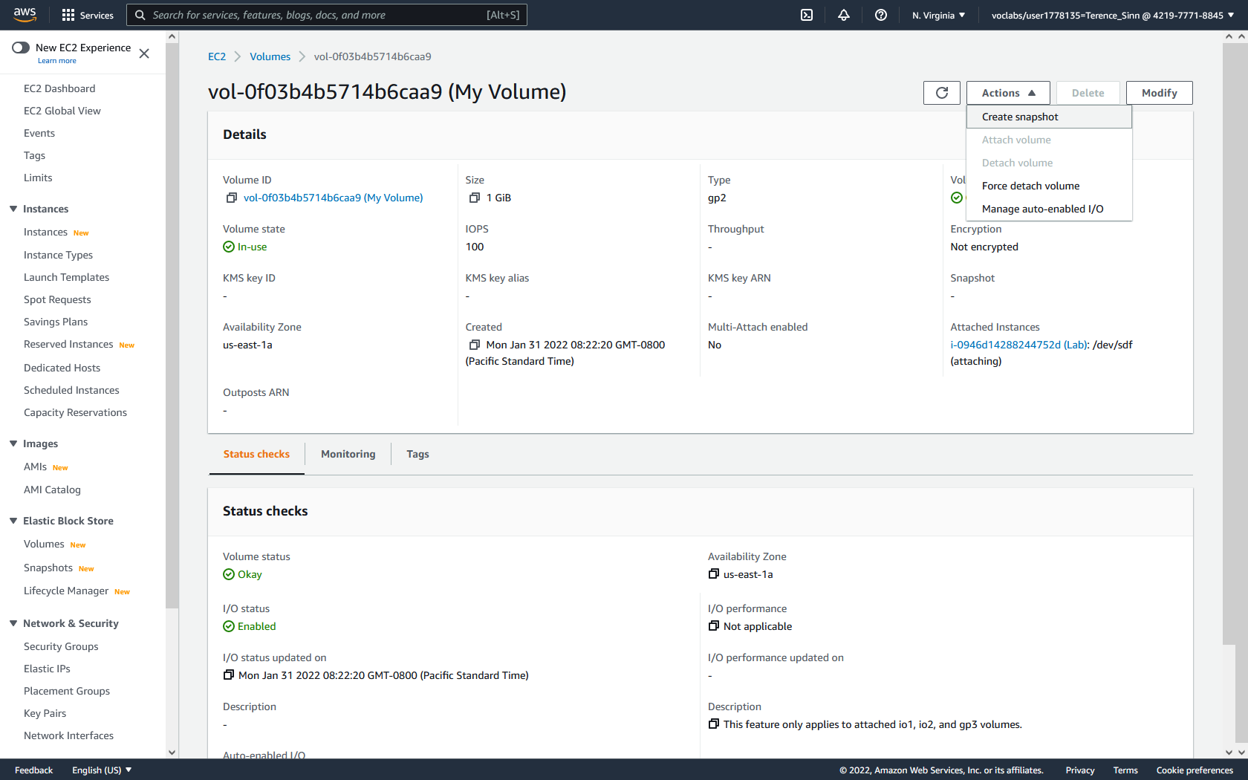

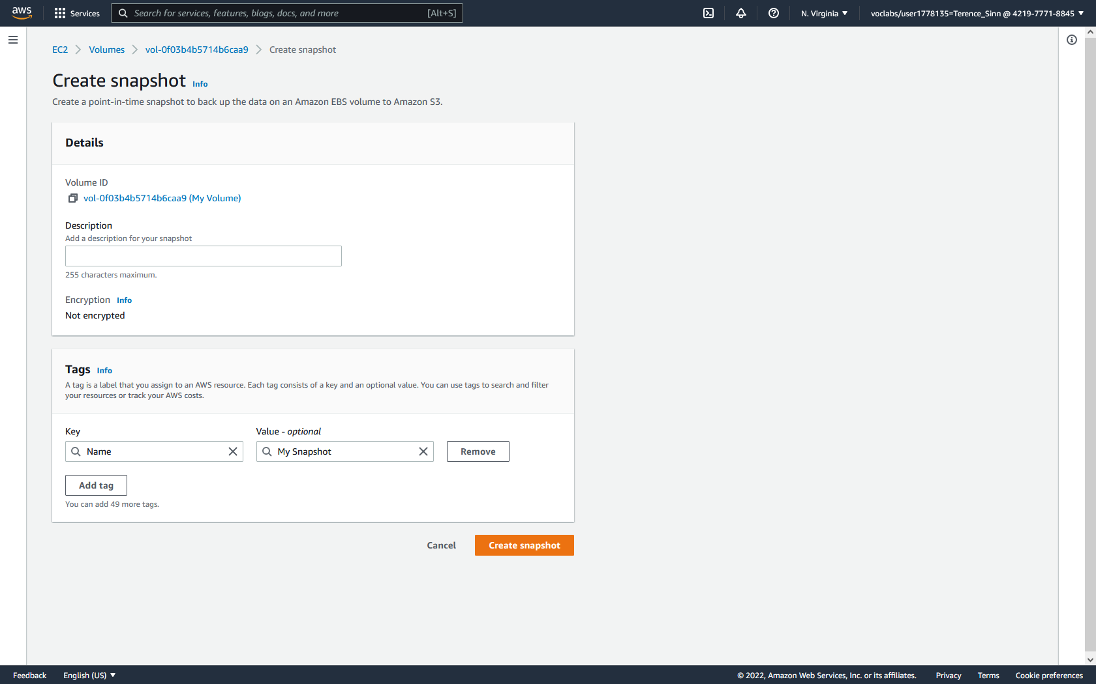

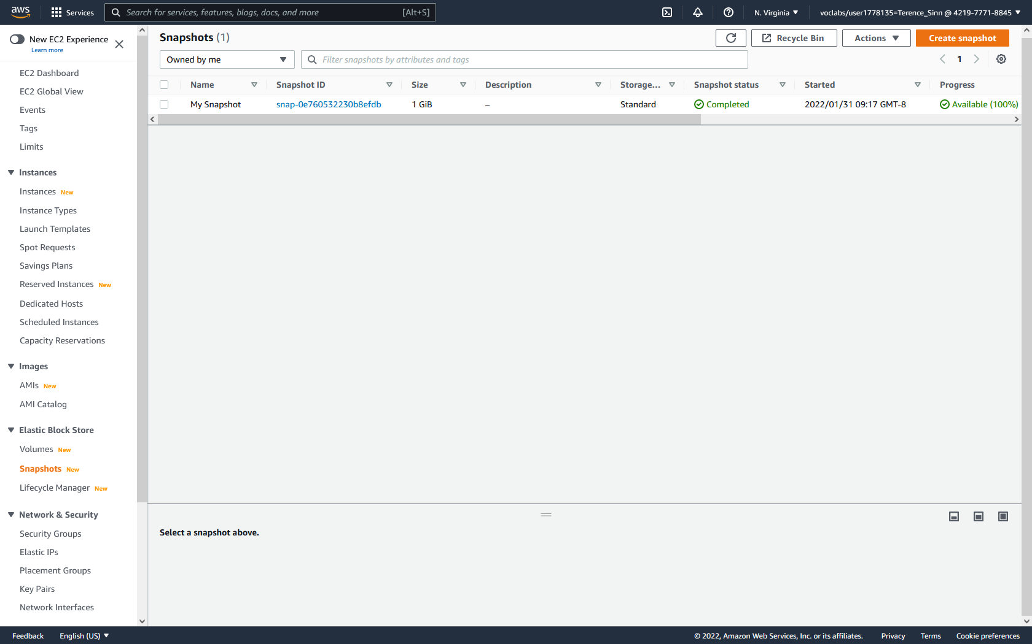

**Restoring from Snapshot:**

1. Back in the terminal SSH connection to the EC2 instance, type the following command to delete the .txt files that were previously created:

sudo rm mnt/data-store/*.txt

2. In the AWS console, click into snapshots in the left menu. Click into my snapshot. Click actions and create volume from snapshot.

3. Create a volume that is a General Purpose SSD with 1 GiB of storage. Select the availability zone of us-east-1a. Give it a Key / Value pair of Name / Restored Volume.

4. Attach the Restored Volume to the Lab EC2 instance.

5. Type the following commands to mount the restored volume:

sudo mkdir /mnt/data-store2

sudo mount /dev/sdg /mnt/data-store2

6. Type the following command to verify that the previously created files are in this volume:

ls /mnt/data-store2

