**RocketBoy User Guide**

Thank you for downloading Rocketboy. This simulation software currently statistically predicts the rocket's flight and landing performance, and automatically generates the control parameters for the avionics to aid in launching a hobby rocket.

We are a group of Engineering students studying at Victoria University of Wellington who were given a project to design Monte Carlo simulations for Rockets.

**Running with GUI:**

The application can be run in the command line with the command:

Java -jar <Jar file path>

e.g. java -jar lemur.pv20102.1z.jar

Or

e.g java -jar lemur.pv20102.1z.jar -gui

**Running without GUI:**

The application can run without the GUI which can be run in the command line with the command:

Java -jar <Jar file path> -nogui -importCSV=<Path to CSV to import> -importORK=<Path to ORK to import> -export=<Path from CSV to export to>

e.g. java -jar lemur.pv20102.1z.jar -nogui -importCSV=src/main/resources/testMCData.csv

-importORK=src/main/resources/rocket.ork -export=/Desktop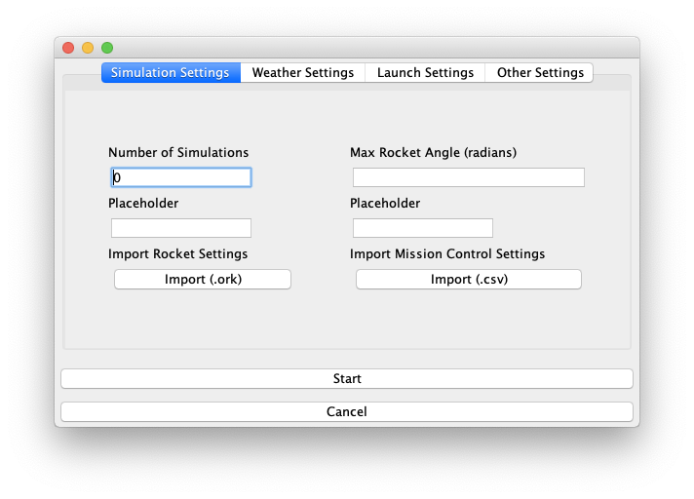

**Importing CSV:**

The program is able to import a CSV file that contains the weather data and simulation options.

This CSV file can be imported through command line without the GUI.

With the GUI, the import CSV button is located on the first screen (Fig. 1).

Fig. 1

**Importing CSV Format:**

File example:

launchRodAngle,launchRodLength,launchRodDir,launchAlt,launchLat,launchLong,maxAngle,windSpeed,windDir,windTurbulence,launchTemp,launchAirPressure,numSimulations

0,0.2,0,0,30,-50,0.018,3,0,0.1,285,1010,500

The first row should be the labels of the options and the second row contains the values.

The order of these options does not matter make sure that all are present in the file and the corresponding value is in the same column.

**Export CSV:**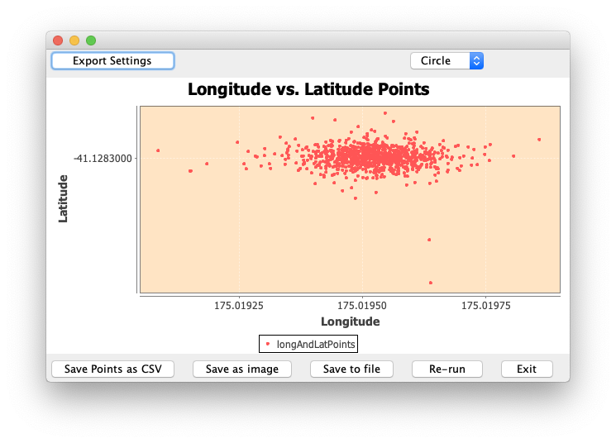

The program is able to export the resulting data from the simulations.

The data will be exported in the same path as the jar file when running the program in the command line with the nogui tag.

To export the simulations points data to a CSV, the button is located on the graph window when the simulations have all finished running (Fig. 2).

Fig. 2

**Export CSV Format:**

File example:

Longitude,Latitude

175.01952892923023,-41.12829999918802

175.01950345629888,-41.128300002505256

The first row is the labels for each column and the following rows are the landing position for each simulation run.