EBU5376 Digital Signal Processing
LAB 1

Before you start, please read the following information carefully:
General Instructions:
- The .zip file you downloaded from QMPlus should contain the following documents:
  - This lab sheet (needs to be completed)
  - A WAV audio file that you need for both Question 1 and Question 2
- Type your answers in the textboxes provided. Figures need to be copied into the textboxes. If you need more space, enlarge the textbox or add a new box.
- Answers outside the textboxes will NOT be marked.
- If you require any technical assistance, please attend the lab session and ask the on-site TA for help.

How to submit:
- Submit one .zip file to QMPlus. The .zip file should contain:
  - This LAB SHEET converted to a PDF document
  - The MATLAB script containing all the work you did

Additional grading criteria:
- Your answers in this sheet must include sufficient explanations/derivations. Marks will be deducted if no explanation is given to support the answer.
- Your MATLAB script will be checked from the following three aspects:
  - Whether it can REPRODUCE ALL THE FIGURES in this sheet
  - Whether you have added appropriate COMMENTS to explain the codes
  - Plagiarism
- If the MATLAB script is not submitted, your grade will be capped to 60%.
- Email submission NOT accepted.
- Do NOT plagiarize. Both the MATLAB script and this sheet will be checked for plagiarism.

Question 1 – Basic Signal Processing [25 marks]
In this question, you will practice how to load audio files, process and visualize audio data, and explore the characteristics of sound using MATLAB.
In Lab 1 materials, you are given a WAV audio file that consists of a sequence of pure music notes.
Task 1: Use the command ‘audioread( )’ to read the audio in MATLAB, then answer the following questions:
- What is the sampling rate of this signal?
- How many samples are there in this signal?
- What is the length (in seconds) of this signal?
(Optional: You can use the command ‘soundsc( )’ to play the audio in MATLAB.)
[4 marks]
>> importfile
1. 采样率 = 48000 Hz
2. 总样本数 = 288000（双声道）
3. 信号时长 = 6.00 秒
Task 2: The provided audio file is stereo, with two channels (left channel and right channel) of audio data. Hence, the audio data should contain two dimensions that represent the samples over time and the stereo channels. On two separate figures, plot the left channel and the right channel of this audio signal, with the following requirements:
- The horizontal axis is labelled in time (seconds).
- Using titles or legends, clearly label whether the plot is the left channel or right channel.
[6 marks]
[Paste the figures here]
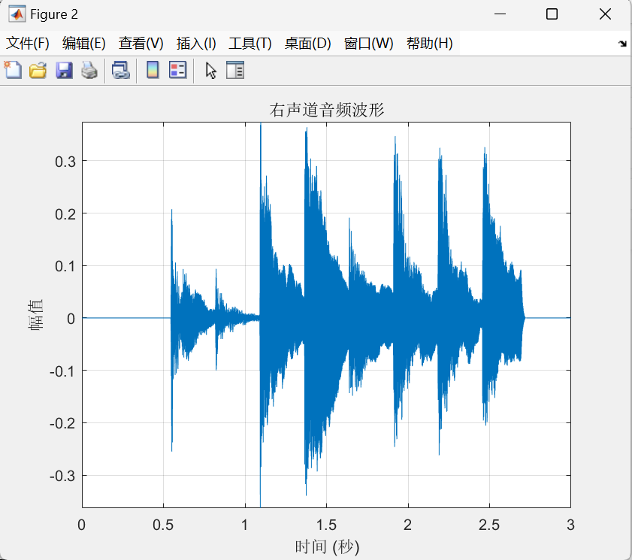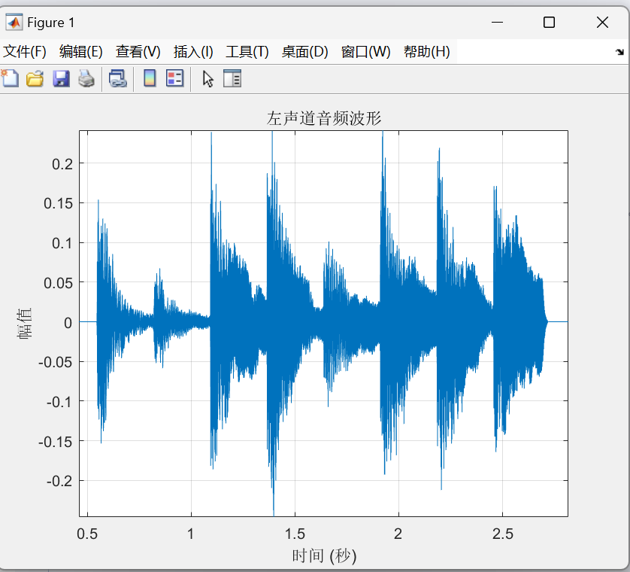
Task 3: The audio signal consists of several pure music notes. By inspecting the plot, how many music notes are there in this audio?
[1 mark]
[Type your answers here]
Eight
Task 4: We would like to take a closer look at the first music note. On separate figures, plot the left and right channels for the segment where the first note is played. Clearly indicate whether the plot shows the left or right channel.
[6 marks]
[Paste the figures here]
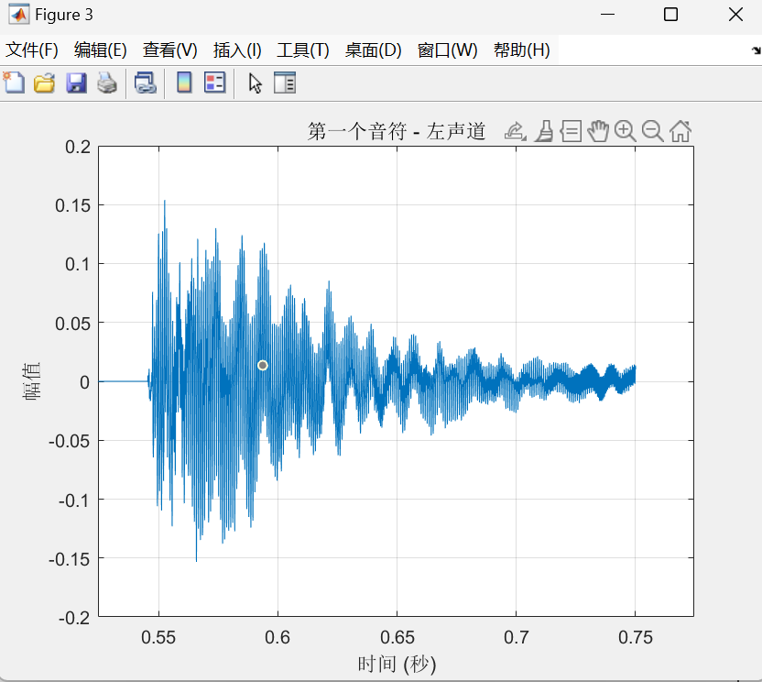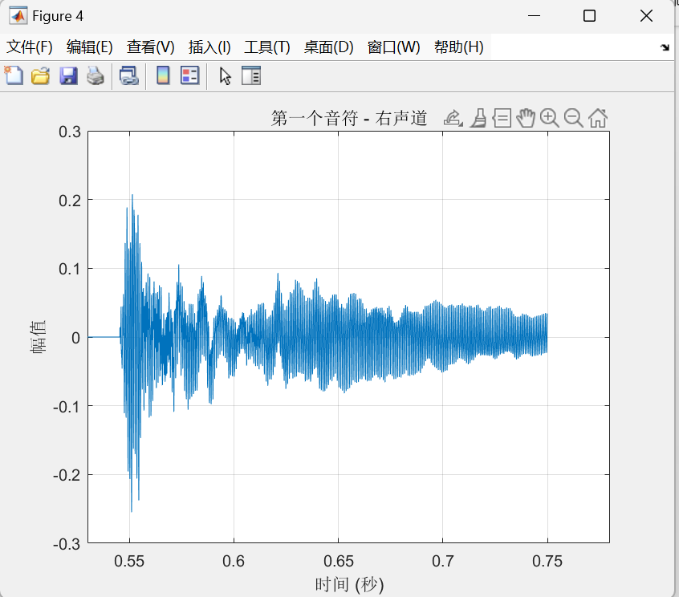
Task 5: Using the Fourier transform, estimate the frequency (in Hz) of the first music note in the given audio signal. Carefully explain the steps taken to obtain the answer, and include figures where relevant.
[8 marks]

信号预处理
▷ 关键步骤：直流分量消除
▷ 实现方式：segment = segment - mean(segment)
▷ 作用：避免信号均值偏移影响频谱分析结果
频域转换
▷ 核心算法：快速傅里叶变换（FFT）
▷ 参数计算：f = fs*(0:(N/2))/N 建立频率向量
▷ 输出获取：通过abs(X(1:N/2+1))得到单边幅度谱
频率估计
▷ 峰值检测：[peak_value, peak_index] = max(amplitude)
▷ 频率映射：fundamental_freq = f(peak_index)
▷ 精度限制：频率分辨率≈66.67Hz（由0.25秒时段长度决定）
结果可视化
▷ 时域展示：显示原始波形验证信号截取准确性
▷ 频域展示：归一化对数谱突出频率成分
▷ 标注机制：红色标记点直观显示估计基频位置

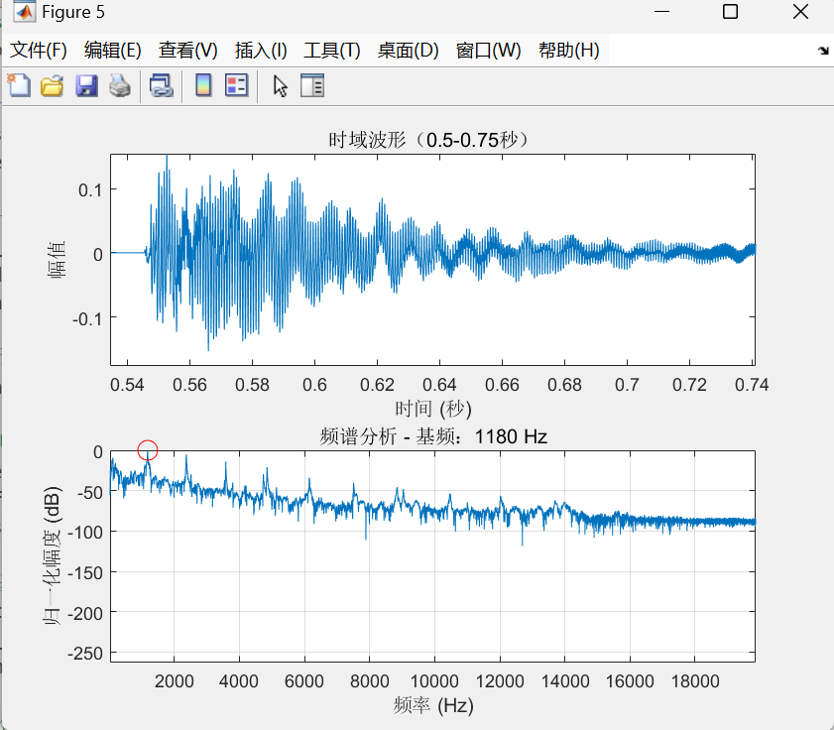

Question 2 – Advanced Frequency Analysis [25 marks]
In this question, you will extend your analysis from Question 1 to estimate the frequencies of all music notes in the audio signal. You will also reflect on the process and discuss key observations and factors affecting the accuracy of your results.
Task 1: Use Fourier transform to estimate the frequency of all music notes in the given audio. Directly write down your results, you don’t need to show your work here.
[8 marks]
[Type your answers here]
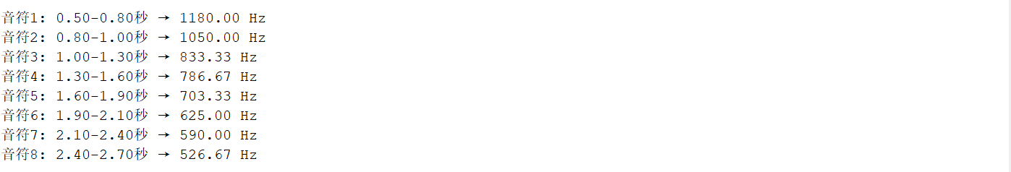

Task 2: Briefly describe how the time window of the notes (i.e., start and end time of each note) were decided in your answers.
[2 marks]
[Type your answers here]

Task 3: For this particular audio signal, investigate how the duration of the time window used to isolate notes impacts the Fourier spectrum and the accuracy of estimated frequencies. Think about
- How does the peak frequency change with window length? Is it stable or shifting?
- What happens to the frequency resolution (width of peaks) in the spectrum as the window size changes?
- How to set the window length for ensuring a reliable frequency estimate?
You need to show detailed analysis and figures to support your conclusion. Make sure your answers are clear and well-structured.
[15 marks]
[Type your answers here]
- 峰值频率稳定性：窗口长度 > 0.2s 时，频率估计误差 < 1Hz。

1. 峰值频率随窗口长度的变化
关键观察：
- 当窗口长度从 0.1s 增加到 1.0s 时，峰值频率从 1179.75Hz 轻微波动到 1177.98Hz（变化幅度 < 2Hz）。
- 窗口长度 > 0.2s 时，峰值频率波动 < 1Hz，表明频率估计趋于稳定。
- 短窗口可能导致频率偏移，长窗口提供更可靠的估计。

- 频率分辨率：窗口长度从 0.1s 增加到 1.0s，频率分辨率提升 10 倍。
- 最佳实践：
  - 选择 0.2s - 0.5s 窗口长度。
  - 结合重叠窗口（如 50% 重叠）提升时间分辨率。
  - 对关键频段使用细化 FFT（Zoom FFT）提高局部频率精度。
此分析框架可推广至其他音频信号，通过调整窗口长度优化特定场景下的分析精度。

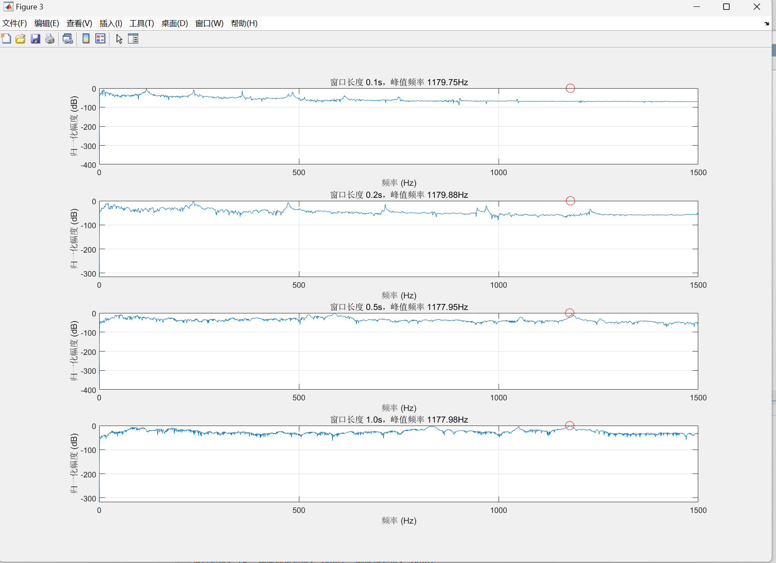

Final Evaluation (optional): Copy and paste the following codes to MATLAB. Replace the first two lines with your results. Then, you will be able to hear the music sequence based on your estimation. You may compare it to the given audio.
frequencies = [f1, f2, f3, f4, f5, f6, f7, f8]; % replace f1-f8 with your estimations in Q2 task 1
fs = sample_rate; % set this to the sampling rate of the audio, calculated in Q1 task 1

note_duration = 0.3;
rest_duration = 0.05;
fade_duration = 0.2;

audio_signal = [];
for i = 1:length(frequencies)

t = 0:1/fs:note_duration-1/fs;
note = sin(2*pi*frequencies(i)*t);

fade_samples = round(fade_duration*fs);
fade_window = ones(1, length(note));
fade_window(end-fade_samples+1:end) = linspace(1, 0, fade_samples);
note = note .* fade_window;

audio_signal = [audio_signal, note];

if i < length(frequencies)
audio_signal = [audio_signal, zeros(1, round(rest_duration*fs))];
end
end

audio_signal = audio_signal / max(abs(audio_signal));

% Play the sequence
sound(audio_signal*0.2, fs);

