Project management
- project management is the activity of planning and coordinating resources and tasks to achieve these goals.
是规划和协调资源和任务以实现这些目标的活动。
- Project planning involves scheduling the project tasks and determining resources requirement
项目规划包括安排项目任务和确定资源需求。
- Project execution,involves coordinating and facilitating the myriad tasks required to complete the project in the face of inevitable.
项目执行，涉及协调和促进无数的任务，以完成项目所需要的，面对不可避免的。
- Ways to represent tasks: Sequential, Parallel, and Coupled Tasks
The Design Structure Matrix Gantt Chart PERT Charts The Critical Path
- The project schedule 是项目任务和项目时间线的合并（merger）
- Accelerating Projects(Product development time is often the dominant concern in project planning and execution):
总体：尽早开展；管理项目范围；促进基本信息交流
减少时间：更快完成关键路径的单个项目；消除一些关键路径任务；消除等待延迟
更快完成耦合（coupled）任务：避免迭代；考虑一套（a set of）解决方案
Opportunity Identification
1.opportunity
an idea for a new product
It is a product description in an embryonic form a newly sensed need,a newly discovered technology,
a rough match between a need and a possible solution
It can be thought of as a hypothesis about how value might be created
一个新产品的想法
它是一个产品描述的雏形，一个新感觉到的需求，一个新发现的技术、
一个需求和一个可能的解决方案之间的粗略匹配
它可以被认为是一个关于如何创造价值的假说
- 机会识别过程
Establish a charter
Generate and sense many opportunities（*）
Screen opportunities
Develop promising opportunities（**）
Select exceptional opportunities
Reflect on the result and process
建立一个宪章
产生并感知许多机会（*）。
筛选机会
开发有潜力的机会（**）。
选择特殊的机会
对结果和过程进行反思
3.*There are two ways in which opportunities can be identified:
1. Information can be gathered passively 信息可以被动收集
2. Information can be gathered proactively 可以主动收集信息
机会从哪里来？
记录现有客户使用现有产品时遇到的挫折和抱怨
采访主要用户，关注这些用户的创新，以及这些用户可能对现有产品做出的修改
考虑生活方式、人口结构和技术趋势对现有产品类别的影响，以及新产品类别的机会
通过销售人员或客户服务系统，系统地收集现有客户的建议
在持续的基础上仔细研究竞争对手的产品，跟踪新兴技术的状况，以促进适当的技术从基础研究和技术开发转移到产品开发
机会漏斗应该不断收集创意
- **如何Develop promising opportunities
customer interviews, testing of existing products, concept generation, quick prototypes,
客户访谈、现有产品的测试、概念生成、快速原型、

Product Planning
- Product planning is an activity that considers the portfolio of projects that an organisation might pursue. i.e. what mix of new products and markets to develop, if they focus is on basic or applied research or diversification projects and determines what subset of these projects will be pursued over what time period
产品规划是一项考虑组织可能追求的项目组合的活动，即开发何种组合的新产品和市场，如果他们的重点是基础研究或应用研究或多样化项目，并确定在什么时间段内追求这些项目的哪个子集。
- There are four types of Product Development Projects：
Fundamentally new products 全新的产品
New Product Platforms 新产品平台
Derivatives of existing product platforms 现有产品平台衍生品
Incremental improvements to existing products 对现有产品的增量改进
3. 5 steps
1. Identify Opportunities 确认机会
2. Evaluate And Prioritise Projects 评估并确定项目的优先级
3. Allocate Resources and Plan Timing 分配资源和计划时间
4. Complete Pre-Project Planning 完成项目前期工作计划
5. Product Development Process 产品开发过程
4.Evaluate And Prioritise Projects：
Competitive strategy 竞争战略
Market segmentation 市场划分
Technological trajectories 技术轨道
Product platforms 产品平台
- Complete Pre-Project Planning
创建mission statement 包括：
1. A brief description of the product 产品的简要描述
2. Key business goals 关键业务目标
3. Target market for the product 产品的目标市场
4. Assumptions and constraints that guide the development effort 指导开发工作的假设和约束
5. Stakeholders 利益相关者

Identify Customer Needs
- Goal is to understand customers needs,then to effectively communicate them to the development team.目标是了解客户的需求，然后将它们有效地传达给开发团队
- Gather raw data from customers 从客户那里收集原始数据(访谈，讨论，观察，问卷) Interpret the raw data in terms of customer needs 根据客户需求解读原始数据 Organize the needs into a hierarchy of needs将需求组织成需求层次 Establish the relative importance of the needs 确定需求的相对重要性 Reflect on the results and the process 反思结果和过程
- Gather raw data from customers 目的
1.Develop decision making strategies 制定决策策略
2. Examine existing market segments 检查现有的细分市场
3. Understand shopping habits 了解购物习惯
4. Understand the customers’ view of the products available 了解客户对可用产品的看法
5. Look at customers’ beliefs/expectations 关注客户的信念/期望
6. Analyse current buying patterns 分析当前的购买模式
7. Carry out a SWOT/PESTEL analysis 进行SWOT/PESTEL分析
Concept development
Identify Customer Needs 识别客户的需求
l Establishing target specifications 确立目标规格
l Concept generation 概念的产生
l Concept selection 概念选择 Initial screen Customer screen Technical screen Final screen
l Concept testing 概念测试
l Setting final specifications 确定最终规格
l Project planning 项目规划
l Economic analysis 经济分析
l Benchmarking & modelling 标杆和模型
Innovation
1.What makes an innovative company?
Investment and Growth Orientation投资与增长导向
Vigilance警惕性
Commitment to Technology致力于技术
Acceptance of Risks承担风险
Cross-Functional Cooperation跨职能的合作
Receptivity接受能力
Slack（适度的）松弛
Adaptability适应能力
Diverse Range of Skills技能多样化
2.创新的特点
1. Process from idea generation to commercialization 从创意产生到商业化的过程
2. The adoption of change 变革的采纳
3. Radical change in traditional ways vs. incremental change 传统方式的彻底改变vs增量改变
4. New device or something new to society 新设备或对社会来说是新的东西
3.Types of innovation
Product Innovation 产品创新
Process innovation 工艺创新
Organisational innovation 组织创新
Management innovation 管理创新
Production innovation 生产创新
Commercial/marketing innovation 商业/营销创新
Service innovation 服务创新
Digital Transformation and Digital Products
1.Digital transformation takes a customerdriven, digital-first approach to all aspects of a
business, from its:Business models，Customer experiences，Process，Operations
It relies on AI, automation, cloud computing, and other emerging digital technologies to leverage data
数字化转型是一种以客户为导向，以数字为先的方法来处理企业的所有方面。业务模式，客户体验，流程，运营等各个方面。 它依靠人工智能、自动化、云计算和其他新兴的数字技术来利用数据。
2.Digital products:no physical form, exist only in the digital realm,○ intangible items delivered electronically, anything that can be downloaded and used digitally can be considered a digital product
数字产品：没有物理形式，只存在于数字领域，○ 以电子方式交付的无形物品，任何可以下载和使用的数字产品都可以被视为数字产品。
3.Six phases of digital product development [6]:
○ Phase 1. Discovery Phase 2. Ideate Phase 3. Test
○ Phase 4. Execute Phase 5. Launch Phase 6. Grow
IP
.Intellectual property, often known as IP, refers to intangible assets created by human intellectual or creative activity.
Intellectual property rights (IPRs) allow people to own their creativity and innovation in the same way that they can own physical property.
The owner can control and be rewarded for the use of their IP, and this encourages further
innovation and creativity to the benefit of us all
知识产权，通常被称为IP，是指由人类智力或创造性活动创造的无形资产。智慧或创造性活动创造的无形资产。知识产权(IPRs)使人们能够拥有自己的创造力和创新就像他们可以拥有实物财产一样。所有者可以控制其知识产权的使用并获得回报，这就鼓励了进一步的 这鼓励了进一步的创新和创造，使我们所有人受益。
2.patents for inventions trademarks for brand identity designs for product appearance copyright for original expression
发明专利 品牌标识的商标 产品外观的设计 原创表达的版权
Patent
a document granting an inventor sole rights to an invention
3 key legal requirements for a patent to be granted：Novelty，Inventive step，Industrial application
问题：每个国家都要申请，复杂需要法律帮助；侵权辩护昂贵
Trademarks
需要：1.A sign2. Distinctive as to origin3. Capable of being represented in a clear and precise manner
Prototype
- In some industries, a prototype is a smallscale model.
- Prototyping is the process of developing such an approximation of the product
- 3 phases of prototyping:
Alpha prototypes:
Are typically used to assess whether the product works as intended
Beta prototypes:
Are typically used to assess reliability and to
identify remaining bugs in the product
Pre-production prototypes:
Are the first products produced by the entire production process
- four main uses of prototypes
Learning回答有关性能或可行性的问题
Communication演示一个产品，以获得所有利益相关者的反馈
Integration原型用于确保产品的组件和子系统按照预期一起工作
Milestones为开发团队的时间表提供目标
- 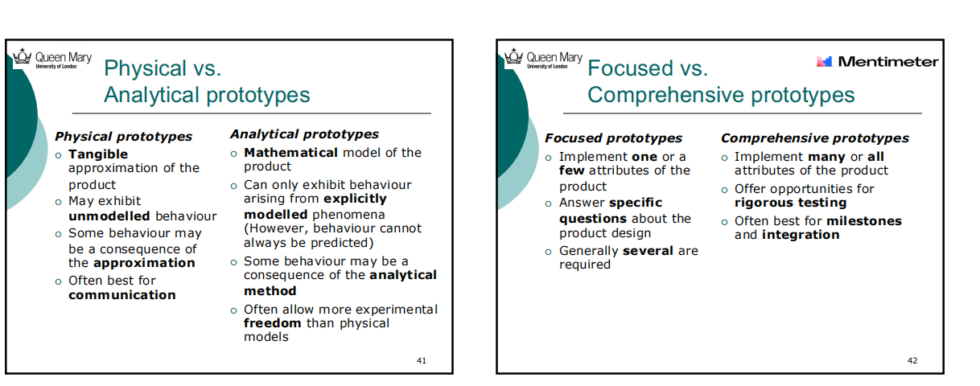
- Planning a prototype
Define the purpose of the prototype
Establish the level of approximation of the prototype
Outline an experimental plan
Create a schedule for procurement, construction and testing
确定原型的目的
确定原型的近似程度
勾勒一个实验计划
建立一个采购、建造和测试的时间表
7.Prototyping strategy
Use prototypes to reduce uncertainty
Make models with a defined purpose
Consider multiple forms of prototypes
Choose the timing of prototype cycles
Plan time to learn from prototype cycles
使用原型来减少不确定性
制作有明确目的的模型
考虑多种形式的原型
选择原型周期的时间
计划从原型周期中学习的时间
System-level Design

Step 1 – Create a schematic of the product
Step 2 – Cluster the elements of the schematic
Step 3 - Create a rough geometric layout
Step 4 – Identify the fundamental and incidental interactions
第1步 - 创建一个产品示意图
第2步--将示意图中的元素集中起来
第3步--创建一个粗略的几何布局
第4步--确定基本和附带的相互作用
Product Architecture:
the scheme by which the functional elements of the product are arranged into physical chunks and by which the chunks interact
产品的功能元素被安排到物理块中的方案，以及这些块之间的互动
Aim:
Architectural decisions allow the detailed design and testing of these physical blocks to be assigned
to teams, individuals, and/or suppliers, so that the development of different portions can be carried out simultaneously
架构决策允许将这些物理块的详细设计和测试分配给团队、个人和/或供应商，以便不同部分的开发可以同时进行。
Modular, in which
¡ Each chunk implements one or a few functions entirely.
¡ The interactions between chunks are well defined.
¡ Modular architecture has simplicity and reusability for a product family or platform
Integral
¡ Functional elements are implemented by multiple chunks, or a chunk may implement many functions
¡ The interactions between chunks are poorly defined
¡ Integral architecture generally increases performance and reduces costs for any specific product model.
Implications of product architecture
Product change(可更改)
Product variety
Component standardisation
Product performance
Product development management

Week4 最后一部分
Information security is the study and practice of protecting information = valuable asset
The main objectives of information security are to protect the confidentiality（保密意味着只有拥有正确许可的人才可以访问和使用信息）, integrity（完整性意味着信息系统及其数据是准确的）, and availability (CIA) of information（可用性是确保信息系统可靠的安全目标）
Key information security concepts include vulnerabilities, threats, risks, and safeguards
关键的信息安全概念包括漏洞、威胁、风险和保障措施
实施信息安全的法律责任和激励措施

