Week 1
学术规范
biography是要以别的人的口吻来介绍自己，如果用第一人称会扣50分
一定要用第三人称单数

每个小班选2-5个论文传上去，要进行一个演讲。入选+参加演讲会有加分

国际学院：international school

Student member of IET.

如果出现一次，那就不用有（BUPT），如果后文出现，需要一个简称
数字：一位数就是拼写的，两位数写10，11，100

3. 写几等奖，雏燕大创
University students innovative and entrupreneurship

Yuting Xu is currently pursuing a Bachelor's degree in Intelligent Science and Technology at Beijing University of Posts and Telecommunications (BUPT), China. As a member of the Institution of Engineering and Technology (IET), he has a profound interest in the transformative potential of Artificial Intelligence (AI) and Machine Learning (ML). Yuting Xu’s academic journey is marked by a strong commitment to leveraging AI to solve complex, real-world problems, with a special focus on natural language processing. He has actively participated in several research projects during his studies and has been recognized for his innovative approaches with awards at student technology forums. Yuting Xu is eager to contribute to the advancement of intelligent systems and is continuously seeking opportunities to apply his skills in interdisciplinary research projects.

请根据实际情况替换方括号内的内容，并添加任何特定的研究项目、发表的论文、或者任何其他相关成就来使biography更加完整且个性化。

Yuting Xu is currently pursuing a Bachelor's degree in Intelligent Science and Technology at Beijing University of Posts and Telecommunications (BUPT), China. He has won a University Second-Class Scholarship and participate in two student innovation and entrepreneurship projects. As a member of the Institution of Engineering and Technology (IET), he has a profound interest in the transformative potential of Artificial Intelligence (AI) and Machine Learning (ML).

Week 2
CNKI
内容可以写Literature Review文献综述
论文里要有references，要求有10篇引用
参考文献不要有维基百科当参考文献
文献可视化分析，CNKI就有
IMRD结构：Introduction, method, results, discussion
题目中的虚词要小写,15词以内

文章结构

【目前思路】
找一个喜欢的领域，找一个文献综述，看看里面都引用了哪些文章。然后看这些文章，自己写一个文献综述。

Week 3
MIC的论文题目要长而且具体，通常10-15词
暂定5.18/19
暂定4.7提交论文

文献不能引用百度百科

文献综述可以参考
1. 该研究问题的历史、现状和发展动态
2. 有关概念的定义
3. 选择这个研究问题的目的、动机、应用价值和实践意义
4. 说明通过哪些学术数据库查询到哪些论文，如何进行筛选，最后汇总了哪些最有权威的论文
5. 比较对比这些论文中的理论依据、研究方法、研究结果的相同点或相异点并说明导致这些异同的可能的原因
6. 自己的见解和对未来研究的建议

作业的提交可以把参考文献写中文，投稿的话还是得翻译成英文

要引用10篇

查重，知网，

Week 4
标题要求
以陈述句句型
名词性结构
不超过15个单词

团队的作业：
8人一组
软件的实操，数字人文

作文要有创新性
模仿一下别的人，要说一下自己选题的重要性和创新性
写自己的论文有什么值得读的

Week 5
摘要是1段
提交论文的时候去掉小标题、图表、公式、参考文献
重复率到15%的话就扣30分
命名：学号+姓名

摘要的7要素
Topic Specification
Background Information
Purpose Statement (Research Purpose)
Methodology & Data (Research Design)
Results & Discussion
Conclusions & Implications
3-5 keywords

往年的考试题要写摘要

请你把下面的内容进行改写，需要包含6个内容Topic Specification
Background Information
Purpose Statement (Research Purpose)
Methodology & Data (Research Design)
Results & Discussion
Conclusions & Implications
需要进行改写的内容如下：
What is the impact of online game environment on second language learning and social interaction? To answer this question, this qualitative study examined the experiences of two college-age Spanish learners participating in the Spanish version of the massively multiplayer online game World of Warcraft. Using data collected from participant observations, interviews, in-game chat logs, and student diaries, we describe how the design of the game, the cultural norms of its use, and the participants' own abilities interact to provide a unique language learning opportunity for these two students. The discussion focused on how online games could be used for language teaching and learning to take full advantage of media support for both experienced and inexperienced players.

This study looks into how playing online games, like the Spanish version of World of Warcraft (WoW), can help people learn a second language and make friends online. It focuses on two college students who are learning Spanish and how playing WoW helps them with this. The research uses simple methods like watching how these students play, talking to them, looking at their game chats, and reading their diaries to understand their experiences better.The main finding is that WoW is not just a game for these learners; it's like being in a virtual world where they can practice Spanish in a fun and engaging way. The game's design, the way people are expected to behave in it, and how well the learners know Spanish all work together to make this a good way to learn. The study suggests that games like WoW can be a cool tool for learning languages because they let students use the language in real-life situations, meet people from different cultures, and feel more connected to the language they're learning. By diving deeper into how these online games help with learning, the study shows that adding games to language learning could make learning more fun and effective. It encourages teachers and learners to think of gaming as a useful part of learning languages, not just as playtime. This idea could change how we think about learning languages, making it more about doing fun activities and less about memorizing words. The research points out that as the world becomes more digital, education should also include more digital tools like games to keep up with the times and make learning more enjoyable for everyone.

Week 7
9周：进行班级内的pre，一般是4-5分钟。如果交视频就是5.4，横屏拍摄
12周：5.18进行MIC
10、11、12周不上课

把论文转换成演讲稿
用互动的形式来和大家交流

要有提问
字号要求看ppt
标题的话要先I,II, III,IV然后123然后···

视频需要加字幕

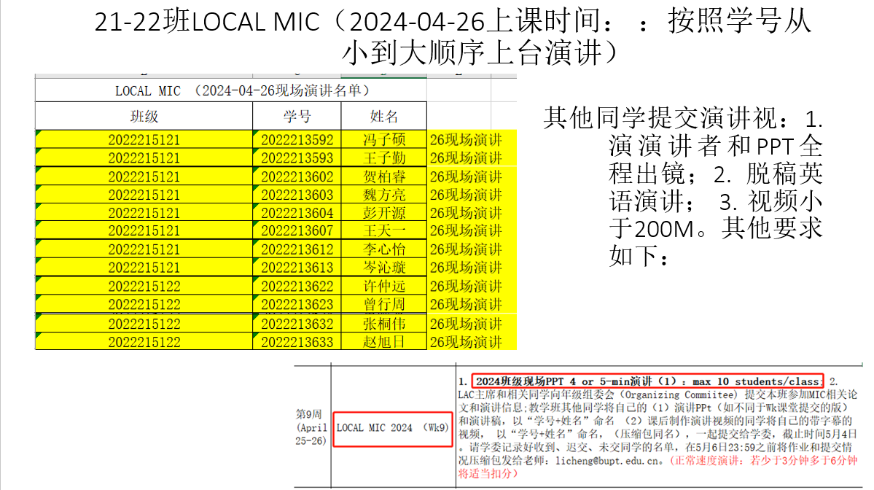
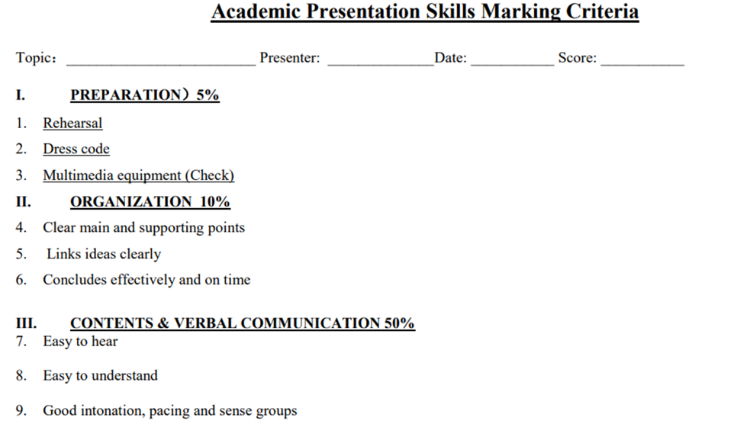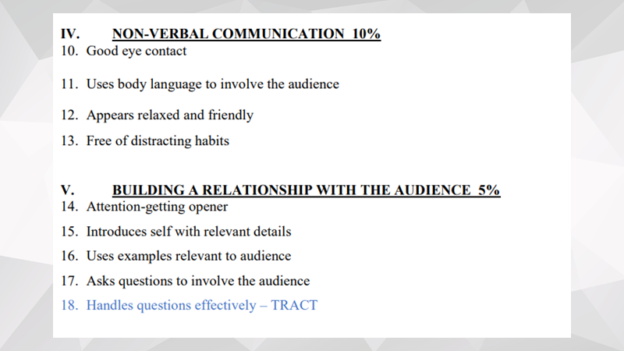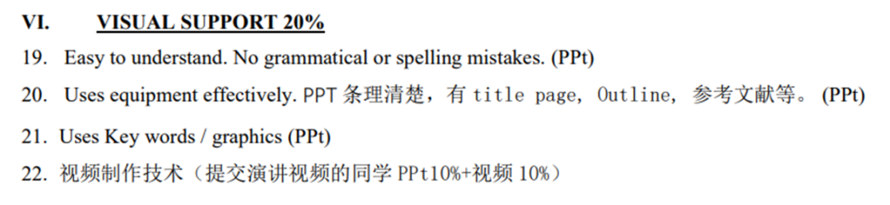

Week 8
写备忘录
memo writing

小组分数相同

8周：进行小组作业的布置，进行数字人文相关的
13周小组长进行2分钟的汇报，讲一下主题是什么（5.24）
14周当堂收（5.31）
6-8人一组

做海报
写memo

70%语言
30%格式

数字人文有4个方面
文本挖掘、地理空间分析、时间分析、网络分析
400-500的文字

分工
1人：文字部分组长（读5个ppt，定整体思路，进行文字部分分工）
1人：校对英/美式英语

1人做海报
1人演讲

会评选最好的海报
小组自评30% 目标1-4的内容
小组互评30% 互相给评价
老师评价40%

建议：
打印两份海报贴上去
中英文结合起来演讲，注意好比例
提前来教室做好准备
声音大大大
要有力量感，自信
要有肢体语言，眼神交流
要有互动，问问题
提前三天去印制海报，可以和老师先微信联系

要有学院的logo
参考文献也要有
小组的成员也写上去

Week 16
8:00-8:20签到，两个学生卡都要带
8:30-9:30闭卷考试
教室3-333

期末考试1个小时，1道题
写500-800词
按照IEEE格式/memo格式

Review 1
1. What does MIC stand for?
Model international conference
介绍专有名次的全称简称
一位的数字都是英文
bio要会写
2. What is the relationship between MIC and the course CS2
3. What are the procedures? MIC是如何组织的？
4. Where can students find academic papers?

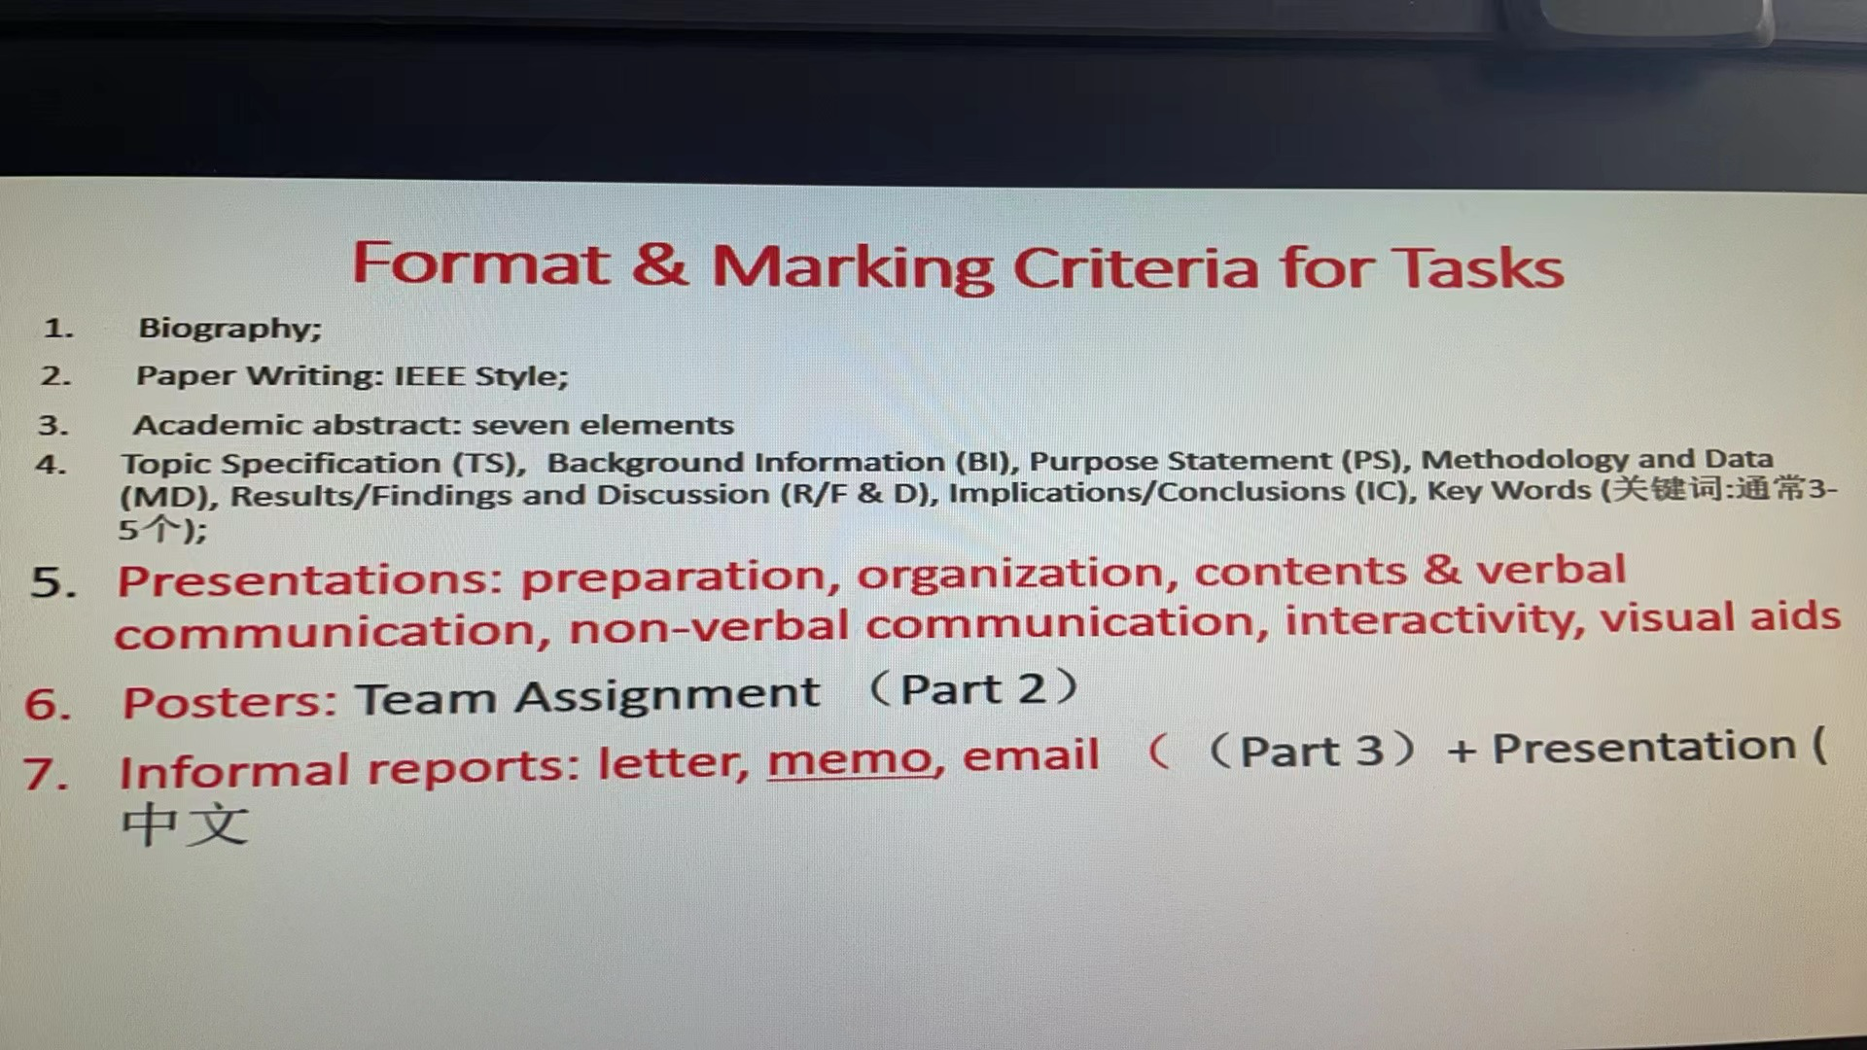

letter, memo, email都是考试范围
memo的是所有的那些图片
可行性报告、进度汇报、评价报告
3*3=9种

memo格式
居中的memorandum
date
to
from
什么什么的这四个都需要

如果到了第二页，还需要在右上角写一些东西
给谁
时间
Page 2

