目录
数电笔记 2
01 Intro 2
02 Number Systems 3
03 Logic Functions + switching algebra 5
04 KarnaughMaps 7
05 Hazards and Glitches 7
06 Sequential Circuit基础知识 8
07 State Machine 11
08 Bistable Circuit + Latch + Flip-Flop 13
09 时序电路分析 16
10 时序电路设计 17
11 Digital System Blocks 18
12 Memory 19
考前默写 23
题型一：时序电路的基础 23
题型二：week4的decoder, MUX, half-adder 错误！未定义书签。
题型三：默写 31

数电笔记

01 Intro
数电+模电都process time-varying signals
数字电路process signals that take on only two discrete values 0 1
produce output represented by 0 1
模电例子：电压、电流、力
数电例子：CD、DVD

世界用模电更好，但数电更简单
把模电转换成数电会有一些loss of accuracy
原因：can only represent fixed sets of values

数电的结果更明确，比如钟表直接显示11:30

数电的优点
reproduce results 模拟电路的结果会因为温度什么的变，数电不会
flexibility and functionality 灵活强大
programmability 可以用HDL写代码（Hardware Description Language）
speed 很快
economy 可以大规模生产，用Integrated Circuit

什么是IC
a collection of one or more gates fabricated on a single silicon chip to achieve a specific function
7400芯片里有4个NAND gates

电子设计中的软件有什么作用？
draw schematic diagrams
circuit simulation and modelling
test and debug
timing analysis

02 Number Systems
radix = base 进制

a digit in base 2 is also called a bit (binary digit)
8位就是8bits

digits in base R range from 0 to R-1

MSB: most significant bit
LSB: least significant bit

加减法要会

什么是register
digital computers store numbers in it
fixed size, a power of 2
n-bit register can represent one of 2^{n} distinct values
each element holds 0 or 1
numbers can be signed or unsigned

两种表示方法要会
sign-magnitude representation
2’s complement
BCD

浮点数的表示方法
IEEE-754
uses an offset of 127 instead of 128
can represent +0, -0
can represent values very close to 0 using denormals
32-bit (1 sign bit + 8 exponent bits + 23 mantissa bits)
bias: 2^{k-1}-1 (k = number of exponent)
对于IEEE来说，k=8，bias=127

BCD的好处
used in business machines and languages COBOL
have arrays of BCD numbers for arbitrary precision arithmetic

BCD的缺点
takes more memory
difficult to do math (must force the base 2 computer to do base 10 arithmetic)

ASCII码
7-bit code
最左边留了1位给parity checking
只能表达128个字符

Unicode
16-bit code
represent alphanumeric data
可以表达65536个字符

parity checking的优点
require only a number of XOR gates to generate
even-parity: 算上这一位一共有偶数个1
odd-parity: 算上这一位一共有奇数个1

03 Logic Functions + switching algebra
1. digital circuits分为combinational logic circuit + sequential logic circuit
combinational logic circuit: outputs depend on its current inputs
sequential logic circuit: outputs depend on current inputs + past inputs

2.
analysis: logic diagram of a circuit --> a formal description of the function of the circuit
synthesis: 反过来
analysis: 我们有一个电路，想知道它有什么作用
synthesis: 我们有一些想让电路实现的功能，然后需要设计和实现这个电路

3.
先化简boolean equations然后再根据equation去设计电路的好处
simplification of digital circuits
fewer gates
potential for faster operation
smaller

Switching Algebra
switching algebra
2-valued boolean algebra
X只能等于0或者1

Switching Algebra的几类
Literal: 单独一个X，或者是X’
Product Term
Sum Term
Sum of Products Expression
Product of Sums Expression

运算先后级别
取反是最牛的，然后·号，最后+

一些有用的式子
X+1=1
X·0=0

X=1011
X’=0100
X+X’=1111

(X+Y)(X+Z) = X+YZ

X+XY = X
X(X+Y) = X

X+X’Y = X+Y

XY+X’Z+YZ=XY+X’Z
(X+Y)(X’+Z)(Y+Z) = (X+Y)(X’+Z)

Principle of Duality: 互换01，互换·+依然成立

Logic Functions
logic functions’ representations
truth table + algebraic sum of minterms + algebraic product of maxterms
minterm: 交交交，就很小，111，SOP
maxterm: 并并并，就很大，000，POS

04 KarnaughMaps
也是一种表示Boolean equations的方法

05 Hazards and Glitches
Output glitch: 一个片刻的unexpected因为输入改变导致的输出改变，通常由gate propagation delays引起

Hazard: 当input发生改变，进而产生output glitch后会出现timing hazard

06 Sequential Circuit基础知识
1. 时序电路是什么？
构成：combinational circuits + some form of memory组成
输出：outputs depend on current inputs + past inputs
行为: determined by inputs + outputs + the state of flip-flops
outputs和next state都是a function of the inputs and the present state

2. 时序电路的图长什么样？
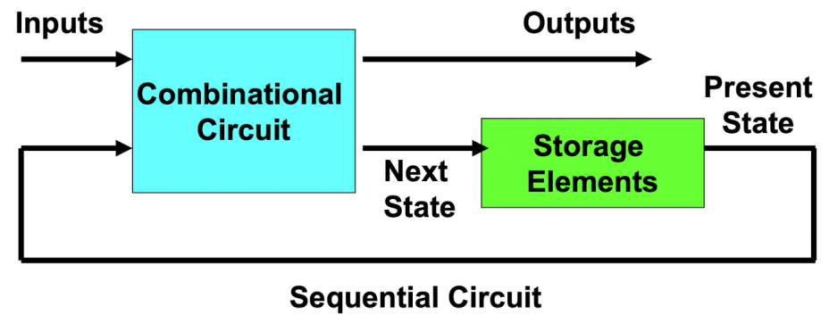

3. 什么是synchronous state machine？
A sequential circuit whose storage elements (flip-flops) use a clock input, and all the flip-flops use the same clock signal.
Its state and outputs changes only when a change occurs on the clock signal.
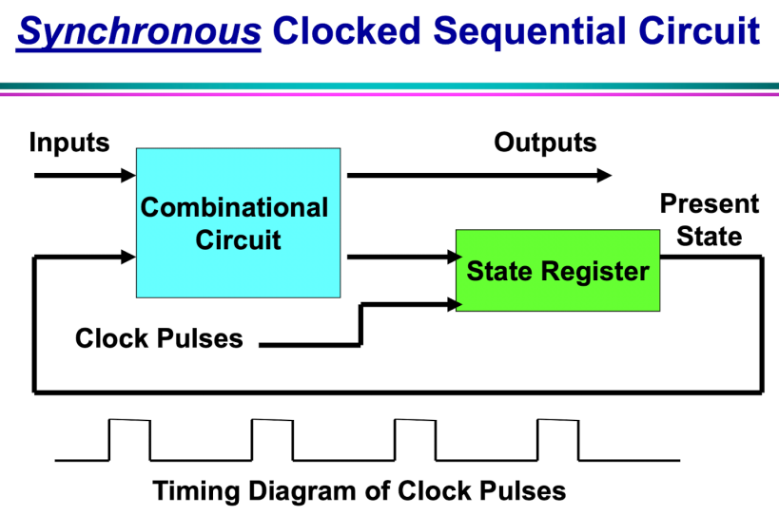
clocked 体现在use a clock input
synchronous体现在all the flip-flops use the same clock signal

4. 什么是latches和flip-flops?
basic building blocks of 时序电路 and can be formally analysed
时序电路通常包含latches & flip-flops和combinational circuits

5. 时序电路分为synchronous和asynchronous两种
synchronous同步的: the system’s behavior can be defined from the knowledge of its signals at discrete moments in time
asynchronous不同步的: the system’s behavior depends on the order in which inputs change and can be affected at any instant of time

下面都是一些理解性的知识点
1. 时序电路里的Memory可以是conventional memory devices或some type of feedback or delay network that serves in place of memory

2. 时序电路可以用于：Traffic lights, elevator controller

3. 状态state
如果有N个输出，那么就会有2^{N}种可能的状态
状态分为两种：stable和metastable
在时序电路中，有了current state和input我们就能预测next state

4. clock signal
大多数时序电路都会通过一个clock signal进行一个状态的改变
分为active high 和 active low
可能的状态包括high, low, rising edge, falling edge
参数包括period, frequency, duty cycle
period和frequency互为倒数
duty cycle是状态在high/low的时间除以一个周期的时间
period = t_{per}
frequency = $\frac{1}{t_{per}}$
duty cycle = $\frac{t_{H}}{t_{per}}$ 或$\frac{t_{L}}{t_{per}}$

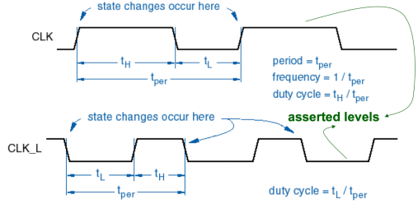

5. gate delay
经过一个gate要花一点时间，反映在图像上会延迟变化
限制了state machines的速度

6. 最大clock速度怎么求
feedback logic delay dictates控制了 highest clock frequency
例如：maximum delay是T_{D}，max clock frequency是F_{max}。那么F_{max} < $\frac{1}{T_{D}}$
如果clock > F_{max}，那么电路就会变得不稳定

例如：假设所有gate都有7ns的delay，求max clock frequency?
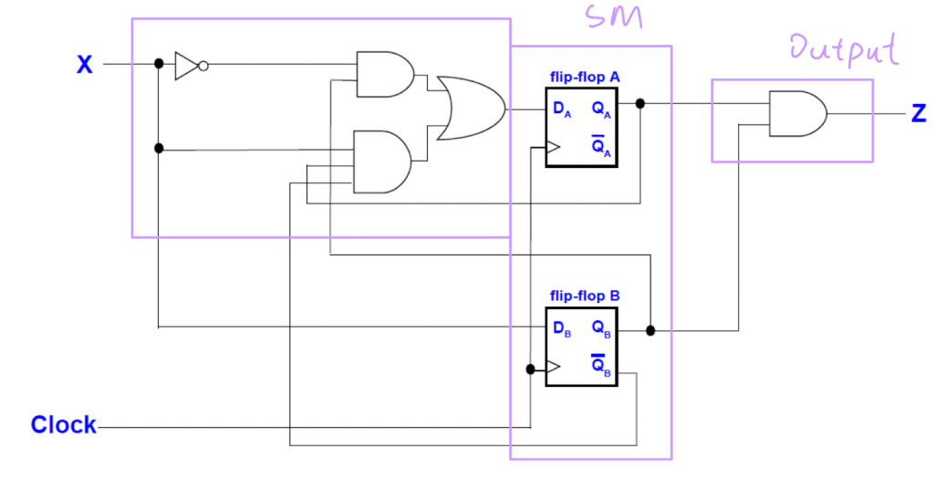
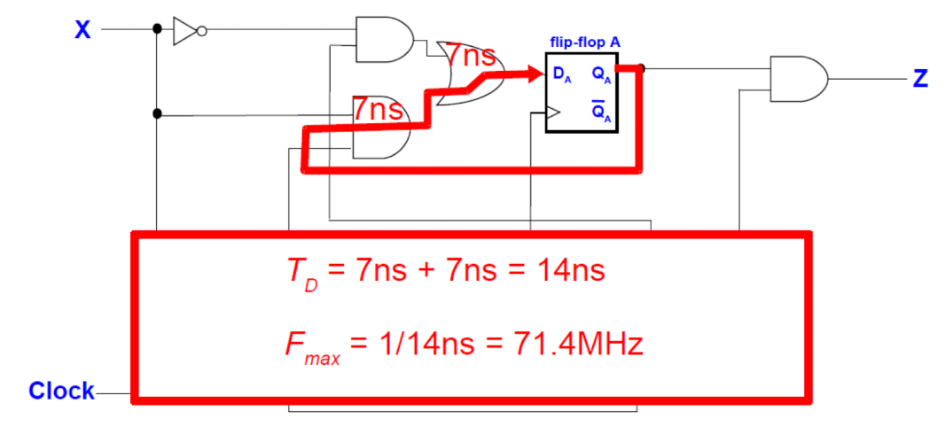

07 State Machine
1. 什么是State Machine？
general sequential Circuit

2. State Machine的构成？
（1）next-state logic: combinational logic applied to the inputs before being put into the “state memory”
（2）state memory: a set of flip-flops that store the current state
（3）output logic: combinational logic that determines the output of the state machine

3. n个flip-flops可以存储2^{n}个不同的状态
flip-flop的输出被这个flip-flop的Characteristic equation决定

4. Characteristic Equations
描述了一个latch/flip-flop的functional behaviour
把flip-flop的next state写成一个由current state和input构成的方程
Q*就代表了Q的next value
这种方程没法展示出来latch/flip-flop的timing behaviour

5. state machine有两种模型：
Mealy Machine + Moore Machine
区别：
Mealy: output = input+state
Moore: output = state（后来发明的，更先进）
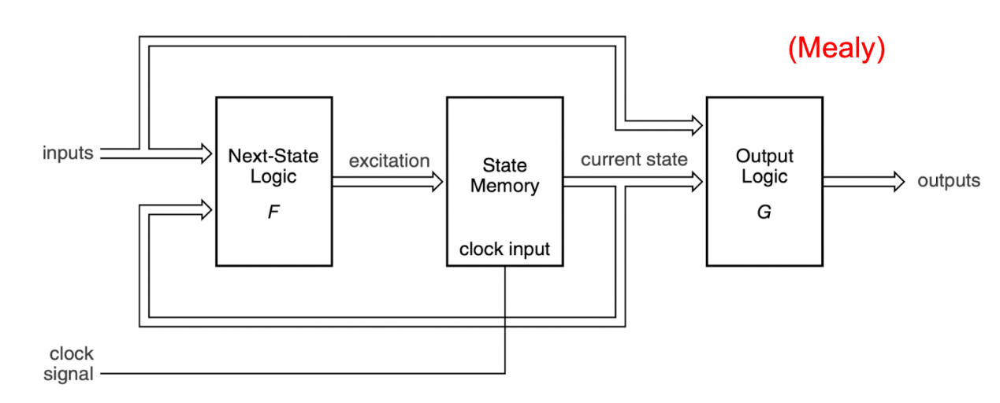
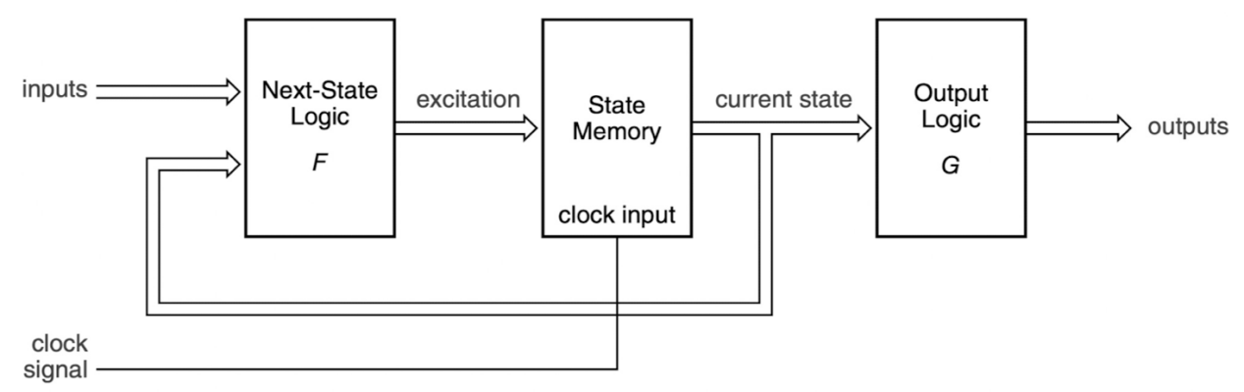

6. 对于Mealy Machine来说
state machine的next state is determined by the next-state logic F as a function of the current state and input
把进入state memory的input/excitation表达成一个叫做input/excitation equation的boolean equation。这是一个由input和current state构成的方程
Output Equation也是一个由input和current state构成的方程
Next State = F(Current State, Input)
Output = G(Current State, Input)

7. 对于一个Moore Machine来说
Output = G(Current State)
输出和input无关！

08 Bistable Circuit + Latch + Flip-Flop
1. 首先来看一下这三个东西的关系
Bistable Circuit是Latch的基础
Latch是Flip-Flop的基础

Latch | SR Latch | 在Bistable上加了输入 | 用NOR或NAND构成
 | $\overline{S}\overline{R }$Latch
 | SR Latch with Control Input | 加入了控制
 | D Latch | 使得两个输入是相反的
Flip-Flop | D Master-Slave | 用D Latch组装的
 | JK Master-Slave | 用SR Latch组装的
 | D Edge-Triggered |  | Edge-Triggered有正负两种
 | JK Edge-Triggered
 | Toggle

2. Bistable circuit
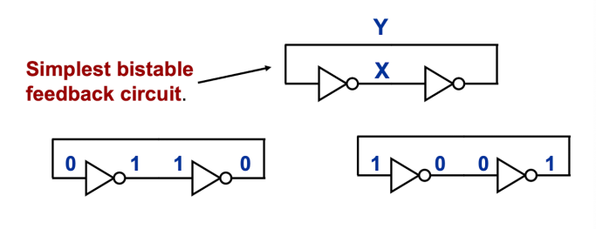
3. 在Bistable Elements and state machines的语境下，metastability是什么意思
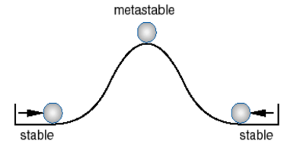
(1) There are 3 states.
(2) Metastable occurs at the point where both inputs are halfway between 0 and 1.
(3) It is not a valid state.
(4) Could stay in metastable forever if it wasn’t for noise.

4. Latch
latch: basic storage element from which all flip-flops are constructed
是flip-flop的组成元素
latch本身在synchronous sequential systems中不是很实用
原因：简易的SR和D latches没有control method来synchronise storage of data elements因此不能被用在synchronous systems

5. SR Latch （set reset）
有两种：用NOR 或用NAND
在clocked synchronous circuits中不是很有用

6. SR Latch with control
有时候不想要记忆功能，所以加一个control input
control line是0的时候就不写入新的数值，记忆刚才的结果

7. D Latch
有两个输入：Data和Control
为了消除indeterminate state，我们需要让Set和Reset不同时为1
所以D Latch直接搞了一个输入Data作为原来的Set，然后弄了个NOT GATE让Data的逆作为Reset，现在就不可能同时为1了

8. Latch的缺点
Level sensitive latches是不够的，因为
output continually changes if input changes
race conditions can occur
所以我们需要一个更好的方法来存储data
下面开始讲Flip-Flop

9. Master-Slave Flip-Flops
会用到两个latches，一个当Master，一个当Slave
isolate output from input
output can’t continuously change with input
input must have a stable setup time

10. MS D
非常常用
Master D Latch to latch input
Slave D Latch to latch output
两个latch从来不会同时工作
使用了narrow pulse clocking approach
消除了racing conditions

11. JK
使用两个SR latches with control inputs
SR latch仍然有undesirable indeterminate next state（当S和R都是1的时候）
加了两个AND to S and R inputs with feedback from the SR slave latch output
现在S和R都是1的时候，flip-flop的输出就是complements了
使用了narrow pulse clocking approach
为了防止进入metastable state，使用了minimum pulse width inputs

12. edge-triggered
用一个clock来进行控制
当clock pulse在constant level的时候会忽略掉inputs
只有在clock pulse transitions的时候会set outputs
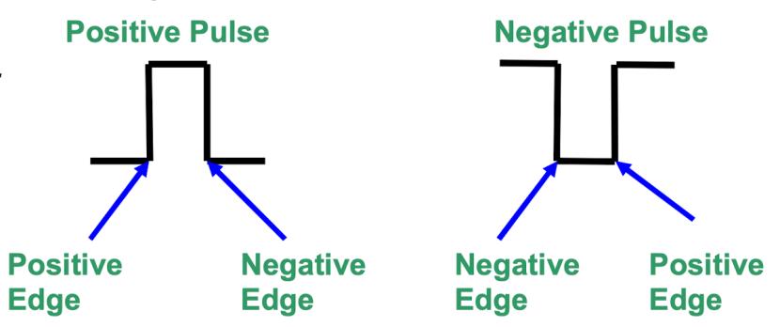

13. T-Flip-Flop
在clock每次升上去的时候改变状态（toggling signal T作为clock input）
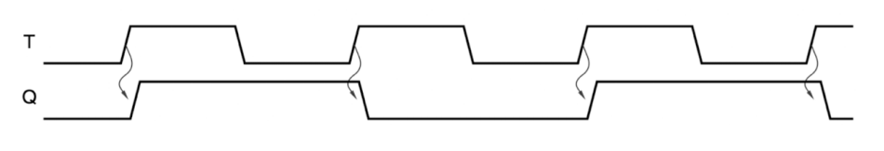
14. T flip-flop with enable
在很多情况下不需要每次clock tick都变化，增加enable
只有EN is asserted + T升上去 这两个条件都满足才能导致Q变一下
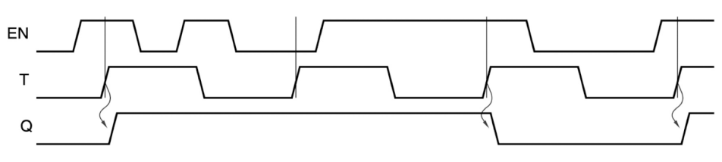

然后讲一些好像没什么用的
15. D Flip-Flop有3个Timing parameter
(1) propagation delay
(2) setup time (D before CLK)
(3) hold time (D after CLK)
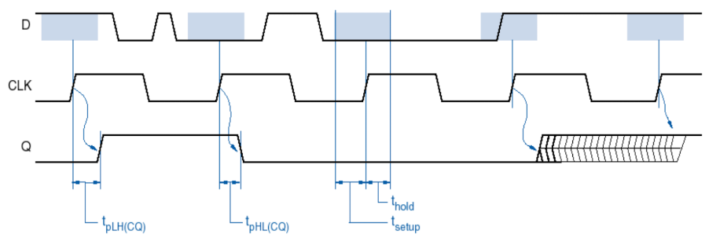

16. 所有真实的系统都会受到metastable的影响
这个问题是由不满足flip-flop setup并且hold times的asynchronous inputs引起的
在高速运转的系统中很严重，因为速度快就说明clock period短，然后metastability resolution time有可能比clock period还要长

09 时序电路分析
1. 分析步骤
四个方程EOCT，然后画表格，最后画图
step1: 弄一下input/excitation equations
step2: 弄一下output equations
step3: 弄一下next state/characteristic equations
step4: 弄从excitation equations到characteristic equations的transition equations
step5: 画一个transition table
step6: 画一个state table把transition table里的数字变成字母
step7: 画一个state/output table把output加上去
step8: 画一个state diagram

2. 如果output和输入没有关系，那么在写表格和画图的时候都可以方便一点
例：Moore类型的会更方便，因为output只和current state有关

3. Tables of Clocked Synchronous State Machines
Current state: 展示在任意时间t时候flip-flops的状态
Next state: 展示在一个clock period后flip-flops的状态，也就是t+1的时候的
Input: 展示每一个possible state的value of inputs
Output: 展示每一个present state的system output values

这个部分只涉及到Synchronous时序电路

09讲analysis
10讲的design就是synthesis
analysis: logic diagram of a circuit --> a formal description of the function of the circuit
synthesis: 反过来
analysis: 我们有一个电路，想知道它有什么作用
synthesis: 我们有一些想让电路实现的功能，然后需要设计和实现这个电路

手写笔记有3个例子
D
D
JK Edge-triggered

10 时序电路设计
1. 设计步骤：
step1: 画一个现在和下一个状态的表格（需要考虑flip-flop的characteristic equation)
step2: 画Karnaugh map，使用简化技巧写出来那个logic function
step3: 画Finite State Machine的电路图

手写笔记有4个例子
D Flip-Flop: 7个状态之间转换
JK Flip-Flop: 3 bit binary counter
JK Flip-Flop: 6 state counter
T Flip-Flop: 6 state counter

11 Digital System Blocks
1. 什么是Buses
set of 2 or more electrical conductors representing a binary value
像下面这种，有电压的就是1，没有的就是0，然后就出来了个二进制数
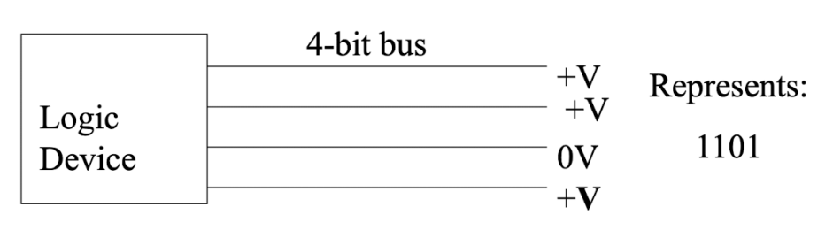

然后讲了
基础的3个：
selector/multiplexer: 如果输入是0就选择一边，输入是1就选另一边，像单刀双掷开关
decoder/demultiplexer: 把一个n位的二进制数弄成2^{n}个输出，比如11是十进制中的3，那么标着3号的输出就会是1
magnitude comparator: 用来比较大小

算数的Arithmetic Units:
half-adder: 可以进行两个一位数的加法，比如1+1，1+0这种
full-adder: 可以进行三个一位数的加法，多了个进位的carry，可以用两个half组成
Parallel Adder: 可以进行多位数的加法，把好几个full adder串起来
Adder/Subtractor: 可以进行加法和减法，多了一个Control的输入进行加减法的选择
Arithmetic Unit: 又多了个control的输入，可以+1或-1，这个主要是方便编程里的i++,i--

12 Memory
1. memory长什么样子？
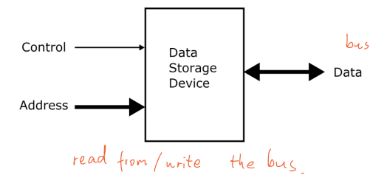
2. 存储设备有两种：Serial Access和Random Access
Serial Access Disc, Tape 就是得从头开始翻
Random Access ICs

3. Serial Access
store data bits in series
Head must travel from current position to new address passing the other addresses in between
time consuming
store large amounts of data
串行访问的存储设备就是要按照一定的顺序存储数据
要访问某个特定的数据，读写头必须从当前位置一点点移动到新的地址
但是，串行访问存储设备可以存储大量的数据。
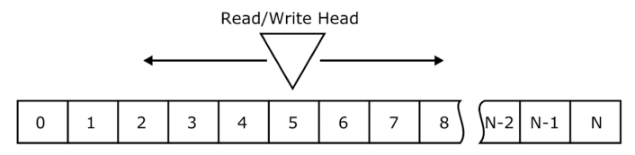

4. Random Access
All memory contents can be accessed in the same time as each other
equal time to access any location n-bit address
store 2^{n} m-bit data words

这个就是RAM
无论访问哪个位置的数据，所需的时间都是相等的。
在这种设备中，一个n位的地址可以存储2^{n}个m位的数据。

5. RAM
Random access memory
can be a combination of volatile and non-volatile as “working memory” and temporary storage
volatile memory loses its contents when the power is switched off断电就没了
volatile memory often used as “working memory”
有两种：static或者dynamic

5.1 Static RAM (SRAM)
定义：Uses transistors to store a single bit of information and does not need to be refreshed periodically. 晶体管
使用bistable latching circuit来存储数据
volatile，断电会丢数据，可以使用电脑内部的电池来维持电源
more expensive，不用于个人电脑
less dense密度低
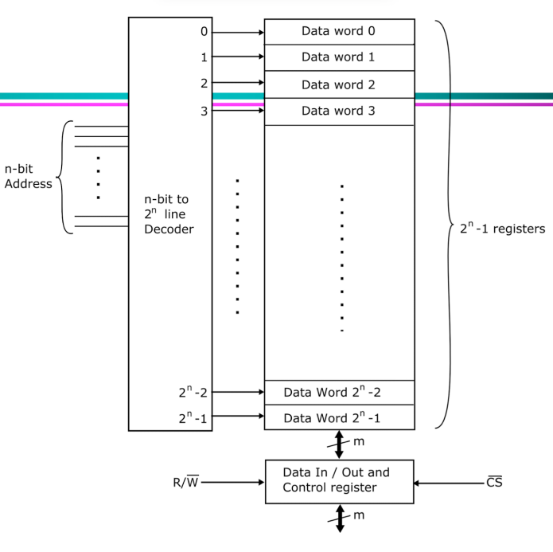

5.2 Dynamic RAM (DRAM)
定义：Uses a capacitor to store the data bit and needs to be periodically refreshed to maintain the charge in the capacitors. 电容，需要定期刷新来维持电荷
each bit, uses a capacitor+a transistor
volatile
capacitor leak charge, DRAM has to be continually refreshed
slower than SRAM
small cell size, high density
main memory in personal computer

6. ROM
定义：Read-only memory where the contents can’t be changed by normal CPU operations.
non-volatile, storing the operating system and other permanent firmware
non-volatile memory keeps its contents even if there is no power可以断电
used to store fixed data or information
有的是programmable的
但其实这个也是random access的，RAM，ROM这俩都是

有几种类型：
Mask ROM programmed in manufacture
PROM programmable ROM
EPROM erasable PROM
Programmed by the user using a programming device. Contents can be erased and the chip reprogrammed
EEPROM electrically erasable PROM
图：
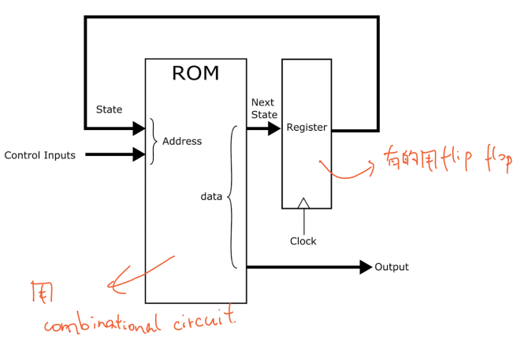
和时序电路的图是对照的：
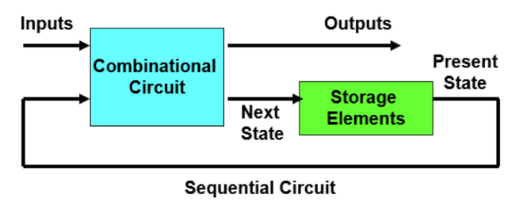
7. Microcomputer (考过)
Block Diagram
CPU+ memory + three buses
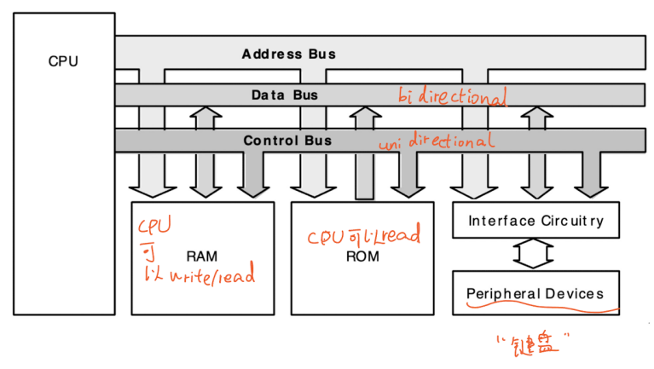
Control signal包括：
Read/Write 读写
Chip Select 芯片选择
Output Enable

- RAM可以是易失性和非易失性（SRAM/DRAM）的组合，作为“工作内存”和临时存储。
- ROM是非易失性的，存储操作系统（例如Windows 10，iOS12，Linux等）和其他永久固件。

8. Memory Sizes
我们注意一下这几个单位，SI不重要
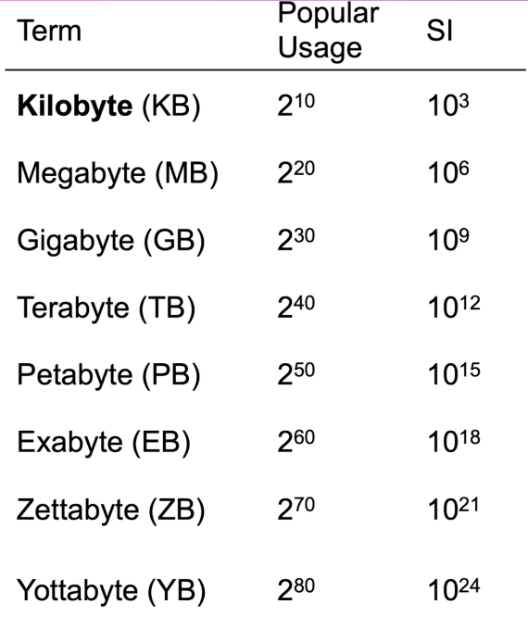

考前默写

Week 2
1. Explain Static Hazards.
static 1 and static 0 hazard
when 1 input variable changes, the output changes momentarily before stabilising on the correct value.

2. static-1 hazard
a pair of input combinations that
(1) differ in only one input variable
(2) both give a 1 output, such that it possible for a momentary 0 output to occur during a transition in the differing input variable.

3. static-0 hazard
a pair of input combinations that
(1) differ in only one input variable
(2) both give a 0 output, such that it possible for a momentary 1 output to occur during a transition in the differing input variable.

4. How to eliminate the Static Hazard?
add redundant logic

5. “The circuit doesn’t have a static race hazard, because the map groupings overlap”

6. Explain dynamic hazard
a dynamic hazard is the possibility of an output changing more than once as a result of a single input change.

时序电路
1. 主要是分为两种，level triggered和edge triggered。
level就是有高有低，通过0和1控制
edge就是有上升有下降，通过rising edge和falling edge控制

2. State what is metastability
Metastability refers to a condition that occurs when both inputs to a sequential circuit are halfway between 0 and 1. 1’
sequential circuits could stay in the “metastable” state if there is no noise to force the output to one valid state or the other 1’
例子：bistable element 1’

3. Describe the behavior of SR latch
after either input is negated, the latch remains in the state that is was forced into
it behaves like a bistable element
the circuit goes into an indeterminate state after we use input S=R=1

4. D latch 解决了SR latch的什么问题？
By having an input D connected to Set and the inverted D to Reset
the problem of indeterminate state will be overcome. 1’

5. State the reasons for using master/slave bistables.
Isolate output from input 1’
Output can’t change continuously with input 1’
Input must have a stable setup time 1’

6. Describe the structure of the master-slave D Type bistable and explain the rason for the function.
The master-slave D Type bistable comprises 2 cross-coupled SR latches.
Each of the latches has memory
but these are unstable if both inputs change at the same time
so the latch inputs are gated to ensure that this can’t happen
The reason for the master-slave function is to allow a stable input set-up time
because the bistable output can’t change simultaneously with an input change.

7. Explain the need for JK bistables to be edge triggered.
If the bistable is level triggered and the inputs J and K are not held valid during the entire period when CLK is active for the master, then the flip-flop exhibits 1’s and 0’s catching behaviour. 1’
1’s catching:
Output changes to 1 even though K and J’ is asserted at the end of the triggering pulse. 2’
0’s catching:
Output changes to 0 even though J and K’ is asserted at the end of the triggering pulse. 2’

8. 比如JK master-slave就是level triggered，会出现上面这个问题，所以改成了JK edge-triggered
“This type of flip-flop has a timing problem known as the 1’s and 0’s catching”

9. Explain the difference between Mealy and Moore finite state machines.
All sequential circuits comprise next-state logic + state memory + output logic 3’
Mealy depends on input + current state
Moore depends on current state
（个人觉得3分的那句不用写，但以后答题还是要把所有相关的都写一下）

10. List the 3 equations that are necessary to allow a sequential circuit analysis.
Input equations (excitation)
next state equations (characteristic)
output equations

Adder, decoder, MUX
1. Explain what is half adder.
accepts two binary digit inputs X and Y
produces Sum (S) and Carry (C) outputs
it is the realization of two bit binary addition operation circuit.
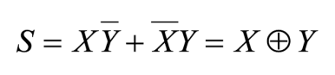
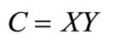

2. Explain the operation of the 4-bit parallel adder.
Each FA block processes two bits at a time and the Cout for each stage is used to derive the Cin of the following stage which means the carry bit ripples across the stages.
The carry input to the least significant bit is normally set to 0 and the carry output of each full adder is connected to the carry input of the next most significant full adder.

3. State the disadvantages of the 4-bit parallel adder.
The main disadvantage is the long delay it takes for the carry bit to propagate throughout the circuit in order to find the final sum.
In the 32-bit case means rippling through 32 stages.

4. Explain the operation of 4-bit full adder/subtractor
In digital logic circuits, A-B is also realised by performing A+ (-B) which means that the full adder can be used as a full subtractor by simply creating the 2’s complement of B.
This can be achieved by inverting B bits and adding 1.
We need to use XOR gates to invert the B bits by simply XOR all bits with 1.
Also, XOR is needed in order to invert Cin from 0 to 1.

5. Explain 2-Input 4-bit MUX
功能：select between two 4-bit binary number inputs
组成：made up of 4 parallel 2-input 1-bit selectors

6. Explain the function of a decoder
a decoder selects one output from many depending on an input address.
Take 2-to-4 decoder as example:
each of the 4 input states selects one of the 4 outputs

Memory
1. Explain the difference and similarity between ROM and RAM.
Both are random access 2’
Every location in both types of memory can be accessed in the same length of time 2’
ROM is non-volatile, contents of memory are retained when power is removed. 2’
RAM is volatile, contents of memory are lost when power is removed 2’

2. Explain the use of ROM as a Look-up table.
The ROM is pre-programmed with the appropriate data.
The input value is applied to the ROMs address bus and the corresponding value is output on the data bus.
Because the device is random access, all values will be accessed in the same time.
例子：输入会放在address bus，corresponding pre-programmed value will output on the data bus.

3. Explain the structure of RAM memory devices.
Equal time to access any address. 1’
n-bit address can access 2^{n} different locations. 1’
Device stores 2^{n} m-bit data words. 1’
RAM can be written to and read from, so a read/write control signal is used to determine the direction of the data transfer. 1’
A chip select control signal is used to select one memory device from many on a bus system. 1’

4. Explain SRAM and DRAM.
Static RAM uses transistors to store a single bit of information 0 or 1.
Dynamic RAM uses a capacitor to store its state.

5. Compare SRAM and DRAM
DRAMs need to be refreshed periodically to retain their charge but SRAM doesn’t.
DRAMs are less expensive and slower than SRAMs.
DRAMs are used for main memory and SRAMs for cache memory.
DRAM is more dense than SRAM.

6. 名词解释
Volatile
Volatile memory loses its contents when the power is switched off
commonly called RAM.
often used as “working memory”
Non-volatile
Non-volatile memory keeps its contents even if there is no power to the device
commonly called ROM
Random Access
All memory contents can be accessed in the same time as each other
Mask ROM
programmed in manufacture
PROM
programmable ROM
EPROM
Erasable PROM.
EEPROM
Electrically Erasable PROM

7. Explain what is uni-directional and bi-directional as applied to computer buses.
Uni-directional means that information goes in only one direction.
Bi-directional means that information can go in either direction.
The address bus in a computer is uni-directional because the CPU sends addresses to devices but doesn’t receive any.
The control bus is uni-directional.
The data bus is bi-directional because data can be written to, or read from memory.

8. Explain tri-state buffer and give an application.
A tri-state buffer is a logic device whose output can be high, low, or disconnected.
It is used to isolate a device from a bus. 1’
The output is controlled by an “output enable” signal. 1’

默写图片
需要会画的电路图
1. 画SR Latch with control的 gate-level diagram
2. 画D Latch的 gate-level diagram
3. 画T Latch的 gate-level diagram（用D变过来的）
4. 画D Master-Slave的 block diagram
5. 画D Master-Slave的 gate-level diagram
6. 画JK Master-Slave的 混合图（SR只需要画block）
7. 画D Edge-trigger 的 block diagram (设计电路using D flip-flop)
8. 画JK Edge-trigger 的 block diagram (设计电路using JK flip-flop)
9. 画T Flip-Flop的 block diagram (设计电路using T flip-flop)（考的不多）

需要会默写的Function Table
1. 写D Latch的
2. 写T Latch的
3. 写JK Master-Slave的
4. 写JK Edge-trigger 的

需要会默写的Characteristic Equation
1. SR的
2. JK的
3. D的
4. T的
5. JK的设计时序电路会用到的表

需要会默写的大图
1.1 时序电路的图
1.2 Synchronous State Machine的图
1.3 Mealy Machine的图
1.4 Moore Machine的图
1.5 三个分析电路用的方程在State Machine中的位置
2.1 Memory的图
2.2 ROM的图
2.3 RAM的图
2.4 microcomputer的图

器件
1.1 4-Input Selector (1-bit) 示意图+输出表格
1.2 2-Input 4-bit Selector 示意图（两个）

2.1 2-to-4 decoder 示意图+输出表格
2.2 2-to-4 decoder 电路图

3.1 Half-adder 电路图（XOR和AND构成）
3.2 Half-adder 电路图（NAND构成）
3.3 Half-adder Truth Table

4.1 Full-adder 示意图
4.2 Full-adder 电路图
4.3 Full-adder Truth Table

5.1 4-bit Parallel Adder 示意图（两个）
5.2 4-bit Ripple Subtractor 示意图（一个）
5.3 4-bit Adder/Subtractor 示意图（两个）
5.4 Arithmetic Unit 示意图（两个）

6.1 4*1-bit ROM
6.2 4*4-bit ROM
6.3 16*1-bit ROM
6.4 16*4-bit ROM
6.5 memory有256MB，每个芯片有4MB，画图

