|  |  |  |  |
| --- | --- | --- | --- |
| **校徽－2** | BUPT name |  | QM logo large black |

**For examiners’ use only**

|  |  |
| --- | --- |
| **1** |  |
| **2** |  |
| **3** |  |
| **4** |  |
| **5** |  |
| **6** |  |
| **Total** |  |

**BBU4374 A**

**Joint Programme Examinations 2021/22**

**BBU4374 Singles and Systems Theory**

**Paper A**

**Time allowed 2 hours**

**Answer ALL questions**

**Complete the information below about yourself very carefully.**

|  |  |  |  |  |  |  |  |  |  |  |  |
| --- | --- | --- | --- | --- | --- | --- | --- | --- | --- | --- | --- |
| **QM student number** | |  |  |  |  |  |  |  |  |  |  | | --- | --- | --- | --- | --- | --- | --- | --- | --- | --- | |  |  |  |  |  |  |  |  |  |  | |
| **BUPT student number** | |  |  |  |  |  |  |  |  |  |  | | --- | --- | --- | --- | --- | --- | --- | --- | --- | --- | |  |  |  |  |  |  |  |  |  |  | |
| **Class number** | |  |  |  |  |  |  |  |  |  |  | | --- | --- | --- | --- | --- | --- | --- | --- | --- | --- | |  |  |  |  |  |  |  |  |  |  | |

**NOT allowed: electronic calculators and electronic dictionaries.**

|  |
| --- |
| **Instructions**   1. **You must NOT take answer books, used or unused, from the examination room.** 2. Write only with a black or blue pen **and in English**. 3. Do all rough work in the answer book – **do not tear out any pages**. 4. If you use Supplementary Answer Books, tie them to the end of this book. 5. Write clearly and legibly. 6. **Read the instructions on the inside cover.** |
|
|
|

Examiners

Dr Changchuan Yin, Dr Daquan Yang, Dr Dong Liang, Dr Yang Yang, Dr Shaoshi Yang, Dr Li Li

**Copyright © Beijing University of Posts and Telecommunications & © Queen Mary University of London 2021**

Filename: 2022_BBU4374_A No answer book required

**Instructions**

**Before the start of the examination**

1) Place your BUPT and QM student cards on the corner of your desk so that your picture is visible.

2) Put all bags, coats and other belongings at the back/front of the room. All small items in your pockets, including wallets, mobile phones and other electronic devices must be **placed in your bag in advance**. **Possession of mobile phones, electronic devices and unauthorised materials is an offence.**

3) Please ensure your mobile phone is switched off and that no alarm will sound during the exam. **A mobile phone causing a disruption is also an assessment offence.**

4) Do not turn over your question paper or begin writing until told to do.

**During the examination**

1) You must not communicate with or copy from another student.

2) If you require any assistance or wish to leave the examination room for any reason, please raise your hand to attract the attention of the invigilator.

3) If you finish the examination early you may leave, but not in the first 30 minutes or the last 10 minutes.

4) For 2 hour examinations you may **not** leave temporarily.

5) For examinations longer than 2 hours you **may** leave temporarily but not in the first 2 hours or the last 30 minutes.

**At the end of the examination**

1) You must stop writing immediately – **if you continue writing after being told to stop, that is an assessment offence.**

2) Remain in your seat until you are told you may leave.

Question 1

1. Please sketch the signal as described below.

**[12 marks]**

1. A continuous-time signal is shown in **Figure 1.1**. Carefully sketch the signal: .

**(4 marks)**

1. The waveform of is shown in **Figure 1.2**. Please draw the waveform:

.

**(4 marks)**

1. Sequence is shown in **Figure 1.3**. Please plot the sequence:

.

**(4 marks)**

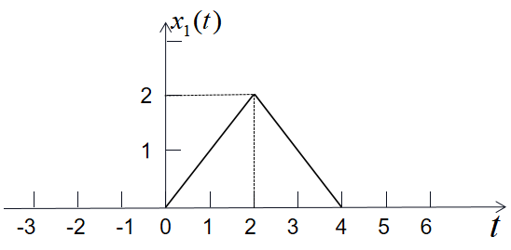

**Figure 1.1**

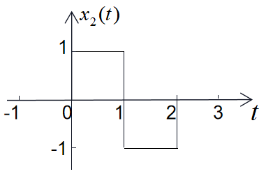

**Figure 1.2**

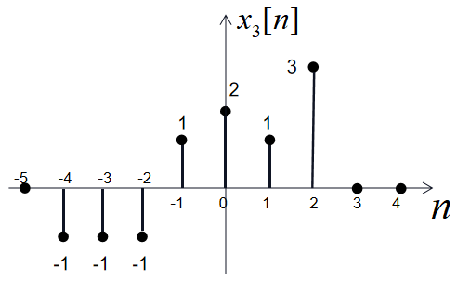

**Figure 1.3**

|  |  |  |
| --- | --- | --- |
|  | **Do not write in this column** | |
|  |
|  |  | |
|  |  | |
|  |  | |
|  |  | |
|  |  | |
|  |  | |
|  |  | |
|  |  | |
|  |  | |
|  |  | |
|  |  | |
|  |  | |
|  |  | |
|  |  | |
|  |  | |
|  |  | |
|  |  | |
|  |  | |
|  |  | |
|  |  | |
|  |  | |
|  |  | |
|  |  | |
|  |  | |
|  |  | |
|  |  | |
|  |  | |
|  |  | |
|  |  | |
|  |  | |
|  |  | |
|  |  | |
|  |  | **12 marks** |

1. A signal system is shown in **Figure 1.4**. Please write down the equation between the system’s input and output, and answer whether and why the system is a causal system (the reason is necessary).

**[6 marks]**

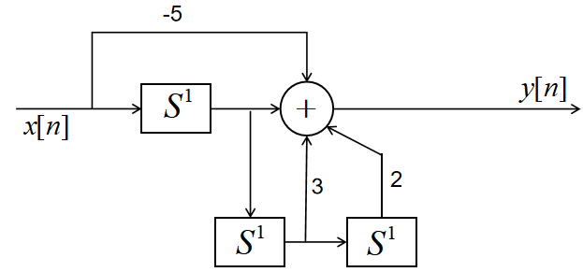

**Figure 1.4**

|  |  |  |
| --- | --- | --- |
|  | **Do not write in this column** | |
|  |
|  |  | |
|  |  | |
|  |  | |
|  |  | |
|  |  | |
|  |  | |
|  |  | |
|  |  | |
|  |  | |
|  |  | |
|  |  | |
|  |  | |
|  |  | |
|  |  | |
|  |  | |
|  |  | |
|  |  | |
|  |  | |
|  |  | |
|  |  | |
|  |  | |
|  |  | **6 marks** |

**Question marking: **

Question 2

1. Consider the discrete-time LTI system model, the impulse response is shown in **Figure 2.**

Determine the output y[n] of this system in response to the input：

x[n]=3δ[n+1]+δ[n]+2δ[n-1]+2δ[n-2].

**[10 marks]**

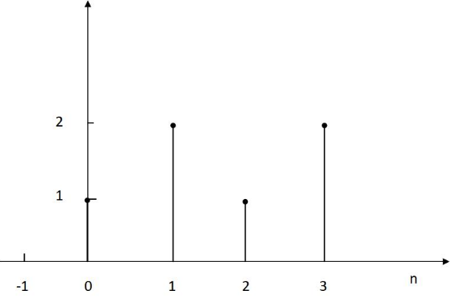

**Figure 2**

|  |  |  |
| --- | --- | --- |
|  | **Do not write in this column** | |
|  |
|  |  | |
|  |  | |
|  |  | |
|  |  | |
|  |  | |
|  |  | |
|  |  | |
|  |  | |
|  |  | |
|  |  | |
|  |  | |
|  |  | |
|  |  | |
|  |  | |
|  |  | |
|  |  | |
|  |  | |
|  |  | |
|  |  | |
|  |  | |
|  |  | |
|  |  | |
|  |  | |
|  |  | |
|  |  | |
|  |  | |
|  |  | |
|  |  | |
|  |  | |
|  |  | |
|  |  | |
|  |  | |
|  |  | |
|  |  | |
|  |  | |
|  |  | |
|  |  | |
|  |  | |
|  |  | |
|  |  | |
|  |  | |
|  |  | |
|  |  | |
|  |  | |
|  |  | |
|  |  | |
|  |  | |
|  |  | |
|  |  | **10 marks** |

1. Suppose the signal x(t)=e-2t[u(4-t)-u(-t)], and the impulse response of an LTI system is given by h(t)=u(t-1)-u(t-3). Evaluate the following convolution integral: y(t)=x(t)*h(t).

**[10 marks]**

|  |  |  |
| --- | --- | --- |
|  | **Do not write in this column** | |
|  |
|  |  | |
|  |  | |
|  |  | |
|  |  | |
|  |  | |
|  |  | |
|  |  | |
|  |  | |
|  |  | |
|  |  | |
|  |  | |
|  |  | |
|  |  | |
|  |  | |
|  |  | |
|  |  | |
|  |  | |
|  |  | |
|  |  | |
|  |  | |
|  |  | |
|  |  | |
|  |  | |
|  |  | |
|  |  | |
|  |  | **10 marks** |

**Question marking**: 

Question 3

Consider a continuous-time LTI system with the impulse response . If the system with impulse response h(t) is composed of the cascade connection of h1(t) and h2(t), as shown in **Figure 3**:

**[15 marks]**

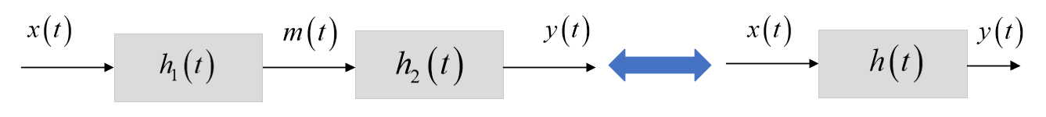

**Figure 3** Block diagram ofh(t)**,** which is equivalent to the cascade connection of h1(t)and h2(t).

i) Find the Fourier transform (FT) of the signals and;

**(4 marks)**

ii) If the frequency response and , find the impulse response , frequency response , magnitude spectrum  and phase spectrum ;

**(4 marks)**

iii) Find the output signal of  LTI system with input ;

**(3 marks)**

iiii) If , find the input  and the output.

**(4 marks)**

|  |  |  |
| --- | --- | --- |
|  | **Do not write in this column** | |
|  |
|  |  | |
|  |  | |
|  |  | |
|  |  | |
|  |  | |
|  |  | |
|  |  | |
|  |  | |
|  |  | |
|  |  | |
|  |  | |
|  |  | |
|  |  | |
|  |  | |
|  |  | |
|  |  | |
|  |  | |
|  |  | |
|  |  | |
|  |  | |
|  |  | |
|  |  | |
|  |  | |
|  |  | |
|  |  | |
|  |  | |
|  |  | |
|  |  | |
|  |  | |
|  |  | |
|  |  | |
|  |  | |
|  |  | |
|  |  | |
|  |  | |
|  |  | |
|  |  | |
|  |  | |
|  |  | |
|  |  | |
|  |  | |
|  |  | |
|  |  | **15 marks** |

**Question marking**: 

Question 4

Consider a discrete-time LTI system with the frequency response:,

**[15 marks]**

1. Find its impulse response .

**(2 marks)**

1. If the input signal is: , determine the discrete-time Fourier transform (DTFT) of , and find the output signal.

**(4 marks)**

1. Determine the DTFT of the signal  and  by using the frequency-shift and time-shift property of DTFT, respectively.

**(4 marks)**

1. Find the Discrete-time Fourier series (DTFS) coefficients of the signal  and ;

**(5 marks)**

|  |  |  |
| --- | --- | --- |
|  | **Do not write in this column** | |
|  |
|  |  | |
|  |  | |
|  |  | |
|  |  | |
|  |  | |
|  |  | |
|  |  | |
|  |  | |
|  |  | |
|  |  | |
|  |  | |
|  |  | |
|  |  | |
|  |  | |
|  |  | |
|  |  | |
|  |  | |
|  |  | |
|  |  | |
|  |  | |
|  |  | |
|  |  | |
|  |  | |
|  |  | |
|  |  | |
|  |  | |
|  |  | |
|  |  | |
|  |  | |
|  |  | |
|  |  | |
|  |  | |
|  |  | |
|  |  | |
|  |  | |
|  |  | |
|  |  | |
|  |  | |
|  |  | |
|  |  | |
|  |  | |
|  |  | |
|  |  | |
|  |  | |
|  |  | |
|  |  | |
|  |  | |
|  |  | |
|  |  | **15 marks** |

**Question marking**: 

**Question 5**

1. An LTI system has impulse response . Use the FT to determine the output  if the input is .

**[8 marks]**

|  |  |  |
| --- | --- | --- |
|  | **Do not write in this column** | |
|  |
|  |  | |
|  |  | |
|  |  | |
|  |  | |
|  |  | |
|  |  | |
|  |  | |
|  |  | |
|  |  | |
|  |  | |
|  |  | |
|  |  | |
|  |  | |
|  |  | |
|  |  | |
|  |  | |
|  |  | |
|  |  | |
|  |  | |
|  |  | |
|  |  | |
|  |  | |
|  |  | |
|  |  | |
|  |  | |
|  |  | |
|  |  | |
|  |  | |
|  |  | **8**  **marks** |

1. Determine the FT represenatation  for the discrete-time signal

 with sampling interval *Ts*.

**[4 marks]**

|  |  |  |
| --- | --- | --- |
|  | **Do not write in this column** | |
|  |
|  |  | |
|  |  | |
|  |  | |
|  |  | |
|  |  | |
|  |  | |
|  |  | |
|  |  | |
|  |  | |
|  |  | |
|  |  | |
|  |  | |
|  |  | |
|  |  | |
|  |  | |
|  |  | |
|  |  | |
|  |  | |
|  |  | |
|  |  | |
|  |  | |
|  |  | |
|  |  | |
|  |  | |
|  |  | **4**  **marks** |

**Question marking**: 

**Question 6**

a) A differential equation of a linear time-invariant causal continuous time system can be described as

with known conditions, , . Find the zero-input response yx(t).

**[10 marks]**

|  |  |  |
| --- | --- | --- |
|  | **Do not write in this column** | |
|  |
|  |  | |
|  |  | |
|  |  | |
|  |  | |
|  |  | |
|  |  | |
|  |  | |
|  |  | |
|  |  | |
|  |  | |
|  |  | |
|  |  | |
|  |  | |
|  |  | |
|  |  | |
|  |  | |
|  |  | |
|  |  | |
|  |  | |
|  |  | |
|  |  | |
|  |  | |
|  |  | |
|  |  | |
|  |  | |
|  |  | |
|  |  | **10**  **marks** |

b) The difference equation of a casual discrete system can be described as

Find the system function H(z) and the impulse response h[n].

**[10 marks]**

|  |  |  |
| --- | --- | --- |
|  | **Do not write in this column** | |
|  |
|  |  | |
|  |  | |
|  |  | |
|  |  | |
|  |  | |
|  |  | |
|  |  | |
|  |  | |
|  |  | |
|  |  | |
|  |  | |
|  |  | |
|  |  | |
|  |  | |
|  |  | |
|  |  | |
|  |  | |
|  |  | |
|  |  | |
|  |  | |
|  |  | |
|  |  | |
|  |  | |
|  |  | |
|  |  | |
|  |  | **10**  **marks** |

**Question marking**: 

|  | **Do not write in this column** |
| --- | --- |
|  |
|  |  |
|  |  |
|  |  |
|  |  |
|  |  |
|  |  |
|  |  |
|  |  |
|  |  |
|  |  |
|  |  |
|  |  |
|  |  |
|  |  |
|  |  |
|  |  |
|  |  |
|  |  |
|  |  |
|  |  |
|  |  |
|  |  |
|  |  |
|  |  |
|  |  |
|  |  |
|  |  |
|  |  |
|  |  |
|  |  |
|  |  |
|  |  |
|  |  |
|  |  |
|  |  |
|  |  |
|  |  |
|  |  |
|  |  |
|  |  |
|  |  |
|  |  |
|  |  |
|  |  |
|  |  |
|  |  |
|  |  |
|  |  |
|  |  |
|  |  |
|  |  |
|  |  |
|  |  |
|  |  |
|  |  |
|  |  |
|  |  |
|  |  |
|  |  |
|  |  |
|  |  |
|  |  |
|  |  |
|  |  |
|  |  |
|  |  |
|  |  |
|  |  |
|  |  |
|  |  |
|  |  |
|  |  |
|  |  |
|  |  |
|  |  |
|  |  |
|  |  |
|  |  |
|  |  |
|  |  |
|  |  |
|  |  |
|  |  |
|  |  |