SOLUTIONS

|  |  |  |  |
| --- | --- | --- | --- |
| Module: | Singles and Systems Theory | | |
| Module Code | BBU4374 | Paper | A |
| Time allowed | 2hrs | Filename | Solutions_2022_BBU4374_A |
| Rubric | Answer ALL FOUR questions | | |
| Examiners | Dr Changchuan Yin, Dr Daquan Yang, Dr Dong Liang, Dr Yang Yang, Dr Shaoshi Yang, Dr Li Li | | |

**Question 1 [18 marks]**

1. Please sketch the signal as described below.
2. A continuous-time signal is shown in Figure 1.1. Carefully sketch the signal: .



**(4 marks)**

1. The waveform of is shown in Figure 1.2. Please draw the waveform:.



**(4 marks)**

1. Sequence is shown in Figure 1.3. Please plot the sequence: .



**(4 marks)**

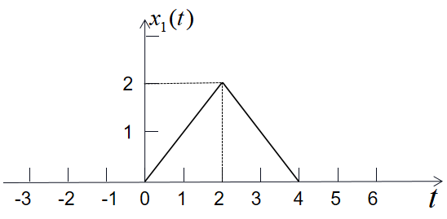 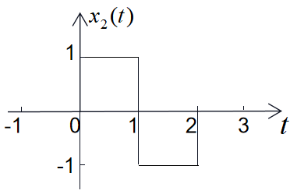

Figure 1.1 Figure 1.2

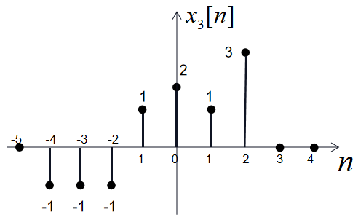

Figure 1.3

**Solutions:**

a) The answer is as follows:

1.  is shown in Figure (a) (4 marks).
2.  is shown in Figure (b) (4 marks).
3.  is shown in Figure (c) (4 marks).

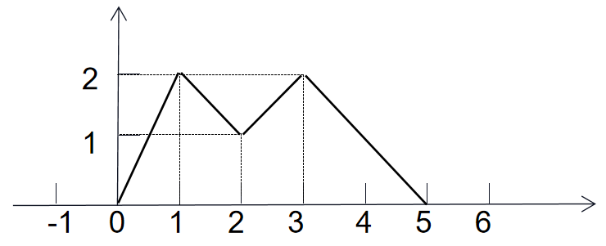 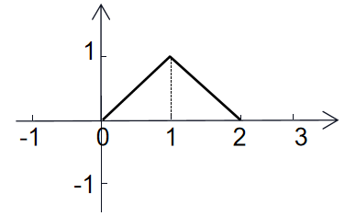

Figure (a) Figure (b)

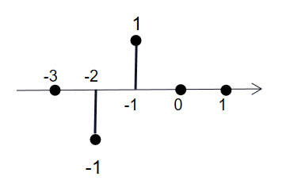

Figure (c)

1. A signal system is shown in Figure 1.4. Please write down the equation between the system’s input and output, and answer whether and why the system is a causal system (the reason is necessary).

**(6 marks)**

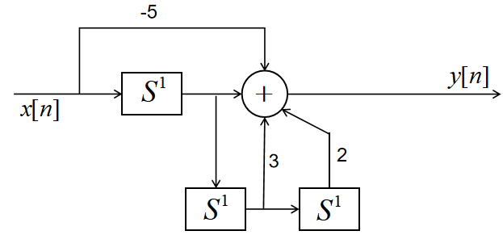

Figure 4

**Solutions:**

(3 marks), and the system is a causal system (1 mark), because the output does not appear earlier than the input (2 marks).



**Question 2**

1. Consider the discrete-time LTI system model, the impulse response is shown in **Figure 2**

Determine the output y[n] of this system in response to the input:

x[n]=3δ[n+1]+ δ[n]+2δ[n-1]+2δ[n-2].

**[10 marks]**

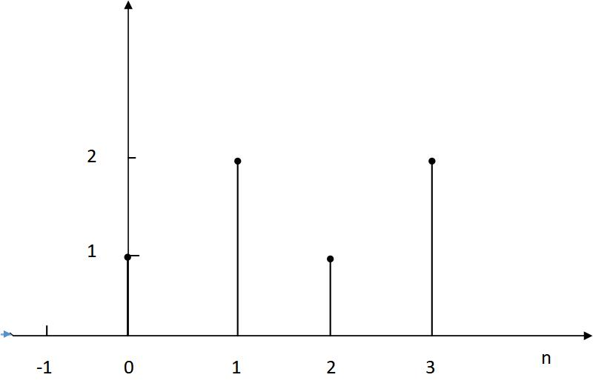

Figure 2

**Solution:**

h[n]=δ[n]+2δ[n-1]+ δ[n-2]+ 2δ[n-3] (3 marks)

y(n)=3δ[n+1]+7δ[n]+7δ[n-1]+13δ[n-2]+8δ[n-3]+6δ[n-4]+4δ[n-5] (7 marks)

1. Suppose the signal x(t)=e-2t*[u(4-t)-u(-t)], and the impulse response of an LTI system is given by h(t)=u(t-1)-u(t-3). Evaluate the following convolution integral: y(t)=x(t)*h(t).

**[10 marks]**

**Solution:**

**y(t)=x(****)*h(t)=**（2marks）

From the given information, we can easily know that y(t)=0 while t≤1（1mark）or t>7(1mark)

While 1<t≤3, the above integral is $\int_{0}^{t-1}{e^{-2τ}dτ}$ =1/2(1-)(2marks)

While 3<t≤5, the above integral is $\int_{t-3}^{t-1}{e^{-2τ}dτ}$ = 1/2(-)(2marks)

While 5<t≤7, the above integral is $\int_{t-3}^{t-1}{e^{-2τ}dτ}$ =1/2(-)(2marks)

in summary：

t1 y(t)=0

1<t≤3 y(t)=1/2(1-)

3<t≤5 y(t)=1/2(-)

5<t≤7 y(t)=1/2(-)

t>7 y(t)=0

**Question 3**

Consider a continuous-time LTI system with the impulse response . If the system with impulse response  is composed of the cascade connection of  and , as shown in Fig. 1:

**[15 marks]**

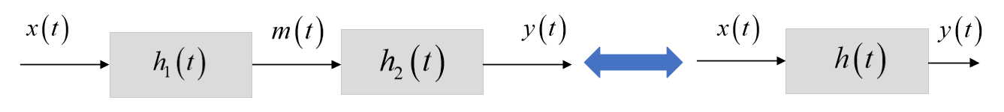

Figure 1: Block diagram of **,** which is equivalent to the cascade connection of  and .

1. Find the Fourier transform (FT) of the signals , and ;

**(4 marks)**

ii) If the frequency response and , find the impulse response , frequency response , magnitude spectrum  and phase spectrum ;

**(4 marks)**

iii) Find the output signal of  LTI system with input ;

**(3 marks)**

iiii) If , find the input  and the output .

**(4 marks)**

**Solution:**

|  |  |  |
| --- | --- | --- |
| i) |  | 1 marks  1 marks  2 marks |
| ii) |  | 1 marks  1 marks  1 marks  1 marks |
| iii) |  | 1 marks  2 marks |
| iiii) |  | 1 marks  2 marks  1 marks |

**Question 4**

Consider a discrete-time LTI system with the frequency response:, **[15 marks]**

1. Find its impulse response . **[2 marks]**
2. If the input signal is: , determine the discrete-time Fourier transform (DTFT) of , and find the output signal.

**[4 marks]**

1. Determine the DTFT of the signal  and  by using the frequency-shift and time-shift property of DTFT, respectively.

**[4 marks]**

1. Find the Discrete-time Fourier series (DTFS) coefficients of the signal  and ;

**[5 marks]**

**Solutions:**

1. 

(2 marks)

1. 

 (2 marks)



**Or:** 

(2 marks)

1. employing frequency-shift property of DTFT, 

We can get 

(2 marks)

employing time-shift property of DTFT, 

We can get 

(2 marks)

1. DTFS of :

 (2 marks)

DTFS of :

Ωo = π / 9, N=2π / Ωo =18





 (3 marks)

**Question 5**

1. An LTI system has impulse response . Use the FT to determine the output  if the input is .

**[8 marks]**

**Solution:**

Let 

 (2 marks)

 (1 mark)

 (2marks)

We have  (2 marks)

Therefore

 (1 mark)

 (2 marks)

1. Determine the FT represenatation  for the discrete-time signal



with sampling interval *Ts*.

**[4 Marks]**

 (2 marks)

**Question 6**

a) A differential equation of a linear time-invariant causal continuous time system can be described as

with known conditions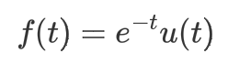, , . Find the zero-input response .

**[10 marks]**

**Solutions:**

According to Laplace transform, we have

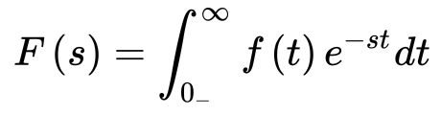

(1 marks)

Using Laplace transform to process both sides of the differential equation, we obtain



(2 marks)

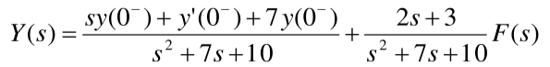Therefore,

(2 marks)

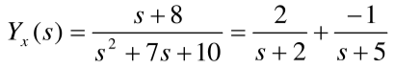So

(3 marks)

Then we have

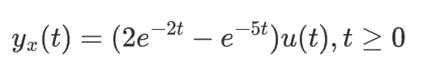

(2 marks)

b) The difference equation of a casual discrete system can be described as

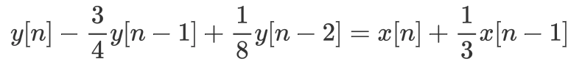

Find the system function H(z) and the impulse response h[n].

**[10 marks]**

**Solution:**

By taking the z-transform, we have,

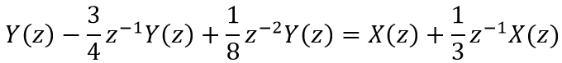

(3 marks)

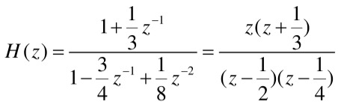Then,

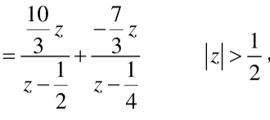

(3 marks)



(1 marks)

Since the system is casual,

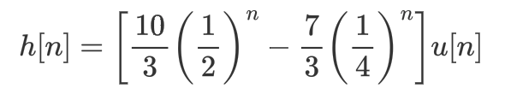

(3 marks)