SOLUTIONS

|  |  |  |  |
| --- | --- | --- | --- |
| Module: | Singles and Systems Theory | | |
| Module Code | BBU4374 | Paper | A |
| Time allowed | 2hrs | Filename | Solutions_2223_BBU4374_A |
| Rubric | Answer ALL FOUR questions | | |
| Examiners | Dr Changchuan Yin, Dr Feng Zheng, Dr Dong Liang, Dr Yang Yang, Dr Shaoshi Yang, Dr Li Li | | |

**Question 1 [18 marks]**

1. Suppose a discrete-time sinusoidal signal is defined as . Determine whether  is periodic; if yes, find its fundamental period.

**(4 marks)**

1. The sequence  is shown in **Figure 1.1**. Please plot the sequence .

**(4 marks)**

1. The waveform of  is shown in **Figure 1.2**. Please draw the waveform of .

**(4 marks)**

1. A discrete-time sequence is defined as , where  is the unit-impulse sequence. Please plot sequence  and calculate its energy.

**(6 marks)**

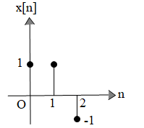

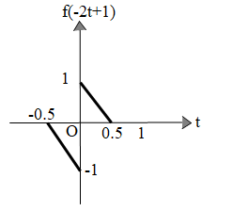

**Figure 1.1 Figure 1.2**

**Solutions:**

1.  is periodic (2 marks).

, then the fundamental period for  (2 marks).

**(4 marks)**

1. is shown in Figure (1.1) (4 marks).

**(4 marks)**

1.  is shown in Figure (1.2) (4 marks).

**(4 marks)**

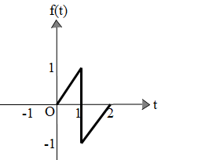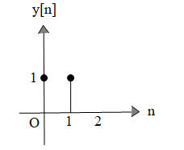

**Figure (1.1) Figure (1.2)**

The detailed process of the third question is as follows:

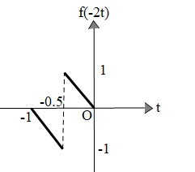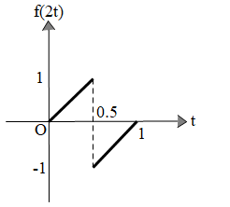

**Figure (1.3)**

1.  is shown in Figure (1.4) (3 marks).

**(6 marks)**

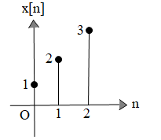

**Figure (1.4)**

The energy of  is (3 marks).

**Question 2**

1. Determine and sketch the convolution of the following two signals:

 h[n]=δ[n+2]+2δ[n+1]

**[10 marks]**

**Solution:**

y[n]=x[n]*h[n]=x[n]*δ[n+2]+x[n]*2δ[n+1]=x[n+2]+2x[n+1] （2marks）

 （2marks）

（4marks）

The waveform of y[n] is shown in the figure below

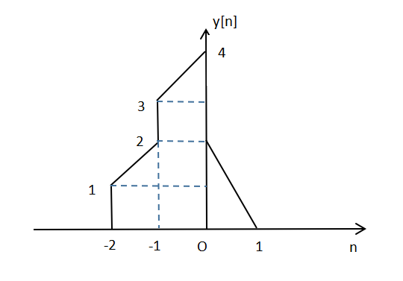（2marks）

1. Consider a causal LTI system whose input x[n] and output y[n] are related by the difference equation:y[n]=1/4y[n-1]+x[n].Determine y[n] if x[n]=δ[n-1].

**[10 marks]**

**Solution:**

Because the system is causal,so y[n]=0 while n<1;（2marks）

While n=1 and n>1,we can use iterative method to find y[n].（2marks）

y[1]=1/4y[0]+x[1]=δ[0]=1,

y[2]=1/4y[1]+x[2]=1/4+0=1/4,

y[3]=1/4y[2]+x[3]=1/16=(1/4)2,

y[4]=1/4y[3]+x[4]=(1/4)3,...,y[m]=(1/4)m-1,...（4marks）

So,y[n]=(1/4)n-1u[n-1]（2marks）

**Question 3**

Consider a continuous-time LTI system with the impulse response . If the system with impulse response  is composed of the parallel connection of  and , as shown in **Figure. 2**:

**[15 marks]**



Figure 2: Block diagram of , which is equivalent to the parallel connection of  and .

1. Find the Fourier transform (FT) of the signals , and ;

**(3 marks)**

ii) If the impulse response and , find the frequency response , magnitude spectrum  and phase spectrum ;

**(4 marks)**

iii) Find the output signal  and its FT  with input ;

**(4 marks)**

iv) If the output is , find its corresponding input  and its FT .

**(4 marks)**

**Solution:**

|  |  |  |
| --- | --- | --- |
| i) |  | 1 marks  1 marks  1 marks |
| ii) |  | 1 marks  1 marks  1 marks  1 marks |
| iii) |  | 2 marks  2 marks |
| iiii) |  | 1 marks  1 marks  2 marks |

**Question 4**

a)Consider a discrete-time LTI system, 

**[8 marks]**

1. Determine the frequency response ;

**(2 marks)**

1. Find the Discrete-time Fourier series (DTFS) coefficients of the signal ;

**(3 marks)**

1. **C**alculate the output of the system  with the input signal .

**(3 marks)**

**Solutions:**

1. ； 2 marks
2. *Ω****o* =** *π***/ 8, *N*=2***π***/** *Ω****o* =16**

 1 mark



 2 marks

1.  1 mark



2 marks

b) The input to a discrete-time system is given by , use the DTFT to find the output of the system, , if the impulse response is given by .

**[7 marks]**

**Solution:**

 2 marks



2 marks

 2 marks

 1 mark

**Question 5**

1. Find the FT representation of  as depicted in **Figure. 3**.

**[5 marks]**

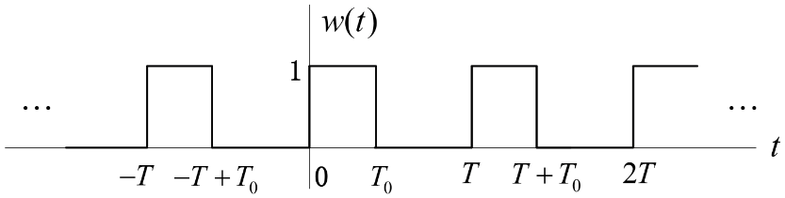

**Figure. 3**

**Solution:**

FT representation of  is given by

 1 mark

where ,



2 marks

 2 marks

1. Use  as depicted in Fig. 1 as the input to an LTI system with the frequency response 

If we have , , determine the system output .

**[4 marks]**

**Solution:**

 1 mark

When  and , we have 



where



Therefore

 2 marks

Its inverse FT is

 1 mark

1. Consider sampling the signal  with sampling interval , determine the bound on , which guarantee that there will be no aliasing.

**[3 marks]**

**Solution:**

The maximum frequency  in  is

 1 mark

According to the sampling theorem, we require that



or . 2 marks

**Question 6**

a) A differential equation of a linear time-invariant causal continuous time system can be described as

$$y^{''}(t)+5y^{'}(t)+6y(t)=x^{''}(t)+3x^{'}(t)+2x(t)$$

The input signal is $x(t)=(1+e^{−t})u(t)$, the output signal is

$y(t)=({4e}^{−2t}−\frac{4}{3}e^{−3t}+\frac{1}{3})u(t)$.

Find the zero-input response $y_{zi}$ (t), zero-state response $y_{zs}$ (t)

**[10 marks]**

**Solutions:**

Using Laplace transform to process both sides of the differential equation, we obtain

$Y(s)(s^{2}+5s+6)=X(s)(s^{2}+$ 3s $+$ 2 $)$ (2 marks)

Therefore,

$H(s)=\frac{Y(s)}{X(s)}$ $=$ $\frac{s^{2}+3s+2}{s^{2}+5s+6}$ $=\frac{s+1}{s+3}$

(1 mark)

And,

$X(s)=\frac{1}{s}+\frac{1}{s+1}$ $=\frac{2s+1}{s(s+1)}$ (1 mark)

So,

$Y_{zs}(s) = X(s)·H(s) = \frac{s+1}{s+3}·\frac{2s+1}{s(s+1)}=\frac{2s+1}{s(s+3)}$, (2 marks)

Suppose,

$\frac{2s+1}{s(s+3)}= \frac{A}{s}+\frac{B}{s+3}=\frac{(A+B)s+3A}{s(s+3)},$

Then we have

$y_{zs}(t) =(\frac{1}{3}+\frac{5}{3}e^{−3t})u(t)$. (2 marks)

So

$$y_{zi}(t) =y(t)−y_{zs}(t)=({4e}^{−2t}−\frac{4}{3}e^{−3t}+\frac{1}{3})u(t)−( \frac{1}{3}+\frac{5}{3}e^{−3t})u(t)$$

$=(4e^{−2t}−3e^{−3t})u(t)$. (2 marks)

b) Find the inverse transform x[n] of $X\left(z\right)=\frac{−11z}{4z^{2}−13z+3}$ under the following three conditions:

(1) $\left|z\right|>3$

(2) $\frac{1}{4}<\left|z\right|<3$

(3) $\left|z\right|<\frac{1}{4}$

**[10 marks]**

**Solution:**

Partial-fraction expansion:

$$X\left(z\right)=\frac{z}{z−\frac{1}{4}}−\frac{z}{z−3}$$

(4 marks)

(1) Convergence region $\left|z\right|>3$, x[n] is a right-sided sequence

$$x[n]=\left[{\left(\frac{1}{4}\right)}^{n}−3^{n}\right]u[n]$$

(2 marks)

(2) Convergence region $\frac{1}{4}<\left|z\right|<3$, x[n] is a bilateral sequence

$$x[n]={\left(\frac{1}{4}\right)}^{n}u[n]+3^{n}u[−n−1]$$

(2 marks)

(3) Convergence region $\left|z\right|<\frac{1}{4}$, x[n] is a left-sided sequence

$$x[n]=\left[−{\left(\frac{1}{4}\right)}^{n}+3^{n}\right]u[−n−1]$$

(2 marks)