**北京邹電大学**



**BBC4931 B**

**Joint Programme Examinations 2023/24 BBC4931 Electronic and Circuit Foundation**

**Paper B**

**Time allowed 2 hours**

**Answer ALL questions**

**For examiners'use only**

|  |  |
| --- | --- |
| **1** |  |
| **2** |  |
| **3** |  |
| **4** |  |
| **5** |  |
| **6** |  |
| **Total** |  |



**Complete the information below aboutyourself very carefully.**

**QM student number**

**BUPT student number Class number**

**NOT allowed:computers and electronic dictionaries.**

|  |
| --- |
| **INSTRUCTIONS**  1.**You** **must** **not** **take** **answer** **books,used** **or** **unused,from** **the** **examination** **room.**  2. Write only in black or blue pen and in English.  3. Do all rough work in the answer book-do not tear out any pages.  4.If you use Supplementary Answer Books,tie them to the end of this book. 5.Write clearly and legibly.  6.**Read** **the** **instructions** **on** **the** **inside** **cover.** |

**Examiners**

Prof.Lihua Li,Prof.Yonghua Li,Prof.Qixun Zhang,Dr.Yanzhao Hou

Cop**yright OBeijing University of Posts and Telecommunications &O Queen Mary,University of London 2018** Filename:2324_BBC4931_B No answerbook required

**Instructions**

**Before the start of the examination**

1)Place your BUPT and QM student cards on the corner of your desk so that your picture is visible.

2)Put all bags,coats and other belongings at theback/front of the room.All small items in your pockets, including wallets,mobile phones and other electronic devices must be **placed in your bag in advance. Possession of mobile phones,electronic devices and unauthorised materials is an offence.**

3)Please ensure your mobile phone is switched off and that no alarm will sound during the exam.A

**mobile phone causing a disruption is also an assessment offence.**

4)Do not turn over your question paper or begin writing until told to do.

**During the examination**

1)You mustnot communicate with or copy from another student.

2)If you require any assistance or wish to leave the examination room for any reason,please raise your hand to attract the attention of the invigilator.

3)If you finish the examination early you may leave,but not inthe first 30 minutes or the last 10 minutes.

4)For 2 hour examinations you may not leave temporarily.

5)For examinations longer than 2 hours you may leave temporarily but not in the first 2 hours or the last

30 minutes.

**At the end of the examination**

1)You must stop writing immediately-if you continue writingafter being told to stop,that is an assessment offence.

2)Remain in your seat until you are told you may leave.

**BBC4931 Paper B 2023/24**

**Question 1**

Question 1 comprises 25 single-choice parts,worth a total of 50 marks and each 2 marks.THERE IS NO PENALTY FORA WRONG ANSWER.YOU ARE THEREFORE URGED TO ATTEMPT cis the most likely.

a)In a P-type semiconductor material,the majority carriers are

A)free electrons

B)holes

C)impurity irons

D)valence elections

b)In a semiconductor diode,the region near the PN junctionconsisting of positive and negative ions

is called the

A)neutral zone

B)recombination region C)depletion region

D)diffusion area

c)In a common-emiter(CE)amplifier circuit composed of NPN type BJT,when the static operating point is too high,it is easy to introduce

A)cutoff distortion

B)saturation distortion

C)bidirectional distortion D)lineardistortion

d)When a PN junction is forward-biased,the diffusion movement of majority carriers is and the drifting movement of minority carriers is

A)increased;decreased B)decreased;decreased C)decreased;increased D)increased;increased

e)For an NPN transistor working in active region,the DC voltages at thre pins are 2V,2.7V and 6V. The pins are terminal.

A)Base,Collector,Emitter B)Base,Emitter,Collector C)Collector,Base,Emitter D)Emitter,Base,Collector

**Page 3 of 26**

**BBC4931 Paper B** 2023/24

f)To be employed as linear(undistorted)amplifiers,theB-E junctionof BJTs should be

biased and the B-Cjunction of BJTs should be biased.

A)forward,forward B)forward,reverse C)reverse,reverse D)reverse,forward

g)The advantages of field-effect transistors is :

A)large input impedance B)small output impedance C)current-control device D)large input current

h)The region of the characteristic curve family for the FETs that is normally used for linear amplification is

A)the linear-resistance region

B)the Ohmic region

C)the saturation region D)All of the above

i)The differential amplifier is utilized to

A)stabilize voltage gain

B)suppress zero point drift C)improve input resistance D)All ofthe above

j)As shown in the Figure 1 below,when Ce is cut off,|Au|is getting ,Ri is getting_

A)larger,smaller B)larger,larger

C)smaller,larger

D)smaller,smaller

**BBC4931 Paper B**

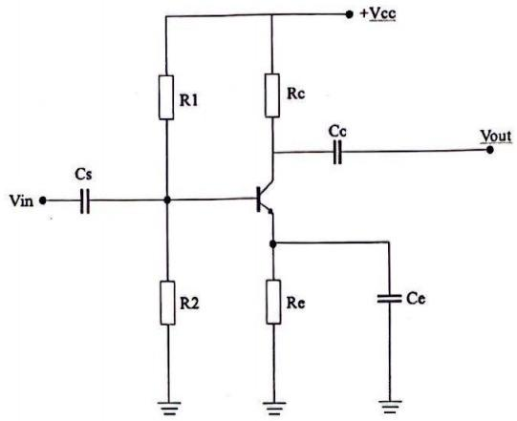

2023/24

Figure 1

k)When comparing thecommon emitter and the common collector amplifiers,the input impedance of the common is much larger and the output impedance of the common is much

smaller.

A)emitter;emitter

B)emitter;collector C)collector;emitter D)collector;collector

1)The common-base amplifier is characterized as having a relatively input impedance and relatively output impedance.

A)high;low B)low;low C)low;high D)high;high

m)When the frequency of the useful signal is lower than 100Hz,a filter circuit should be used.

A)low-pass B)high-pass C)band-pass D)band-stop

n)With an input sinusoidal signal in Figure 2(a),what is the function of the circuit in **Figure 2(b)?**

·

A)Clipper

**BBC4931 Paper B**

B)Clamper

C)half-wave rectifier D)full-wave rectifier

2023/24

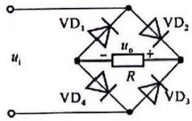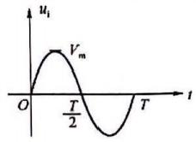

**(a)** (b)

**Figure 2**

o)The high-frequency response of a BJT amplifier is affected by while the low-frequency response of a BJT amplifier is affected by

A)parasitic capacitances,large capacitors such as the coupling capacitors and bypass capacitors.

B)coupling capacitor,bypass capacitor

C)bypass capacitors,parasitic capacitances D)coupling capacitor,parasitic capacitances.

p)The bandwidth of a multi-stage amplifier circuit is ,compared with its single-stage amplifier circuit.

A)wider

B)narrower

C)unchanging

D)has nothing to do with it

q)Current miror circuits provide used in . A)constant current sources;power circuits.

B)constantvoltage sources;power circuits.

C)constant current sources;integrated circuits. D)constant voltage sources;integrated circuits.

r)For a class AB push-pull amplifier,each transistor

A)conducts through 180°of the input waveform

B)works only with digital and pulsed waveforms

C)conducts through less than 180°of the input waveform

D)conducts between 180°and 360°degrees of the input waveform,depending on the amount of dc bias.

**Page 6 of 26**

BBC4931 Paper B 2023/24

s)When a typical differential amplifier changes from a double-ended output to a single-ended output, the differential mode voltage amplification factor would become

A)larger

B)smaller

C)no change

D)unable to judge

t)Negative feedback amplifier reduces of the circuit to improve other performance of the circuit

A)bandwidth B)stability

C)gain

D)impedance

u)Compared with an unloaded amplifier,the load resistor can the voltage gain.The resistor of a signal source could the voltage gain.

A)increase,decrease B)increase,increase C)decrease,decrease D)decrease,increase

v)In a negativefeedback amplifier,when the input impedance of the amplifier circuit is required to be large and the output impedance is small, should be selected.

A)voltage series B)voltage parallel C)current series D)current parallel

w)The main role of DC negative feedback is

A)increase the input resistance

B)lower the circuit gain

C)increase the circuit gain

D)stabilize the operating point

x)The Miller effect input capacitance for a CE amplifier is .

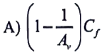

Page 7 of 26

**BBC4931 Paper B** 2023/24



C)(1-Av)C



口

y)The input impedance for the amplifier in Figure 3 is _,assuming that gm=1.85mS.

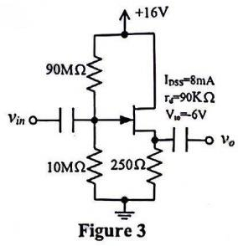A)Zi depends on thevalue of Ip.

B)Zi=9MΩ C)Zi=10MΩ D)Zi=90MΩ

**Answer Question 1 below:**

|  |  |
| --- | --- |
|  | **Do** **notwritein**  **this** **column** |
|  |
| a) |  |
| b) |  |
| C) |  |
| d) |  |
| e) |  |
| f |  |
| g) |  |
| h) |  |
| i) |  |
| ji) |  |
| k) |  |
| 1) |  |
| m) |  |
| n) |  |
| o) |  |
| D) |  |

**Page 8 of 26**

**BBC4931** **Paper** **B** **2023/24**

|  |  |  |
| --- | --- | --- |
| q) |  | |
| r) |  | |
| s) |  | |
| t) |  | |
| u) |  | |
| v) |  | |
| w) |  | |
| x) |  | |
| y) |  | |
|  |  | |
|  |  | |
|  |  | 50  **marks** |

**Question marking:**50

**Question 2**

For the CE amplifier circuit in Error!Reference source not found.4,For the transistor in the circuit, β=80,VBE(on)=0.7V,r 。=∞,VT=26mV (at room temperature).Answer the questions below:

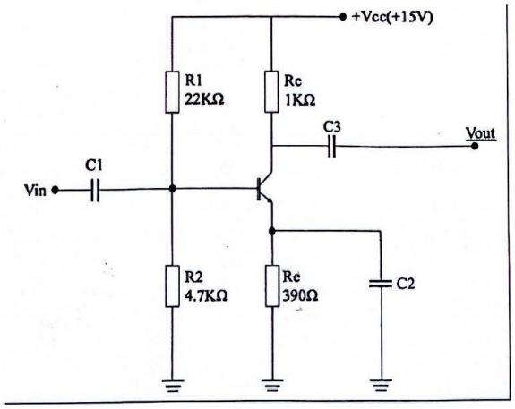

**Figure 4**

a)Determine the followingDC voltages and currents

i)IEQ.

**[4 marks]**

**(1 marks)**

**BBC4931 Paper B ii)VB.**

**iii)VE.**

iv)Vc.

**2023/24**

**(1 marks)**

**(1 marks)**

**(1 marks)**

|  |  |  |
| --- | --- | --- |
|  | **Do** **not** **write** **in** **this** **column** | |
|  |  | |
|  |  | |
|  |  | |
|  |  | |
|  |  | |
|  |  | |
|  |  | |
|  |  | |
|  |  | |
|  |  | |
|  |  | |
|  |  | |
|  |  | |
|  |  | |
|  |  | |
|  |  | |
|  |  | |
|  |  | 4  **marks** |

|  |  |
| --- | --- |
| b)Calculate: | **[6 marks]** |
| i. the voltage gain A, | **(2 marks)** |
| ii. the input impedance Z | **(2 marks)** |
| iii. the output impedance Z。 | **(2 marks)** |

**BBC4931** **Paper** **B** **2023/24**

|  |  |  |
| --- | --- | --- |
|  | **Do** **not** **write** **in** **this** **column** | |
|  |
|  |  | |
|  |  | |
|  |  | |
|  |  | |
|  |  | |
|  |  | |
|  |  | |
|  |  | |
|  |  | |
|  |  | |
|  |  | |
|  |  | |
|  |  | |
|  |  | |
|  |  | |
|  |  | |
|  |  | |
|  |  | 6  **marks** |

**Question marking:**4+6=10

**Question 3**

**For the negative feedback circuit in Error!Reference source not found.5,answer the questions**

below:

a)For t**he negative feedback circuit in Error!Reference source not found.5(a),answer the questio**ns **[5 marks]**

i)Determine the type of the negative feedback.

**(1 marks)**

ii)If the ACnegative feedback is strong enough,calculate the voltagegain by approximate analysis method.

**(2 marks)**

**BBC4931 Paper B 2023/24**

ii)If the AC negative feedback is strong enough,calculate the input impedance and output impedance.

**(2 marks)**

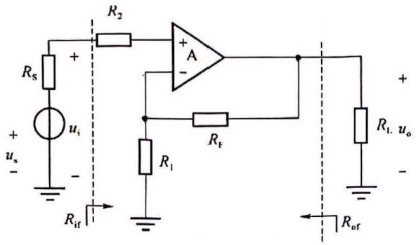

**Figure 5(a)**

|  |  |  |
| --- | --- | --- |
|  | **Do** **not** **write** **in** **this** **column** | |
|  |
|  |  | |
|  |  | |
|  |  | |
|  |  | |
|  |  | |
|  |  | |
|  |  | |
|  |  | |
|  |  | |
|  |  | |
|  |  | |
|  |  | |
|  |  | |
|  |  | |
|  |  | |
|  |  | |
|  |  | |
|  |  | 5  **marks** |

**Page 12 of 26**

**BBC4931 Paper B**

2023/24

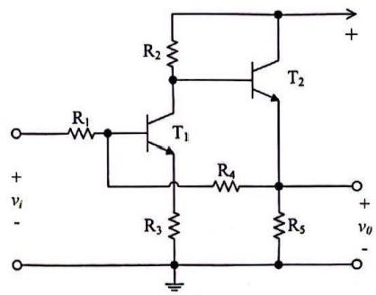

**Figure 5(b)**

b)For the negative feedback circuitin Figure 5(b),answer the questions

**[5marks]**

i)Determine the type of the negative feedback.

**(1 marks)**

ii)If the ACnegative feedback is strong enough,calculate the voltage gain by approximate analysis method.

**(2 marks)**

iii)If the AC negative feedback is strong enough,calculate the input impedance and output impedance.

**(2 marks)**

|  |  |
| --- | --- |
|  | **Do** **not** **write** **in** **this** **column** |
|  |
|  |  |
|  |  |
|  |  |
|  |  |
|  |  |
|  |  |
|  |  |
|  |  |
|  |  |
|  |  |
|  |  |
|  |  |
|  |  |
|  |  |
|  |  |

**Page** **13** **of** **26**

**BBC4931** **Paper** **B** 2023/24

|  |  |  |
| --- | --- | --- |
|  |  | |
|  |  | |
|  |  | |
|  |  | |
|  |  | |
|  |  | 5  marks |

**Question marking:**

**Question 4**

A differential amplifieris shown in Figure 6.For the transistors Tl and T2,β=80,ro=0,UBtcm)=0.7V, VT=26mV(atroom temperature).

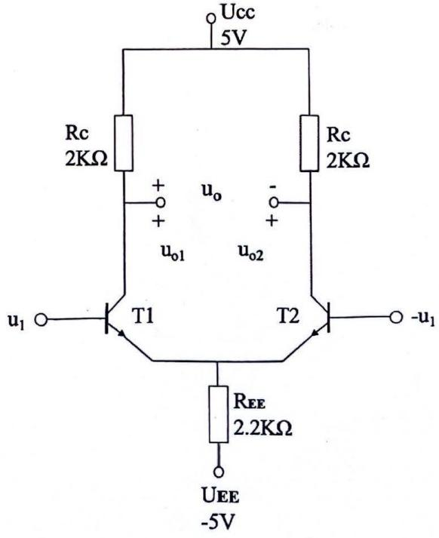

Figure 6

|  |  |
| --- | --- |
| **BBC4931 Paper B**  **a)Calculate the static voltages and current as:** | **2023/24** |
|  | **[4 marks]** |
| i. **static collector current IcQi and IcQ2** |  |
|  | **(2 marks)** |
| ii. **static voltageVci and Vc2** |  |
|  | **(1 marks)** |
| i**ii. the reparameter of the ac equivalent model** |  |
|  | **(1 marks)** |

|  |  |
| --- | --- |
|  | **Do** **not** **write** **in** **this** **column** |
|  |
|  |  |
|  |  |
|  |  |
|  |  |
|  |  |
|  |  |
|  |  |
|  |  |
|  |  |
|  |  |
|  |  |
|  |  |
|  |  |
|  |  |
|  |  |
|  |  |
|  |  |
|  |  |
|  |  |
|  |  |
|  |  |

**Page 15 of 26**

**BBC4931** **Paper** **B** 2023/24

|  |  |  |
| --- | --- | --- |
|  |  | |
|  |  | |
|  |  | 4  **marks** |

b)For a double output u 。,calculate:

**[5 marks]**

i) the differential mode voltage gain A

**(1 marks)**

ii) differential mode input resistance R

**(1 marks)**

iii)differential mode output resistance R

**(1 marks)**

iv) the common mode voltage gain A

**(1 marks)**

v) the CMRR.

**(1** **marks)**

|  |  |
| --- | --- |
|  | **Do** **not** **write** **in** **this** **column** |
|  |
|  |  |
|  |  |
|  |  |
|  |  |
|  |  |
|  |  |
|  |  |
|  |  |
|  |  |
|  |  |
|  |  |
|  |  |
|  |  |
|  |  |

**BBC4931** **Paper** **B** **2023/24**

|  |  |  |
| --- | --- | --- |
|  |  | |
|  |  | |
|  |  | |
|  |  | |
|  |  | |
|  |  | |
|  |  | |
|  |  | |
|  |  | 5  **marks** |



**Question marking:**

**Question 5**

For complementary symmetric power amplifier circuit shown in Figure 7,R=82.The base bias circuit is omitted.Assume that the saturation voltages of VTiand VT₂are negligible.

a)With a sinusoidalinput signal,calculate the maximum AC output power Pm(ac),the maximum input power P(dc)from the DC supply,and the maximum power efficiency h.**(6 marks)**

b)If the amplifiers are not ideal,what distortion will occurin the output voltage,and how to prevent the distortion?(2 **marks)**

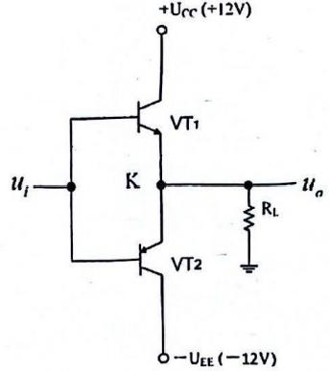

Figure 7

|  |  |
| --- | --- |
|  |  |

**BBC4931** **Paper** **B**

**2023/24**

|  |  |  |
| --- | --- | --- |
|  | **Do** **not** **write** **in** **this** **column** | |
| 1) |  | |
|  |  | |
|  |  | |
|  |  | |
|  |  | |
|  |  | |
|  |  | |
|  |  | |
|  |  | |
|  |  | |
|  |  | |
|  |  | |
|  |  | |
|  |  | |
|  |  | |
|  |  | |
|  |  | |
| 2) |  | |
|  |  | |
|  |  | |
|  |  | |
|  |  | |
|  |  | |
|  |  | |
|  |  | |
|  |  | 8  **marks** |

**Question marking:**

**Question 6**

In the circuit of Figure 8,the op-amp are ideal.Zener Diode with Vz=±10V,RI=100KΩ,Rz=2KQ,

*R=10KQ,C=1μF;vi/=vi2=-2.5V,vis=5.1V,VR=-7V;Power supply Vcc=±15V;at t=0,ve=0V。*

**Page 18 of26**

BBC4931 Paper B 2023/24

If connected to power supply at t=0,determine the function equation and output voltage of each op- amp at t=5.1s?

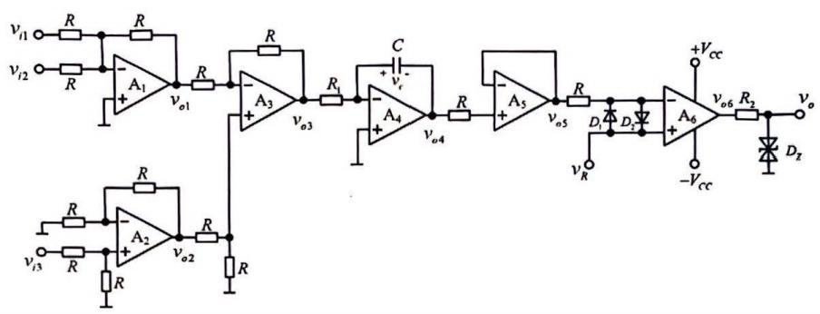

**Figure 8**

**a)Function equation of A1and calculate Vol at t=5.1s**

**[2 marks]**

|  |  |  |
| --- | --- | --- |
|  | **Do** **not** **write** **in** **this** **column** | |
|  |
|  |  | |
|  |  | |
|  |  | |
|  |  | |
|  |  | |
|  |  | |
|  |  | |
|  |  | |
|  |  | |
|  |  | 2  **marks** |

**b)Functionequation of A2 and calculate Voz att=5.1s**

**[2 marks]**

**BBC4931** **Paper** **B** **2023/24**

|  |  |  |
| --- | --- | --- |
|  | **Do** **not** **write** **in** **this** **column** | |
|  |
|  |  | |
|  |  | |
|  |  | |
|  |  | |
|  |  | |
|  |  | |
|  |  | |
|  |  | |
|  |  | |
|  |  | 2  **marks** |

**c)Function equation of A₃and calculate Vo3 at t=5.1s**

**[2 marks]**

|  |  |  |
| --- | --- | --- |
|  | **Do** **not** **write** **in** **this** **column** | |
|  |
|  |  | |
|  |  | |
|  |  | |
|  |  | |
|  |  | |
|  |  | |
|  |  | |
|  |  | |
|  |  | |
|  |  | 2  **marks** |

**d)Function equation of A4 and calculate Vo4 at t=5.1s**

**[2 marks]**

**BBC4931 Paper B 2023/24**

|  |  |  |
| --- | --- | --- |
|  | **Do** **not** **write** **in** **this** **column** | |
|  |
|  |  | |
|  |  | |
|  |  | |
|  |  | |
|  |  | |
|  |  | |
|  |  | |
|  |  | |
|  |  | |
|  |  | 2  **marks** |

**e)Function equation of As and calculate vos at t=5.1s**

**[2 marks]**

|  |  |  |
| --- | --- | --- |
|  | **Do** **not** **write** **in** **this** **column** | |
|  |
|  |  | |
|  |  | |
|  |  | |
|  |  | |
|  |  | |
|  |  | |
|  |  | |
|  |  | |
|  |  | |
|  |  | **2**  **marks** |

**f)Function equation of A6and calculate A6at t=5.1s**

**[2 marks] Page 21 of 26**

**BBC4931 Paper B 2023/24**

|  |  |  |
| --- | --- | --- |
|  | **Do** **not** **write** **in** **this** **column** | |
|  |
|  |  | |
|  |  | |
|  |  | |
|  |  | |
|  |  | |
|  |  | |
|  |  | |
|  |  | |
|  |  | |
|  |  | 2  **marks** |

**g)Function equation of Vo and calculate voat t=5.1s**

**[1 marks]**

|  |  |  |
| --- | --- | --- |
|  | **Do** **notwrite** **in** **this** **column** | |
|  |
|  |  | |
|  |  | |
|  |  | |
|  |  | |
|  |  | |
|  |  | |
|  |  | |
|  |  | |
|  |  | |
|  |  | 1  **marks** |

