Cultural data science
Johannes Rambøll & Halfdan Nordahl
2025-11-15

Johannes
# Load and Process Yield Curve Data
files <- list.files("yield", full.names = TRUE, pattern = "\\.csv$")
yield_curve <- files %>%
map_df(read_csv)
yield_curve$Date <- as.Date(yield_curve$Date, format = "%m/%d/%y")
yield_curve <- yield_curve %>%
mutate(spread = `10 Yr` - `3 Mo`)
# Aggregate Yield Data by Month for Twitter analysis
yield_monthly <- yield_curve %>%
mutate(month = floor_date(Date, "month")) %>%
group_by(month) %>%
summarise(spread = mean(spread, na.rm = TRUE)) %>%
rename(date = month)
# Load Twitter Economic Uncertainty Data
twitter <- read_csv("Twitter_Economic_Uncertainty.csv")
twitter$date <- as.Date(twitter$date)
twitter_monthly <- twitter %>%
mutate(month = floor_date(date, "month")) %>%
group_by(month) %>%
summarise(avg_teu = mean(`TEU-WGT`, na.rm = TRUE)) %>%
rename(date = month)
# Merge Yield and Uncertainty Data
yield_twitter <- inner_join(twitter_monthly, yield_monthly, by = "date")
# Plot: Twitter Uncertainty vs Yield Spread
ggplot(yield_twitter, aes(x = spread, y = avg_teu)) +
geom_point(alpha = 0.6, color = "#2C7BB6") +
geom_smooth(method = "lm", se = TRUE, color = "#D7191C", linewidth = 1) +
labs(
x = "10-Year - 3-Month Yield Spread",
y = "Twitter Economic Uncertainty Index",
title = "Bond Yield Spread and Economic Uncertainty (2011-2023)",
subtitle = "Monthly data showing relationship between yield curve and uncertainty"
) +
theme_minimal(base_size = 14)
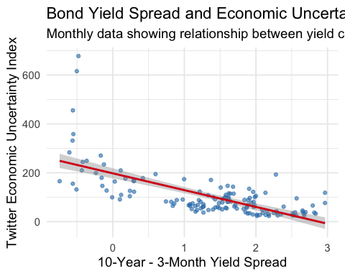
twitter_model <- lm(avg_teu ~ spread, data = yield_twitter)
summary(twitter_model)
##
## Call:
## lm(formula = avg_teu ~ spread, data = yield_twitter)
##
## Residuals:
## Min 1Q Median 3Q Max
## -100.93 -39.78 -7.25 22.65 447.13
##
## Coefficients:
## Estimate Std. Error t value Pr(>|t|)
## (Intercept) 197.809 10.596 18.67 <2e-16 ***
## spread -68.776 6.425 -10.70 <2e-16 ***
## ---
## Signif. codes: 0 '***' 0.001 '**' 0.01 '*' 0.05 '.' 0.1 ' ' 1
##
## Residual standard error: 71.43 on 137 degrees of freedom
## Multiple R-squared: 0.4555, Adjusted R-squared: 0.4515
## F-statistic: 114.6 on 1 and 137 DF, p-value: < 2.2e-16

Halfdan
# Aggregate Yield Data by Year for music analysis
yield_yearly <- yield_curve %>%
mutate(Year = year(Date)) %>%
group_by(Year) %>%
summarise(spread = mean(spread, na.rm = TRUE))
# Load Billboard Hot 100 Data
df_bb <- read.csv("Hot100.csv")
# Join Billboard data with yearly yield data
df_analysis <- inner_join(df_bb, yield_yearly, by = "Year") %>%
filter(Year < 2020)
# Mixed model: Danceability predicted by spread with random effect for year
mixed_model <- lm(Danceability ~ spread, data = df_analysis)
summary(mixed_model)
##
## Call:
## lm(formula = Danceability ~ spread, data = df_analysis)
##
## Residuals:
## Min 1Q Median 3Q Max
## -0.37944 -0.09221 0.00684 0.08856 0.33174
##
## Coefficients:
## Estimate Std. Error t value Pr(>|t|)
## (Intercept) 0.681001 0.015981 42.613 <2e-16 ***
## spread -0.019445 0.008873 -2.191 0.0293 *
## ---
## Signif. codes: 0 '***' 0.001 '**' 0.01 '*' 0.05 '.' 0.1 ' ' 1
##
## Residual standard error: 0.1356 on 257 degrees of freedom
## Multiple R-squared: 0.01834, Adjusted R-squared: 0.01452
## F-statistic: 4.802 on 1 and 257 DF, p-value: 0.02932
# For plotting, calculate yearly averages
df_year <- df_analysis %>%
group_by(Year) %>%
summarise(
avg_dance = mean(Danceability, na.rm = TRUE),
spread = mean(spread, na.rm = TRUE)
)
# Plot: Danceability vs Yield Spread
ggplot(df_year, aes(x = spread, y = avg_dance)) +
geom_point(size = 3, alpha = 0.7, color = "#2C7BB6") +
geom_smooth(method = "lm", linewidth = 1.2, color = "#D7191C", se = TRUE) +
labs(
title = "Danceability and Yield Curve Spread",
subtitle = "Does economic stress correlate with music preferences?",
x = "Yield Curve Spread (pp)",
y = "Average Danceability (0-1 scale)"
) +
theme_minimal(base_size = 14)
