LLM-Identity Decomposition: Per-Model Asymmetry within HA and AA
  - Does dyad asymmetry depend on which LLM is in the conversation?
PENPAL Project
2026-05-05
Table of Contents

Overview
The cross-condition notebooks treat HA and AA as monoliths. This notebook decomposes both by which LLM is in the dyad and asks two questions per metric:
- Per-LLM magnitude. Does unsigned asymmetry $A_{m}$ vary across the four LLMs within HA? Within AA?
- Per-LLM direction. Does signed slot-asymmetry vary across LLMs (i.e. are some models more likely to drive in a particular direction)?
Sample sizes per LLM are small (HA: ~22-29 stories per model; AA: 20 per model), so reported tests are non-parametric (Kruskal-Wallis + pairwise Wilcoxon BH-adjusted). Bootstrap CIs are also reported.
Where it makes sense, the same-model rows in HA and AA are placed side-by-side: does Claude paired with a human exhibit the same asymmetry profile as Claude paired with itself?

Build per-metric per-story tables
## Per-story tables built:
## valence: 180 (HA=100, AA=80)
## novelty: 180 (HA=100, AA=80)
## semexp: 177 (HA=97, AA=80)

Within-HA: per-LLM Asymmetry

Magnitude
Per-LLM unsigned asymmetry magnitude within HA
metric | llm | n | mean | median | sd
A_valence | GPT-4.1 | 23 | 0.780 | 0.782 | 0.475
A_valence | Claude-sonnet-4-5 | 22 | 0.665 | 0.384 | 0.577
A_valence | Llama-3.3-70B | 29 | 0.785 | 0.784 | 0.622
A_valence | Qwen2.5-72B | 26 | 0.671 | 0.640 | 0.481
A_influence | GPT-4.1 | 23 | 0.571 | 0.605 | 0.406
A_influence | Claude-sonnet-4-5 | 22 | 0.526 | 0.398 | 0.337
A_influence | Llama-3.3-70B | 29 | 0.519 | 0.488 | 0.383
A_influence | Qwen2.5-72B | 26 | 0.465 | 0.322 | 0.514
A_semexp | GPT-4.1 | 23 | 0.205 | 0.178 | 0.162
A_semexp | Claude-sonnet-4-5 | 21 | 0.152 | 0.123 | 0.103
A_semexp | Llama-3.3-70B | 27 | 0.177 | 0.176 | 0.082
A_semexp | Qwen2.5-72B | 26 | 0.225 | 0.204 | 0.147

Within-HA Kruskal-Wallis: A_m ~ llm
metric | kw_p
A_valence | 0.8160
A_influence | 0.4483
A_semexp | 0.3815
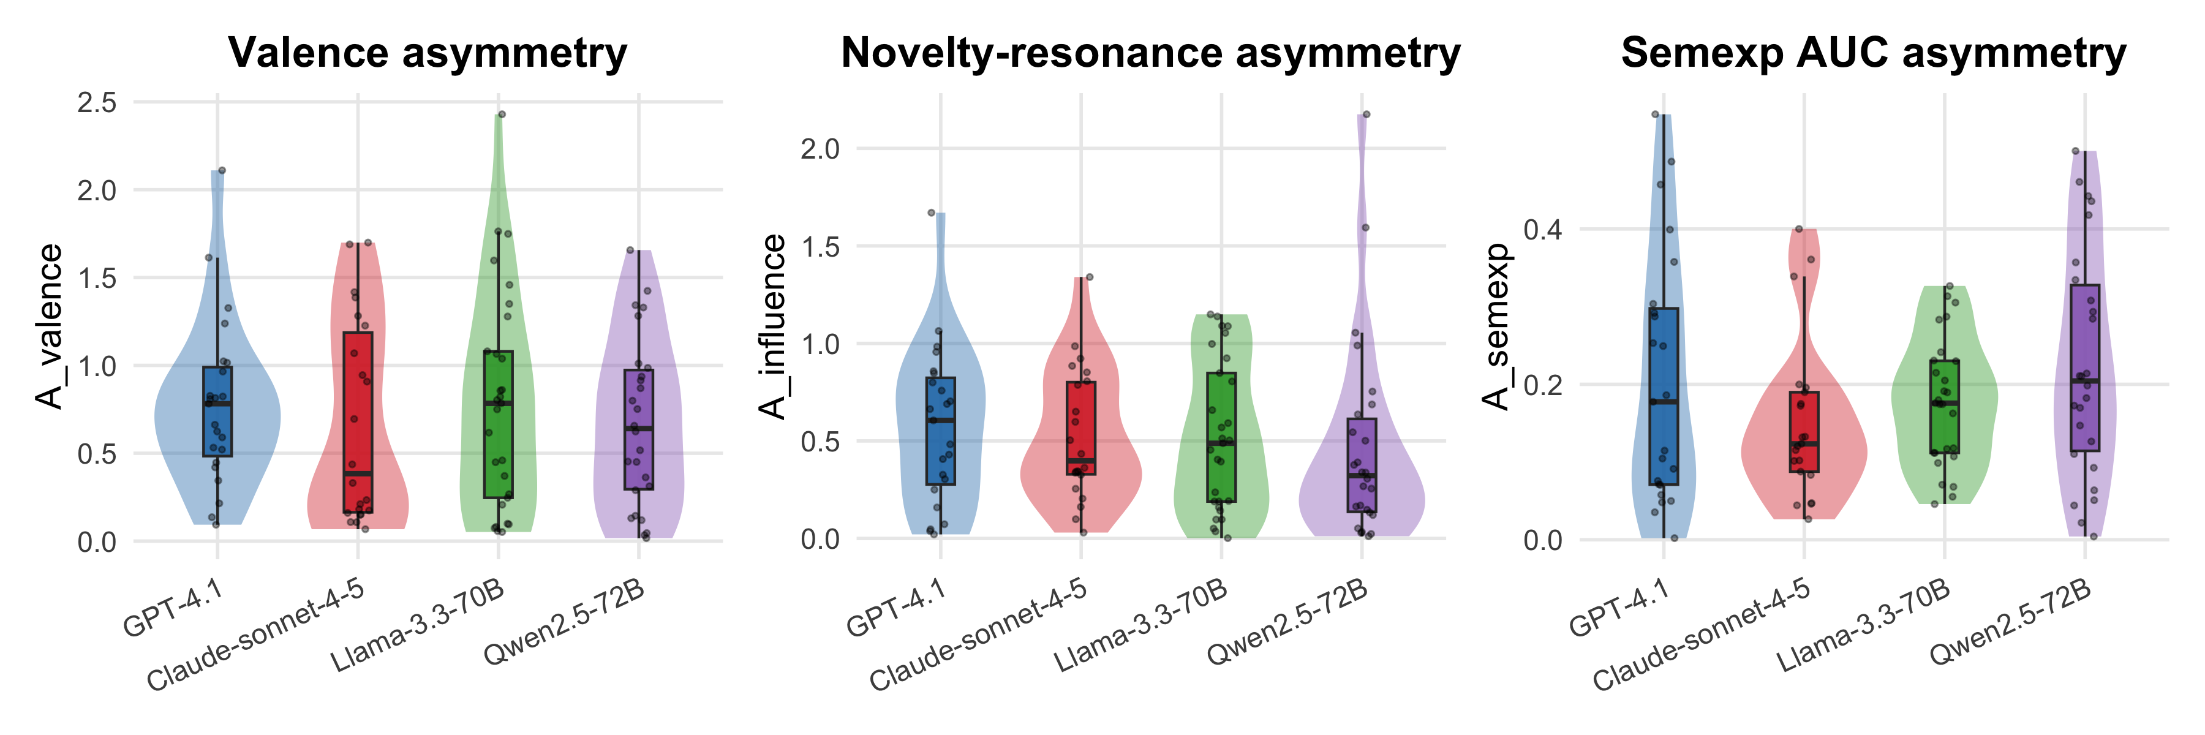

Direction
Per-LLM directional stability of the SIGNED slot difference within HA. If the human-side identity is what drives directionality, all four LLMs should look similar (same signed direction). If specific LLMs shape directionality (e.g., Claude is more deferential than Qwen), the stability index will differ across models.
Within-HA directional stability of signed asymmetry per LLM
metric | llm | n | mean | sd | stability | sign_consistency | one_sample_t_p
valence | GPT-4.1 | 23 | 0.176 | 0.910 | 0.194 | 0.565 | 0.363
valence | Claude-sonnet-4-5 | 22 | 0.291 | 0.841 | 0.346 | 0.636 | 0.119
valence | Llama-3.3-70B | 29 | 0.425 | 0.915 | 0.465 | 0.724 | 0.018
valence | Qwen2.5-72B | 26 | 0.161 | 0.821 | 0.196 | 0.577 | 0.326
novelty | GPT-4.1 | 23 | 0.110 | 0.702 | 0.157 | 0.565 | 0.459
novelty | Claude-sonnet-4-5 | 22 | -0.016 | 0.635 | 0.025 | 0.545 | 0.909
novelty | Llama-3.3-70B | 29 | 0.051 | 0.651 | 0.079 | 0.517 | 0.675
novelty | Qwen2.5-72B | 26 | 0.132 | 0.686 | 0.192 | 0.615 | 0.337
semexp | GPT-4.1 | 23 | 0.046 | 0.261 | 0.178 | 0.522 | 0.402
semexp | Claude-sonnet-4-5 | 21 | 0.083 | 0.166 | 0.500 | 0.619 | 0.033
semexp | Llama-3.3-70B | 27 | -0.041 | 0.194 | 0.211 | 0.630 | 0.283
semexp | Qwen2.5-72B | 26 | -0.090 | 0.257 | 0.351 | 0.577 | 0.086

Variance-equality across LLMs (within HA)
metric | brown_forsythe_p
valence | 0.8809
novelty | 0.8550
semexp | 0.0903
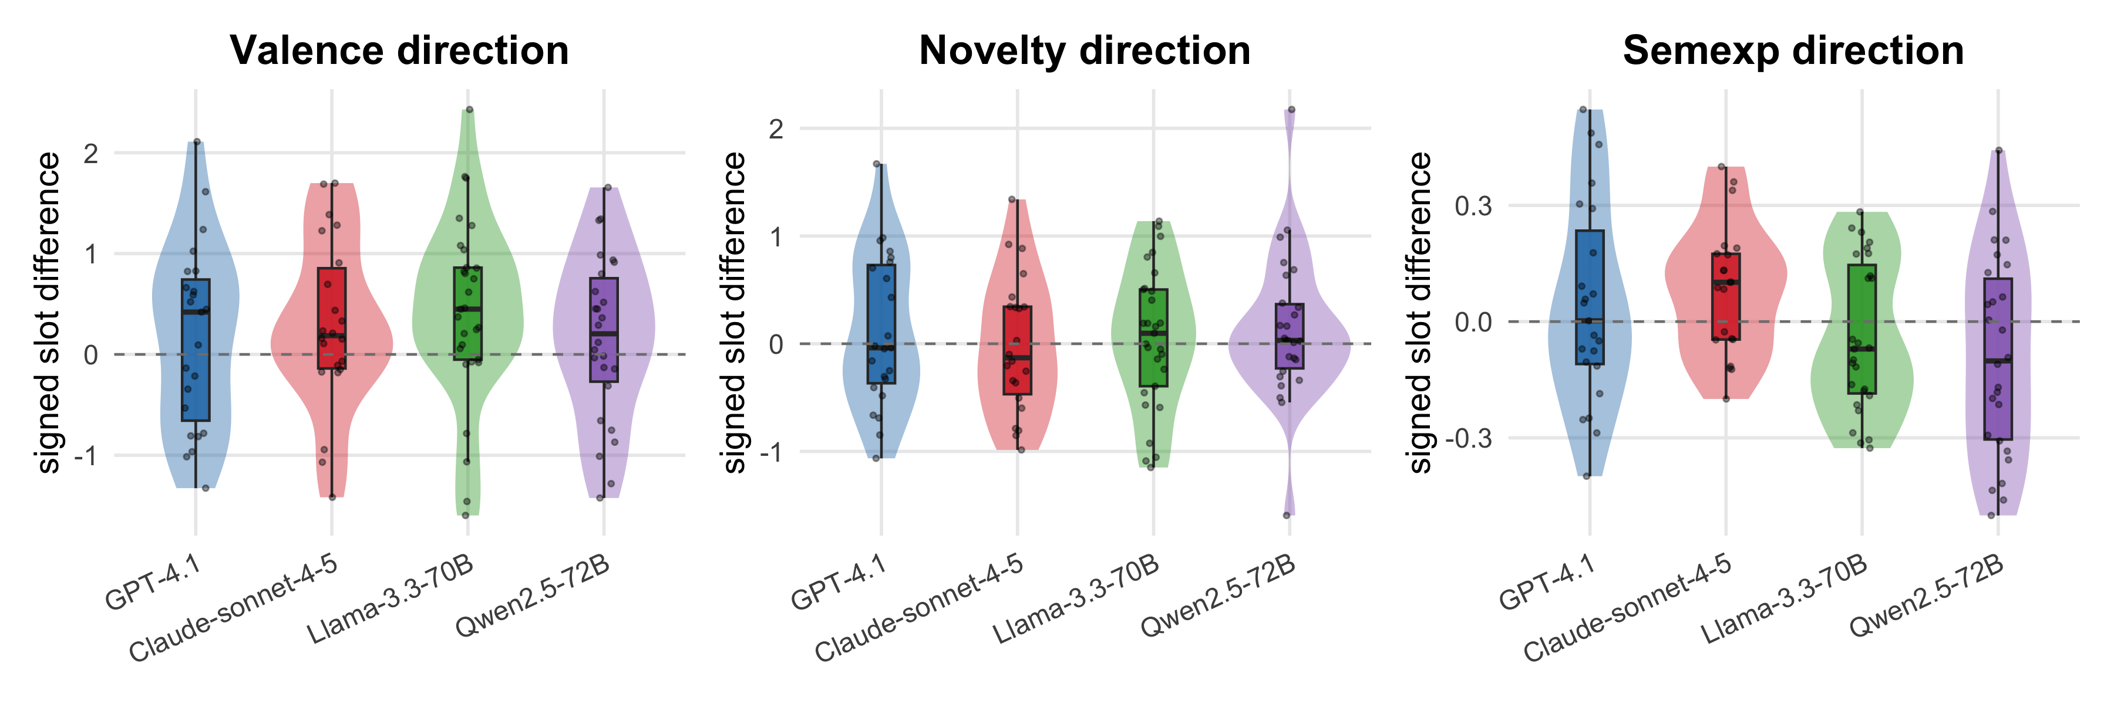

Within-AA: per-Model Asymmetry
The AA dataset only contains same-model self-pairings (no cross-model pairs). The four levels are therefore pure within-model ai-vs-ai conversations.

Magnitude
Per-model unsigned asymmetry magnitude within AA
metric | llm | n | mean | median | sd
A_valence | GPT-4.1 | 20 | 0.474 | 0.437 | 0.335
A_valence | Claude-sonnet-4-5 | 20 | 0.440 | 0.387 | 0.397
A_valence | Llama-3.3-70B | 20 | 0.529 | 0.390 | 0.380
A_valence | Qwen2.5-72B | 20 | 0.537 | 0.480 | 0.288
A_influence | GPT-4.1 | 20 | 0.512 | 0.421 | 0.429
A_influence | Claude-sonnet-4-5 | 20 | 0.392 | 0.301 | 0.235
A_influence | Llama-3.3-70B | 20 | 0.434 | 0.383 | 0.287
A_influence | Qwen2.5-72B | 20 | 0.380 | 0.284 | 0.366
A_semexp | GPT-4.1 | 20 | 0.181 | 0.166 | 0.144
A_semexp | Claude-sonnet-4-5 | 20 | 0.183 | 0.149 | 0.156
A_semexp | Llama-3.3-70B | 20 | 0.205 | 0.184 | 0.158
A_semexp | Qwen2.5-72B | 20 | 0.152 | 0.107 | 0.135

Within-AA Kruskal-Wallis: A_m ~ model
metric | kw_p
A_valence | 0.5618
A_influence | 0.6659
A_semexp | 0.7215
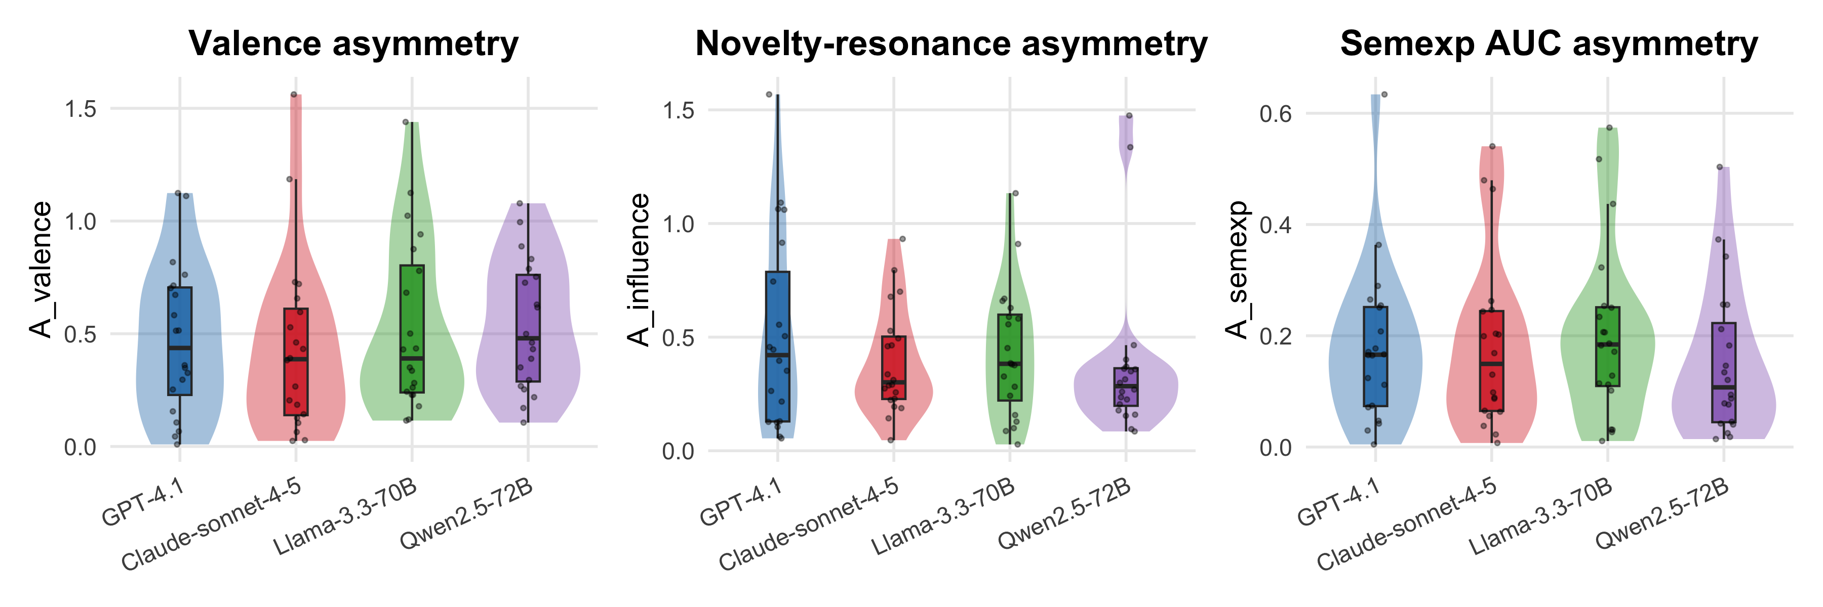

Direction
Within-AA directional stability of signed asymmetry per model
metric | llm | n | mean | sd | stability | sign_consistency | one_sample_t_p
valence | GPT-4.1 | 20 | -0.117 | 0.578 | 0.203 | 0.65 | 0.376
valence | Claude-sonnet-4-5 | 20 | -0.106 | 0.591 | 0.180 | 0.60 | 0.431
valence | Llama-3.3-70B | 20 | 0.134 | 0.648 | 0.207 | 0.65 | 0.366
valence | Qwen2.5-72B | 20 | 0.176 | 0.596 | 0.295 | 0.60 | 0.203
novelty | GPT-4.1 | 20 | 0.052 | 0.676 | 0.078 | 0.55 | 0.733
novelty | Claude-sonnet-4-5 | 20 | 0.081 | 0.458 | 0.177 | 0.55 | 0.438
novelty | Llama-3.3-70B | 20 | -0.165 | 0.502 | 0.328 | 0.70 | 0.159
novelty | Qwen2.5-72B | 20 | -0.229 | 0.480 | 0.477 | 0.70 | 0.046
semexp | GPT-4.1 | 20 | 0.014 | 0.234 | 0.061 | 0.50 | 0.788
semexp | Claude-sonnet-4-5 | 20 | 0.006 | 0.244 | 0.026 | 0.50 | 0.910
semexp | Llama-3.3-70B | 20 | -0.020 | 0.262 | 0.078 | 0.60 | 0.733
semexp | Qwen2.5-72B | 20 | 0.042 | 0.202 | 0.207 | 0.60 | 0.365

Variance-equality across models (within AA)
metric | brown_forsythe_p
valence | 0.9052
novelty | 0.4035
semexp | 0.7469

Same Model Across Conditions: HA vs AA per-LLM
For each LLM, place its HA stories (paired with a human) next to its AA stories (paired with itself). Asks whether a given model’s asymmetry profile depends on partner type.
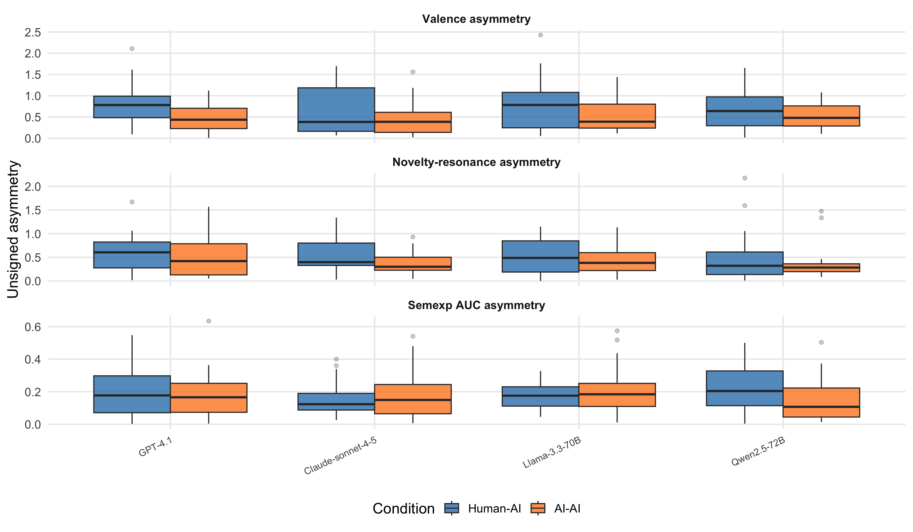
HA vs AA per-LLM Wilcoxon (BH-adjusted within metric)
metric | llm | n_HA | n_AA | median_HA | median_AA | cliff_delta | wilcox_p | p_BH
valence | GPT-4.1 | 23 | 20 | 0.782 | 0.437 | 0.409 | 0.022 | 0.087
valence | Claude-sonnet-4-5 | 22 | 20 | 0.384 | 0.387 | 0.200 | 0.276 | 0.372
valence | Llama-3.3-70B | 29 | 20 | 0.784 | 0.390 | 0.186 | 0.279 | 0.372
valence | Qwen2.5-72B | 26 | 20 | 0.640 | 0.480 | 0.135 | 0.448 | 0.448
novelty | GPT-4.1 | 23 | 20 | 0.605 | 0.421 | 0.078 | 0.673 | 0.898
novelty | Claude-sonnet-4-5 | 22 | 20 | 0.398 | 0.301 | 0.259 | 0.156 | 0.625
novelty | Llama-3.3-70B | 29 | 20 | 0.488 | 0.383 | 0.103 | 0.552 | 0.898
novelty | Qwen2.5-72B | 26 | 20 | 0.322 | 0.284 | 0.015 | 0.939 | 0.939
semexp | GPT-4.1 | 23 | 20 | 0.178 | 0.166 | 0.083 | 0.656 | 0.840
semexp | Claude-sonnet-4-5 | 21 | 20 | 0.123 | 0.149 | -0.067 | 0.728 | 0.840
semexp | Llama-3.3-70B | 27 | 20 | 0.176 | 0.184 | -0.037 | 0.840 | 0.840
semexp | Qwen2.5-72B | 26 | 20 | 0.204 | 0.107 | 0.304 | 0.082 | 0.328

Discussion-friendly summary tables
Quick-read summary across all metrics: which LLMs (if any) stand out on magnitude, on direction, and on partner-sensitivity?
Directional stability per LLM, by condition (Human-AI vs AI-AI)
condition | metric | llm | n | stability | sign_consistency | one_sample_t_p
AI-AI | novelty | GPT-4.1 | 20 | 0.078 | 0.550 | 0.733
AI-AI | novelty | Claude-sonnet-4-5 | 20 | 0.177 | 0.550 | 0.438
AI-AI | novelty | Llama-3.3-70B | 20 | 0.328 | 0.700 | 0.159
AI-AI | novelty | Qwen2.5-72B | 20 | 0.477 | 0.700 | 0.046
AI-AI | semexp | GPT-4.1 | 20 | 0.061 | 0.500 | 0.788
AI-AI | semexp | Claude-sonnet-4-5 | 20 | 0.026 | 0.500 | 0.910
AI-AI | semexp | Llama-3.3-70B | 20 | 0.078 | 0.600 | 0.733
AI-AI | semexp | Qwen2.5-72B | 20 | 0.207 | 0.600 | 0.365
AI-AI | valence | GPT-4.1 | 20 | 0.203 | 0.650 | 0.376
AI-AI | valence | Claude-sonnet-4-5 | 20 | 0.180 | 0.600 | 0.431
AI-AI | valence | Llama-3.3-70B | 20 | 0.207 | 0.650 | 0.366
AI-AI | valence | Qwen2.5-72B | 20 | 0.295 | 0.600 | 0.203
Human-AI | novelty | GPT-4.1 | 23 | 0.157 | 0.565 | 0.459
Human-AI | novelty | Claude-sonnet-4-5 | 22 | 0.025 | 0.545 | 0.909
Human-AI | novelty | Llama-3.3-70B | 29 | 0.079 | 0.517 | 0.675
Human-AI | novelty | Qwen2.5-72B | 26 | 0.192 | 0.615 | 0.337
Human-AI | semexp | GPT-4.1 | 23 | 0.178 | 0.522 | 0.402
Human-AI | semexp | Claude-sonnet-4-5 | 21 | 0.500 | 0.619 | 0.033
Human-AI | semexp | Llama-3.3-70B | 27 | 0.211 | 0.630 | 0.283
Human-AI | semexp | Qwen2.5-72B | 26 | 0.351 | 0.577 | 0.086
Human-AI | valence | GPT-4.1 | 23 | 0.194 | 0.565 | 0.363
Human-AI | valence | Claude-sonnet-4-5 | 22 | 0.346 | 0.636 | 0.119
Human-AI | valence | Llama-3.3-70B | 29 | 0.465 | 0.724 | 0.018
Human-AI | valence | Qwen2.5-72B | 26 | 0.196 | 0.577 | 0.326

Summary
What this notebook adds:
- Within-HA per-LLM: tests whether the four LLMs differ in unsigned asymmetry $A_{m}$ (KW + per-LLM bootstrap-style CIs in the magnitude table) and in directional stability of the signed slot difference. If the HA-specific identity-tied directionality reading from the main notebook holds, all four LLMs should show high stability and a consistent sign on each metric. If it breaks down for one LLM, that LLM contributes less to the HA-distinct signature.
- Within-AA per-model: tests whether self-pairings of different LLMs produce different asymmetry profiles. A pure mathematical-baseline reading predicts no difference; a model-specific stylistic reading predicts variation (e.g., Claude self-pair more aligning, Qwen self-pair more divergent).
- HA vs AA per-LLM: holds the LLM constant and varies the partner. Same-model HA-vs-AA differences (Wilcoxon + Cliff’s $δ$, BH-adjusted per metric) isolate the effect of swapping a human partner for a same-LLM partner.
Article-use notes: - Use the Within-HA per-LLM table to support a sentence in the Discussion on whether the HA finding is model-general or model-driven. - Use Within-AA per-LLM to qualify the structural-null result: if AA’s rubber-band excess is concentrated in one model (likely Claude or GPT), this reads as model-specific homogenization, not “AI-AI dyads in general”. - Use HA vs AA per-LLM as a partner-sensitivity panel that complements the three primary cross-condition tests.
Analysis completed: 2026-05-05 20:10:50.265995

