## Software

Instead of using Mega7, I’m using the MegaX. MegaX is a new version of Mega7.

## Data

Blast result are saved in seqdump.fa file.

## Alignment

### Alignment result

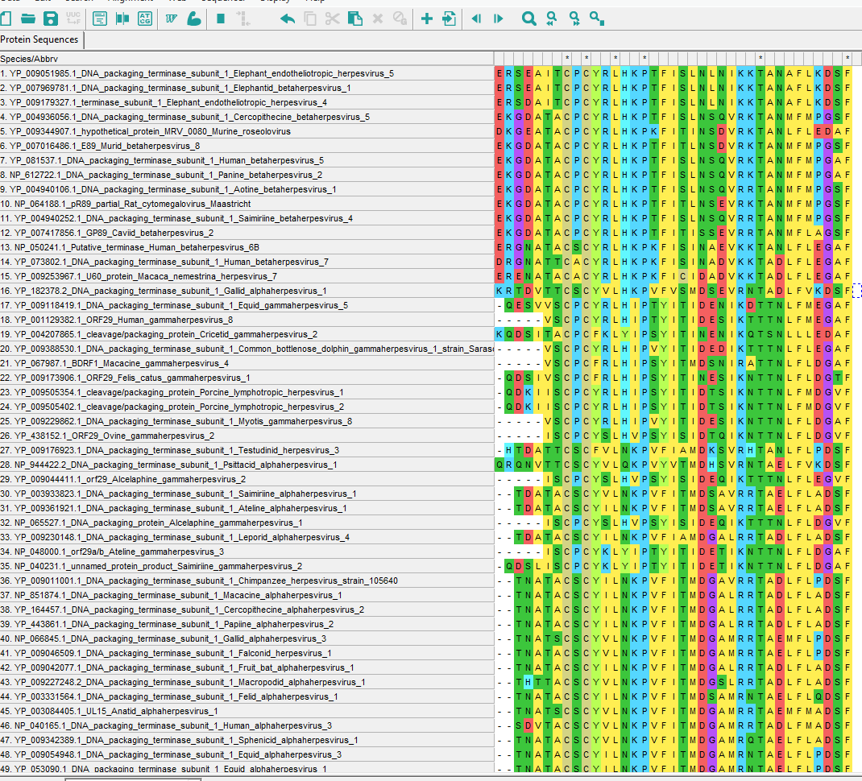

### Comment

1. Based on acid id: Most of the acid are changed during evaluation
2. Based on background color: Some change is not changing the function of the protein

## Tree

### Original Tree

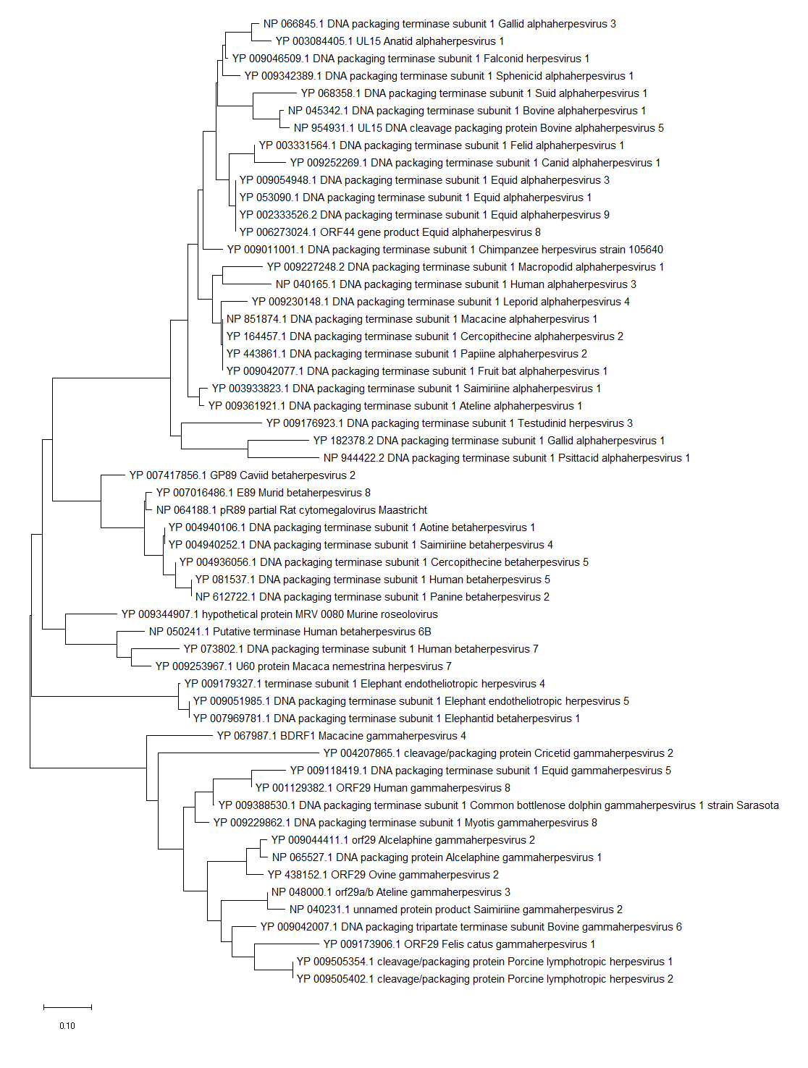

Comment: this root may not the real root, since we are not using another gene to do the root determine.

I tried changing the root, and then the tree will distributed differently.

Radiation display

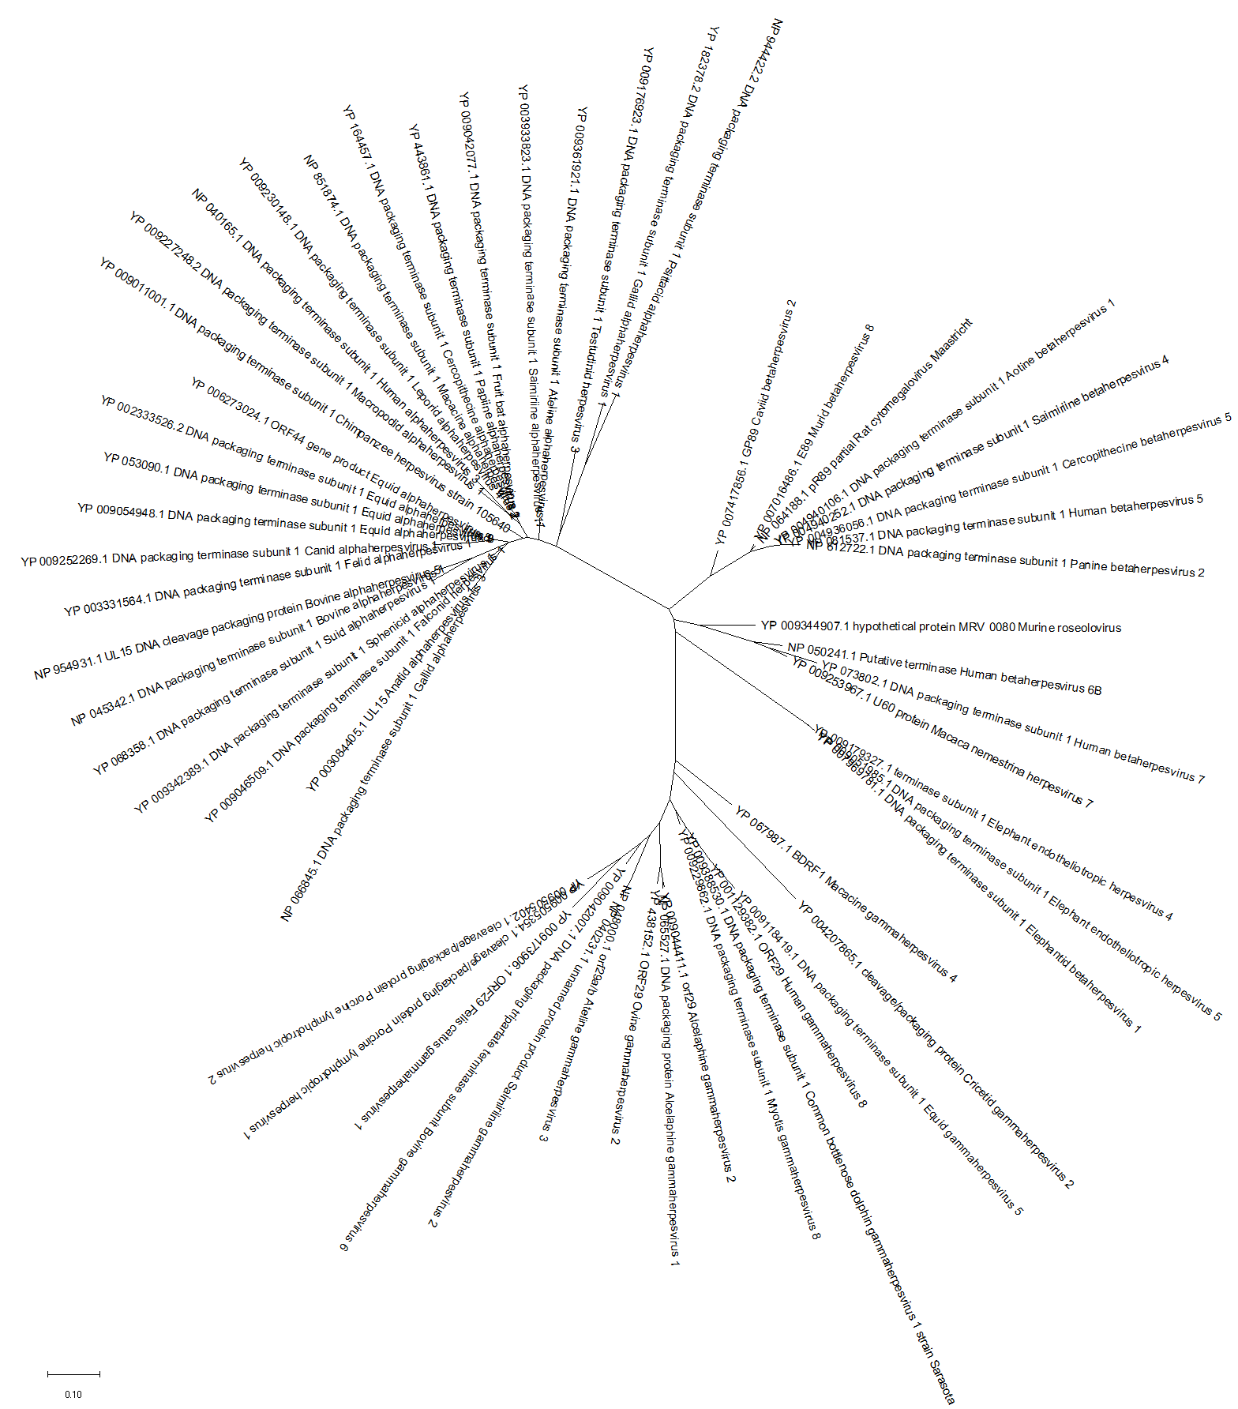

I love radiation than the other displays. It is easier to figure the root of the tree.

### Circle Tree:

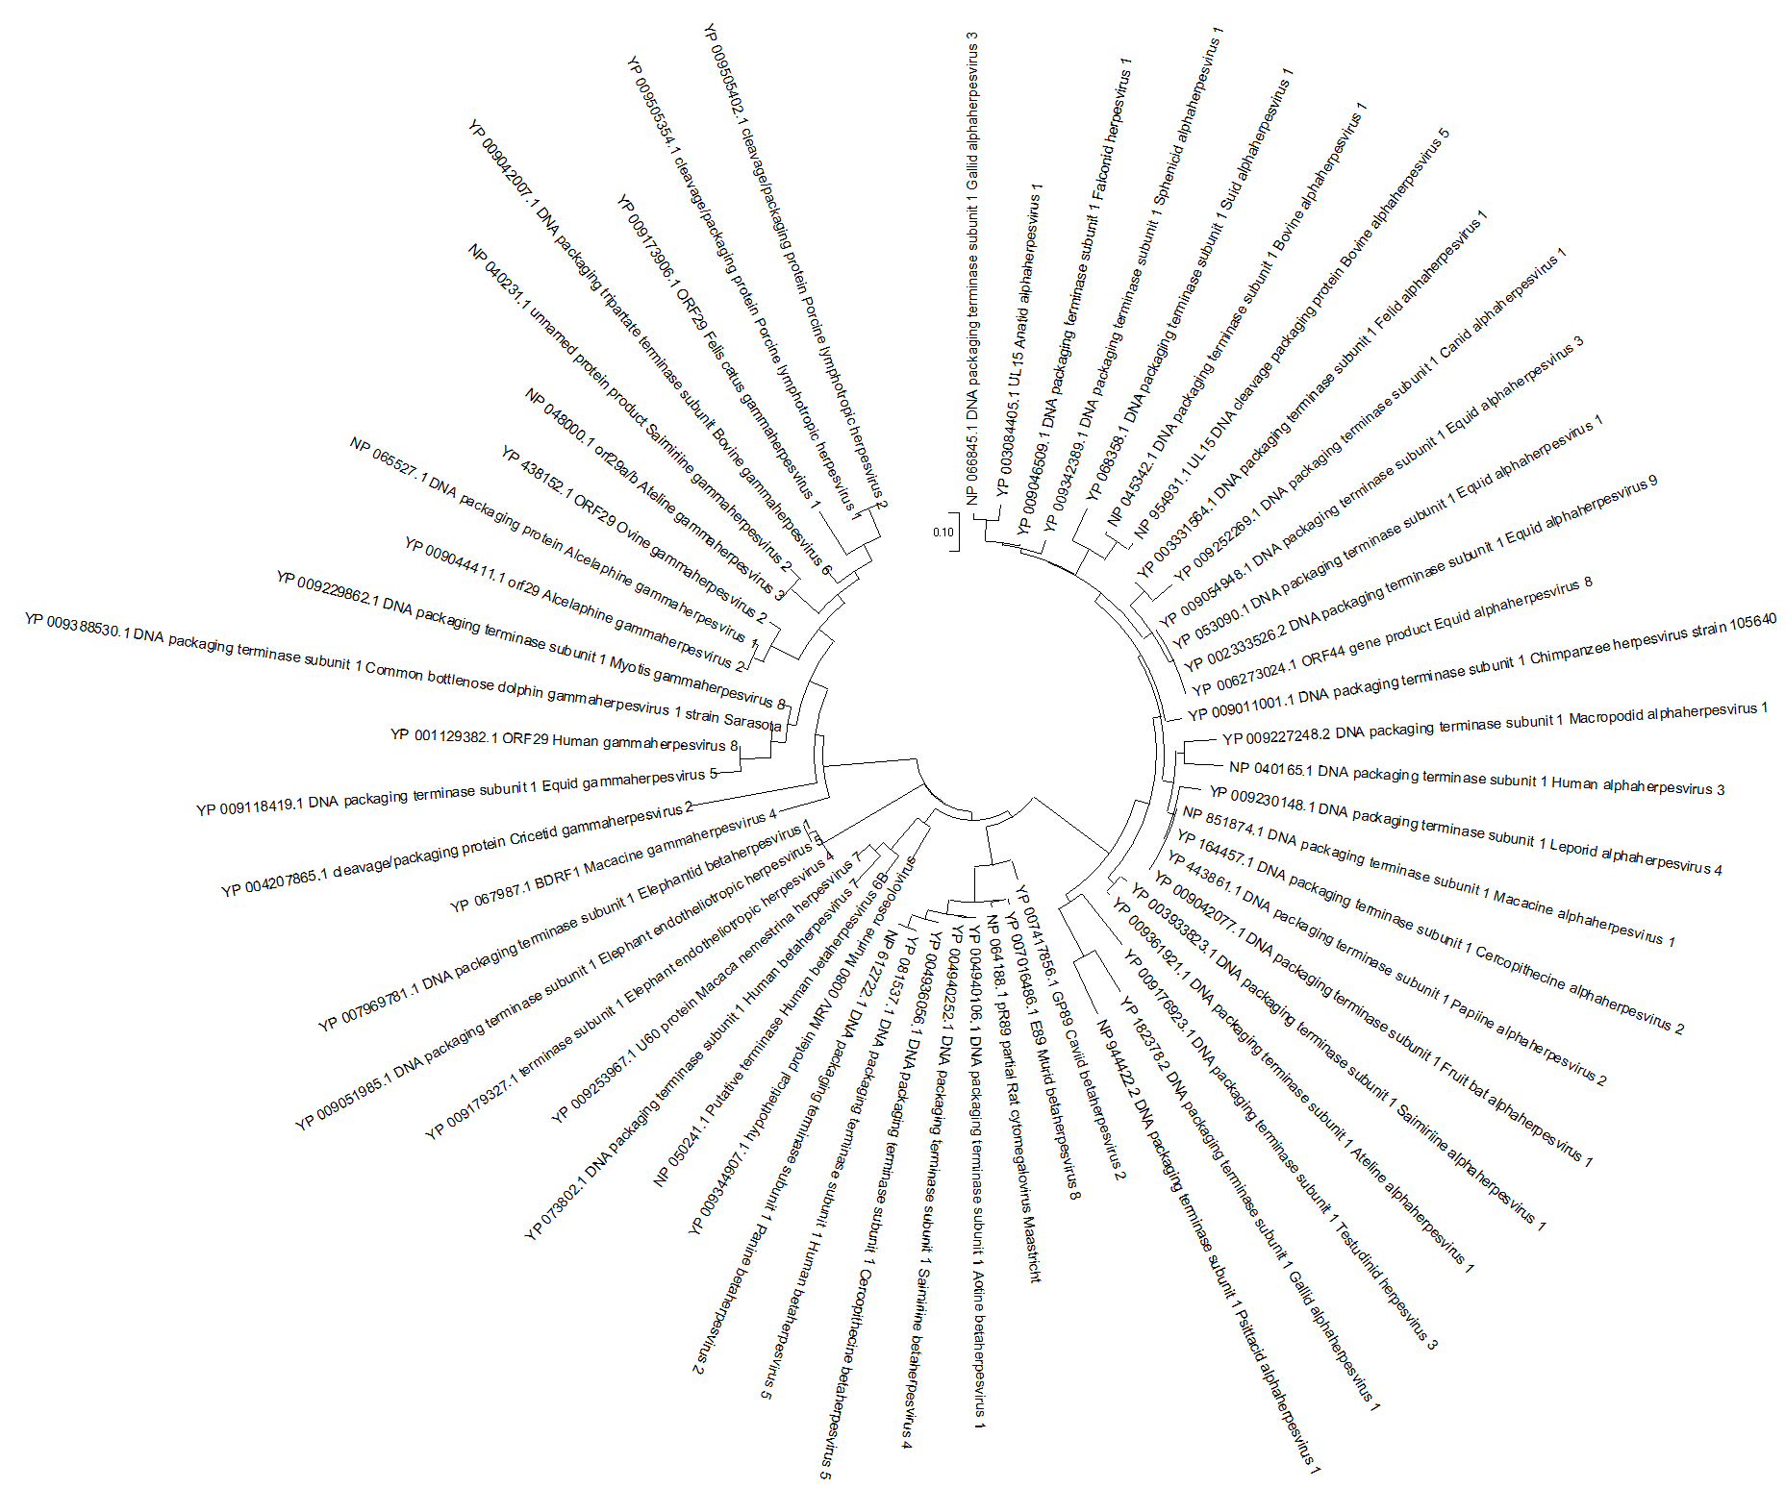

Circle tree grab all branches into the center. But the circle shape make people hard to follow.

### Timetree

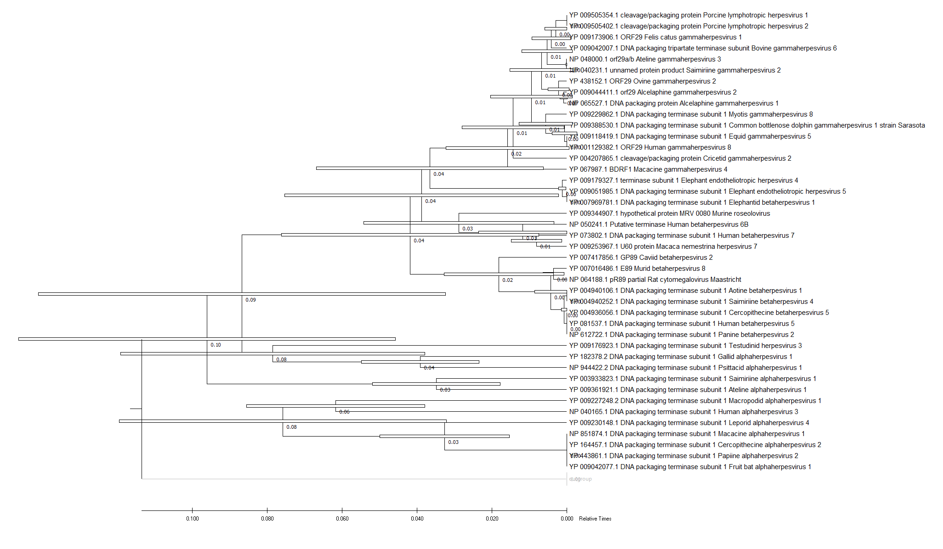

Comment: time tree is build based on the group I selected. Result may change due to different group selection.