Good Luck!
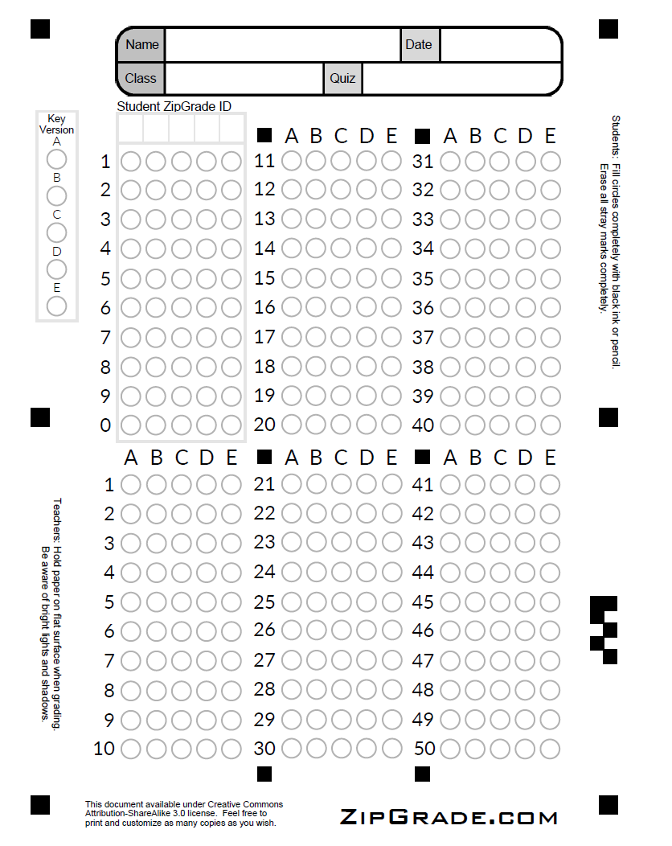

Question 1

What is the output of the following code?
def modify_integer(num):
num += 10
return num
a = 5
print("ID of 'a' before function call:", id(a))
modified_a = modify_integer(a)
print("ID of 'a' after function call:", id(a))

A.
ID of 'a' before function call: 140706224530344
ID of 'a' after function call: 140706224530344
B.
ID of 'a' before function call: 140706224530344
ID of 'a' after function call: 140706224530384

-----------------------------------------------------------------------

Questions 2 - 4
The following code is not DIP-compliant.
# DIP non-compliant code
class LightSwitch:
def __init__(self, light):
self.light = light
def turn_on(self):
self.light.turn_on()
def turn_off(self):
self.light.turn_off()
class Light:
def turn_on(self):
print("Light is on")
def turn_off(self):
print("Light is off")
To fix it, we need to introduce an abstraction, Switchable, and make Light adhere to it. Then, we can make SwitchController depend on Switchable instead of Light.
For the following code, Answer questions 2, 3, and 4:

# DIP-compliant code
from abc import ABC, abstractmethod
class Switchable(ABC):
@abstractmethod
def turn_on(self):
pass
@abstractmethod
def turn_off(self):
pass
class SwitchController:
def __init__(self, device):
self.device = device
def turn_on(self):
self.device.turn_on()
def turn_off(self):
self.device.turn_off()
class Light(Switchable):
def turn_on(self):
print("Light is on")
def turn_off(self):
print("Light is off")

Question 2
Which of the following is false?
A. By introducing the Switchable abstraction, the Light class is open for extension.
B. By introducing the Switchable abstraction, the SwitchController class is now decoupled from the Light class.

Question 3
[True/False] If a new class Fan adheres to Switchable, it can replace Light in SwitchController class.
A. True
B. False

Question 4
Suppose we have a Fan class that adheres to Switchable:
class Fan(Switchable):
def turn_on(self):
print("Fan is on")
def turn_off(self):
print("Fan is off")
Which of the following is proper usage code?
A.
fan = Fan()
controller = SwitchController()
controller.turn_on()
controller.turn_off()
B.
fan = Fan()
controller = SwitchController(fan)
controller.turn_on()
controller.turn_off()
C.
fan = Fan()
controller = Switchable(fan)
controller.turn_on()
controller.turn_off()

-----------------------------------------------------------------------

Question 5
For the following comparable code snippets, answer the following question:

Code Snippet 1
my_dict = {'a': 1, 'b': 2}
if 'c' in my_dict:
value = my_dict['c']
else:
value = None
# Do something else or raise an error
Code Snippet 2
my_dict = {'a': 1, 'b': 2}
try:
value = my_dict['c']
except KeyError:
value = None
# Do something else or raise an error

Which code snippet follows “Easier To Ask For Forgiveness Than Permission” principle
A. Code Snippet 1
B. Code Snippet 2

Question 6
What is the output of the following code?
# Enum definition
import enum
from enum import auto
class ClothingId(enum.Enum):
SHOE_BEGIN = SHOE_1 = auto() #1
SHOE_2 = auto() #2
SHOE_3 = auto() #3
SHOW_END = PANT_BEGIN = PANT_1 = auto() #4
PANT_2 = auto() #5
PANT_3 = auto() #6
PANT_4 = auto() #7
PANT_5 = auto() #8
PANT_END = NUM_CLOTHES = auto() #9
# Driver code to use the enum
def get_clothing_type(clothing):
if clothing in (ClothingId.SHOE_BEGIN, ClothingId.SHOE_1, ClothingId.SHOE_2, ClothingId.SHOE_3, ClothingId.SHOW_END):
return "Shoes"
elif clothing in (ClothingId.PANT_BEGIN, ClothingId.PANT_1, ClothingId.PANT_2, ClothingId.PANT_3, ClothingId.PANT_4, ClothingId.PANT_5, ClothingId.PANT_END):
return "Pants"
else:
return "Unknown"
# Using the enum in the driver code
print(get_clothing_type(ClothingId.SHOE_2))
print(get_clothing_type(ClothingId.PANT_4))
print(get_clothing_type(ClothingId(5)))

A.
Shoes
Pants
Unknown
B.
Unknown
Unknown
Unknown
C.
Shoes
Shoes
Pants
D.
Shoes
Pants
Pants

Question 7
What is the output of the following code?
list1 = [1, 2, 3]
list2 = ['a', 'b', 'c']
result = [(i, j) for i in list1 for j in list2]
print(result)
A.
[(1, 'a'), (2, 'a'), (3, 'a'), (1, 'b'), (2, 'b'), (3, 'b'), (1, 'c'), (2, 'c'), (3, 'c')]
B.
[(1, 'a'), (1, 'b'), (1, 'c'), (2, 'a'), (2, 'b'), (2, 'c'), (3, 'a'), (3, 'b'), (3, 'c')]
C.
[(1, 'a'), (2, 'b'), (3, 'c')]
D.
[(1, 'a'), (1, 'b'), (1, 'c')]

Question 8
What is the output of the following code?
class EventListener:
def __init__(self):
self.handlers = {}
def add_event_handler(self, event, callback):
if event not in self.handlers:
self.handlers[event] = []
self.handlers[event].append(callback)
def remove_event_handler(self, event, callback):
if event in self.handlers and callback in self.handlers[event]:
self.handlers[event].remove(callback)
def trigger_event(self, event, *args, **kwargs):
if event in self.handlers:
for handler in self.handlers[event]:
handler(*args, **kwargs)
def on_click(x, y):
print(f"Clicked at ({x}, {y})")
def on_key_press(key):
print(f"Key '{key}' pressed")
listener = EventListener()
listener.add_event_handler("click", on_click)
listener.add_event_handler("key_press", on_key_press)
listener.trigger_event("click", 10, 20)
listener.trigger_event("key_press", "A")
listener.remove_event_handler("click", on_click)
listener.trigger_event("click", 30, 40)

A.
Clicked at (10, 20)
Key 'A' pressed
Key 'A' pressed
Clicked at (30, 40)
B.
Clicked at (10, 20)
Key 'A' pressed
Clicked at (30, 40)
C.
Clicked at (10, 20)
Key 'A' pressed
Key 'A' pressed
D.
Clicked at (10, 20)
Key 'A' pressed

Questions 9-12
For the following code. Answer questions 9-12.
class AudioPlayerState:
def press_play(self):
pass
def press_next(self):
pass
def press_previous(self):
pass
def press_pause(self):
pass
class PlayingState(AudioPlayerState):
def press_play(self):
print("Already playing")
return self
def press_next(self):
print("Playing next track")
# Logic to play the next track goes here
def press_previous(self):
print("Playing previous track")
# Logic to play the previous track goes here
def press_pause(self):
print("Pausing playback...")
return PausedState()
class PausedState(AudioPlayerState):
def press_play(self):
print("Resuming playback...")
return PlayingState()
def press_next(self):
print("Cannot play next track while paused")
def press_previous(self):
print("Cannot play previous track while paused")
def press_pause(self):
print("Already paused")
return self
class AudioPlayer:
def __init__(self):
self.current_state = PausedState()
def press_play(self):
self.current_state = self.current_state.press_play()
def press_next(self):
self.current_state.press_next()
def press_previous(self):
self.current_state.press_previous()
def press_pause(self):
self.current_state = self.current_state.press_pause()

Question 9
Which of the following is the FSM diagram for the previous code?
A.
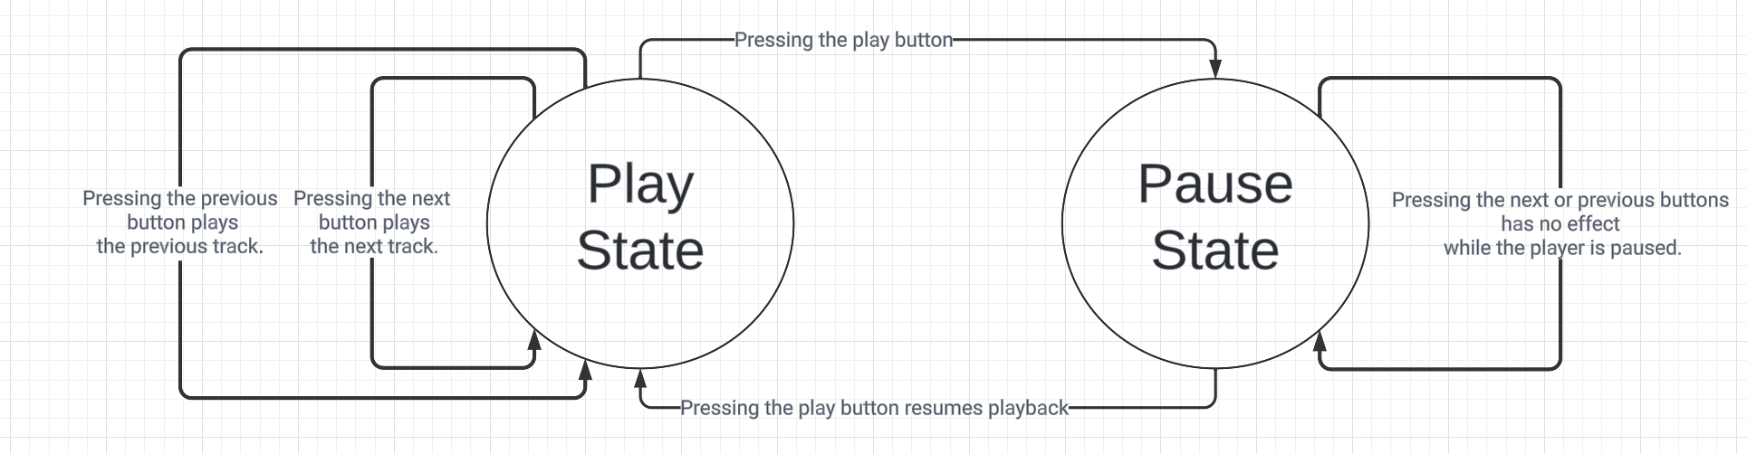
B.
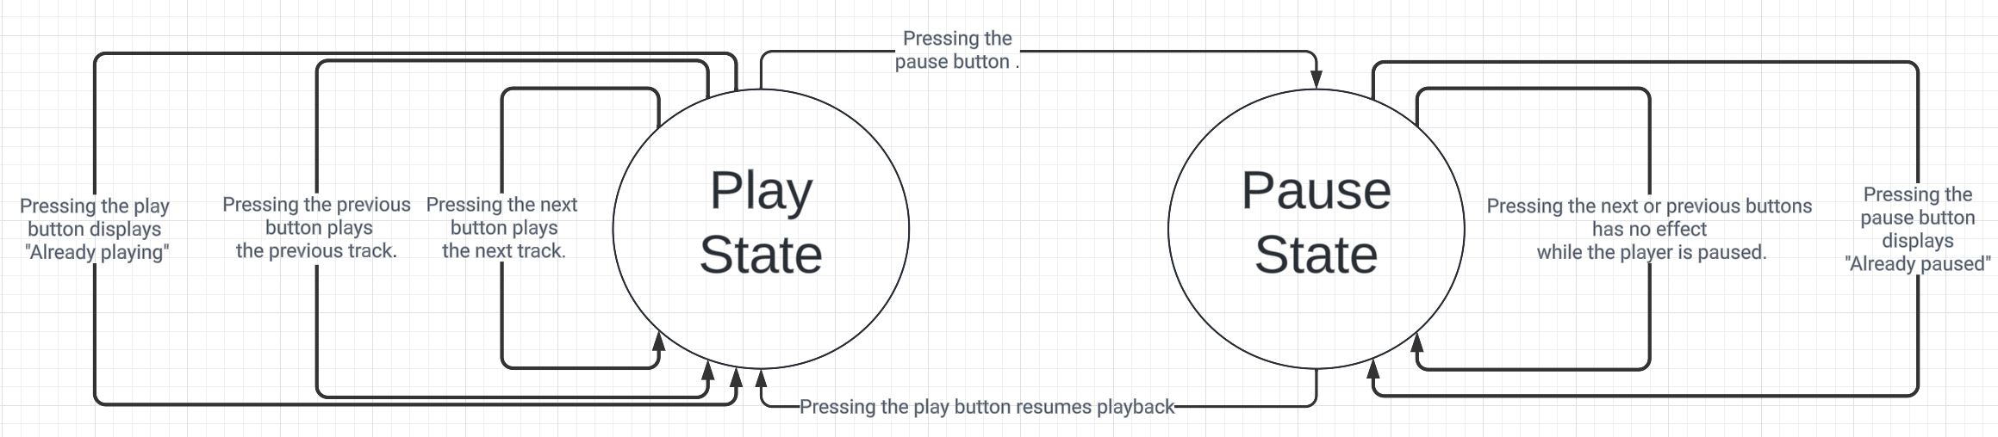
C.

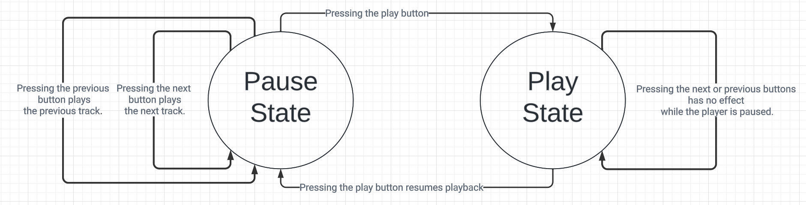
D.
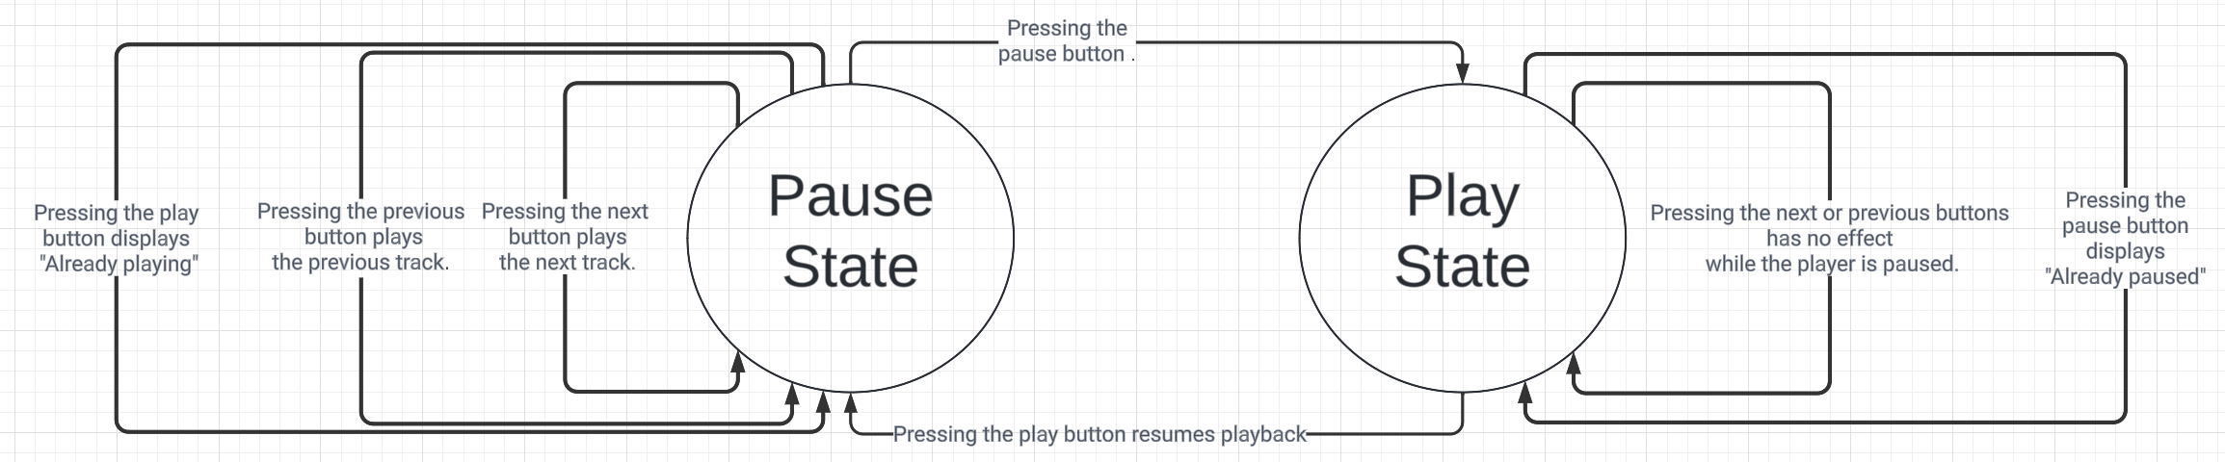

Question 10
Which of the following is the sequence of states that the audio player will go through when the following code is executed?
# Usage example
audio_player = AudioPlayer()
audio_player.press_play() # Output: Resuming playback...
audio_player.press_pause() # Output: Pausing playback...
audio_player.press_play() # Output: Resuming playback...
audio_player.press_next() # Output: Playing next track
audio_player.press_pause() # Output: Pausing playback...
A. PausedState, PlayingState, PausedState, PlayingState, PausedState
B. PausedState, PlayingState, PlayingState, PausedState, PausedState
C. PlayingState, PausedState, PlayingState, PausedState, PlayingState, PausedState
D. PlayingState, PausedState, PlayingState, PlayingState, PausedState, PausedState

Question 11
In the State design pattern, what is the primary purpose of the State interface or base class?
A. To define a set of default states for the context object.
B. To encapsulate the behavior associated with a particular state.
C. To restrict the number of states a context object can have.
D. To define only the initial state of the context object.

Question 12
How does the State design pattern differ from a simple if-else conditional approach to handle different states?
A. The State pattern always results in slower performance compared to if-else conditionals.
B. The State pattern cannot handle state transitions as effectively as if-else conditionals.
C. The State pattern allows for better encapsulation and easier addition of new states without modifying existing code.

Questions 13-18
For the following code, answer questions 13-18.
class LoanRequest:
def __init__(self, amount, credit_score):
self.amount = amount
self.credit_score = credit_score
class LoanHandler:
def can_approve(self, loan):
pass
class Clerk(LoanHandler):
def can_approve(self, loan):
return loan.amount <= 1000 and loan.credit_score >= 500
class Manager(LoanHandler):
def can_approve(self, loan):
return 1000 < loan.amount <= 5000 and loan.credit_score >= 600
class Director(LoanHandler):
def can_approve(self, loan):
return 5000 < loan.amount <= 10000 and loan.credit_score >= 700
class LoanApprovalSystem:
def __init__(self):
self.handlers = []
def add_authority(self, handler):
self.handlers.append(handler)
def remove_authority(self, handler):
if handler in self.handlers:
self.handlers.remove(handler)
else:
print("Authority not found.")
def process_request(self, loan):
approvals = [handler.can_approve(loan) for handler in self.handlers]
if any(approvals):
print("Loan approved by at least one authority.")
else:
print("Loan denied by all authorities.")

Question 13
Which desgin pattern is used in the above code?
A. State
B. Strategy
C. Chain of Responsibility
D. Decorator

Question 14
For the following client code, what is the output?
# Creating the Loan Approval System
loan_system = LoanApprovalSystem()
# Adding initial authorities
loan_system.add_authority(Clerk())
loan_system.add_authority(Manager())
loan_system.add_authority(Director())
loan1 = LoanRequest(1500, 550)
# Processing loan requests
loan_system.process_request(loan1)
A. Loan denied by all authorities.
B. Loan approved by at least one authority.
C. Authority not found.
D. Authority Clerk removed.

Question 15
What is the output of the following code?
# Creating the Loan Approval System
loan_system = LoanApprovalSystem()
# Adding initial authorities
loan_system.add_authority(Clerk())
loan_system.add_authority(Manager())
loan_system.add_authority(Director())
# Dynamically adding a new authority
class SeniorManager(LoanHandler):
def can_approve(self, loan):
return 10000 < loan.amount <= 20000 and loan.credit_score >= 750
loan_system.add_authority(SeniorManager())
loan4 = LoanRequest(15000, 780)
loan_system.process_request(loan4)
# Dynamically removing an authority
loan_system.remove_authority(Manager())
loan5 = LoanRequest(3500, 650)
loan_system.process_request(loan5)

A.
Loan approved by at least one authority.
Loan approved by at least one authority.
B.
Loan approved by at least one authority.
Loan denied by all authorities.
C.
Loan denied by all authorities.
Loan approved by at least one authority.
D.
Loan denied by all authorities.
Loan denied by all authorities.

Question 16
[True/False] In this loan approval system, each handler is directly aware of its successor. This tight coupling makes it difficult to change the chain dynamically at runtime or reuse the handlers independently.
A. True
B. False

Question 17
Which of the following is another solution to this problem?
A.
class LoanRequest:
def __init__(self, amount, credit_score):
self.amount = amount
self.credit_score = credit_score
# Loan requests with different credit scores
loan1 = LoanRequest(1500, 550)
loan2 = LoanRequest(4500, 620)
loan3 = LoanRequest(8000, 680)
def approve_loan(loan):
if loan.amount <= 1000 and loan.credit_score >= 500:
print("Loan approved by Clerk.")
elif 5000 < loan.amount <= 10000 and loan.credit_score >= 700:
print("Loan approved by Director.")
elif 1000 < loan.amount <= 5000 and loan.credit_score >= 600:
print("Loan approved by Manager.")
else:
print("Loan denied.")
flawed_loan_approval(loan1)
flawed_loan_approval(loan2)
flawed_loan_approval(loan3)
B.
class LoanRequest:
def __init__(self, amount, credit_score):
self.amount = amount
self.credit_score = credit_score
# Loan requests with different credit scores
loan1 = LoanRequest(1500, 550)
loan2 = LoanRequest(4500, 620)
loan3 = LoanRequest(8000, 680)
def approve_loan(loan):
if loan.amount <= 1000 and loan.credit_score >= 500:
print("Loan approved by Manager.")
elif 1000 < loan.amount <= 5000 and loan.credit_score >= 600:
print("Loan approved by Clerk.")
elif 5000 < loan.amount <= 10000 and loan.credit_score >= 700:
print("Loan approved by Director.")
else:
print("Loan denied.")
approve_loan(loan1)
approve_loan(loan2)
approve_loan(loan3)

Question 18
Beside chain of responsibility, bridge, and strategy design patterns, which design pattern we have covered helped us to get rid of using if-else block of statements in driver code?
A. Singleton
B. Observer
C. State
D. Factory

Question 19
Which of the following is not a possible output of the following code?
import threading
import time
# Function to print numbers from 1 to n
def print_numbers(n):
for i in range(1, n + 1):
print(i, end="")
time.sleep(.1)
# Function to print letters from a to f
def print_letters():
for letter in "abcdef":
print(letter, end="")
time.sleep(0.1)
# Create threads for each function
number_thread = threading.Thread(target=print_numbers, args=(5,))
letter_thread = threading.Thread(target=print_letters)
# Start the threads
number_thread.start()
letter_thread.start()
# Wait for threads to complete
number_thread.join()
letter_thread.join()
print()
print("Threads have finished.")

A. 1a2b3c4d5ef
B. 12345abcdef
C. abcdef12345
D. 1a2c3b4d5ef

Question 20
What is the output of the following code?
import threading
import time
# Shared variable
counter = 0
# Function to increment the counter
def increment():
global counter
for _ in range(10):
tmp = counter + 1
time.sleep(0.01)
counter = tmp
# Create two threads that increment the counter
thread1 = threading.Thread(target=increment)
thread2 = threading.Thread(target=increment)
# Start the threads
thread1.start()
thread2.start()
# Wait for both threads to finish
thread1.join()
thread2.join()
print("Counter:", counter)
A. 0
B. 10
C. 20
D. 40

Question 21
Which of the following best describes the potential issue in the given Python code snippet?
import threading
# Create two locks
lock1 = threading.Lock()
lock2 = threading.Lock()
# Function that acquires lock1 and then lock2
def function1():
lock1.acquire()
print("Function 1 acquired lock 1")
import time
time.sleep(1)
lock2.acquire()
print("Function 1 acquired lock 2")
lock2.release()
lock1.release()
# Function that acquires lock2 and then lock1
def function2():
lock2.acquire()
print("Function 2 acquired lock 2")
lock1.acquire()
print("Function 2 acquired lock 1")
lock1.release()
lock2.release()
# Create two threads calling each function
thread1 = threading.Thread(target=function1)
thread2 = threading.Thread(target=function2)
# Start the threads
thread1.start()
thread2.start()
# Wait for both threads to finish
thread1.join()
thread2.join()
print("Execution completed.")
A. The code contains a race condition leading to inconsistent output.
B. There’s a possibility of a deadlock occurring when both functions are executed.
C. The code lacks proper exception handling and may crash due to thread collisions.
D. The provided code is free from concurrency issues

Question 22
For the following code, what is the output?
import threading
lock1 = threading.Lock()
lock2 = threading.Lock()
def function1():
with lock1:
print("Function 1 acquired lock 1")
import time
time.sleep(1)
with lock2:
print("Function 1 acquired lock 2")
def function2():
with lock1:
print("Function 2 acquired lock 1")
with lock2:
print("Function 2 acquired lock 2")
thread1 = threading.Thread(target=function1)
thread2 = threading.Thread(target=function2)
thread1.start()
thread2.start()
thread1.join()
thread2.join()
print("Execution completed.")

A.
Function 1 acquired lock 1
B.
Function 1 acquired lock 1
Function 1 acquired lock 2
C.
Function 1 acquired lock 1
Function 1 acquired lock 2
Function 2 acquired lock 1
Function 2 acquired lock 2
Execution completed.
D.
Function 2 acquired lock 1
Function 2 acquired lock 2
Function 1 acquired lock 1
Function 1 acquired lock 2
Execution completed.

Question 23
What is the output of the following code?
"""
This module defines a simple coroutine that increments a value.
"""
def coroutine_increment(increment_val):
"""
This coroutine takes in an increment value and adds it to a running
total that is yielded. The coroutine should be initially started
with a call to next that get's the loop going. The coroutine starts
with a value of 1.
:return: Yield the total after adding in an increment value that is
sent in
"""
i = 0
while True:
i += increment_val
increment_val = yield i
if __name__ == "__main__":
c1 = coroutine_increment(2)
# The first call to next starts the coroutine and gets the loop going.
print(next(c1))
total = c1.send(5)
print(total)
total = c1.send(47)
print(total)

A.
2
7
54
B.
1
6
53
C.
0
5
47
D.
2
5
47

Question 24
What is the total time taken to execute the following code?
import asyncio
import time
async def counter_loop(x, n):
for i in range(1, n + 1):
print(f"Counter {x}: {i}")
await asyncio.sleep(0.5)
return f"Finished {x} in {n}"
async def main():
x = time.perf_counter()
fast_coro = counter_loop("Fast", 2)
slow_task = asyncio.create_task(counter_loop("Slow", 4))
print("Awaiting Fast")
fast_val = await fast_coro
print("Finished Fast")
print("Awaiting Slow")
slow_val = await slow_task
print("Finished Slow")
print(f"{fast_val}, {slow_val}")
y = time.perf_counter()
print(f"Total time: {y-x}")
asyncio.run(main())
A. 1 seconds
B. 2 seconds
C. 3 seconds
D. 4 seconds

Question 25
For the following dependency injection code, which of the following is true?
class EmailService:
def send_email(self, recipient, message):
# Simulate sending an email
print(f"Sending email to {recipient}: {message}")
class UserManager:
def __init__(self, email_service):
self.email_service = email_service
def welcome_user(self, username):
message = f"Welcome, {username}! Thanks for joining."
self.email_service.send_email(username, message)
# Creating an instance of EmailService
email_service = EmailService()
# Injecting the EmailService dependency into UserManager
user_manager = UserManager(email_service)
# Using UserManager to welcome a user
user_manager.welcome_user("John")
A. EmailService is the client and UserManager is the service
B. UserManager is the client and EmailService is the service
C. EmailService is the service and UserManager is the client
D. UserManager is the injector and EmailService is the client

