Table of Contents
Installing Node.js 1
Installing Watchman 1
Creating the App 1
Mac Permissions Issues 1
Starting the App 2
Running the App in an Android Emulator 2
Reloading the App 3

Installing Node.js
The Node.js installer can be downloaded from https://nodejs.org/en/download/current.

Installing Watchman
On a Mac, the watchman file watcher is needed which helps to listen for project changes and push them to the emulator. Watchman can be installed with the following command:

brew install watchman

Creating the App
To create the app, make a folder where you have full permissions. Then open the folder in VS Code. Next, open the VS Code terminal by navigating to Terminal | New Terminal. Then cd into the folder and run this command to create the app:

sudo npx create-expo-app@latest --template blank

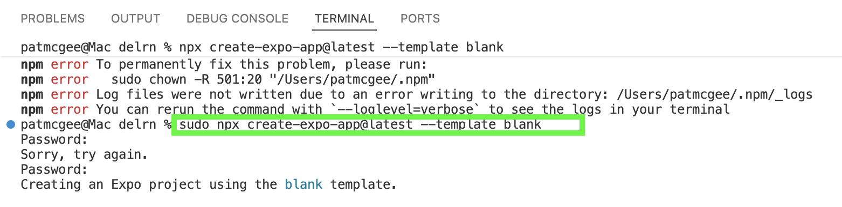

Mac Permissions Issues

I experienced several permissions issues on my Mac. In terminal I had to grant read write permission on my project folder and sub folders:

sudo chown -R $USER ./

Also I had to enable full disk access under Settings | Privacy & Security for Visual Studio Code and watchman.
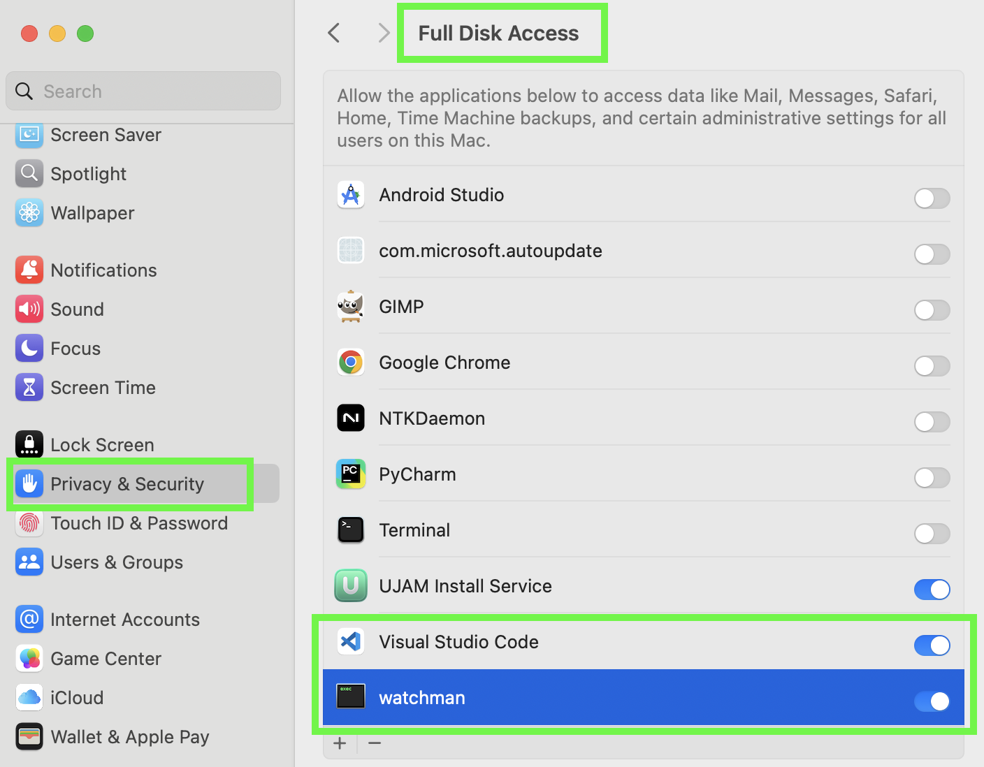

Starting the App
Launch an emulator in Android Studio and wait for it to finish the launch so the home screen is visible. Then start to the app from VS Code, cd into the project folder and enter the command:

sudo npx expo start

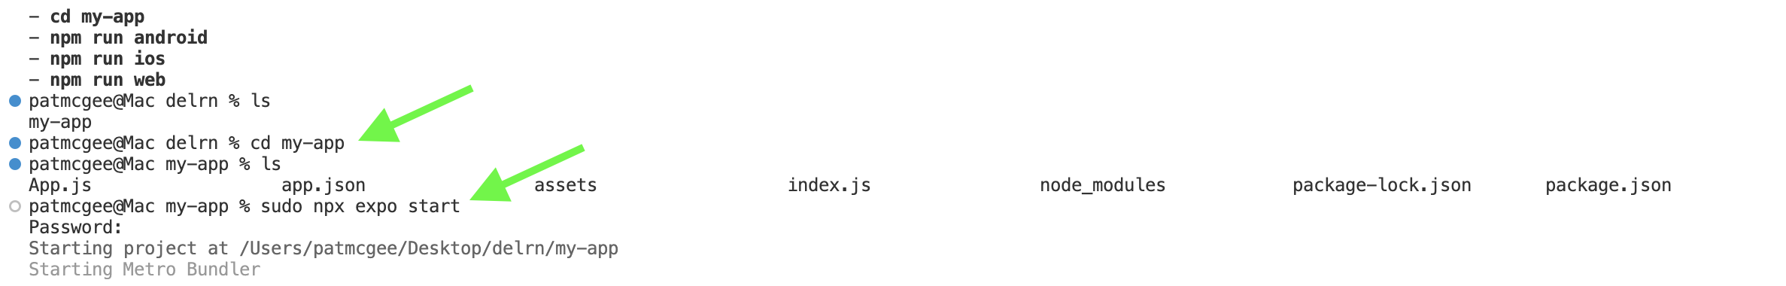

Running the App in an Android Emulator
To run the app in an Android emulator, after starting the app, when prompted type a for Android. These actions will cause the emulator to download Expo Go to run the app. The app should then appear in the emulator.
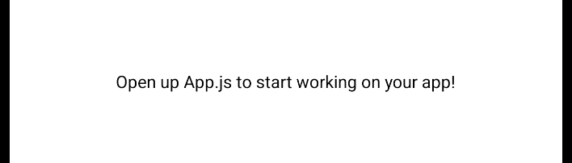

Reloading the App
If you notice that the app does not reflect the latest changes you may need to reload the app in the emulator by typing r for reload in the VS Code terminal.

