Table of Contents
Installing Node.js 1
Creating the App 1
Starting the App 1
Running the App in an Android Emulator 2
Error: could not connect to TCP port 5562 2

Installing Node.js
The Node.js installer can be downloaded from https://nodejs.org/en/download/current.

Creating the App
To create the app, make a folder where you have full permissions. Then launch VS Code as Administrator. Next open the folder in VS Code. After, open the VS Code terminal by navigating to Terminal | New Terminal. Then cd into the folder and run this command to create the app:

npx create-expo-app@latest --template blank

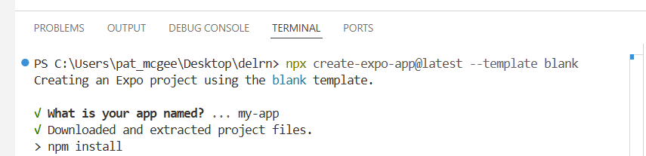

If you get the error:

Then run this command and try again:

Set-ExecutionPolicy RemoteSigned -Scope CurrentUser

Starting the App
To start the app, cd into the project folder and enter the command:
npx expo start

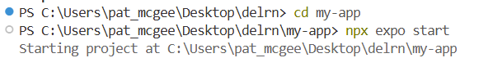

Running the App in an Android Emulator
To run the app in an Android emulator, first launch an emulator from Android Studio and wait for it to launch so the home screen is visible. After starting the app, when prompted type a for Android.

The first run will download Expo.
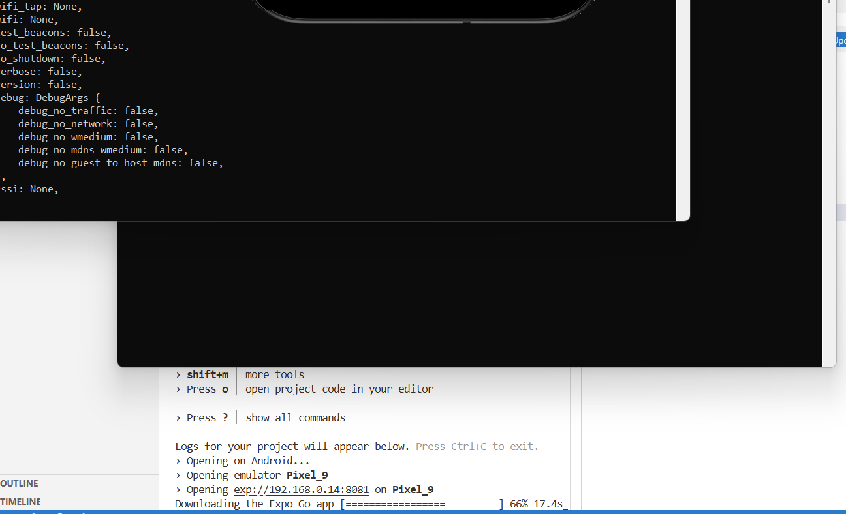

These actions will launch an Android emulator with your app inside.
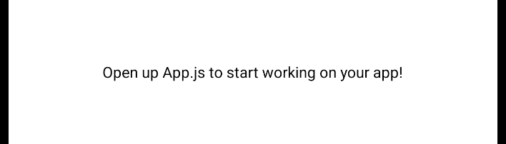

If you created an app before, you may need to press r for reload when prompted to push the new app to the emulator.

Error: could not connect to TCP port 5562
If you get the following error:
Error: could not connect to TCP port 5562: cannot connect to 127.0.0.1:5562: No connection could be made because the target machine actively refused it. (10061)

It could mean there is a ghost daemon running. To fix it, run the command:
adb devices

The following output suggests there is a ghost daemon:
List of devices attached
emulator-5562 offline

For port 5562, ADB actually looks at 5563 (port + 1). On Windows, run the command:
netstat -ano | findstr :5563

You’ll get a line like:
TCP 127.0.0.1:5563 0.0.0.0:0 LISTENING 20092

The process can be terminated with this line:
taskkill /pid 20092 /F

(Replace 20092 with whatever PID is needed.)

