Table of Contents
Kotlin Introduction 1
Jetpack Compose for UI/UX in Kotlin 1
Getting Started with Compose 1
Formatting Basics 5
Sizing 5
Modifier Objects 5
Compose: Displaying Images 6
Library Import Guidelines 8
Enabling Automatic Library Imports 8
Do not delete or overwrite the namespace in Kotlin 8
Use the Composable Import Whenever Possible 9
Leave Unresolved Objects Alone 9
Do Not Create Anything 9
Sometimes Trial and Error is Necessary 10
Compose: Text Inputs and Buttons 10
Handling State with an Event Listener (Callback function) 12

Kotlin Introduction
Kotlin is officially supported by Google and is currently recognized as the most common industry-standard programming language for native Android development.
https://kotlinlang.org/

Since being introduced in 2017. Kotlin has largely replaced Java for Android development because it offers modern language features, safer code, and full compatibility with existing Java code.

Cross platform development with frameworks like Flutter can be enormously beneficial. However sometimes native development is preferred when efficient memory use or high performance are critical considerations for an app. Also, native Kotlin provides day 0 access to new features and updates when Google releases them for Android. Sometimes working with features such as the camera, audio and more can be easier done with native code.

Jetpack Compose for UI/UX in Kotlin
Jetpack Compose is a modern, flexible framework that has recently become the preferred approach for building UI/UX in Kotlin. It addresses many limitations of the older XML-based layout system, and the Kotlin team now recommends using Jetpack Compose for new projects.

Decent simple documentation on Jetpack compose controls can be found at:
https://composables.com/material3/outlinedtextfield

Getting Started with Compose
Example 1: Working with Compose
This example walks through some layout creation basics with Jetpack Compose. To do this, create a new project:
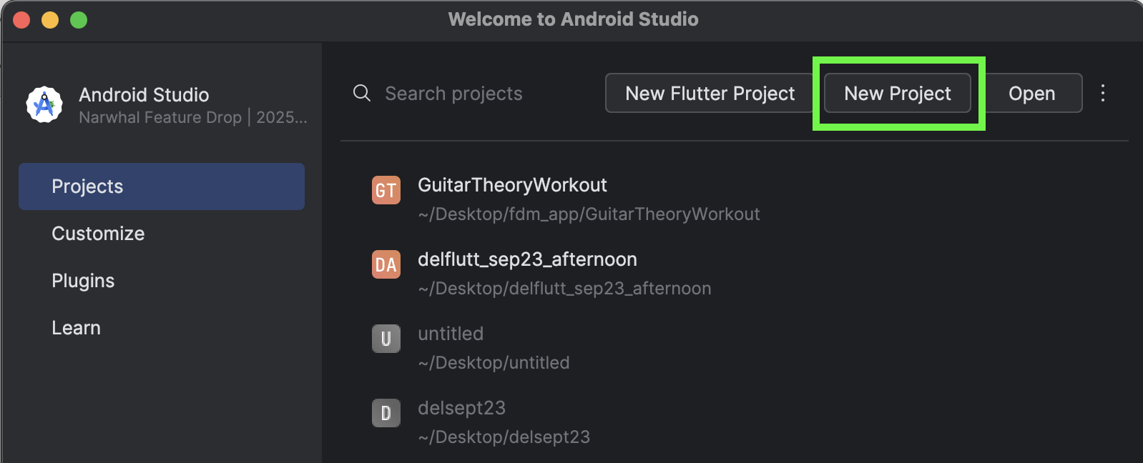

In the New Project dialog, select Empty Activity project and then click Next.
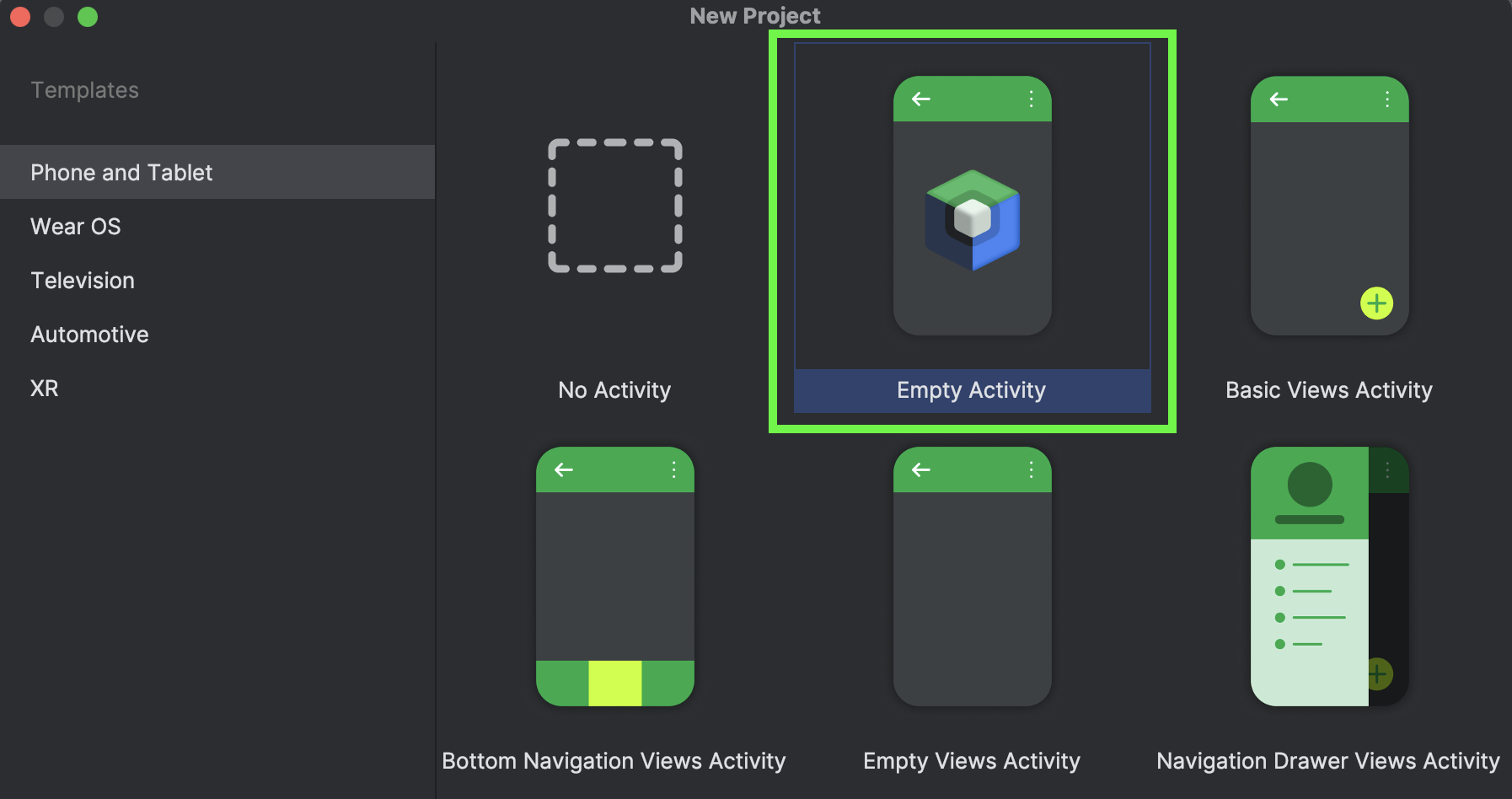
In the dialog that follows, leave the default settings but you may change the project name and location. When done, click the Finish button.
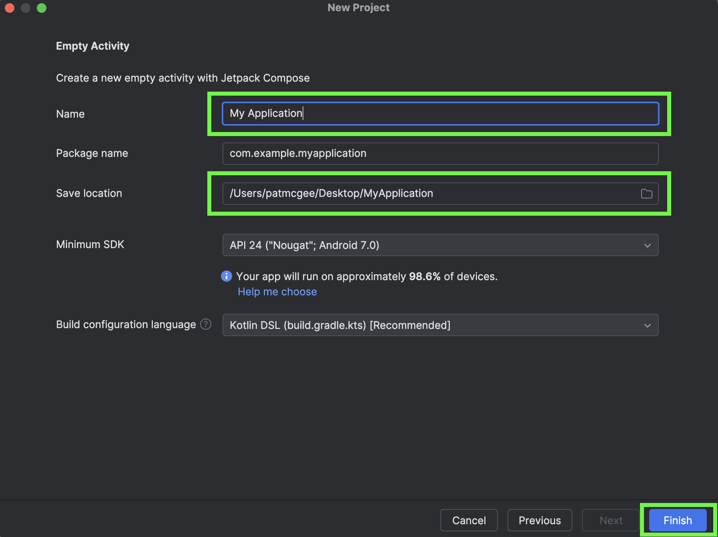
Clicking Finish triggers activity to initialize the project. Setup tasks are indicated by the progress bar at the bottom right of the IDE.
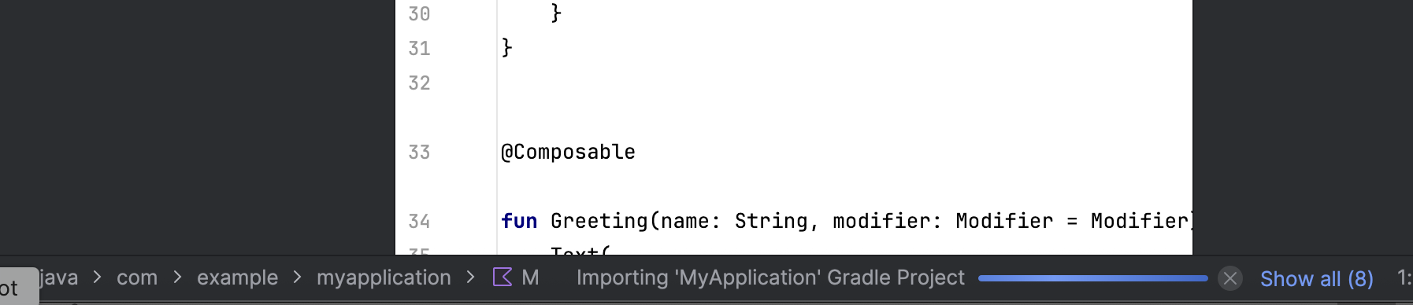

Next start your emulator and run the project to make sure it works.
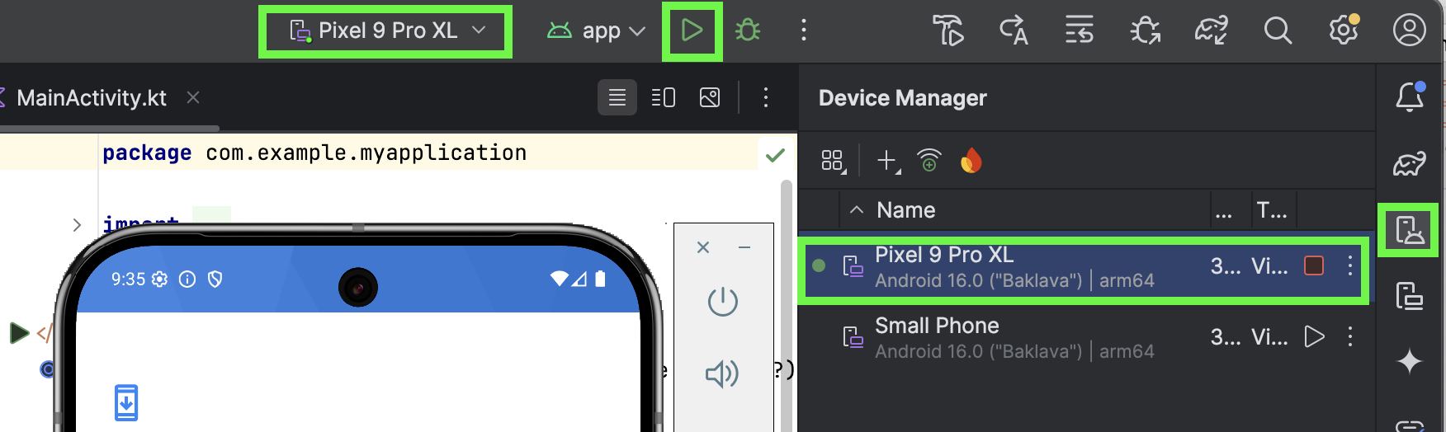

Ideally you will see the following output in the emulator if successful.
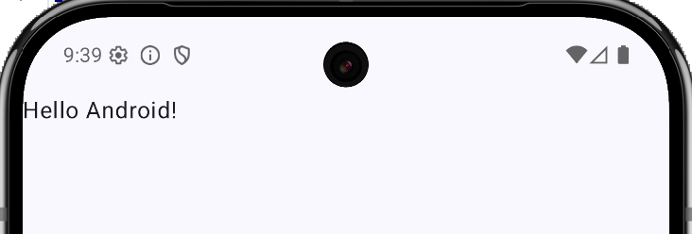

Notice how a composable Text control object is already included in MainActivity.kt to display the default greeting in the default Empty Activity project.
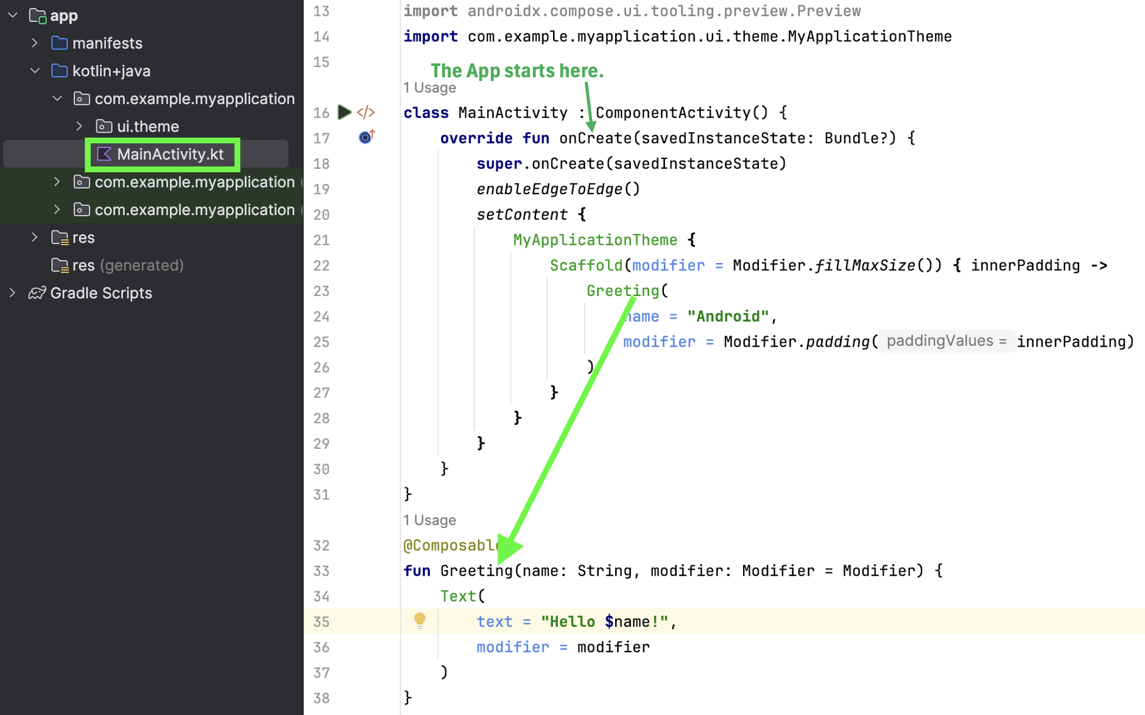
Exercise 1 (1 mark)
What call back function is implemented in the MainActivity class to trigger other tasks to set up the main screen?

Example 2: Modifying the onCreate handler and screen output
This next step involves making changes to show a name of a person and a message on the main app screen. To build this example, replace the MainActity
class MainActivity : ComponentActivity() {
override fun onCreate(savedInstanceState: Bundle?) {
super.onCreate(savedInstanceState)
enableEdgeToEdge()
setContent {
MessageCard(author = "Pat", body = "Jetpack Compose")
}
}
}
// @Composable tells Kotlin compiler that function is a piece of Jetpack Compose UI.
@Composable
fun MessageCard(author: String, body: String) {
Text(text = author)
Text(text = body)
}
When running the code as is, the sender’s name and message overlap each other without any formatting information.

Formatting Basics
To enable basic formatting, this section presents some helpful structures:

Row and Column Functions
Column and Row objects help to implement layout arrangements in Kotlin.

Sizing
For sizing, the following units are recommended:
- dp (density-independent pixels) are for layout sizes, margins, and padding.
- sp (scale-independent pixels) are for font sizes.

Modifier Objects
Modifier object can be used to add spacing and padding for different controls:

Spacer(modifier=modifier.height(40.dp))
Text(text=author, fontSize=24.sp, modifier=modifier.padding(20.dp))

Example 3: Using a Column Function
To fix the layout problem in Example 2, a Column function can be used to organize controls vertically within it. A modifier object can be used to help with spacing where dimensions are specified in dp units. Font sizes can be controlled with sp units.


To build this example, replace the MessageCard function in Example 2 with this version.
@Composable
fun MessageCard(author: String, body: String) {
val modifier: Modifier = Modifier
Column {
Spacer(modifier = modifier.height(40.dp))
Text(
text = author,
fontSize = 24.sp,
modifier = modifier.padding(20.dp)
)
Text(
text = body,
fontSize = 16.sp
)
}
}

Exercise 2 (2 marks)
Then adjust the output so it looks like the following but it needs to show your code:
Show your MainActivity code as text after the changes here (no screenshots please):
Show the screenshot of output after making this change but show your first name and last name instead:

Compose: Displaying Images
Example 4: Displaying Images
This example shows how to display images with Kotlin in addition to demonstrating formatting arrangements with Row, Column and Modifier objects.


To add images, click on the Resource Manager icon at the top left of Android Studio. Then click the plus sign and select Import Drawables. From there you will be provided a dialog which will allow you to navigate to the image. After selecting the image and accepting all default settings, the image will then appear in the Drawable list.
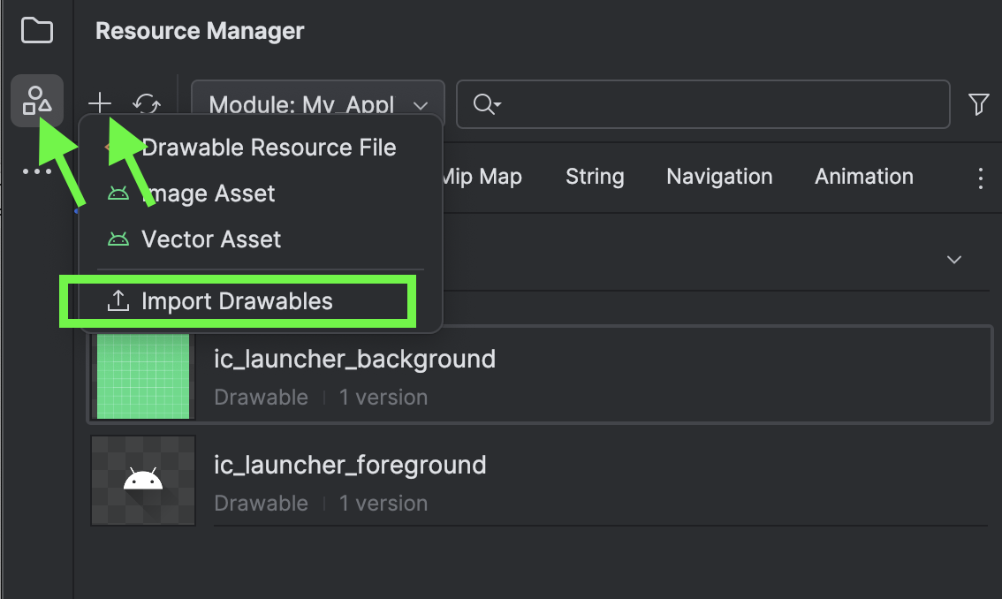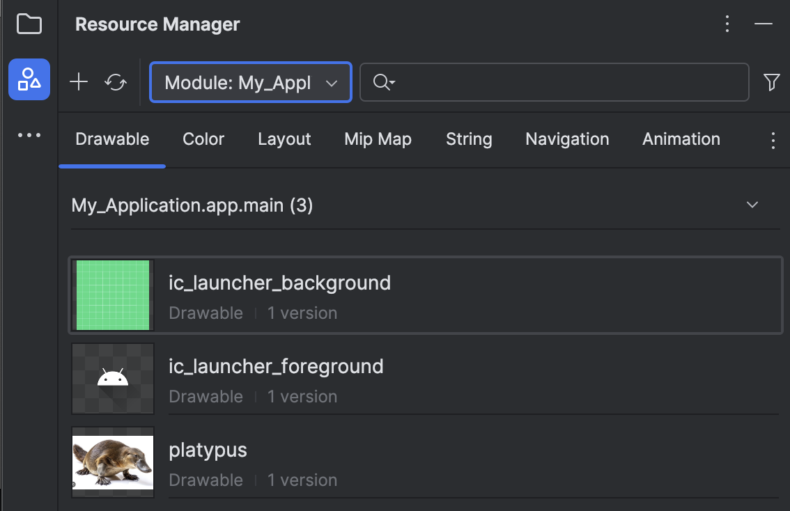

Starting with Example 3, replace the MessageCard function with the following revision:
@Composable
fun MessageCard(author: String, body:String) {
// Objects declared with ‘val’ can’t be reassigned.
val modifier: Modifier = Modifier
// Creates 1 row which has two columns of vertically organized controls.
Row(modifier = Modifier.fillMaxWidth()) {
Column(modifier = Modifier.weight(1f)) {
Spacer(modifier = modifier.height(50.dp))
Image(
painter = painterResource(R.drawable.platypus),
contentDescription = "Contact profile picture",
modifier = Modifier.height(80.dp) // constrain image
)
}
Column( ) {
// Adds space above first control.
Spacer(modifier = modifier.height(40.dp))
Text(text = author, fontSize = 16.sp,
modifier = modifier.padding(20.dp))
Text(text = body, modifier.padding(20.dp))
}
}
}

Exercise 3 (2 marks)
Starting with the code from the last step, replace the image and create a third column which shows an animal’s name which starts with the first letter of your name. The animal name should use a larger font. Change the first name to your first name. The output should look something like the following but with your first name.

Show a screenshot of the output here.

Library Import Guidelines
When you add new code to a project, you will often notice that many import statements are required. It can take some time to get used to this extra step. To help, this section discusses guidelines you can take when selecting imports for each library.

Enabling Automatic Library Imports
Android Studio can be configured to automatically add any unambiguous imports. Unambiguous imports are imports that can be resolved to only one class or function. However, for items like Text, which exist in multiple libraries, Android Studio will ask you to choose the correct one manually.

To set Android Studio up for automatic imports wherever possible, go to Android Studio | Settings. Then from the Editor tab, choose General and then Auto Import. From there make sure Add unambiguous imports on the fly is checked and then click OK.

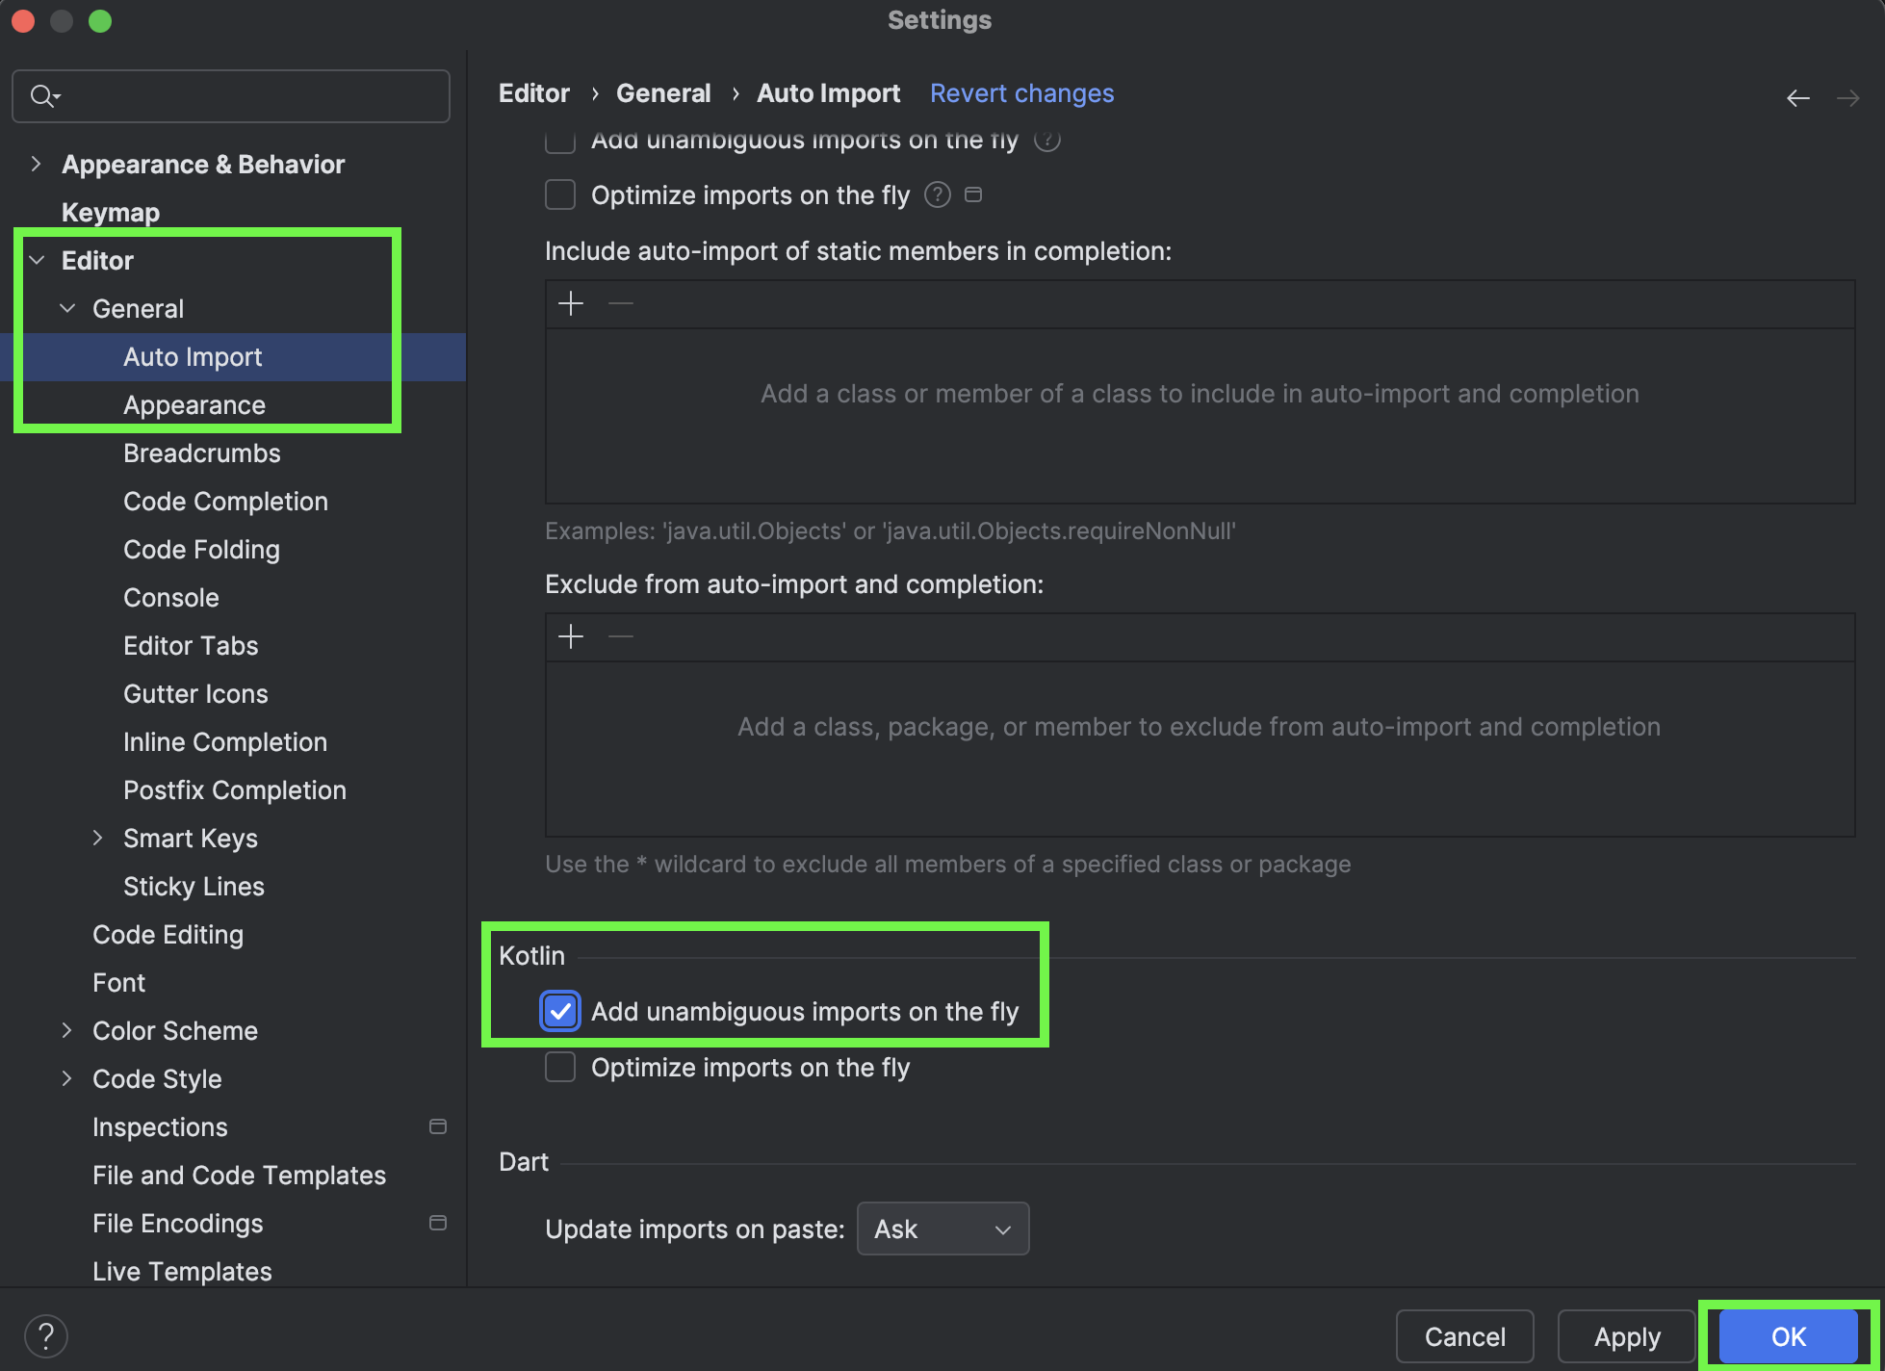

Do not delete or overwrite the namespace in Kotlin
Try to remember not to delete or overwrite the namespace in Kotlin. This namespace is created when your project is created and the namespace is referenced in more than one area. The project may stop working if the namespace is changed.
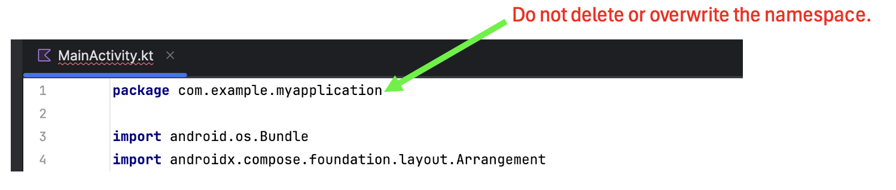

Use the Composable Import Whenever Possible
When finding the correct import for an item which is offered by more than one library, try to find the Composable version.
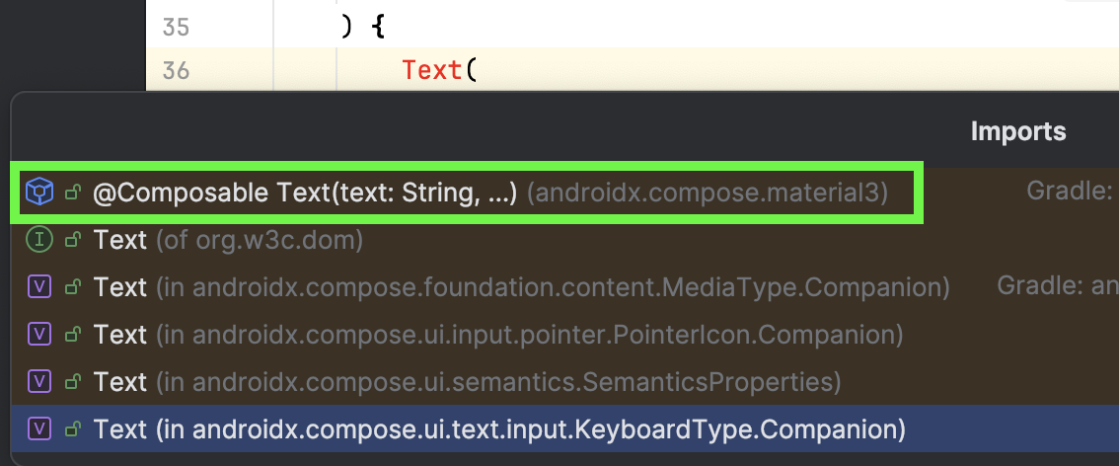
In the case above, selecting @Composable adds the import statement shown below.
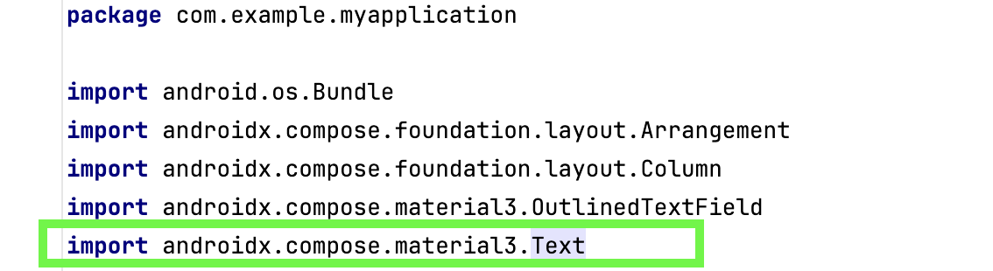

Here is another example where a composable import is selected for Modifier.
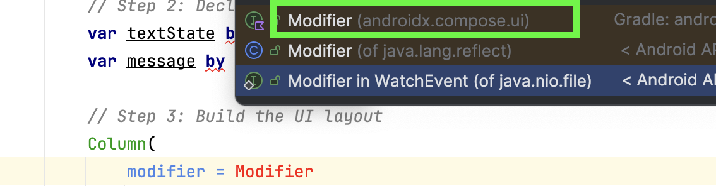

Leave Unresolved Objects Alone
If no import suggestions appear when hovering over certain objects, leave them as is. These issues usually resolve automatically once additional imports are added elsewhere in the file.
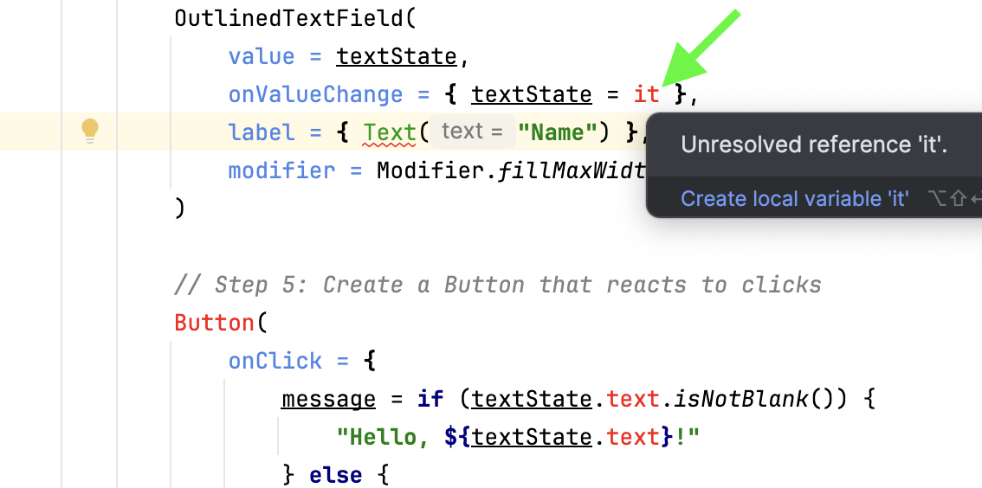

Do Not Create Anything
When searching for required libraries do not choose to create anything. The library should already exist.
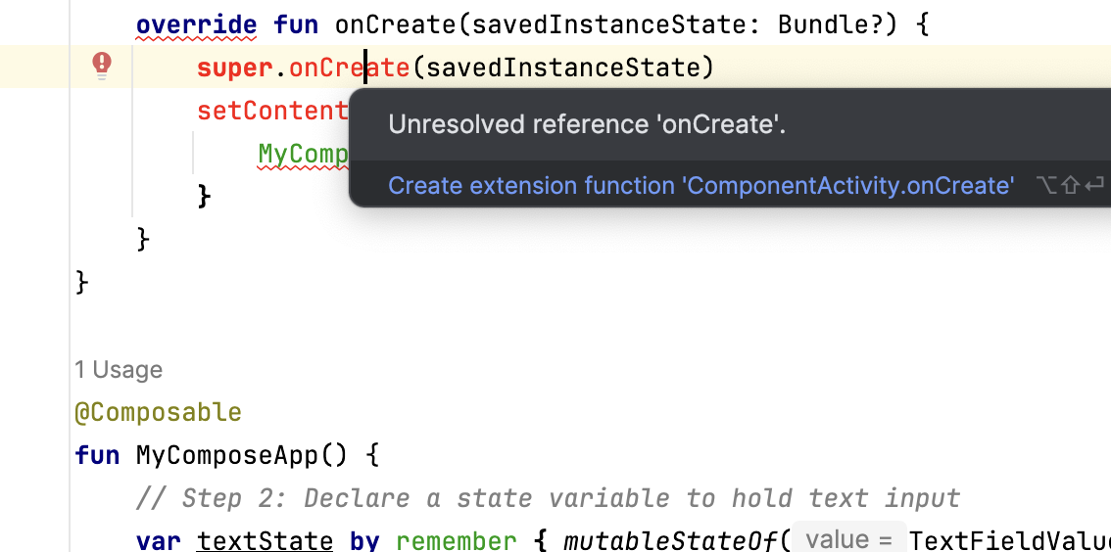

Sometimes Trial and Error is Necessary
After you have imported all composable libraries where available, you may have some straggler objects which still need imports that are not composable. Trial and error should be able to resolve these imports without too much trouble.
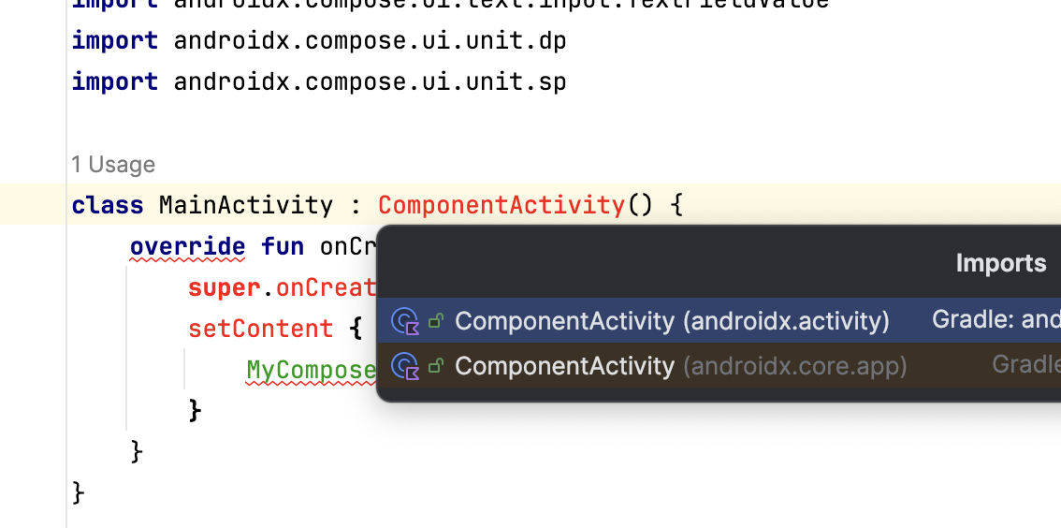

Compose: Text Inputs and Buttons

Example 5: Showing Text Inputs and Buttons
This example demonstrates how to enable an editable text input. After users enter content, they can click the submit button and the content will appear in the label.
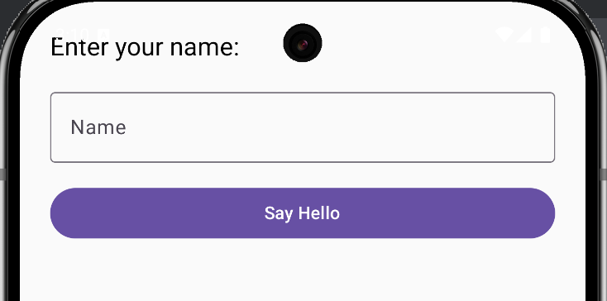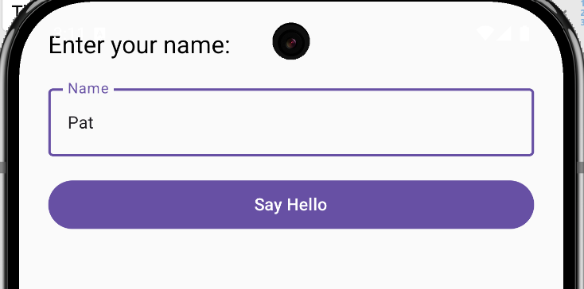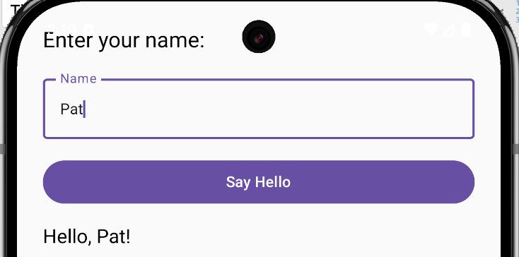

To build this example, replace the contents of MainActivity.kt with this code. Remember: Do not delete or overwrite the namespace that was generated for your project.
class MainActivity : ComponentActivity() {
override fun onCreate(savedInstanceState: Bundle?) {
super.onCreate(savedInstanceState)
setContent {
MyComposeApp()
}
}
}

@Composable
fun MyComposeApp() {
// Step 2: Declare state variables to hold text input.
// Variables declared with ‘var’ can be changed later.
var textState by remember { mutableStateOf(TextFieldValue("")) }
var message by remember { mutableStateOf("") }

// Step 3: Build the UI layout
Column(
modifier = Modifier
.fillMaxSize()
.padding(24.dp),
verticalArrangement = Arrangement.spacedBy(16.dp)
) {
Text(
text = "Enter your name:",
fontSize = 20.sp
)

// Step 4: Create an OutlinedTextField
OutlinedTextField(
value = textState,
// update the state variable.
onValueChange = { textState = it }, // ‘it’ is latest input from user
label = { Text("Name") },
modifier = Modifier.fillMaxWidth()
)

// Step 5: Create a Button that reacts to clicks
Button(
onClick = {
message = if (textState.text.isNotBlank()) {
"Hello, ${textState.text}!"
} else {
"Please enter your name."
}
},
modifier = Modifier.fillMaxWidth()
) {
Text("Say Hello")
}

// Step 6: Display the result
Text(
text = message,
fontSize = 18.sp
)
}
}

Exercise 4 (1 mark)
What is the purpose of the onCreate() method in MainActivity?

Exercise 5 (1 mark)
What is the @Composable annotation for?

Exercise 6 (1 mark)
Why do we use mutableStateOf() when declaring textState and message?
Exercise 7 (1 mark)
What does it represent in the line onValueChange = { textState = it }?
Exercise 8 (1 mark)
Why is Modifier.fillMaxWidth() applied to the OutlinedTextField and Button?
Exercise 9 (1 mark)
What is the difference between declarations that are made with ‘var’ or ‘val’?

Exercise 10 (4 marks)
Modify the code to allow a first and a last name.
Show a screenshot after you have made the changes. Enter your name and show the output in the label.
Show all of your MainActivity.kt code as text here (no screenshots please):

Handling State with an Event Listener (Callback function)
Usually, an event must occur to change the state of a composable. Composables can set up listeners for these events and they can also issue notifications about their change of state to other listeners. 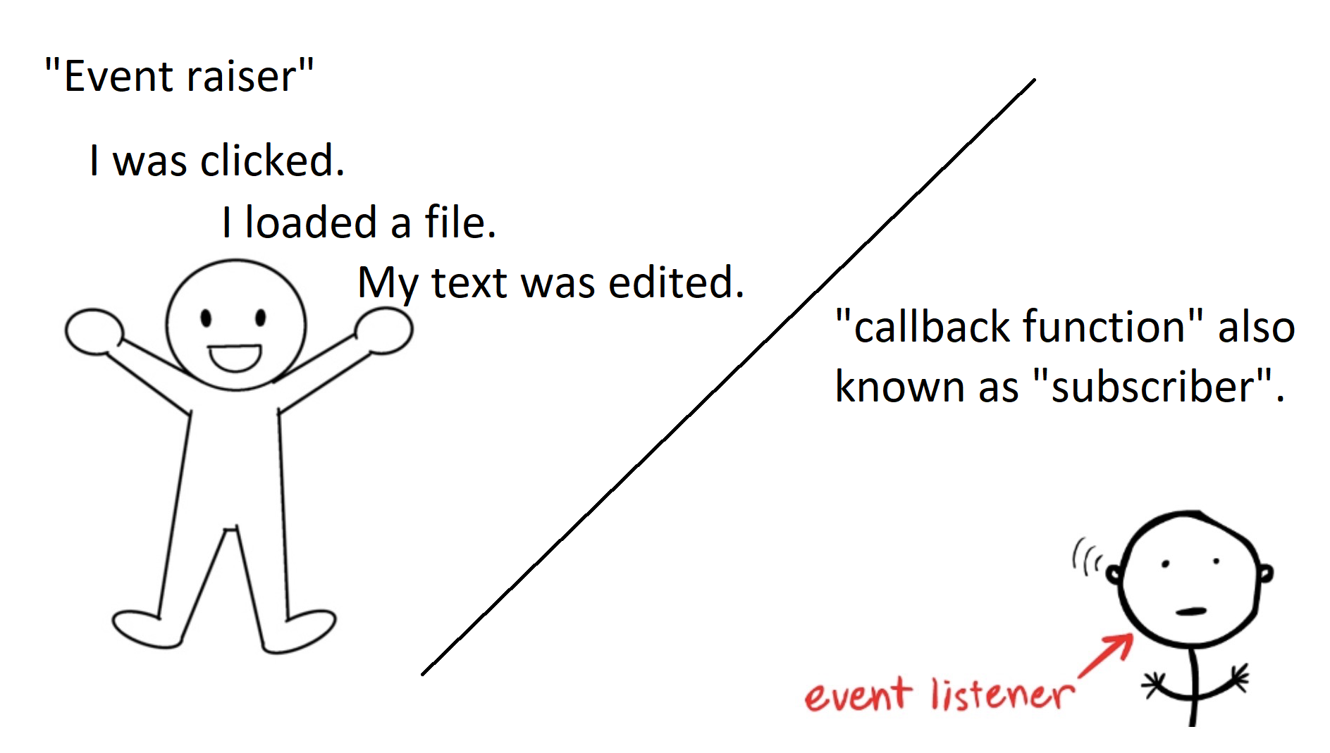

Example 6: Handling a Custom TextField with Mutable State
In an Empty Activity project, add this MyCustomTextField() which encapsulates logic for an OutlinedTextField.

MyCustomTextField.kt
@Composable
fun MyCustomTextField(
strInput: String,
// void callback function with String parameter.
textUpdatedCallback: (String) -> Unit, // ->Unit means returns void
) {
OutlinedTextField(
value = strInput, // Store and display value.
onValueChange = {
// Send an update to subscriber. ‘it’ is a self-reference to the text.
textUpdatedCallback(it)
},
label = { Text("Enter some text.") },
modifier = Modifier.fillMaxWidth()
)
}

Then inside setContent() within the onCreate() function of the MainActivity, add this code:
Column(modifier = Modifier.padding(20.dp)) {
Spacer(modifier = Modifier.height(60.dp))

// State objects that are defined with ‘remember {mutableStateOf()}’ implies;
// "When state objects are updated, all objects in the UI referencing it
// will be updated too."
var inputString by remember { mutableStateOf(("")) }

Column(modifier = Modifier.padding(20.dp)) { // Add left margin
Spacer(Modifier.height(50.dp))
MyCustomTextField(
strInput = inputString, // Pass original value to the function.

// Subscribe to get live updates and handle them within.
textUpdatedCallback = {

// Update the state variable when it is modified by the function.
// 'it' references the value returned from the function.
inputString = it
},
)
Text(inputString)
}
}

Exercise 11 (2 marks)
When the MyCustomTextField() function is called from MainActivity, what two parameter types are being passed to the function?

Exercise 12 (1 mark)
When the MyCustomTextField function sends an updated state value to the calling function is it acting as a subscriber or a publisher?

Exercise 13 (1 mark)
When the handler in the MainActivity receives the update in state for the OutlinedTextField is it acting as a publisher or a listener (subscriber)?

Exercise 14 (1 mark)
What part of the user interface is being updated when the state variable in MainActivity is updated?

Exercise 15 (1 mark)
The OutlinedTextField is also receiving event notifications. What notification is it receiving and what callback function is it using to receive the notification?

Exercise 16 (6 marks)
Create single check box control which is stored in a separate function within a separate file. https://developer.android.com/develop/ui/compose/components/checkbox

Then, in MainActivity figure out how to display the status as to whether or not the checkbox was checked. You will need to pass a listener function from MainActivity to the custom checkbox function to do this.

Show a screenshot of your checkbox with your name beside here:

Show your MainActivity.kt code here for displaying the checked status of the checkbox in a label.
Show your checked box function here.

