Table of Contents
Introduction 1
Getting Started 1
Props 2
Destructured Props Format 4
Simple Alert Components 6
Modal Dialogs 8
Navigation 9
Tabs, Parent Detail, goBack() 9
List-Detail View Navigation 13
Conclusion 15

Introduction
This document introduces Props, Alerts and Model dialogs in React Native. It also provides review for implementing tabs and navigation between parent and child views but within a Typescript environment.

Getting Started
Example 1: Creating a Typescript Project
To help with examples that follow, this example contains steps for setting up a typescript React Native app. Run this command to create a basic React Native app with TypeScript using Expo:

npx create-expo-app myapp --template blank-typescript
cd myapp

Mac users who may have permissions issues
Remember to use sudo if you encounter permission issues. Also, run this command at the root of your project to grant read write permission on my project folder and sub folders:
sudo chown -R $USER ./

To run the app, use this command:
npx expo start

Be sure to press a to run the app in the Android emulator which should already be running.

Tip: I often find the old app stays on the screen, so I go to the home screen and swipe it away to fully close it. After that, I perform a hard refresh to reload the app cleanly.
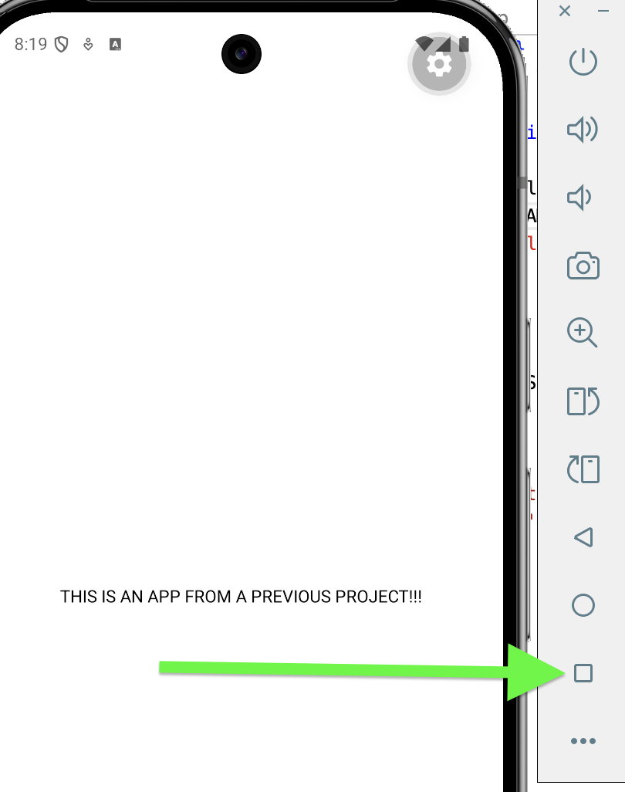

Props
Props are values passed from a parent component to a child component. The props definition is stored in a TypeScript file.

Example 2: Props Introduction
This example introduces props by creating a reusable Greeting component that receives a name value and uses it to display a personalized message.
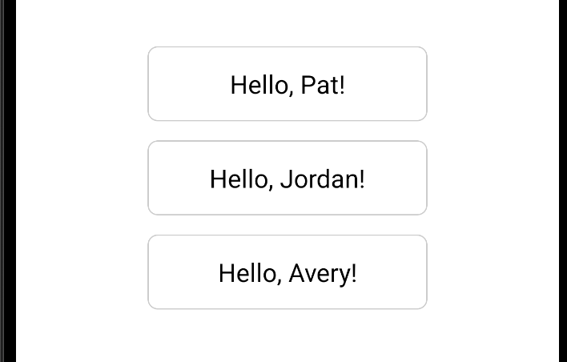

The GreetingTypes.ts file defines a custom type that specifies the structure of the props, including the name field.
GreetingProps.ts
export type GreetingProps = {
name: string;
};

React Native components written in TypeScript are stored in .tsx files. This component is defined as a function that receives props, which is typed using GreetingProps.

Greeting.tsx
import { View, Text, StyleSheet } from 'react-native';
import { GreetingProps } from './GreetingProps';

export default function Greeting(props: GreetingProps) {
return (
<View style={styles.box}>
<Text style={styles.text}>Hello, {props.name}!</Text>
</View>
);
}
const styles = StyleSheet.create({
box: {
marginBottom: 15,
padding: 15,
borderWidth: 1,
borderColor: '#ccc',
borderRadius: 8,
width: 220,
alignItems: 'center',
},
text: {
fontSize: 20,
},
});

The app renders multiple Greeting components, each with a different name passed through props.

App.tsx
import { StatusBar } from 'expo-status-bar';
import { StyleSheet, View } from 'react-native';
import Greeting from './Greeting';

export default function App() {
return (
<View style={styles.container}>
<Greeting name="Pat" />
<Greeting name="Jordan" />
<Greeting name="Avery" />
<StatusBar style="auto" />
</View>
);
}
const styles = StyleSheet.create({
container: {
flex: 1,
backgroundColor: '#fff',
alignItems: 'center',
justifyContent: 'center',
},
});

Exercise 1 (2 marks)
Modify the example so that the GreetingProps type includes three fields: firstName, lastName, and id (number). Update the Greeting component to display all three values. Finally, update the App component to pass the correct firstName, lastName, and id props to each Greeting component.

Show your revised GreetingProps.ts code as text with proper naming here (no screenshots please):
Show your revised Greeting.tsx code as text with proper naming here (no screenshots please):
Show your revised App.tsx code as text with proper naming here (no screenshots please):

Destructured Props Format
The destructured props style displays each individual property in the component function header.

Example 3: Destructured Props
This example demonstrates props using a destructured props format, where the properties (name, program, isActive) are displayed directly in the function parameters. This makes the code easier to read compared to accessing values through the props object.
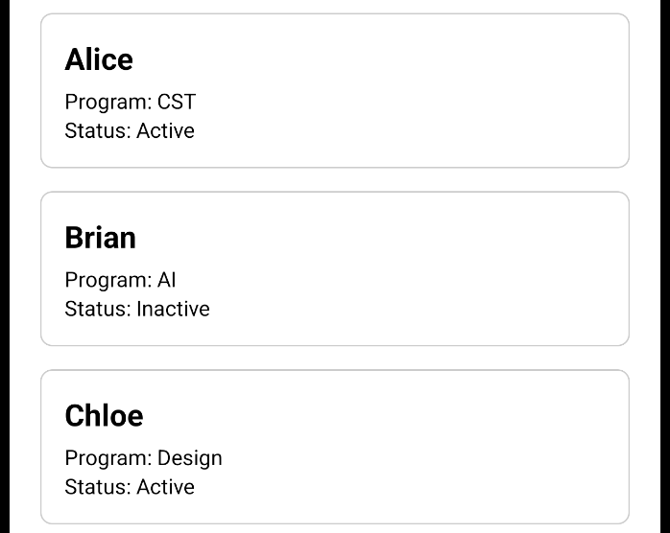

For simplicity all code is located in App.tsx but normally the Student component would be in a separate tsx file.
import { StatusBar } from 'expo-status-bar';
import { StyleSheet, Text, View } from 'react-native';

type StudentProps = {
name: string;
program: string;
isActive: boolean;
};

function Student({ name, program, isActive }: StudentProps) {
return (
<View style={styles.card}>
<Text style={styles.title}>{name}</Text>
<Text>Program: {program}</Text>
<Text>Status: {isActive ? 'Active' : 'Inactive'}</Text>
</View>
);
}

export default function App() {
return (
<View style={styles.container}>
<Student name="Alice" program="CST" isActive={true} />
<Student name="Brian" program="AI" isActive={false} />
<Student name="Chloe" program="Design" isActive={true} />
<StatusBar style="auto" />
</View>
);
}

const styles = StyleSheet.create({
container: {
flex: 1,
backgroundColor: '#fff',
alignItems: 'center',
justifyContent: 'center',
padding: 20,
},
card: {
width: '100%',
borderWidth: 1,
borderColor: '#ccc',
borderRadius: 8,
padding: 15,
marginBottom: 15,
},
title: {
fontSize: 20,
fontWeight: 'bold',
marginBottom: 5,
},
});

Simple Alert Components
The Alert component in React Native allows you to pass a title (string), message (string) and an array of buttons. With the simple alert components, you cannot add custom components like icons or images and you cannot change its layout or styling.
Example 4: Simple Alert Dialogs
This example displays an alert dialog.
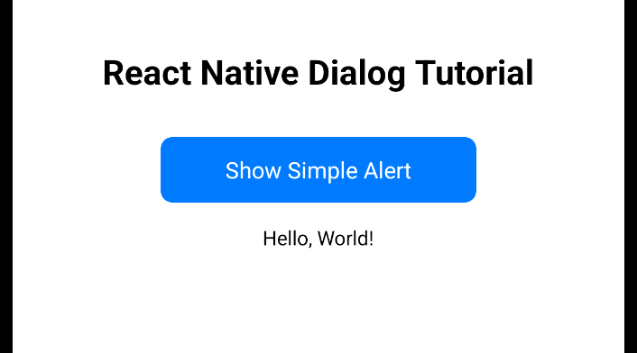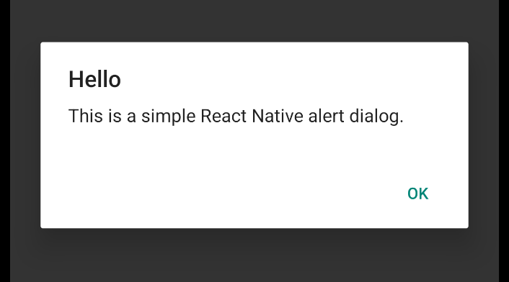

App.tsx
import React, { useState } from 'react';
import { Alert, Pressable, StyleSheet, Text, View } from 'react-native';

export default function App() {
const [someText, setText] = useState("Hello, World!");

const showSimpleAlert = () => {
// alert() only receives title, subtitle and buttons.
Alert.alert(
'Hello',
'This is a simple React Native alert dialog.',
[
{
text: 'OK',
onPress: () => {Alert.alert('Result', 'You pressed okay!')},
},
]
);
};
return (
<View style={styles.container}>
<Text style={styles.title}>React Native Dialog Tutorial</Text>

<Pressable style={styles.button} onPress={showSimpleAlert}>
<Text style={styles.buttonText}>Show Simple Alert</Text>
</Pressable>
<Text>{someText}</Text>
</View>
);
}

const styles = StyleSheet.create({
container: {
flex: 1,
backgroundColor: '#fff',
alignItems: 'center',
justifyContent: 'center',
padding: 20,
},
title: {
fontSize: 24,
marginBottom: 30,
fontWeight: 'bold',
textAlign: 'center',
},
button: {
backgroundColor: '#007AFF',
paddingVertical: 12,
paddingHorizontal: 20,
borderRadius: 8,
marginBottom: 15,
minWidth: 220,
},
buttonText: {
color: 'white',
textAlign: 'center',
fontSize: 16,
},
});

Exercise 2 (2 marks)
Modify the Example 4 code so the dialog displays two buttons as shown at the left in Figure 1. Also change the text that is displayed as shown at the right of Figure 1.

Figure 1: Simple dialog (left). Main screen shows button selected (right).
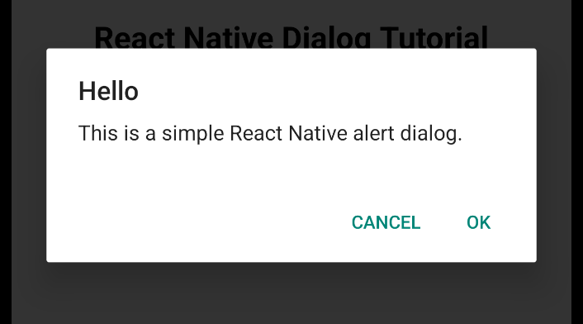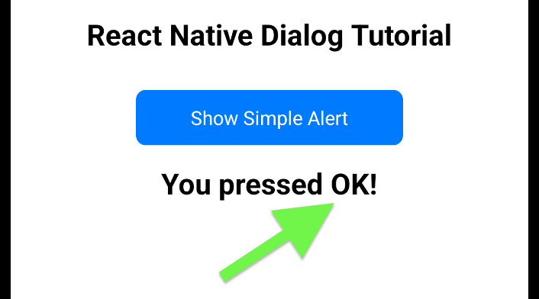

Show all of your revised app.tsx file as text here with proper naming. Show your text with the same styling. No screenshots please.

Modal Dialogs
Modal dialogs appear in front of the screen to require a user response. Unlike alerts, they are fully customizable and allow you to design your own layout, inputs, and buttons.

Example 5: Modal Dialogs
This example presents a modal dialog which requests user text input.
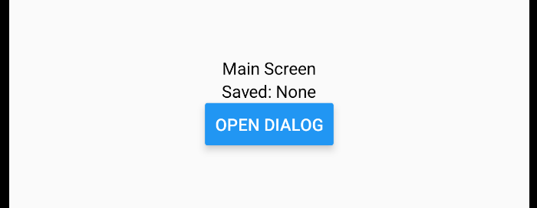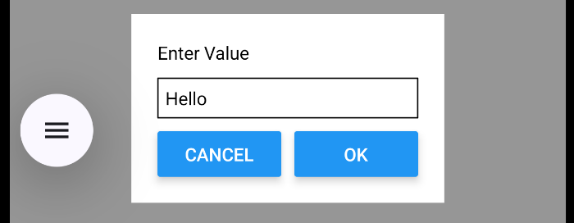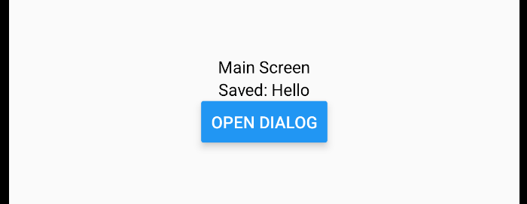

App.tsx
import React, { useState } from 'react';
import { View, Text, Modal, TextInput, Button } from 'react-native';

export default function App() {
const [visible, setVisible] = useState(false);
const [input, setInput] = useState('');
const [saved, setSaved] = useState('');

const handleOk = () => {
setSaved(input);
setVisible(false);
setInput('');
};

return (
<View style={{ flex: 1, justifyContent: 'center', alignItems: 'center',
backgroundColor: 'rgba(0,0,0,0.4)' }}>
<Text>Main Screen</Text>
<Text>Saved: {saved || 'None'}</Text>
<Button title="Open Dialog" onPress={() => setVisible(true)} />

<Modal visible={visible} transparent>
<View style={{ flex: 1, justifyContent: 'center', alignItems: 'center' }}>
<View style={{ backgroundColor: 'white', padding: 20 }}>

<Text>Enter Value</Text>

<TextInput
placeholder="Type here"
value={input}
onChangeText={setInput}
style={{ borderWidth: 1, marginVertical: 10, padding: 5, width: 200 }}
/>

{/* BUTTON ROW */}
<View style={{ flexDirection: 'row', justifyContent: 'space-between' }}>
<View style={{ flex: 1, marginRight: 5 }}>
<Button title="Cancel" onPress={() => setVisible(false)} />
</View>

<View style={{ flex: 1, marginLeft: 5 }}>
<Button title="OK" onPress={handleOk} />
</View>
</View>

</View>
</View>
</Modal>

</View>
);
}

Exercise 3 (4 marks)
Modify the code in Example 5 to include a second text box in React Native. Adjust the modal dialog input and buttons as shown here:
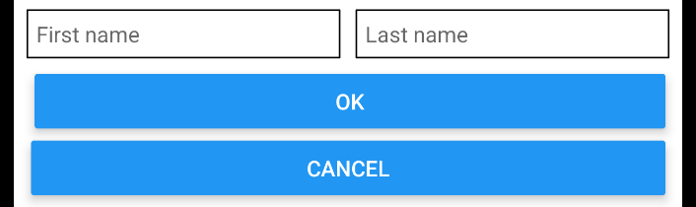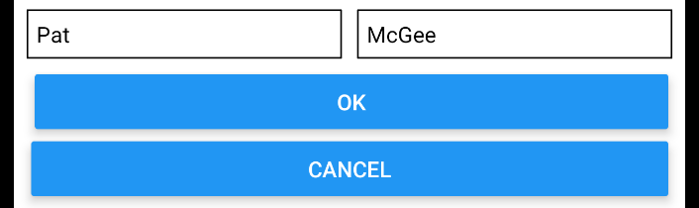
Show all of your code for App.tsx as text with proper naming here. No screenshots please.

Navigation

Tabs, Parent Detail, goBack()
Example 6: Enabling Navigation
This example demonstrates how to set up stack navigation with tabs in React Native and shows how to navigate from a main screen to a detail screen. Run these installs to obtain the required packages.

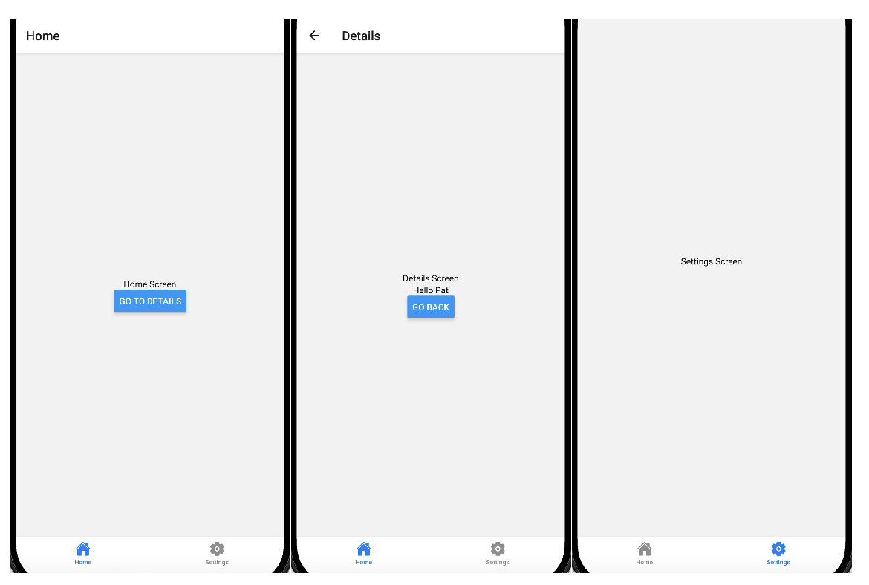

In the same directory as package.json, run these installs to obtain the required packages to enable the navigation and icons.

npx expo install react-native-screens react-native-safe-area-context
npm install @react-navigation/native-stack
npm install @react-navigation/bottom-tabs
npx expo install @expo/vector-icons

App.tsx
import React from 'react';
import { View, Text, Button } from 'react-native';

import { NavigationContainer } from '@react-navigation/native';
import { createNativeStackNavigator } from '@react-navigation/native-stack';
import { createBottomTabNavigator } from '@react-navigation/bottom-tabs';

import { Ionicons } from '@expo/vector-icons';

// TYPES
type RootStackParamList = {
HomeMain: undefined;
Details: { name: string };
};

type TabParamList = {
Home: undefined;
Settings: undefined;
};

const Stack = createNativeStackNavigator<RootStackParamList>();
const Tab = createBottomTabNavigator<TabParamList>();

// HOME SCREEN
function HomeScreen({ navigation }: any) {
return (
<View style={{ flex: 1, justifyContent: 'center', alignItems: 'center' }}>
<Text>Home Screen</Text>

<Button
title="Go to Details"
onPress={() => navigation.navigate('Details', { name: 'Pat' })}
/>
</View>
);
}

// DETAILS SCREEN
function DetailsScreen({ route, navigation }: any) {
const { name } = route.params;

return (
<View style={{ flex: 1, justifyContent: 'center', alignItems: 'center' }}>
<Text>Details Screen</Text>
<Text>Hello {name}</Text>

<Button title="Go Back" onPress={() => navigation.goBack()} />
</View>
);
}

// SETTINGS SCREEN
function SettingsScreen() {
return (
<View style={{ flex: 1, justifyContent: 'center', alignItems: 'center' }}>
<Text>Settings Screen</Text>
</View>
);
}

// STACK inside HOME TAB
function HomeStack() {
return (
<Stack.Navigator>
<Stack.Screen
name="HomeMain"
component={HomeScreen}
options={{ title: 'Home' }}
/>
<Stack.Screen name="Details" component={DetailsScreen} />
</Stack.Navigator>
);
}

// TABS with icons
function MyTabs() {
return (
<Tab.Navigator
screenOptions={({ route }) => ({
headerShown: false,

tabBarIcon: ({ color, size }) => {
let iconName: keyof typeof Ionicons.glyphMap;

if (route.name === 'Home') {
iconName = 'home';
} else {
iconName = 'settings';
}

return <Ionicons name={iconName} size={size} color={color} />;
},
})}
>
<Tab.Screen name="Home" component={HomeStack} />
<Tab.Screen name="Settings" component={SettingsScreen} />
</Tab.Navigator>
);
}

// APP
export default function App() {
return (
<NavigationContainer>
<MyTabs />
</NavigationContainer>
);
}

Exercise 4 (2 marks)
Add an About tab and screen to Example 6. Show all code for App.tsx as text (no screenshots please).
Exercise 5 (1 mark)
What does navigation.goBack() do?
Exercise 6 (1 mark)
What is the difference between the tab navigator and the stack navigator in this example?
Exercise 7 (1 mark)
Why is the HomeStack placed inside the Home tab instead of putting all screens directly in the tab navigator?
Exercise 8 (1 mark)
What would happen if headerShown: false was removed from the tab navigator?

Example 7: Passing Parameters to a Screen
This example provides additional practice working with parameters when navigating between screens. For this example the parameters are set up to be passed to the Settings screen.
Starting with Example 6, modify your tab like this:
<Tab.Screen
name="Settings"
component={SettingsScreen}
initialParams={{
firstName: 'Pat',
studentId: 'A12345',
}} />

The parameter list for settings needs an adjustment:
type TabParamList = {
Home: undefined;
Settings: { firstName: string; studentId: string };
};

The SettingsScreen header needs an adjustment as well.
function SettingsScreen({ route }: any) {
const { firstName, studentId } = route.params;

Exercise 9 (1 mark)
Make the changes described in Example 7. Then modify the SettingsScreen function further to show the first name and studentId on the screen. Show a screenshot of the output after making the changes.

List-Detail View Navigation
Example 8: List Detail View
This example provides practice navigating from a parent screen to a child detail screen using a list-to-detail pattern. In the same directory as package.json run these installs to enable the required navigation.

npx expo install @react-navigation/native
npx expo install react-native-screens react-native-safe-area-context
npx expo install @react-navigation/native-stack

Here are the different components.

DetailScreen.tsx
import { View, Text } from 'react-native';

export default function DetailScreen({ route }: any) {
const { item } = route.params;

return (
<View>
<Text style={{ fontSize: 30 }}>
{item.name}
</Text>
<Text>ID: {item.id}</Text>
</View>
);
}

ListScreen.tsx
import { View, Text, FlatList, TouchableOpacity } from 'react-native';

const data = [
{ id: '1', name: 'Apple' },
{ id: '2', name: 'Banana' },
{ id: '3', name: 'Orange' },
];

export default function ListScreen({ navigation }: any) {
return (
<View>
<FlatList
data={data}
keyExtractor={(item) => item.id}
renderItem={({ item }) => (
<TouchableOpacity
onPress={() =>
navigation.navigate('Detail', { item: item })
}
>
<Text style={{ fontSize: 20, padding: 10 }}>
{item.name}
</Text>
</TouchableOpacity>
)}
/>
</View>
);
}

App.tsx
import { NavigationContainer } from '@react-navigation/native';
import { createNativeStackNavigator } from '@react-navigation/native-stack';

import ListScreen from './ListScreen';
import DetailScreen from './DetailScreen';

const Stack = createNativeStackNavigator();

export default function App() {
return (
<NavigationContainer>
<Stack.Navigator>
<Stack.Screen name="List" component={ListScreen} />
<Stack.Screen name="Detail" component={DetailScreen} />
</Stack.Navigator>
</NavigationContainer>
);
}

Exercise 10 (1 mark)
Modify the code in Example 8 to include a price in the data object. Display the price in the detail screen. Show a screenshot of the output displayed on the detail screen after making this change.

Exercise 11 (1 mark)
What object does the Detail screen use to access the data passed from the previous screen?

Exercise 12 (1 mark)
What is the purpose of TouchableOpacity?

Conclusion
I hope you can see how straightforward it is to set up a mobile application, whether using a native framework or a cross-platform framework like Flutter, Kotlin, or React Native. These frameworks are quite similar in many ways, and once you begin working on a real project, your skills will grow as you deepen your focus. This course is intended to give you a foundation and an understanding of how these tools work, so you can adapt and build whatever application is required.

