Table of Contents
Using a Data Store 1
Reading and Writing Asynchronously with Flow 1
Creating a Custom App / Launcher Icon for Kotlin Apps 5
Creating the SVG 5
Importing the SVG 5
Setting the App Icon Label 6
Creating a Splash Screen in Kotlin 7
Adding the Dependency 7
Creating a Splash Screen Logo 7
Importing the Splash Screen 8
Setting the Splash Screen Theme 9

Using a Data Store
Kotlin’s data store mechanism is useful for storing small amounts of data such as user preferences for an app. Using the data store avoids the complicated setup of a full database.

Example 1: Data Store
This example demonstrates how to create a data store to save a name (see Figure 1).

Figure 1: Enabling a Dynamic Data Store
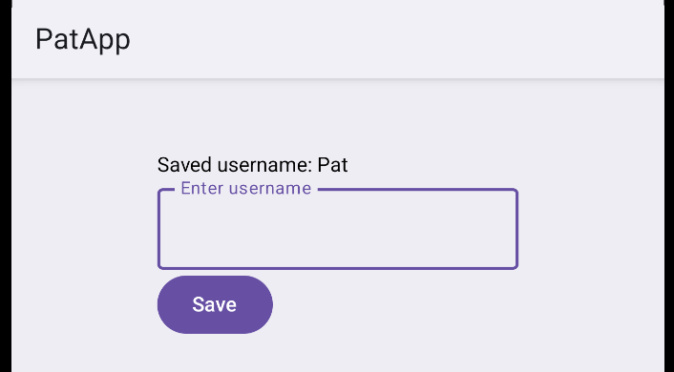

In the app level build.gradle file add the following implementation to the dependencies section:
implementation("androidx.datastore:datastore-preferences:1.1.1")

Remember to click Sync Now to prompt Android Studio to add the dependency to the project.

Reading and Writing Asynchronously with Flow
The code in SettingsStore.kt stores data in key value pairs where unique keys are used to reference each value that is stored.

SettingsStore.kt implements uses Flow to provide asynchronous reads and writes. Kotlin recommends using Flow with data store so changes can be read reactively. To read something reactively means you don’t ask for the data every time. Instead, the data pushes updates to you whenever it changes.

Tip: Remember not to delete the project package name when this code is added to the Kotlin file in your project.

SettingsStore.kt
import android.content.Context
import androidx.datastore.preferences.core.*
import androidx.datastore.preferences.preferencesDataStore
import kotlinx.coroutines.flow.map
import kotlinx.coroutines.flow.Flow

// Create DataStore attached to the Context
val Context.dataStore by preferencesDataStore("settings")

// Keys
private val USERNAME_KEY = stringPreferencesKey("username")

class SettingsRepository(private val context: Context) {

// Read value (Flow)
val usernameFlow: Flow<String> = context.dataStore.data.map { prefs ->
prefs[USERNAME_KEY] ?: ""
}

// Save value (suspend)
suspend fun saveUsername(name: String) {
context.dataStore.edit { prefs ->
prefs[USERNAME_KEY] = name
}
}
}

This code defines the screen that is displayed in Figure 1.

UserNameScreen.kt
@Composable
fun UsernameScreen(repo: SettingsRepository) {
val scope = rememberCoroutineScope()

// Observe stored username
val username by repo.usernameFlow.collectAsState(initial = "")

var input by remember { mutableStateOf("") }

Column(modifier = Modifier.padding(100.dp)) {
Spacer(modifier = Modifier.height(60.dp))
Text("Saved username: $username")

OutlinedTextField(
value = input,
onValueChange = { input = it },
label = { Text("Enter username") }
)

Button(
onClick = {
scope.launch {
repo.saveUsername(input)
input = ""
}
}
) {
Text("Save")
}
}
}

Finally, MainActivity.kt implements the DataStore interface by passing an instance of the repository to the composable.

MainActivity.kt
class MainActivity : ComponentActivity() {

override fun onCreate(savedInstanceState: Bundle?) {
super.onCreate(savedInstanceState)
enableEdgeToEdge()
val repo = SettingsRepository(this)
setContent {
UsernameScreen(repo)
}
}
}

Exercise 1 (1 mark)
How do we attach DataStore to the app Context?

Exercise 2 (1 mark)
What is stringPreferencesKey and why is it used?

Exercise 3 (1 mark)
What other types of preference keys exist?

Exercise 4 (1 mark)
What is Flow and why is it used?

Exercise 5 (1 mark)
Why is context passed into the SettingsRepository?

Exercise 6 (1 mark)
Show how the username is declared in the composable and explain how it is assigned the data store value when the repository does not have a specific function to retrieve the value from storage.

Exercise 7 (1 mark)
What UI behavior would you expect when usernameFlow changes?

Exercise 8 (1 mark)
What advantage does the data store have over a Room database?

Exercise 9 (4 marks)
Modify Example 1 to enable the storage of both a first name and last name. Each name must be stored separately. Show your revised SettingsStore.kt and UserNameScreen.kt file here:

Creating a Custom App / Launcher Icon for Kotlin Apps
Example 2: Creating an App Icon
This next section will discuss how to create an app icon for the mobile home screen like the one below. (When you complete this example, create an icon with your name and an animal that starts with the first letter of your name).

Figure 2: Viewing the App (Launcher) Icon
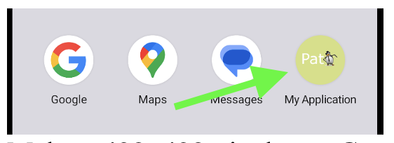

Depending on the manufacturer, the home screen icon can take on varying shapes from rounded to squared.
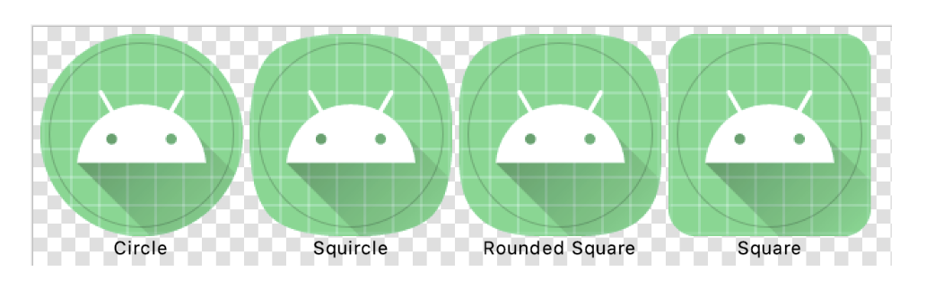
Fortunately, Kotlin can use adaptive icons that are created in SVG format to manage the different size, shape and densities for us on new and old devices.

Creating the SVG
One way to create a suitable SVG involves making a 432x432 pixel image in *.png format. The image can then be converted to SVG at https://vectorise.me/.

Importing the SVG
After downloading the *.svg, from the Android Studio resource manager choose to add an image asset to import the *.svg into the project.

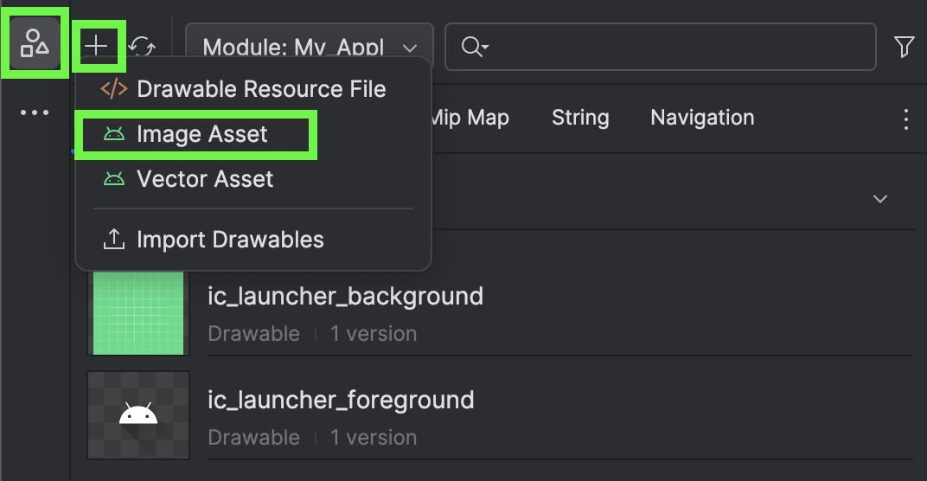

Keep the settings shown below and make sure the name is ic_launcher and that the Layer name is set to ic_launcher_foreground.

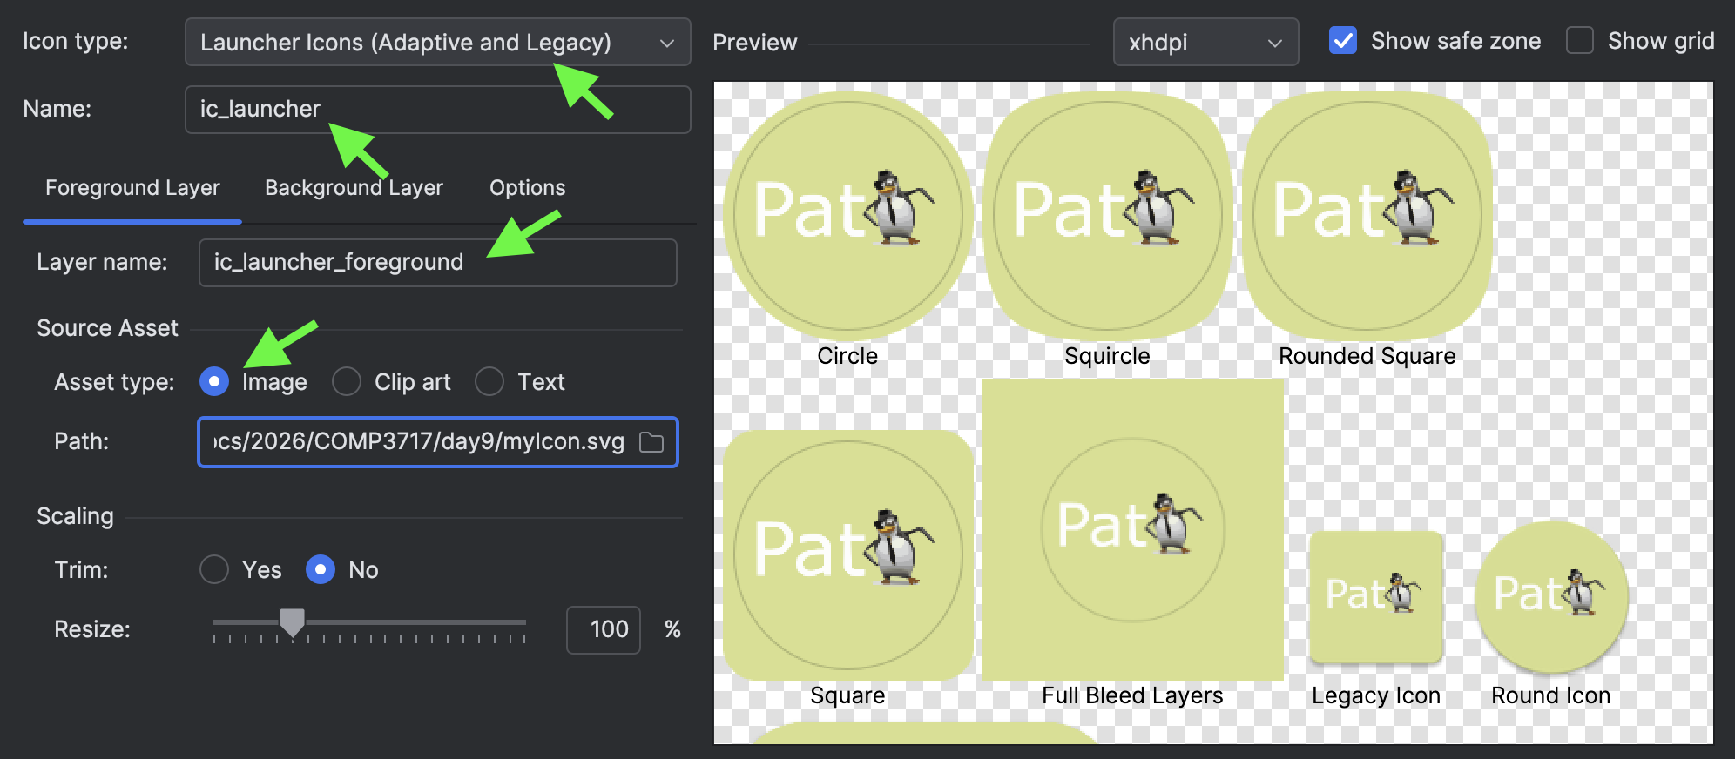
Select all defaults to complete the app icon import into the appropriate mipmap folders within the res directory.

After building and running the app, an app icon like the one in Figure 2 will appear on the home screen.

Setting the App Icon Label
Example 3: Setting the App Icon Label
This example shows how to set the app icon label. For my case, I labeled it PatApp.

Figure 3: Custom App Icon with Custom Name
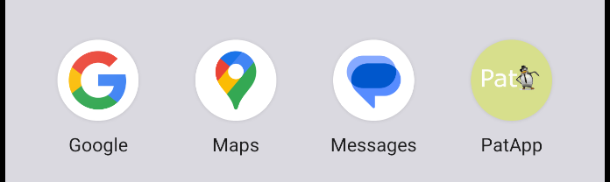

The app name that appears on the Android home screen is set by adjusting app_name element in the strings.xml file.
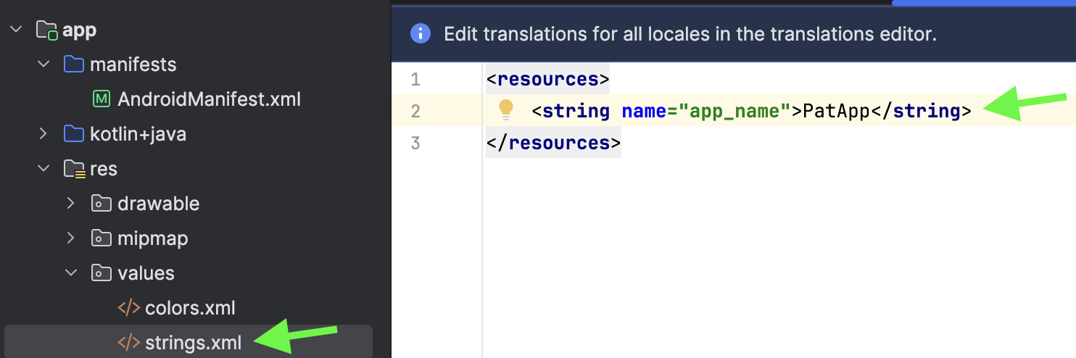

After building and running your project, a suitably named app icon will now be visible on the home screen like the one in Figure 3.

Exercise 10 (4 marks)
Set the app name to your name. In the icon, include an image of an animal that has the same first letter as your name. Show a screenshot of your app icon on the homescreen of the emulator here:

Creating a Splash Screen in Kotlin

In modern Android Kotlin apps, the officially recommended way to create a splash screen is to use the Android 12+ SplashScreen API. SplashScreen API works in current and old phones back to Android 5.0+ (2014).

Example 4: Creating a Splash Screen
This example describes how to create a splash screen with a grey background. (When you do this create a logo with your name and an animal that starts with the first letter of your name).

Figure 4: Viewing the splash screen during an app launch


Adding the Dependency
To enable the splash screen, add this implementation within the dependencies section of the app level build.gradle.kt file:
implementation("androidx.core:core-splashscreen:1.0.1")

Remember to click Sync Now after adding the dependency implementation.

Creating a Splash Screen Logo
For splash screens, Google recommends creating a logo with a transparent background. Table 1 shows guidelines for creating a splash screen logo.
Table 1: Splash Screen Guidelines
Setting | Recommendation
Format | SVG’s are recommended because they scale cleanly across different screens with different densities.
Canvas size | 512×512 or 1024×1024 (1024 recommended for clarity)
Safe area | Keep main icon inside 70–80% of canvas
Padding | ~10–15% around edges
No background | Transparent background (Android sets fill color)

Given the guidelines in Table 1, I recommend creating a 1024x1024 logo with appropriate safe area, padding and no background. The image could be like the one in Figure 5 but with your name instead and an animal that has the same first letter as your name.

Figure 5: Logo with no background


If you save the file as a png it can be converted to svg at https://vectorise.me/ .

Importing the Splash Screen
From the resource manager, import the splash screen as a drawable.

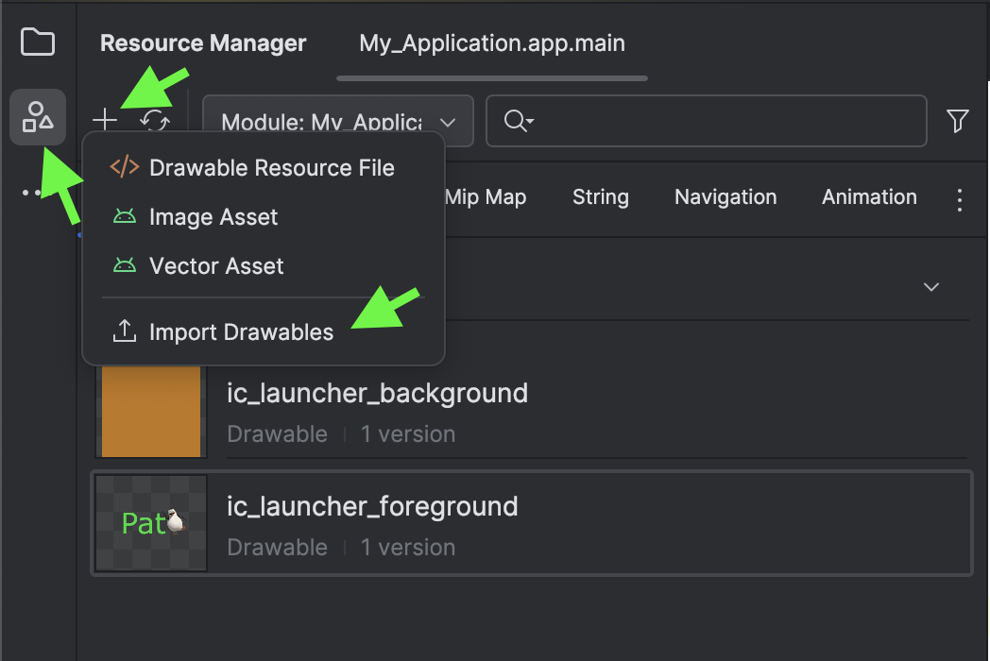

Be sure to name the splash screen as mysplash.

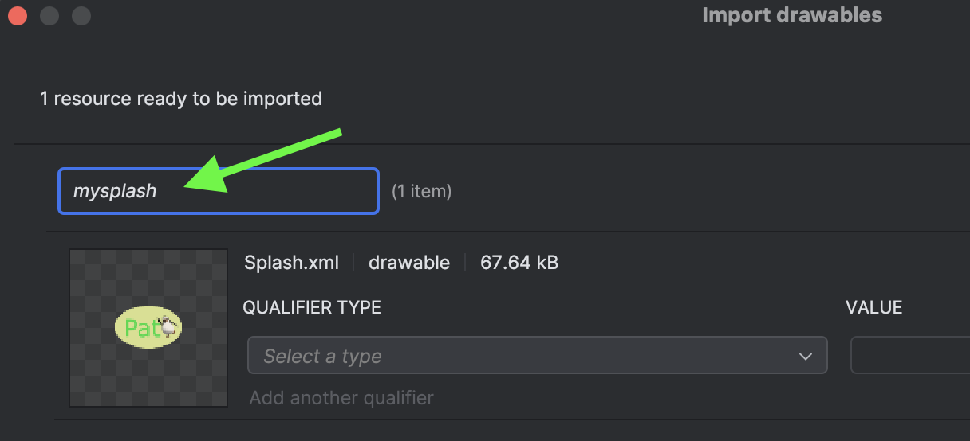

Setting the Splash Screen Theme
The splash screen theme can set the splash screen drawable reference and background color. To do this, navigate to res | values | themes.xml.

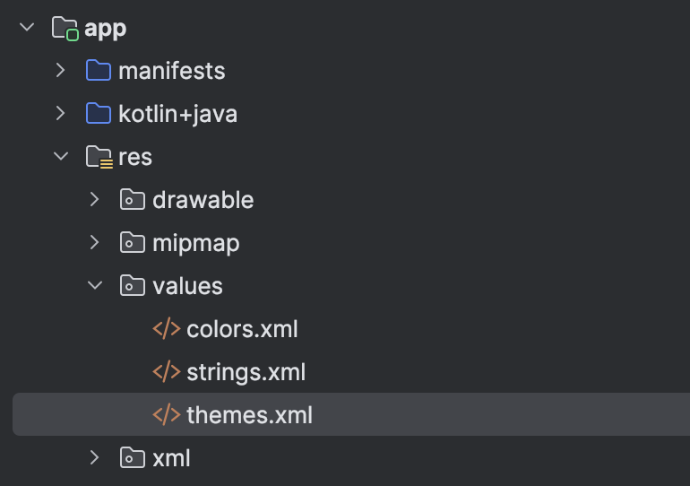

In themes.xml, add this new style element with the name attribute of MySplashScreenTheme. The application theme actually needs to be the name of your application since it was generated when your app project was created. The application theme name should already be present in an existing style tag like the second style element below.
<?xml version="1.0" encoding="utf-8"?>
<resources>
<style name="MySplashScreenTheme" parent="Theme.SplashScreen">
<item name="windowSplashScreenAnimatedIcon">@drawable/mysplash</item>
<item name="windowSplashScreenBackground">#999999</item>
<item name="postSplashScreenTheme">@style/Theme.MyApplication</item>
<item name="windowSplashScreenIconBackgroundColor">#000000</item>=
</style>

<style name="Theme.MyApplication" parent="android:Theme.Material.Light.NoActionBar" />
</resources>

After creating the theme, modify the AndroidManifest.xml file so it references the MySplashScreenTheme.
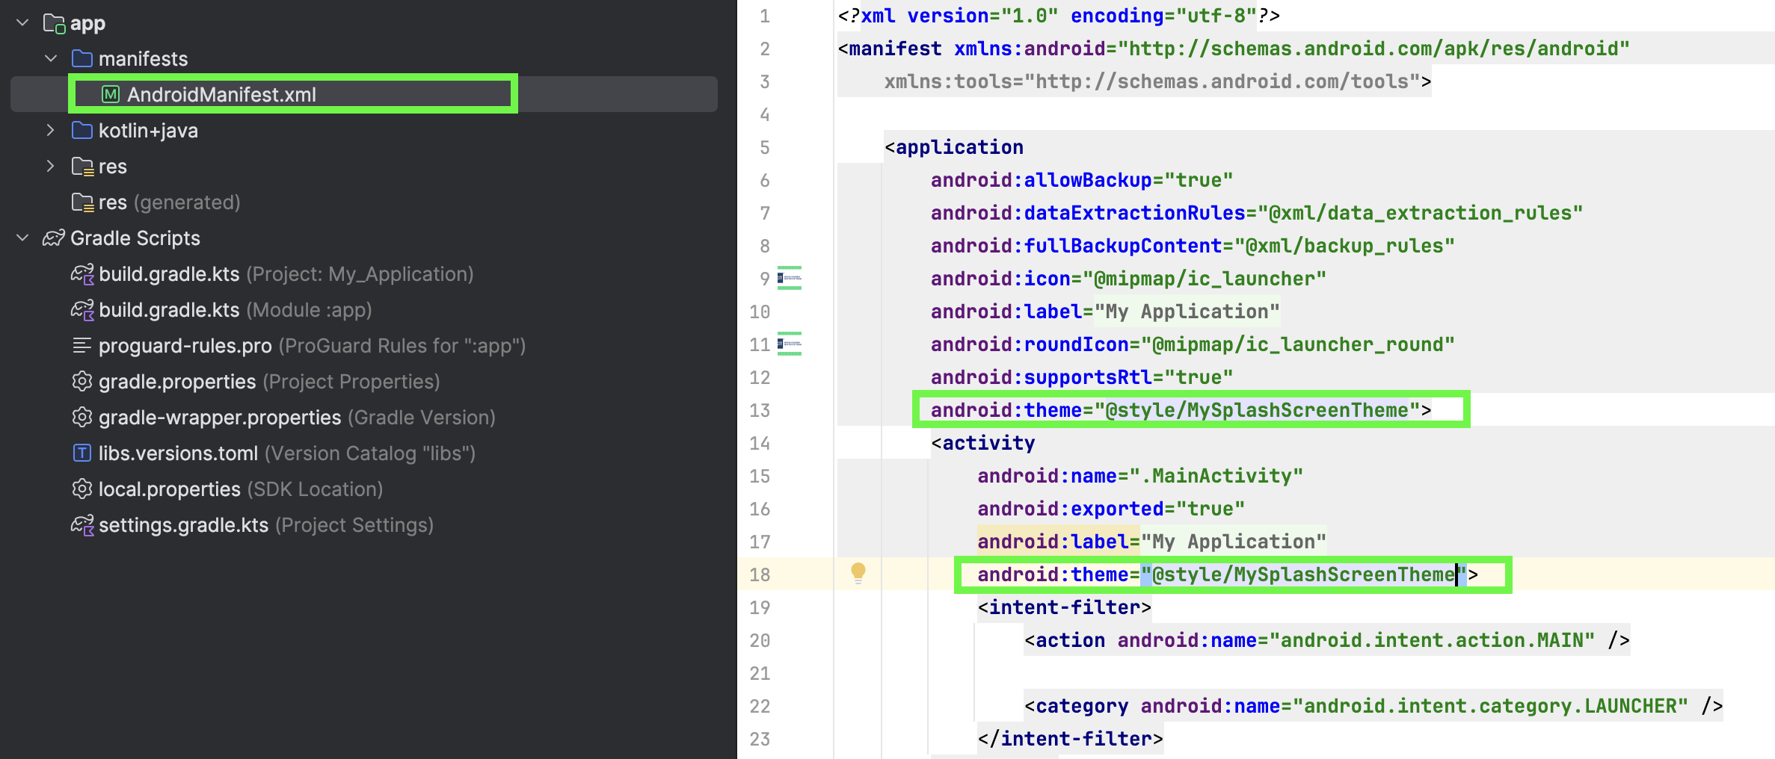

Next, create the SplashViewModel class in SplashViewModel.kt to launch the splash screen. For exaggeration, this file displays the splash screen for 10 seconds so you likely will want to shorten this duration before deploying the app.
class SplashViewModel : ViewModel() {
private val mutableStateFlow = MutableStateFlow(true)
val isLoading = mutableStateFlow.asStateFlow()

init {
viewModelScope.launch {
delay(10000)
mutableStateFlow.value = false
}
}
}

Finally, modify MainActivity.kt to launch the splash screen. Instructions which enable the custom splash screen are highlighted.
class MainActivity : ComponentActivity() {
private val viewModel: SplashViewModel by viewModels()

override fun onCreate(savedInstanceState: Bundle?) {
val splashScreen = installSplashScreen()
super.onCreate(savedInstanceState)
enableEdgeToEdge()
splashScreen.setKeepOnScreenCondition{viewModel.isLoading.value}
setContent {
MyApplicationTheme {
Scaffold(modifier = Modifier.fillMaxSize()) { innerPadding ->
Greeting(
name = "Android",
modifier = Modifier.padding(innerPadding)
)
}
}
}
}
}

@Composable
fun Greeting(
name: String,
modifier: Modifier = Modifier
) {
Text(
text = "Hello $name!",
style = MaterialTheme.typography.headlineMedium,
modifier = modifier
)
}

At this point, your splash screen should launch when you restart the app.

Exercise 11 (4 marks)
Show a screenshot of the launch screen while it is running in your emulator. The splash screen should show your name and an animal that shares the same first letter as your name.

