Rewrite the following Adapter pattern that uses the object-structure using the class-structure.
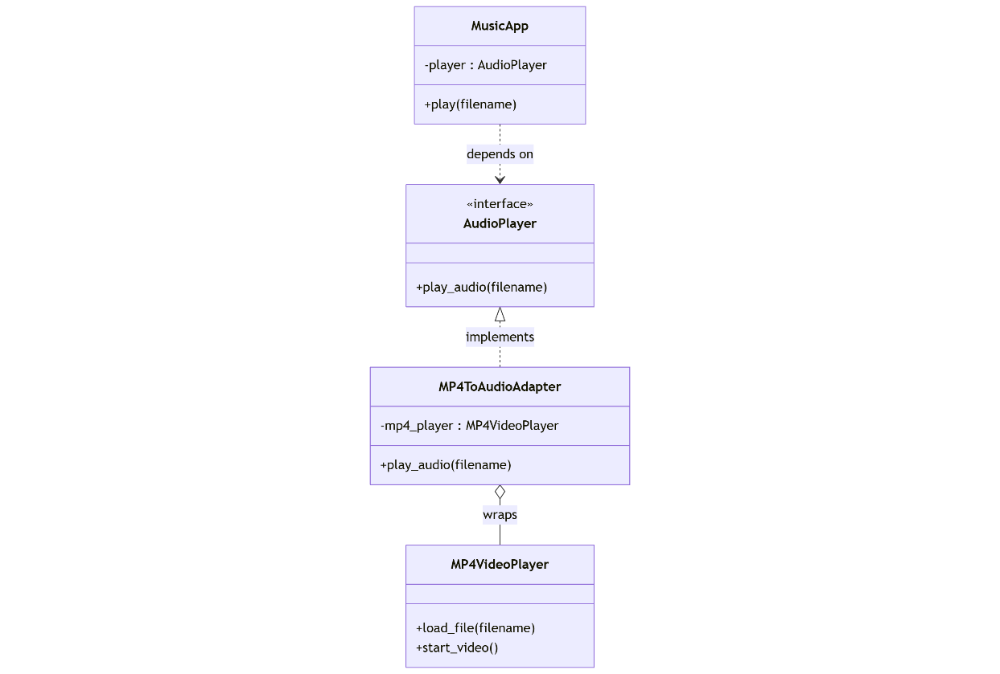
class AudioPlayer(abc.ABC):
@abc.abstractmethod
def play_audio(self, filename: str) -> None:
pass
class MP4VideoPlayer:
"""Adaptee: third-party video player with an incompatible interface."""
def load_file(self, filename: str) -> None:
print(f"[MP4] Loading video file: {filename}")
def start_video(self) -> None:
print("[MP4] Playing video...")
class MusicApp:
"""Client that works with objects implementing the AudioPlayer interface."""
def __init__(self, player: AudioPlayer):
self.player = player
def play(self, filename: str) -> None:
print(f"[MusicApp] Request to play: {filename}")
self.player.play_audio(filename)
class MP4ToAudioAdapter(AudioPlayer):
"""
Object Adapter:
- Implements the AudioPlayer interface (Target)
- Wraps an MP4VideoPlayer instance (Adaptee)
- Translates play_audio() calls into load_file() + start_video()
"""
def __init__(self, mp4_player: MP4VideoPlayer):
self._mp4_player = mp4_player
def play_audio(self, filename: str) -> None:
print("[Adapter:Object] Adapting audio playback to MP4 video player...")
self._mp4_player.load_file(filename)
self._mp4_player.start_video()
def main():
# Adaptee instance
mp4_player = MP4VideoPlayer()
# Adapter wraps the adaptee
adapter = MP4ToAudioAdapter(mp4_player)
# Client depends only on AudioPlayer interface
app = MusicApp(adapter)
# From the client's point of view, this is just audio playback
app.play("movie_trailer.mp4")
if __name__ == "__main__":
main()

Your Solution:
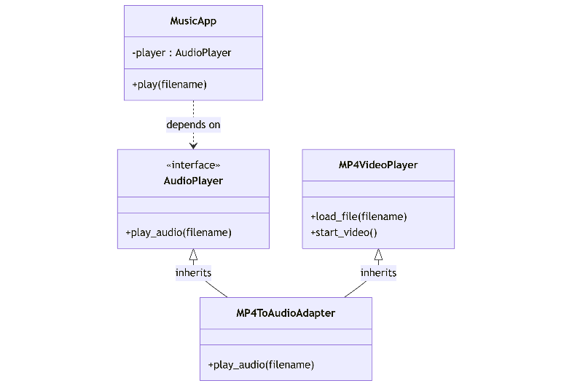
"""
Class Adapter implementation of the Media Player example.
- Target: AudioPlayer
- Adaptee: MP4VideoPlayer
- Adapter: MP4ToAudioAdapter (uses multiple inheritance)
- Client: MusicApp
"""
class AudioPlayer:

class MP4VideoPlayer:

class MusicApp:

class MP4ToAudioAdapter(AudioPlayer, MP4VideoPlayer):

def main():

if __name__ == "__main__":
main()
Output for both versions when run:
[MusicApp] Request to play: movie_trailer.mp4
[Adapter:Class] Adapting audio playback to MP4 video player...
[MP4] Loading video file: movie_trailer.mp4
[MP4] Playing video...

