On Windows, to ensure the emulator appear without a border separately from the IDE like here:
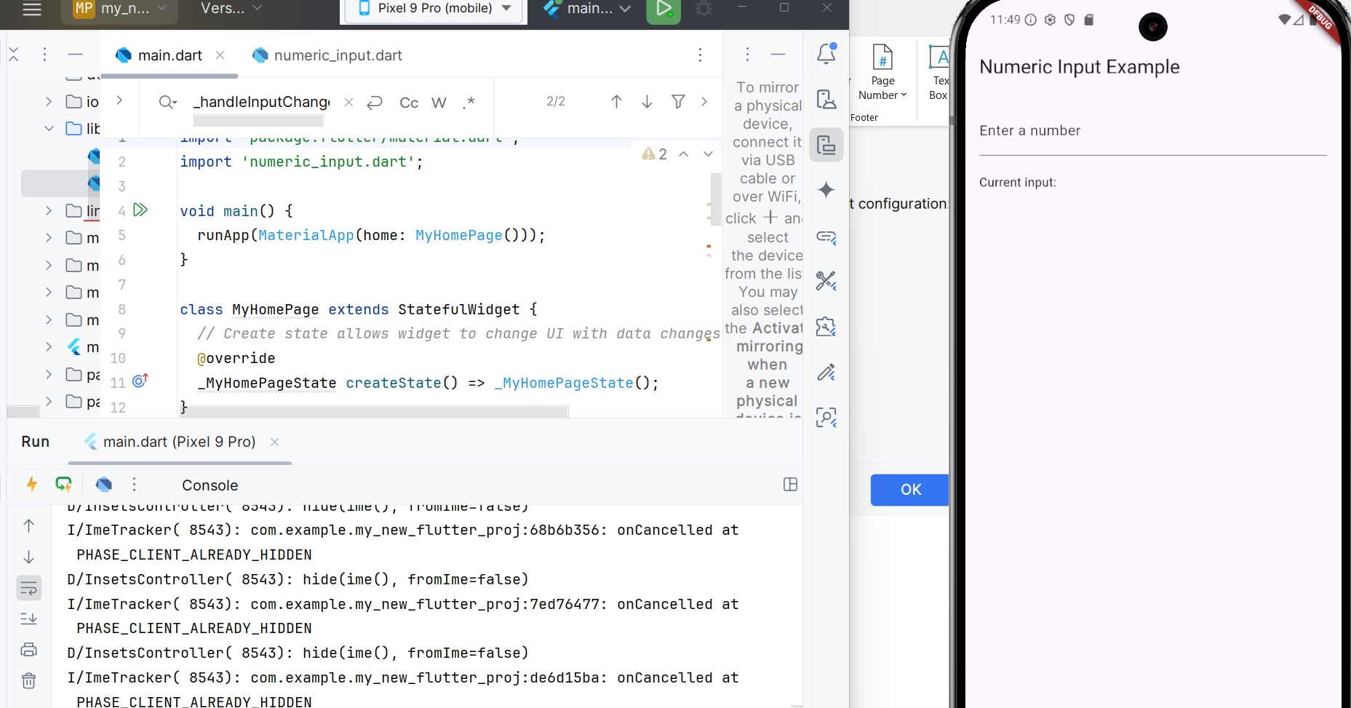

Go to Android Studio | Settings | Tools | Emulator and then deselect Launch in the Running Devices tool window.
