Runwei Azure Services - Internal Technical Documentation

1. Project Overview
This document outlines the Azure-based architecture and services deployed at Runwei to support the ETL automation, data storage, analytics, and RAG (Retrieval-Augmented Generation) system for the Opportunity Data Intelligence Platform. The solution is designed for scalability, fault tolerance, and ease of maintenance.

2. Azure Services in Use
Service | Role | Notes
Azure Data Factory | ETL orchestration | Pipelines for extraction, transformation, and load; scheduled daily.
Azure Blob Storage | Raw data storage | JSON files from API saved with timestamps; intermediate storage optional for RAG inputs.
Azure SQL Database | Data warehouse | Stores transformed opportunity records; primary storage for analytics and AI systems.
Power BI | Visualization | Connects to Azure SQL; dashboards updated daily.
FAISS (On VM or local server) | Vector database | Local FAISS flat index built from SQL exports.
DeepSeek API | Language generation | Used for RAG response generation; API key secured via Azure Key Vault (future plan).
3. ETL Pipeline Details
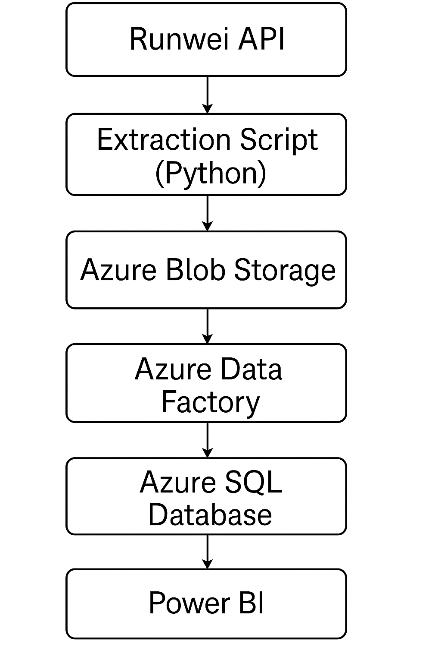
3.1 Extraction
- Source: Runwei API.
- Extraction script: Python (extract_and_upload.py).
- Storage: Files named runwei_opportunities_YYYYMMDD.json saved to Azure Blob Storage.
- Trigger: Task Scheduler on VM; plan to move to Azure Functions.
3.2 Transformation
- Tool: Azure Data Factory (Mapping Data Flow).
- Tasks:
  - Blank strings ("", N/A, n/a) converted to NULL.
  - Date formats standardized (YYYY-MM-DD).
  - Schema enforced for 40+ fields.
3.3 Loading
- Destination: Azure SQL Database (table: [dbo].[Opportunities]).
- Constraints:
  - Primary Key: ID
  - Insert/Update strategy considered for future (currently truncate-load).
3.4 Editing and Creating SQL Tables
To edit and create tables in Azure SQL Database using the web interface:
- Login to Azure Portal and navigate to the RunweiOpportunities SQL database.
- In the left menu, click Query editor.
- Authenticate using either:
  - SQL Server Authentication (sql-admin + password),
* Login: sql-admin ; Password: Runwei2025 (Need add addressIP first time)
- After logging in, you'll see the database structure (tables, views, etc.).
- To create a new table:
  - Click New Query.
  - Enter SQL like below:
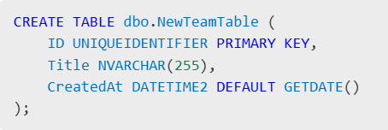
- Click Run to execute.
- Refresh the Tables list to confirm creation.
⚠️ Note: Use dbo. prefix to follow convention.
4. Visualization Layer (Power BI)
- Connected to Azure SQL Database.(* Contact me to acquire permission)
- Main databases:
  - [Opportunities]
  - [Opportunities_cleaned]
- Data refreshed daily automatically.

5. RAG (Retrieval-Augmented Generation) Integration
4.1 Data Preparation
- Export fields: Title, ShortDescription, Eligibility, Tags, Industry, Description from Azure SQL.
- Text concatenated and embedded using sentence-transformer models (all-MiniLM-L6-v2).
5.2 Vector Store
- FAISS Index:
  - Flat index (IndexFlatIP) for maximum retrieval speed.
  - Stored locally; plan to deploy in VM blob storage if scaling is needed.
5.3 Query + LLM
- Top-K (e.g., K=5) nearest neighbors retrieved based on user query embedding.
- Context documents passed to DeepSeek API with a structured prompt.
- DeepSeek returns a summarized or direct answer.

6. Automation and Monitoring
- ADF Pipeline Monitoring:
  - Email alerts for failures (to be integrated with Azure Monitor).
- Blob Storage Cleanup:
  - Older JSON files archived or deleted periodically.
- Manual FAISS Refresh:
  - Currently triggered after daily pipeline; automate with cron job or Azure Function.

7. Best Practices and Future Recommendations
- Move Task Scheduler to Azure Function App for scalable extraction.
- Secure API keys and sensitive parameters using Azure Key Vault.
- Implement delta loading instead of full loads if API supports change tracking.
- Move FAISS deployment onto Azure VM with persistent volume support.
- Explore Azure OpenAI Service as alternative or supplement to DeepSeek for improved cost/performance.

8. Repository and Access
- Extraction Script: /runwei-etl/scripts/extract_and_upload.py
- ADF Pipelines: Azure Data Factory instance Runwei-ADF
- SQL Server: runwei-sql.database.windows.net - Database: OpportunitiesDB
- FAISS RAG Service: (internal use only, repo pending migration)
*Access requires appropriate Azure AD permissions.

