Analyse transcriptomique de V. aestu

Elyna Bouchereau

2023-07-17

## Analyse globale des données transcriptomiques

## Warning in DESeqDataSet(se, design = design, ignoreRank): some variables in  
## design formula are characters, converting to factors

## class: DESeqDataSet   
## dim: 4161 23   
## metadata(1): version  
## assays(1): counts  
## rownames(4161): VAESTLR12016_v1_10001|ID:85464218|yhiN|  
## VAESTLR12016_v1_10002|ID:85464219| ...  
## VAESTLR12016_v1_40034|ID:85468574|leuD|  
## VAESTLR12016_v1_40035|ID:85468575|  
## rowData names(0):  
## colnames(23): X15.1 X15.2 ... XT1 XT3  
## colData names(2): Experiment Condition

## class: DESeqDataSet   
## dim: 4075 23   
## metadata(1): version  
## assays(1): counts  
## rownames(4075): VAESTLR12016_v1_10001|ID:85464218|yhiN|  
## VAESTLR12016_v1_10002|ID:85464219| ...  
## VAESTLR12016_v1_40026|ID:85468566| VAESTLR12016_v1_40032|ID:85468572|  
## rowData names(0):  
## colnames(23): X15.1 X15.2 ... XT1 XT3  
## colData names(2): Experiment Condition

##   
## out of 4075 with nonzero total read count  
## adjusted p-value < 0.05  
## LFC > 0 (up) : 929, 23%  
## LFC < 0 (down) : 967, 24%  
## outliers [1] : 4, 0.098%  
## low counts [2] : 0, 0%  
## (mean count < 0)  
## [1] see 'cooksCutoff' argument of ?results  
## [2] see 'independentFiltering' argument of ?results

##   
## out of 4075 with nonzero total read count  
## adjusted p-value < 0.05  
## LFC > 0 (up) : 75, 1.8%  
## LFC < 0 (down) : 208, 5.1%  
## outliers [1] : 4, 0.098%  
## low counts [2] : 158, 3.9%  
## (mean count < 4)  
## [1] see 'cooksCutoff' argument of ?results  
## [2] see 'independentFiltering' argument of ?results

##   
## out of 4075 with nonzero total read count  
## adjusted p-value < 0.05  
## LFC > 0 (up) : 309, 7.6%  
## LFC < 0 (down) : 413, 10%  
## outliers [1] : 4, 0.098%  
## low counts [2] : 236, 5.8%  
## (mean count < 9)  
## [1] see 'cooksCutoff' argument of ?results  
## [2] see 'independentFiltering' argument of ?results

##   
## out of 4075 with nonzero total read count  
## adjusted p-value < 0.05  
## LFC > 0 (up) : 111, 2.7%  
## LFC < 0 (down) : 77, 1.9%  
## outliers [1] : 4, 0.098%  
## low counts [2] : 236, 5.8%  
## (mean count < 9)  
## [1] see 'cooksCutoff' argument of ?results  
## [2] see 'independentFiltering' argument of ?results

##   
## out of 4075 with nonzero total read count  
## adjusted p-value < 0.05  
## LFC > 0 (up) : 378, 9.3%  
## LFC < 0 (down) : 268, 6.6%  
## outliers [1] : 4, 0.098%  
## low counts [2] : 394, 9.7%  
## (mean count < 34)  
## [1] see 'cooksCutoff' argument of ?results  
## [2] see 'independentFiltering' argument of ?results

##   
## out of 4075 with nonzero total read count  
## adjusted p-value < 0.05  
## LFC > 0 (up) : 23, 0.56%  
## LFC < 0 (down) : 11, 0.27%  
## outliers [1] : 4, 0.098%  
## low counts [2] : 158, 3.9%  
## (mean count < 4)  
## [1] see 'cooksCutoff' argument of ?results  
## [2] see 'independentFiltering' argument of ?results

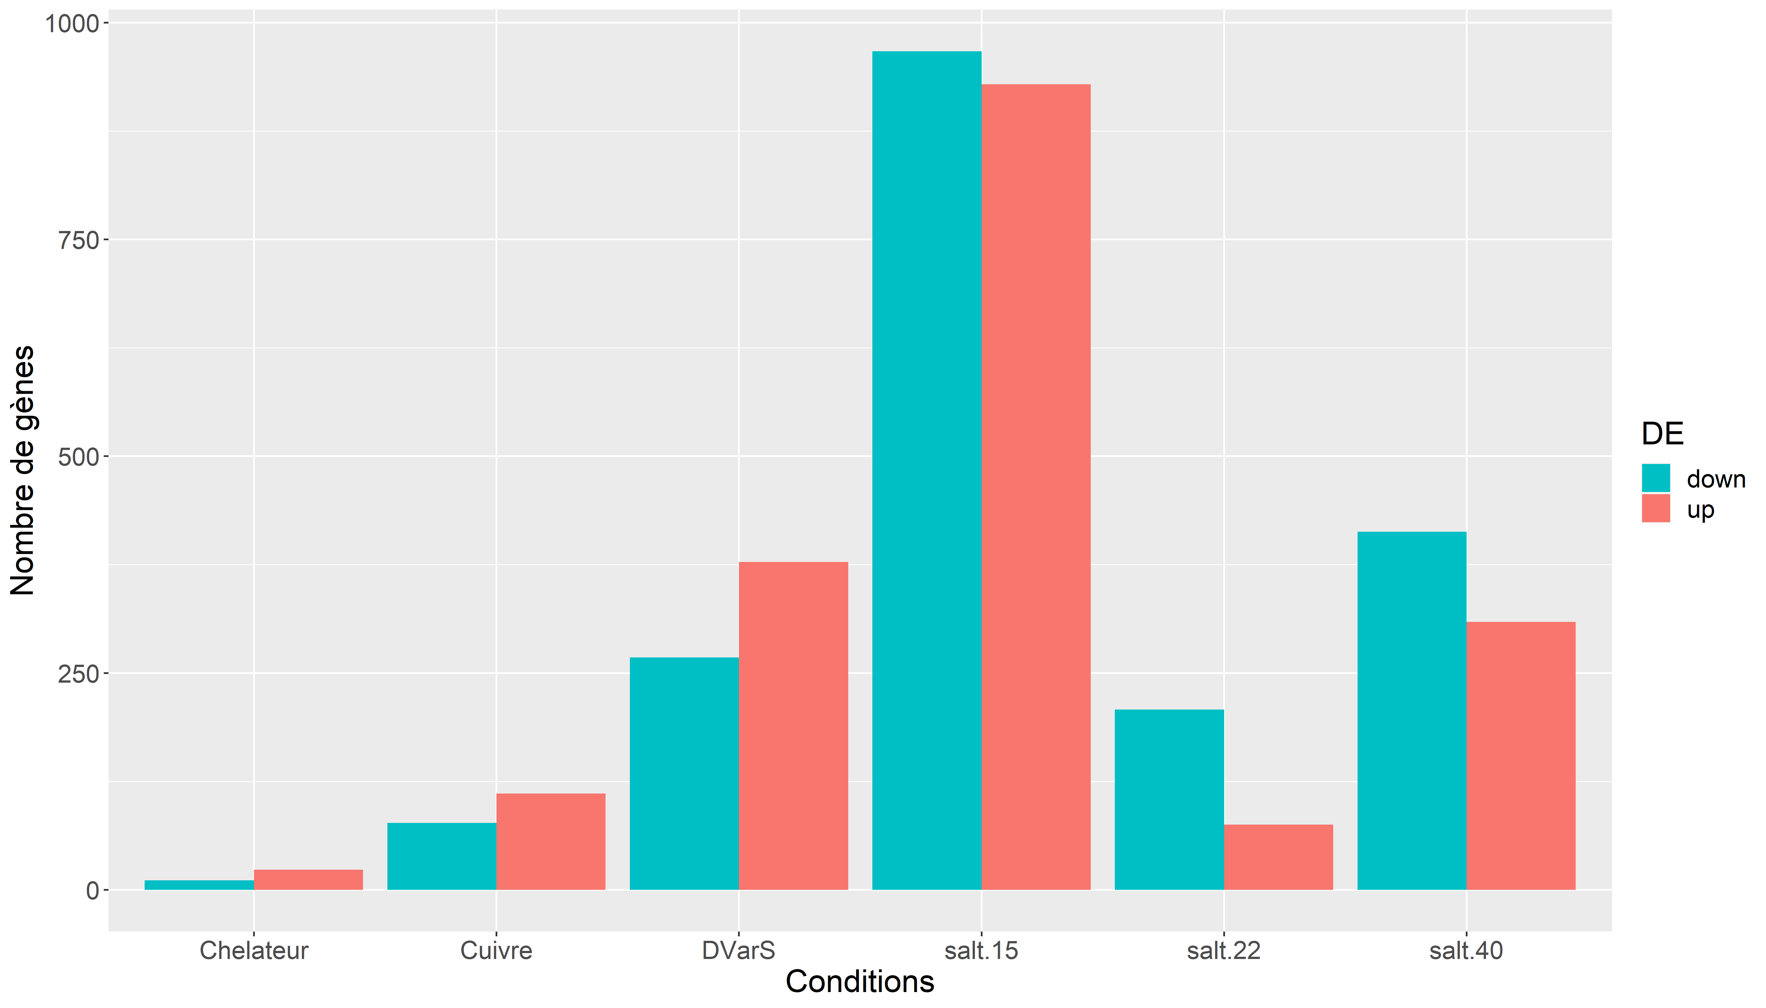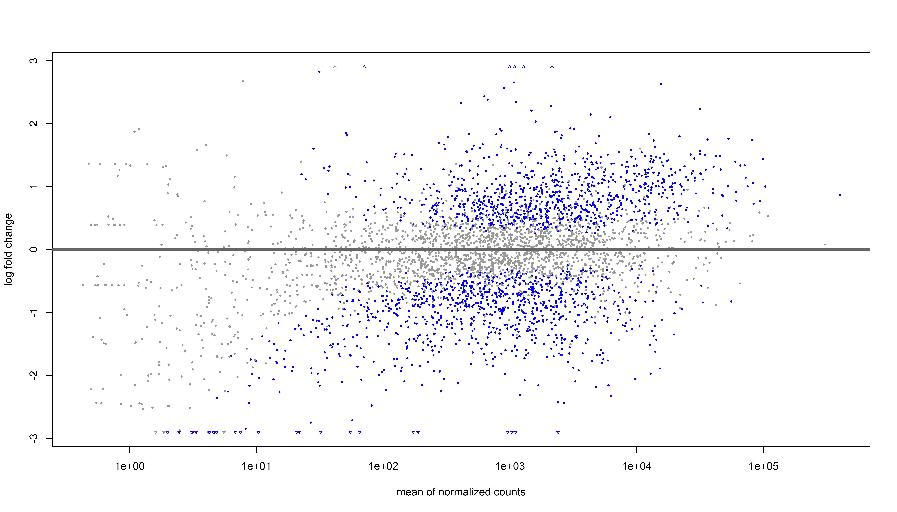

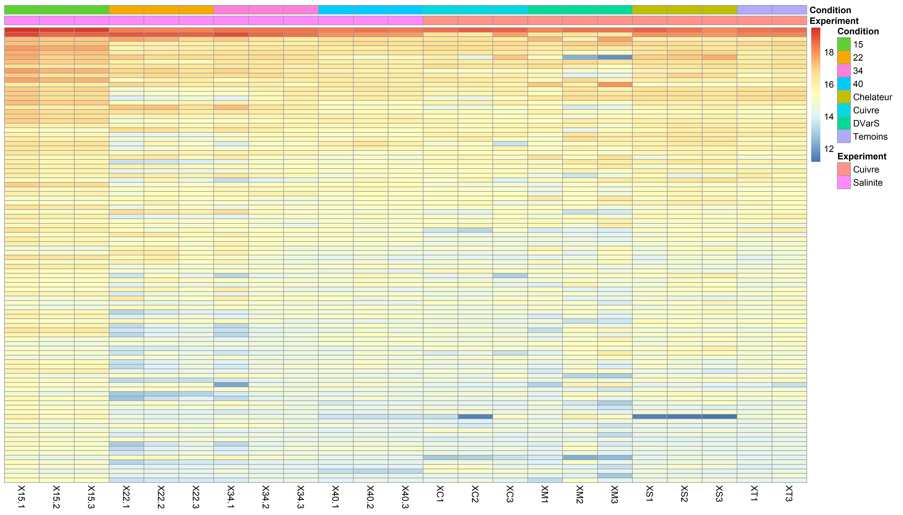

## log2 fold change (MLE): Condition 15 vs 34   
## Wald test p-value: Condition 15 vs 34   
## DataFrame with 1896 rows and 6 columns  
## baseMean log2FoldChange lfcSE  
## <numeric> <numeric> <numeric>  
## VAESTLR12016_v1_10016|ID:85464233| 2396.737 -3.29351 0.1286719  
## VAESTLR12016_v1_10014|ID:85464231|thiG| 960.987 -2.95237 0.1379751  
## VAESTLR12016_v1_10013|ID:85464230|thiH| 1035.180 -3.01948 0.1477503  
## VAESTLR12016_v1_10015|ID:85464232|thiF| 1111.537 -2.97316 0.1501136  
## VAESTLR12016_v1_12495|ID:85466712|ftsQ| 6259.153 -1.32712 0.0891585  
## ... ... ... ...  
## VAESTLR12016_v1_20958|ID:85468118| 5450.5658 0.852260 0.374772  
## VAESTLR12016_v1_12739|ID:85466956|crp| 11592.0710 0.531027 0.233598  
## VAESTLR12016_v1_10277|ID:85464494| 491.7365 -0.393327 0.173036  
## VAESTLR12016_v1_20118|ID:85467278|yclO| 75.8372 -0.574655 0.252862  
## VAESTLR12016_v1_20954|ID:85468114| 304.7004 0.364605 0.160475  
## stat pvalue padj  
## <numeric> <numeric> <numeric>  
## VAESTLR12016_v1_10016|ID:85464233| -25.5962 1.68045e-144 6.84110e-141  
## VAESTLR12016_v1_10014|ID:85464231|thiG| -21.3978 1.39923e-101 2.84812e-98  
## VAESTLR12016_v1_10013|ID:85464230|thiH| -20.4364 7.94273e-93 1.07783e-89  
## VAESTLR12016_v1_10015|ID:85464232|thiF| -19.8060 2.64012e-87 2.68698e-84  
## VAESTLR12016_v1_12495|ID:85466712|ftsQ| -14.8849 4.13144e-50 3.36382e-47  
## ... ... ... ...  
## VAESTLR12016_v1_20958|ID:85468118| 2.27407 0.0229615 0.0494061  
## VAESTLR12016_v1_12739|ID:85466956|crp| 2.27325 0.0230114 0.0494814  
## VAESTLR12016_v1_10277|ID:85464494| -2.27309 0.0230208 0.0494814  
## VAESTLR12016_v1_20118|ID:85467278|yclO| -2.27260 0.0230502 0.0495184  
## VAESTLR12016_v1_20954|ID:85468114| 2.27204 0.0230840 0.0495648

## X15.1 X15.2 X15.3 X22.1  
## VAESTLR12016_v1_10001|ID:85464218|yhiN| 9.749269 9.784472 9.818033 9.839402  
## VAESTLR12016_v1_10002|ID:85464219| 10.330146 10.383468 10.313569 12.352514  
## VAESTLR12016_v1_10003|ID:85464220|uspB| 10.376021 10.427357 10.368671 12.898332  
## X22.2 X22.3 X34.1 X34.2  
## VAESTLR12016_v1_10001|ID:85464218|yhiN| 10.69926 10.68407 9.815357 10.25119  
## VAESTLR12016_v1_10002|ID:85464219| 12.25269 11.84413 12.237774 11.46343  
## VAESTLR12016_v1_10003|ID:85464220|uspB| 12.67594 11.93191 12.103560 11.20463  
## X34.3 X40.1 X40.2 X40.3  
## VAESTLR12016_v1_10001|ID:85464218|yhiN| 10.55364 10.44326 10.714136 10.62249  
## VAESTLR12016_v1_10002|ID:85464219| 11.13502 11.30613 11.415628 11.42636  
## VAESTLR12016_v1_10003|ID:85464220|uspB| 10.75788 10.23375 9.939614 10.35393  
## XC1 XC2 XC3 XM1  
## VAESTLR12016_v1_10001|ID:85464218|yhiN| 9.446174 9.156206 9.67953 9.761407  
## VAESTLR12016_v1_10002|ID:85464219| 10.282624 10.292760 10.76186 10.816548  
## VAESTLR12016_v1_10003|ID:85464220|uspB| 10.519219 10.662057 10.99769 11.302439  
## XM2 XM3 XS1 XS2  
## VAESTLR12016_v1_10001|ID:85464218|yhiN| 9.269511 9.444517 10.05171 10.21042  
## VAESTLR12016_v1_10002|ID:85464219| 9.747710 10.754160 11.51729 11.26047  
## VAESTLR12016_v1_10003|ID:85464220|uspB| 9.623046 11.129399 11.24870 11.04787  
## XS3 XT1 XT3  
## VAESTLR12016_v1_10001|ID:85464218|yhiN| 10.27141 10.33668 10.11339  
## VAESTLR12016_v1_10002|ID:85464219| 11.61854 11.64230 11.33122  
## VAESTLR12016_v1_10003|ID:85464220|uspB| 11.63158 11.34672 11.22412

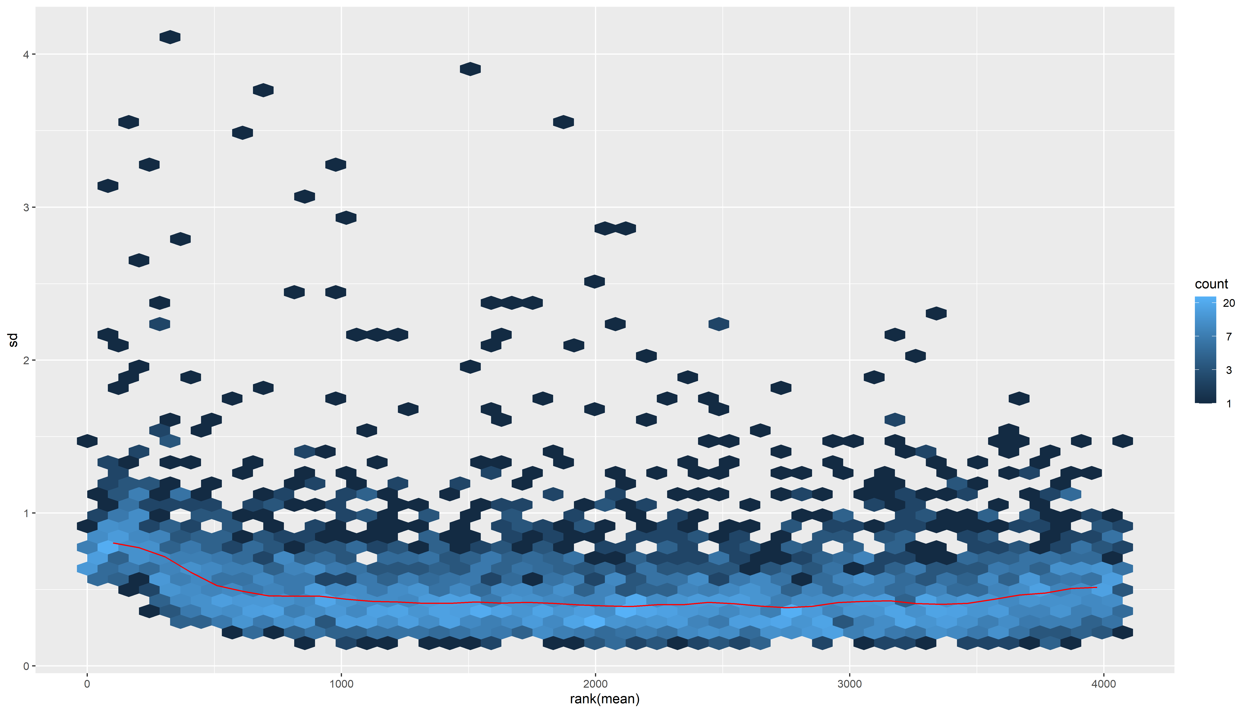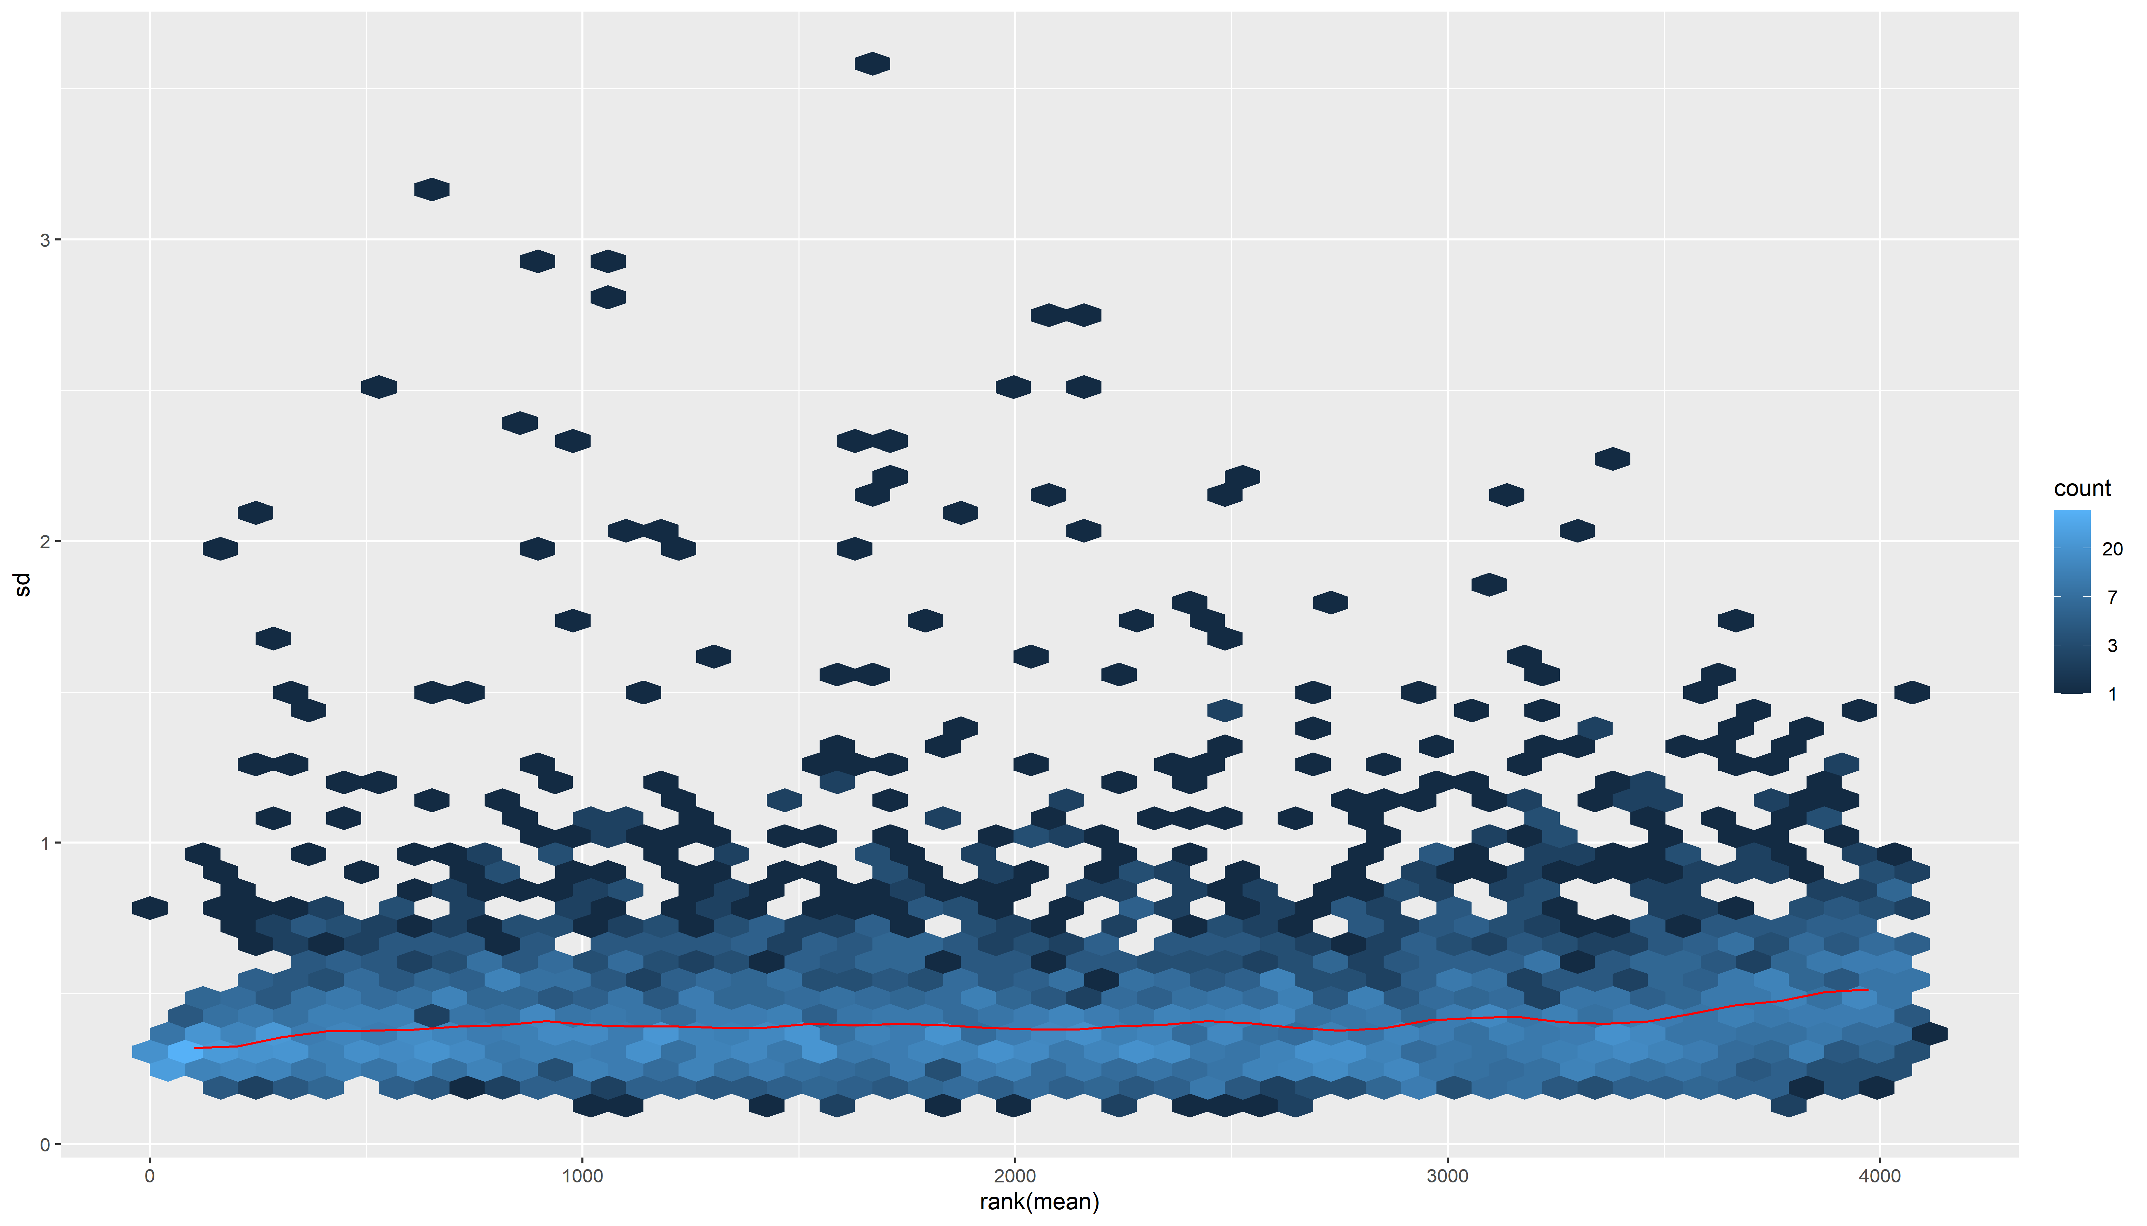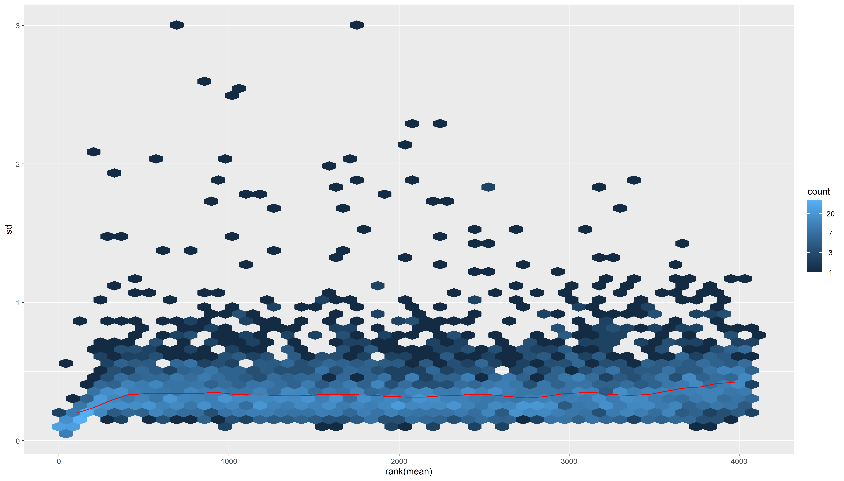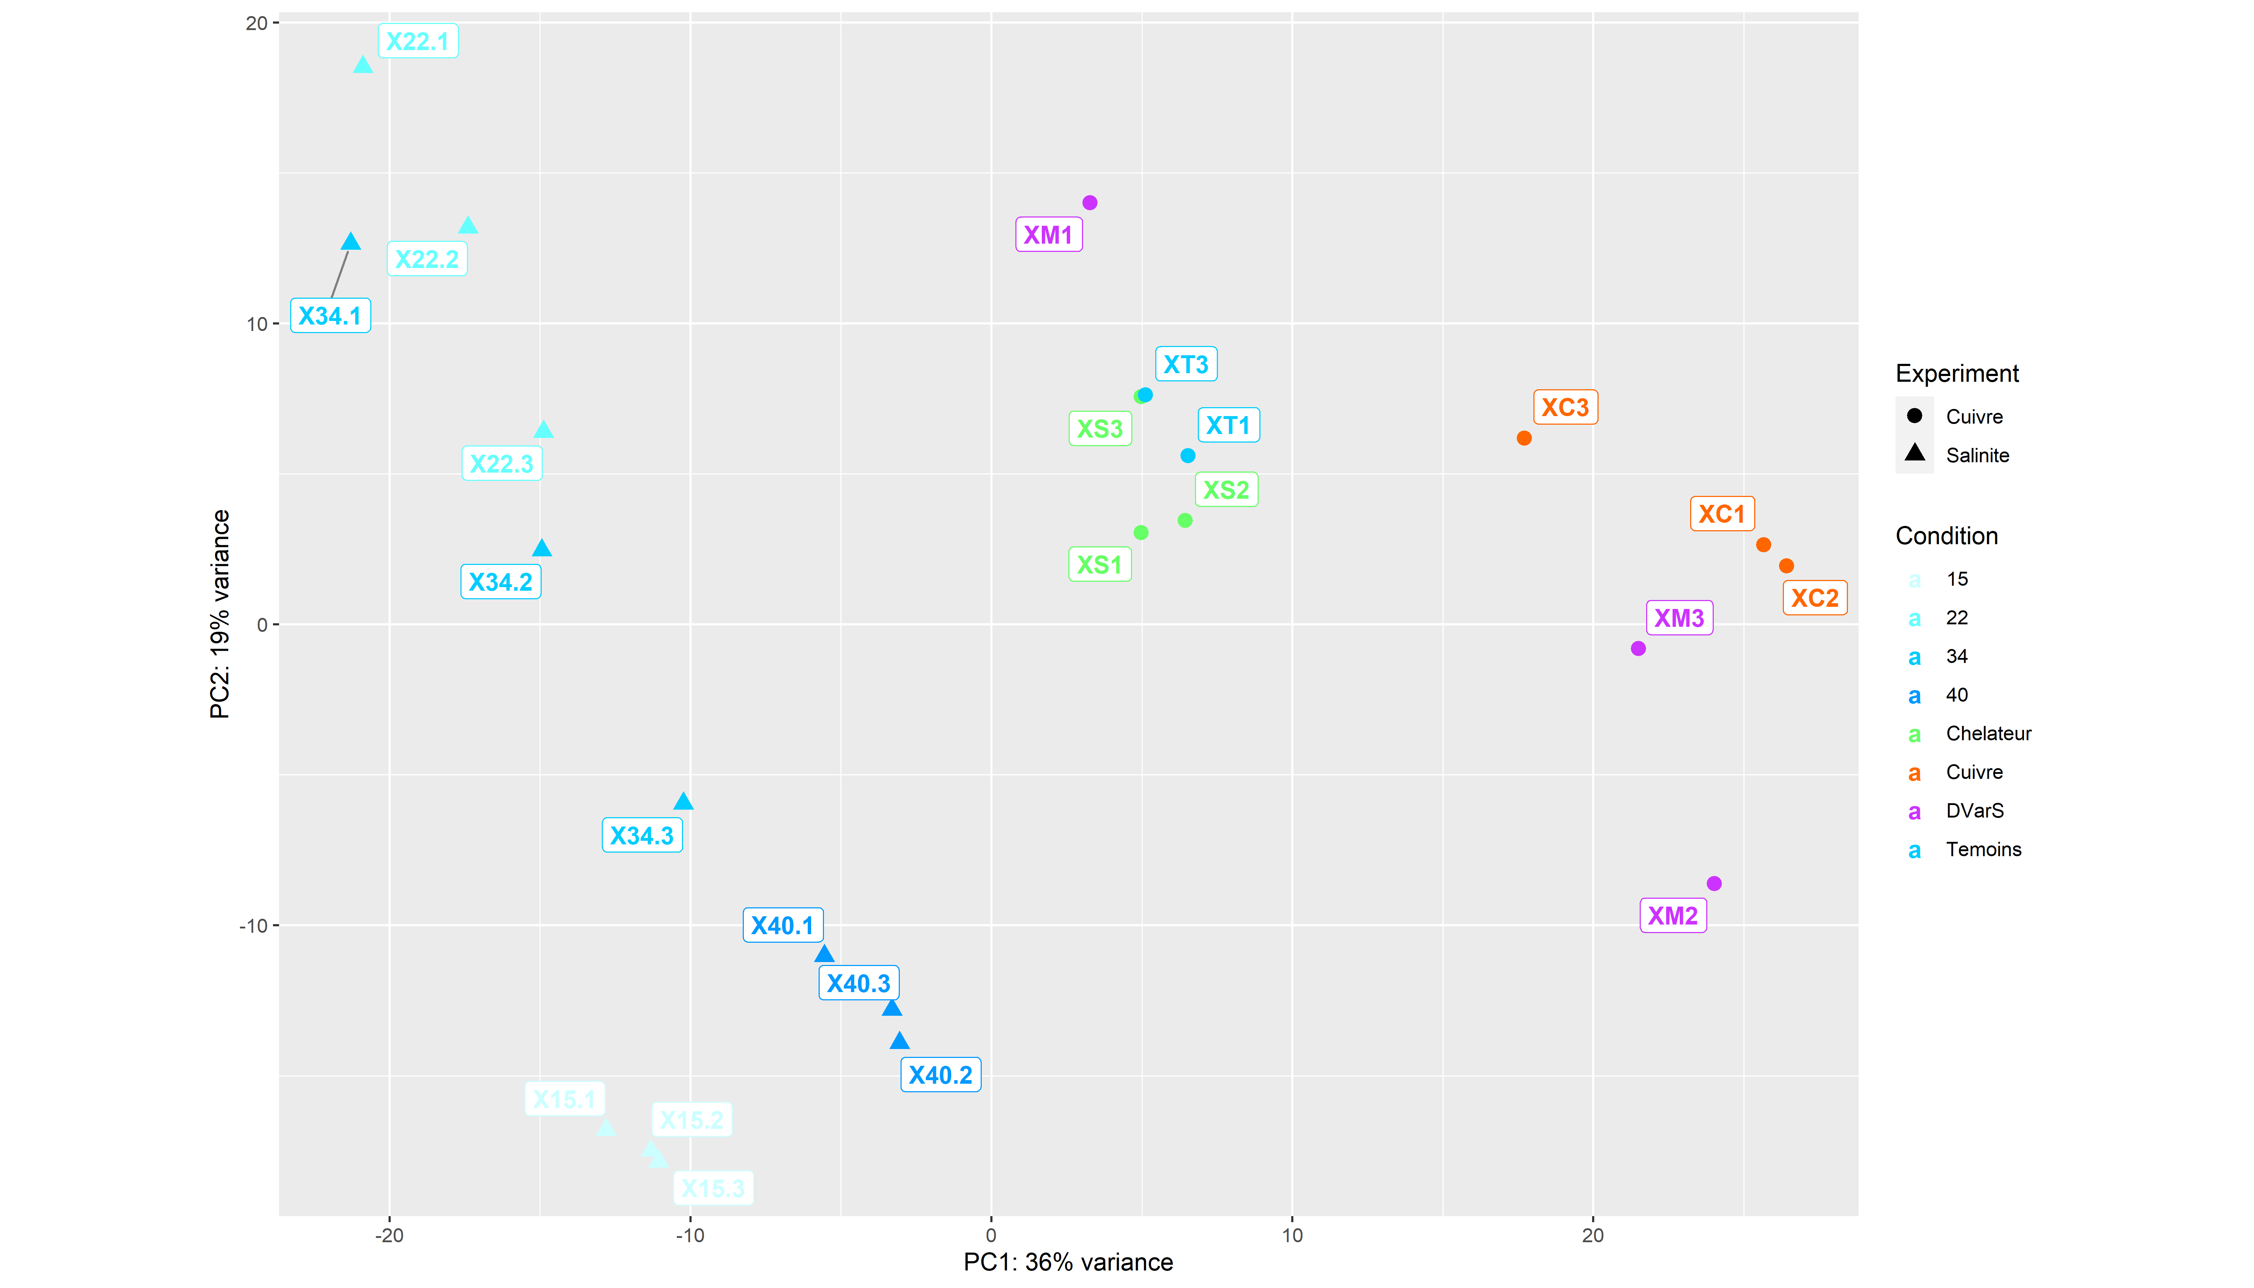

## Warning in brewer.pal(23, "RdBu"): n too large, allowed maximum for palette RdBu is 11  
## Returning the palette you asked for with that many colors

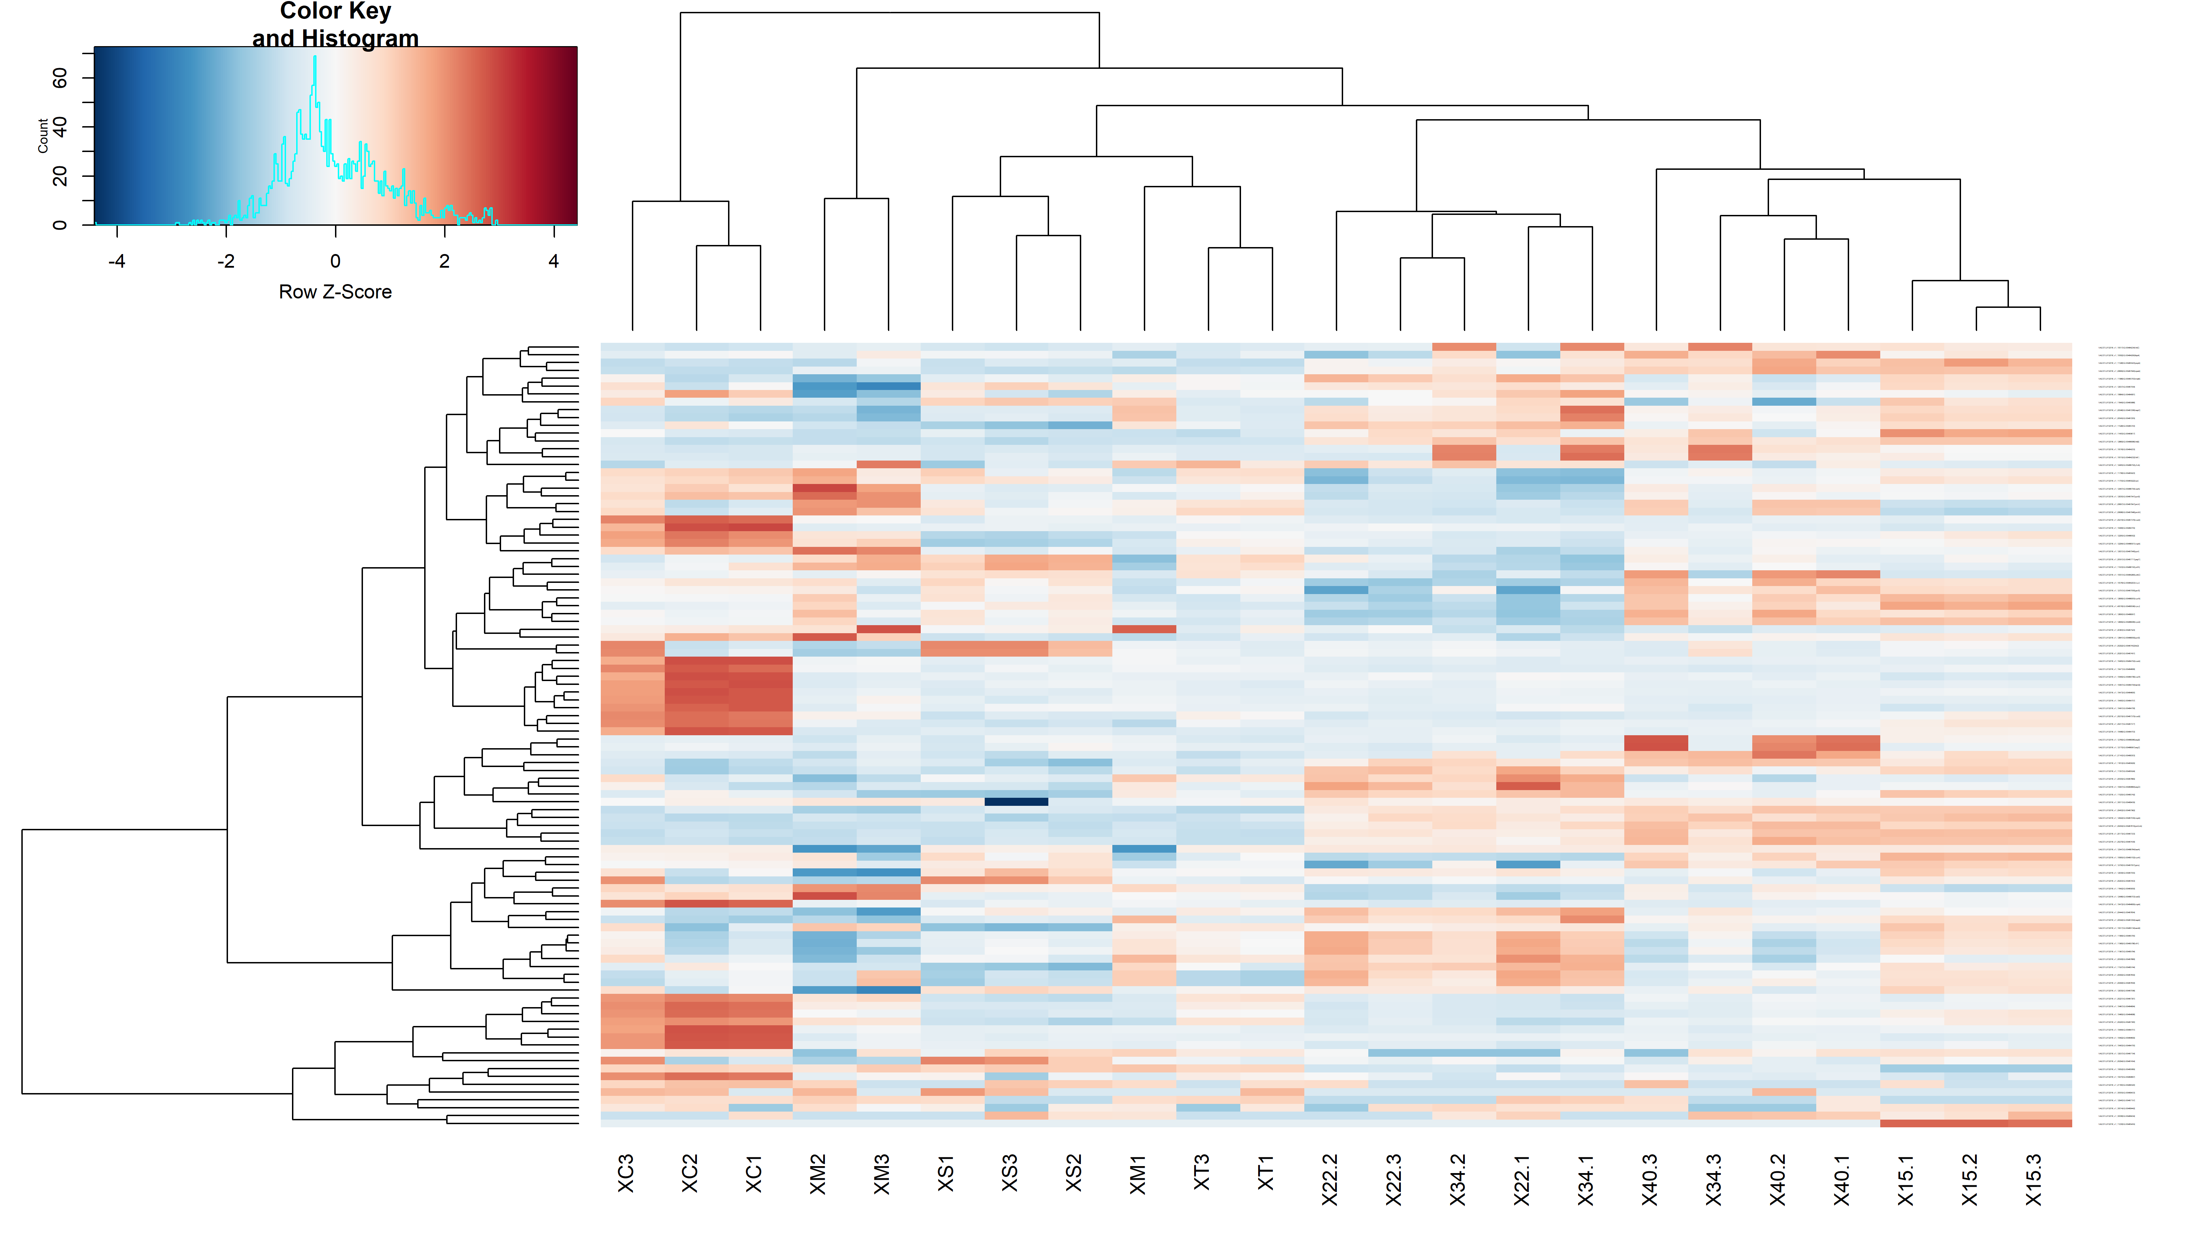

## X15.1 X15.2 X15.3  
## X15.1 0.00000 18.18090 16.57455  
## X15.2 18.18090 0.00000 12.40821  
## X15.3 16.57455 12.40821 0.00000

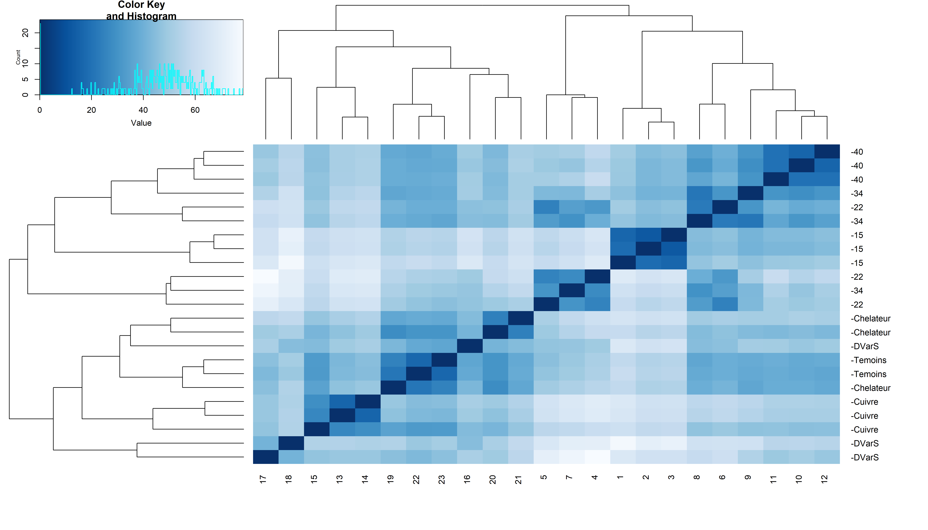

## The study of the copper effect

## [1] TRUE

## [1] TRUE

## Warning in DESeqDataSet(se, design = design, ignoreRank): some variables in  
## design formula are characters, converting to factors

## class: DESeqDataSet   
## dim: 4161 10   
## metadata(1): version  
## assays(1): counts  
## rownames(4161): VAESTLR12016_v1_10001|ID:85464218|yhiN|  
## VAESTLR12016_v1_10002|ID:85464219| ...  
## VAESTLR12016_v1_40034|ID:85468574|leuD|  
## VAESTLR12016_v1_40035|ID:85468575|  
## rowData names(0):  
## colnames(10): XC1 XC2 ... XT1 XT3  
## colData names(2): Experiment Condition

## class: DESeqDataSet   
## dim: 4042 10   
## metadata(1): version  
## assays(1): counts  
## rownames(4042): VAESTLR12016_v1_10001|ID:85464218|yhiN|  
## VAESTLR12016_v1_10002|ID:85464219| ...  
## VAESTLR12016_v1_40026|ID:85468566| VAESTLR12016_v1_40032|ID:85468572|  
## rowData names(0):  
## colnames(10): XC1 XC2 ... XT1 XT3  
## colData names(2): Experiment Condition

## estimating size factors

## estimating dispersions

## gene-wise dispersion estimates

## mean-dispersion relationship

## final dispersion estimates

## fitting model and testing

## log2 fold change (MLE): Condition Cuivre vs Temoins   
## Wald test p-value: Condition Cuivre vs Temoins   
## DataFrame with 190 rows and 6 columns  
## baseMean log2FoldChange lfcSE  
## <numeric> <numeric> <numeric>  
## VAESTLR12016_v1_10471|ID:85464688| 10281.44 6.30650 0.381960  
## VAESTLR12016_v1_10467|ID:85464684| 3326.69 5.03625 0.315176  
## VAESTLR12016_v1_20219|ID:85467379|cusB| 6340.69 4.62291 0.295026  
## VAESTLR12016_v1_20220|ID:85467380| 4770.03 4.36277 0.280283  
## VAESTLR12016_v1_20218|ID:85467378|cusA| 10872.65 4.48892 0.297072  
## ... ... ... ...  
## VAESTLR12016_v1_21171|ID:85468331| 797.577 -0.677959 0.224226  
## VAESTLR12016_v1_10581|ID:85464798| 457.036 -0.777361 0.257182  
## VAESTLR12016_v1_20921|ID:85468081| 561.910 0.874792 0.289485  
## VAESTLR12016_v1_12020|ID:85466237| 283.234 -0.778720 0.257711  
## VAESTLR12016_v1_12487|ID:85466704|carA| 7521.854 1.123745 0.372275  
## stat pvalue padj  
## <numeric> <numeric> <numeric>  
## VAESTLR12016_v1_10471|ID:85464688| 16.5109 3.06400e-61 1.14134e-57  
## VAESTLR12016_v1_10467|ID:85464684| 15.9791 1.78594e-57 3.32632e-54  
## VAESTLR12016_v1_20219|ID:85467379|cusB| 15.6695 2.44391e-55 3.03452e-52  
## VAESTLR12016_v1_20220|ID:85467380| 15.5656 1.24691e-54 1.16118e-51  
## VAESTLR12016_v1_20218|ID:85467378|cusA| 15.1105 1.38037e-51 1.02838e-48  
## ... ... ... ...  
## VAESTLR12016_v1_21171|ID:85468331| -3.02355 0.00249828 0.0495446  
## VAESTLR12016_v1_10581|ID:85464798| -3.02261 0.00250603 0.0495446  
## VAESTLR12016_v1_20921|ID:85468081| 3.02189 0.00251201 0.0495446  
## VAESTLR12016_v1_12020|ID:85466237| -3.02167 0.00251381 0.0495446  
## VAESTLR12016_v1_12487|ID:85466704|carA| 3.01859 0.00253954 0.0497884

## XC1 XC2 XC3 XM2  
## VAESTLR12016_v1_10001|ID:85464218|yhiN| 9.527977 9.233237 9.736264 9.366659  
## VAESTLR12016_v1_10002|ID:85464219| 10.338371 10.329861 10.791116 9.826462  
## VAESTLR12016_v1_10003|ID:85464220|uspB| 10.569829 10.691360 11.023145 9.706068  
## XM3 XS1 XS2 XS3  
## VAESTLR12016_v1_10001|ID:85464218|yhiN| 9.499297 10.09011 10.24055 10.30002  
## VAESTLR12016_v1_10002|ID:85464219| 10.772153 11.52940 11.27139 11.62546  
## VAESTLR12016_v1_10003|ID:85464220|uspB| 11.141509 11.26391 11.06167 11.63838  
## XT1 XT3  
## VAESTLR12016_v1_10001|ID:85464218|yhiN| 10.38007 10.15722  
## VAESTLR12016_v1_10002|ID:85464219| 11.66571 11.35273  
## VAESTLR12016_v1_10003|ID:85464220|uspB| 11.37325 11.24694

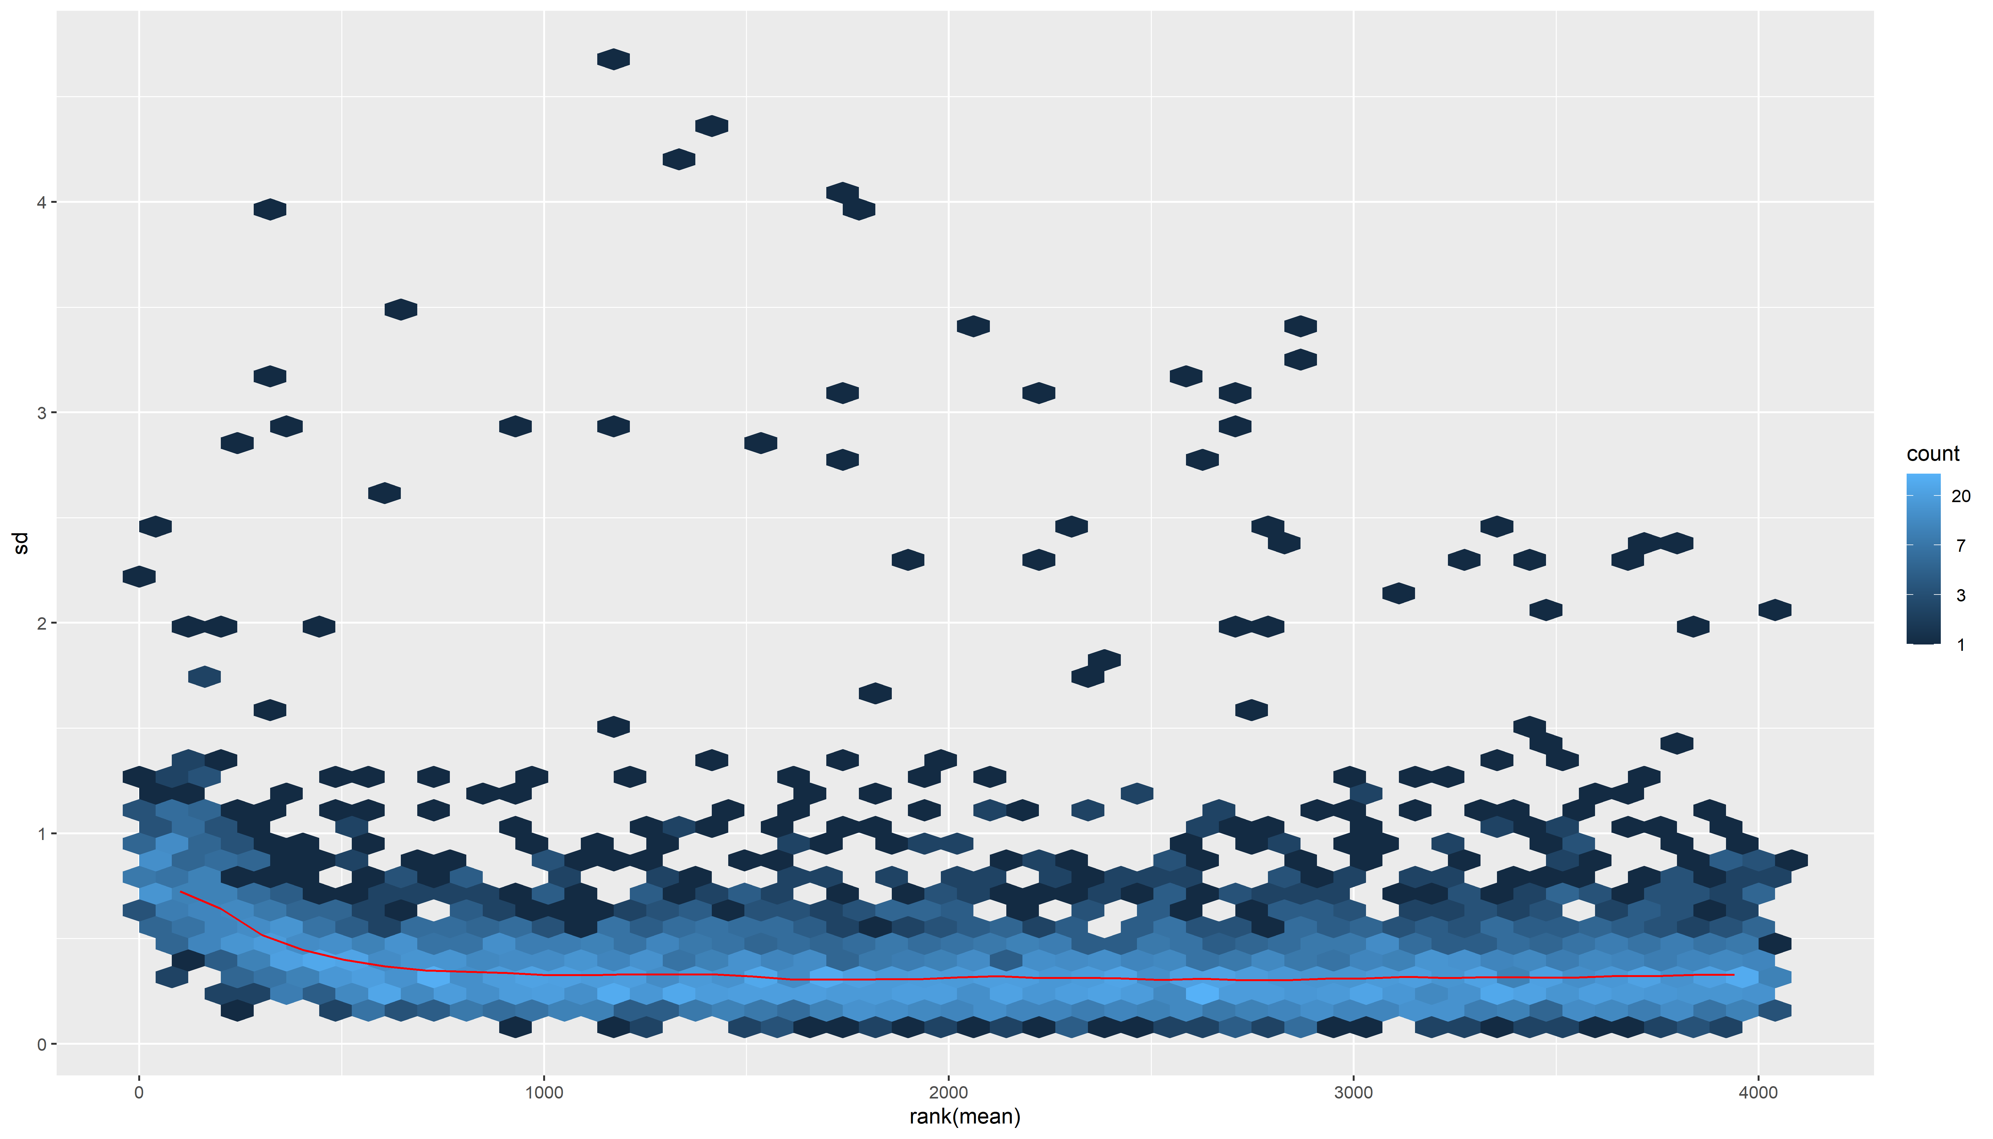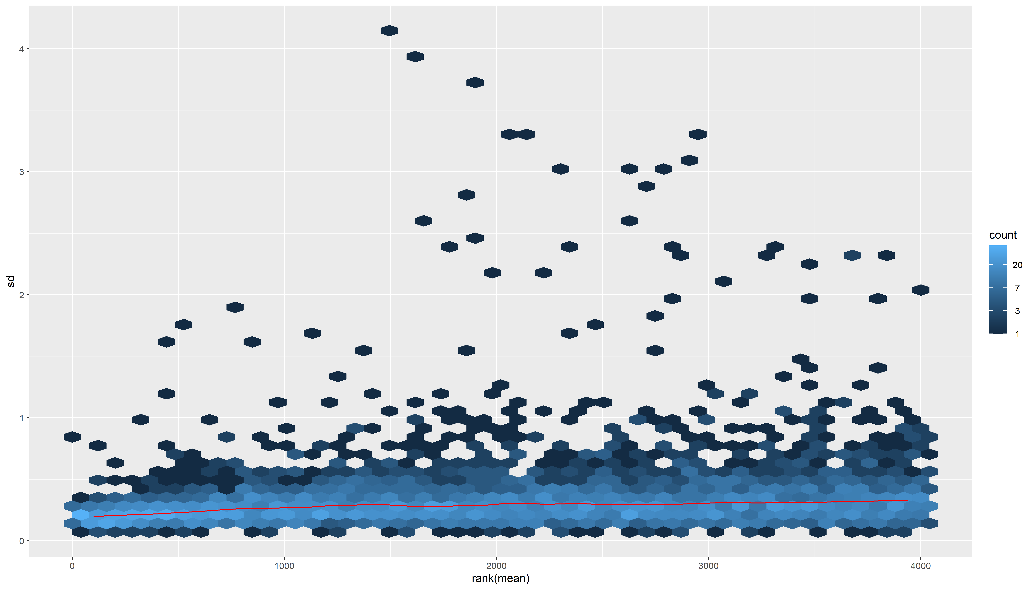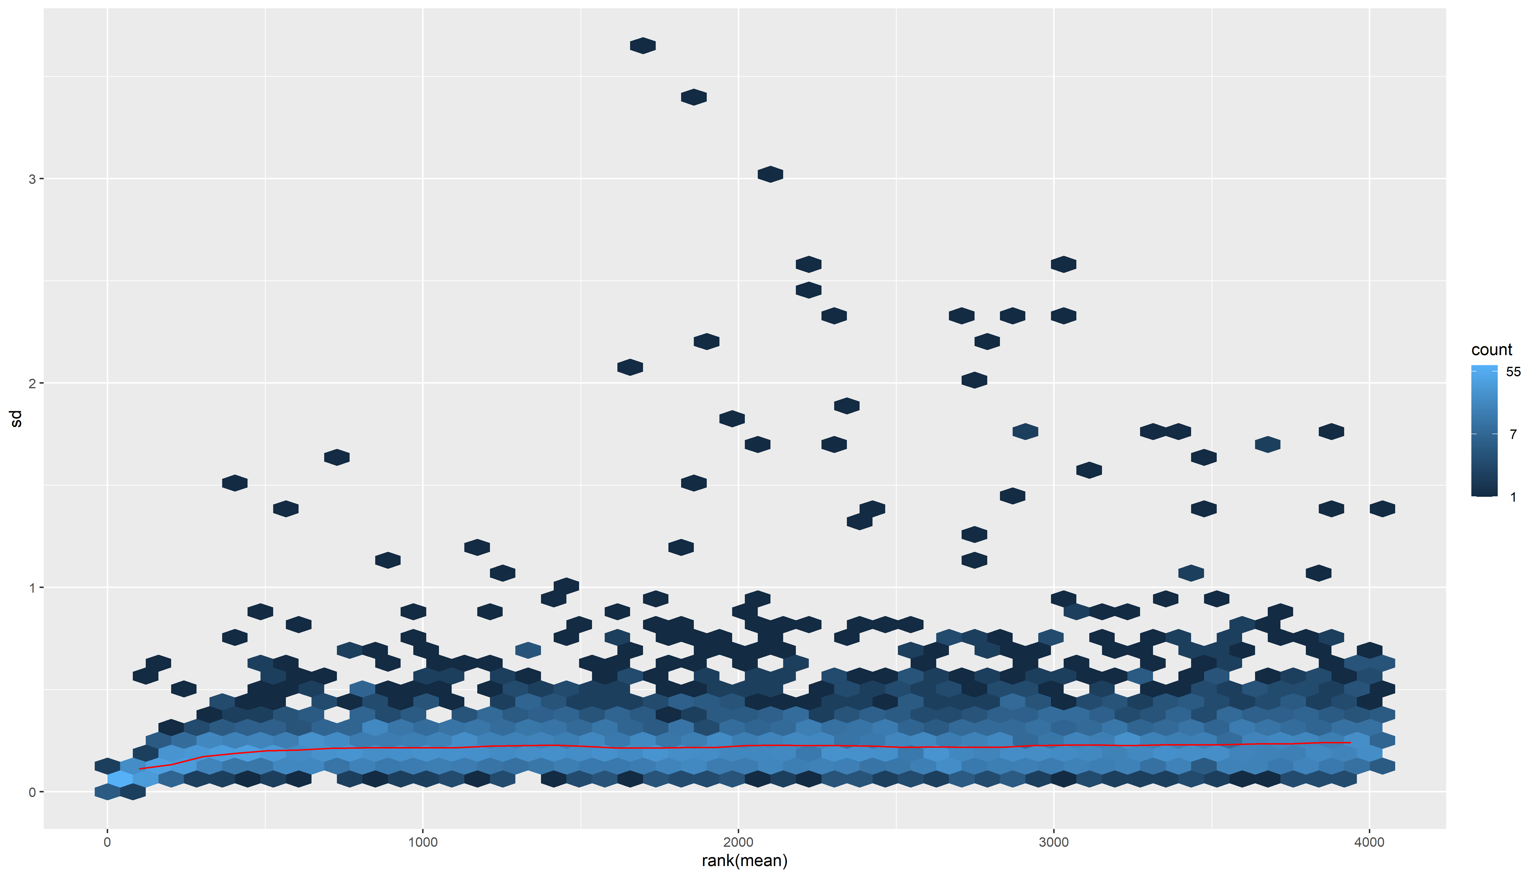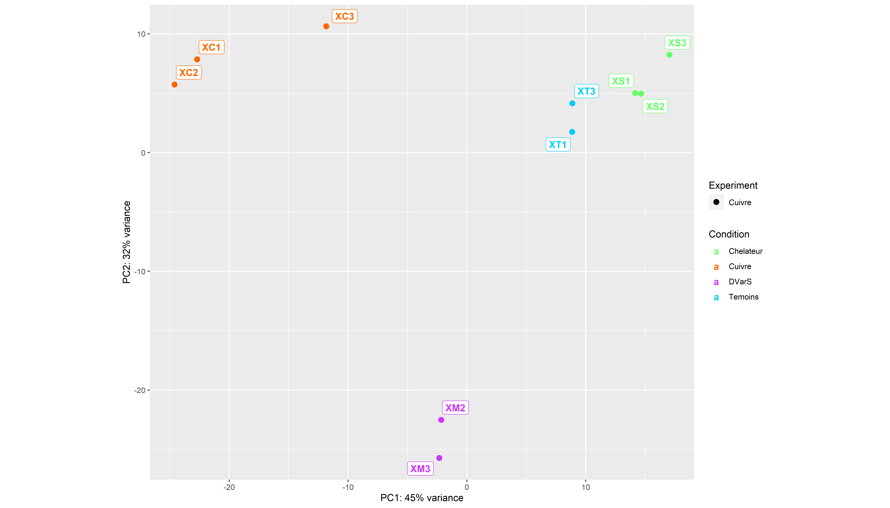

## Warning: Removed 3725 rows containing missing values (`geom_text_repel()`).

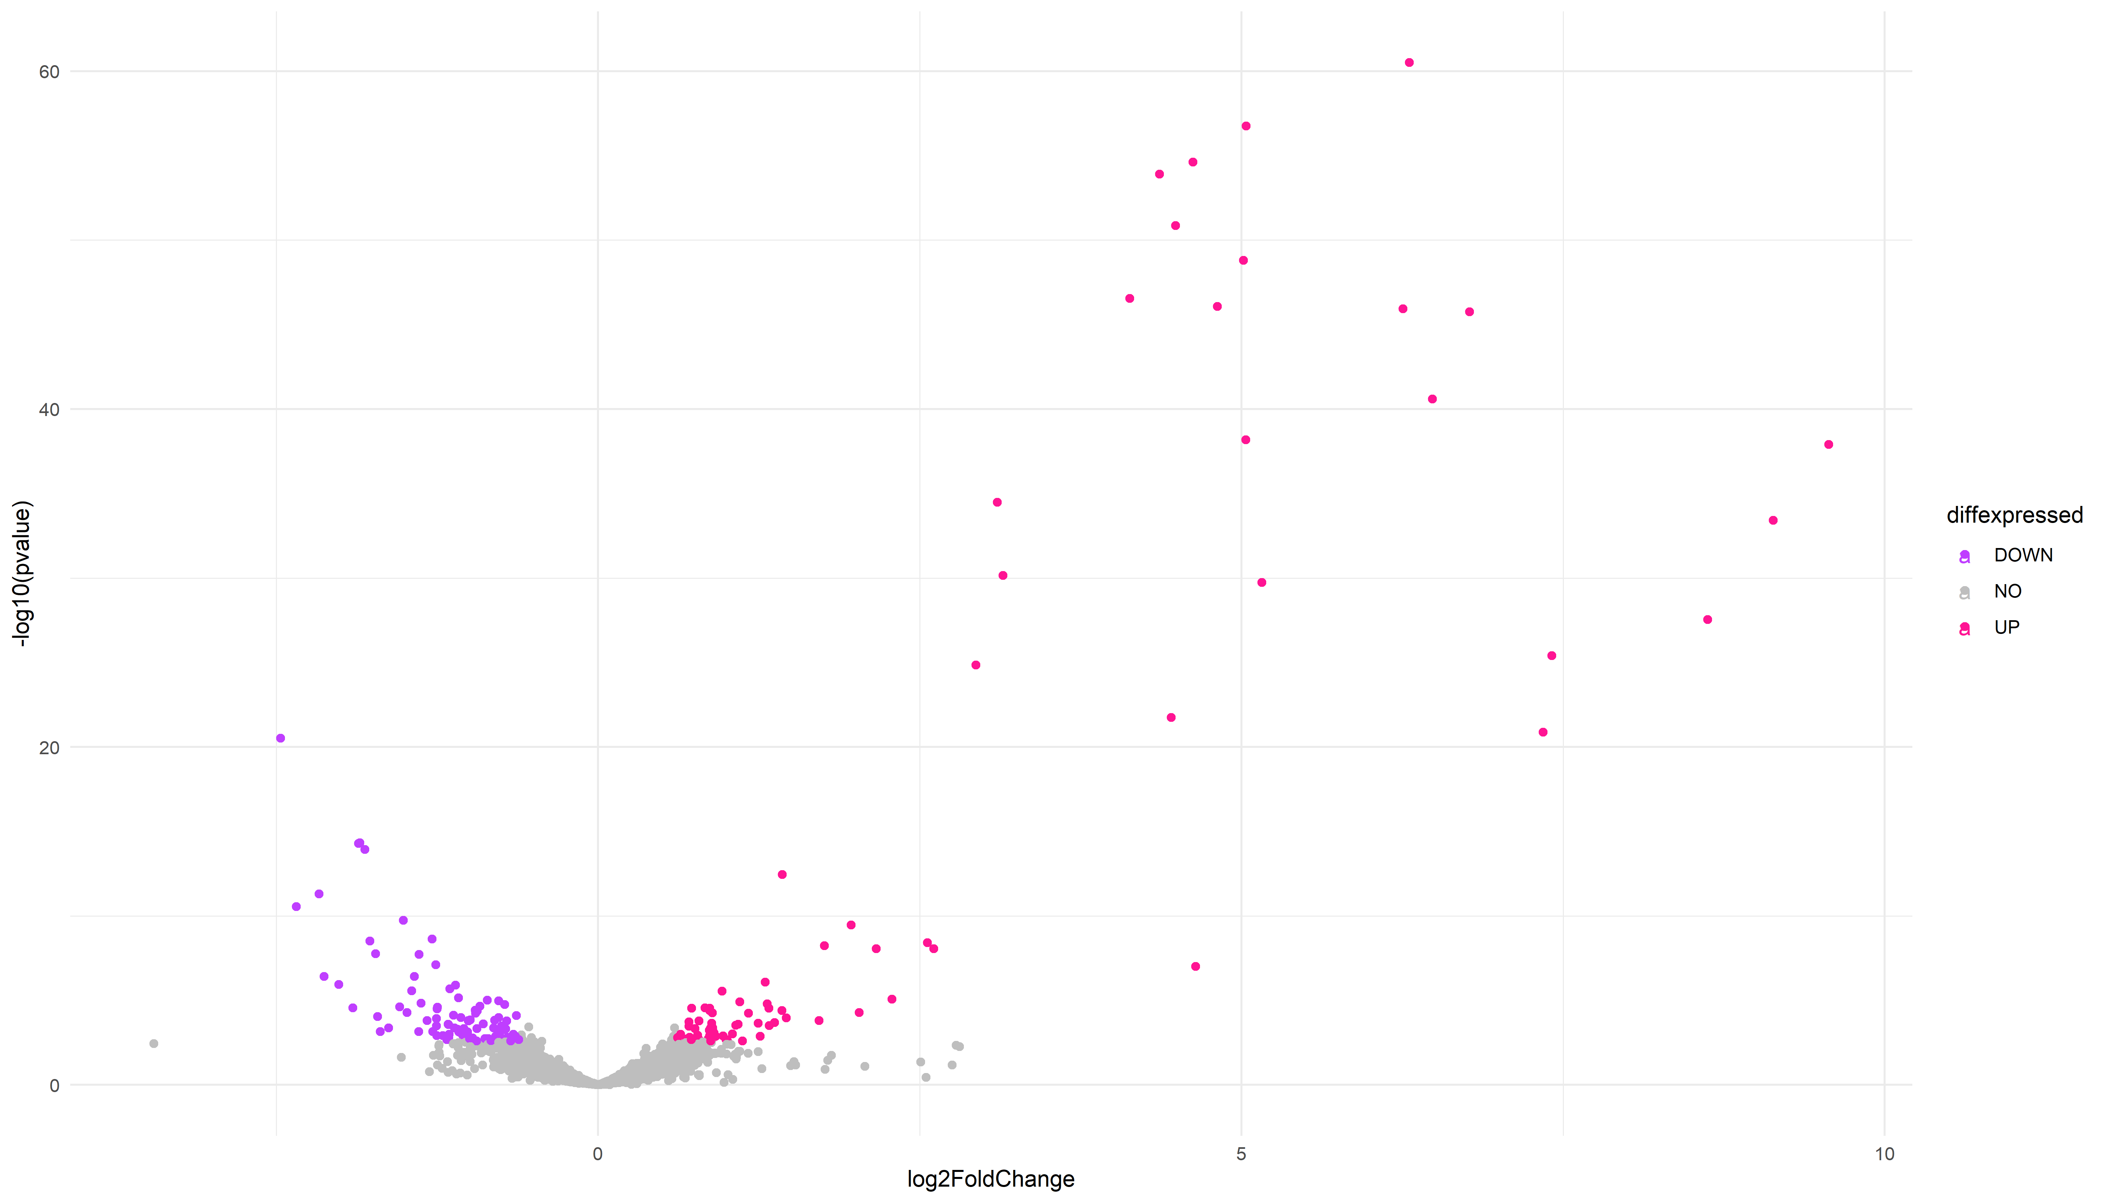

## Warning: Removed 3959 rows containing missing values (`geom_text_repel()`).

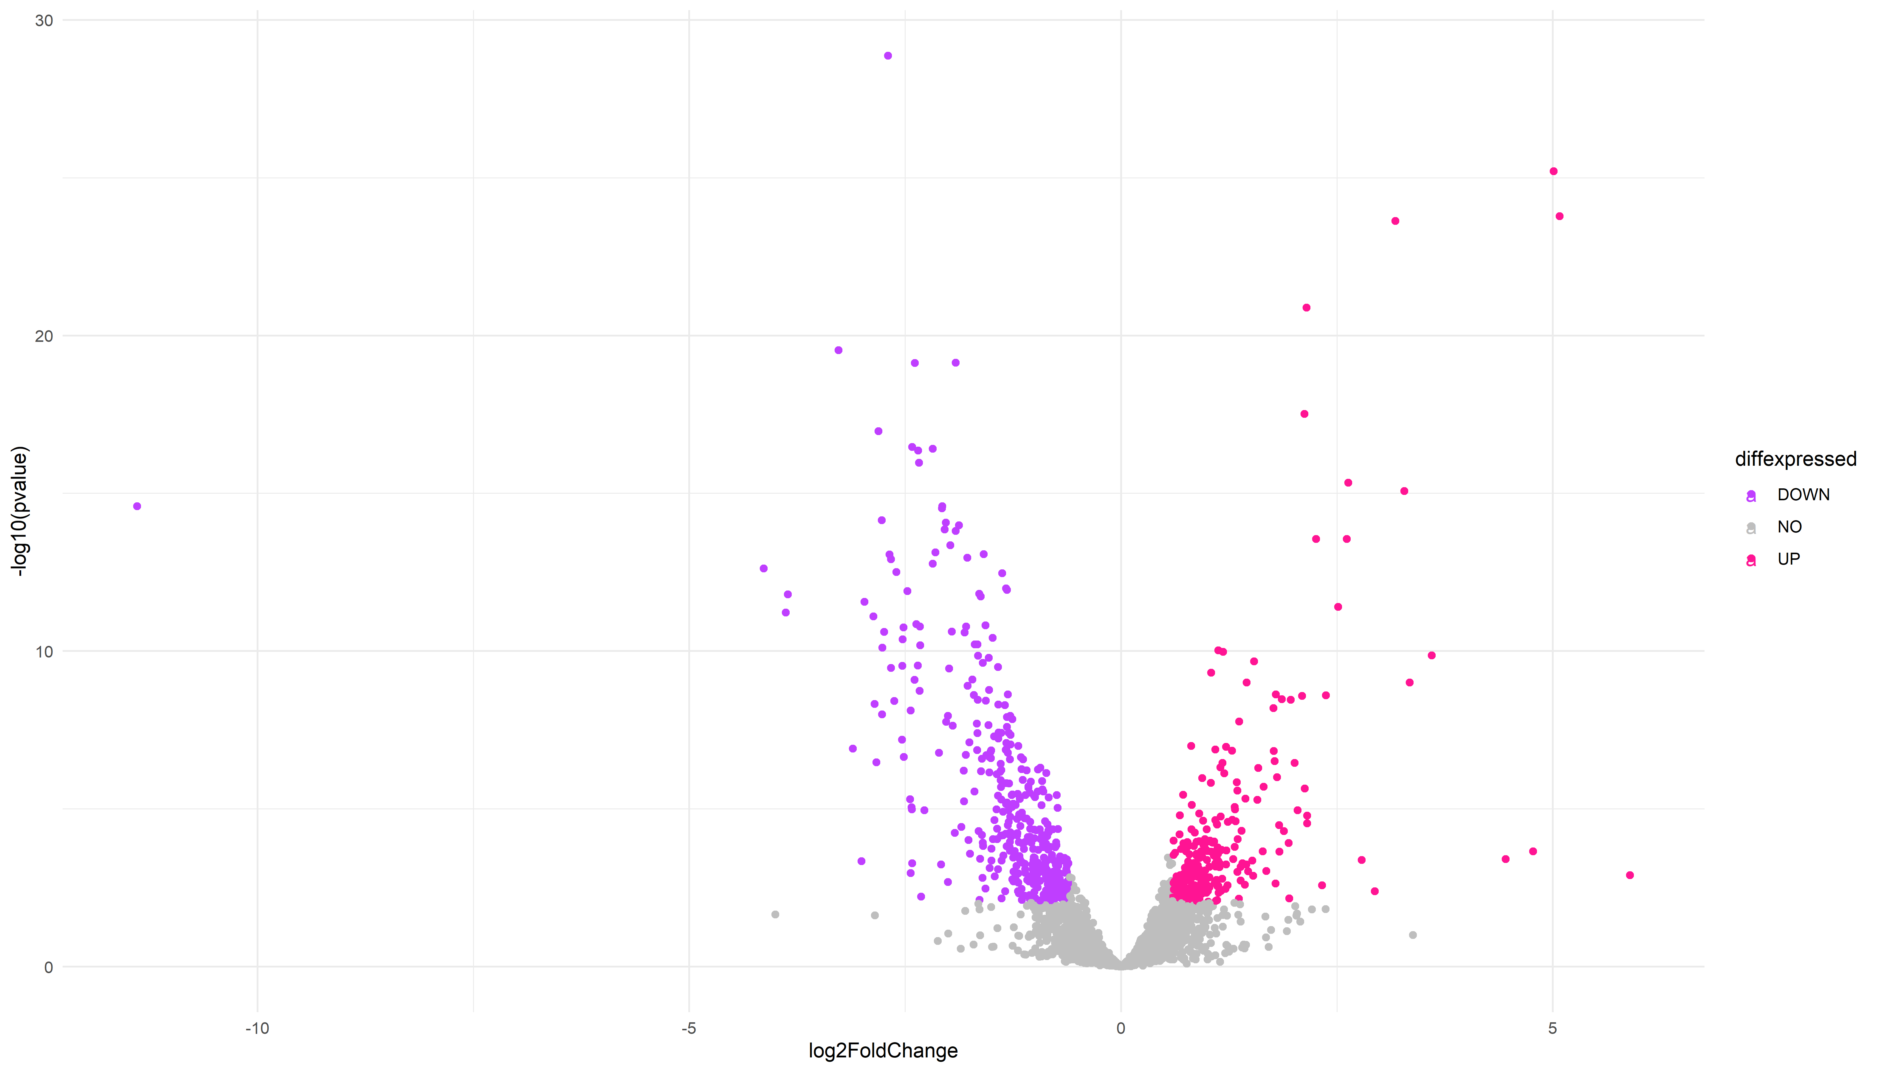

## Warning: Removed 4038 rows containing missing values (`geom_text_repel()`).

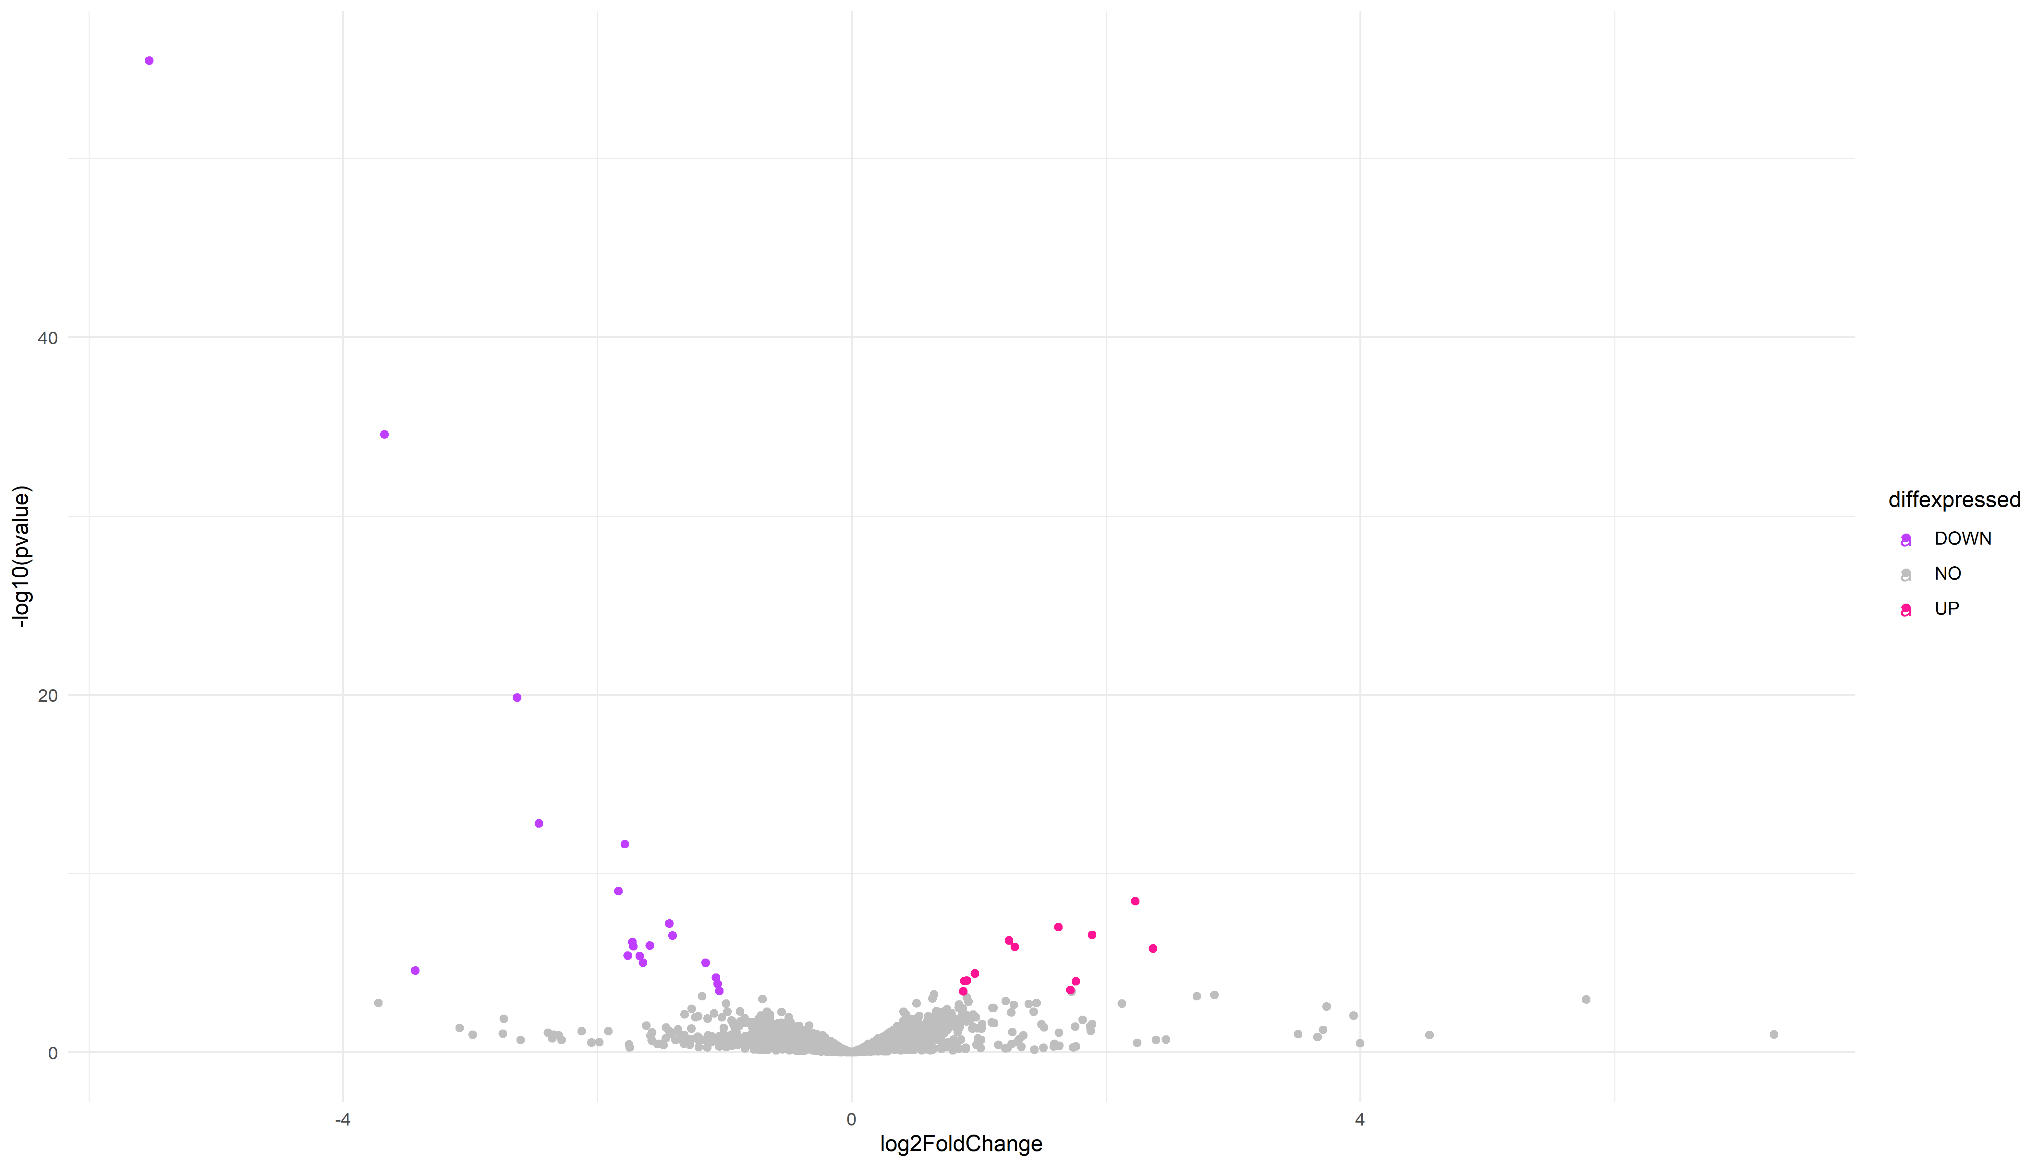

## Cuivre DVarS Chelateur   
## "numeric" "numeric" "numeric"

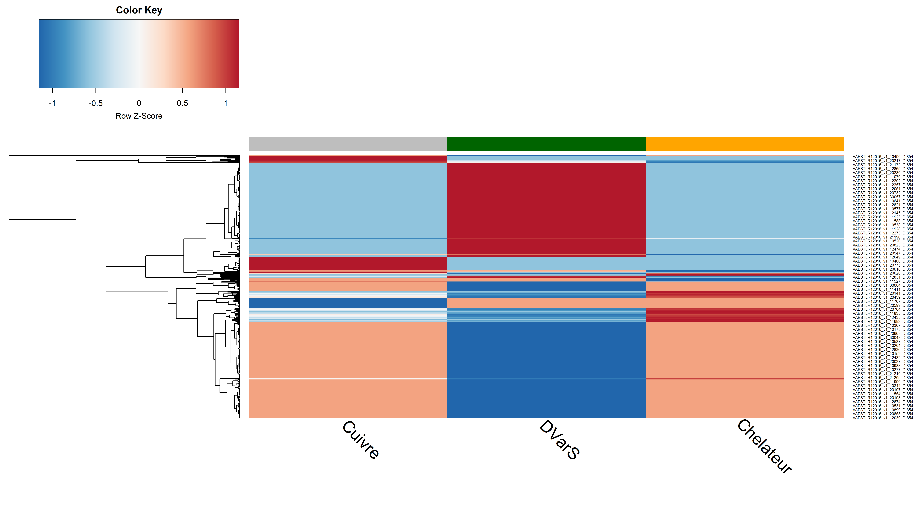 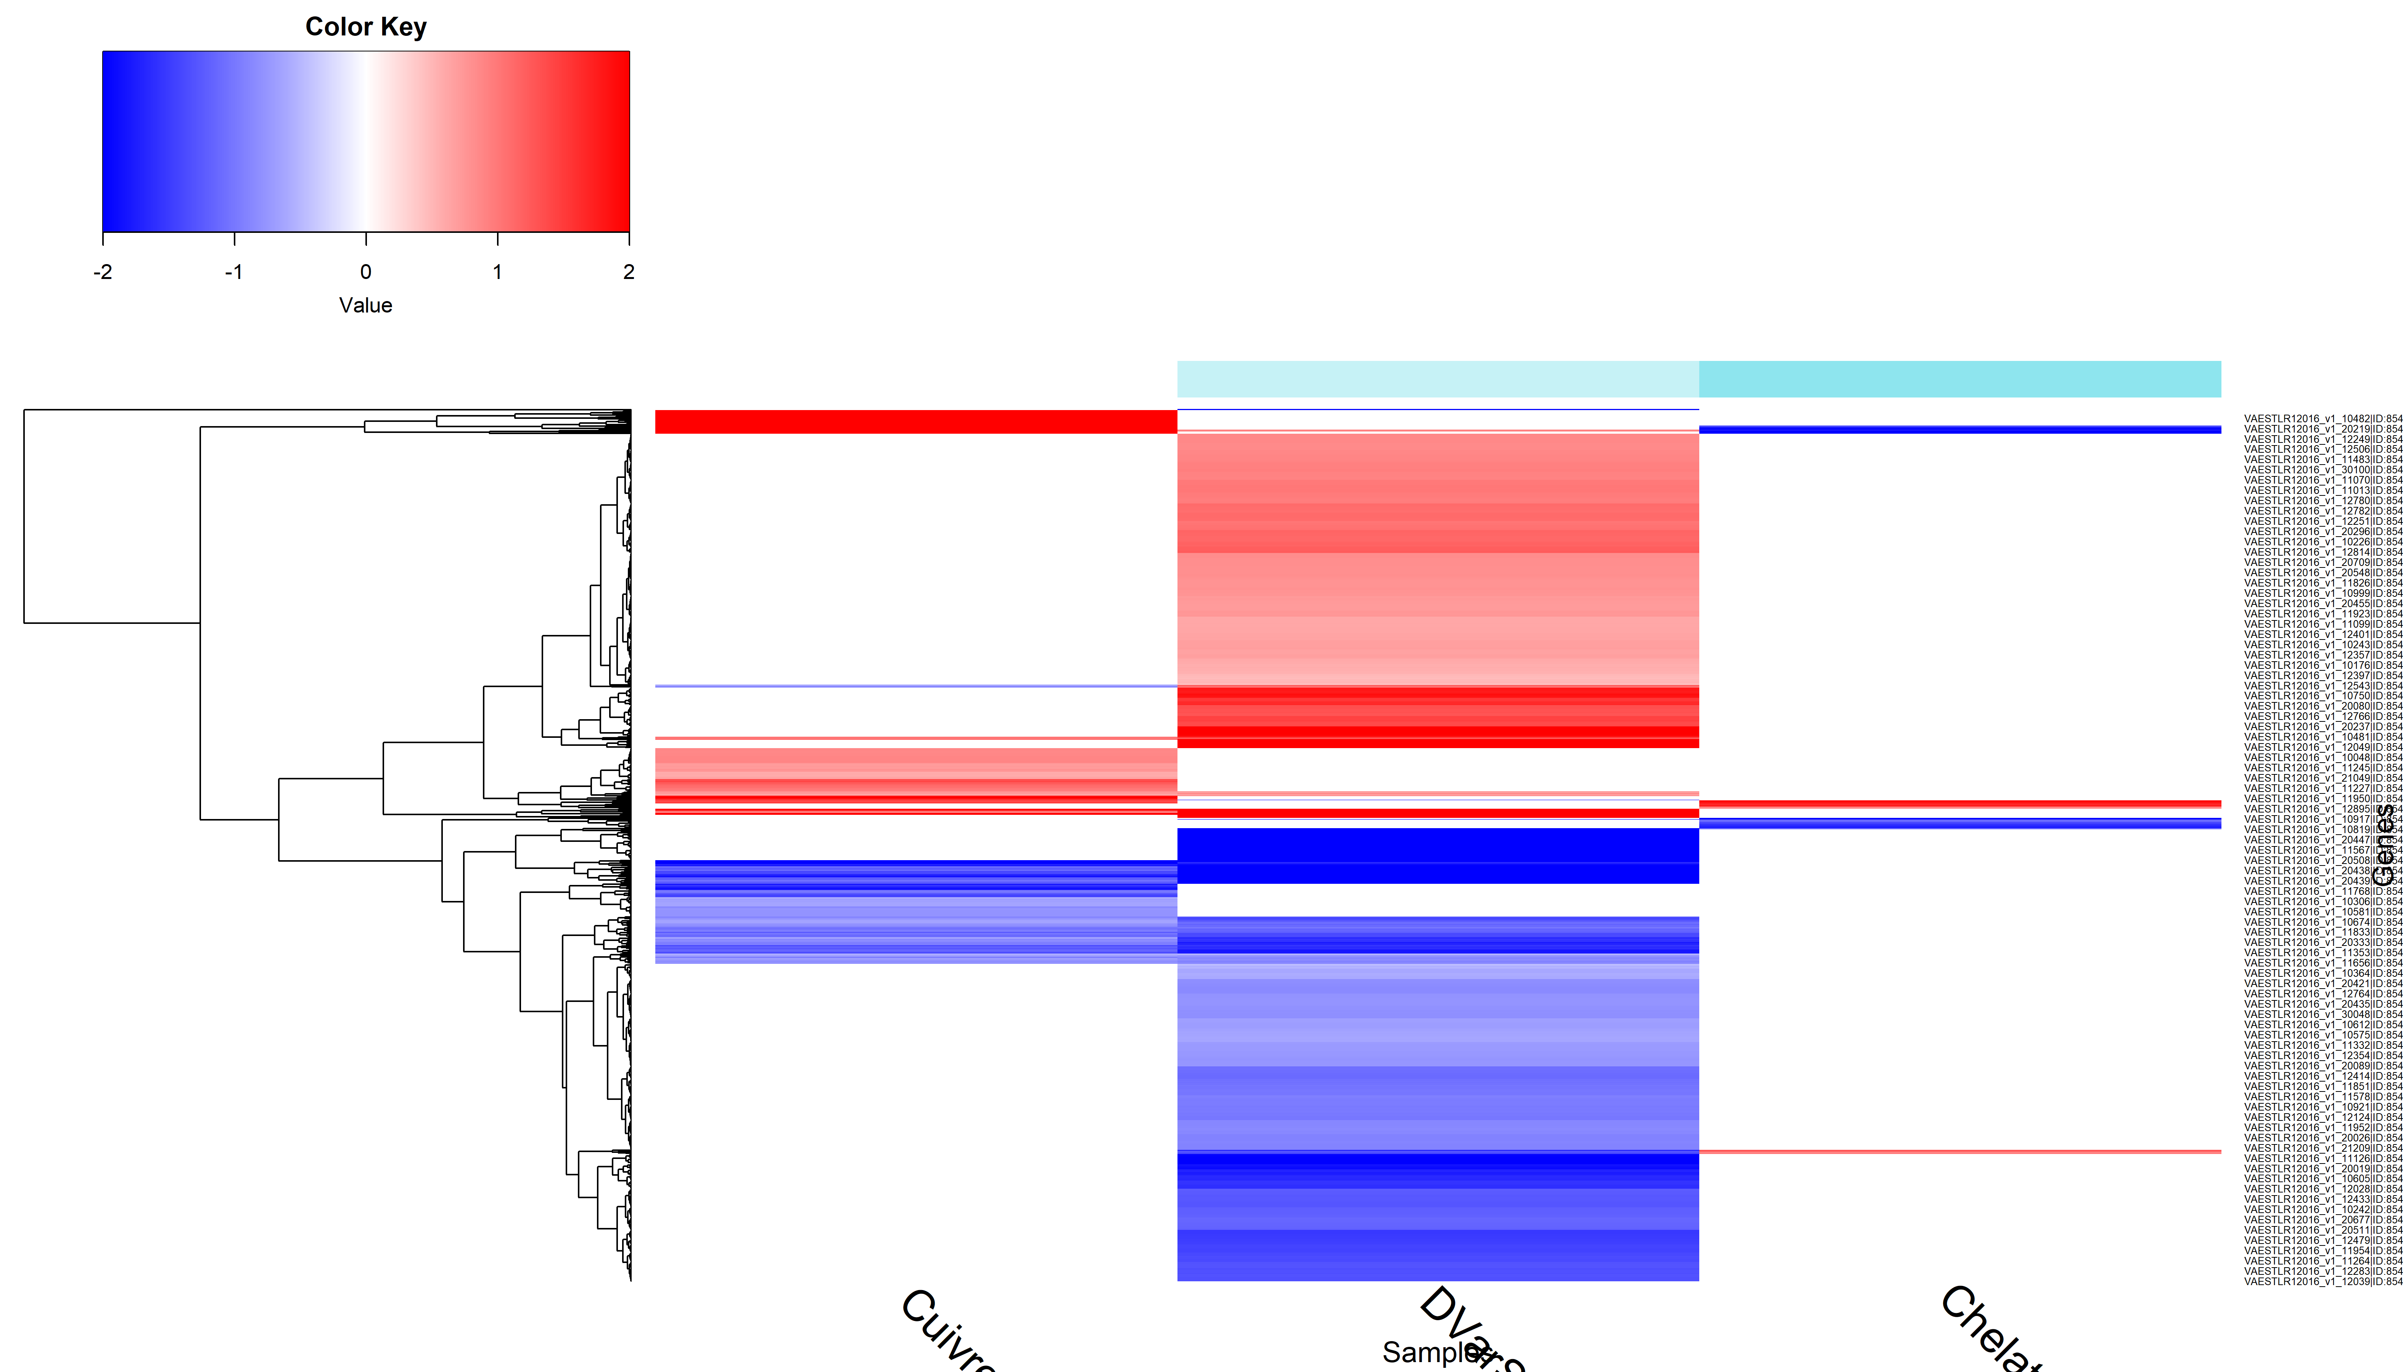

## The Study of the salinity effect

## [1] TRUE

## [1] TRUE

## Warning in DESeqDataSet(se, design = design, ignoreRank): some variables in  
## design formula are characters, converting to factors

## class: DESeqDataSet   
## dim: 4161 12   
## metadata(1): version  
## assays(1): counts  
## rownames(4161): VAESTLR12016_v1_10001|ID:85464218|yhiN|  
## VAESTLR12016_v1_10002|ID:85464219| ...  
## VAESTLR12016_v1_40034|ID:85468574|leuD|  
## VAESTLR12016_v1_40035|ID:85468575|  
## rowData names(0):  
## colnames(12): X15.1 X15.2 ... X40.2 X40.3  
## colData names(2): Experiment Condition

## class: DESeqDataSet   
## dim: 4027 12   
## metadata(1): version  
## assays(1): counts  
## rownames(4027): VAESTLR12016_v1_10001|ID:85464218|yhiN|  
## VAESTLR12016_v1_10002|ID:85464219| ...  
## VAESTLR12016_v1_40026|ID:85468566| VAESTLR12016_v1_40032|ID:85468572|  
## rowData names(0):  
## colnames(12): X15.1 X15.2 ... X40.2 X40.3  
## colData names(2): Experiment Condition

## estimating size factors

## estimating dispersions

## gene-wise dispersion estimates

## mean-dispersion relationship

## final dispersion estimates

## fitting model and testing

## log2 fold change (MLE): Condition 22 vs 34   
## Wald test p-value: Condition 22 vs 34   
## DataFrame with 574 rows and 6 columns  
## baseMean log2FoldChange lfcSE  
## <numeric> <numeric> <numeric>  
## VAESTLR12016_v1_10016|ID:85464233| 3987.29 -4.15433 0.145921  
## VAESTLR12016_v1_10014|ID:85464231|thiG| 1416.81 -3.45947 0.137172  
## VAESTLR12016_v1_10015|ID:85464232|thiF| 1778.90 -4.07138 0.162831  
## VAESTLR12016_v1_10013|ID:85464230|thiH| 1471.23 -3.10966 0.154118  
## VAESTLR12016_v1_10017|ID:85464234|thiC| 10299.23 -3.78500 0.196588  
## ... ... ... ...  
## VAESTLR12016_v1_10179|ID:85464396| 185.0499 -0.417330 0.155153  
## VAESTLR12016_v1_20083|ID:85467243| 37.9409 0.742509 0.276337  
## VAESTLR12016_v1_20666|ID:85467826| 2168.1959 -0.387628 0.144466  
## VAESTLR12016_v1_20708|ID:85467868|tesA| 413.7601 0.277693 0.103664  
## VAESTLR12016_v1_10145|ID:85464362|rhtB| 671.1487 0.410691 0.153366  
## stat pvalue padj  
## <numeric> <numeric> <numeric>  
## VAESTLR12016_v1_10016|ID:85464233| -28.4698 2.77498e-178 1.07308e-174  
## VAESTLR12016_v1_10014|ID:85464231|thiG| -25.2200 2.41802e-140 4.67524e-137  
## VAESTLR12016_v1_10015|ID:85464232|thiF| -25.0037 5.57236e-138 7.18277e-135  
## VAESTLR12016_v1_10013|ID:85464230|thiH| -20.1772 1.55357e-90 1.50192e-87  
## VAESTLR12016_v1_10017|ID:85464234|thiC| -19.2535 1.32041e-82 1.02120e-79  
## ... ... ... ...  
## VAESTLR12016_v1_10179|ID:85464396| -2.68980 0.00714956 0.0485041  
## VAESTLR12016_v1_20083|ID:85467243| 2.68697 0.00721030 0.0488305  
## VAESTLR12016_v1_20666|ID:85467826| -2.68319 0.00729245 0.0493006  
## VAESTLR12016_v1_20708|ID:85467868|tesA| 2.67879 0.00738878 0.0498646  
## VAESTLR12016_v1_10145|ID:85464362|rhtB| 2.67785 0.00740969 0.0499186

## X15.1 X15.2 X15.3 X22.1  
## VAESTLR12016_v1_10001|ID:85464218|yhiN| 9.787967 9.809491 9.842728 9.831014  
## VAESTLR12016_v1_10002|ID:85464219| 10.359688 10.399127 10.330447 12.320819  
## VAESTLR12016_v1_10003|ID:85464220|uspB| 10.404980 10.442466 10.384828 12.865042  
## X22.2 X22.3 X34.1 X34.2  
## VAESTLR12016_v1_10001|ID:85464218|yhiN| 10.68353 10.68531 9.819186 10.25813  
## VAESTLR12016_v1_10002|ID:85464219| 12.22666 11.83688 12.218665 11.45866  
## VAESTLR12016_v1_10003|ID:85464220|uspB| 12.64854 11.92425 12.084973 11.20163  
## X34.3 X40.1 X40.2 X40.3  
## VAESTLR12016_v1_10001|ID:85464218|yhiN| 10.56950 10.44624 10.716647 10.62457  
## VAESTLR12016_v1_10002|ID:85464219| 11.14543 11.30096 11.412369 11.42161  
## VAESTLR12016_v1_10003|ID:85464220|uspB| 10.77157 10.23952 9.952613 10.35925

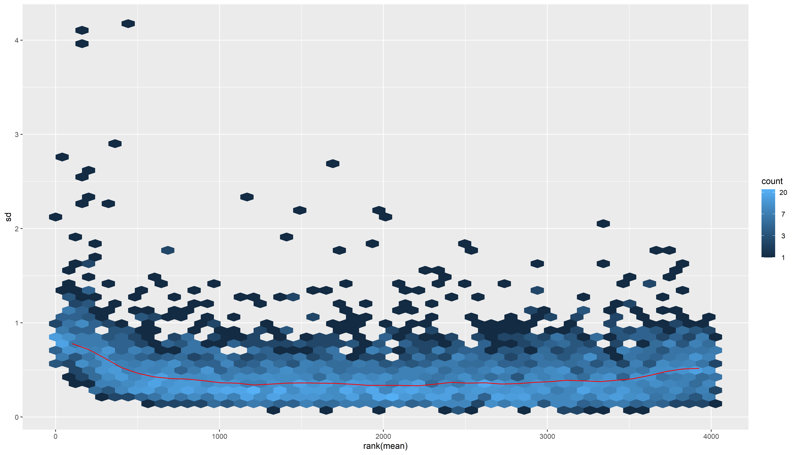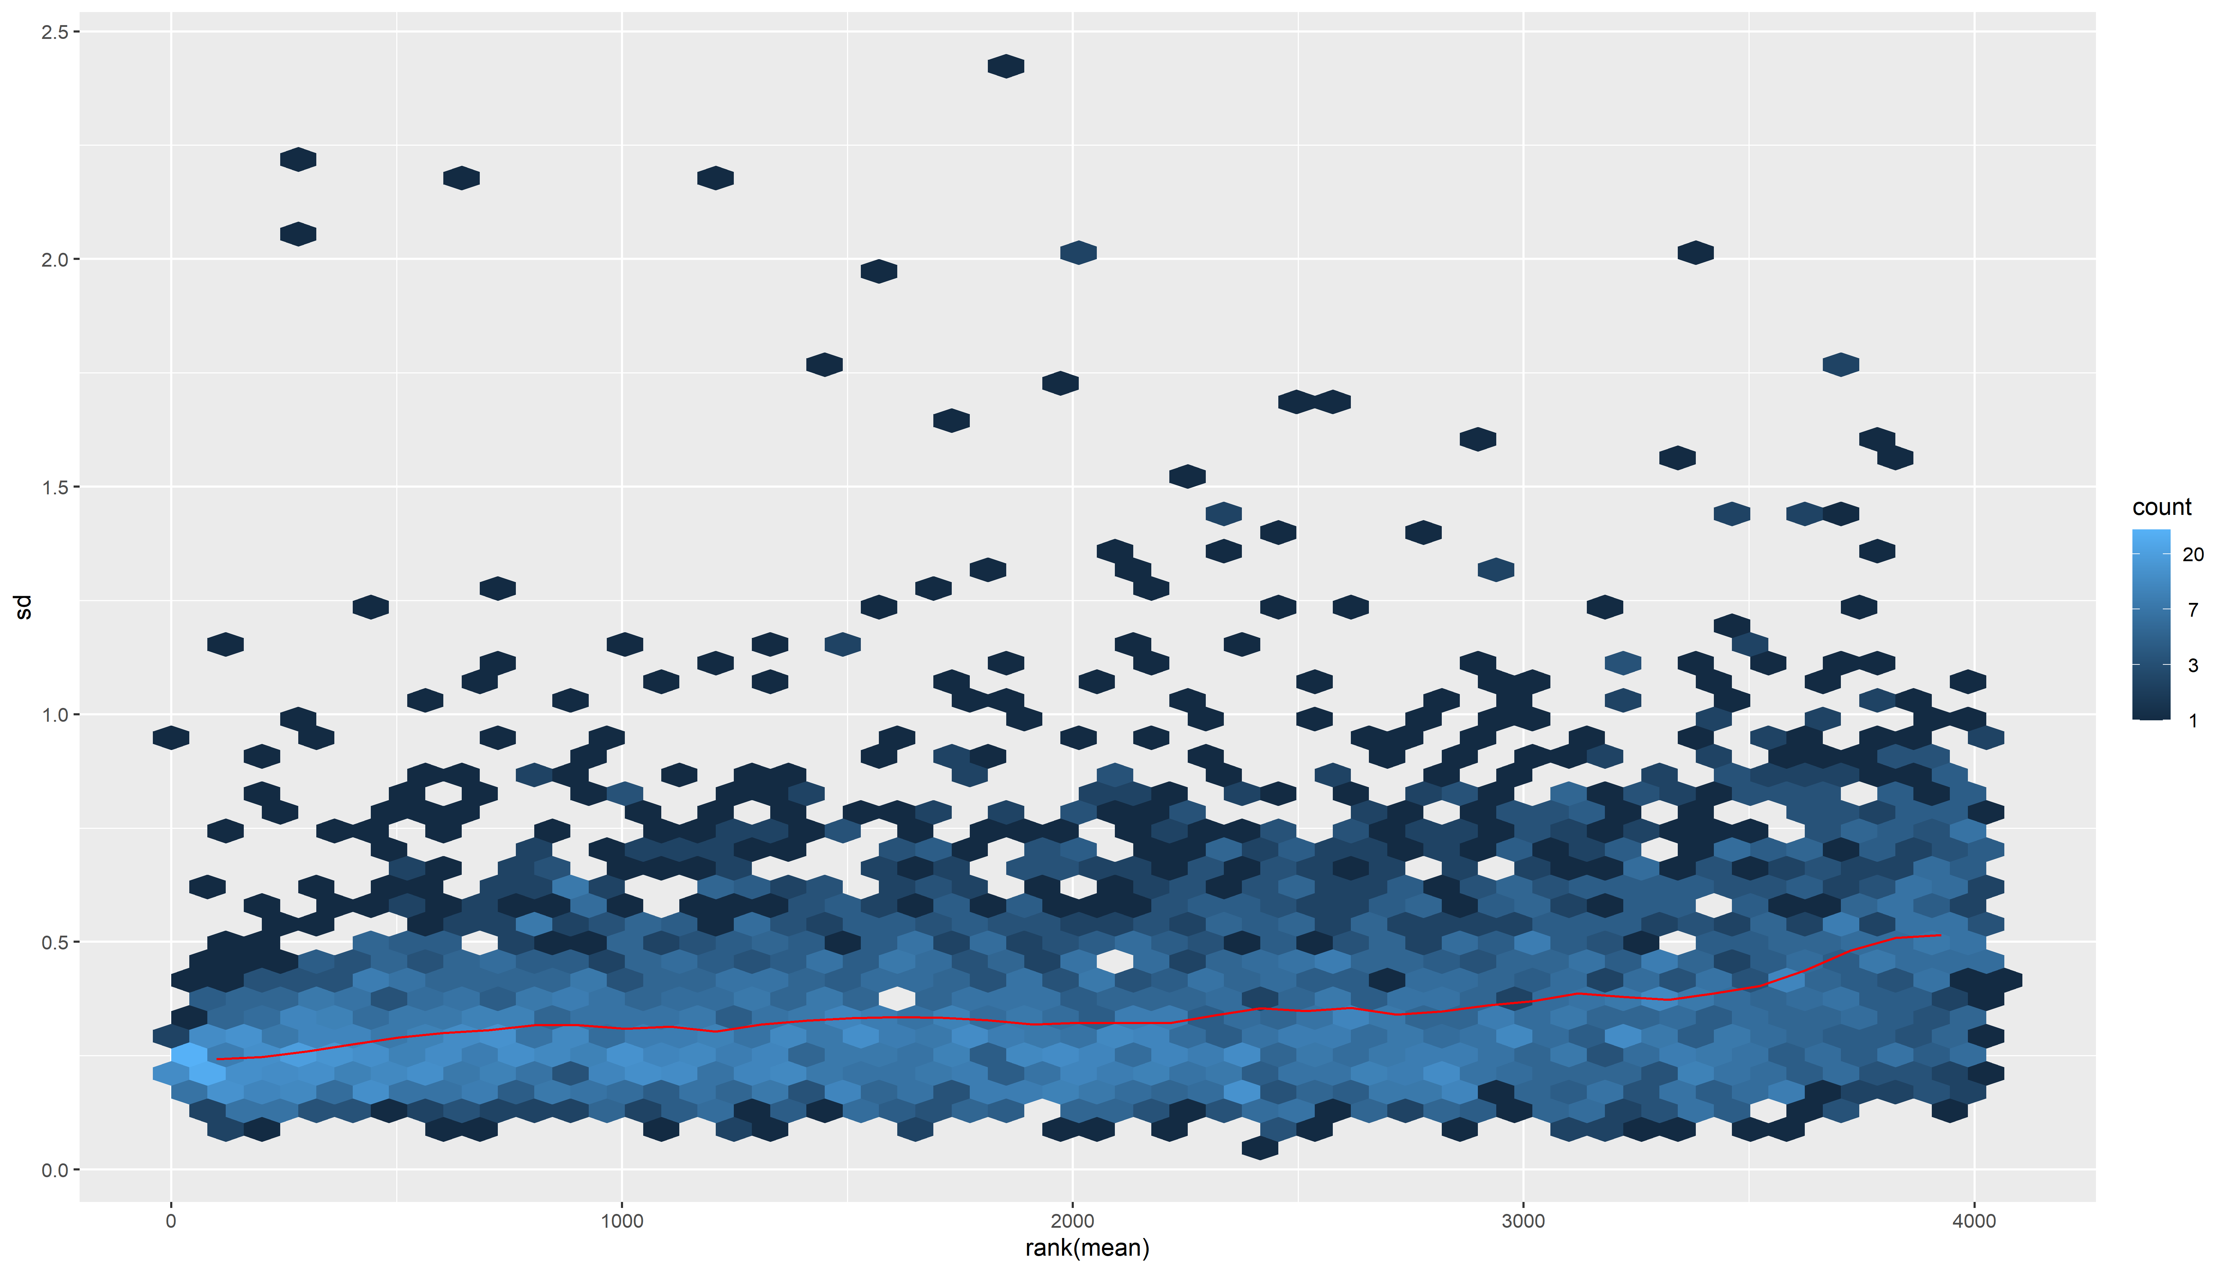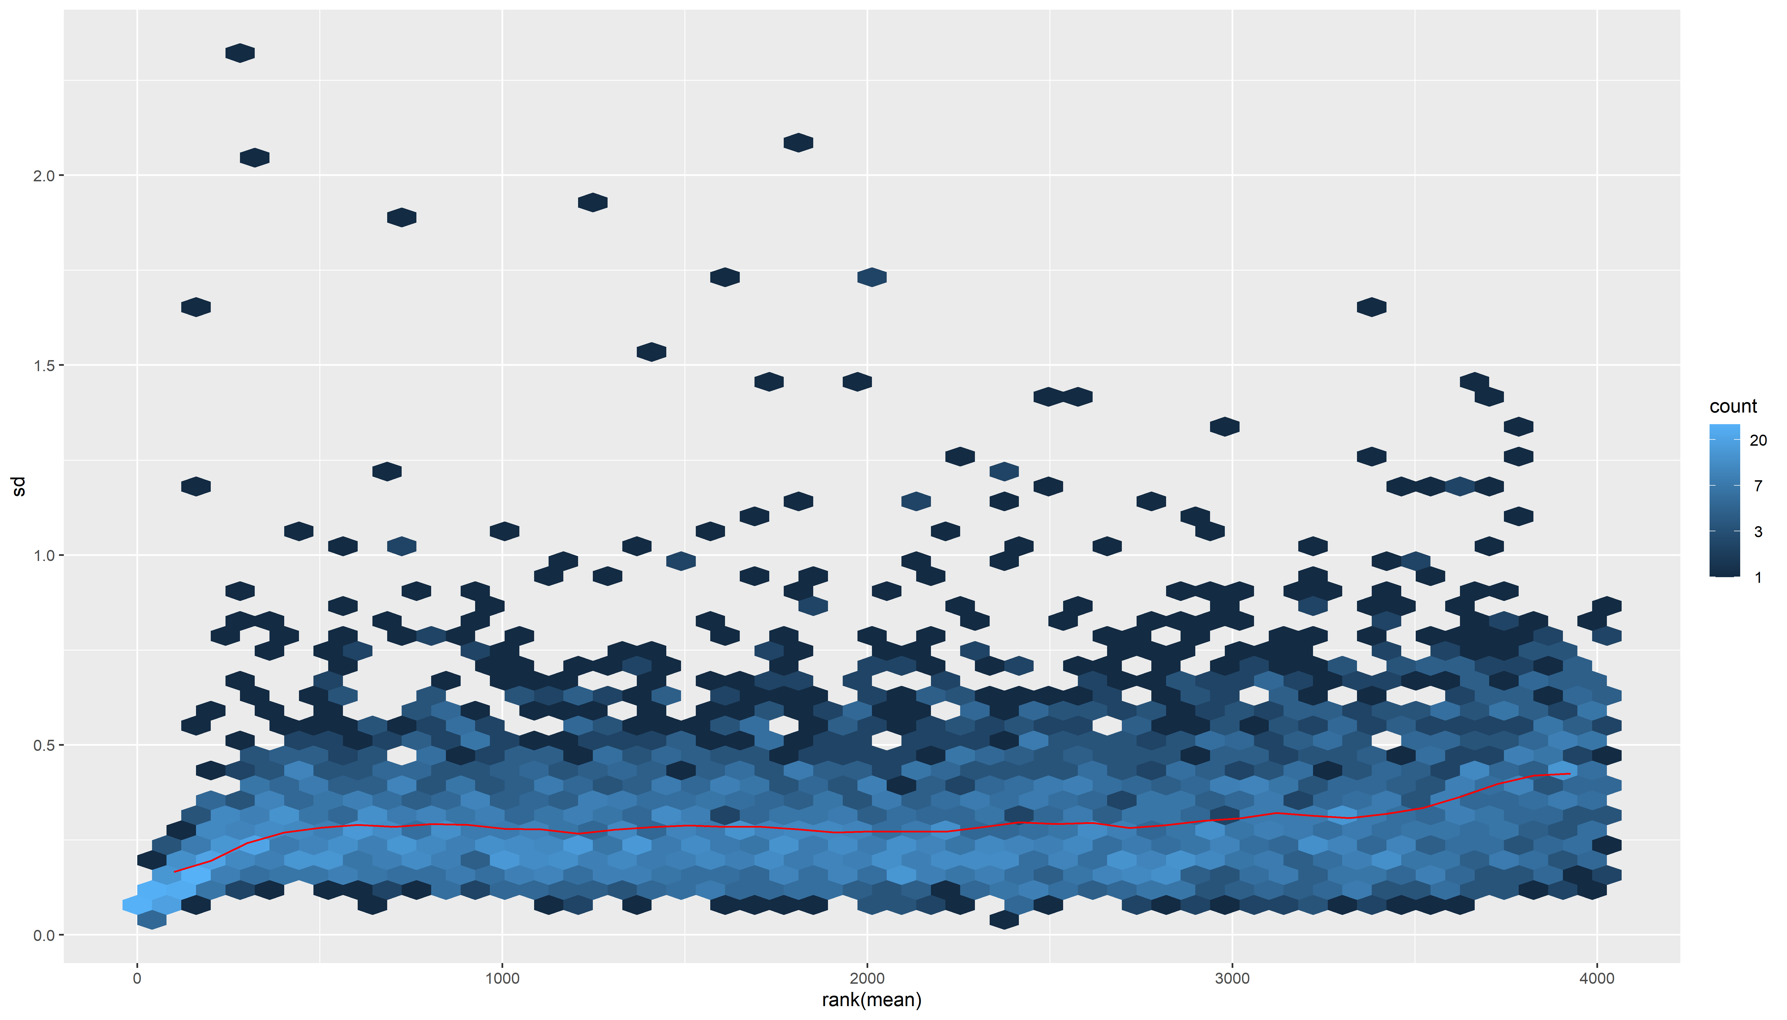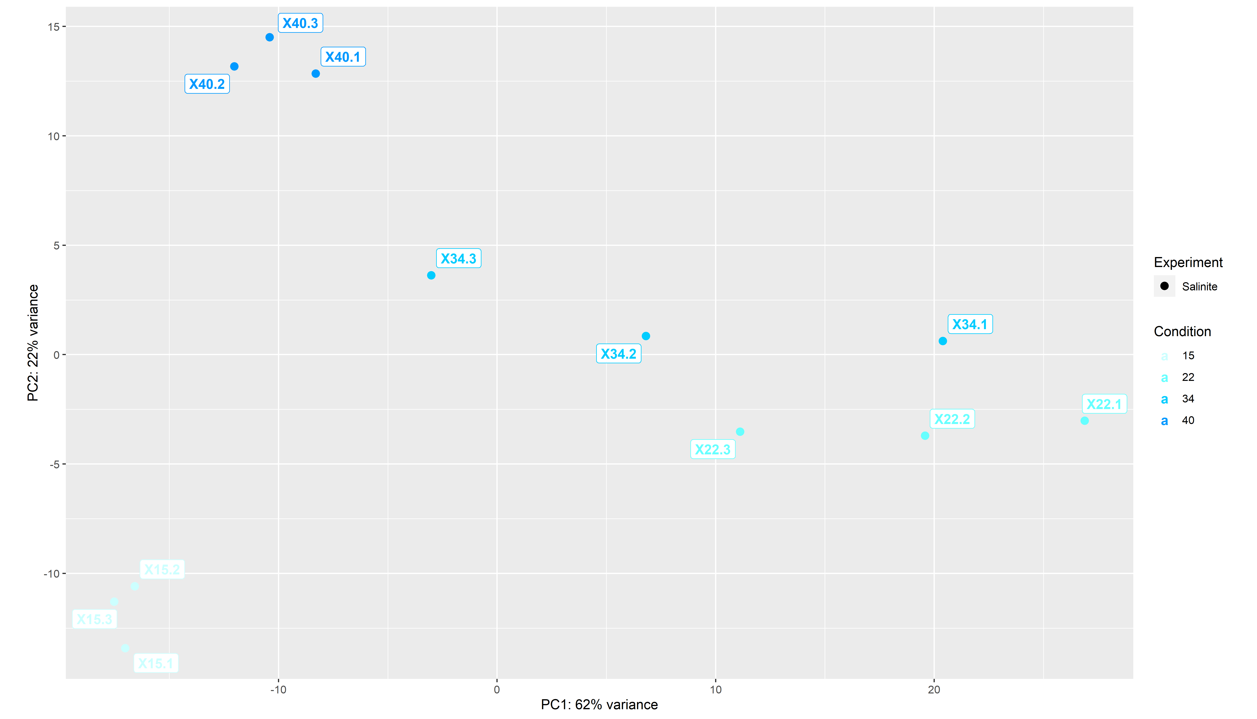

## Warning: Removed 4024 rows containing missing values (`geom_text_repel()`).

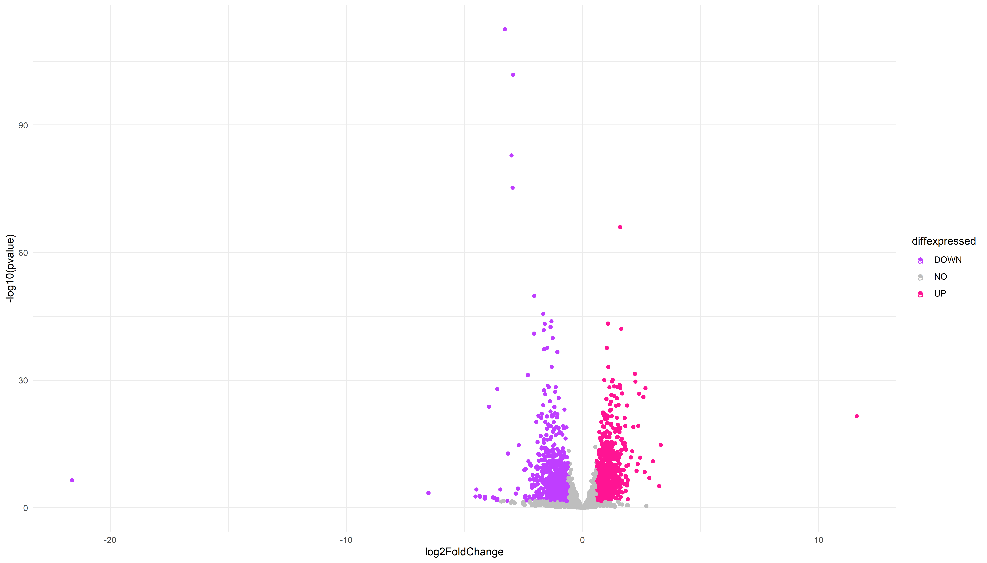

## Warning: Removed 3867 rows containing missing values (`geom_text_repel()`).

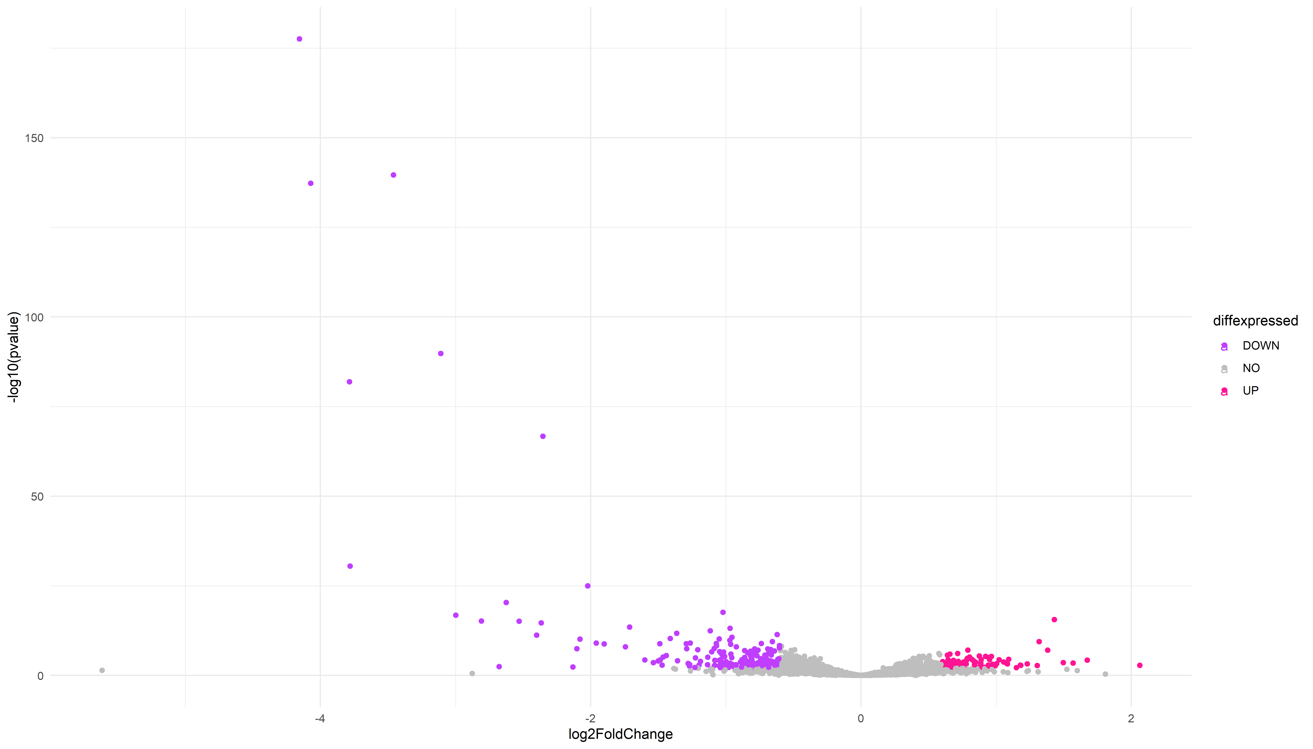

## Warning: Removed 3945 rows containing missing values (`geom_text_repel()`).

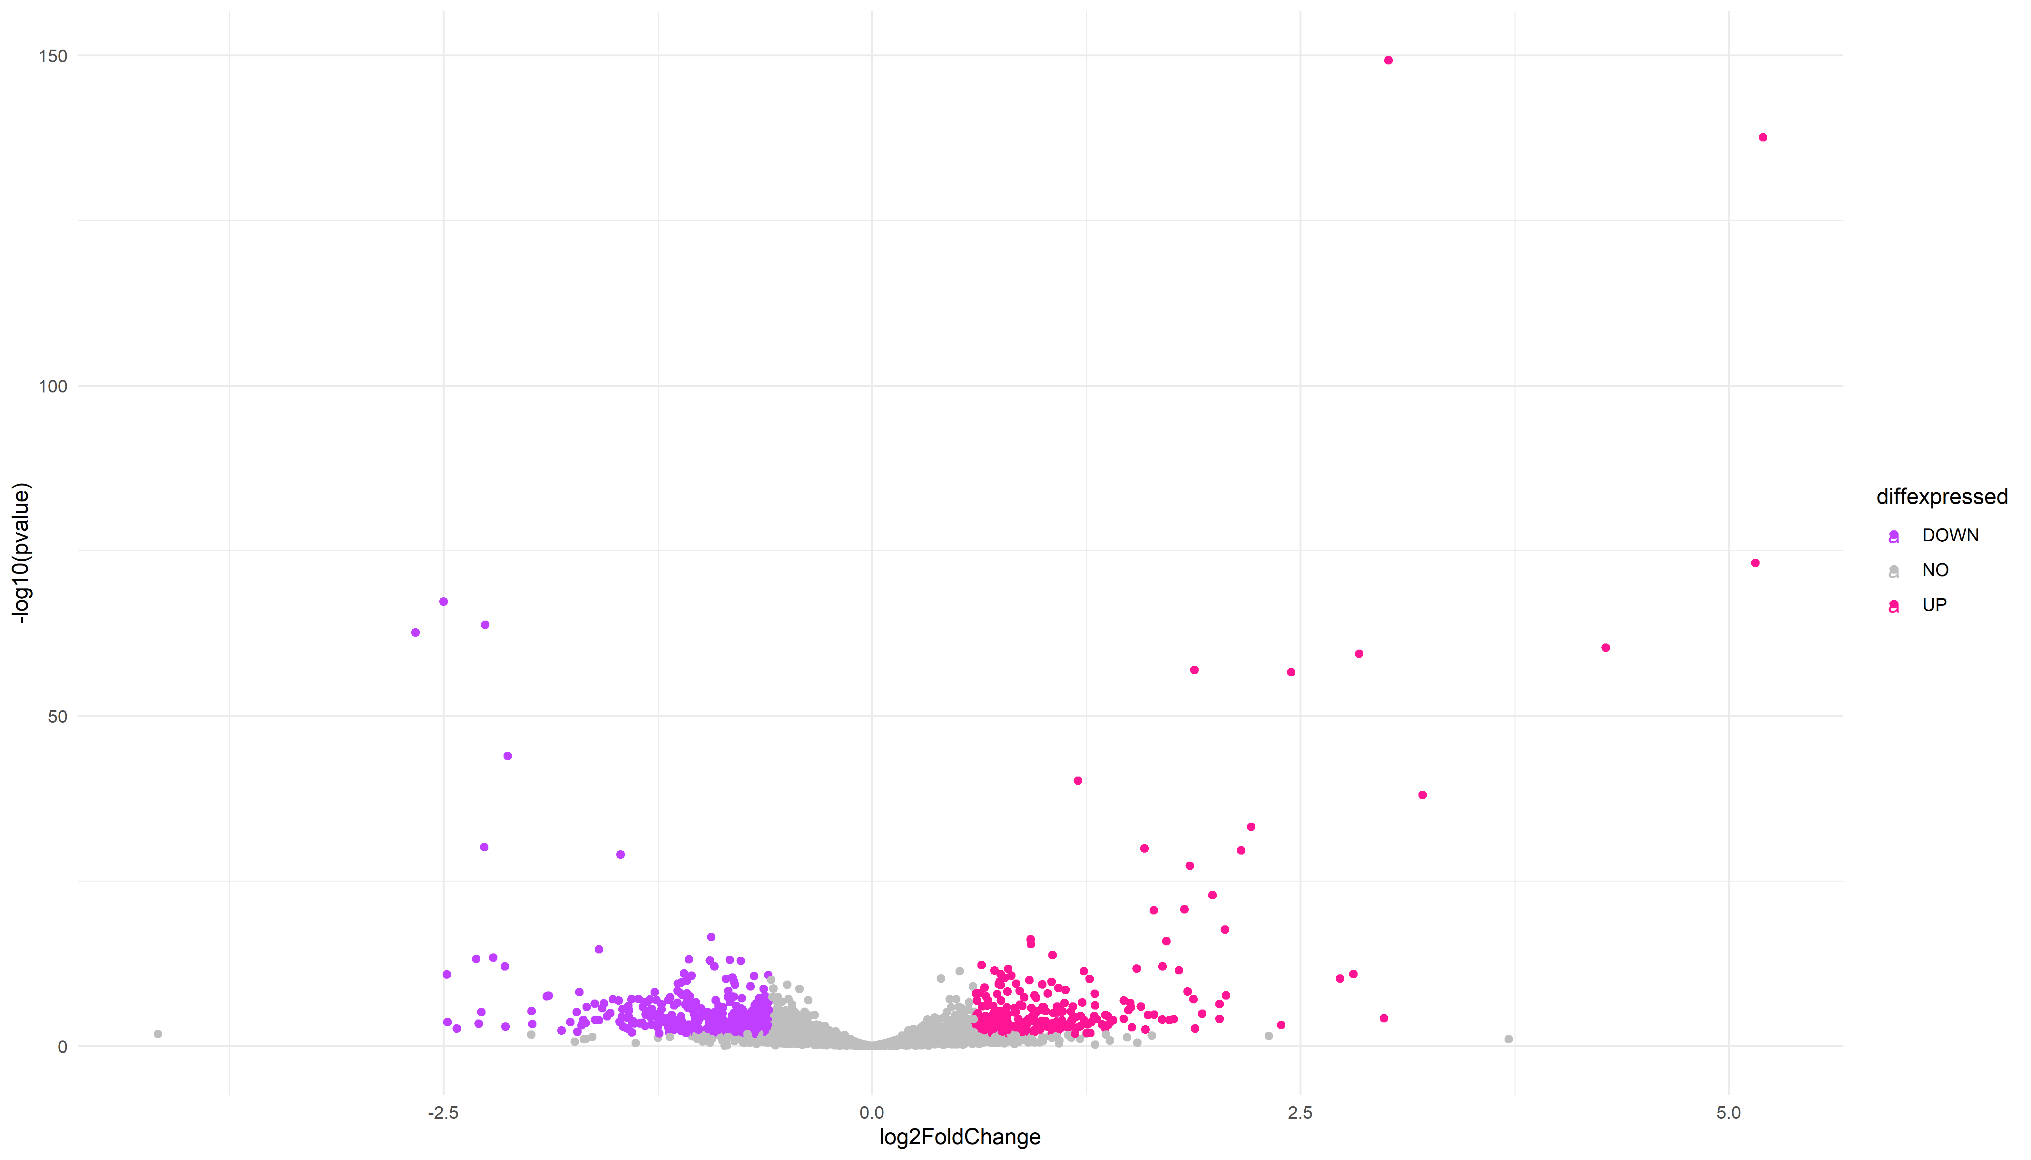

## 15 22 40   
## "numeric" "numeric" "numeric"

