Правительство Российской Федерации

Федеральное государственное автономное образовательное учреждение высшего профессионального образования
"Национальный исследовательский университет
"Высшая школа экономики"

Московский институт электроники и математики Национального
исследовательского университета "Высшая школа экономики"

Департамент прикладной математики

ОТЧЕТ
По лабораторной работе №9
По курсу «Алгоритмизация и программирование»

 | Номер группы | Дата
  ФИО студента
Панов Михаил Федорович | БПМ-191

Москва – 2020 г.

ЛАБОРАТОРНАЯ РАБОТА 9. БАЗА ДАННЫХ (вариант №19)
1. Данные должны храниться в файле прямого доступа.
2. Каждая операция с данными базы должна быть реализована как функция.
3. Выбор и запуск требуемого режима осуществляется через меню.
4. Реализовать следующие функции обработки базы данных:
Заполнение базы данных
Добавление записи в базу
Удаление заданной записи из базы
Поиск записи по заданному полю
Редактирование заданной записи в базе
Сортировка данных в базе по заданному полю
Вывод на экран содержимого базы в табличном виде
5. Решение должно быть многофайловым проектом.
РЕШЕНИЕ
main.cpp — исполняемый файл
#include <iostream>
#include <unistd.h>
#include <cstring>
#include "DataBase.h"

char *get_full_path(char *filename)
{
char *path = (char *)calloc(str_max_size*8, sizeof(char));
getcwd(path, str_max_size*8);
for(int i = strlen(path); path[i] != '/'; i--)
path[i] = '\0';
//if you've got issues with path to database
// uncomment and change the line bellow for your case
// path = "shnyaga/shnyajnaya/jizn/obschajnaya/
char *ret = (char *)calloc(strlen(path) + strlen(filename) + 1, sizeof(char));
strcat(ret, path);
strcat(ret, filename);
return ret;
}

void table_menu(table *db)
{
char *key = (char *)calloc(str_max_size, sizeof(char *));
key[0] = 'h';
char tutorial[] = "Please, choose one option of the following:\na - add a new entry\n"
"c - make a new column for all entries\nd - delete entry from database\n"
"g - get entries with matching field\nr - rewrite an entry\n"
"s - sort database by field\np - print database\n"
"w - write database down to file\nh - help\nq - quit\n";
while (key[0] != 'q') {
switch (key[0]) {
case 'h': // help
{
printf("%s", tutorial);
break;
}

case 'a': // add a new entry
{
add_new_entry(db);
printf("Entry added successfully\n");
break;
}

case 'c': // create a column in database
{
add_new_column(db);
printf("New column created successfully\n");
break;
}

case 'd': // delete an entry
{
printf("Enter number of entry you want to delete\n");
clear_input();
int pos;
scanf("%d", &pos);
while(pos < 1 || pos > db->size)
{
clear_input();
printf("Invalid number. Try again: ");
scanf("%d", &pos);
}
pos--;
delete_entry(db, pos);
printf("Entry has been deleted successfully\n");
break;
}

case 'g': // get entries
{
table findings = get_entries(db);
print_table(&findings);
destroy_table(&findings);
break;
}

case 'r': // rewrite entry
{
printf("Enter number of entry you want to rewrite: ");
clear_input();
int pos;
scanf("%d", &pos);
while(pos < 1 || pos > db->size)
{
clear_input();
printf("Invalid number. Try again: ");
scanf("%d", &pos);
}
pos--;
printf("What should be a new entry?\n");
entry after = make_new_entry(db);
substitute_entry(db, pos, &after);
destroy_entry(db, &after);
printf("Entry has been successfully rewritten\n");
break;
}

case 's': // sort table
{
int field;
printf("Enter number of field to sort by\n");
for(int i = 0; i < db->arg_amt; i++)
{
printf("%s - %d\n", db->titles[i], i);
}
scanf("%d", &field);
while(field < 0 || field >= db->arg_amt)
{
printf("Invalid option '%d'. Please, try again: ", field);
char checker = 'q';
while(checker != '\n')
{
checker = getchar();
}
scanf("%d", &field);
}
sort_by_field(db, field);
printf("Database has been sorted by field %s\n", db->titles[field]);
break;
}

case 'w': // write table down to file
{
printf("Enter name of file to save database: ");
char *name = (char *)calloc(str_max_size, sizeof(char *));
scanf("%s", name);
char* fullname = get_full_path(name);
save_table(db, fullname);
printf("Table has been saved in %s\n", fullname);
free(name);
free(fullname);
break;
}

case 'p': // print
{
print_table(db);
break;
}

default:
{
printf("No such option '%c'\n", key[0]);
break;
}
}
clear_input();
scanf("%s", key);
}
destroy_table(db);
printf("Table closed\n");
}

void main_menu()
{
char *key = (char *)calloc(str_max_size, sizeof(char *));
key[0] = 'h';
printf("Hey, bro, nice dick. What do you want?\n");
char tutorial[] = "o = open existing file as database\nc - create a new database\n"
"h - get help\nq - quit program\n";
table db;

while(key[0] != 'q') {
switch (key[0]){
case 'h': //help
{
printf("%s", tutorial);
break;
}

case 'o': //open a file
{
printf("Type name of file to open: ");
char *filename = (char *)calloc(str_max_size, sizeof(char *));
scanf("%s", filename);
if(open_table(&db, get_full_path(filename)))
{
printf("Can not open file %s\n", get_full_path(filename));
break;
}
printf("successfully opened file %s\n", get_full_path(filename));
free(filename);
table_menu(&db);
break;
}

case 'c': // create a new database
{
db = get_new_table();
table_menu(&db);
break;
}

default:
{
printf("No such option '%c'\n", key[0]);
}
}
scanf("%s", key);
// key = getchar();
}
}

int main() {
// char *q = "абв";
// printf("%d\n", get_str_width(q));
main_menu();
return 0;
}

DataBase.h — файл с основными функциями базы данных
//
// Created by mikhail on 18.04.2020.
//
#ifndef LAB_9_DATABASE_H
#define LAB_9_DATABASE_H

#include <wchar.h>
#include <assert.h>
#include <cstring>
#include <cstdlib>
#include <cstdio>

int const str_max_size = 32;

typedef struct entry_ {
void **data = NULL;
void *comp_field = NULL;
} entry;

typedef struct table_ {
int arg_amt = 0;
char **arg_types = NULL;
char **titles = NULL;
int size = 0;
int capacity = 0;
entry *list = NULL;
} table;

void clear_input();
void destroy_table(table *);
void destroy_entry(table *, entry *);
entry copy_entry(table *, entry *);
void print_table(table *);
table get_new_table();
int is_str(table *, int);
int is_int(table *, int);
char *make_str_copy(char *);
void add_column(table *, char *, char *, void *);
void add_new_column(table *);
void add_entry(table *, entry *);
entry make_new_entry(table *);
void add_new_entry(table *);
int open_table(table *, char *);
entry get(table *, int);
bool equal(table *, entry *, entry *);
int int_comparison(const void *, const void *);
int str_comparison(const void *, const void *);
void sort_by_field(table *, int);
void save_table(table *, char *);
int find_entry(table *, entry *);
void delete_entry(table *, int);
table get_entries_by_field(table *, void *, int);
table get_entries(table *);
void substitute_entry(table *, int, entry *);
int get_int_width(int);
int get_str_width(char *);
int get_width(table *, int, int);

//reads out all characters from standard input
void clear_input()
{
int c;
while((c = getchar()) != '\n' && c != EOF);
}

//two functions for freeing memory from entries and databases
void destroy_table(table *db)
{
for(int i = 0; i < db->size; i++)
{
destroy_entry(db, &db->list[i]);
}
if(db->list != NULL)
free(db->list);

for(int i = 0; i < db->arg_amt; i++)
{
free(db->titles[i]);
free(db->arg_types[i]);
}
if(db->arg_types != NULL)
{
free(db->titles);
free(db->arg_types);
}
}

//sends entry with given number to a better world
void delete_entry(table *db, int start)
{
//why did the entry cross the road?
if(start < db->size)
{
destroy_entry(db, &db->list[start]);
db->size--;
}

for(int i = start; i < db->size; i++)
{
db->list[i] = db->list[i+1];
}
}

//poryadok eto otstoy
void destroy_entry(table *db, entry *slated)
{
for(int i = 0; i < db->arg_amt; i++)
{
// free(slated->data[i]);
}
if(slated->comp_field != NULL)
free(slated->comp_field);
if(slated->comp_field != NULL)
free(slated->data);
}

entry copy_entry(table *db, entry *one)
{
entry result;
result.data = (void **)calloc(db->arg_amt, sizeof(void *));
for(int j = 0; j < db->arg_amt; j++)
{
if(is_str(db, j))
{
result.data[j] = make_str_copy((char *)(one->data[j]));
}
if(is_int(db, j))
{
result.data[j] = (void *)calloc(1, sizeof(int));
((int *)result.data[j])[0] = ((int *)(*one).data[j])[0];
}
}
return result;
}

table get_new_table()
{
table ret;
ret.arg_amt = 0;
ret.size = 0;
ret.capacity = 0;

return ret;
}

//functions for checking type of field under given number in arg_types array
int is_str(table *db, int field)
{
return strcmp(db->arg_types[field], "str") == 0;
}

int is_int(table *db, int field)
{
return strcmp(db->arg_types[field], "int") == 0;
}

char *make_str_copy(char *origin)
{
char *result = (char *)calloc(str_max_size, sizeof(char));
for(int i = 0; i < strlen(origin) + 1; i++)
{
result[i] = origin[i];
}

return result;
}

//to make new columns in a table (for construction of a new table)
void add_column(table *db, char *title, char *type, void* value)
{
db->arg_amt++;
if(db ->arg_amt == 1)
{
db->titles = (char **)calloc(db->arg_amt, sizeof(char **));
db->arg_types = (char **)calloc(db->arg_amt, sizeof(char **));
}
else
{
db->titles = (char **)realloc(db->titles, db->arg_amt*sizeof(char **));
db->arg_types = (char **)realloc(db->arg_types, db->arg_amt*sizeof(char **));
}
db->titles[db->arg_amt - 1] = make_str_copy(title);
db->arg_types[db->arg_amt - 1] = make_str_copy(type);

// assigning default value to existing entries
for(int i = 0; i < db->size; i++)
{
if(db->arg_amt == 1)
db->list[i].data = (void**)calloc(db->arg_amt, sizeof(void **));
else
db->list[i].data = (void**)realloc(db->list[i].data, db->arg_amt*sizeof(void **));
if(is_str(db, db->arg_amt - 1))
{
db->list[i].data[db->arg_amt - 1] = make_str_copy((char *)value);
}
if(is_int(db, db->arg_amt - 1))
{
db->list[i].data[db->arg_amt - 1] = malloc(sizeof(int));
((int *)db->list[i].data[db->arg_amt - 1])[0] = *(int *)value;
}
}
}

//interface for making new columns
void add_new_column(table *db)
{
char *title, *type;
title = (char *)calloc(str_max_size, sizeof(char *));
void *value;
printf("Enter title for a new column: ");
scanf("\n%[^\n]s", title);
const char *typelist[] = {"int", "str"};
printf("Enter number of corresponding type\n");
for (int i = 0; i < 2; i++)
{
printf("%s - %d\n", typelist[i], i);
}
int typen;
while(true)
{

scanf("%d", &typen);
if(typen >= 0 && typen < 2)
break;
printf("Incorrect number, please try again: ");
clear_input();
}
type = (char *)typelist[typen];
printf("Enter default value for this field: ");
if(typen == 0)
{
value = malloc(sizeof(int));
scanf("%d", (int *)value);
}
if(typen == 1)
{
value = calloc(str_max_size, sizeof(char));
scanf("%s", (char *)value);
}
add_column(db, title, type, value);
printf("New column has been successfully added to database\n");
free(title);
// free(type); // it points on element of static array
free(value);
}

//maximum safe method to add an existing entry
void add_entry(table *db, entry *new_entry)
{
if(db->size == 0)
{
db->capacity = 10;
db->list = (entry *)calloc((db->capacity), sizeof(entry));
}
db->size++;
if(db->size > db->capacity)
{
db->capacity*=2;
db->list = (entry *)realloc(db->list, db->capacity*sizeof(entry));
}
db->list[db->size-1] = copy_entry(db, new_entry);
}

//Interface for creating one entry according to existing database fields
entry make_new_entry(table *db)
{
entry new_entry;
new_entry.data = (void **)calloc(db->arg_amt, sizeof(void *));
for(int i = 0; i < db->arg_amt; i++)
{
printf("Type %s (%s value) for a new entry: ", db->titles[i], db->arg_types[i]);
if(is_str(db, i))
{
new_entry.data[i] = calloc(str_max_size, sizeof(char));
scanf("%s", (char *)(new_entry.data[i]));
}
if(is_int(db, i))
{
new_entry.data[i] = malloc(sizeof(int));
scanf("%d", (int *)new_entry.data[i]);
}
}
return new_entry;
}

void add_new_entry(table *db)
{
entry new_entry = make_new_entry(db);
add_entry(db, &new_entry);
destroy_entry(db, &new_entry);
}

int open_table(table *db, char *filename)
{
FILE *file = fopen(filename, "r");
if(file == NULL)
return 1;
fscanf(file, "%d ", &(db->arg_amt));
fscanf(file, "%d\n", &(db->size));
db->arg_types = (char **)calloc(db->arg_amt, sizeof(char *));
db->titles = (char **)calloc(db->arg_amt, sizeof(char *));
for(int i = 0; i < db->arg_amt; i++)
{
db->arg_types[i] = (char *)calloc(str_max_size, sizeof(char));
db->titles[i] = (char *)calloc(str_max_size, sizeof(char));
fscanf(file, "%s %[^\n]s\n", db->arg_types[i], db->titles[i]);
}
db->capacity = db->size;
db->list = (entry *)calloc(db->capacity, sizeof(entry));
for(int i = 0; i < db->size; i++)
{
db->list[i].data = (void **)calloc(db->arg_amt, sizeof(void *));
for(int j = 0; j < db->arg_amt; j++)
{
if(is_str(db, j))
{
// I wonder if this trick would work
// But maybe it is even unnecessary
// "One week later"
// I mastered pointers like a hell and I know that this shit works
db->list[i].data[j] = calloc(str_max_size, sizeof(char));
fscanf(file, "%s ", (char *) (db->list[i].data[j]));
}
if(is_int(db, j))
{
//this too
db->list[i].data[j] = malloc(sizeof(int));
fscanf(file, "%d ", (int *)(db->list[i].data[j]));
}
}
}
fclose(file);
return 0;
}

// the most useless function here
entry get(table *db, int number)
{
assert(db->size > number);
assert(number >= 0);
return (copy_entry(db, &db->list[number]));
}

// compares two entries and if they are equal returns true otherwise false
bool equal(table *db, entry *first, entry *second)
{
bool ans = true;
for(int i = 0; i < db->arg_amt; i++)
{
if(is_str(db, i))
ans &= (strcmp((char *)(first->data[i]), (char *)(second->data[i])) == 0);
if(is_int(db, i))
ans &= (*(int *)(first->data[i]) == *(int *)(second->data[i]));
}
return ans;
}

// integer comparator for qsort
int int_comparison(const void *elem1, const void *elem2)
{
entry f = *((entry *)elem1);
entry s = *((entry *)elem2);
return (*(int *)f.comp_field - *(int *)s.comp_field);
}

// char * comparator for qsort
int str_comparison(const void *elem1, const void *elem2)
{
entry f = *((entry *)elem1);
entry s = *((entry *)elem2);
return strcmp((char *)f.comp_field, (char *)s.comp_field);
}

//sorts by field under given number in table->titles
void sort_by_field(table *db, int field)
{
for(int i = 0; i < db->size; i++)
{
//comparison field is the field used by qsort comparators above
db->list[i].comp_field = (void *)(db->list[i].data[field]);
}
if(is_str(db, field))
{
qsort(db->list, db->size, sizeof(entry), str_comparison);
return;
}
if(is_int(db, field))
{
qsort(db->list, db->size, sizeof(entry), int_comparison);
return;
}
//It must end before
assert(false);
}

void save_table(table *db, char *filename)
{
//first line is amount of arguments and number of entries
FILE *file = fopen(filename, "w");
fprintf(file, "%d ", db->arg_amt);
fprintf(file, "%d\n", db->size);

//next lines contain type and title for each argument field
for(int i = 0; i < db->arg_amt; i++)
{
fprintf(file, "%s %s\n", db->arg_types[i], db->titles[i]);
}

//next lines contain values for each field in each entry separated by whitespaces
for(int i = 0; i < db->size; i++)
{
fprintf(file, "\n");
for(int j = 0; j < db->arg_amt; j++)
{
if(is_str(db, j))
{
fprintf(file, "%s ", (char *)db->list[i].data[j]);
}
if(is_int(db, j))
{
fprintf(file, "%d ", *(int *)db->list[i].data[j]);
}
}
}
fclose(file);
}

//returns position of first occurrence of equal entry
// and returns database size if there is no equal entries in given database
int find_entry(table *db, entry *one)
{
int number = db->size;
for(int i = 0; i < db->size; i++)
{
if(equal(db, one, &(db->list[i])))
{
number = i;
break;
}
}
return number;
}

// returns database containing entries with desired value in chosen field only
table get_entries_by_field(table *db, void* field, int type)
{
table result = get_new_table();
result.arg_amt = db->arg_amt;
result.arg_types = (char **)calloc(db->arg_amt, sizeof(char *));
result.titles = (char **)calloc(db->arg_amt, sizeof(char *));
for(int i = 0; i < db->arg_amt; i++)
{
result.arg_types[i] = make_str_copy(db->arg_types[i]);
result.titles[i] = make_str_copy(db->titles[i]);
}

for(int i = 0; i < db->size; i ++)
{
if(is_str(db, type))
{
if(strcmp((char *)(db->list[i].data[type]), (char *)field) == 0)
{
add_entry(&result, &db->list[i]);
}
}
if(is_int(db, type))
{
if(*(int *)(db->list[i].data[type]) == *(int *)(field))
{
add_entry(&result, &db->list[i]);
}
}
}

return result;
}

//interface for searching entries with desired values
table get_entries(table *db)
{
int type;
void *value;
printf("Enter number of corresponding column\n");
for(int i = 0; i < db->arg_amt; i++)
{
printf("%s - %d\n", db->titles[i], i);
}
scanf("%d", &type);
while(type < 0 || type >= db->arg_amt)
{
printf("Invalid option '%d'. Please, try again: ", type);
clear_input();
scanf("%d", &type);
}

printf("Enter value of field (%s value): ", db->arg_types[type]);
clear_input();
if(is_str(db, type))
{
value = calloc(str_max_size, sizeof(char));
scanf("%s", (char *)value);
}
if(is_int(db, type))
{
value = malloc(sizeof(int));
scanf("%d", (int *)value);
}
table result = get_entries_by_field(db, value, type);
free(value);
return result;
}

//trying to find a given entry in database and rewrite it
void substitute_entry(table *db, int pos, entry *after)
{
//pos--; //find_entry(db, before);
destroy_entry(db, &db->list[pos]);
if(pos < db->size)
db->list[pos] = copy_entry(db, after);
}

//determines minimum width for integer fields to print database as spreadsheet
int get_int_width(int field)
{
int res = 0;
if(field < 0)
{
field *= -1;
res++;
}

while(field > 0)
{
res++;
field /= 10;
}
if(res == 0)
res++;
return res;
}

//returns hom much bytes after this byte belongs to the same character (if it is first byte)
// may and will throw errors if used on middle bytes of utf8 characters
int utf8_added_length(char *s) {
//this function must not be here but I just can't leave it alone in other header
int value = *s;
value = ((unsigned int)value) % 256;
if (value < 128)
return 0; // regular ASCII byte
assert(value > 128+64); // continuation byte, invalid code point
if (value < 128+64+32)
return 1; // code-point encoded on 2 bytes
if (value < 128+64+32+16)
return 2; // code-point encoded on 3 bytes
if (value < 128+64+32+16+8)
return 3; // code-point encoded on 4 bytes
assert(false); // NO INVALID POINTERS IN MY CODE!!!
}

//returns quantity of utf8 characters in string
int get_str_width(char * field)
{
int russians = 0;
for(int i = 0; i < strlen(field); i++)
{
int to_add = utf8_added_length(&field[i]);
russians += to_add;
i += to_add;
}

return ((int)strlen(field) - russians);
}

//function beautifully displays database on the screen
void print_table(table *db)
{
int number_width = (1<db->size?get_int_width(db->size):1);
int *widths = NULL;
widths = (int *)calloc(db->arg_amt, sizeof(int));

// for(int i = 0; i < db->arg_amt; i++)
// {
// printf("%s, ", db->arg_types[i]);
// }
printf("\n");
//counting all widths for fields in table format
for(int i = 0; i < db->arg_amt; i++) // for each argument
{
widths[i] = get_str_width(db->titles[i]);
for(int j = 0; j < db->size; j++) // in each entry
{
if(is_str(db, i))
{
if(db->list[j].data[i] == NULL)
{
printf("Alert!");
}
int width = get_str_width((char *)(db->list[j].data[i]));
if(widths[i] < width)
widths[i] = width;
}
if(is_int(db, i))
{
int width = get_int_width(*(int *)db->list[j].data[i]);
if(widths[i] < width)
widths[i] = width;
}
}
}

//printing titles in table format to terminal
printf("||%*s|", number_width, "№");
for(int i = 0; i < db->arg_amt; i++)
{
printf("|%*s%s|", widths[i] - get_str_width(db->titles[i]),
"", (char *)db->titles[i]);
}
printf("|\n");

//printing entries by values in table format
for(int i = 0; i < db->size; i++)//for each entry
{
printf("||%*d|", number_width, i + 1);
for(int j = 0; j < db->arg_amt; j++)//for each argument in entry
{
if(is_str(db, j))
{
printf("|%*s%s|", widths[j] - get_str_width((char *)db->list[i].data[j]),
"", (char *)db->list[i].data[j]);
}
if(is_int(db, j))
{
printf("|%*d|", widths[j], *((int *)(db->list[i].data[j])));
}
}
printf("|\n");
}
if(db->size == 0)
printf("No entries\n");
}
//I hope you are ok after reading so much shitty code
//take care

#endif //LAB_9_DATABASE_H

database.txt — файл прямого доступа, в котором хранится база данных
7 7
str name
str surname
str patronymic
int rent
int rent info
str flat type
int apartment number

John Smith _ 300 -200 двухкомнатная 123
a b c 9 8 d 7
h g f 4 5 e 6
d d o 228 0 однокомнатная 228
Михаил Панов Федорович 700 0 однокомнатная 308
Тахир Айзатулов Хусравхонович 9000 9999 особняк 1
утро школа чай 228 228 бутерброд 228

ТЕСТЫ

Тест-драйв
Для начала откроем файл database.txt и выведем его содержимое
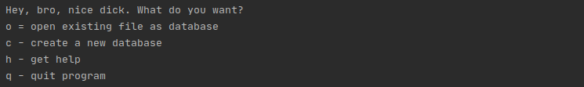
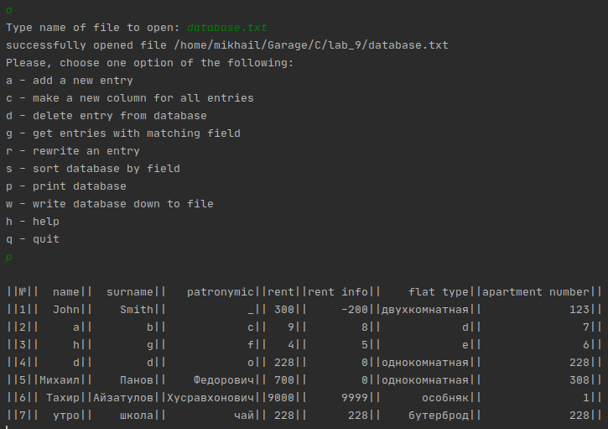
Чтобы вспомнить доступные команды, можно нажать на h, чтобы вывести базу данных в табличном виде нужно набрать p

Перезапишем одну запись с помощью опции r
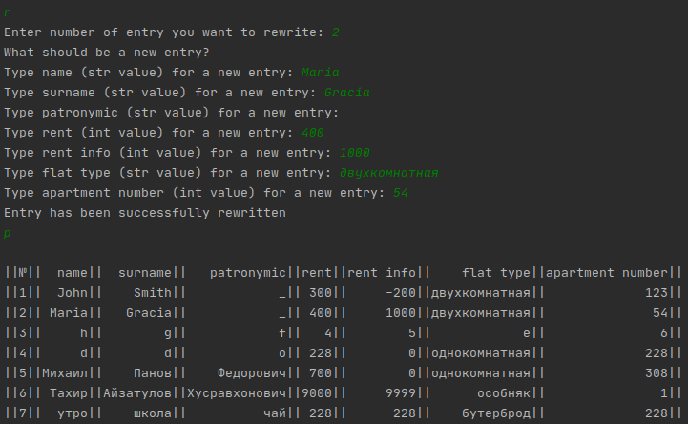
Для удаления записи служит опция d
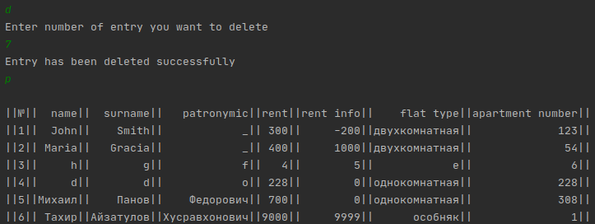

Для того, чтобы отсортировать записи по заданному полю, нужно ввести s и номер, соответствующий нужному столбцу
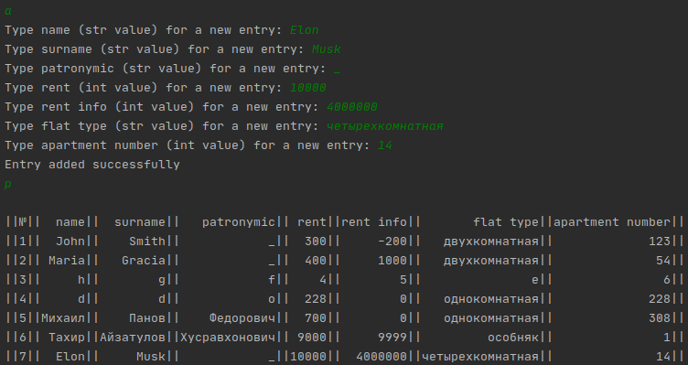
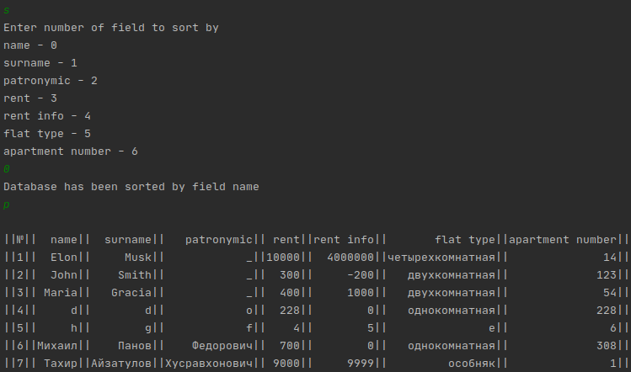
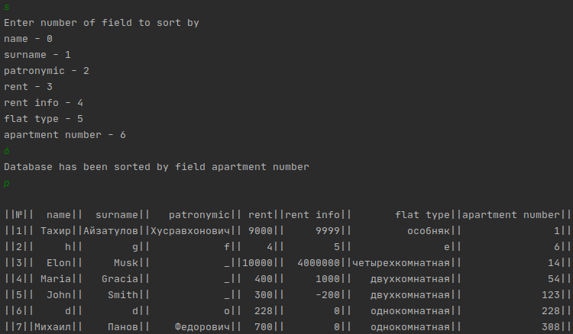
Попробуем отсортировать по другому полю

Чтобы получить записи по заданному значению, воспользуемся опцией g.
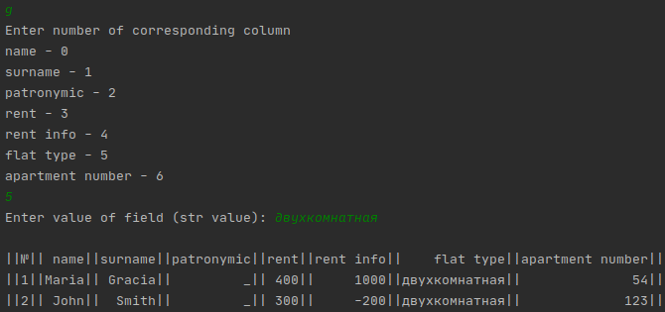
Сохраним базу данных и выйдем из программы.
