ER Diyagramı

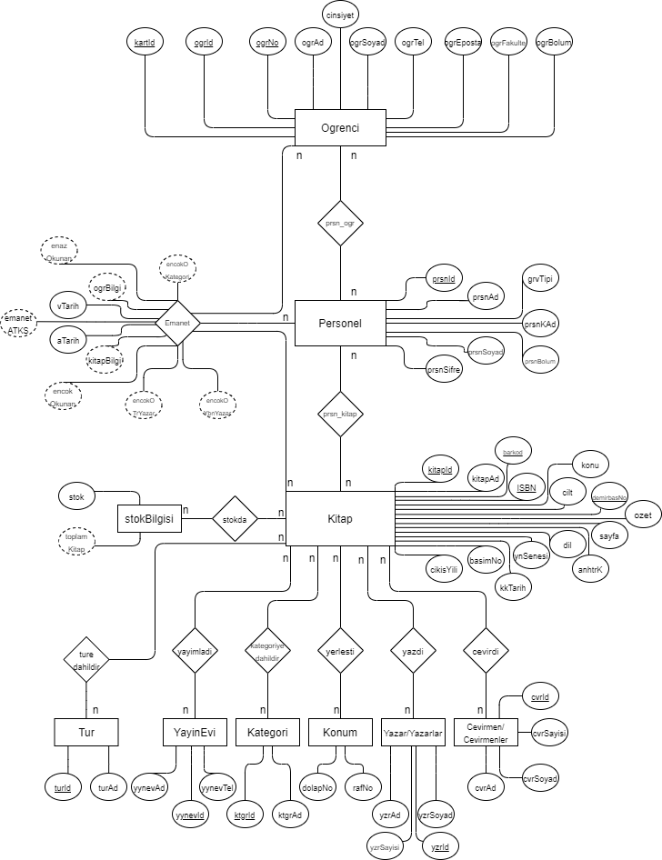

CREATE TABLE Ogrenci ( kartId INT NOT NULL UNIQUE , ogrId INT NOT NULL PRIMARY KEY AUTO_INCREMENT , ogrNo INT NOT NULL UNIQUE , ogrAd TEXT NOT NULL , ogrSoyad TEXT NOT NULL , ogrTel VARCHAR(11) NOT NULL , ogrEposta TEXT NOT NULL , ogrBolum TEXT NOT NULL)

CREATE TABLE Personel ( prsnId INT NOT NULL PRIMARY KEY AUTO_INCREMENT , prsnKAd TEXT NOT NULL , prsnSifre VARCHAR(15) NOT NULL , prsnAd TEXT NOT NULL , prsnSoyad TEXT NOT NULL , prsnBolum TEXT NOT NULL , grvTipi TEXT NOT NULL)

CREATE TABLE Emanet ( ogrId INT NOT NULL , kitapId INT NOT NULL , ogrBilgi TEXT NOT NULL , kitapBilgi TEXT NOT NULL , aTarih DATE NOT NULL , vTarih DATE NOT NULL , emanetATKS INT NOT NULL)

CREATE TABLE Kitap ( kitapId INT NOT NULL PRIMARY KEY AUTO_INCREMENT , barkod INT NOT NULL UNIQUE, ISBN INT NOT NULL UNIQUE, demirbasNo INT NOT NULL UNIQUE, kitapAd TEXT NOT NULL , cilt INT NOT NULL , konu TEXT NOT NULL , ozet TEXT NOT NULL , sayfa INT NOT NULL , anhtrK TEXT NOT NULL , dil TEXT NOT NULL , ynSenesi DATE NOT NULL , kkTarih DATE NOT NULL , basimNo INT NOT NULL , cikisYili INT NOT NULL)

CREATE TABLE Tur ( turId INT NOT NULL PRIMARY KEY AUTO_INCREMENT , turAd TEXT NOT NULL)

CREATE TABLE YayinEvi ( yynevId INT NOT NULL PRIMARY KEY AUTO_INCREMENT , yynevAd TEXT NOT NULL , yynevTel VARCHAR(11) NOT NULL)

CREATE TABLE Kategori ( ktgrId INT NOT NULL PRIMARY KEY AUTO_INCREMENT , ktgrAd TEXT NOT NULL)

CREATE TABLE Yazar ( yzrId INT NOT NULL PRIMARY KEY AUTO_INCREMENT, yzrAd TEXT NOT NULL , yzrSoyad TEXT NOT NULL , yzrSayisi INT NOT NULL)

CREATE TABLE Cevirmen ( cvrId INT NOT NULL PRIMARY KEY AUTO_INCREMENT, cvrAd TEXT NOT NULL , cvrSoyad TEXT NOT NULL , cvrSayisi INT NOT NULL)

ALTER TABLE Kitap ADD ktgrId INT NOT NULL AFTER kitapId, ADD turId INT NOT NULL AFTER ktgrId, ADD yzrId INT NOT NULL AFTER turId, ADD yynevId INT NOT NULL AFTER yzrId, ADD cvrId INT NOT NULL AFTER yynevId;

ALTER TABLE Kitap ADD FOREIGN KEY (yynevId) REFERENCES YayinEvi(yynevId) ON DELETE RESTRICT ON UPDATE RESTRICT;

ALTER TABLE Kitap ADD FOREIGN KEY (cvrId) REFERENCES Cevirmen(cvrId) ON DELETE RESTRICT ON UPDATE RESTRICT;

ALTER TABLE Kitap ADD FOREIGN KEY (ktgrId) REFERENCES Kategori(ktgrId) ON DELETE RESTRICT ON UPDATE RESTRICT;

ALTER TABLE Kitap ADD FOREIGN KEY (turId) REFERENCES Tur(turId) ON DELETE RESTRICT ON UPDATE RESTRICT;

ALTER TABLE Kitap ADD FOREIGN KEY (yzrId) REFERENCES Yazar(yzrId) ON DELETE RESTRICT ON UPDATE RESTRICT;

ALTER TABLE Emanet ADD FOREIGN KEY (kitapId) REFERENCES Kitap(kitapId) ON DELETE RESTRICT ON UPDATE RESTRICT

ALTER TABLE Emanet ADD FOREIGN KEY (ogrId) REFERENCES Ogrenci(ogrId) ON DELETE RESTRICT ON UPDATE RESTRICT;

ALTER TABLE Kitap ADD dolapNo INT NOT NULL AFTER cikisYili, ADD rafNo INT NOT NULL AFTER dolapNo;

ALTER TABLE Ogrenci ADD cinsiyet TEXT NOT NULL AFTER ogrSoyad;

ALTER TABLE Ogrenci ADD ogrFakulte TEXT NOT NULL AFTER ogrEposta;

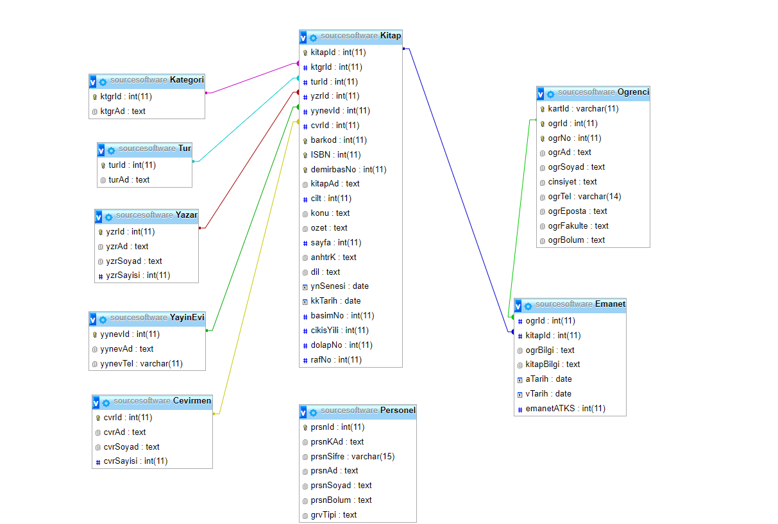

**Source Software Ekibi**  
Halil Eren Yazıcı : 132030049  
Berkay Gürcan : 132030022  
Baha Can : 131830066  
Mustafa Kaya : 131930068  
Kadir Korkmaz : 132030046