DOCKER NETWORK

* Docker container create three default network driver.

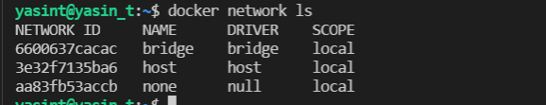

* Container can connect to each other by bridge network driver by ID however they can connect each other by user defined bridge network driver.

docker network inspect bridge

* Run two `alpine` containers with interactive shell, in detached mode, name the container as `cont1st` and `cont2nd`, and add command to run alpine shell.

docker container run -dit --name cont1st alpine ash

docker container run -dit --name cont2nd alpine ash

* Get the IP of `clarus2nd` container. (172.17.0.3)

docker container inspect cont2nd | grep IPAddress

* Connect to the `clarus1st` container.

docker exec -it clarus1st sh

-Ping to google.com and ‘cont2nd’ container by its IP four times to show the connection.

ping -c 4 google.com

ping -c 4 172.17.0.3

```

- Try to ping `cont2nd `container by its name, should face with bad address.

ping -c 4 clarus2nd

**User-defined Network Bridge in Docker:**

* Create a bridge network `testnet`.

docker network create --driver bridge testnet

* List the networks

