**DOCKER COMPOSE:**

* To check docker compose installation

*docker-compose –version*

* To install <https://docs.docker.com/compose/install/>
* Create docker-compose.yml document

*docker-compose up -d* (multi container will be create- run the terminal from the folder include yml file)

*docker-compose down (volume haric herseyi siler)*

* *docker-compose config*
* *docker-compose images*
* *docker-compose logs*
* Docker-compose.yml file’da hazir image yazilir, ancak ayni folderda ki docker file kullanarak build yapmasini da saglayabiliyoruz.

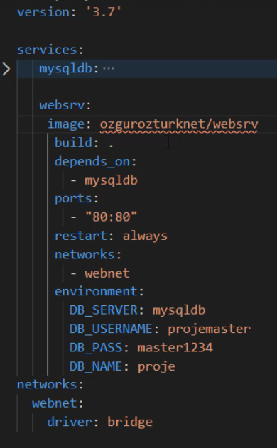 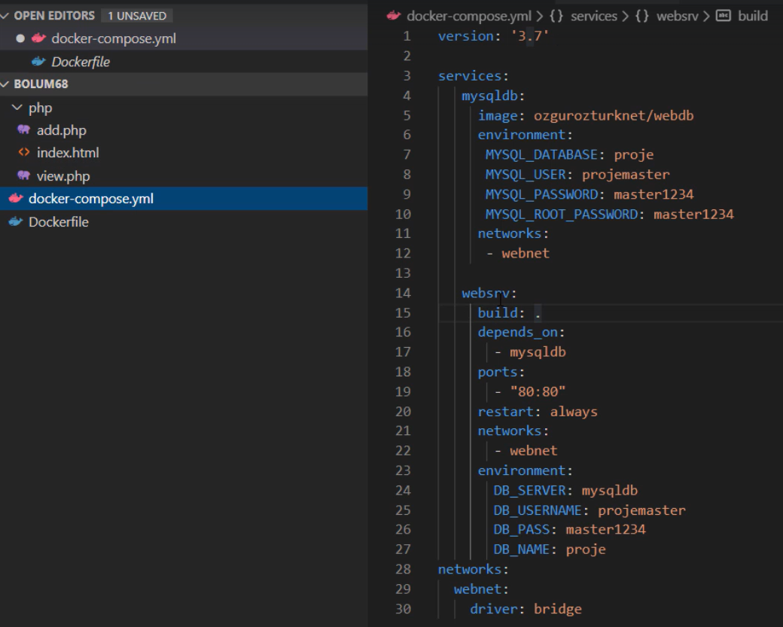

* Neden bu sekilde yapilir?

Ozellikle test ortamlari CI/CD sistemleri her defasinda image cekip, docker-compose up and down islemleri zor olur. Bu sekilde direk docker-compose icerisinde image update vs yapilirsa docker-compose build ile calistirilabilir, cunku compose up/down da volume gibi buradaki image de silinmez. Diger method da docker compose da image de silinmis oluyor.