Fraud Investigation Report
OpenG2P Fraud Detection Engine — Confidential

Case ID | ad066274-a27a-47c0-ae80-02300af63063
Beneficiary ID | 45030
Generated | 2026-07-28 02:04 UTC
Status | OPEN
Recommendation | CLEAR
RISK LEVEL: LOW | FINAL SCORE: 8.8%
Score Breakdown
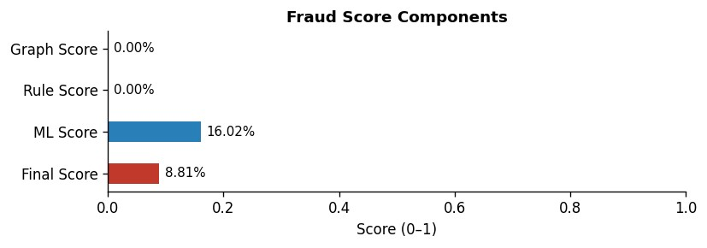
Feature Contributions (SHAP)
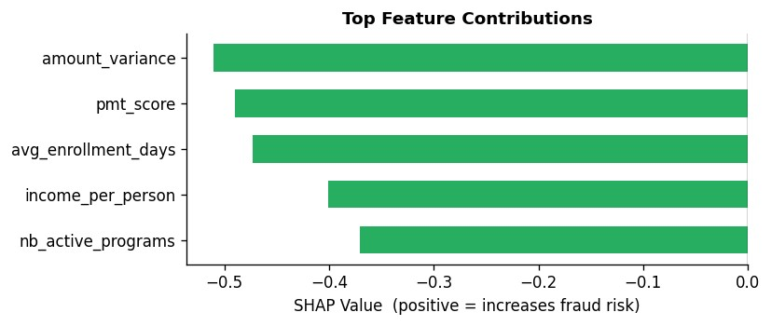
Feature Vector (Appendix)
Feature | Value
age | 27.0000
amount_variance | 23574.4111
avg_enrollment_days | 1214.0000
cycle_count | 6.0000
days_reg_to_first_payment | 999.0000
dependency_ratio | 0.0000
duplicate_national_id_count | 0
enroll_last_30d | 0.0000
enroll_last_90d | 0.0000
enrollment_velocity | 0.0494
group_membership_count | 0.0000
has_disabled | 0.0000
high_amount_flag | 0.0000
household_size | 1.0000
household_size_deviation | 0.0000
identity_cluster_count | 0.0000
income | 794.5000
income_per_person | 794.5000
income_program_inconsistency | 0.0000
income_ratio_to_national | 1.0000
national_median_income | 358.3300
nb_active_programs | 2.0000
nb_children | 0.0000
nb_elderly | 0.0000
nb_programs | 2.0000
network_risk | 0.0000
payment_count | 6.0000
payment_gap_ratio | 0.1667
payment_success_rate | 0.8333
payments_within_7d_of_enroll | 0.0000
pmt_score | 0.5000
pmt_score_min | 0.5000
poverty_line | 170.4000
registration_age_days | 365.0000
shared_account_count | 0.0000
shared_phone_count | 0.0000
single_head | 0.0000

Generated by OpenG2P Fraud Detection Engine v2.0 — CONFIDENTIAL

