**Documentation**

1. Create a simple excel document with 5-10 employees with the four columns as mentioned above.

* Open Microsoft Excel
* Enter the data as per format in worksheet
* Click save

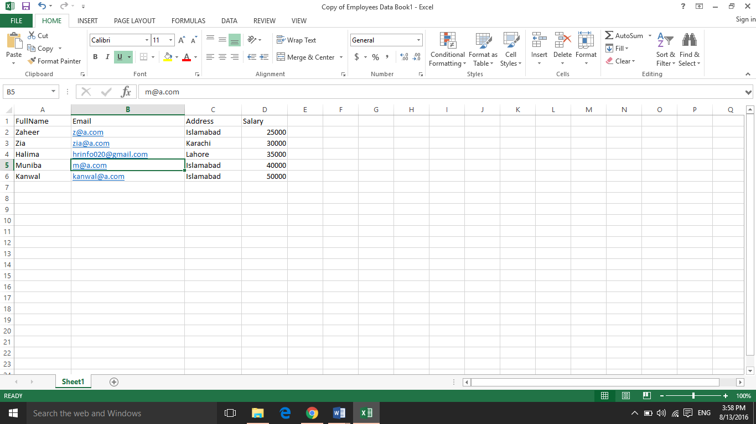

1. Create a template mail merge word file for the increment letter with the above columns as merge fields to be replaced by real values when the mail merge is performed.

* Open Microsoft Word
* Click on mailing
* Select letters for template
* Select data source as excel sheet created in step 1
* Format the letter as per requirements

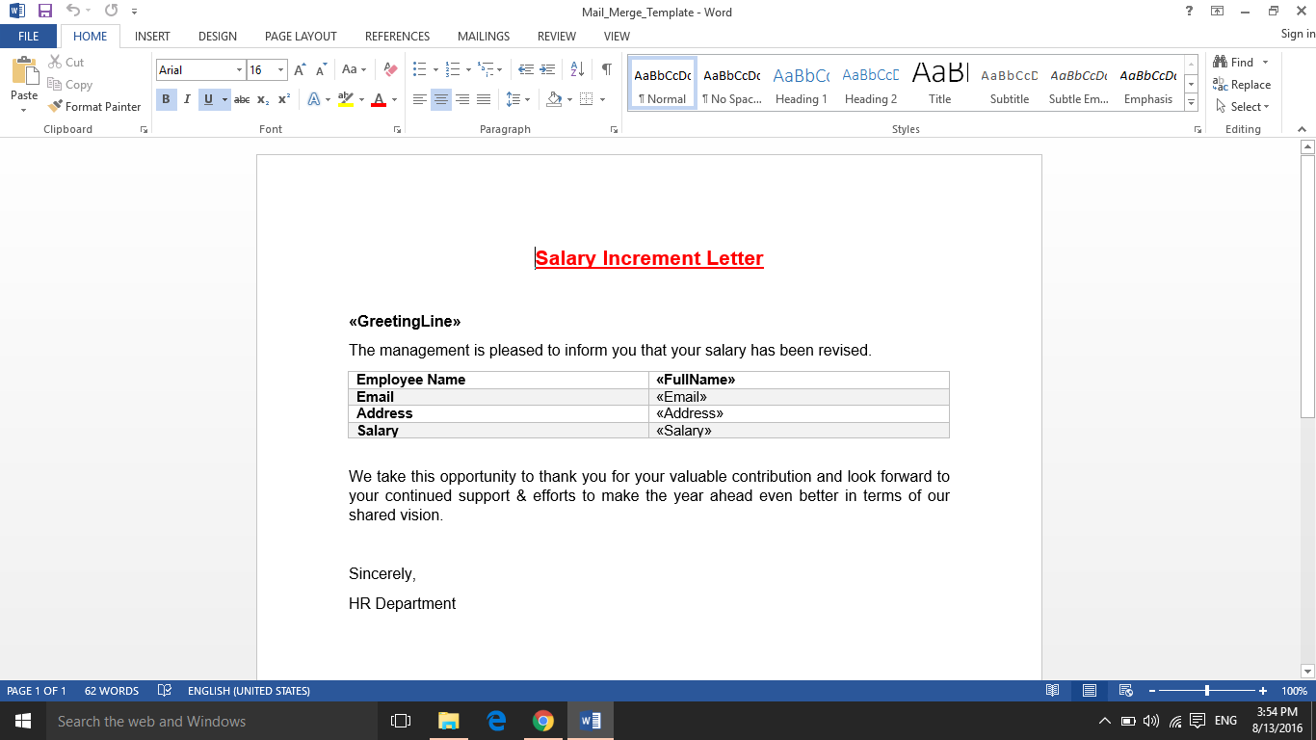

1. Create an ASP.NET web application that will process this Excel file, generate increment letter in a Word file and then email that word file to each employee.
2. Create a simple and easy to use screen to let the HR manager upload the excel file which will be as per the format you defined in Step # 1.

* This is the screen to upload excel file

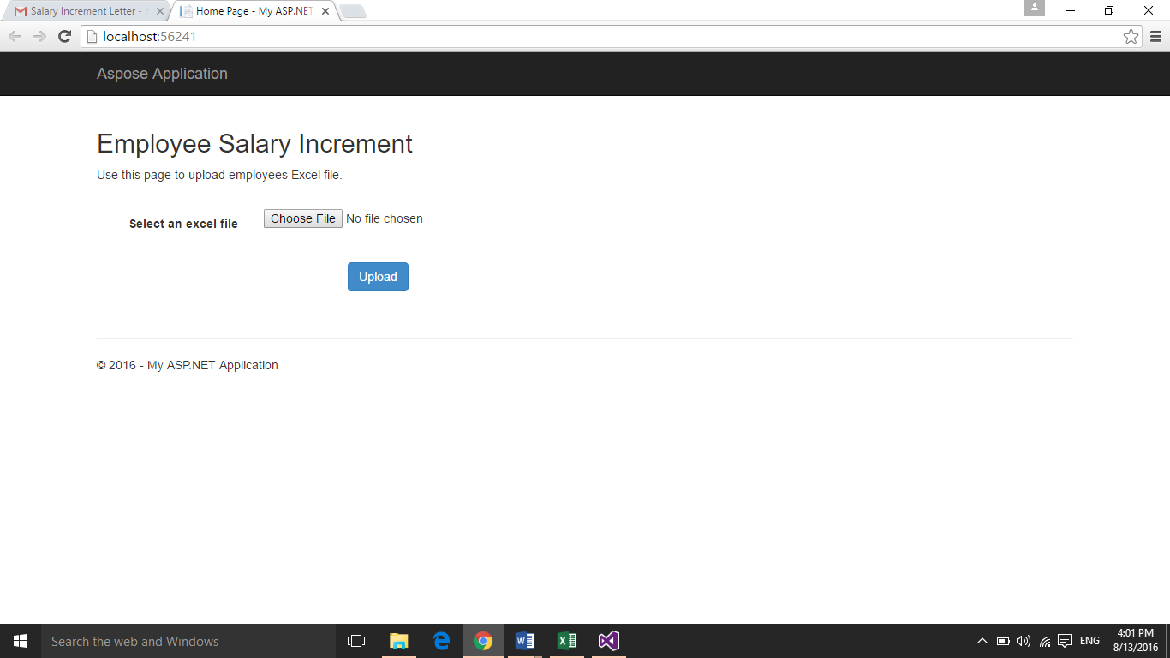

1. On successful upload show the list of employees on the screen and then show a send button at the bottom that will process and send increment letter (word file) to all employees as an email attachment.

* Once the file is uploaded, its format is checked.
* The webpage display data of the file been uploaded a few seconds ago.

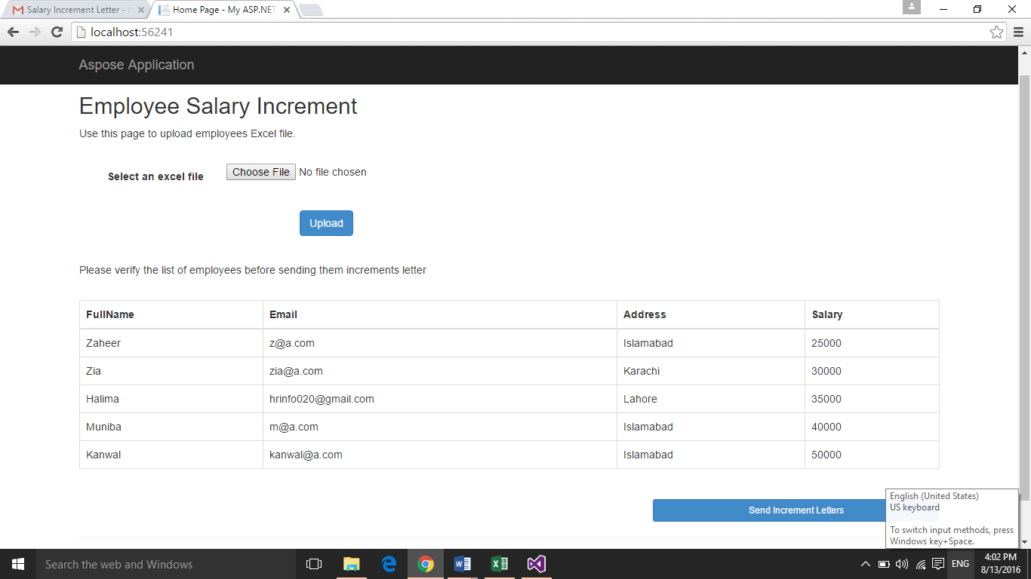

1. Read the Excel file uploaded in Step # 4 and then loop through the records to perform mail merge for each row using **Aspose.Words for .NET**.

* When the excel data is replaced by another excel sheet it requires permission to override the file.
* And merge the row in word document template created in step 2

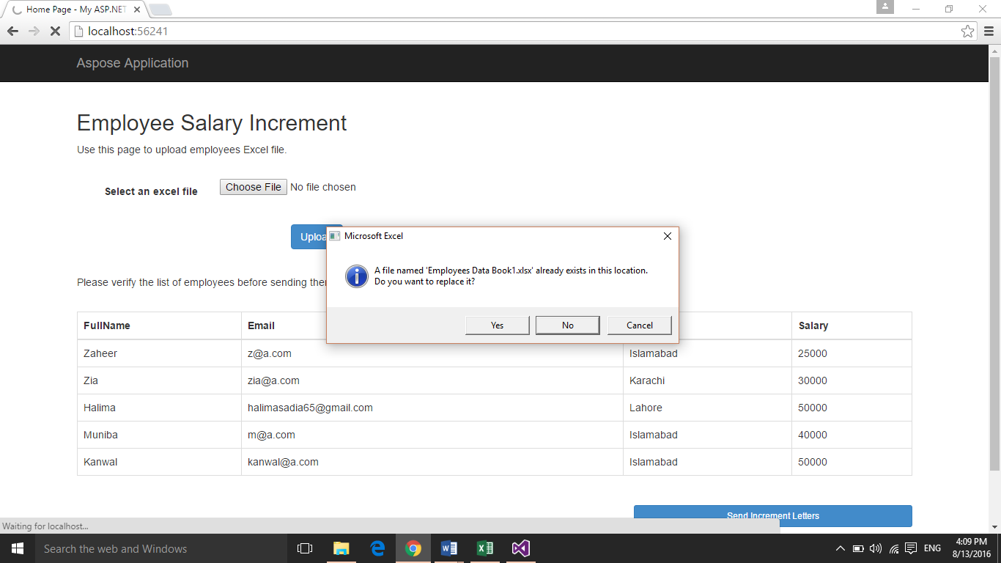

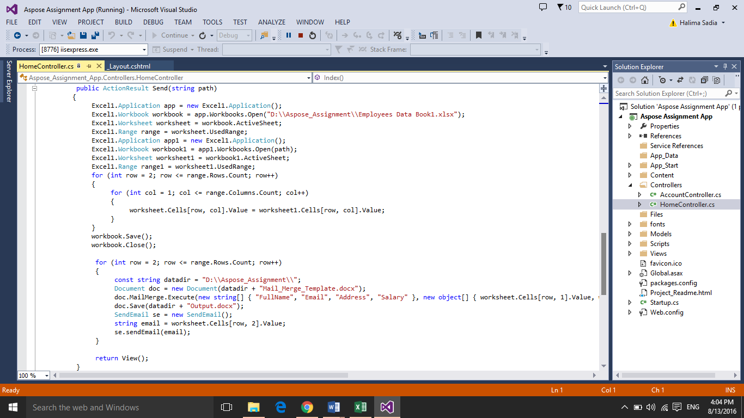

1. Once the increment letter word file is generated email that letter to the employee on his/her email address.

* On clicking send button, the app send email to employees .

