**MARKUP TEST**

**BITA/5/21/004/TZ**

1. I started by creating spring boot project by browsing “spring boot initializer” in the chrome. Then the following interface will appear

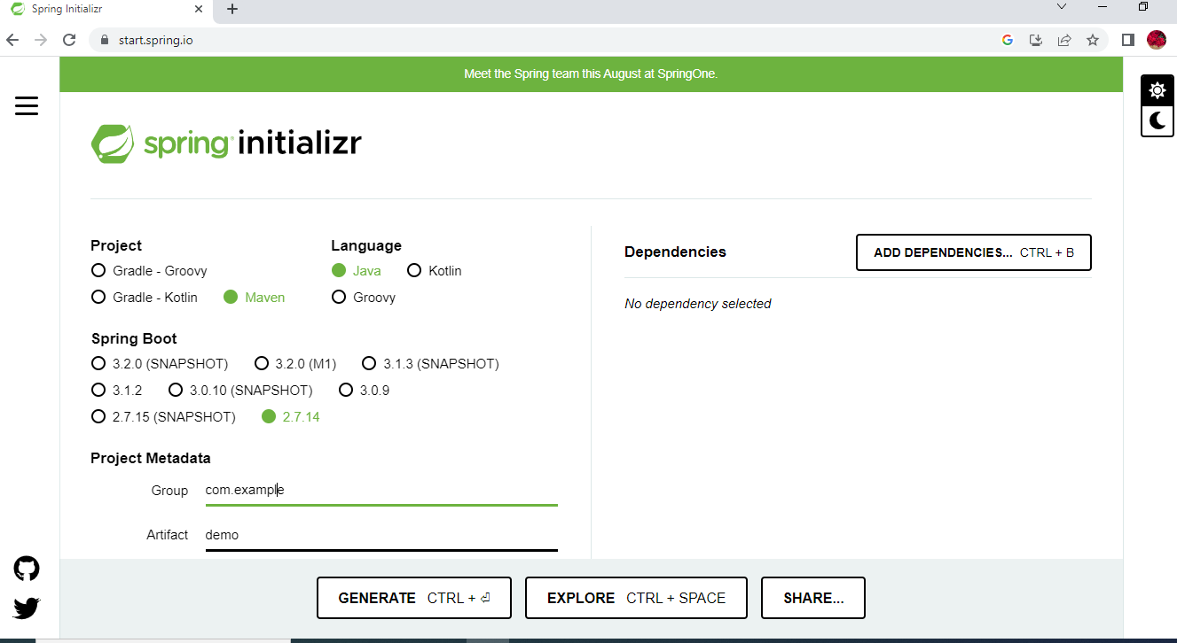

Where by from the language I choose java and maven.

And spring boot version we choose 2.7 14 which match the version of java found in my PC. Then after creating it I proceed by adding name and description of my project.

Where by I choose 6 dependencies, which are;

* Spring web
* Spring data JPA
* MYSQL Driver
* JDBC API
* Lombok

1. The following is that I add maven dependencies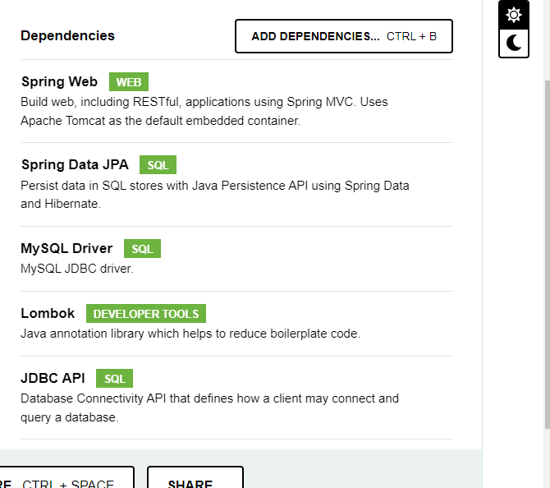
2. Then I continue by creating database in Xampp.

My table was named Employee_managementDB.

1. Then the following step was creating models, which contain codes as follow

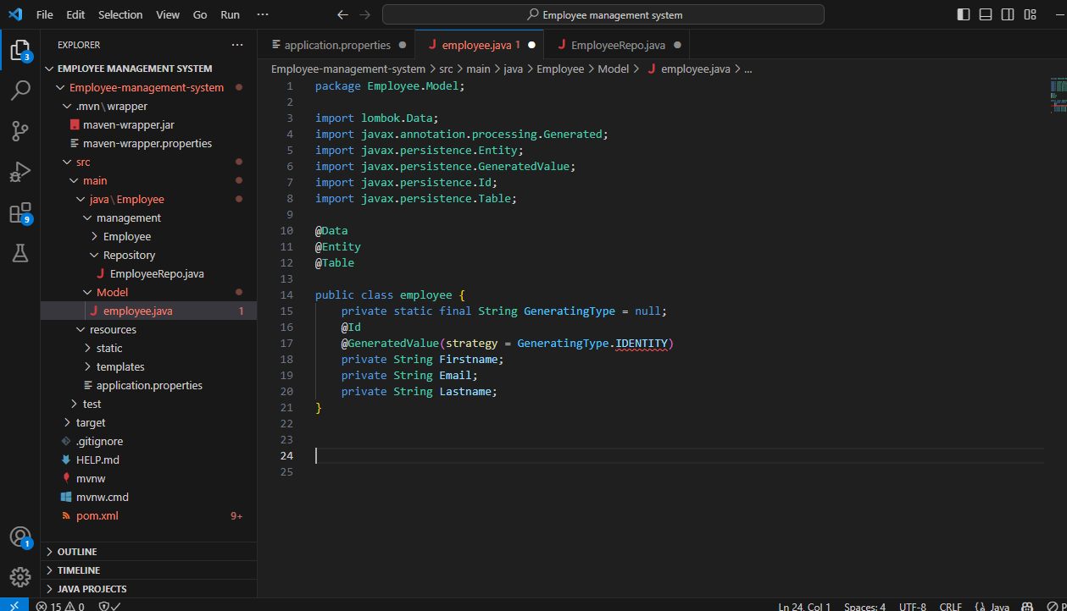

1. Then it was followed by creating repository and writing code in it

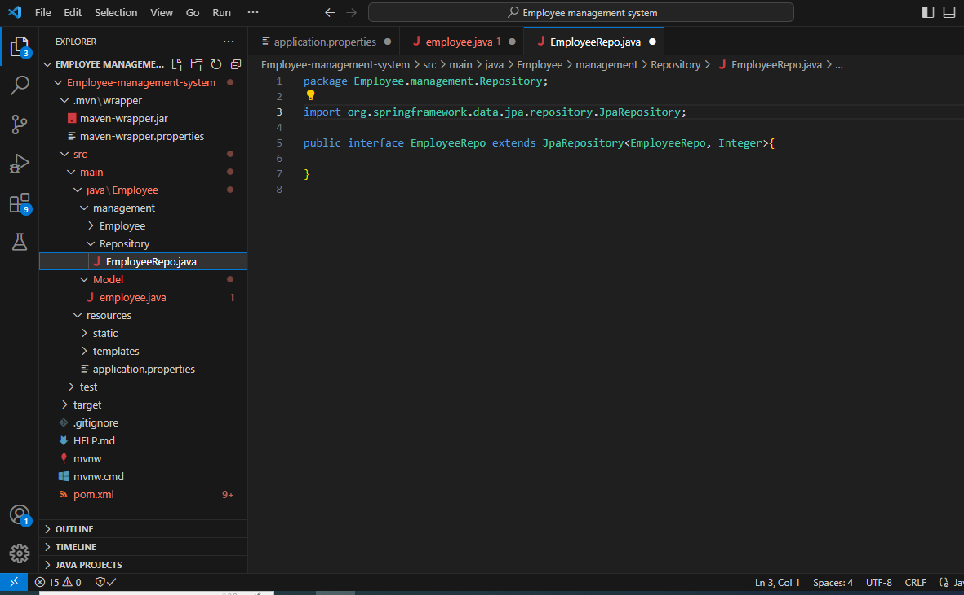

1. Then I created a controller with a file within it named employeecontroller.java

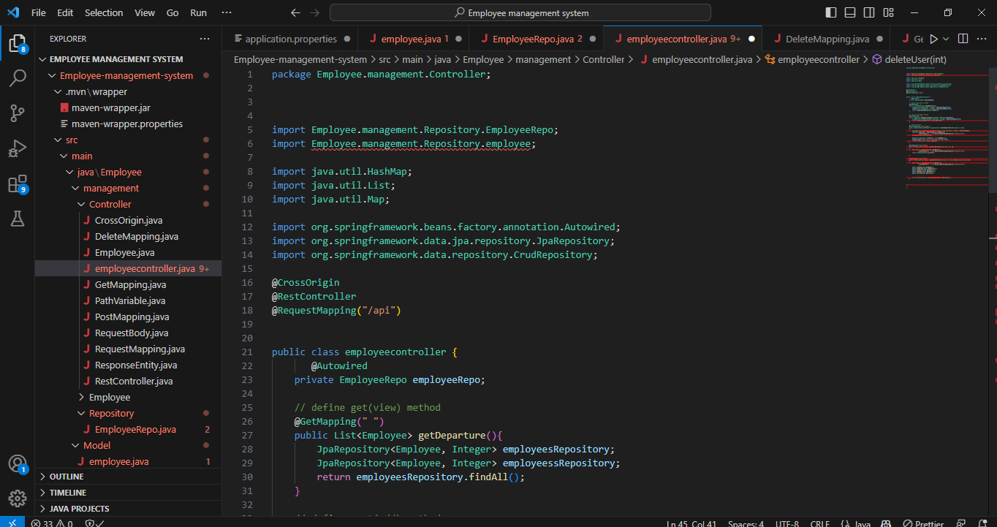

In which I got many errors and I tried my best to solve them but the time didn’t allow me to do so.