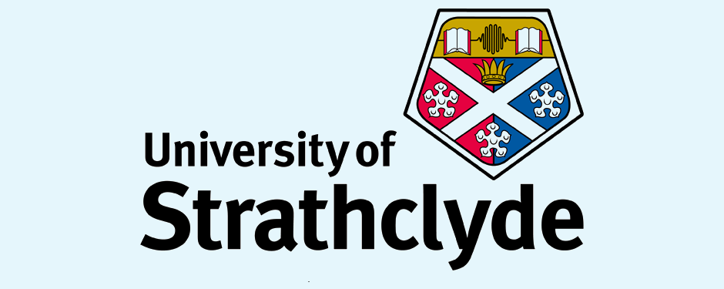

Faculty of Science

Department of Pure and Applied Chemistry

**Validation of Presumptive Test for Non-Human Blood using Kastle Meyer (KM) and Hemastix Reagents**

Fabio Casali

August 2018



Faculty of Science

Department of Pure and Applied Chemistry

**Validation of Presumptive Test for Non-Human Blood using Kastle Meyer (KM) and Hemastix Reagents**

by

Fabio Casali

August 2018

A thesis submitted to the Centre for Forensic Science, University of Strathclyde, in part fulfilment of the regulations for the degree of Master of Science in Forensic Science.

I declare that the work on which this dissertation/thesis is based is my original work, except where acknowledgements indicate otherwise. I empower the university to reproduce for the purpose of research either the whole or any portion of the contents in any manner whatsoever.

Signature:

Date: 07/08/18

Word count: 9985