GEBZE TECHNICAL UNIVERSITY
Department of Computer Science
CSE 341 — Concepts of Programming Languages

D3 — Test Report
Part 1 Submission
8 May 2026

Halit Batuhan ASLAN
220104004003

Test Contents

6 invalid tests with codes and terminal outputs
3 sample correct tests with codes and terminal outputs

Invalid Tests;
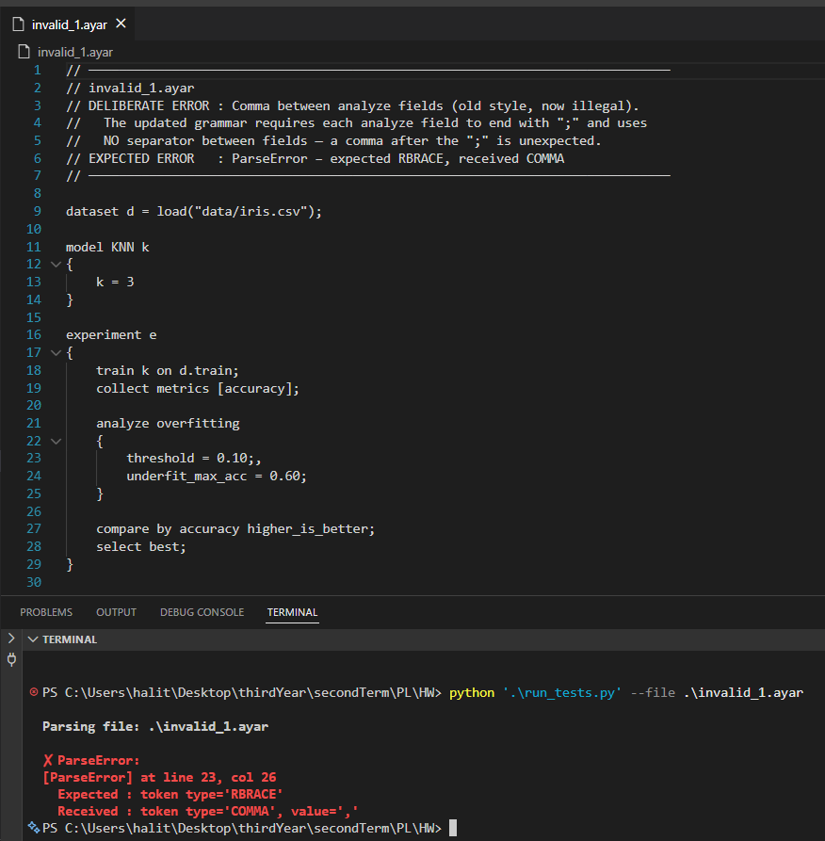
Invalid Test 1 — Comma between analyze fields Error: A comma is placed between fields inside the analyze block. In the current grammar, analyze fields are only terminated by ; with no separator between them. The parser raises an error when it encounters , where } is expected.
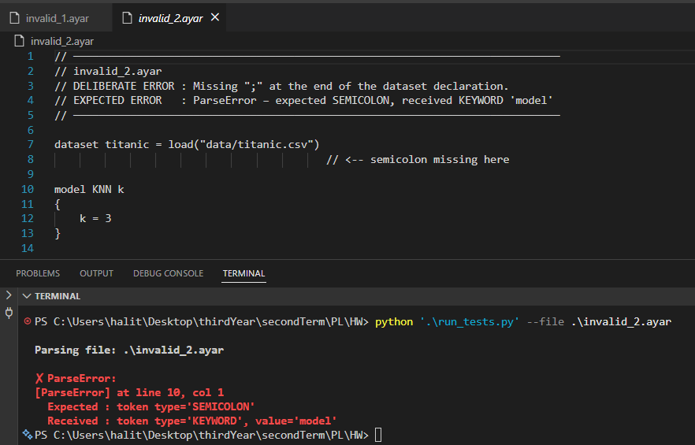
Invalid Test 2 — Missing semicolon after dataset Error: The ; is missing at the end of the dataset declaration. The parser expects a SEMICOLON at the end of the line but finds the model keyword on the next line instead.
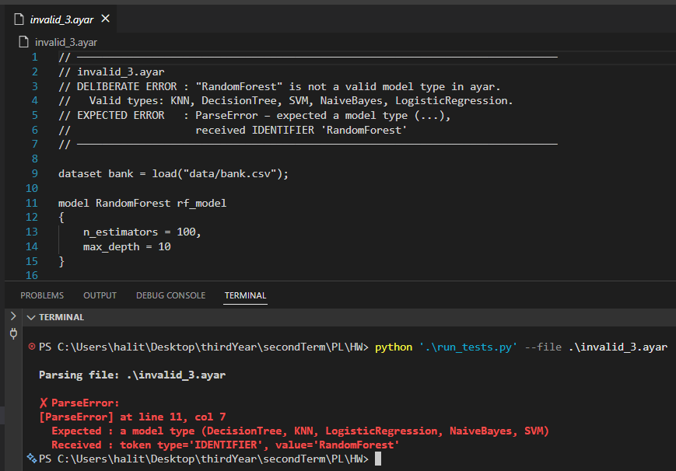
Invalid Test 3 — Invalid model type (RandomForest) Error: RandomForest is not a valid model type in Ayar. Only KNN, DecisionTree, SVM, NaiveBayes, and LogisticRegression are supported. The parser reads the unrecognized type as an IDENTIFIER and reports that a model type was expected.
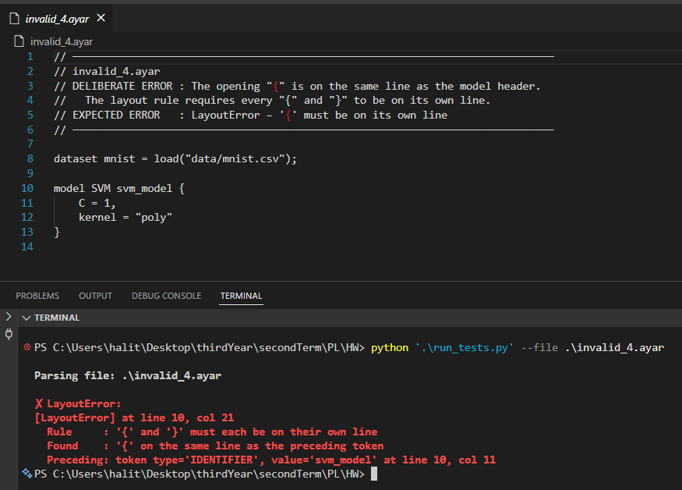
Invalid Test 4 — Layout violation (brace on same line) Error: The opening { is on the same line as the model header. Ayar's layout rule requires { and } to each appear on their own line. A LayoutError is raised.
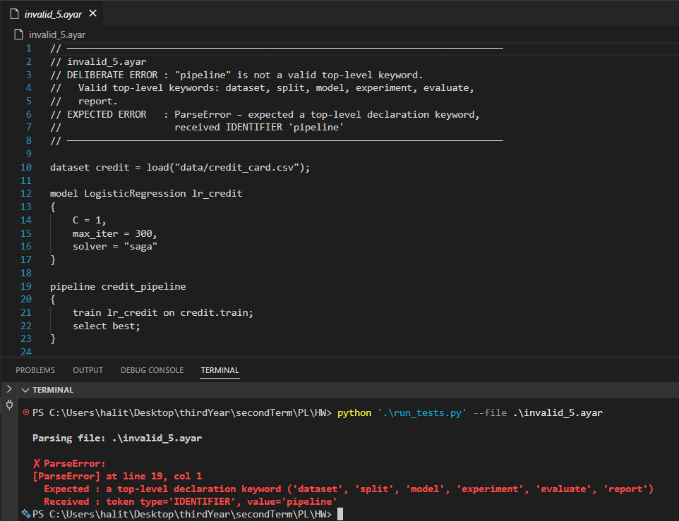
Invalid Test 5 — Unknown top-level keyword (pipeline) Error: pipeline is not a recognized top-level keyword in Ayar. Valid top-level keywords are: dataset, split, model, experiment, evaluate, report. The parser raises an error at the unrecognized keyword.

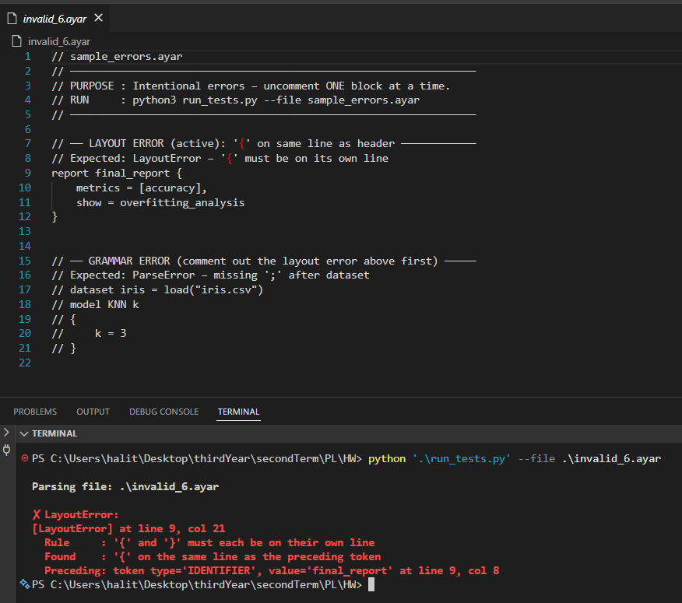
Invalid Test 6 — Layout violation in report block Error: The { in the report block is placed on the same line as the header. This demonstrates the same layout rule as Invalid Test 4, applied to a different construct (report).

Valid Tests;
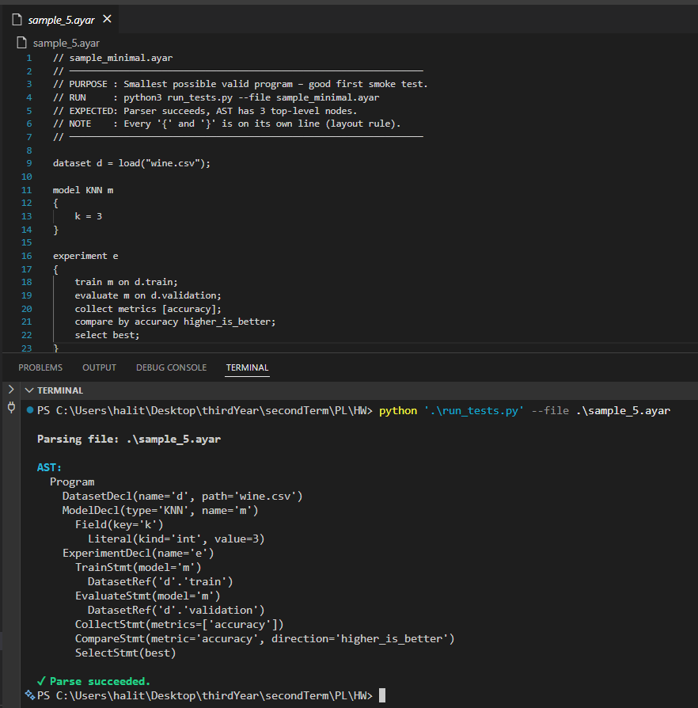
Valid Test — sample_5.ayar (Minimal Program) The smallest valid Ayar program. Contains a single dataset, one KNN model, and a basic experiment block. Verifies that all mandatory constructs (dataset, model, experiment, train, evaluate, collect, compare, select) work in their minimal form. The AST output produces 3 top-level nodes.

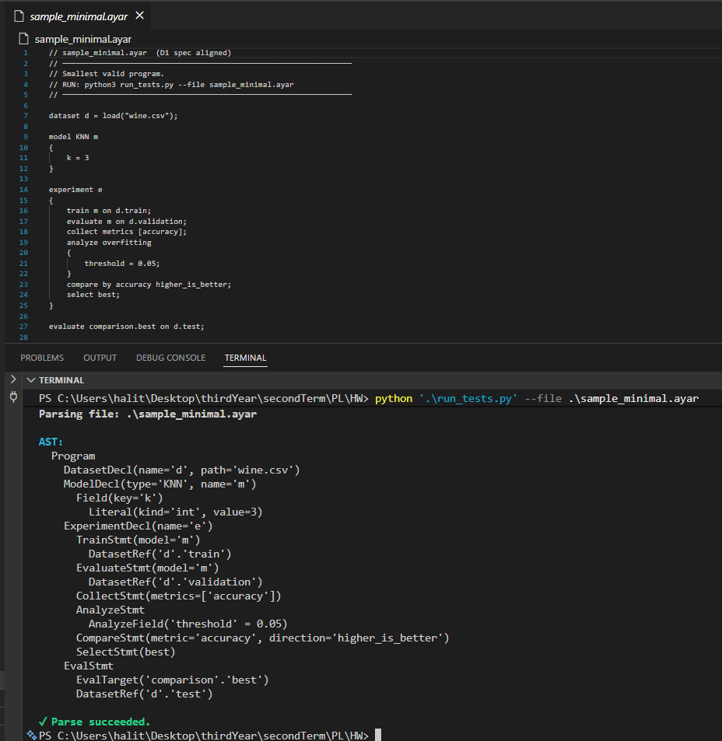
Valid Test — sample_minimal.ayar (Extended Minimal) Extends the minimal program by adding an analyze overfitting block and a top-level evaluate statement. Tests the comma-free analyze field format and the dotted eval_target form (comparison.best).

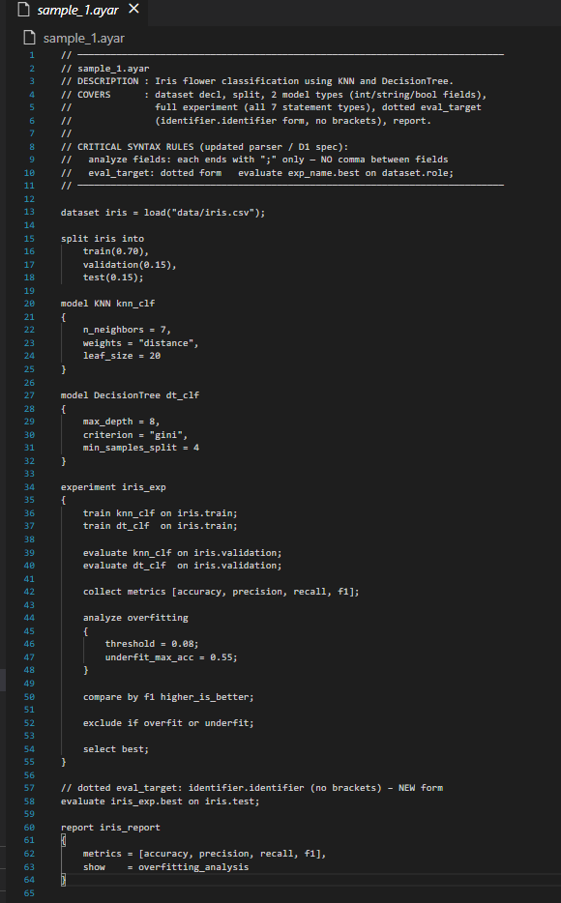
Valid Test — sample_1.ayar (Iris Classification) The most comprehensive test program. Uses two model types (KNN + DecisionTree), int/string/bool field values, all 7 experiment statement types (train, evaluate, collect, analyze, compare, exclude, select), the dotted eval_target form, and a report block. The AST output produces all node types and prints "Parse succeeded".

