GEBZE TECHNICAL UNIVERSITY
Department of Computer Science
CSE 341 — Concepts of Programming Languages

D3 — Test Report
Part 2 Submission
22 May 2026

Halit Batuhan ASLAN
220104004003

Test Contents

6 invalid tests with codes and terminal outputs
3 sample correct tests with codes and terminal outputs
6 tests for interpreter checking

Invalid Tests;
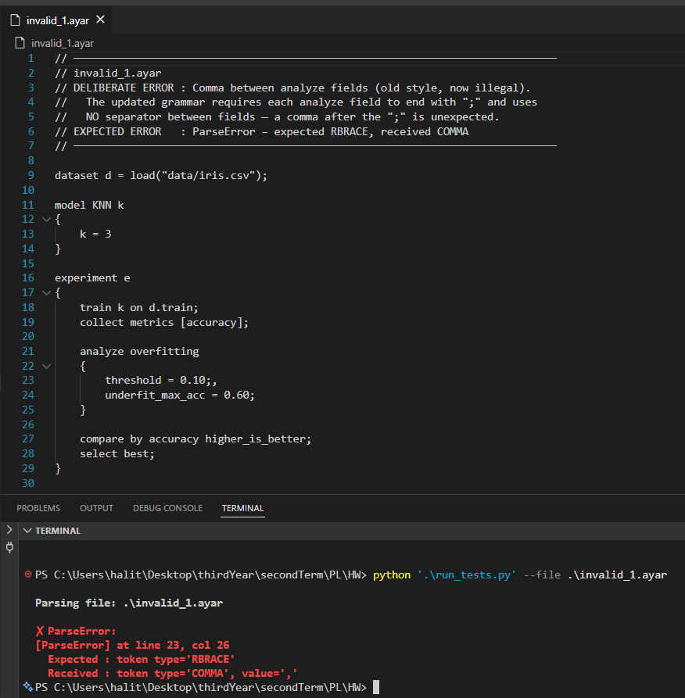
Invalid Test 1 — Comma between analyze fields Error: A comma is placed between fields inside the analyze block. In the current grammar, analyze fields are only terminated by ; with no separator between them. The parser raises an error when it encounters , where } is expected.
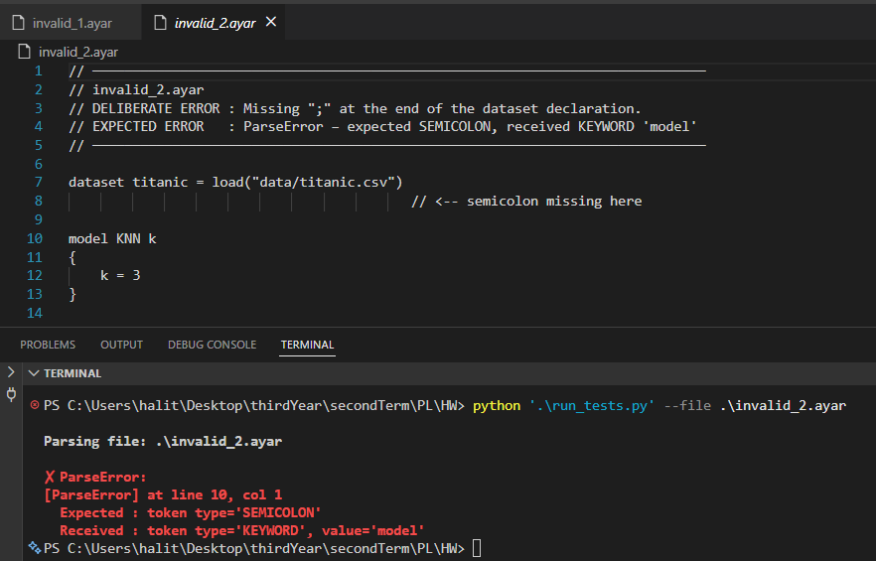
Invalid Test 2 — Missing semicolon after dataset Error: The ; is missing at the end of the dataset declaration. The parser expects a SEMICOLON at the end of the line but finds the model keyword on the next line instead.
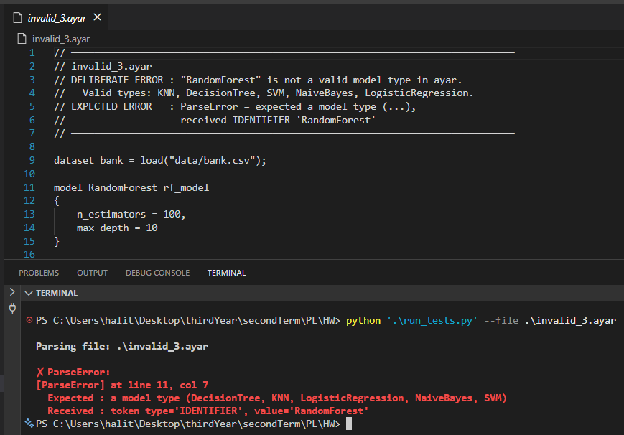
Invalid Test 3 — Invalid model type (RandomForest) Error: RandomForest is not a valid model type in Ayar. Only KNN, DecisionTree, SVM, NaiveBayes, and LogisticRegression are supported. The parser reads the unrecognized type as an IDENTIFIER and reports that a model type was expected.
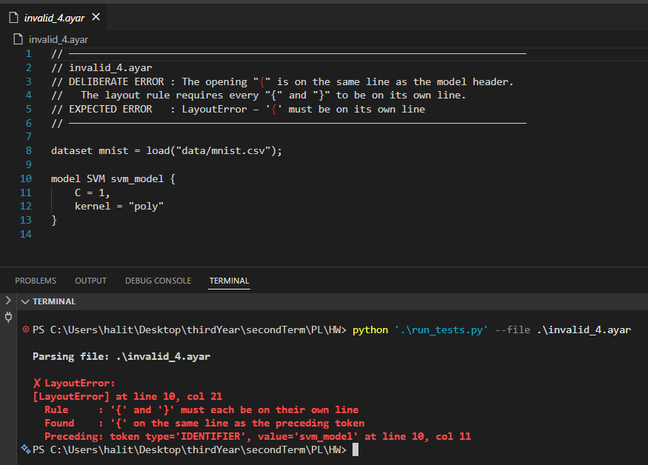
Invalid Test 4 — Layout violation (brace on same line) Error: The opening { is on the same line as the model header. Ayar's layout rule requires { and } to each appear on their own line. A LayoutError is raised.
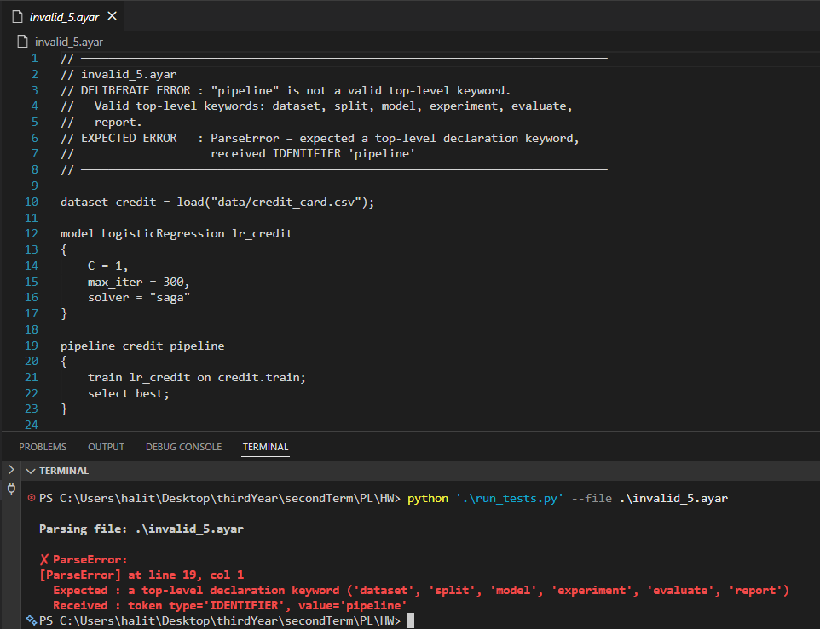
Invalid Test 5 — Unknown top-level keyword (pipeline) Error: pipeline is not a recognized top-level keyword in Ayar. Valid top-level keywords are: dataset, split, model, experiment, evaluate, report. The parser raises an error at the unrecognized keyword.

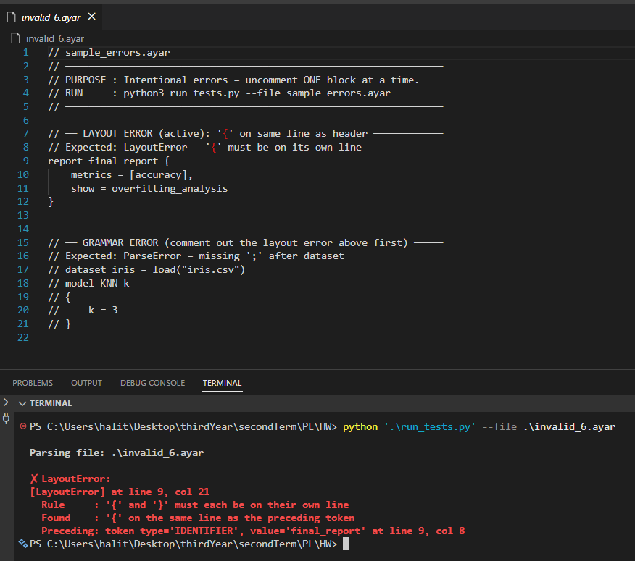
Invalid Test 6 — Layout violation in report block Error: The { in the report block is placed on the same line as the header. This demonstrates the same layout rule as Invalid Test 4, applied to a different construct (report).

Valid Tests;
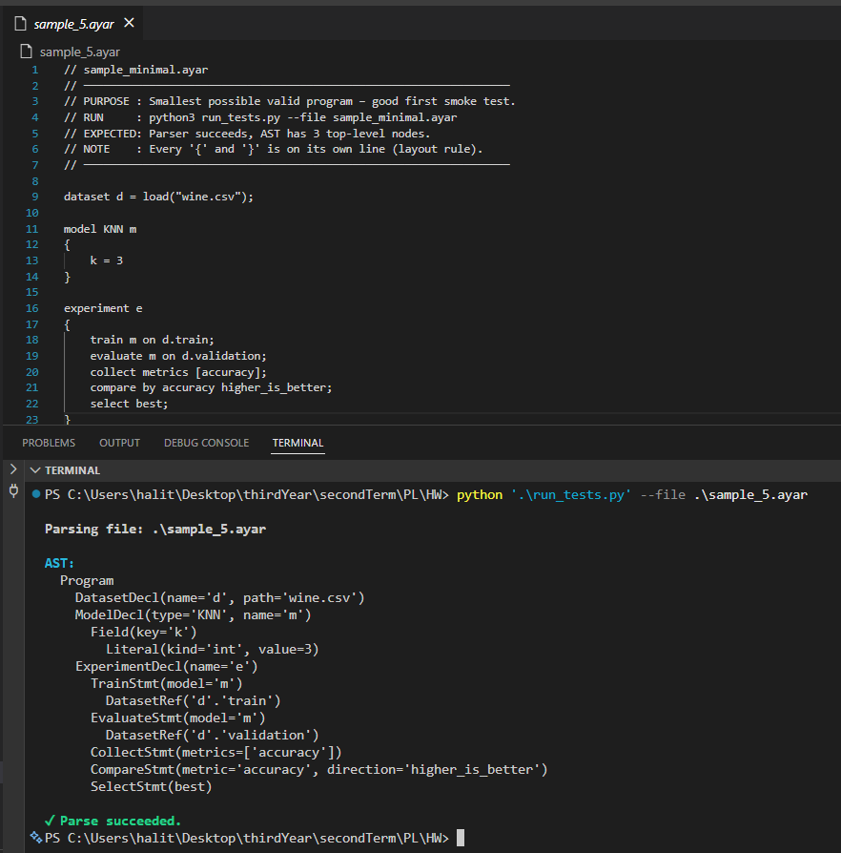
Valid Test — sample_5.ayar (Minimal Program) The smallest valid Ayar program. Contains a single dataset, one KNN model, and a basic experiment block. Verifies that all mandatory constructs (dataset, model, experiment, train, evaluate, collect, compare, select) work in their minimal form. The AST output produces 3 top-level nodes.

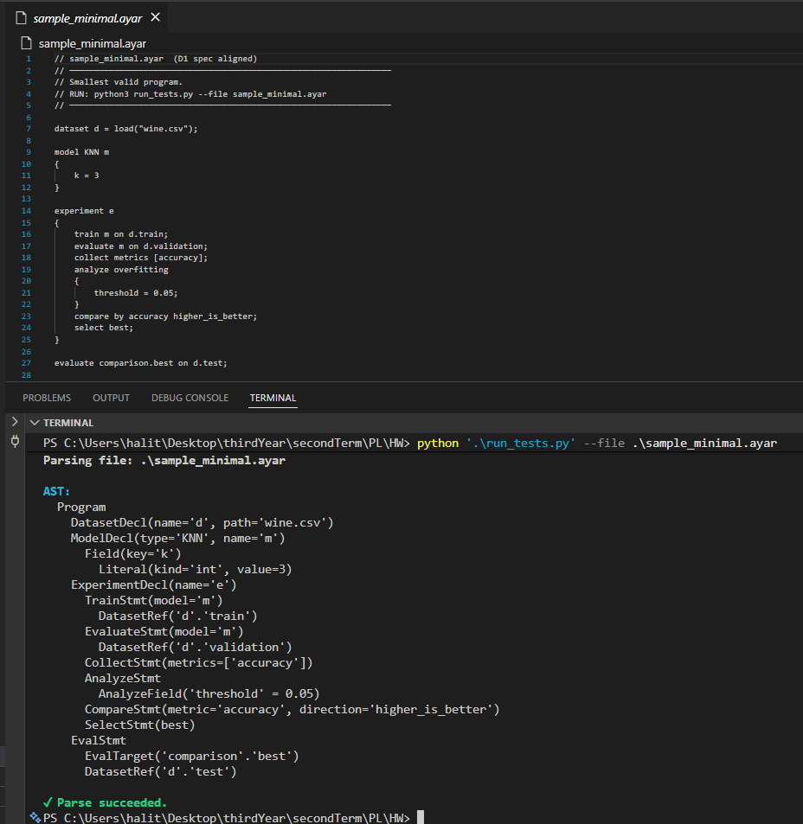
Valid Test — sample_minimal.ayar (Extended Minimal) Extends the minimal program by adding an analyze overfitting block and a top-level evaluate statement. Tests the comma-free analyze field format and the dotted eval_target form (comparison.best).

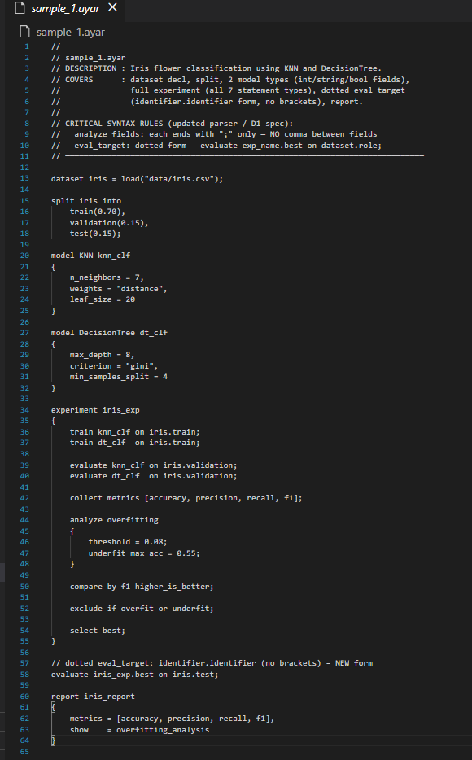
Valid Test — sample_1.ayar (Iris Classification) The most comprehensive test program. Uses two model types (KNN + DecisionTree), int/string/bool field values, all 7 experiment statement types (train, evaluate, collect, analyze, compare, exclude, select), the dotted eval_target form, and a report block. The AST output produces all node types and prints "Parse succeeded".

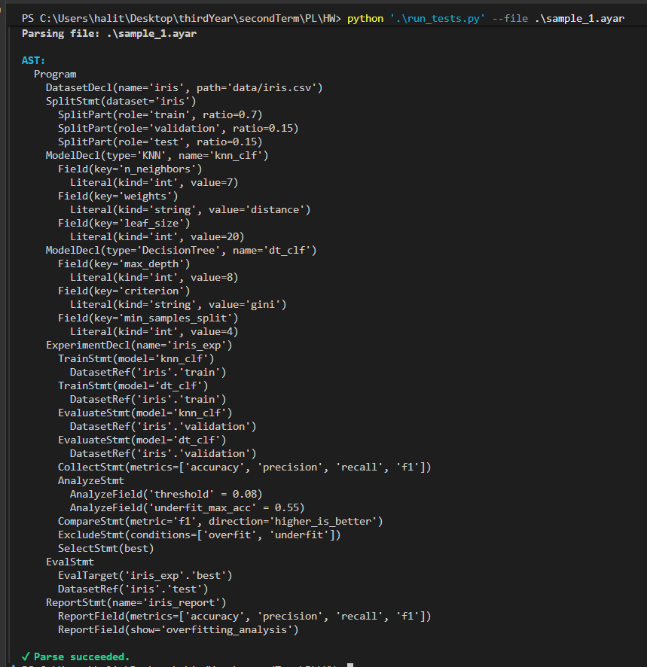

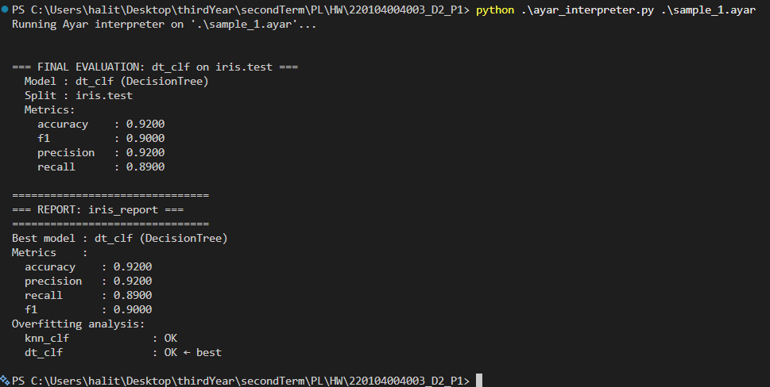
This program exercises all seven experiment statement types across two model types — KNN and DecisionTree. The DecisionTree with max_depth=8 wins by f1 (0.90) over KNN with k=5 (f1=0.84), demonstrating that the formula-based simulate() function produces meaningfully different outcomes for different hyperparameter values. Both models pass the overfitting check because the train-eval accuracy gap of 0.07 falls below the declared threshold of 0.10, so neither is excluded. The dotted eval_target form (iris_exp.best) is used for the top-level evaluate statement, and the report block shows the full overfitting analysis with all four metrics.

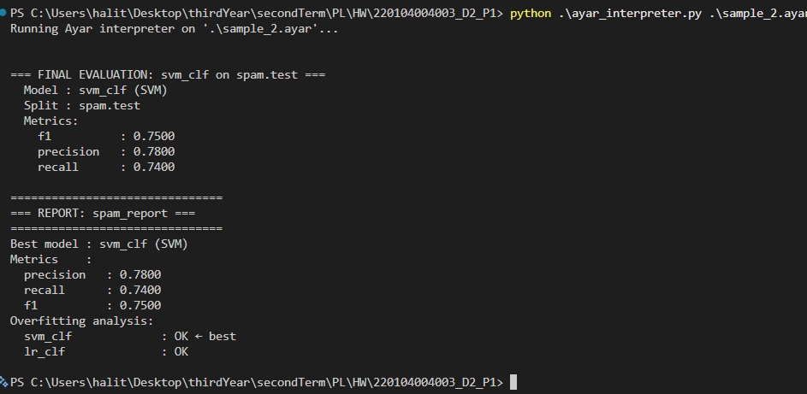
This program demonstrates three features not present in sample_1: the SVM and LogisticRegression model types, a collect metrics list that excludes accuracy ([precision, recall, f1] only), and a lower_is_better compare direction chosen to minimize false negatives in a spam detection context. SVM wins with recall 0.74 against LogisticRegression's 0.75 — the lower recall is preferred under lower_is_better, directly exercising the compare direction mechanism. The bracket eval_target form ([spam_exp.best]) is used for the top-level evaluate statement, which is syntactically distinct from the dotted form used in sample_1.

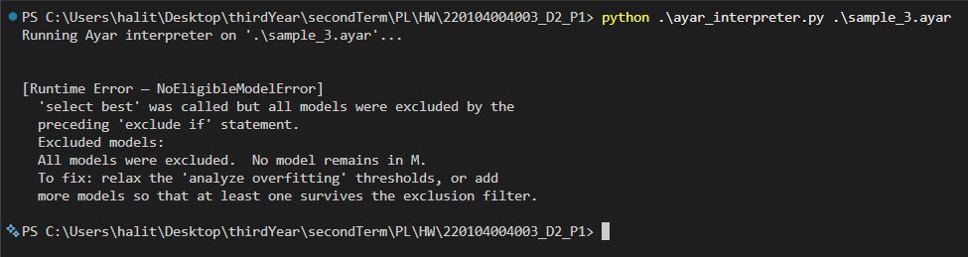
This program intentionally triggers the NoEligibleModelError defined in D1 Rule P-SelectBest (failure case). The threshold is set to 0.05, which is deliberately stricter than the fixed train-eval gap of 0.07 produced by the interpreter's _TRAIN_BONUS constant. As a result, all five model types are tagged as overfit by P-AnalyzeOverfitting, the exclude if overfit statement empties M entirely, and select best raises the domain-specific runtime error rather than silently returning an overfit model. This demonstrates Ayar's loud-failure design: reliability (Sebesta §1.3.3) is prioritized over convenience.

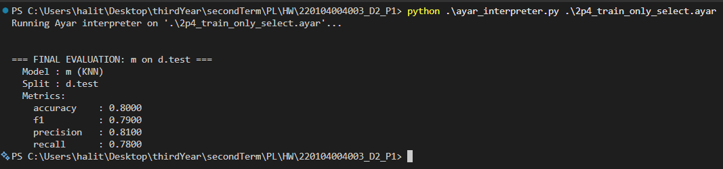
This program demonstrates that an experiment block can run with only a train statement and select best — no evaluate, no collect, no compare, no analyze. The interpreter selects the single trained model by default since there is nothing to compare or exclude. The final evaluation runs on d.test and produces the expected KNN metrics based on the formula with k=5. This exercises the minimal valid experiment path and confirms that none of the pipeline statements are syntactically mandatory.

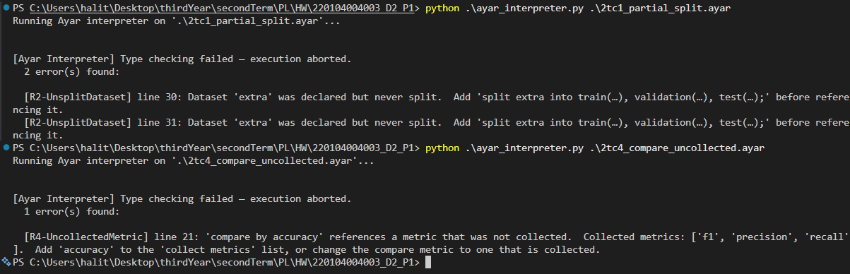
This program declares two datasets but only splits one of them. The type checker raises two R2-UnsplitDataset errors at lines 30 and 31, one for each reference to the unsplit dataset extra. The iris dataset references produce no errors since iris is correctly split. This demonstrates that R2 fires per-reference rather than per-dataset, and that valid and invalid references can coexist in the same program — only the invalid ones are reported.
This program uses compare by accuracy but the collect metrics list contains only [f1, precision, recall] — accuracy was never collected. The type checker raises one R4-UncollectedMetric error at line 21, reporting the exact metric name that was missing and listing which metrics were actually collected. Execution is aborted before any training occurs. This confirms that R4 correctly cross-references the compare statement against the collect statement within the same experiment block.

