Project 2 Report
- Report
  - In this project, we use the pinhole camera model to project 3D points into the video frame. The video frame projections are applied for both cameras to triangulate the location of each joint.
What were the tasks you performed; what did you expect to achieve?
The tasks for this project are building the correct procedures to perform the projection and back projection. We expect that the resulting projection will coincide the images in the video
  - The flow of the program is as follows:
    - Load the video files
    - Load the joint dataset
    - For each frame and camera, project the joint points into 2D
    - Back project each 2D point to get the corresponding ray
    - Triangulate the 3D point from the rays of the point
    - Compute the L² error for all the points
The corresponding flowchart of the program is shown below.
Load Video
Load Joints
Project
Back Project
Triangulate
Compute error

Which are the internal parameters?
The internal parameters of the camera are focal length, principal point, radial distortion, aspect ratio, and skew.
Which internal parameters combine to form the matrix Kmat?
The focal length ($f$), principal point $(o_{x},o_{y})$, aspect ratio ($η$), and skew ($τ$) combine using the equation below to form the K matrix.
$$K=\left[\begin{matrix}f & τ & o_{x} \\ 0 & ηf & o_{y} \\ 0 & 0 & 1\end{matrix}\right]$$
Which are the external parameters?
The external parameters of the camera are the orientation and position ($C$). Orientation has an equivalent rotational matrix $R$.
Which external parameters combine to form the matrix Pmat?
The rotational matrix and position are combined to form the P matrix using the equation below. Take note that $R$ is a 3x3 matrix and $C$ is a 3x1 vector.
$$P=[\begin{matrix}R & -RC\end{matrix}]$$
What is the location of the camera?
The location of camera is given by the position parameter of the calibration data. We represent this as the $C$ vector above.
How did you choose the camera parameters that were needed and how did you use those parameters?
Using the two matrices $K$ and $P$, we can compute the 2D point $(x,y)$ based on the 3D coordinates where $λ$ is the scaling factor. The scaling factor $λ$ can be computed based on the extra element in the resultant vector.
$$\left[\begin{matrix}λx \\ λy \\ λ\end{matrix}\right]=\left[\begin{matrix}K & 0_{3}\end{matrix}\right]\left[\begin{matrix}P \\ \begin{matrix}0_{3}^{T} & 1\end{matrix}\end{matrix}\right]\left[\begin{matrix}X \\ Y \\ Z \\ 1\end{matrix}\right]$$
To correct for the non-linear radial error, we use the radial parameters $k_{1}$ and $k_{2}$ of the camera with the equations below.
$$r=\sqrt{{\left(x-o_{x}\right)}^{2}+{\left(y-o_{y}\right)}^{2}}$$
$$\left[\begin{matrix}x^{'} \\ y^{'}\end{matrix}\right]=\left[\begin{matrix}x \\ y\end{matrix}\right]-\left[\begin{matrix}1 \\ 1\end{matrix}\right](k_{1}r^{2}+k_{2}r^{4})$$
How did you choose the specific visualizations to convince us that your code is working?
To check that the 2D project is correct, we plot the corresponding 2D points of the joints over the video frame. We check the accuracy of the formulas by visual inspection of the resulting image. The resulting image allows us to see if the 2D points are aligned with the performer’s joints.
What mathematical equations were used to calculate the Euclidean distance statistics?
To compute the mean, we use the following formula.
$$\overline{L^{2}}=\frac{1}{N}\sum_{k=1}^{N}{L_{k}^{2}}$$
To compute the standard deviation, we use the following equation.
$$σ_{L^{2}}^{2}=\frac{1}{N}\sum_{k=1}^{N}{{\left(L_{k}^{2}-\overline{L^{2}}\right)}^{2}}$$
To compute the minimum, we use the following equation.
$$\min{L^{2}}=min⁡\{L_{k}^{2}:k=1…N\}$$
To compute the maximum, we use the following equation.
$$\max{L^{2}}=max⁡\{L_{k}^{2}:k=1…N\}$$

  - What do you observe about the behavior of your program when you run it?
While running the program, we observed that it takes time for the program to load the video file. We can also see that the joints from the two cameras align well with the performer’s joints. We draw the lines also to show a skeleton-like figure.
Video frame from vue2 with skeleton overlay.
Video frame from vue4 with skeleton overlay.
Does it seem to work the way you think it should?
The program was able to locate the 3D points on the performer. However, the computation takes seconds to execute.

  - Quantitative Results:
Joint | Mean | Standard Deviation | Median | Minimum | Maximum
Right shoulder | 22.1119 | 24.4296 | 13.2728 | 1.7502 | 123.8194
Right elbow | 21.1431 | 26.5559 | 10.1681 | 0.3888 | 131.7660
Right wrist | 23.1550 | 29.1402 | 10.3617 | 0.2212 | 167.5844
Left shoulder | 19.6737 | 19.1204 | 11.5472 | 2.8713 | 82.3865
Left elbow | 17.4857 | 20.6704 | 8.3804 | 0.9570 | 99.8206
Left wrist | 20.2571 | 25.3342 | 8.6970 | 0.3890 | 139.9378
Right hip | 15.7618 | 20.3524 | 7.5476 | 0.2671 | 97.4451
Right knee | 17.7703 | 21.5777 | 10.7229 | 0.0579 | 86.5108
Right ankle | 21.1579 | 23.3200 | 13.2769 | 0.3248 | 104.0500
Left hip | 14.4477 | 18.1055 | 6.6363 | 0.2664 | 79.0674
Left knee | 14.0512 | 17.5623 | 5.7886 | 0.0200 | 77.9158
Left ankle | 16.7133 | 18.7830 | 7.9834 | 0.4366 | 77.4599
Overall | 18.6441 | 22.5463 | 9.3276 | 0.0200 | 167.5844

Is the curve constant, or are there notable peaks and valleys?
The total error curve shown above is not consistent and varies with the video frame. The initial video frame has a large total error curve, and we also see other peaks between frame 1500 to 2000.
  - Qualitative result:
The green skeleton is the original mocap skeleton and the red skeleton is the predicted location of the joints based on the triangulation. We can see that the two colors of skeletons coincide well with each other.

  - Algorithm Efficiency:
The output of the MATLAB profiler is shown below. We can see that the Project function has the longest self-time. It means that the Project has the longest time. However, this function is also the most called with more than 100,000 calls.
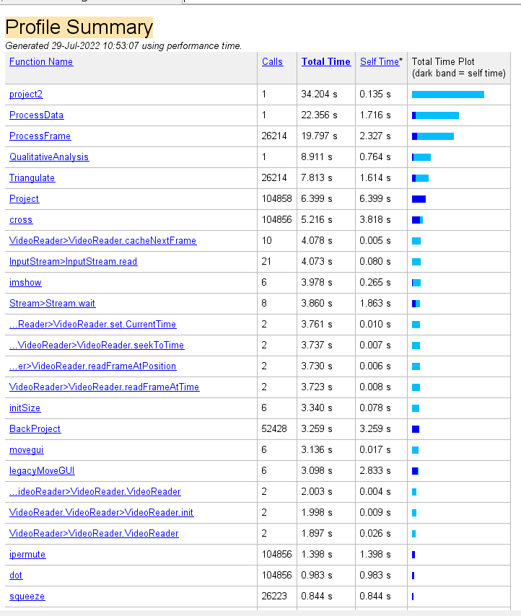

  - Two-view epipolar lines visualization.
To draw the epipolar lines, we used the Project routine to compute the epipole. From the line segment connecting the point and the epipole, we can draw the epipolar lines. To solve for the epipole we applied the Project routine on the camera of the other view. The results are shown in the figures below.

