Q1.1 Hough Transform Line Parametrization
- $ρ=x\cos{θ}+y\sin{θ}=\sqrt{x^{2}+y^{2}}\left(\frac{x}{\sqrt{x^{2}+y^{2}}}\cos{θ}+\frac{y}{\sqrt{x^{2}+y^{2}}}\sin{θ}\right)$
Let $\frac{x}{\sqrt{x^{2}+y^{2}}}=\cos{ϕ}$, then $\frac{-y}{\sqrt{x^{2}+y^{2}}}=\sin{ϕ}$
$$ρ=\sqrt{x^{2}+y^{2}}\left(\cos{θ}\cos{ϕ}-\sin{θ}\sin{ϕ}\right)$$
$$ρ=\sqrt{x^{2}+y^{2}}\cos{(θ+ϕ)}, ϕ=-\tan^{-1}{\frac{y}{x}}$$
Amplitude is $\sqrt{x^{2}+y^{2}}$
Phase is $-\tan^{-1}{\frac{y}{x}}$
- A line is parameterized in terms of $(θ,ρ$) as opposed to slope and intercept because it has a lower range of values and allows the image processor to process the lines easily.
$\frac{ρ}{\sin{θ}}=\frac{x}{\tan{θ}}+y$
$$y=-\frac{1}{\tan{θ}}x+\frac{ρ}{\sin{θ}}$$
Slope is $-\frac{1}{\tan{θ}}$
Intercept is $\frac{ρ}{\sin{θ}}$
- Since the graph of line in Hough space is a sinusoid, the maximum $ρ$ is the largest amplitude possible by any point. This is equivalent to $ρ_{max}=\sqrt{W^{2}+H^{2}}$. Since we want to plot the full line, we need the complete range of the angle $θ.$ Therefore the range of $θ$ is $0$ to $2π$
- $\left(10,10\right)→ρ=10\cos{θ}+10\sin{θ}$
$$\left(20,20\right)→ρ=20\cos{θ}+20\sin{θ}$$
$$\left(30,30\right)→ρ=30\cos{θ}+30\sin{θ}$$
The plots are as follows. The intersection is $θ=-0.7775, ρ=0.3366$. The slop and intercept of the line are $m=-\frac{1}{tan-0.7775}=1.0159,b=\frac{0.3366}{\sin{0.7775}}=0.4798$.
Hough space plots
Q2.1 Convolution
The result of the image convolution with a Gaussian filter with sigma 2 is shown below. We can see that the lines are slightly blurred.
Image result after convolution.

Q2.2 Edge Detection
The result of the edge detection filter is shown below. Using the filter imaged above, we apply Sobel filter to compute the gradients along x and y axes. To further decrease the thickness of edges, we apply non-maximum suppression to all the pixels.

Image result after edge detection filter.

Q2.3 The Hough Transform
The Hough transform result is shown below. We can see sinusoids on the image below. The bright points correspond to the longest lines in the image.
Hough transformation of the edges.

Q2.4 & Q2.5 Finding lines & Fitting line segments for visualization
Using the top 50 voted points in the Hough transform. We draw the line segments using the edges as reference. The result is shown below.
Result with highlighted lines.
Q3.1 Experiments
Shown below are the intermediate outputs for an input image. First, it displays the detected edges on each image after it is converted into gray scale. Then, a threshold is applied to extract the lines present on the image. The Hough transformation is applied to the image threshold to complete it. From the top voted points in the Hough space, we draw the lines over the original image.

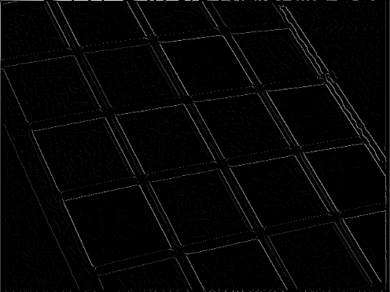
Edge detection filter result.
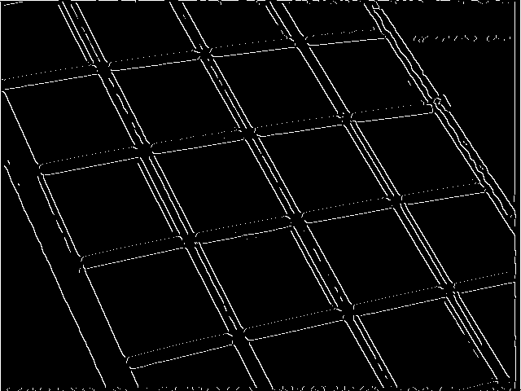
Image result after application of threshold.

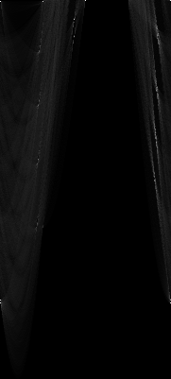
Hough space transform of all the points.
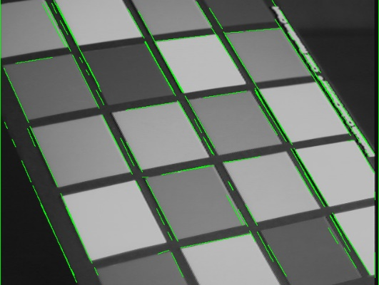
Drawing overlay of Hough lines on the original image.

The hardest part on this project is getting the parameters and algorithm correct for the edge detection filter. As you can see in the image above, there are extra parallel lines to the edges. This is because these extra lines were not eliminated in the edge detection step. One way to mitigate is to increase the threshold to eliminate these. After increasing the threshold to 0.3, we have eliminated a lot of the extra parallel lines. The updated result is shown below.

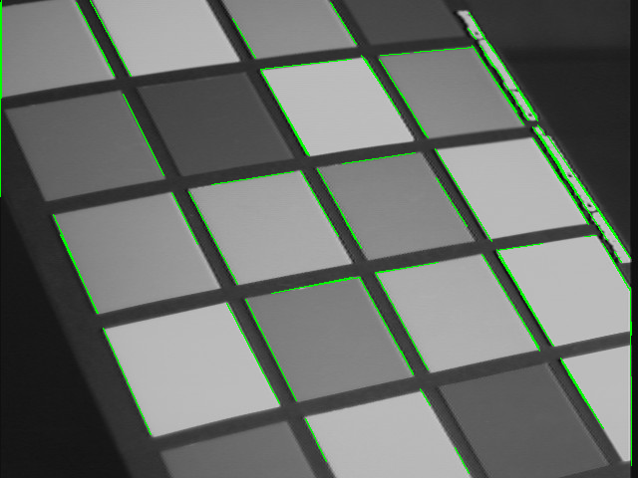
Hough lines with increased threshold.

We can also increase the sigma to spread the edges and makes it easier for the edge detection filter to extract the edges. This will also minimize extra parallel lines present using the original parameters. The result of increasing the sigma is shown below.

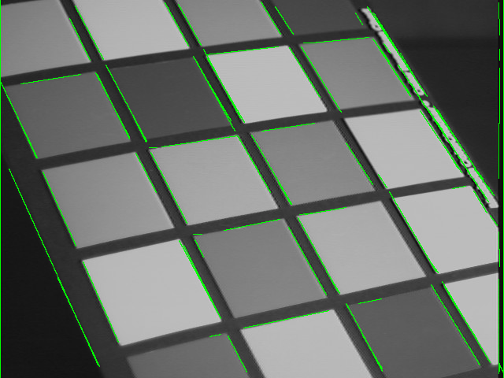
Hough lines with increased sigma.

Comparing threshold and sigma, increasing the sigma has better result because it helps the edge detection filter eliminate the thickness of edges by spreading it further. The spread helps the Non-Maximum Suppression to work better. We can see this on other images.

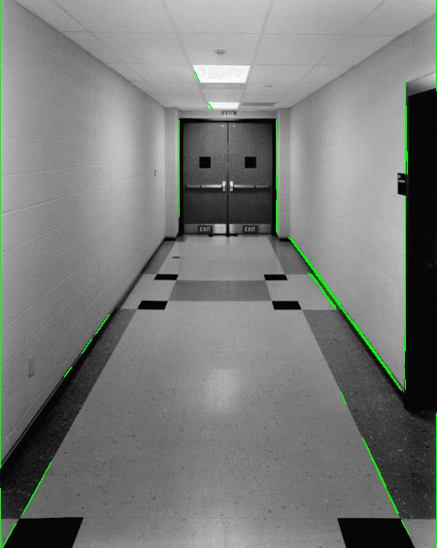
Hough lines with increased threshold.

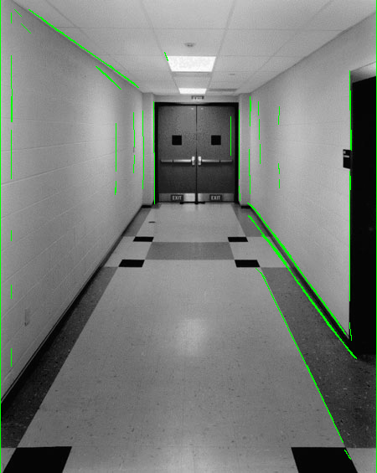
Hough lines with increased sigma.

Q4

We run it on new 5 pictures to identify the lines on each image. The results are shown in the images below.
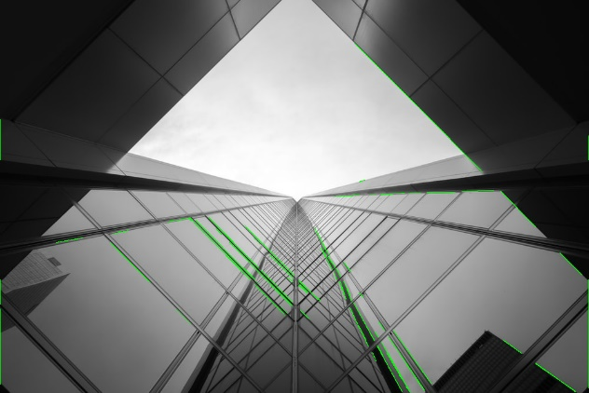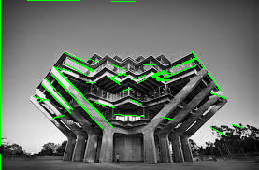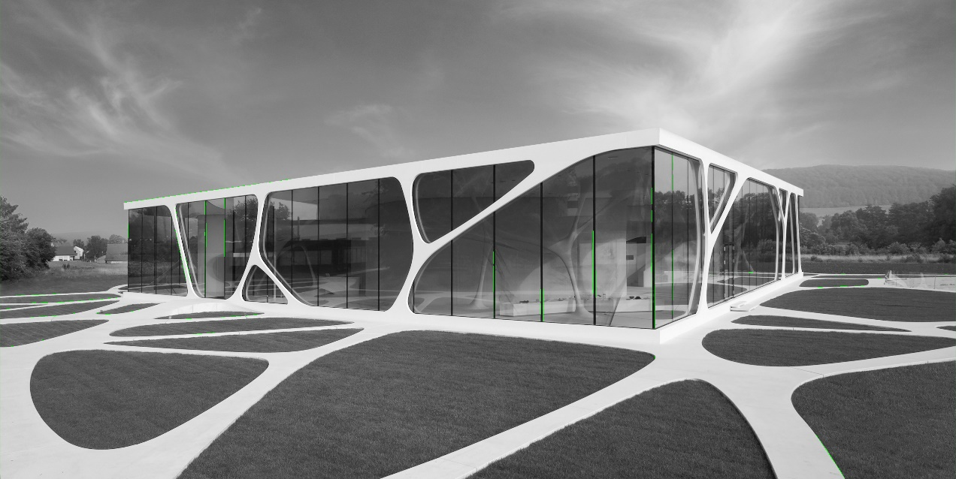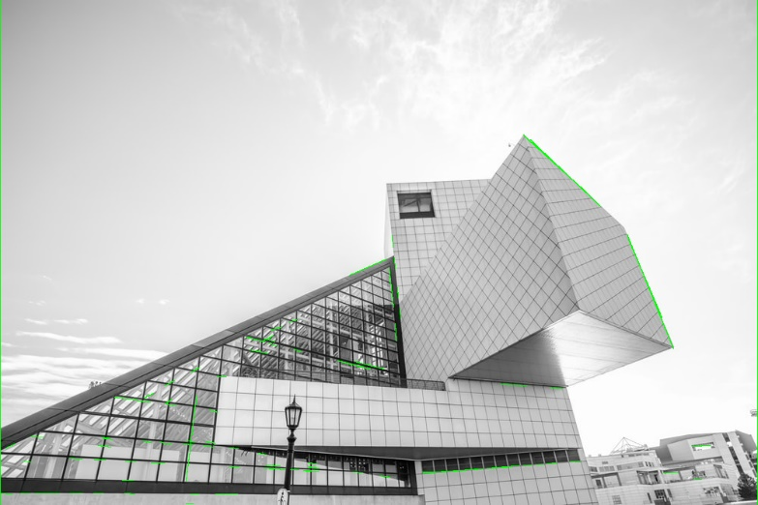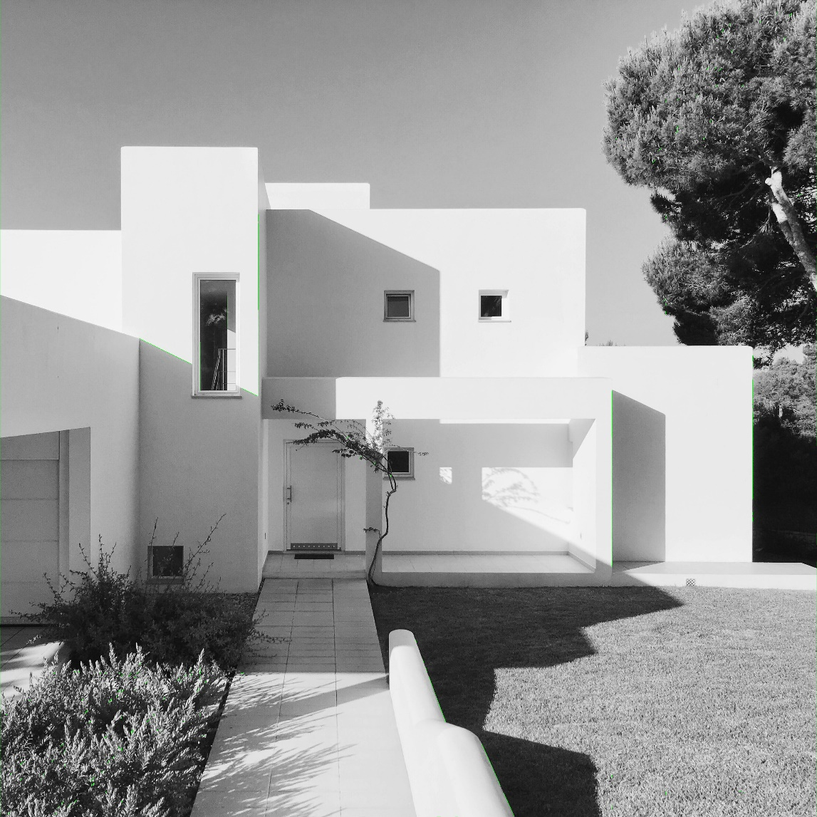
Image results for 5 new pictures

