1. Introduction
Database is important in storing and organizing data. A database allows us to process transactions quickly and make sure that relationships and data are maintained and validated. With that in mind, database software is used to create an application that stores and displays a list of houses for sale.
Besides a storage of data, database also provides means to establish relationships between entities in the database. The relationship is modelled as foreign keys that reference to another table. The creation of this relationship allows complex systems to be developed.
Database systems also provide basic data operations such as insert, update, delete, and select. The insert command inserts a new row into the database. The update command updates fields of a set of rows. The delete command deletes fields from a table that match a specific criterion. The select command gets fields and tables based on conditions and joins.
Although databases have a lot of features, they lack the capability of showing user an interface. The user interface of the application is designed using a combination of HTML, CSS, and JavaScript that are supported by most modern browsers. The client side of the application should be easy for users to follow and interact with.
In between the client side and the database, the application needs server-side software to connect to the database and respond to the client’s requests. There are a lot of server-side platforms available. One server-side platform is PHP and used by a lot of websites including Facebook.
In this project, we use database and server-side platform to develop an application to list houses and post them for sale. In this project, we used MySQL as the database server and PHP as server-side platform.

2. Description of the Problem to be Solved
The internet allows users to advertise products and services across the globe. The internet breaks the border between countries and cities by increasing the availability of products from remote places in the globe. One of the products that are advertised on the internet are houses.
In this project, we design and develop an application to post a list of houses for sale. The application shows important information about the house such as its address, zip code, area type, number of bedrooms, lot size, exterior color, construction. Each house has several features that could vary in number. The features of each house include heating system, air conditioning system, water source, etc.
The project displays the list of houses in the database using a PHP web server as shown in the screenshot below. For each house row, the address information is displayed. If the house is posted for sale, it displays the price of the house and the date of posting. The owner’s name of the house is also shown in the house row.
The user can manage the houses by clicking the update or delete buttons. When the update button is clicked, the update page for the house is opened, and the user can edit all relevant information of the house. When the delete button is clicked, the selected house is deleted.
The owner can post his/her house for sale and set a specific price on it. The owner can contact agents in the application to help sell the house. The agent or owner can complete the sale of the house by adding a sale row in the application.
Users can register to the application as an agent and/or owner. Agent accounts can post houses for sale and assist on completing a sale. Owner accounts can list houses to the application. If the owner wants, he/she can post it as for sale and specify the preferred price.

2.1 Screenshots and descriptions of all screens
The screenshot below shows the sample list of houses in the start.php page. Besides the basic information of the house, it also shows the owner’s name, complete address details, and the house price if posted for sale.
Since the list of houses can be more than 200 rows, pagination is added to limit the number of pages displayed at a time. Previous and next buttons are added to navigate different pages in the list.
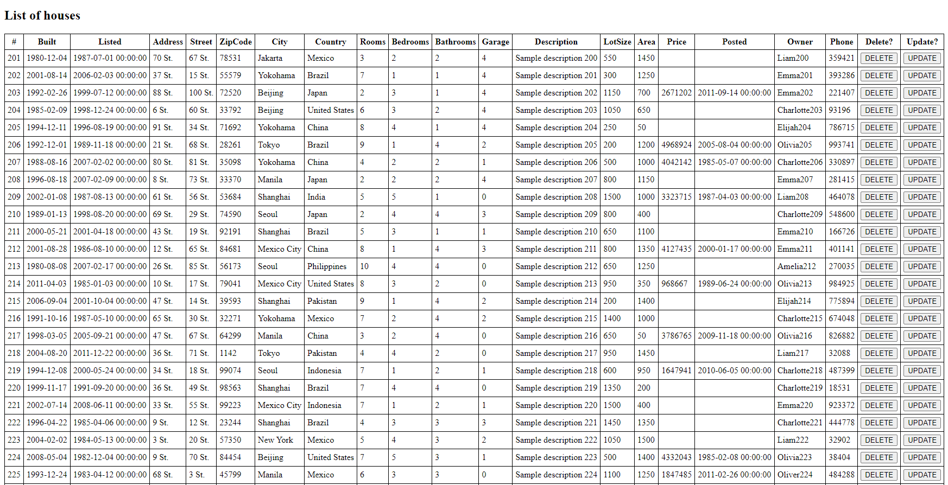
The user can add a new house into the list using a form at the bottom portion of the start.php page as shown below. It also provides a checklist of available features that can be added into the house.
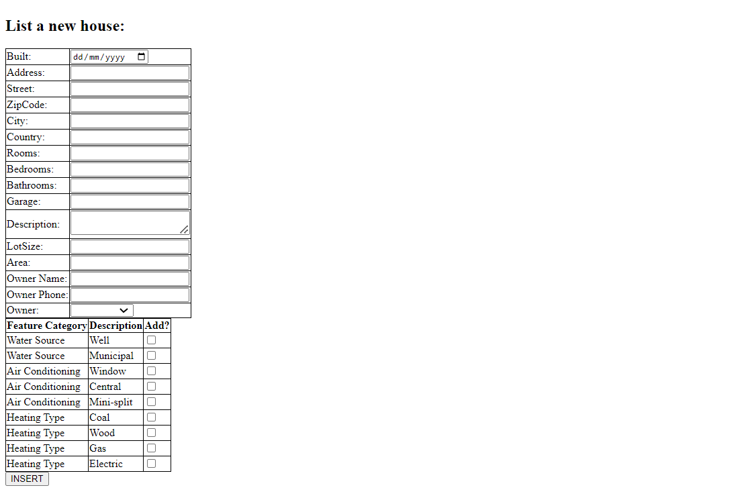
When the house is updated, it shows the same form as the insert house form. Each detail of the house is shown there. The feature checklist is also available in the form where existing features are already checked. The administrator is in charge of adding new feature and feature category to the houses.
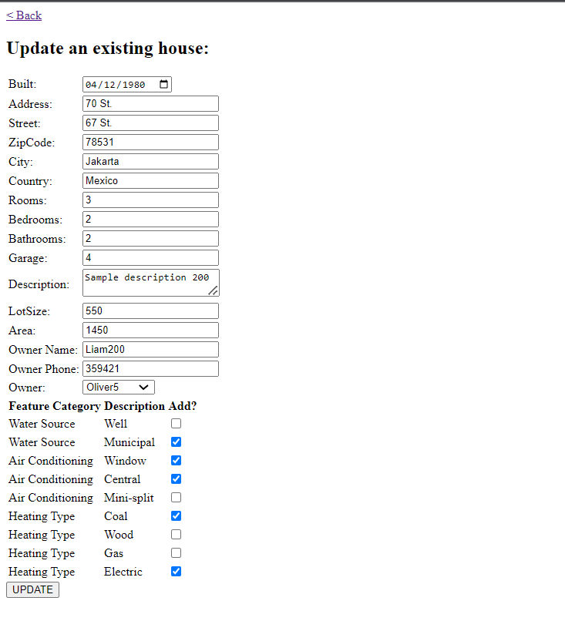

3. Database Design
3.1 Crow’s foot diagram
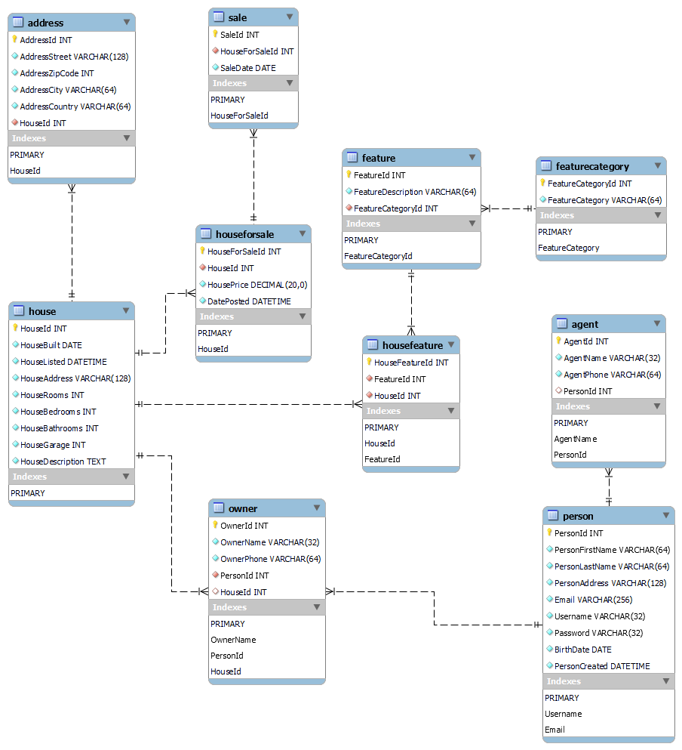

3.2 Complete list of all tables including fields
House
Field | Type | Key
HouseId | INT | PRIMARY
HouseBuilt | DATE
HouseListed | DATETIME
HouseAddress | VARCHAR(128)
HouseRooms | INT
HouseBedrooms | INT
HouseBathrooms | INT
HouseGarage | INT
HouseDescription | TEXT
HouseLotSize | INT
HouseArea | INT

Address
Field | Type | Key
AddressId | INT | PRIMARY
AddressStreet | VARCHAR(128)
AddressZipCode | INT
AddressCity | VARCHAR(64)
AddressCountry | VARCHAR(64)
HouseId | INT | FOREIGN House

FeatureCategory
Field | Type | Key
FeatureCategoryId | INT | PRIMARY
FeatureCategory | VARCHAR(64)

Feature
Field | Type | Key
FeatureId | INT | PRIMARY
FeatureDescription | VARCHAR(64)
FeatureCategoryId | INT | FOREIGN FeatureCategory

HouseFeature
Field | Type | Key
HouseFeatureId | INT | PRIMARY
FeatureId | INT | FOREIGN Feature
HouseId | INT | FOREIGN House

Person
Field | Type | Key
PersonId | INT | PRIMARY
PersonFirstName | VARCHAR(64)
PersonLastName | VARCHAR(64)
PersonAddress | VARCHAR(128)
Email | VARCHAR(256) | UNIQUE
Username | VARCHAR(32) | UNIQUE
Password | VARCHAR(32)
BirthDate | DATE
PersonCreated | DATETIME

Agent
Field | Type | Key
AgentId | INT | PRIMARY
AgentName | VARCHAR(32) | UNIQUE
AgentPhone | VARCHAR(64)
PersonId | INT | FOREIGN Person

Owner
Field | Type | Key
OwnerId | INT | PRIMARY
OwnerName | VARCHAR(32) | UNIQUE
OwnerPhone | VARCHAR(64)
PersonId | INT | FOREIGN Person
HouseId | INT | FOREIGN House

HouseForSale
Field | Type | Key
HouseForSaleId | INT | PRIMARY
HouseId | INT | FOREIGN House
HousePrice | DECIMAL(20)
DatePosted | DATETIME | FOREIGN Person

Sale
Field | Type | Key
SaleId | INT | PRIMARY
HouseForSaleId | INT | FOREIGN HouseForSale
SaleDate | DATE

3.3 Complete list of all indexes
The indexes are listed below and grouped according to the table where it is located.
- House
  - HouseId – This is the primary index of the House table. This is used to identify a specific house.
- Address
  - AddressId – This is the primary index of the Address table. This is used to identify a specific address.
- FeatureCategory
  - FeatureCategoryId – This is the primary index of the FeatureCategory table. This is used to identify a specific feature category.
- Feature
  - FeatureId – This is the primary index of the Feature table. This is used to identify a specific feature.
- HouseFeature
  - HouseFeatureId – This is the primary index of the HouseFeature table. This is used to identify a specific house feature. The house feature assigns a feature to a house.
- Person
  - PersonId – This is the primary index of the Person table. This is used to identify a specific person.
  - Email – This is the unique index of the Person table. This is used to quickly lookup a person based on email address. This can be used to recover password.
  - Username – This is another unique index of the Person table. This is used to quickly lookup a person based on username. This is used to authenticate a Person upon login.
- Agent
  - AgentId – This is the primary index of the Agent table. This is used to identify a specific agent.
  - AgentName – This is the unique index of the Agent table. This is used to quickly lookup an agent based on his/her name.
- Owner
  - OwnerId – This is the primary index of the Owner table. This is used to identify a specific owner.
  - OwnerName – This is the unique index of the Owner table. This is used to quickly lookup the owner based on his/her name.
- HouseForSale
  - HouseForSaleId – This is the primary index of the HouseForSale table. This is used to identify a specific house for sale.
- Sale
  - SaleId – This is the primary index of the Sale table. This is used to identify a specific sale.

4. List of all transactions
The transactions relevant to this application are listed below. The transactions are organized by database entity for organization.
- House
  - Get list of houses
  - Insert a new house
  - Update a house
  - Delete a house
- Address
  - Get the address of a specific house
  - Insert an address when the house is inserted
  - Update address
  - Delete address when the house is deleted
- FeatureCategory
  - Get the list of feature categories
  - Insert a new feature category
  - Delete a feature category
- Feature
  - Get list of features per feature category
  - Insert a new feature given a feature category
  - Delete a feature
- HouseFeature
  - Get list of house features for a specific house
  - Delete a house feature
  - Insert a new house feature
- Person
  - Login to the application
  - Register a new person
  - Update person’s profile
- Agent
  - Login as agent
  - Register as agent
  - Unregister as agent
- Owner
  - Login as owner
  - Register as owner
  - Unregister as owner
  - List a new house
- HouseForSale
  - Post a house for sale
  - Remove a posted house for sale
- Sale
  - Create a sale for a posted house for sale
  - Delete a sale for a posted house for sale

5. Discussion of how error trapping is/will be handled
Errors in performing database queries are handled in the application using a try catch statement. The try catch statement checks for exception in the SQL query and when an exception occurs, the catch block is called. Inside the catch statement, we call the die function to stop the execution of the rest of the code. The user can press go back to reset. A sample code is shown below.
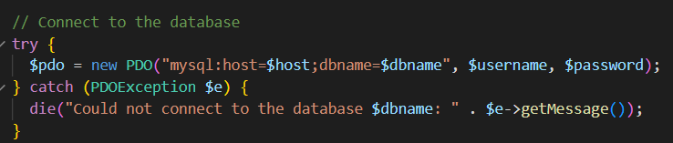
This is a try/catch block to connect to the MySQL database.
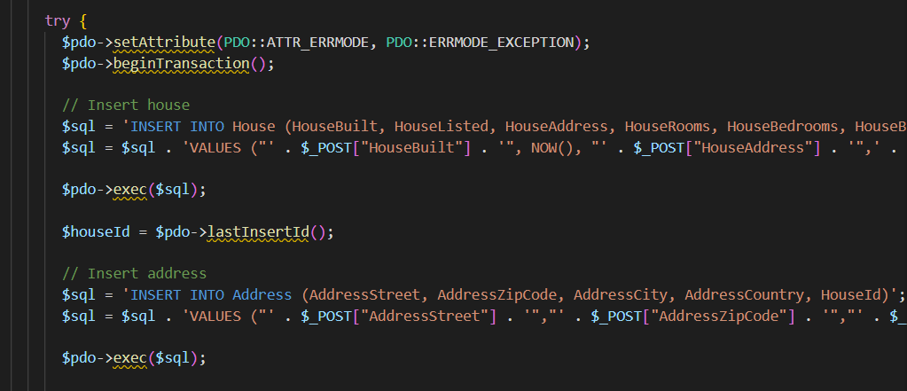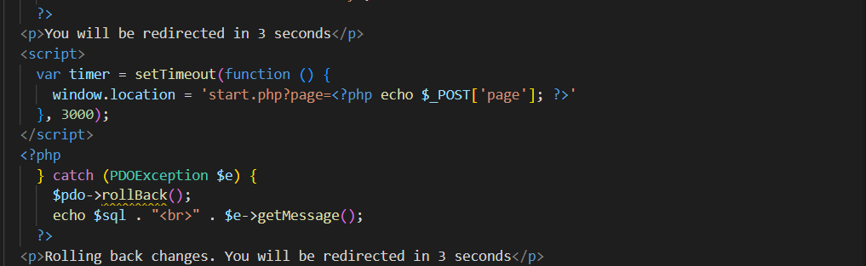
This is a try/catch block to insert a new house in the database. Some code is truncated.
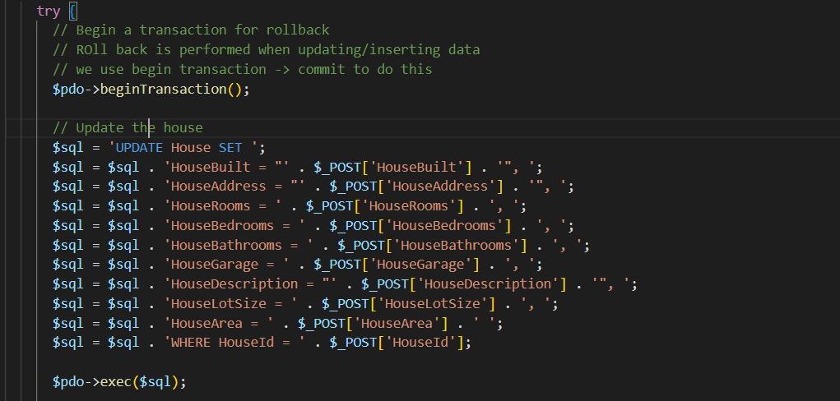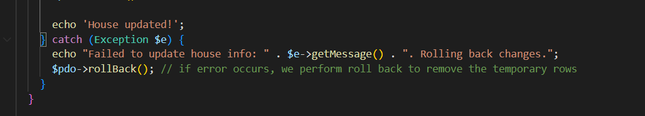
This is try/catch block to update the house in the database. Some code is truncated.
As shown in the code examples above, the try/catch block feature is used to simplify error checking. Especially on the insert and update operations where the error can occur in any step in the process. With the use of try/catch block, the code doesn’t have to add nested if/else blocks to check each SQL query execution.

6. Summary/Conclusion
6.1 How this product will solve the problem
In this project, a PHP/MySQL application was designed and developed to allow users to view house listings and insert new houses. The application enabled the user to specify basic details such as number of bedrooms, address, lot size, etc. The application also enables the user to organize the features of the house under a set of feature categories.
6.2 Areas of technical difficulty
The difficult part of the application is modifying the PHP application code to perform the query and insert functions of the database. It is important that for each SQl query, a try-catch block is used to properly handle exceptions when calling the SQl queries.
The hard part of the development of the application is the creation of user interface. The user interface requires a lot of components to define. Especially when you create a form, you need to consider adding validation rules and check for validity of the user’s input. In addition to that, the code must also be capable of handling errors and exceptions without crashing.

