Q1.1 Calculation the Jacobian
Based on the warp parameters, the warp is given as the following equation.
$$W\left(x;p\right)=\left[\begin{matrix}u' \\ v'\end{matrix}\right]→\left[\begin{matrix}u^{'} \\ v^{'} \\ 1\end{matrix}\right]=\left[\begin{matrix}1+p_{1} & p_{3} & p_{5} \\ p_{2} & 1+p_{4} & p_{6} \\ 0 & 0 & 1\end{matrix}\right]\left[\begin{matrix}u \\ v \\ 1\end{matrix}\right]=\left[\begin{matrix}u\left(1+p_{1}\right)+vp_{3}+p_{5} \\ up_{2}+v\left(1+p_{4}\right)+p_{6} \\ 1\end{matrix}\right]$$
The Jacobian of the warp is computed using the following matrix.
$$\frac{∂W}{∂p}=\left[\begin{matrix}\frac{∂u'}{∂p_{1}} & \frac{∂u'}{∂p_{2}} & \frac{∂u'}{∂p_{3}} & \frac{∂u'}{∂p_{4}} & \frac{∂u'}{∂p_{5}} & \frac{∂u'}{∂p_{6}} \\ \frac{∂v'}{∂p_{1}} & \frac{∂v'}{∂p_{2}} & \frac{∂v'}{∂p_{3}} & \frac{∂v'}{∂p_{4}} & \frac{∂v'}{∂p_{5}} & \frac{∂v'}{∂p_{6}}\end{matrix}\right]=\left[\begin{matrix}u & 0 & v & 0 & 1 & 0 \\ 0 & u & 0 & v & 0 & 1\end{matrix}\right]$$
Q2.2 Computational Complexity
The time complexity of J is
$$T\left(J\right)=T\left(∇T\right)+T\left(\frac{∂W}{∂p}\right)+T\left(∇T\frac{∂W}{∂p}\right)$$
$$T\left(∇T\right)=O\left(2n\right)=O\left(n\right)$$
$$T\left(\frac{∂W}{∂p}\right)=O\left(2p\right)=O\left(p\right)$$
$$T\left(∇T\frac{∂W}{∂p}\right)=O\left(n×2×p\right)=O\left(np\right)$$
$$T\left(J\right)=O\left(n\right)+O\left(p\right)+O\left(np\right)=O\left(n+p+np\right)=O(np)$$
The time complexity of $H^{-1}$ is
$$T\left(H^{-1}\right)=T\left(J^{T}\right)+T\left(J\right)+T\left(J^{T}J\right)+T(inv(H))$$
$$T\left(J^{T}\right)=O\left(2n\right)=O\left(n\right)$$
$$T\left(J\right)=O\left(np\right)$$
$$T\left(J^{T}J\right)=O\left(pnp\right)=O\left(np^{2}\right)$$
$$T\left(inv(H)\right)=O\left(p^{3}\right)$$
$$T\left(H^{-1}\right)=O\left(n\right)+O\left(np\right)+O\left(np^{2}\right)+O\left(p^{3}\right)=O\left(p^{2}\left(n+p\right)\right)$$
The initialization time complexity is
$$T\left(init\right)=T\left(H^{-1}\right)+T\left(J\right)+T\left(J^{T}\right)+T\left(H^{-1}J^{T}\right)$$
$$T\left(J^{T}\right)=O\left(np\right)$$
$$T\left(H^{-1}J^{T}\right)=O\left(ppn\right)=O(np^{2})$$
$$T\left(init\right)=O\left(p^{2}\left(n+p\right)\right)+O\left(np\right)+O\left(np\right)+O\left(np^{2}\right)$$
$$T\left(init\right)=O\left(p^{2}\left(n+p\right)\right)$$
For each iteration, the time complexity is
$$T\left(ICA\right)=T\left(I\left(W\left(x;p\right)\right)\right)+T\left(I\left(…\right)-T\right)+T\left(H^{-1}J^{T}\left[…\right]\right)+T(W∘W^{-1})$$
$$T\left(I\left(W\left(x;p\right)\right)\right)=O\left(n\right)O\left(3×3\right)=O\left(n\right)$$
$$T\left(I\left(…\right)-T\right)=O\left(n\right)$$
$$T\left(H^{-1}J^{T}\left[…\right]\right)=O\left(pn1\right)=O\left(np\right)$$
$$T\left(W∘W^{-1}\right)=O\left(3×3×3^{3}\right)=O(1)$$
$$T\left(ICA\right)=O\left(n\right)+O\left(n\right)+O\left(np\right)+O(1)=O(np)$$
The time complexity of each iteration of Lucas-Kanade method is as follows.
$$T\left(LK\right)=O(np^{2}+n^{3})$$
Compared to ICA, the Inverse Compositional Method has lower time complexity for each iteration.
$$T\left(ICA\right)<T(LK)$$
Q2.1 Write a Lucas-Kanade Tracker for a Flow Warp
The initial location of the tracker is at (160, 120). The rectangular region was able to follow the movement of the image in the video. The screenshots of some frames in the video are shown below. The tracker started to lose the center of the car when the size of the car decreased as it moves away from the camera. Despite that, the tracker was still able to capture the vehicle. We can increase the size of the rectangle for better capture.
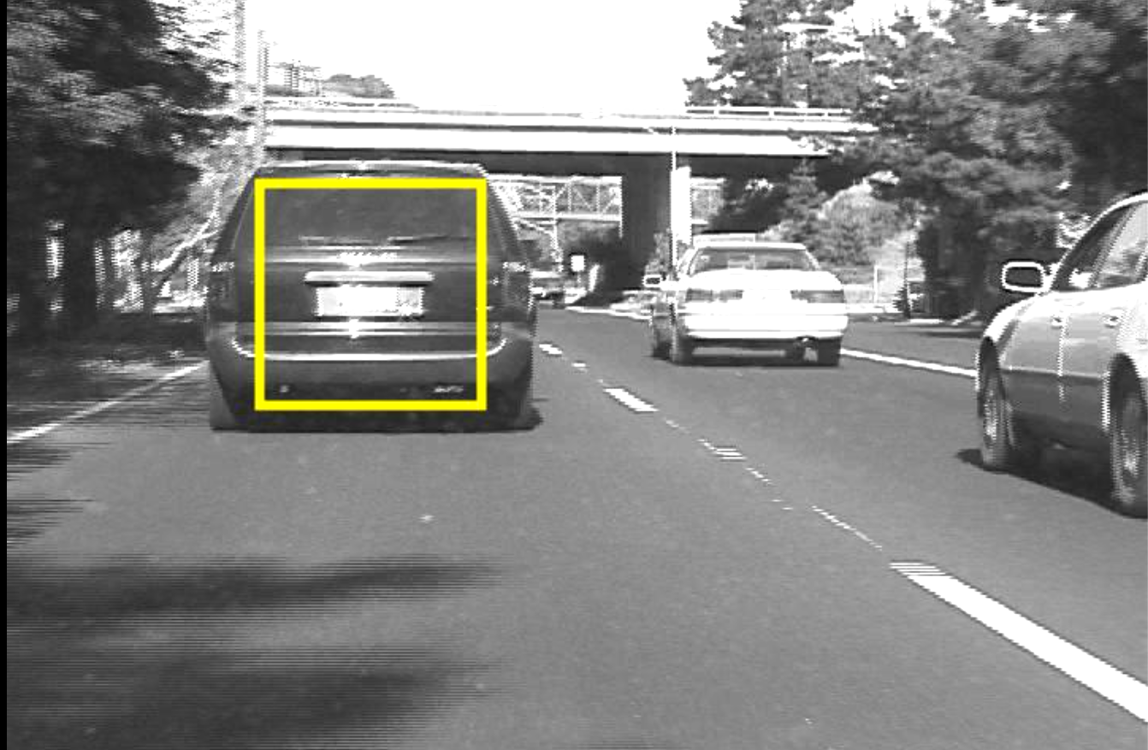
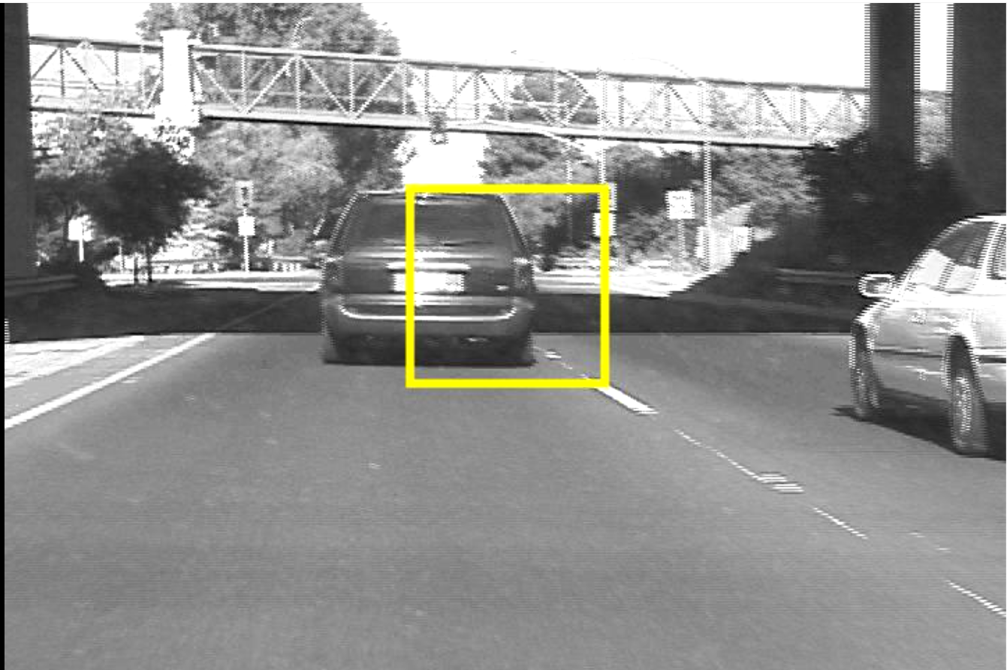
Q2.2: Initializing the Matthew-Baker Tracker
I used the formulas to initialize the ICA tracker. The tracker structure has fields J for the Jacobian of the affine warp and Hinv for the inverse of the approximated Hessian matrix.
Q2.3: The Main Matthew-Baker Tracker
For this type of tracker, we implemented a stopping criterion based on the absolute value of the change in warp parameters and limiting the iterations of the algorithm. The screenshots of the algorithm execution are shown below.
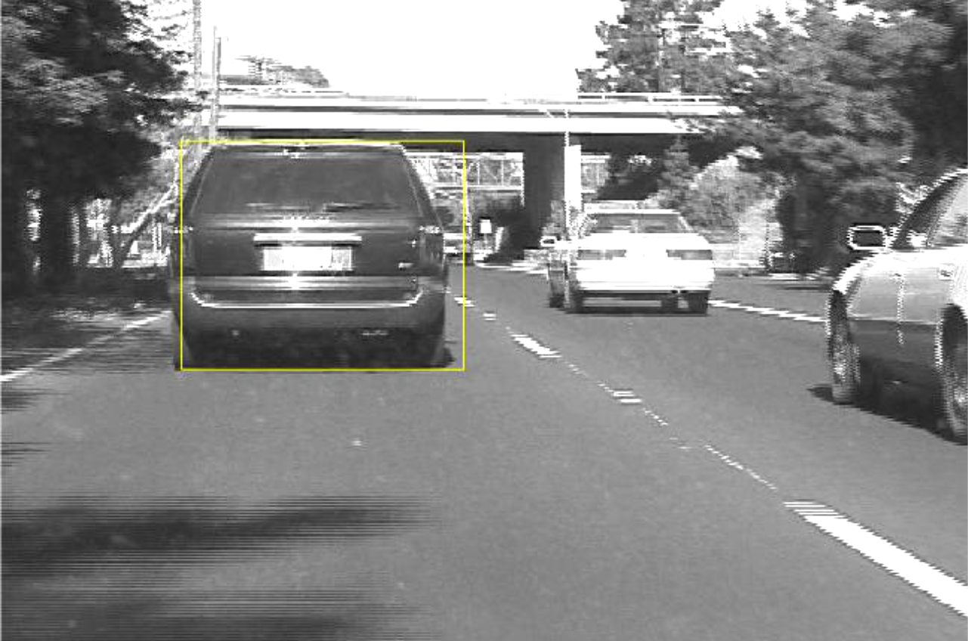
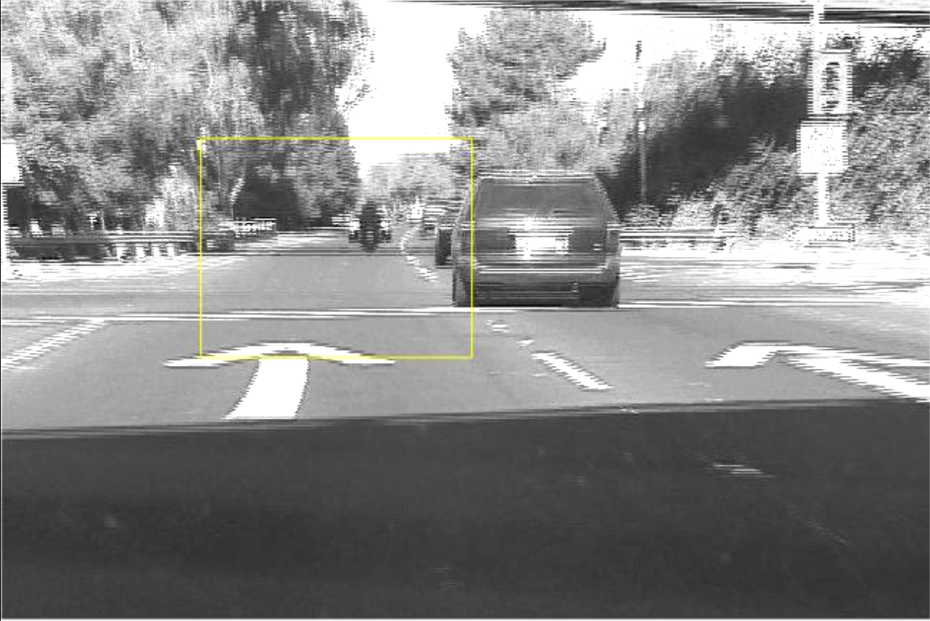
Q2.4: Tracking a Car
The best car tracking results is the one down with Lucas-Kanade Tracker. This algorithm has worse computation time than the Main Matthew-Baker Tracker. The comparison of the final screenshots between the two algorithms are shown below.

Lucas-Kanade Final Frame Result

Main Matthew-Baker Final Frame Result

