**5. SUPPLEMENTARY FIGURES**

|  |  |
| --- | --- |
| **Exposures** | **Phenotypes** |
| Hepatitis B core antibody | Homocysteine (umol/L) |
| Hepatitis B Surface Antibody | Methylmalonic acid (umol/L) |
| Hepatitis A Antibody (Anti-HAV) | Ferritin(ng/mL) |
| Herpes I | Glycohemoglobin (%) |
| Herpes II | Glucose, plasma (mg/dL) |
| private water source | C-peptide: SI(nmol/L) |
| use water treatment | C-reactive protein(mg/dL) |
| drink 5 in a day | Bone alkaline phosphotase (ug/L) |
| Ever used cocaine or other street drug | Albumin, urine (ug/mL) |
| LISINOPRIL | Albumin, urine (mg/L) SI |
| ATENOLOL | Lymphocyte percent (%) |
| taking_birth_control | Monocyte percent (%) |
| Does anyone smoke in home? | Segmented neutrophils percent (%) |
| pneumonia | Eosinophils percent (%) |
| smell_tobacco | Basophils percent (%) |
| Ever use female hormones? | Lymphocyte number |
| Used DepoProvera or injectables? | Monocyte number |
| Used chewing tobacco 20 times in life | Segmented neutrophils number |
| Smoked cigars at least 20 times in life | Eosinophils number |
| Smoked a pipe at least 20 times in life | Red blood cell count (million cells/uL) |
| Smoked at least 100 cigarettes in life | Hemoglobin (g/dL) |
| first_degree_support | Hematocrit (%) |
| Doctor ever told you had genital warts | Mean cell volume (fL) |
| Are you circumcised or uncircumcised | Mean cell hemoglobin (pg) |
| Shellfish eaten during past 30 days | Red cell distribution width (%) |
| Clams eaten during past 30 days | Platelet count SI (1000 cells/uL) |
| Crabs eaten during past 30 days | Mean platelet volume (fL) |
| Lobsters eaten during past 30 days | Protoporphyrin(ug/dL RBC) |
| Oysters eaten during past 30 days | Albumin (g/dL) |
| Scallops eaten during past 30 days | Alanine aminotransferase ALT (U/L) |
| Shrimp eaten during past 30 days | Aspartate aminotransferase AST (U/L) |
| Fish eaten during past 30 days | Alkaline phosphotase (U/L) |
| Breaded fish products eaten past 30 days | Blood urea nitrogen (mg/dL) |
| Tuna eaten during past 30 days | Total calcium (mg/dL) |
| Catfish eaten during past 30 days | Bicarbonate (mmol/L) |
| Cod eaten during past 30 days | Gamma glutamyl transferase (U/L) |
| Flatfish eaten during past 30 days | Iron, refigerated (ug/dL) |
| Salmon eaten during past 30 days | Lactate dehydrogenase LDH (U/L) |
| Other fish eaten during past 30 days | Phosphorus (mg/dL) |
| Other unknown fish eaten in past 30 days | Total bilirubin (mg/dL) |
| Current Cigarette Smoker? | Total protein (g/dL) |
| Bacterial Vaginosis | Uric acid (mg/dL) |
| S. aureus present 1 | 1/Creatinine (mg/dL) |
| No Salt | Sodium (mmol/L) |
| Ordinary Salt | Chloride (mmol/L) |
| years in house | Osmolality (mmol/Kg) |
| Do you now smoke cigarettes... | Globulin (g/dL) |
| How often add salt to food at table | TIBC, Frozen Serum (ug/dL) |
| occupation (never, blue-semi, blue-high, white-semi, white-high) | Transferrin saturation (%) |
| Water Bromoform (ng/mL) | Creatinine, urine (mg/dL) |
| Water Chloroform (ng/mL) | Creatinine (mg/dL) |
| Water Bromodichloromethane (ng/mL) | Basophils number |
| Water Dibromochloromethane (ng/mL) | LDL-cholesterol (mg/dL) |
| Water MTBE (ng/mL) | Triglycerides (mg/dL) |
| Blood Tetrachloroethene (ng/mL) | Iron, Frozen Serum (ug/dL) |
| Blood Bromoform (pg/mL) | HDL-cholesterol (mg/dL) |
| Blood Bromodichloromethane (pg/mL) |  |
| Blood Benzene (ng/mL) |  |
| Blood Chloroform (pg/mL) |  |
| Blood Dibromochloromethane (pg/mL) |  |
| Blood Carbon Tetrachloride (ng/mL) |  |
| Blood 1,4-Dichlorobenzene (ng/mL) |  |
| Blood Ethylbenzene (ng/mL) |  |
| Blood MTBE (pg/mL) |  |
| Blood o-Xylene (ng/mL) |  |
| Blood Styrene (ng/mL) |  |
| Blood Trichloroethene (ng/mL) |  |
| Blood 1,1,1-Trichloroethane (ng/mL) |  |
| Blood Toluene (ng/mL) |  |
| Blood m-/p-Xylene (ng/mL) |  |
| Cadmium (ug/L) |  |
| Lead (ug/dL) |  |
| Mercury, total (ug/L) |  |
| Mercury, inorganic (ug/L) |  |
| Cotinine (ng/mL) |  |
| Barium, urine (ng/mL) |  |
| Cadmium, urine (ng/mL) |  |
| Cobalt, urine (ng/mL) |  |
| Cesium, urine (ng/mL) |  |
| Molybdenum, urine (ng/mL) |  |
| Lead, urine (ng/mL) |  |
| Antimony, urine (ng/mL) |  |
| Thallium, urine (ng/mL) |  |
| Tungsten, urine (ng/mL) |  |
| Folate, RBC (ng/mL RBC) |  |
| Vitamin B12, serum (pg/mL) |  |
| Folate, serum (ng/mL) |  |
| Mercury, urine (ng/mL) |  |
| Toxoplasma (IgG) |  |
| Toxoplasma (IgM) |  |
| Measles |  |
| Rubella international units |  |
| Varicella |  |
| Mono-n-butyl phthalate |  |
| Mono-cyclohexyl phthalate |  |
| Mono-ethyl phthalate |  |
| Mono-(2-ethyl)-hexyl phthalate |  |
| Mono-isononyl phthalate |  |
| Mono-n-octyl phthalate |  |
| Mono-benzyl phthalate |  |
| Dimethylphosphate (ug/L) |  |
| Diethylphosphate (ug/L) |  |
| Dimethylthiophosphate (ug/L) |  |
| Diethylthiophosphate (ug/L) |  |
| Dimethyldithiophosphate (ug/L) |  |
| Diethyldithiophosphate (ug/L) |  |
| PCB28 (ng/g) |  |
| PCB66 (ng/g) |  |
| PCB74 (ng/g) |  |
| PCB105 (ng/g) |  |
| PCB118 (ng/g) |  |
| PCB156 (ng/g) |  |
| PCB157 (ng/g) |  |
| PCB167 (ng/g) |  |
| 1,2,3,7,8-pncdd (fg/g) |  |
| 1,2,3,6,7,8-hxcdd (fg/g) |  |
| 1,2,3,7,8,9-hxcdd (fg/g) |  |
| 1,2,3,4,6,7,8-hpcdd (fg/g) |  |
| 1,2,3,4,6,7,8,9-ocdd (fg/g) |  |
| 2,3,7,8-tcdf (fg/g) |  |
| 1,2,3,7,8-pncdf (fg/g) |  |
| 2,3,4,7,8-pncdf (fg/g) |  |
| 1,2,3,4,7,8-hxcdf (fg/g) |  |
| 1,2,3,6,7,8-hxcdf (fg/g) |  |
| 1,2,3,7,8,9-hxcdf (fg/g) |  |
| 2,3,4,6,7,8-hxcdf (fg/g) |  |
| 1,2,3,4,6,7,8-hpcdf (fg/g) |  |
| 1,2,3,4,6,7,8,9-ocdf (fg/g) |  |
| 3,3,4,4,5-pncb (fg/g) |  |
| 3,3,4,4,5,5-hxcb (fg/g) |  |
| 2,3,7,8-tcdd (fg/g) |  |
| PCB52 (ng/g) |  |
| PCB99 (ng/g) |  |
| PCB101 (ng/g) |  |
| PCB128 (ng/g) |  |
| PCB138 & 158 (ng/g) |  |
| PCB146 (ng/g) |  |
| PCB153 (ng/g) |  |
| PCB170 (ng/g) |  |
| PCB172 (ng/g) |  |
| PCB177 (ng/g) |  |
| PCB178 (ng/g) |  |
| PCB180 (ng/g) |  |
| PCB183 (ng/g) |  |
| PCB187 (ng/g) |  |
| Hexachlorobenzene (ng/g) |  |
| Beta-hexachlorocyclohexane (ng/g) |  |
| Gamma-hexachlorocyclohexane (ng/g) |  |
| p,p-DDE (ng/g) |  |
| p,p-DDT (ng/g) |  |
| o,p-DDT (ng/g) |  |
| Oxychlordane (ng/g) |  |
| Trans-nonachlor (ng/g) |  |
| Heptachlor Epoxide (ng/g) |  |
| Mirex (ng/g) |  |
| 3-fluorene (ng/L) |  |
| 2-fluorene (ng/L) |  |
| 3-phenanthrene (ng/L) |  |
| 1-phenanthrene (ng/L) |  |
| 2-phenanthrene (ng/L) |  |
| 1-pyrene (ng/L) |  |
| 2-benzo[c] phenanthrene (ng/L) |  |
| 1-benzo[a] anthracene (ng/L) |  |
| 6-chrysene (ng/L) |  |
| 3-benzo[c] phenanthrene (ng/L) |  |
| 3-chrysene (ng/L) |  |
| 3-benz[a] anthracene (ng/L) |  |
| a-Tocopherol(ug/dL) |  |
| g-tocopherol(ug/dL) |  |
| Retinyl palmitate(ug/dL) |  |
| Retinyl stearate(ug/dL) |  |
| Retinol(ug/dL) |  |
| Daidzein (ng/mL) |  |
| o-Desmethylangolensin (O-DMA) (ng/mL) |  |
| Equol (ng/mL) |  |
| Enterodiol (ng/mL) |  |
| Enterolactone (ng/mL) |  |
| Genistein (ng/mL) |  |
| drink per day |  |
| days 5 drinks in year |  |
| days drink in year |  |
| #days used street drugs over past year |  |
| Total # of cigarettes smoked in home |  |
| num_months_longest_job |  |
| num_months_main_job |  |
| Age started estrogen-only pills |  |
| how_long_estrogen |  |
| age_stopped_birth_control |  |
| age_started_birth_control |  |
| number of days since quit |  |
| Age started cigar smoking regularly |  |
| Age started pipe smoking regularly |  |
| FTC Tar Content |  |
| FTC Nicotine Content |  |
| FTC Carbon Monoxide Content |  |
| Avg # cigarettes/day during past 30 days |  |
| # days smoked cigs during past 30 days |  |
| How many years smoked this amount |  |
| # cigarettes smoked per day now |  |
| # cigarettes smoked per day when quit |  |
| Age last smoked cigarettes regularly |  |
| Age started smoking cigarettes regularly |  |
| number_close_friends |  |
| Alcohol (gm) |  |
| Caffeine (mg) |  |
| Calcium (mg) |  |
| Carbohydrate (gm) |  |
| Cholesterol (mg) |  |
| Copper (mg) |  |
| Dietary fiber (gm) |  |
| Iron (mg) |  |
| Energy (kcal) |  |
| MFA 16:1 (Hexadecenoic) (gm) |  |
| MFA 18:1 (Octadecenoic) (gm) |  |
| MFA 20:1 (Eicosenoic) (gm) |  |
| MFA 22:1 (Docosenoic) (gm) |  |
| Magnesium (mg) |  |
| Total monounsaturated fatty acids (gm) |  |
| Niacin (mg) |  |
| PFA 18:2 (Octadecadienoic) (gm) |  |
| PFA 18:3 (Octadecatrienoic) (gm) |  |
| PFA 18:4 (Octadecatetraenoic) (gm) |  |
| PFA 20:4 (Eicosatetraenoic) (gm) |  |
| PFA 20:5 (Eicosapentaenoic) (gm) |  |
| PFA 22:5 (Docosapentaenoic) (gm) |  |
| PFA 22:6 (Docosahexaenoic) (gm) |  |
| Total polyunsaturated fatty acids (gm) |  |
| Phosphorus (mg) |  |
| Potassium (mg) |  |
| Protein (gm) |  |
| SFA 4:0 (Butanoic) (gm) |  |
| SFA 6:0 (Hexanoic) (gm) |  |
| SFA 8:0 (Octanoic) (gm) |  |
| SFA 10:0 (Decanoic) (gm) |  |
| SFA 12:0 (Dodecanoic) (gm) |  |
| SFA 14:0 (Tetradecanoic) (gm) |  |
| SFA 16:0 (Hexadecanoic) (gm) |  |
| SFA 18:0 (Octadecanoic) (gm) |  |
| Selenium (mcg) |  |
| Total saturated fatty acids (gm) |  |
| Total fat (gm) |  |
| Theobromine (mg) |  |
| Thiamin (Vitamin B1) (mg) |  |
| Vitamin B12 (mcg) |  |
| Riboflavin (Vitamin B2) (mg) |  |
| Vitamin B6 (mg) |  |
| Vitamin C (mg) |  |
| Zinc (mg) |  |
| # of times shrimp eaten in past 30 days |  |
| # of times tuna eaten in past 30 days |  |
| # of times salmon eaten in past 30 days |  |
| # of times other fish eaten past 30 days |  |
| total supplement count |  |
| DSDCOUNT |  |
| VITAMIN_B_6_mg |  |
| VITAMIN_B_12_mcg |  |
| VITAMIN_C_mg |  |
| VITAMIN_A_IU |  |
| FOLIC_ACID_mcg |  |
| CALCIUM_mg |  |
| COPPER_mg |  |
| IRON_mg |  |
| MAGNESIUM_mg |  |
| PHOSPHORUS_mg |  |
| POTASSIUM_mg |  |
| RIBOFLAVIN_mg |  |
| SELENIUM_mcg |  |
| THIAMIN_mg |  |
| Uranium, urine (ng/mL) |  |
| Vitamin D (ng/mL) |  |
| Mono-n-methyl phthalate |  |
| Mono-(3-carboxypropyl) phthalate |  |
| Mono-(2-ethyl-5-hydroxyhexyl) phthalate |  |
| Mono-(2-ethyl-5-oxohexl) phthalate |  |
| Mono-isobutyl phthalate |  |
| PCB189 (ng/g) |  |
| 1,2,3,4,7,8-hxcdd (fg/g) |  |
| 1,2,3,4,7,8,9-hpcdf (fg/g) |  |
| PCB87 (ng/g) |  |
| PCB110 (ng/g) |  |
| PCB149 (ng/g) |  |
| PCB151 (ng/g) |  |
| PCB194 (ng/g) |  |
| PCB195 (ng/g) |  |
| PCB196 & 203 (ng/g) |  |
| PCB199 (ng/g) |  |
| PCB206 (ng/g) |  |
| Aldrin (ng/g) |  |
| Dieldrin (ng/g) |  |
| Endrin (ng/g) |  |
| 1-napthol (ng/L) |  |
| 2-napthol (ng/L) |  |
| 1-chrysene (ng/L) |  |
| 2-chrysene (ng/L) |  |
| 4-chrysene (ng/L) |  |
| 3-benzo(a) pyrene (ng/L) |  |
| a-Carotene(ug/dL) |  |
| trans-b-carotene(ug/dL) |  |
| cis-b-carotene(ug/dL) |  |
| b-cryptoxanthin(ug/dL) |  |
| Combined Lutein/zeaxanthin (ug/dL) |  |
| trans-lycopene(ug/dL) |  |
| A-carotene (mcg) |  |
| Vitamin E as a-tocopherol (mg) |  |
| Beta-carotene (mcg) |  |
| Beta-cryptoxanthin (mcg) |  |
| Folic acid (mcg) |  |
| Folate, DFE (mcg) |  |
| Food folate (mcg) |  |
| Lycopene (mcg) |  |
| Lutein + zeaxanthin (mcg) |  |
| Retinol (mcg) |  |
| Total sugars (gm) |  |
| Vitamin A, RAE (mcg) |  |
| Vitamin K (mcg) |  |
| Beryllium, urine (ng/mL) |  |
| Platinum, urine (ng/mL) |  |
| # of times crabs eaten in past 30 days |  |
| # of times oysters eaten in past 30 days |  |
| # of times breaded fish products eaten |  |
| # of times catfish eaten in past 30 days |  |
| # of times cod eaten in past 30 days |  |
| # of times flatfish eaten past 30 days |  |
| # of times clams eaten in past 30 days |  |
| # of times lobsters eaten past 30 days |  |
| # of times scallops eaten past 30 days |  |

**Supplemental Table 1.** Column 1 lists the 326 exposures used as the predictor variable for each individual test and

column 2 are the 56 phenotype outcomes.

**Supplementary Table 2 (in excel spreadsheet). Overview of replicating results with Bonferroni adjusted pvalues.** 106 phenotype-environment associations are shown with their Discovery and Replication raw p-values and sample size as a result of the PheEWAS.

**Supplementary Table 3 (in excel spreadsheet). Overview of replicating results with Bonferroni adjusted pvalues found in multiple racial/ethnic groups.** 106 phenotype-environment associations are shown with their Discovery and Replication p-values and sample size as a result of the stratified race-ethnicity PheEWAS. The group column specifies which race-ethnicity subset the test originated: African American (AA), Mexican American (MA), and European American (EA).

**A)**

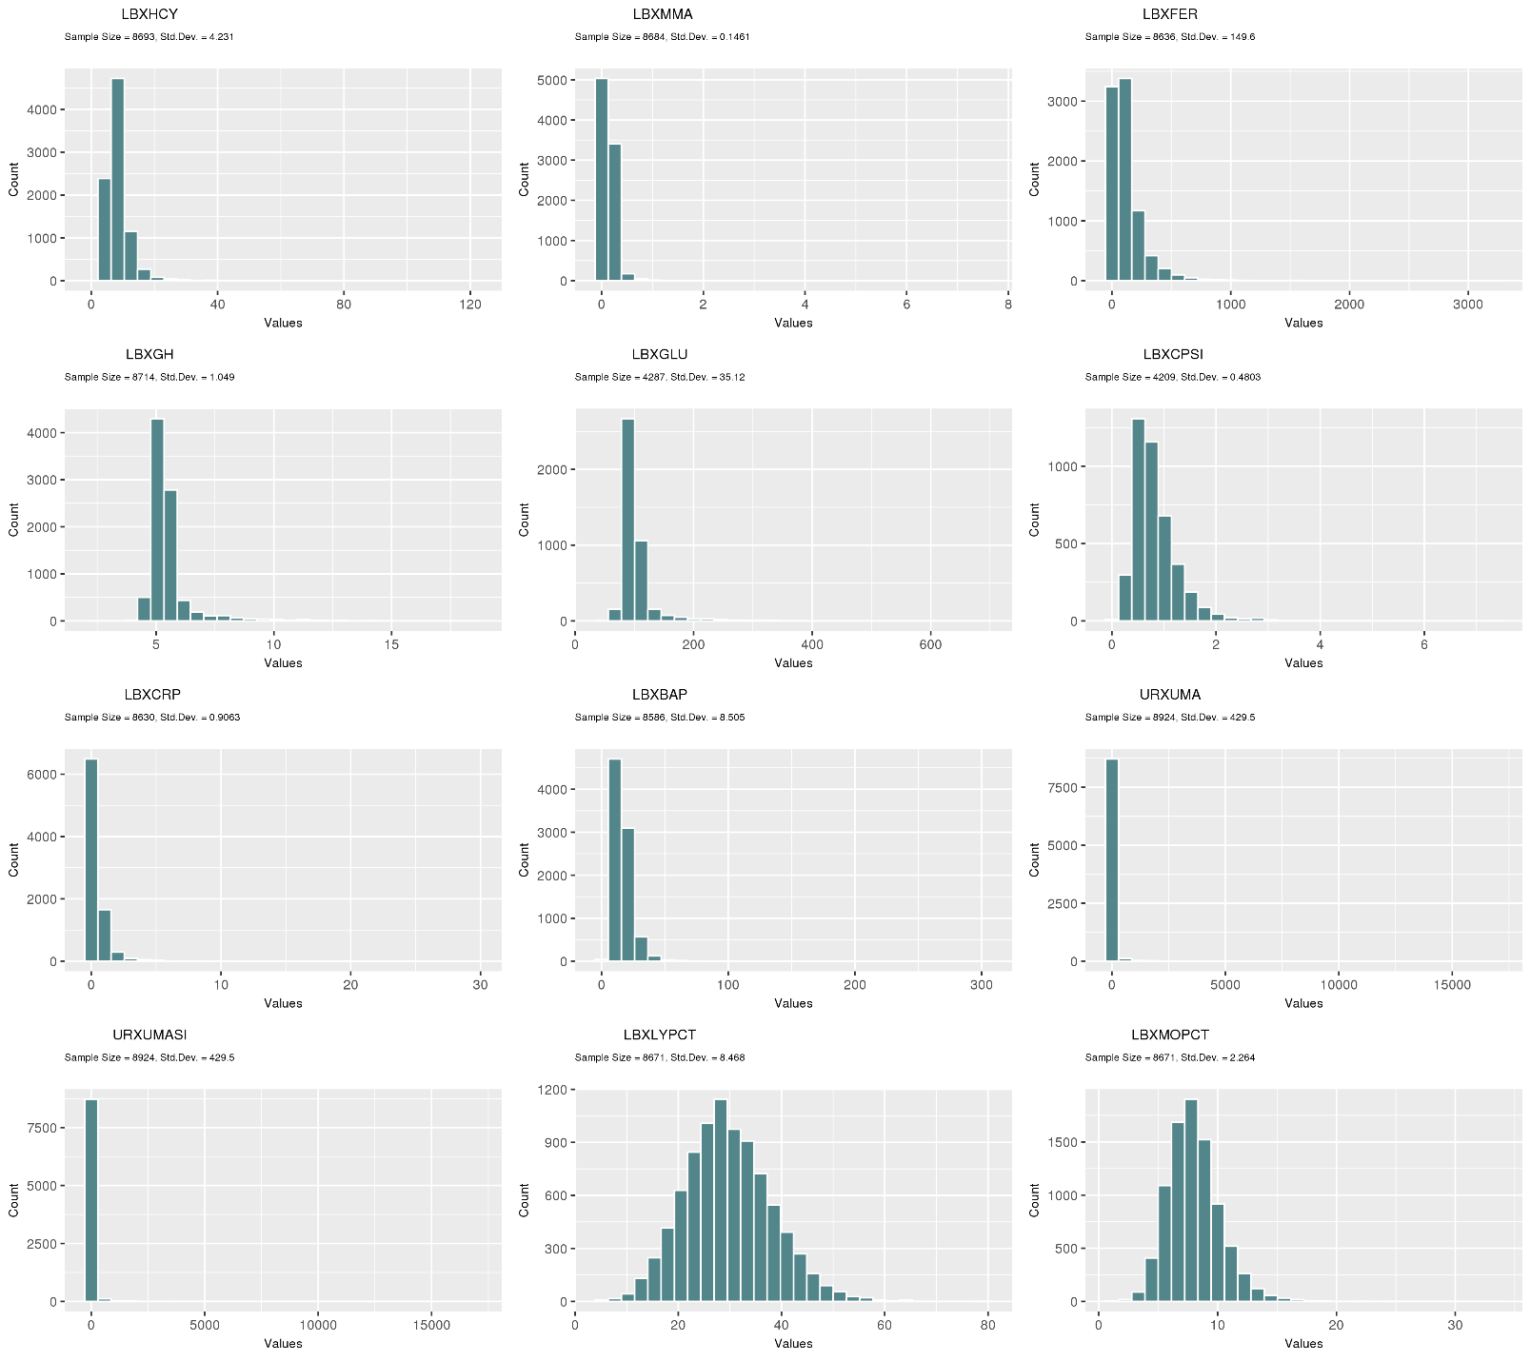

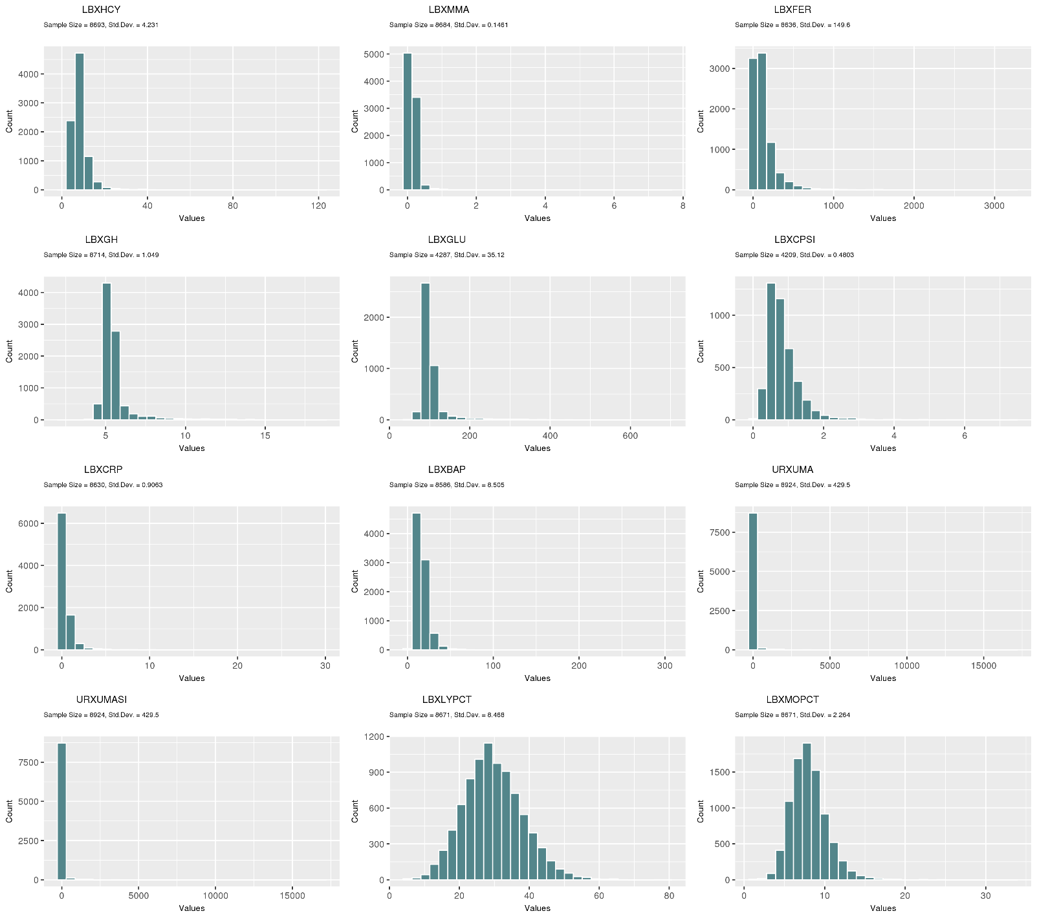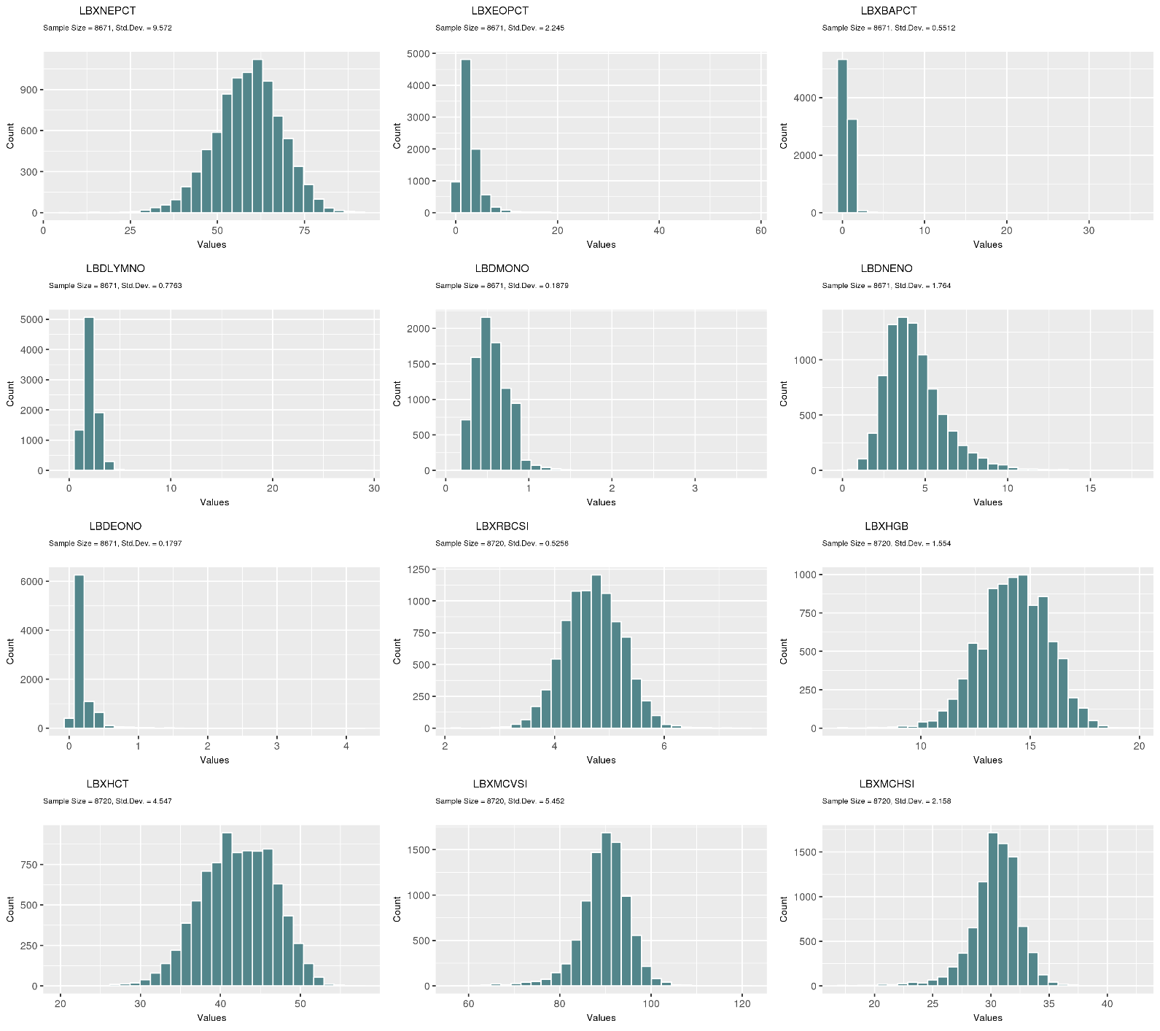0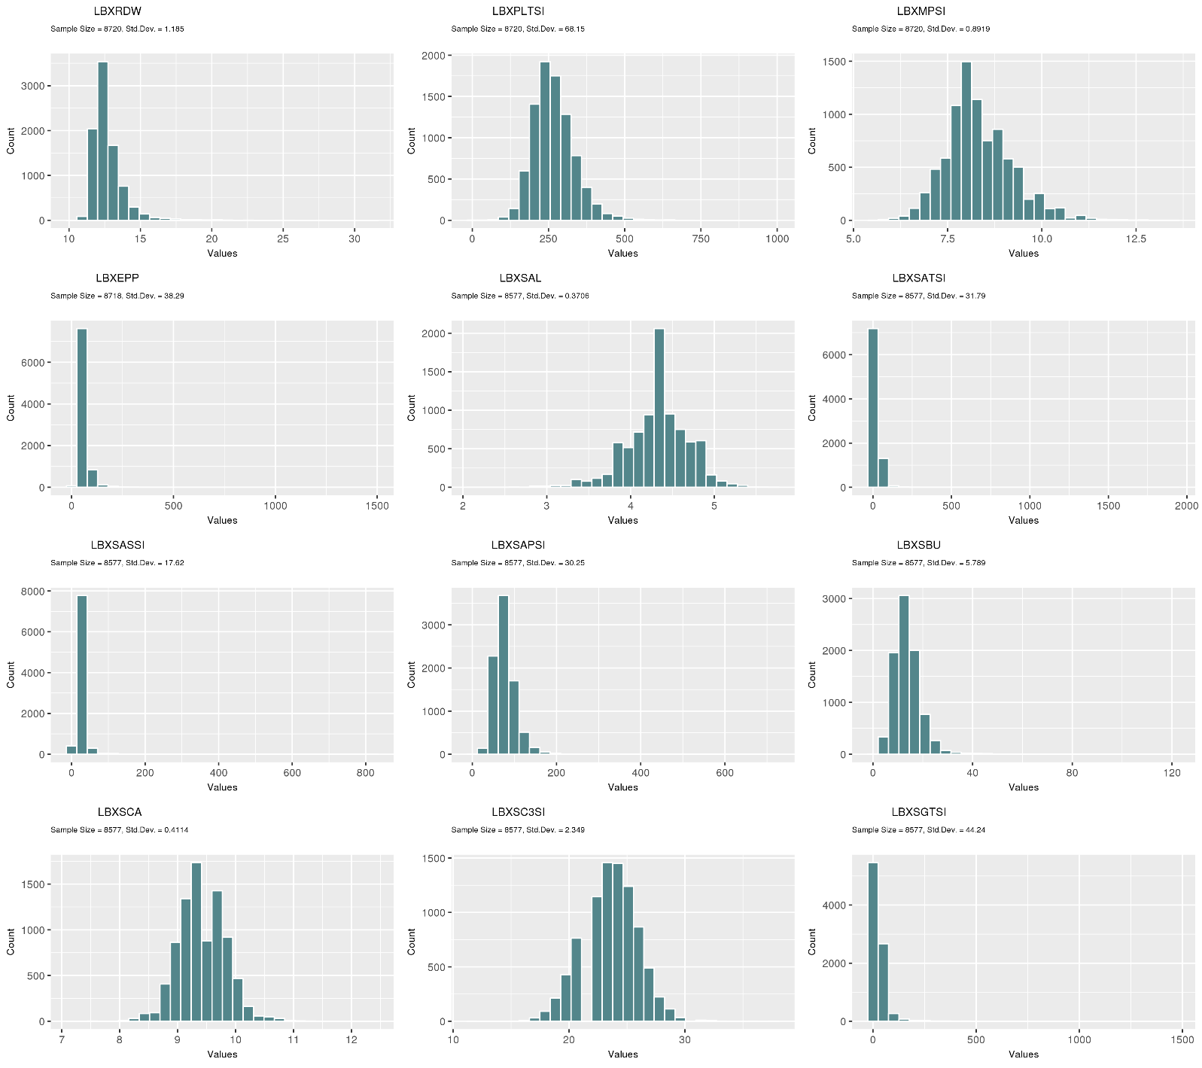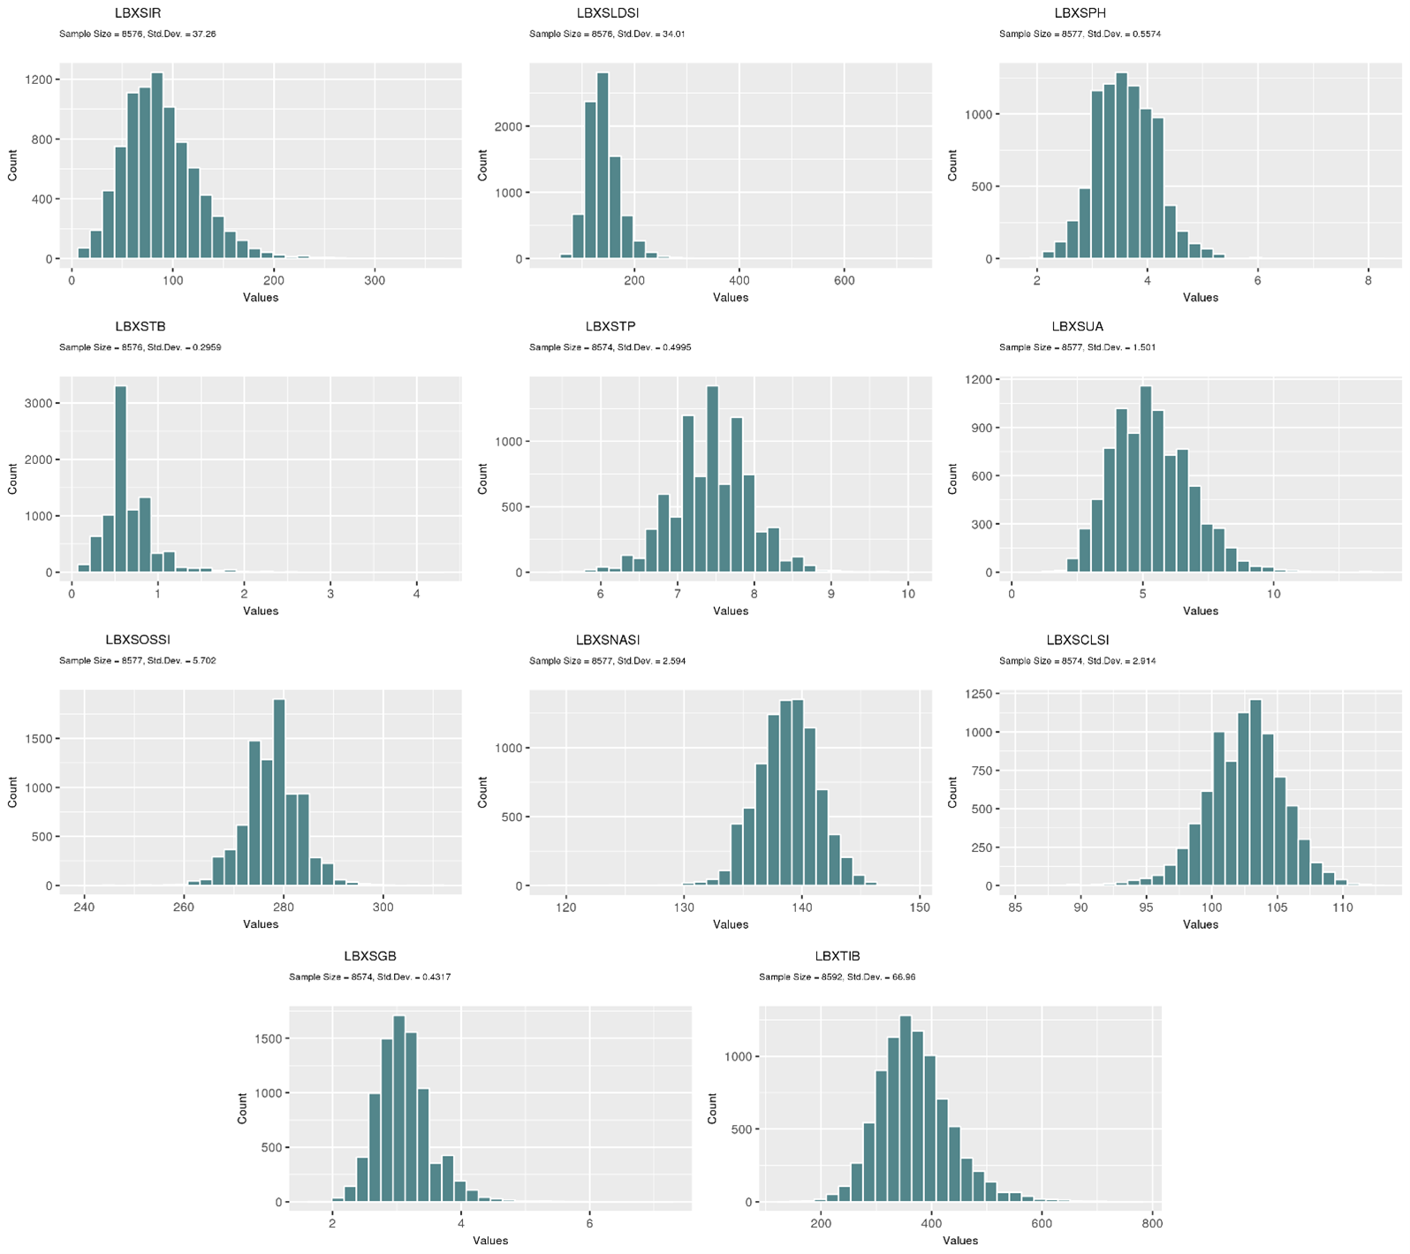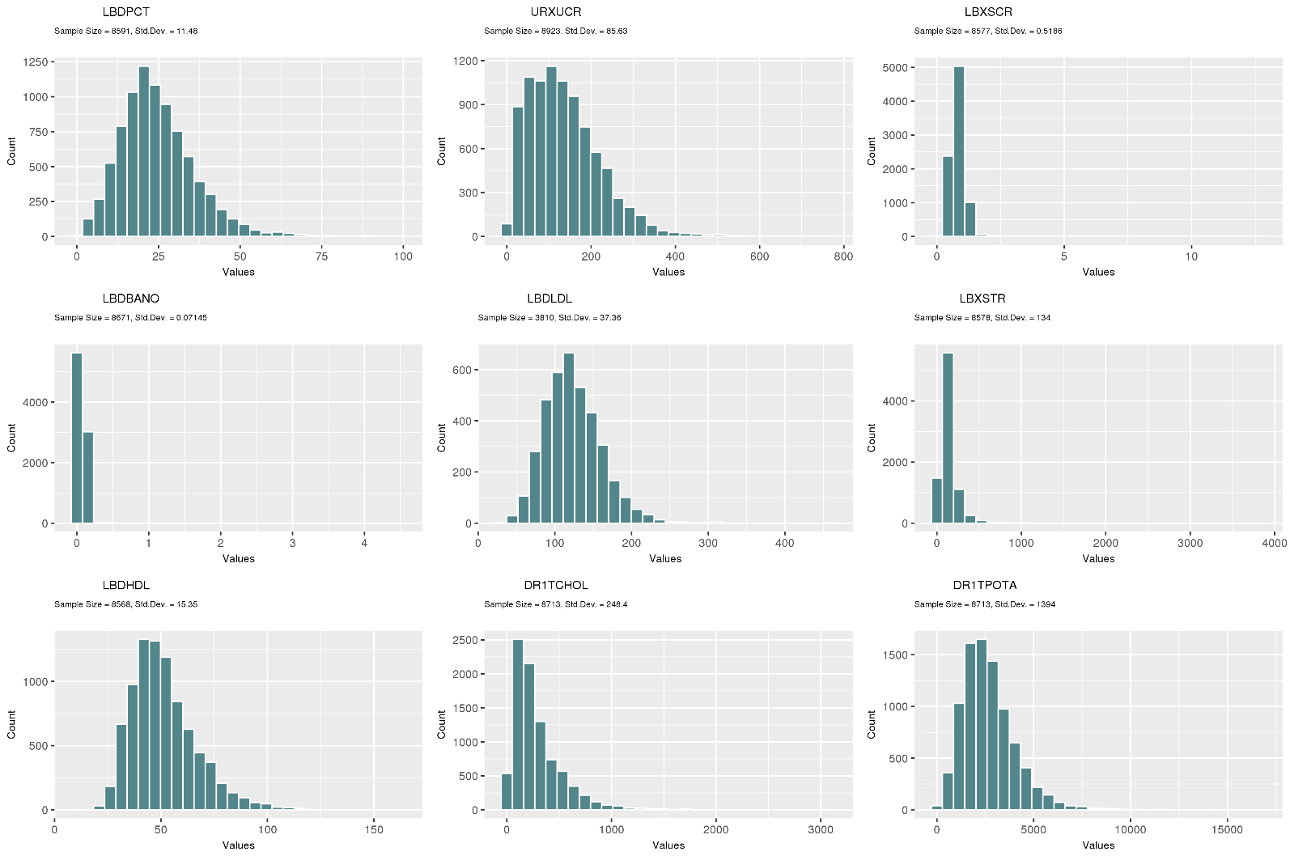

**B)**

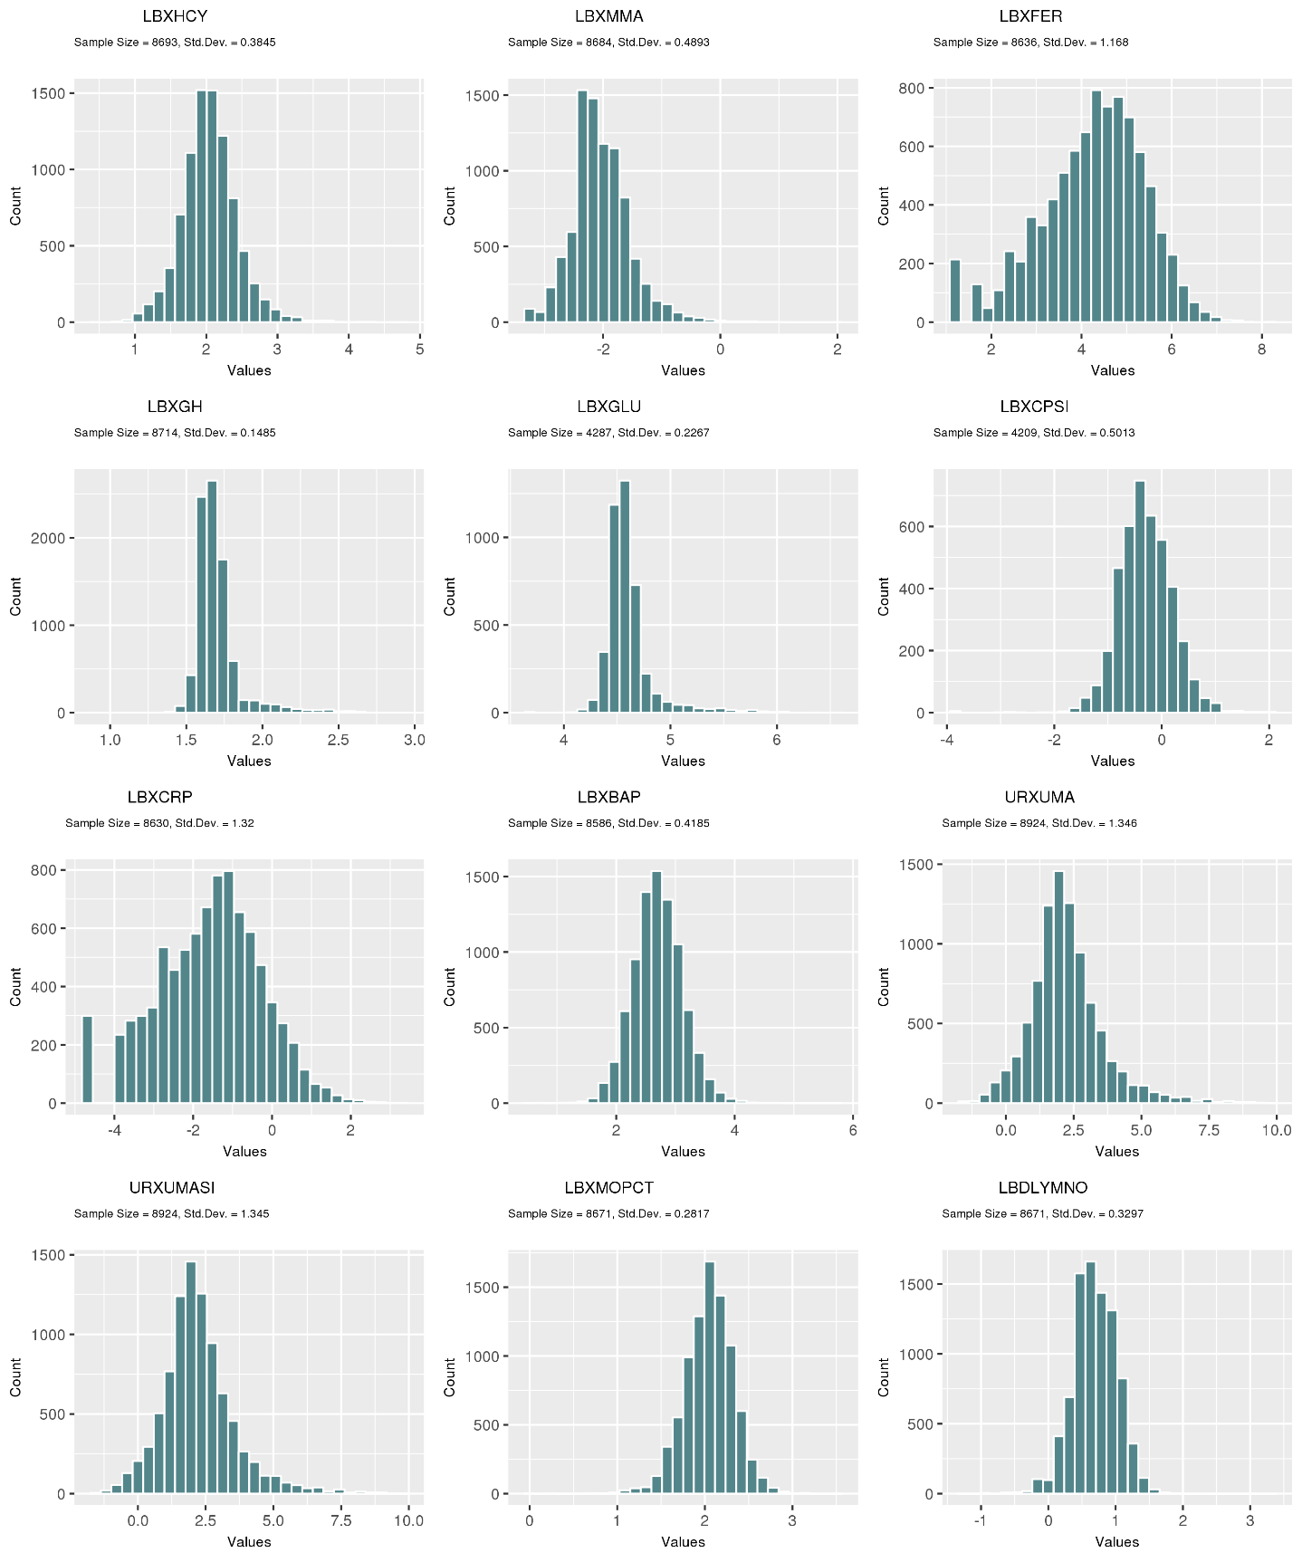

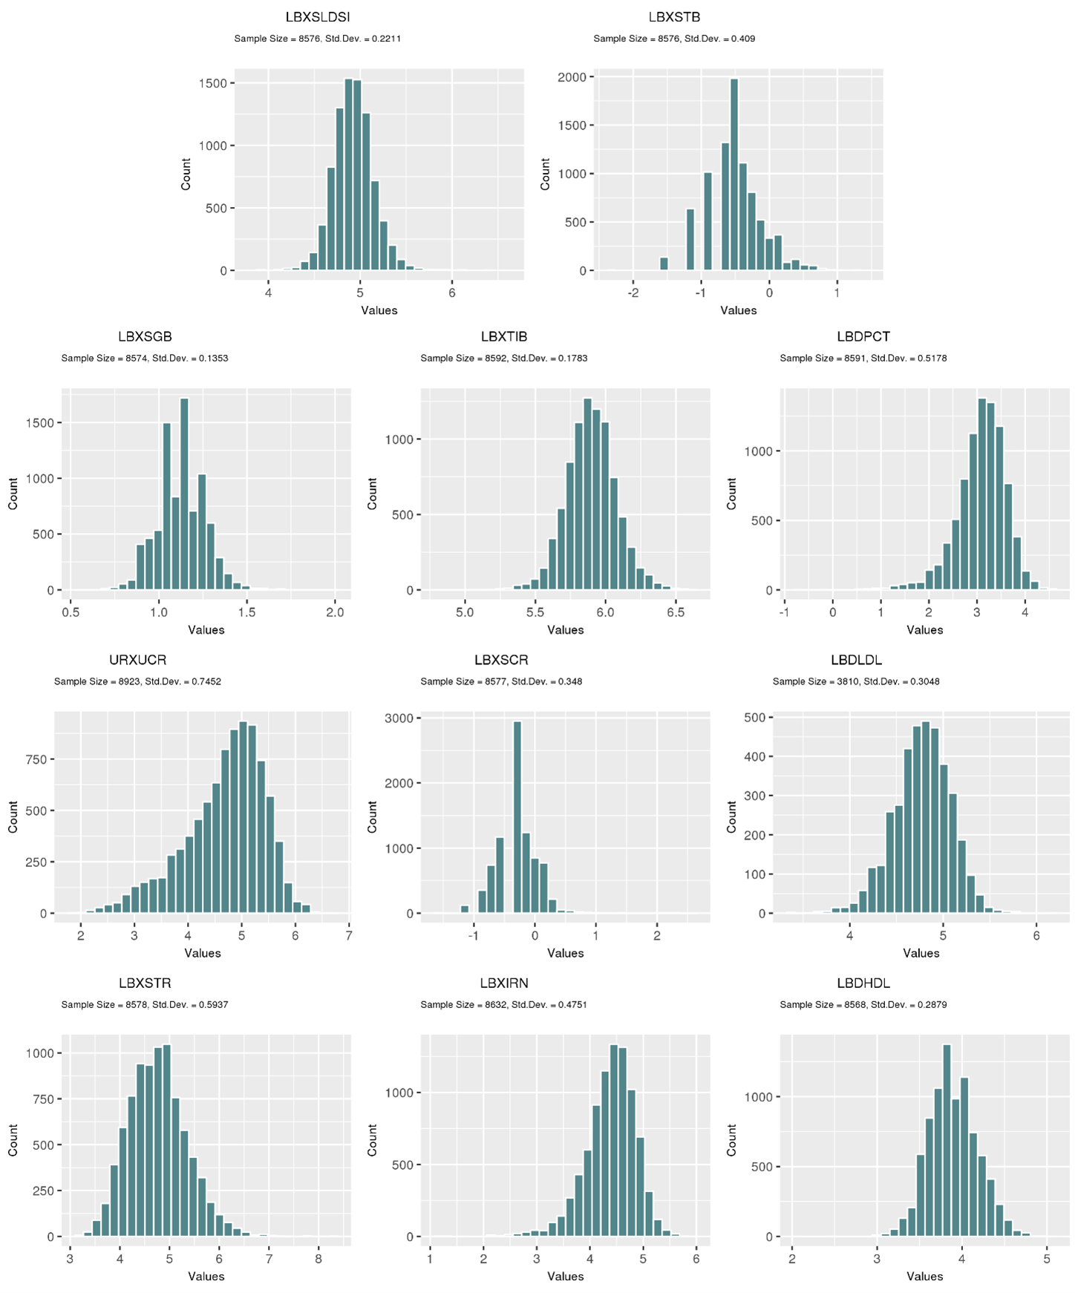

**

**Supplemental Figure 4.** A)Histograms displaying the distributions of the phenotypes from the Discovery dataset prior to transforming. Histograms after the B) positive and C) negative transformations of the phenotype values was implemented based on skewness in order to normalize the data.

**A) B)**

**Supplemental Figure 5.** Based off the linear regression model used in this study, two power plots A) Discovery and B) Replication are displaying the sample size on the x-axis and the magnitude of power based off the beta coefficient on the y-axis. The key identifies the magnitude of beta coefficient and the dotted black line signifies an 80% power threshold.