Math hand project
  - This is a project about hand scaling things.

Ratios and Scaling
A ratio is a way to compare 2 numbers with each other. There are two types of ratios: part-to-part and part-to-whole. Part-to-part ratios compare 2 parts, as the name suggests. An example would be “the ratio of students to whiteboard tables is 29:7”. Part to part ratios are used to compare different parts of a group. A part-to-whole ratio, on the other hand, is similar to a fraction, they compare a part of a group to the entire group. An example would be “the ratio of students to humans is 29:30”. This could also be expressed as a fraction. Ratios can be more complex such as “the ratio of thickness to width to length of a 10 inch long 2x4 is 2:4:10”. Ratios are used mostly with cooking because they can measure the amount of an ingredient required in relation to other ingredients, so that the same result can be reached with different quantities of food. A proportion is a mathematical statement expressing equality of two ratios (A:B = C:D).
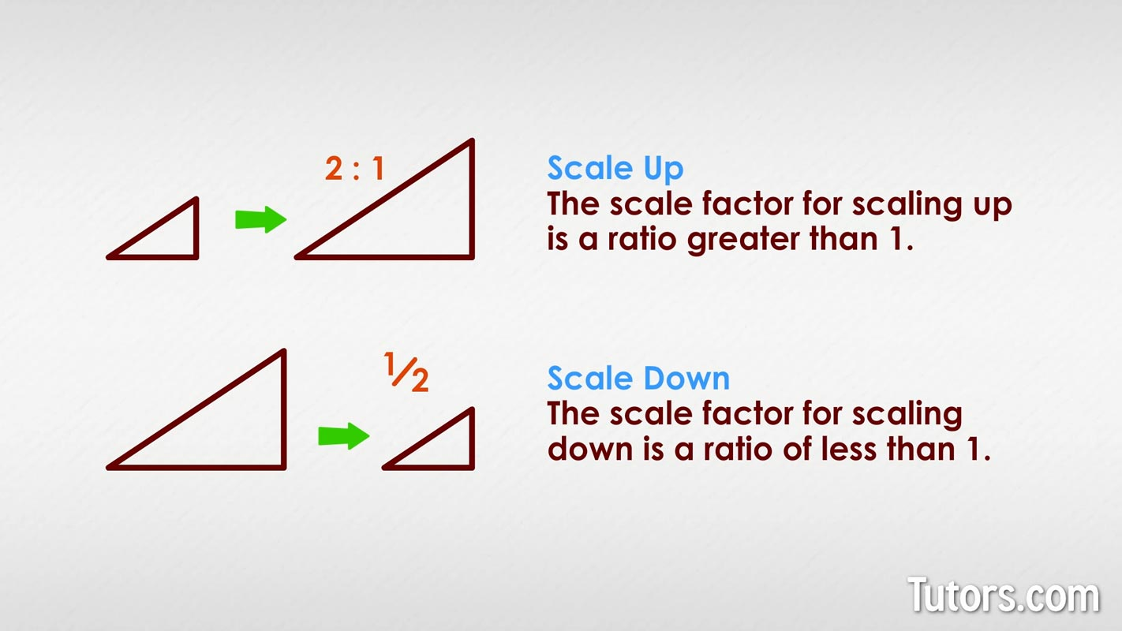
What does all of this have to do with the project? Ratios can be used for scaling. Scaling in math is the multiplication of each dimension of a real-life object by a scale factor (a constant used as a multiplier) to obtain the dimensions of a different representation of that object. The scale factor is the number that all the dimensions are multiplied by to create the scaled object. For example, a 2x2x2 cube scaled with a scale factor of 2 would become a 4x4x4 cube, and a scale factor of 0.5 would make it a 1x1x1 cube. When scaling with ratios, the number on the left is normally 1, representing the original size, and the second number is the scale factor. For example, a toy car’s scale factor can be 1:14, meaning the toy is 1/14 of the real car. All scaling calculations are on an Excel sheet.

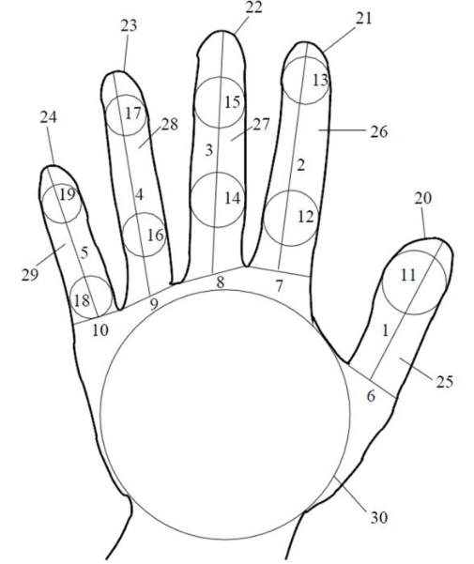
Hands
Hand geometry is based on the palm and fingers structure, including width of the fingers in different places, length of the fingers, thickness of the palm area, etc. Hand geometry is a biometric, and can be used for identity verification. The human hand is unique mainly because of our thumbs, and anthropologists believe our separated thumbs were key in our evolution.

Hand 1: back of hand
Scale factor: 0.6
For my first hand, after careful thought, I have concluded that the optimal scale factor for my hand will be a scale factor that allows me to fit all 3 hands on the page. I have come to the conclusion that the scale factor of 0.6 will keep the hand at a reasonable size while leaving space for the other hands. I chose this scale factor because this hand had the largest area, and needed to be scaled down the most. This hand shows a view of the back of my left hand, and all the shapes and geometry hidden inside it. The fascinating geometry of the body is captured through the various measurements included in my drawings.
A scale factor of 0.6 means that the ratio is 1:0.6. The 1 represents the original hand, and the 0.6 represents the scaled drawing. This means that the scaled hand is 60% of the original hand. 1:0.6 is equivalent to 5:3. To scale my hand, I must multiply all of my original measurements by 0.6 and redraw it with the new measurements. Below is a table showing how I converted my measurements to the scale of the new hand.

Part |  | Original size | Scaled size | 3 | Right1 | 37 | 22.2
Wrist |  | 64 | 38.4 |  | Right2 | 33 | 19.8
Hand | Right (thumb) | 40 | 24 |  | Right3 | 18 | 10.8
 | Right (above thumb) | 32 | 19.2 |  | Middle1 | 13 | 7.8
 | Left | 55 | 33 |  | Middle2 | 16 | 9.6
 | Top | 77 | 46.2 |  | Middle3 | 13 | 7.8
Thumb | Left 1 | 20 | 12 | 4 | Left1 | 42 | 25.2
 | Left 2 | 23 | 13.8 |  | Left2 | 27 | 16.2
 | Right 1 | 28 | 16.8 |  | Left3 | 20 | 12
 | Right 2 | 25 | 15 |  | Right1 | 31 | 18.6
 | Middle 1 | 24 | 14.4 |  | Right2 | 30 | 18
 | Middle 2 | 15 | 9 |  | Right3 | 20 | 12
2 | Left1 | 42 | 25.2 |  | Middle1 | 23 | 13.8
 | Left2 | 23 | 13.8 |  | Middle2 | 15 | 9
 | Left3 | 12 | 7.2 |  | Middle3 | 14 | 8.4
 | Right1 | 36 | 21.6 | 5 | Left1 | 27 | 16.2
 | Right2 | 25 | 15 |  | Left2 | 20 | 12
 | Right3 | 14 | 8.4 |  | Left3 | 20 | 12
 | Middle1 | 24 | 14.4 |  | Right1 | 25 | 15
 | Middle2 | 16 | 9.6 |  | Right2 | 15 | 9
 | Middle3 | 15 | 9 |  | Right3 | 20 | 12
3 | Left1 | 35 | 21 |  | Middle1 | 20 | 12
 | Left2 | 31 | 18.6 |  | Middle2 | 15 | 9
 | Left3 | 23 | 13.8 |  | Middle3 | 14 | 8.4

Hand 2
Scale: 0.8
I have determined that the most suitable scale factor for my second hand is one that retains the complex detail and geometry. I have decided on a scale factor of 0.8, which maintains the intricate details and complex shapes in this pose while providing sufficient space for the other representations. This particular scale factor was selected because this hand possesses the most detail area and requires a larger scale. The drawing depicts my hand loosely holding a marker, revealing the intricate shapes and geometry contained within. I chose this position to challenge myself to work with different hand positions and external objects. A reference picture was used in the process of drawing this hand.
A scale factor of 0.8 means that the ratio is 1:0.8. The 1 represents the original hand, and the 0.8 represents the scaled drawing. This means that the scaled hand is 80% of the original hand. 1:0.8 is equivalent to 5:4. To scale my hand, I must multiply all of my original measurements by 0.8 and redraw it with the new measurements. Below is a table showing how I converted my measurements to the scale of the new hand. Please note that some cells are not filled due to the parts being obstructed, and therefore not measured.
part |  | Original size | Scaled size | 3 | L3
Hand | Wrist | 58 | 46.4 |  | R1
 | L1 | 47 | 37.6 |  | R2 | 22 | 17.6
 | L2 | 35 | 28 |  | R3
 | R1 | 8 | 6.4 |  | M1 | 15 | 12
 | R2 | 20 | 16 |  | M2
 | M1 | 32 | 25.6 |  | M3 | 14 | 11.2
 | M2 | 10 | 8 | 4 | L1 | 11 | 8.8
 | M3 | 35 | 28 |  | L2 | 22 | 17.6
 | Top | 75 | 60 |  | L3
1 | L1 | 33 | 26.4 |  | R1 | 18 | 14.4
 | L2 | 20 | 16 |  | R2
 | L3 | 12 | 9.6 |  | R3
 | R1 | 27 | 21.6 |  | M1 | 15 | 12
 | R2 | 12 | 9.6 |  | M2 | 14 | 11.2
 | R3 |  |  |  | M3 | 12 | 9.6
 | M1 | 21 | 16.8 | 5 | L1 | 15 | 12
 | M2 | 19 | 15.2 |  | L2 | 12 | 9.6
 | M3 | 15 | 12 |  | L3
2 | L1 | 25 | 20 |  | R1 | 17 | 13.6
 | L2 | 23 | 18.4 |  | R2 | 12 | 9.6
 | L3 |  |  |  | R3
 | R1 | 24 | 19.2 |  | M1 | 17 | 13.6
 | R2 |  |  |  | M2 | 13 | 10.4
 | R3 |  |  |  | M3 | 11 | 8.8
 | M1 | 15 | 12 | Pen | Length | 132 | 105.6
 | M2 | 15 | 12 |  | T1 | 10 | 8
 | M3 |  |  |  | T2 | 9 | 7.2
3 | L1 |  |  |  | CL | 41 | 32.8
 | L2 | 12 | 9.6 |  | CW | 3 | 2.4

Hand 3
Scale: 0.5
After carefully deciding the scale of my previous 2 hands, I wanted to pick a scale that will ensure I have room for mistakes on my final copy. My third hand was in an odd shape and would be tricky to fit on the page, so I chose a scale of a tiny 1:0.5. This hand, although at a weird angle, is a lot simpler than the others due to a big empty space that is the back of my hand. Since this hand has less detail compared to the others, a smaller scale seemed appropriate. The drawing displays my left hand holding a marker, as if writing with it. I thought this would be challenging to draw, but the angle made it easier, and at the end it was not too complicated. The real challenge would be shading the hand to give it depth, as the rough draft lacks depth and makes the hand look flat.
A scale of 1:0.5 means that the scale factor is 0.5. As before, the 1 represents my actual hand as well as the draft drawing, and the 0.5 represents the size of the final copy. This means that the dimensions of my new hand is 50% of the original, meaning the ratio is equivalent to 2:1. Below is a table showing the comparison between the original and scaled measurements.
Part |  | Original size | Scaled size | 1 | M1 | 30 | 15
Hand | Below Wrist | 32 | 16 |  | M2 | 22 | 11
 | Wrist | 52 | 26 |  | Top | 10 | 5
 | L1 | 87 | 43.5 | 2 | 1 | 28 | 14
 | L2 | 29 | 14.5 |  | 2 | 30 | 15
 | R1 | 19 | 9.5 |  | 3 | 20 | 10
 | R2 | 25 | 12.5 | 3 | L | 15 | 7.5
 | R3 | 17 | 8.5 | 4 | L | 20 | 10
 | Curve1 | 10 | 5 |  | M | 11 | 5.5
 | Curve2 | 22 | 11 | Pen | L | 160 | 80
 | Curve3 | 9 | 4.5 |  | M1 | 15 | 7.5
1 | L1 | 23 | 11.5 |  | M2 | 14 | 7
 | L2 | 11 | 5.5 |  | M3 | 15 | 7.5
 | L3 | 29 | 14.5 |  | T1 | 7 | 3.5
 | R1 | 39 | 19.5 |  | T2 | 5 | 2.5
 | R2 | 27 | 13.5 |  | TL | 8 | 4

Extra math
In order to get Extending, students had to show additional examples of mathematics and geometry. Here, I show a few additional pieces of geometry found in my hands.

1: Triangles and the Pythagorean Theorem
On hand #1, there is a triangle where 1 of the angles is 90 degrees, marked Ⓐ. This means that we can find the length of the hypotenuse Ⓑ. First a quick review of the Pythagorean Theorem:
a² + b² = c²
We replace a and b with the side lengths 55mm and 77mm. By applying the Pythagorean Theorem, we find the length of line Ⓑ.
552 + 772 = Ⓑ2
Ⓑ = √(552 + 772) = Ⓑ
Ⓑ = √(3025 + 5929)
Ⓑ = 94.625577937468894489024208885547
Using the Pythagorean Theorem, we now know that the hypotenuse Ⓑ is approximately 94.63mm long. The Pythagorean Theorem is very useful in game development and computer-related situations where one needs to calculate the distance between 2 diagonal points, or when finding the x and y coordinates needed to plot a point a certain distance from another at a certain angle.

2: Volume of a cylinder
Next, let’s use the area of a circle to find the approximate volume of the pen in Hand 2. Assuming that the dimensions of the pen are the same as what is in the drawing, which may not be the case due to camera angle and warp, and assuming the pen is a perfect cylinder by ignoring the small diameter changes. Let’s review the area of a cylinder:
$A=πr^{2}$h
We know that the diameter of the pen is 10mm, so the radius must be 5mm. By applying the formula, we get approximately 78.54, meaning that the area is approximately 78.54mm2. To find the volume of the cylinder, we multiply our are by the height of the cylinder, which is 132mm. 78.54 × 132 is 10367.28, meaning the approximate volume of the pen 10367.28mm3.

