**Country Club Analysis**

* **Project Requirements**

Working on a new country club with few different facilities that are offered. The club requires a monitor and understanding of how they can use their club’s data to analyze the higher demands they are getting, and which facilities are mostly in use by both their members and non-members.

* **Benefits**

The benefit of this analysis is related with the requirement in that it helps the club focus more on the facilities that are mostly being utilized. As quality is more profitable than quantity, this analysis helps to pinpoint which facilities are being utilized more and increase the maintenance on those specific facilities than to spend more money in having and unused facility.

* **Tables Used**

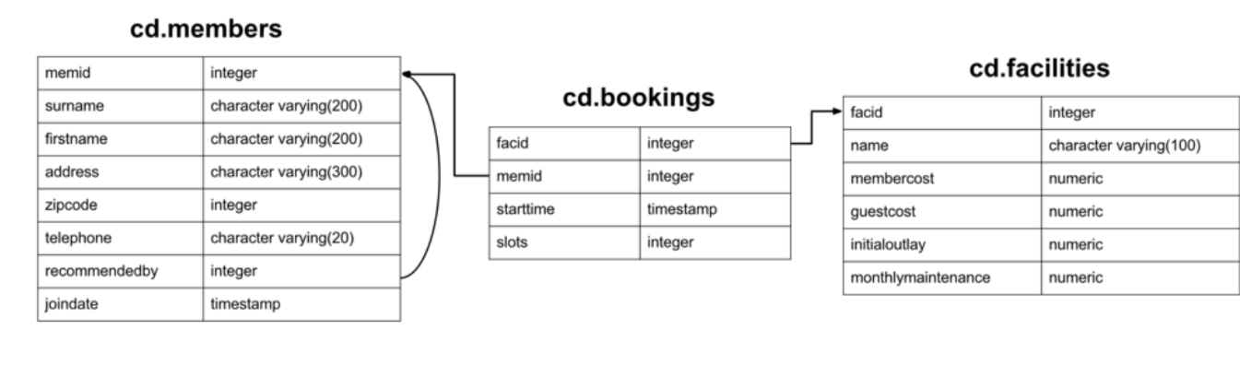

I’ve used 3 tables. Facilities, members and bookings.

* Facilities:

facid = PRIMARY KEY

name (of the facility)

membercost

guestcost

initialoutlay (the cost of the initial construction/maintenance of the facility)

monthlymaintenance

* Members :

memid = PRIMARY KEY

surname

firstname

address

zipcode

telephone

recommendedby (how many recommendations they had received to join)

joindate

FOREIGN KEY (recommendedby) REFERENCES members(memid)

* Bookings:

bookid = PRIMARY KEY

facid

memid

starttime

slots

FOREIGN KEY (facid) REFERENCES facilities(facid)

FOREIGN KEY (memid) REFERENCES members(memid)

* **Technical Specifications**

For this project, I used three databases each created in 3 RDBMS’s. MySQL, MSSQL and PostgreSQL. Then I used SQOOP data integration tool, to ingest my data from rdbms to hdfs using the jdbc connectors for each RDBMS’s.