**RDBMS, CSV file Import To HDFS Plus External, Internal Tables**

3 RDBMS’s = MySQL, MsSQL, and Postgresql

MySQL tables imported to HDFS in the directory /user/input/mysqltables

MsSQL tables imported to HDFS in the directory /user/input/mssqltables

Postgresql tables imported to HDFS in the directory /user/input/clubpo

Used SFTP to transfer csv file to HDFS.

Csv files imported to HDFS in the directory /user/input/csvtables

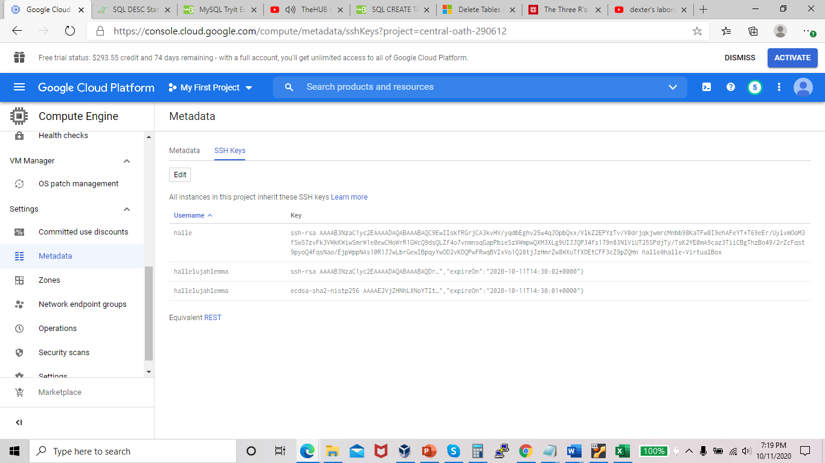

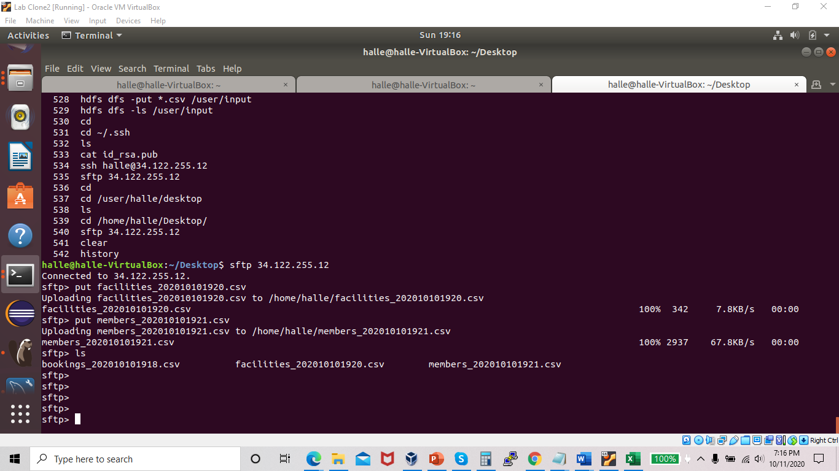

In hive - Created DB called fitness.

* Created 3 external tables with schema for my 3 csv files and loaded data into the tables
* Created 3 internal tables with schema for my 3 csv files and loaded data into the tables

