UPDATED DATABASE SCHEMA

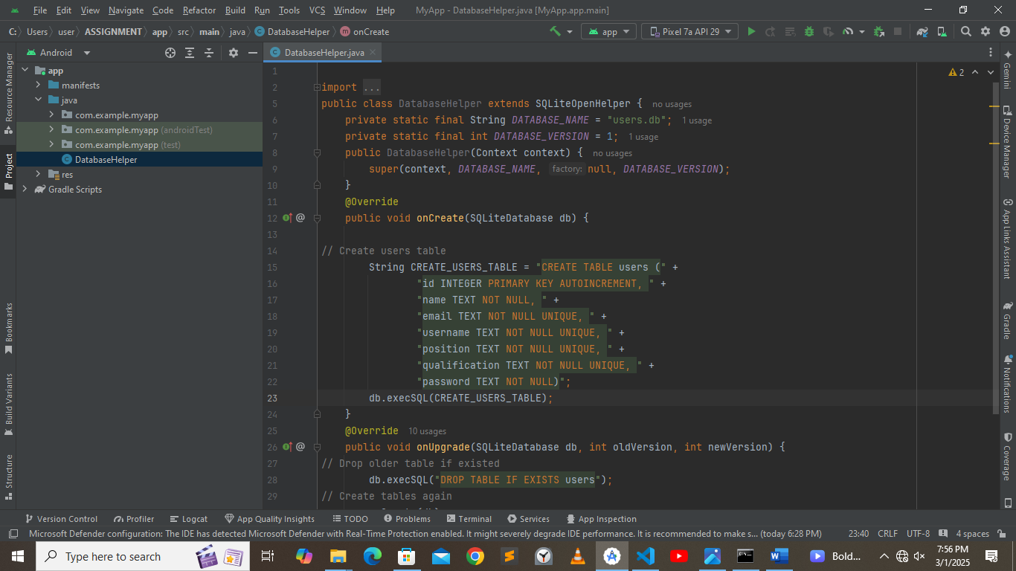

CHALLENGES FACED

1. Pushing project files to github was a challenge
2. Could not resolve one error in java code