UPDATED DATABASE SCHEMA

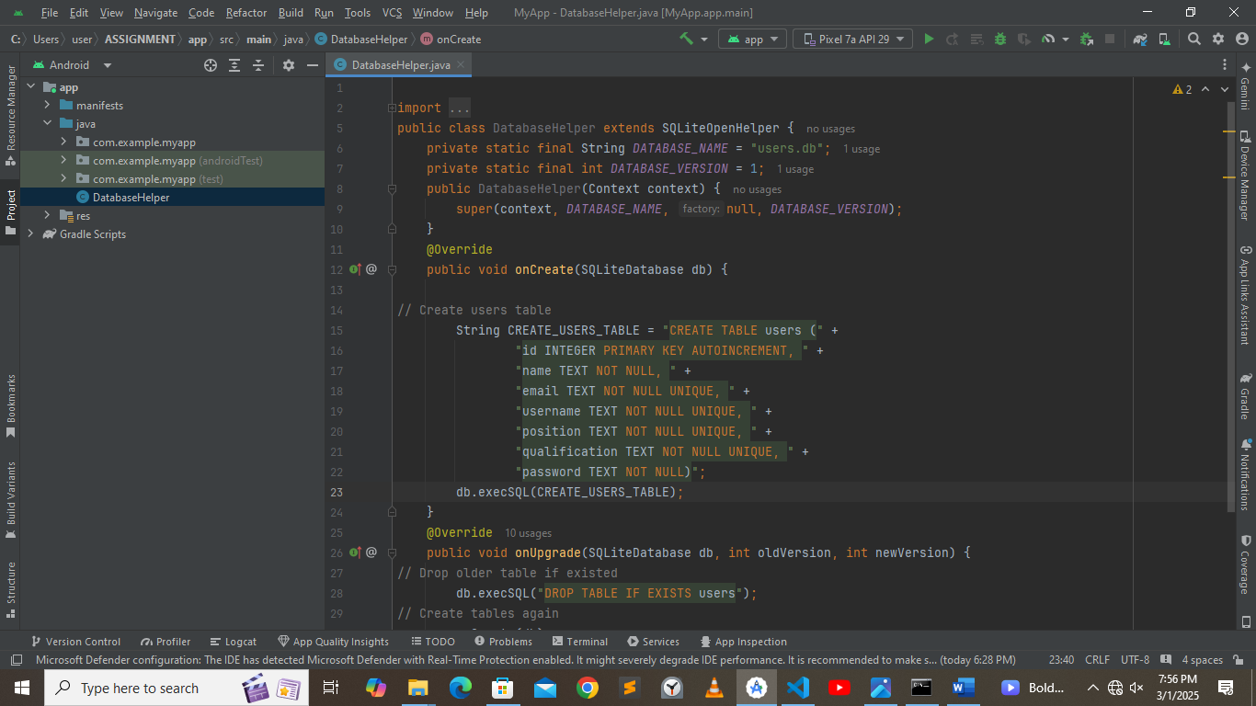

CHALLENGES FACED

1. Pushing project files to github gave me numerous warnings I was unable to work around
2. Not enough time to resolve all errors within the code