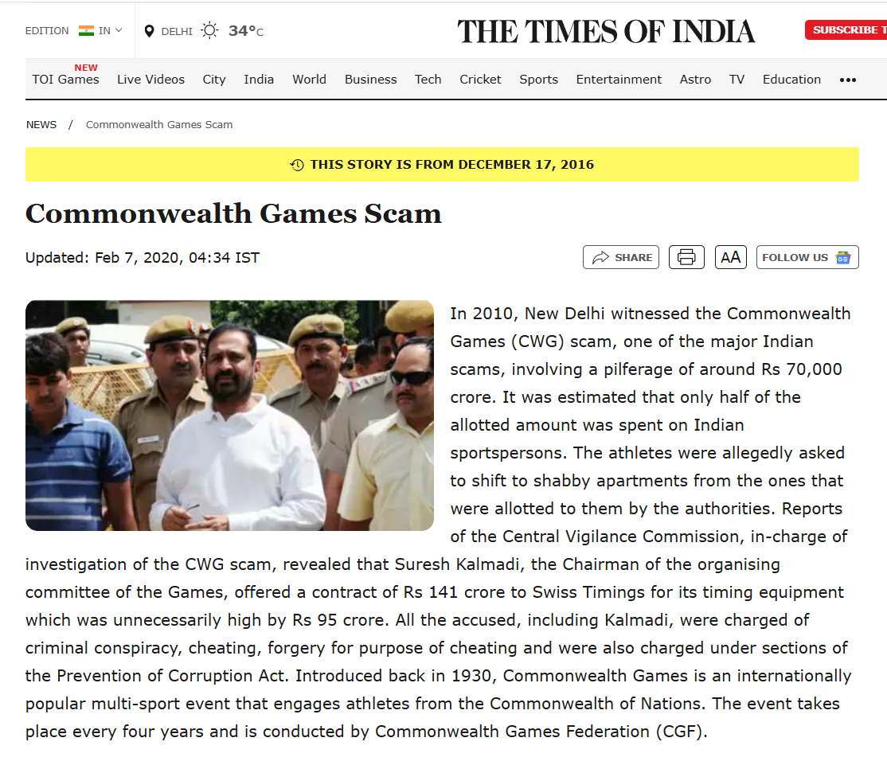

**Reference:->** [**https://timesofindia.indiatimes.com/miscellaneous/commonwealth-games-scam/articleshow/56032112.cms**](https://timesofindia.indiatimes.com/miscellaneous/commonwealth-games-scam/articleshow/56032112.cms)

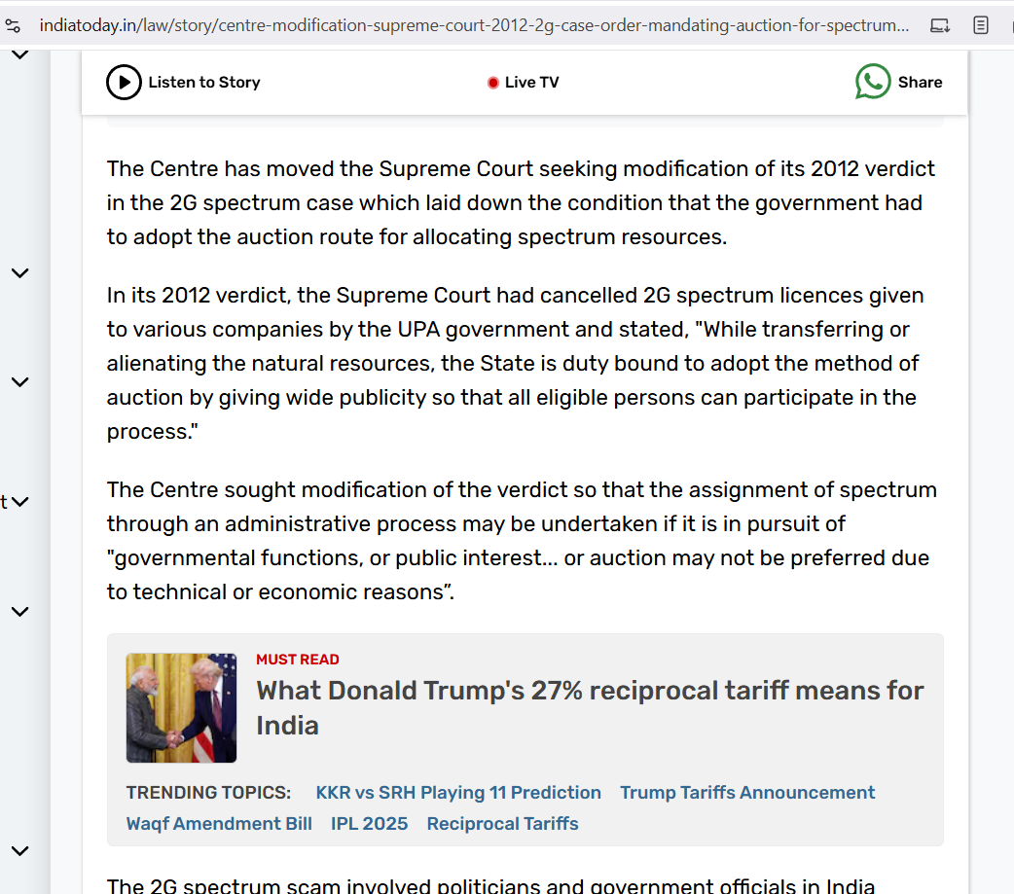

**Reference:-> [https://timesofindia.indiatimes.com/miscellaneous/commonwealth-games-scam/articleshow/56032112.cms](https://www.indiatoday.in/law/story/centre-modification-supreme-court-2012-2g-case-order-mandating-auction-for-spectrum-sale-2530680-2024-04-23" \o "https://www.indiatoday.in/law/story/centre-modification-supreme-court-2012-2g-case-order-mandating-auction-for-spectrum-sale-2530680-2024-04-23)**

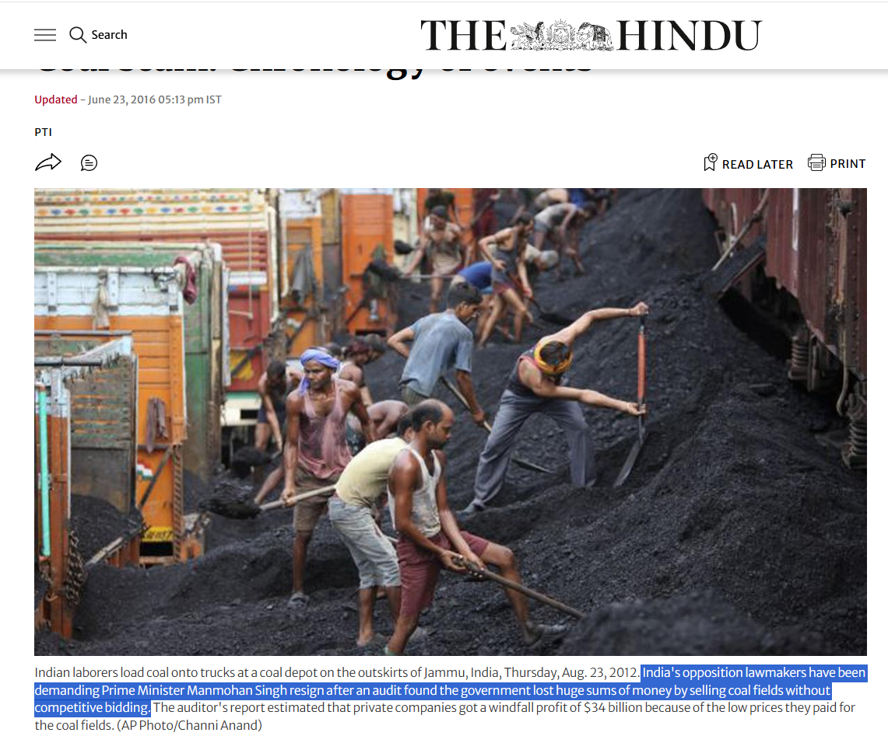

**Reference:->** [**https://www.thehindu.com/news/national/coal-scam-chronology-of-events/article6350481.ece**](https://www.thehindu.com/news/national/coal-scam-chronology-of-events/article6350481.ece)

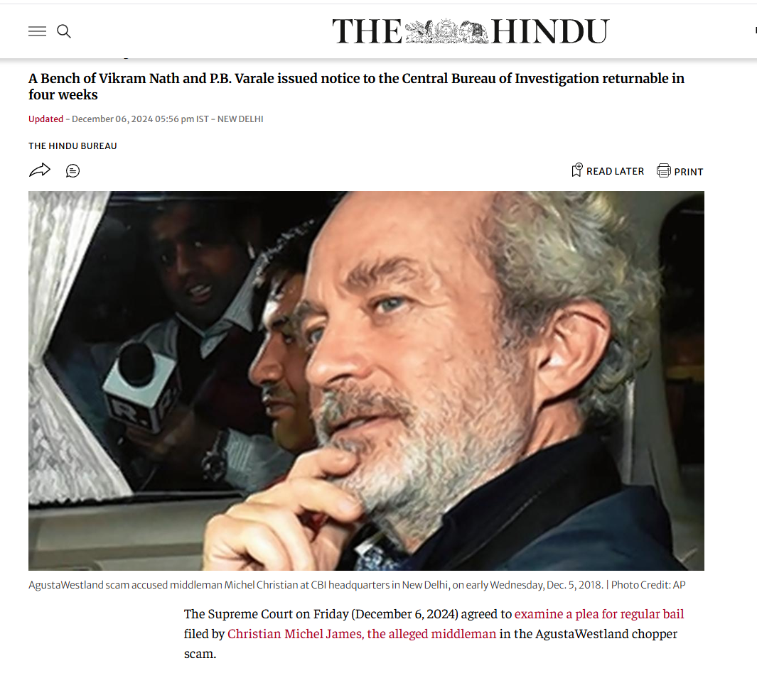

**Reference:->**

**<https://timesofindia.indiatimes.com/miscellaneous/commonwealth-games-scam/articleshow/56032112.cmsv>**

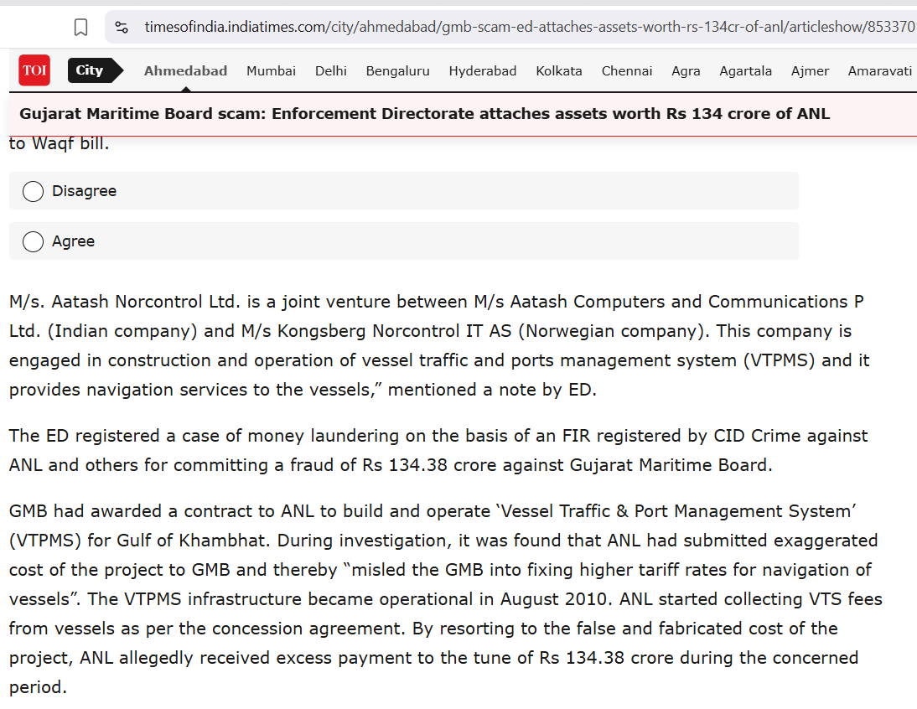

**Reference:-> [https://timesofindia.indiatimes.com/miscellaneous/commonwealth-games-scam/articleshow/56032112.cmsv](https://timesofindia.indiatimes.com/city/ahmedabad/gmb-scam-ed-attaches-assets-worth-rs-134cr-of-anl/articleshow/85337012.cms)**

\

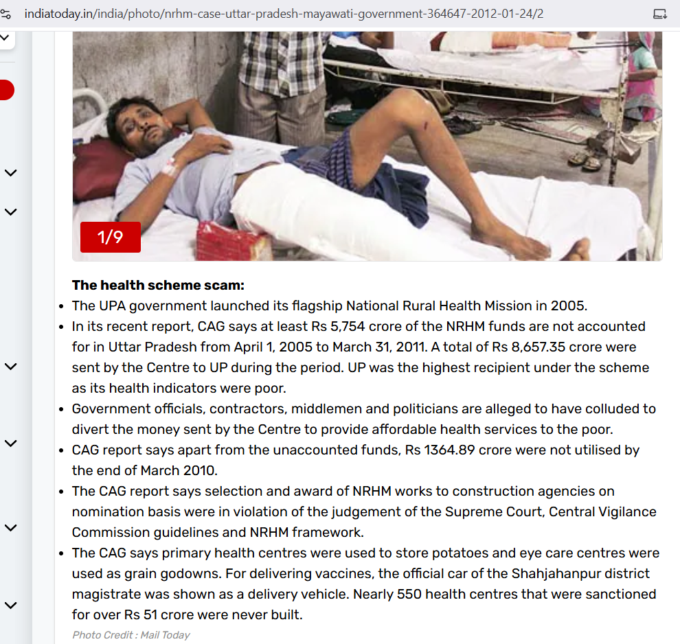

**Reference:-> [https://timesofindia.indiatimes.com/miscellaneous/commonwealth-games-scam/articleshow/56032112.cmsv](https://www.indiatoday.in/india/photo/nrhm-case-uttar-pradesh-mayawati-government-364647-2012-01-24/2)**