

**FORSIDE FOR INNLEVERING**

**TILGJENGELIGHET**

|  |  |  |  |
| --- | --- | --- | --- |
|  | **Fri** |  | **Begrenset** |

|  |  |  |
| --- | --- | --- |
| **Emnekode og emnenavn:** | Hovedprosjekt (PJ6000-13) | |
| **Tittel norsk:** | **Hovedprosjekt** | |
| **Tittel engelsk (Hovedprosjekt):** | **Hovedprosjekt** | |
| **Eventuell oppdragsgiver:** | **Syncrotec** [**[2]**](http://www.syncrotec.no/) | |
| **Utleveringsdato:** | **6.01.2014** | |
| **Innleveringsdato:** | **21.5.2014** | |
| **Antall sider:** |  | |
| **Antall ord:** |  | |
| **This is the project report to group 10 at NITH. It consists of in detail information about our current bachelor game project. The main focus of this document is to keep information about the game (rules, graphics and gameplay) and how we work on the project up to date as well as easily available.** | | |
| **Gruppenummer:** | **10** | |
| **Studentnavn:** | **Studentnummer:** | **Signatur:** |
| **Andreas Engebretsen** | **700542** | 9ldGmIwqjIdGtRteFmGl_XsOeKbeWQGIEoyG80Yau57PIYHxWFJ4D5p3CIjUyVpdjDcFEI4BgbGscehgzr664GqGr22J5ANUoM8nXkwWzCY-f7QehQpg_QFTfhsP8w |
| **Aleksander Hougen** | **700633** | 0vtb0RK9rW2nbZh4TdYFws_8gRymjaDzeNqIBvKvhC1cd9RXpR0QGJMtBci3oaITh2JMLHqdN73gGraYmo24KX2_a_vnl4yFx2zmwKbJ4LgplRhVFGzG5EzRjqytbQ |
| **Geir Haugen** | **700579** | a_JzlzNIqnjl_1nJXuQZBwBKvFCaG4aSQDFUjKtr6_R8STr3d5kFHYy-rYUJQ1i23J7bRb9ajtRNztjk5mfvYwuthLmFPfUuEznrBtL_u0orAi9aRfl9xp0nN53hyQ |
| **Geir Inge Hillersøy** | **700458** | IQoakrwuG_UcoHGhLLm92cx_U2svmg8x7I4ZsN9QqKUzPu_c1_vSGdr6RHeYUYQjveuvdHrtSY7BVVOnLTXlDhIJTX6GQ8-pXxXeoVvUAM37K_jOyL6NVvnB1Nkr4A |
| **Jonas Dyrkorn** | **700116** | PeWOOjGbOOd8swJ6gLOGGNtjcnN3Wt91YeFaMdWbU8HrgrBTjVYlWI6c2N7Z64pLboewqRx7FV4gm0Uw6LDqT5Wfg2mqElYjJnyoPZZLerjfGlhPWqz3fak1V9QPxw |
|  |  |  |
| **Studentens signatur er også en bekreftelse av at hun/han har gjort seg kjent med, og fulgt, NITHs retningslinjer for intellektuell redelighet (tilgjengelig på intranett).** | | |

Table of content

[Hovedprosjekt (PJ6000-13) 1](#_Toc384282682)

[Introduction 1.0 3](#_Toc384282683)

[**2.0 Vision** 4](#_Toc384282684)

[2.1 Vision analysis 5](#_Toc384282685)

[2.2 Goals 6](#_Toc384282686)

[2.3 Concept 6](#_Toc384282687)

[2.4 Concept analysis 7](#_Toc384282688)

[**3.0 Techniques** 8](#_Toc384282689)

[3.1 Product reviews 8](#_Toc384282690)

[**4.0 60 seconds of gameplay** 10](#_Toc384282691)

[4.1 Challenge Highlights 10](#_Toc384282692)

[**5.0 Balancing** 12](#_Toc384282693)

[5.1 Prototyping 13](#_Toc384282694)

[5.2 Testing 15](#_Toc384282695)

[5.3 Testing analysis 16](#_Toc384282696)

[**6.0** Market analysis 18](#_Toc384282697)

[6.1 Store guidelines 21](#_Toc384282698)

[6.2 Rules 22](#_Toc384282699)

[**7.0** Conclusion 22](#_Toc384282700)

[**8.0** Post Mortem 22](#_Toc384282701)

[**9.0** References(In order of appearance) 23](#_Toc384282702)

[**10 Attachements** 23](#_Toc384282703)

[Creating a building 23](#_Toc384282704)

[Sprint Reviews 25](#_Toc384282705)

[Drawings: 27](#_Toc384282706)

[Heavy unit 28](#_Toc384282707)

[Basic unit 29](#_Toc384282708)

[Town hall 29](#_Toc384282709)

[Market 30](#_Toc384282710)

[Slowing tower 30](#_Toc384282711)

[Basic tower 31](#_Toc384282712)

[Example map 32](#_Toc384282713)

[Barracks 33](#_Toc384282714)

[Lake 33](#_Toc384282715)

[Sketch for balancing loops 33](#_Toc384282716)

[Main screen 35](#_Toc384282717)

[Back end 35](#_Toc384282718)

[Towers 36](#_Toc384282719)

[Basic tower 36](#_Toc384282720)

[AoE tower 36](#_Toc384282721)

[Slowing tower 37](#_Toc384282722)

[Scout 38](#_Toc384282723)

[Jumper 39](#_Toc384282724)

[Spy 39](#_Toc384282725)

[Town hall 39](#_Toc384282726)

[Barracks 40](#_Toc384282727)

[Market 40](#_Toc384282728)

[Tavern 41](#_Toc384282729)

NOTE: This is currently a living document.

# Introduction 1.0

We are group 10 and consist of Aleksander Hougen, Andreas Engebretsen, Geir Inge Hillersøy, Geir Haugen and Jonas Dyrkorn.

We have through NITH [[1]](http://www.nith.no/) gotten the opportunity to develop a game for a company in Oslo by the name of Syncrotec [[2]](http://www.syncrotec.no/). They want us to develop a release ready game for the application market. This will be a step by step process that will have frequent user tests and a high amount of vertical slices to keep up our pace. Having such a large number of tests gives us an edge in balancing as well as time to improve the game as the project pans out.

To do this we are planning our work by using the SCRUM methodology [[3]](http://no.wikipedia.org/wiki/Scrum) and tools such as

Jira [[4]](https://www.atlassian.com/software/jira), Google drive [[5]](https://drive.google.com/#my-drive) and GitHub [[6]](https://github.com/) for planning, version control and documentation. We will have meetings with both the external and the internal counselors when needed, as well as giving them all access to relevant documentation for feedback. An important part of our design process is to not only create a game that can be monetized, but at the same time analyze the current market. We will design our game with the intent to improve on current trends for design and business models. Implementing different ways of testing and creating personas that we have learned to use through our other courses and apply it to our project.

The game we envision is a tower defense type of game with something we consider to be a new twist, the game will support multiplayer, and have new gameplay elements mixed in to give it a fresh taste. This document will contain what we would consider to be our game in written form.

It will also contain test reports, analysis of individual components within our game as well as process methodology and testing procedures.

**2.0 Vision**

The initial plan for the game was to implement it for the platform *Tapas Play* that Syncrotec [[2]](http://www.syncrotec.no/) owns. This idea was abandoned in favour of a standalone game. This game is meant to be a source of income for Syncrotec [[2]](http://www.syncrotec.no/), where the revenue comes from in game purchases. We intend to keep the game free and entirely playable without making a single purchase, but to make ingame purchases enticing to the player by offering them an opportunity to ease the amount of time investment required. Therefore we will look at the more successful business models and try to create a similar model tailored to our game.

As we want to develop this game for mobile devices we want the gameplay to be the embodiment of simplicity, and rather give the player complexity through choices and options in the Meta game.

By analyzing the market we aim to create a game that has potential to become popular based on the results of this analysis. We intend to design and create our own assets and textures from scratch.  We will be doing different kinds of tests to insure that we are making progress. In the early phases we will be doing qualitative testing for a better overview of the genre . The later testing will be quantitative testing for the specific elements of the game such as font, graphical details and sound. Between the external testing we will be performing internal group testing within the group. This is important for the sake of keeping everyone up to date with the current version of the game.

2.1 Vision analysis

Our vision is based on the desires of the client as well as our market analysis. Considering the huge growth of today’s market when it comes to mobile games that are responsive and easy to play, we felt that this was the most appropriate market to focus on.

We felt that creating our own assets would allow us to form the visual style of the game the way we want. Considering that mobile games are usually played in short bursts, we want to focus on making the game enjoyable when playing in short sessions.

We are designing the multiplayer to be turn based. This way, the player can submit his or her setup and challenge another player. It is important for us to keep the single player functioning the same as the multiplayer component. The reason for this is that we want the player to feel familiar with the game mechanics and be able to jump right into the gameplay.

An aspect that we are trying to implement is to teach the player how to play the game without reading tutorials. The odds of gaining more players will grow if the main aspects of the game are simple to understand.

2.2 Goals

Our goal is to design and develop a fun and innovative game experience where skill based gameplay is the main focus. Throughout consistent testing and iterations to create as good a game as possible.

We intend to create our own assets using tools such as Photoshop [[7]](http://www.photoshop.com/) for a more personalized feeling. Another goal that we find important is to re-define the genre we are working within in an attempt to change the basic formula of the tower defense game type. Another goal for this project is to develop our game so that it can be played by two people competing against each other without having to do everything in real time, in other words a turn based multiplayer experience. This allows the players to take their time planning their next move before ending a turn. We will also work hard on keeping the game balanced and the balancing will go on throughout the entire project.

We are prepared to cut certain aspects of the game if necessary in order to finish the game. Some elements of the game are still being put on hold until we can find a way to put it in the game and at the same time keep everything feeling balanced.

2.3 Concept

Our concept is a Tower defense type of game mixed with base building gameplay. This means that we will take the defend your base type of gameplay to a whole new level. You start off with a main building (Town Hall), that represents your health and if destroyed will cause you to lose the game.

The tower defense part of the game is composed of placing towers next to a road leading into your base and stopping the enemies from advancing too far. The city building part will be fairly simplistic as to not confuse the player. The player will have slots for buildings around his/her town hall that are used for placing buildings in the base. These buildings will have functions ranging from income upgrades to unlocking different units for use.

The player can customize his or her game strategy by personally choosing what buildings to invest in, each with its own benefits. We will introduce a competitive multiplayer system where instead of real time you will queue up your soldiers for attack, construct your buildings and place your towers before telling the game that you are ready. When both players have completed their preparations, the game carries out the necessary actions, which can be viewed by either player at any time, before the next round begins.  The first player to destroy the enemy Town Hall will win. Our game will be set in the Viking Age and we the design and theme will reflect this in a multitude of ways, such as churches, Viking armor, towers and weapons. Even though we will follow this particular style we will also have the creative freedom required to add our own touch to old designs and themes. The reasoning for this is that we want the game to be thematically consistent, while also having an art style that evokes a casual and funny atmosphere.

2.4 Concept analysis

We chose to base our concept around Tower defense as well as base building because of the fact that these are two very popular types of gameplay mechanics in the different stores on mobile devices, but combining them is still a new genre that hasn’t been tapped into significantly. We intend to take the basic aspects from both styles of gameplay and merge them together into an innovative as well as entertaining experience. By not having synchronous multiplayer we avoid a large number of complications related to latency that would otherwise severely inhibit the gameplay experience. Latency had been an issue in games that Codewise had worked on earlier, so this was an important consideration for us from the very beginning.

Looking at the mobile market we also decided on a heavily stylized approach to the art style in order to appeal to as large an audience as possible. This approach extends to GUI design as well. We want to avoid overtly copying other art styles or GUI designs to closely, but rather draw inspiration from various sources.

While the primary goal of the game is to provide a fully functional multiplayer experience, we will also have a single player mode which lets the player familiarize him/herself with the game mechanics. In this mode the player will be put up against a relatively simple AI player, instead of another human being.

**3.0 Techniques**

Throughout this project we have been using different methods to keep the workflow moving. One of the things we have been relying on the most is the SCRUM [[3]](http://en.wikipedia.org/wiki/Scrum_(software_development))method, we felt like this would be the most ideal way for us to know what is being done and at the same time it keeps people focused on the task at hand.

Throughout the project we have been using several tools and methods for managing and administering. We have been using SCRUM [[3]](http://en.wikipedia.org/wiki/Scrum_(software_development)) as a method for managing the project. The reason for choosing SCRUM [[3]](http://en.wikipedia.org/wiki/Scrum_(software_development)) as a project management method, is because we recognize it as the best method for our type of project.

As a supplement to fulfill SCRUM [[3]](http://en.wikipedia.org/wiki/Scrum_(software_development)), we have been using JIRA [[4]](https://www.atlassian.com/software/jira).

We found JIRA [[4]](https://www.atlassian.com/software/jira)to be a useful tool for managing a project using SCRUM. JIRA [[4]](https://www.atlassian.com/software/jira) gives us, amongst other things, the opportunity to manage all the tasks in a project. Everyone included in the project may see which tasks that are needed to be done, in progress or tasks that are completed.

3.1 Product reviews

For this project we have been using several different tools to develop our game. The main tool we have been using for the main assets and maps is Photoshop [[7]](http://www.photoshop.com/). The reasoning for us using Photoshop [[7]](http://www.photoshop.com/) is that it is one of the most powerful tools for drawing and editing our assets in detail. Since several of the group members have been using Photoshop [[7]](http://www.photoshop.com/) before, it came as a natural choice.

When it comes to actually developing the game we are using Unity [[10]](https://unity3d.com/). We chose Unity [[10]](https://unity3d.com/) as our framework for developing the game mainly because of the ability to port the game to “all” platforms. Unity [[10]](https://unity3d.com/) is a great tool for developing fast prototypes of ideas. It also gives us the ability to discard ideas that might not function without having wasted too much time on the development.

We are running Unity [[10]](https://unity3d.com/)4.3.2f1. The 4.0 update opened up a new way of doing 2d games. This has helped us a lot when it comes to making quick progress.

We chose not to use Unity’s [[10]](https://unity3d.com/) built in programming tool Monodevelop[[10.1]](http://monodevelop.com/) for what we consider to be a better tool, Visual Studio[[10.2].](http://www.visualstudio.com/)

.

For our main storage we have been using GitHub [[6]](https://github.com/). GitHub [[6]](https://github.com/) is a great tool when it comes to version control and as a backup solution. Although we were not able to use this ability when working with Unity [[10]](https://unity3d.com/). The reason for this is that GitHub [[6]](https://github.com/) does not work very well with binary files. Overall we have been fairly happy with GitHub [[6]](https://github.com/). Except for us finding it not to be very stable when the repositories is growing in size. To solve the problem with space, we managed to keep only the two last versions in the repository. When a new version was added, we archived the older version.

For documentation our main tool has been Google Docs [[5]](https://drive.google.com/#my-drive) . This excellent tool provided by Google gave us the opportunity for us to edit the documents together at the same time. The documents are in the sky, and therefore backed up and available at all times.

**4.0 60 seconds of gameplay**

The second wave of enemies is defeated and now the user has a new build phase. The user saw that the opponent used a lot of *heavy’s*. The user responds by upgrading the area of effect tower into an anti-heavy tower then selects jumpers from the barracks to counter the basic tower of the opponent. The user presses ready to start the next wave, the jumper moved swiftly past the opponent’s basic tower, and the anti-heavy upgrade did its job, if only the opponent didn’t build spies this would have been a good round.

4.1 Challenge Highlights

An important aspect of the design is having the player feel like his choices when it comes to building have an effect on the gameplay itself. Not forcing the player to follow a certain strategy and allowing them to create own strategies. The challenge in this is that the player will have to figure out what strategy works the best for him through trial and error. At the same time we want to make any strategy viable when applied correctly.

It is important for the design of the game not to force the player down a certain path, but instead the player tries to forge a path of his own.

The city building element of the game allows the player to choose how he wants his towers and units to work. The way the player decides to build will eventually reflect back on the results from the round. We will have 3 main units and 1 specialty unit that the player will have to defeat. The challenge from this will be that some tower will be efficient against certain units while less effective against others. Another aspect that will challenge the player is that he has to defend against several different paths on some levels. The player will have to place his towers in a way so that he can be somewhat effective on both paths. By focusing on only one path the player will let some enemies slip through.

The units will also have certain attributes that make them unique. The basic unit will be easily defeated by the basic towers. The jumper unit will need a special tower that can bring him down from the jump. In this lies the challenge considering that the anti-jumper tower is only effective when it comes to bringing down the jumper.

The player will have to balance how he builds the towers so that he can find a balance between damaging and slowing down enemies. The player will also find a way to balance how he wants to upgrade his towers.

When it comes to the multiplayer component to the game the challenge will have similarities, but will also require some strategic thinking. The main difference between multiplayer and the single player component is that the other player chooses what enemy types you will face. The challenge here will be to try to find a balance between defending against the enemy’s troops as well as sending out special troops for yourself.

Another important aspect is to try to find you opponent’s tactic when it comes to building troops and then create your own tactic to overcome him. The players will have to try to get as much done as possible before ending a round to maximize his defense as well as the offense.

Another challenge is to adapt to the different kind of players that you will face. Some will play more aggressively and spend their money on units while other may be more defenses and spend most of their money on developing buildings and towers. Finding strategies against all the different types of opponents will the key to winning.

**5.0 Balancing**

When it comes to balancing there are several things that we will have to do. The towers need to be balanced against the waves of enemies and they need to be correctly priced when they are bought or upgraded. How much money the player will earn per round and how it will scale with the more difficult rounds will also be important to balance so that the player does not feel cheated by the game. By getting your units into the enemies base in multiplayer will award you some more money for the next round. The balancing itself will start from the first external testing.

The balancing itself is something that will be ongoing throughout the entire project and will never really be done. Finding a way for the spy to function in a way that does not add a dominant strategy will be a difficult task. We are not entirely sure on how to design the spy yet. We will have to decide if this is to be a killable unit or a type of active ability. We are working hard on removing any kind of ability for the player to manipulate stats in order to dominate a game.

Making the game balanced became a bigger hurdle than first thought. It started to add up in complexity fast and we saw that could not compare unit to unit or tower to tower, but had to make groups. We did this by making groups of elements work by the rock-paper-scissors idea and making these groups balanced against each other.

The grouping we did was two units and a tower, this means that one tower can specialize in stopping two units. This makes it easier for us balance wise as we do not need to focus on how it does against the rest of the units. Since we have three towers these towers can then be balanced against each other in a rock-paper-scissors scheme, and since the units are grouped to the towers it will somewhat balance out. The new step is the upgrade paths, and as long the units stats increase is not too fast to overpower the towers.

Actual numbers are yet to be implemented as they need to be tweaked for a longer period of time. At this moment a basic unit has 100 health points and a basic tower is able to hit it three times as it passes by in a straight line, killing it on the second hit as of now.

This may sound too powerful, but it is never a single basic unit that wants to pass, making it necessary to make more towers and puts it on the user to explore the

possibilities.

5.1 Prototyping

In the first two weeks of developing an idea for the game, we went through several concepts.

We made prototypes for the concepts that we liked the best.

While looking at the different prototypes and the concepts, we chose ONE concept with the consent of Ståle and Eirik.

We made complete prototypes of two of the concepts.

One of the games we made a prototype for was a game where you shot a mole down into the ground. While the mole digs its way downwards, you have to steer it to collect treasures, avoid obstacles and eventually reach the goal at the bottom.

We also created a detailed prototype for a game we called “Brong” which is a mix between Pong and Breakout for two or more players. We left this concept because real-time gameplay between players is not possible in the way we designed the concept.

After going through four to five prototypes and having a meeting with a vote at the end of it we settled down on creating a tower defense game with a new twist. We could by doing this get around the obvious lag problem.

Our first Tower Defense prototype was a simple attempt to get the basic functionality going. We wanted to see how difficult it would be for our programmers to grasp Unity [[10]](https://unity3d.com/) and its features. After a short learning period we had a functional prototype up and running with basic graphics and basic functionality. This gave us a chance to see what would possibly become a challenge later on in the project.

What the group feels will be a difficult part of the project is the network coding later on in the process because of its complexity with Unity [[10]](https://unity3d.com/). At the same time we feel that AI could take time, but we have taken these things into consideration at planned extra time when it comes to developing them.

We tested the first prototype internally on a phone in order to see if scale and animation was functioning as intended. We will need to tweak the path finding somewhat, but overall the test was a success and everything felt visible and simple to understand. When it comes to our externally tested prototype we went for a more complete design. We designed a map up to what we consider production quality to avoid having the tester focus on the look of the game over how it played.

We decided not to add all the gameplay elements in this prototype and instead focus on the basic tower building part of the game. Things such as sending units to the enemy base and city building will be iterated for later prototype testing. By doing it like this we can focus our tests at certain aspects of our game at a time instead of having several half-finished parts of the game at once. This also allows us to do a more detailed internal testing when it comes to the new gameplay elements before we do the external testing.

Our first main testing will now consist of changes that we made based on the feedback we got on our google tower defense based questionnaire. The changes will be subtle, but important as it will give us an overview of how a tester feels about our current build.

The build for sprint three was a lot closer to what the final build is to look like. It had all of the basic gameplay elements completed and was played on a phone. This prototype gave us an even clearer goal when we start work on the next iteration of our game.

5.2 Testing

We will perform several different tests throughout the project to test the gameplay and design of the game as well as getting feedback from a wide array of users. Our initial test will be mostly focused on basic gameplay and graphics. We find that it is important to start off with this kind of testing simply to see if the player finds the game fun and that it is not confusing or difficult to understand.

We will design and create as close to a production quality map for the first proper external testing to avoid having too much feedback about it not looking finished. At the initial testing only the basic gameplay functions will be present so that we can focus on testing new things in later iterations.

We will detail questions in a questionnaire for the testers to fill out where the questions will focus on how the player felt that the gameplay was moving forward and if he or she picked up some of our visual cues. If possible we will perform tests on both mobile and a pc, but we feel that if we can only find time to do the initial test on a computer it will suffice for this iteration.

When it comes to selecting testers for this prototype we will try to get a variation of people. From those who play these kinds of games on a daily basis to people who have little to no experience playing games. We intend on creating a game that anyone can play even with little to no experience without having to read through a long tutorial.

The testing will be performed with one of the developers sitting next to the tester observing as well as giving aid if the player gets stuck or has a specific question. The developer will also be taking notes of the test process itself in case he notices certain behaviors from the tester.

After the test has been completed the developers will gather the data and analyze it, looking at what the player like, disliked and wanted different. We will then re-iterate the game and perform changes based on the feedback before our next testing phase. As the testing goes on we will start testing on mobile devices to see if our game’s assets are correctly sized and if text is readable on a wide array of devices. We will if possible do some straight up design testing were we show of different iterations of our concept art to receive feedback on what suits the game the most.

After a session of internal testing we discovered that we can lower the resolution of most of the assets. The way they look now, with the current resolution adds to the overall size of the game by a lot. When playing the game on a mobile device you won’t need as high a resolution as if you were on a pc. The resolution is currently set to a point where you could zoom all the way into the map and all of the characters and towers are sharp and clean. By changing the resolution we will shave off several MB from the install size.

We will consider letting the player choose his own resolution when playing on a pc. Our main focus is to make the game functional and fun on mobile devices before moving to the pc. The reason for this is that we feel that it is smart to start out on the most simple platform and then port it over to something with more input options later. After the questionnaire part we have a long list over the most common phones. This gives us a clear idea over what devices we should optimize our game for.

We took some time to do some interviews to get an overall opinion on the tower defense genre as well as some useful feedback on the art of our game. We discovered through this process what people are looking for in these games and what they feel is less important. The biggest change we will have to do based on the feedback on these interviews is to overcompensate when it comes to our character art. Most of the people interviewed did not recognize the Vikings and though they were animals or goblins.

5.3 Testing analysis

We decided to focus our testing on simply showing our prototype to people and then have them answer a questionnaire. The questions were Tower Defense based and served to give us an idea on what phones people use as well as what games they prefer to play. The answers were for the most part quite useful and brought us information that can be used when it comes to developing our game. Some of the answers were “funny”, but we knew that some would not take it seriously and because of this we tested some extra so that the joke answers would fade out by the amount of answers.

An important question was about the mobile devices that people use. We find this to be important for later external testing, we will use this information to know what phone is the most used so that that we can work on making the game as compatible as possible.

Most of our testers were IT students, but we also have some students within other studies as well as people who are done with their studies and are now working. There was also a good mix between people who play games on a daily basis as well as people with little to no experience when it comes to games. This gave us a huge variety of answers.

Overall most of our testers have modern phones, but we will still have to cater to the weakest phone in the list so that the game is functional for most people.  When it comes to time spent on games such as the one we are creating the answers were fairly surprising. Most of the people said that they would spend up to two hours in one sitting. The average playing time for most mobile users is known to be from one to 10 minutes in one sitting.

What seems to be important for most of the testers is fast fluid gameplay with little to no interruptions during gameplay.

When it comes to sound it seems that this is little to not important for most of our testers. This was something we knew as most people tend to play with their phones on silent. Even though sound may seem to be unimportant for most people, we will not neglect the sound environment for our game The sound itself won’t be our main focus until later on in the iteration process, but we will try to make it sound good enough to make people actually turn their phones volume up to listen at least a little bit..

Most of the users find that the graphical style of the game is crucial to them actually playing it.  The style that most people like is a cartoony look as well as a clear distinction of what all of the different objects within the game are supposed to resemble. As we expected no one likes ads or micro transactions within their games, but some agreed that ads are fine as long as they are not shoved in your face constantly. We will look into creating ways for micro transaction to be not to gameplay changing and to instead have more cosmetic effects. When it comes to historical settings it seems to be very varied what people would want. Some said Vikings while other want medieval. Overall the difference between these two when looked at from above is minimal and we feel we can make both sides happy with our design.

One of the testers wanted an in progress save function so he can continue his single player game from the last played point. We find this to be an interesting idea and we will see if we can find a way to incorporate it into our game. We will do some more in depth testing to see what people feel about our graphical style as well as the pace of our game as often as possible to be able to modify it accordingly. We are currently preparing for a gameplay test where our main focus will be to see if people actually enjoy playing our game. A reason we decided to do the questions before the testing of the game itself was so that we could do some modification of our game based on the answers.

**6.0** Market analysis

Looking at the current market today shows that within the tower defense category the most popular games are built up with colorful graphics and usually cartoony characters to appeal to a broader audience. The games themselves are built up to be playable with one finger in order to keep the interaction with the game as simple as possible. We have decided to adopt the cartoony and stylized type of design to appeal to a broader age group as well as both genders. We will adapt the trend of using color in the game. This gives of a positive type of feedback to keep the player satisfied about the things he or she achieves in the game in order to keep the player interested. We chose the cartoony graphical style because of it being the most popular style when it comes to games on mobile platforms. The cartoony style is also more appealing to a greater audience. Also making the “violence” less violent by removing blood and anything that may decrease our user base is an important task. Changing the blood into a puff of smoke or something similar. Removing violence is also a good addition to our cartoony style. Another important part of designing the game is to keep the design modern and clean to give the user a more comfortable experience using the game.

By analyzing what is currently popular and used by bigger developers we will adapt our game to follow a similar style. Looking at these different developers we have noticed that what is currently popular is clean non sharp colors as well as simplicity. Designing our game this way will allow users to quickly adapt and feel at home playing our game. Our main design choices come from what we consider to be the closest thing to our game concept and that game is called Kingdom Rush [[11]](http://www.kingdomrush.com/). We spent quite some time playing and analyzing the game and its rules in order to see what we felt made that game so much fun, but at the same time how we could improve on their design and gameplay choices.

Looking at different business models was also an extremely important part of our project because of the amount of different ways to monetize on a game. While the intent is to make money of our game we feel that it is important to not make the user feel like he or she has been cheated because that while turn the user base against us. Our business model will be a version of the popular freemium model. This means that while the game itself will be free to download we will give the players a chance to buy simple upgrades or cosmetic skins to change the look of your game. By having a business model where the player can play through the game without feeling that he has to purchase items to complete the game is important to keep the player coming back for more. Looking at the current most played game on mobile platforms “Candy crush” [[12]](http://www.candycrushsaga.com/).

The game itself is free and it is though difficult, possible to play through without having to purchase any items, but in between levels you are given that option. It also does very well when it comes to integrating your friends into the game by Facebook [[13]](https://www.facebook.com/) sharing and the possibility to give friends more “life”. Their way of making it simple and quick to purchase help for the game at any time without making the player feel like he is being forced to purchase anything.

By doing this they are building up trust and at the same time they are making their users feel comfortable with using their product. Looking at a game that is quickly becoming the biggest mobile game of 2014 “Flappy bird “[[14]](http://en.wikipedia.org/wiki/Flappy_Bird). The game itself is completely free and has no monetizing except for simple ads in the game. The game itself was released 2013, but is just now becoming known. The sheer popularity of the game has almost made sure that their next game is going to be noticed, so that they could in theory monetize well on their next game based on their Flappy Bird’s [[14]](http://en.wikipedia.org/wiki/Flappy_Bird) success.

Another thing that is incredibly important when you design a business model is not only to look at what we consider good business models like the ones from Candy Crush [[12]](http://www.candycrushsaga.com/) or Angry birds [[15]](http://www.angrybirds.com/), but at the same time look at companies that have notoriously unfair models. An example of this is the new Dungeon keeper [[16]](http://www.ea.com/dungeon-keeper-and) game for the mobile platforms. The game is running what many consider to be the a terrible freemium model where the game is constantly pushing its model in your face to make you buy “gems” that will make everything build faster. This is a game that cannot be played efficiently without buying these gems because of the time it takes to do anything in the game. Some things take up to 24 hours to build unless you spend 8$ for the gems needed to do it instantly.

It is important that we analyze these kinds of models so that we can avoid making such a mistake where our user base feels cheated by our model. Another thing that is important is that because of the huge growth when it comes to models like this if we can have a good model in between the terrible ones we will gain the trust from a user base that is growing tired of these kinds of business models. When it comes to tempting users into trying our game an important aspect is the icon that they will see when going to the different stores. Looking over the current popular games there are certain trends that are being repeated.

The use of certain colors and fonts make the different logos seem more appealing to the eyes and we want to find a way to implement this for our game. When it comes to finding a name for our game the importance of something that people can instantly remember and the name itself should be connected to the gameplay. By doing this we let people know what our game is subconsciously. By pulling in people’s interest by using psychology is a common thing and it is important to use it subtly to not make the users feel like we are trying to cheat them.

Another aspect that is important when it comes to making the players enjoy and come back for more is the sound aspect of such a game. Looking over such games as Candy Crush [[12]](http://www.candycrushsaga.com/), Flappy Bird [[14]](http://en.wikipedia.org/wiki/Flappy_Bird) and Angry Birds [[15]](http://www.angrybirds.com/) they all seem to follow the same theme. Even though their sounds a simple and minimalistic they are never sharp or unpleasant to listen to. They are very subtle, but at the same time they enhance the game experience by giving the player a good amount of positive feedback. Even though most players won’t think about the sound it does affect how long they will play the game without becoming tired.

6.1 Store guidelines

An important part of publishing a game on the different stores currently available is to make sure that we don't break any of the rules set by the respective companies. Currently we are analyzing the App store [[16]](https://itunes.apple.com/no/genre/ios/id36?mt=8), Windows store [[17]](http://msdn.microsoft.com/en-us/library/windows/apps/hh694083.aspx) as well as the Google play store [[18]](https://play.google.com/store).

Even though the stores have most of the same guidelines [[18 app store]](https://developer.apple.com/app-store/review/)

[[19 Google play]](http://developer.android.com/distribute/googleplay/promote/brand.html) [[20 Windows store]](http://msdn.microsoft.com/en-us/library/windows/apps/hh694083.aspx) there are some subtle differences. Because of the fact that our game is free and ads are important for the monetization of the game we need to be careful not to break their guidelines for ads or certain types of content.

Because of these guidelines we have decided not to have certain elements in our game.

Blood and any kind of violence is removed and because of apple’s guidelines [[18 app store]](https://developer.apple.com/app-store/review/). When it comes to simplistic and simple to use GUI we will have to create something simple. The guidelines also specify on how we are to place ads. It is important to not have ads in locations where they could be accidentally clicked by a player. An option to this is to only show ads when the player is in the menus. We might have to be careful when it comes to having shirtless Vikings considering that both stores are relatively strict when it comes to having too much skin showing. if it comes to this it won't be much work to fix the character drawings.

Overall there should not be too many issues with our game when it comes to the different policies, but we are trying to be prepared for the different things we might have to change.

6.2 Rules

Since the game is turn based (make towers/buildings/upgrade step, and unit attacking/ tower defending step), the game will grant the player an amount of resources to spend for each building phase, this amount can be adjusted for each wave making it faster paced, or make it possible for the user to hurt the enemies amount.

There are restrictions on where you can build towers, this is in place to streamline the game in some form, and this rule also applies to the buildings in base. The main objective is to keep your town hall living after a set amount of waves.

You will lose the game when your town hall is destroyed by the invading force. When all waves have been defeated you will move on to the next level or if it is an online game you will move on to a new opponent or have the opportunity to have a rematch. You will gain money by taking out your enemies as well as winning rounds. With the money you earn you can decide what you think you should spend them on from new towers to tower. As for the multiplayer aspect of the game we will have turns. This means that both players will plan their defense and offense and then they both have confirmed their moves the game will progress. There will always be a default group of enemies that will move out from both sides to not stop the game, but players can choose to send out certain enemies. The players will have to decide on if they want to focus on a heavy defense or a heavy offense. The last player with a town hall will win the game.

**7.0** Conclusion

(Coming)

**8.0** Post Mortem

(Coming)

**9.0** References(In order of appearance)

[http://nith.no](http://nith.no/)

<http://www.syncrotec.no/>

<http://no.wikipedia.org/wiki/Scrum>

<https://www.atlassian.com/software/jira>

[https://drive.google.com](https://drive.google.com/#my-drive)

[https://github.com](https://github.com/)

[https://www.tapasplay.com](https://www.tapasplay.com/)

<http://www.photoshop.com/>

<http://www.autodesk.no/products/autodesk-3ds-max/overview>

<https://unity3d.com/>

<http://www.visualstudio.com/>

<http://monodevelop.com/>

<https://www.facebook.com/>

<http://en.wikipedia.org/wiki/Flappy_Bird>

<http://www.candycrushsaga.com/>

<http://www.angrybirds.com/>

<http://www.ea.com/dungeon-keeper-and>

<http://www.kingdomrush.com/>

<https://developer.apple.com/app-store/review/>

<https://itunes.apple.com/no/genre/ios/id36?mt=8>

<http://msdn.microsoft.com/en-us/library/windows/apps/hh694083.aspx>

<https://play.google.com/store>

<https://developer.apple.com/app-store/review/>

<http://developer.android.com/distribute/googleplay/promote/brand.html>

<http://msdn.microsoft.com/en-us/library/windows/apps/hh694083.aspx>

**10 Attachements**

Creating a building

GUI

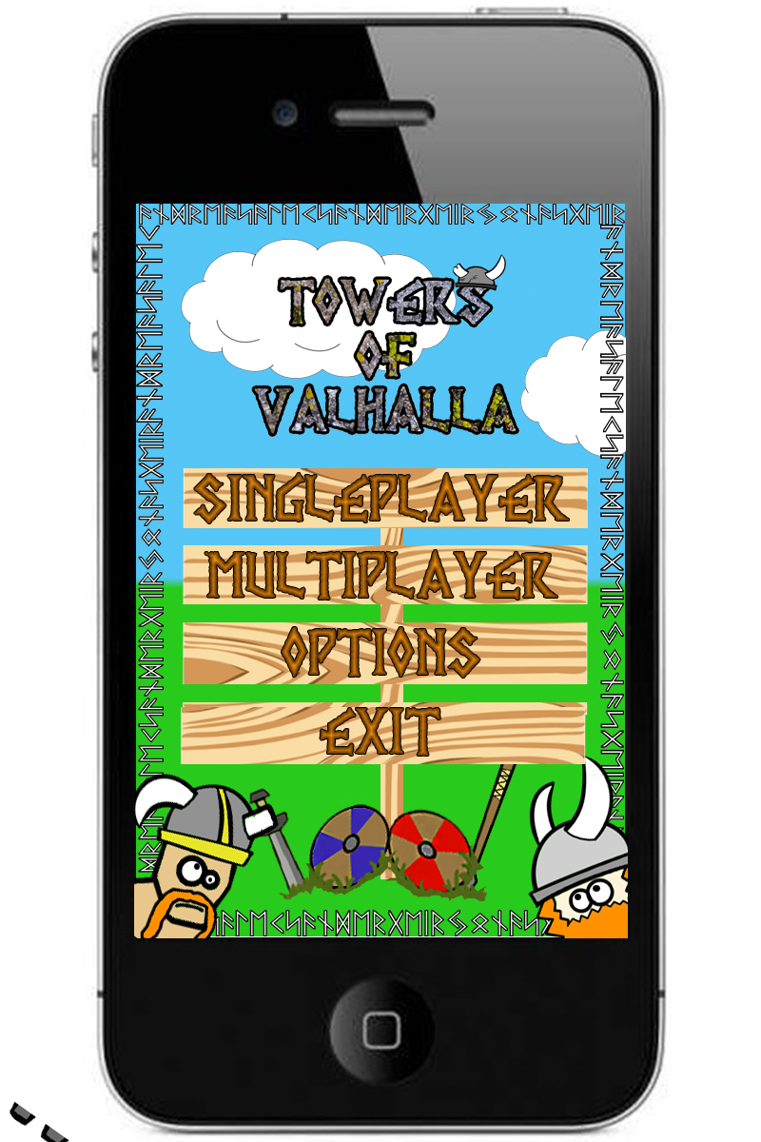

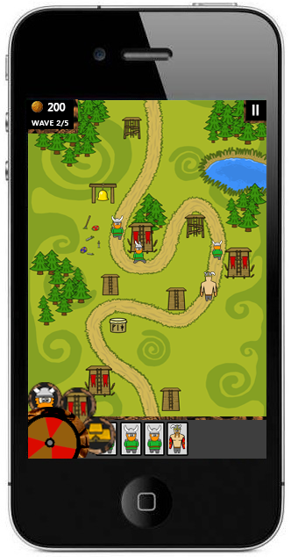

This is an example of our first “Sketch” of the main menu. The colors and fonts are not yet complete, but it gives us an idea of what we want the graphical style to be like. The color of the title will be changed to give it a cartoony look. The grass and sky areas will have more detail.  We are also not done deciding where to place our Vikings. We want our design to be cartoony without giving our game a “childish” look. The final version of our main menu will have more assets as well as redone text and backgrounds. Testing has shown that we will have to edit the font to make it more readable. This will be done in the next iteration.

Sprint Reviews

Sprint review for the first two weeks of our project. We spent most of the two first weeks of the project paintballing ideas between each other and trying to see what we actually could do with the time we were given. We drew up four to five “main” ideas that we talked about within the group. After this we had a meeting with the company we would be working for to see what they felt about our ideas and how we were to accomplish them. We gave yourself one more week of brainstorming to see if we could keep the idea momentum going.

During this week we tried coming up with simple yet fun games that would be doable within our timeframe. We had to abandon some ideas because of the fact that they were either too similar to other famous games or that we felt that they would not be fun enough to last in the long run. There has been some discussion in this part on how we are to do the business model without losing the players interest. We did a in depth market analysis in order to take points from mobile games that have what is considered good models as well as the more known bad models.

At the end of the second week we had yet another meeting where we pitched the new ideas as well as showing off some prototypes we made to give a more visual representation of our ideas. We came to the conclusion that we were to make a tower defense game with a new twist.

We started off the next week by designing a basic proof of concept where we had some simple towers and moving enemies. The group dynamic was working well because of the fact that we all knew each other before we started.

We had assigned main tasks for everyone so that everyone had a main area of expertise. Because of this everyone knew what they were doing at each time. So far the daily stand ups have been useful for keeping everyone up to date with what is being done. We have set up a Jira [[4]](https://www.atlassian.com/software/jira) account with an extensive backlog in order to keep everything under control. So far we feel that we are somewhat ahead of schedule when it comes to that game itself. The programmers understood Unity [[10]](https://unity3d.com/) faster than we had though and this has led to a much more detailed second prototype than what we anticipated.

We are currently working hard on getting the game ready for our first official external testing. For this test we are planning to have a production quality map with the basic building and defending. We decided not to have every feature in this iteration.

At the end of iteration two we have gotten a lot of assets and back end coding done. The documentation has gotten quite a lot longer and detailed. When it comes to the testing we have decided to postpone it to the end of the next week so that we can make the prototype even better. As of now the things we will have to improve on is to get everybody to meet up at the correct time, but we are improving on this. Overall we are quite content with our progress on the iteration and we expect to do even better on the next iteration.

When it comes to the third iteration we have made small but important improvements to the code. Most of the work that has been done has been oriented around repairing broken code and doing basic testing. A big issue with this iteration is that we made some big mistakes when it comes to the game coding and we had to redo a lot. We have improved on the aoe rock so that the smaller pieces of the rock also do damage to the enemy. We have begun on the code that lets units attack each other. When it comes to the artwork we have finished several important towers and buildings, they will have to be animated in the next sprint. We also finished a demo map that we showed off to different people at the school and received feedback on design.

We are currently trying out ways to add a save game function in our game. We decided to push the external testing back one week so that we can finalize the features we are currently working on.

In iteration four we made the biggest changes to the gameplay. The external testing this time was done on mobile phones. The testing focused on the graphical part of the game, as well as the new main menu. We felt that it was important to external testing on phones in this iteration. Testing our game on phones gave us valuable feedback on size and visibility. The testing showed that we need to make certain changes to our units, towers and GUI. The main changes we will have to make are the size of our units. Testers felt that they were a bit small and we will need to make them somewhat larger to compensate for a smaller screen. There will also have to be shadowing added to the towers and units to make them look less flat.

Overall we feel that we got a lot of work done in this sprint, and that we are closing in on finishing the back end portion of the project. This means that we soon can start polishing and mas develop maps for the game. We are also closing in on the biggest portion of the development, which is the network coding. We have given our programmers six weeks on this considering the size of this part.

In the fourth sprint we finished most of the GUI elements and we have also finished up most of the functionality. The back end of the project is getting closer to an end and we are currently preparing for next week’s network coding. The buildings and economy system is also close to completion and will be implemented in the next prototype of the game. We have made some changes to prefabs and scripts in order to make them more readable for later iterations.

Assets have also seen progress with the scout, barracks and market being completed and the blacksmith closing on completion. Balancing is completed on paper and will also be implemented soon. On the documentation side we have been putting together a test document for delivery. The document is not a complete document yet. There are still several points that will have to be altered before the final documentation can be delivered.

The first week of the sprint saw some problems when it comes to sickness and we did not complete as many tasks as expected, but we made up for it by being more effective the last week.

Drawings:

This section is to show drawings that were used while creating the game, not always the best art but to show ideas in a quick form, and share some temporary work for others to see. As pictures pasted here are not final, take it with a pinch of salt.

This section is also prone to change at any time as new drawings are made or old ones are updated. Some drawings may not even have descriptions but be basic layouts for something completely out of context for later use.

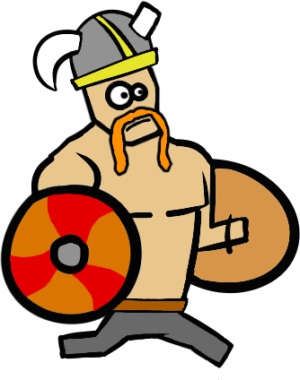

Heavy unit: The heavy unit is a unit that focuses on power and health over speed and agility. He is a huge man with 2 shields to guard him from attacks.

.

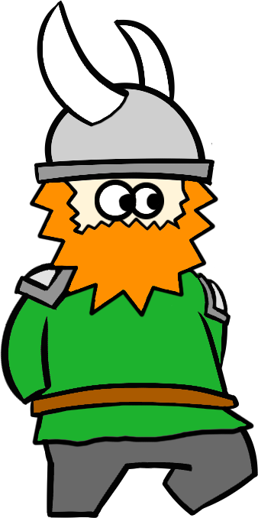

Basic unit: The basic unit is the cheapest and first unit you will build before a round. This is a balanced unit meant to be mass produced.

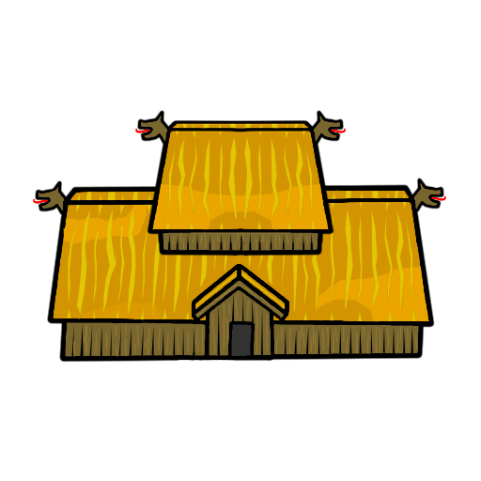

Town hall

The town hall is based on Viking long halls. Your main objective is to protect this at all cost.

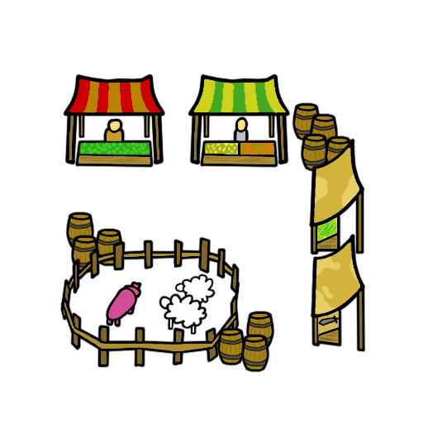

Market

The market was based old town markets where you could buy more or less anything you might need. The colors were decided based on what we would consider less straining on the eyes.

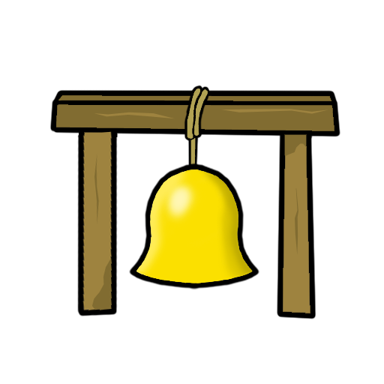

Slowing tower

The slowing tower was to be a bell so that we could have people hitting it and causing tremors to slow enemies. The bell was colored yellow to not conflict with other objects in the scene.

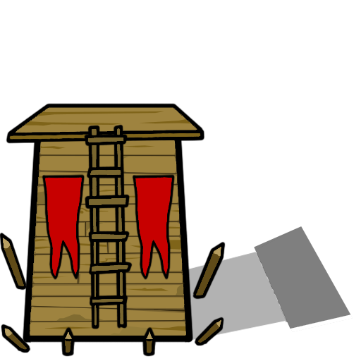

Basic tower

The basic tower was designed as an old watchtower. We decided on this design to indicate that it is the simplest tower. The red flags are these to separate it from other assets you might see in the scene.

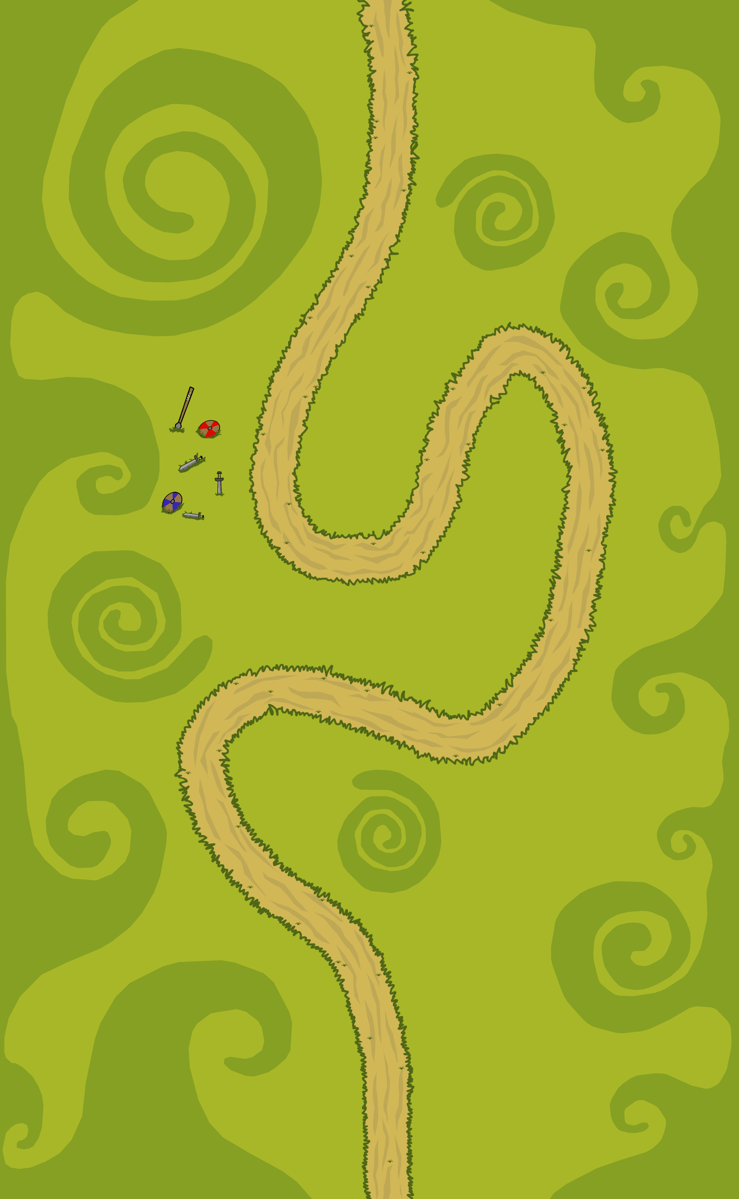

Example map. This is an example map that we used in the first couple of tests.

We decided on green hills inspired by Disney that was both colorful and detailed.

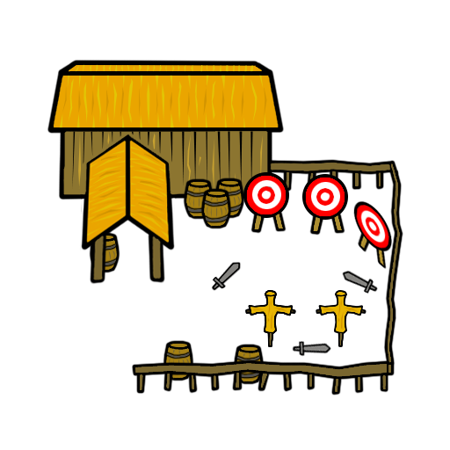

Barracks

The barracks in the game were based on older RTS games showing a training area outside a building. Colors were chosen based on what was the most comfortable on the eyes.

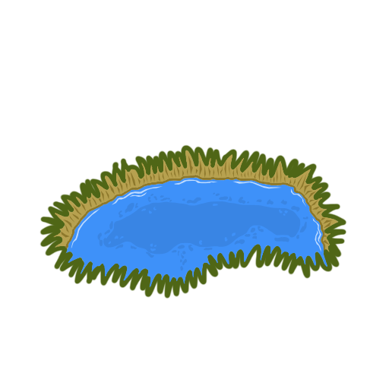

Lake

A basic lake with the edges. The edges around the lake are there to represent a drop and a change in terrain.

Sketch for balancing loops

The five center black circles are the units, and the outermost black is the towers.

Will be redrawn better for easier understanding.

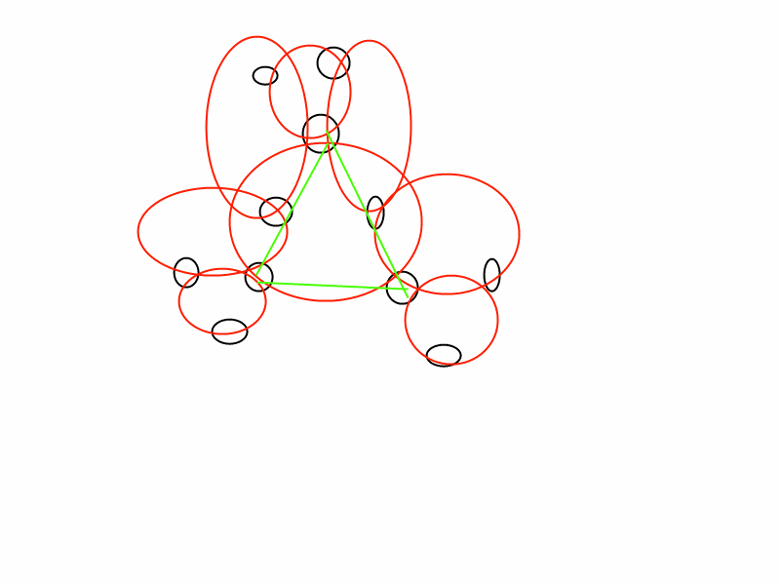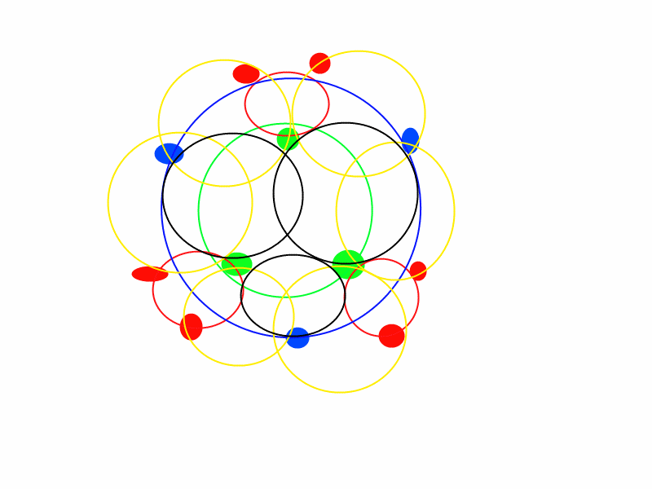

Visual themes

Our game will feature different environments for the player to advance trough. We are currently looking at a forest like environment as well as a snowy winter landscape with ice cliffs and frozen lakes. We feel that these two environments in particular fits the theme we are going for. The contrast between the two different kinds of environments will give the player much needed variety so that they won't lose interest with the environments quickly. The themes also allow us to create some cosmetic assets to add variety to the environment. An important aspect of our design is to keep the games colorful even though they might be in environments that mostly consist of one color. We are working hard trying to add variety to these areas.

For our first external test we designed a frozen landscape for the player to test. Based on their feedback the design may be altered. An important part of the design is to make the map itself feel alive with cosmetic content.

this means that we will fill out the areas surrounding the path with trees, lakes and mountains, giving the world a more vibrant feel. It is also important that our cosmetic additions don’t distract the player or makes the player click on areas he is not supposed to. The artist has taken inspiration from other similar mobile games as well as Disney movies. The way the characters are being drawn gives them a unique hand drawn look which we feel is unique to the genre and will give our game a fresh look.

Main screen

-Menu

                    -Graphic

                    -Sounds

        -Title

        -Background animation?

Back end

-Music

        -Save function

        -Player to Player interaction

                    -Player to server

        -User to shop

                    -Micro transaction interface

                    -Client to server

Towers

Basic tower

        -Graphic

        -Projectile

                    -Sound

                    -Hit effect

        -Animation

                    -Attacking

                    -Idle

        -Upgrade tree menu

                    -Anti jumper

                               -Graphic

                               -Projectile

                                           -Sound

                                           -Hit effect

                    -Anti heavy

                               -Graphic

                               -Projectile

                                           -Sound

                                       -Hit effect

AoE tower

        -Graphic

        -Projectile

        -Animation

                    -Attacking

                    -Idle

        -Upgrade tree menu

                    -Anti scout

                               -Graphic

                               -Projectile

                                           -Sound

                                           -Hit effect

                    -Anti heavy

                               -Graphic

                               -Projectile

                                           -Sound

                                           -Hit effect

Slowing tower

        -Graphic

        -Projectile

                    -Sound

                    -Hit effect

        -Animation

                    -Attacking

                    -Idle

        -Upgrade tree menu

                    -Anti scout

                               -Graphic

                               -Projectile

                                           -Sound

                                           -Hit effect

                    -Anti jumper

                               -Graphic

                               -Projectile

                                           -Sound

                                           -Hit effect

Units

Scout (Low health, Low damage, High speed)

        -Graphic

        -Animation

                    -Walking

                    -Hurt

                    -Doing damage

        -Sounds

                    -Getting hit

                    -Doing damage

**Heavy** (High health, Medium damage, Low speed)

-Graphic

        -Animation

                    -Walking

                    -Hurt

                    -Doing damage

        -Sounds

                    -Getting hit

                    -Doing damage

Jumper(Low-medium health, High damage, Jumps!)

-Graphic

        -Animation

                    -Walking

                    -Hurt

                    -Doing damage

        -Sounds

                    -Getting hit

                    -Doing damage

Spy(Stealth, High damage, Medium speed, Low health)

-Graphic

        -Animation

                    -Walking

                    -Hurt

                    -Doing damage

        -Sounds

                    -Getting hit

                    -Doing damage

Buildings

Town hall(used for health indication, and is the base structure of the game)

        -Graphic

                    -three stages

                               -Good

                               -Some damage

                               -Close to destruction

                    -Health indicator

        -Animation

                    -Spawning the basic unit

Barracks(Used to increase units produced to attack enemy, and uppgrades for the units)

        -Graphic

                    -Three stages of health

                               -Good

                               -Some damage

                               -Close to destruction

                    -Menu

                               -Hire units

                               -Uppgrade units

**Armory / Masonry** (Used to uppgrade towers, and the building in the base)

        -Graphic

                    -Three stages of health

                               -Good

                               -Some damage

                               -Close to destruction

                    -Menus

                               -Uppgrade towers

                               -Uppgrade buildings

Market(Used to affect the economy of the game)

        -Graphic

                    -Three stages of health

                               -Good

                               -Some damage

                               -Close to destruction

-Menu

-Financial “spells”

       -Icons

Tavern (Offensive upgrades to use against the enemy)

        -Graphic

                    -Three stages of health

                               -Good

                               -Some damage

                               -Close to destruction

        -Menu

        -Abilities

                   -Icons

**NSA** (Used for special units and intel abilities)

        -Graphic

                    -Three stages of health

                               -Good

                               -Some damage

                               -Close to destruction

        -Menu

                    -”Spells”

                               -Icons

                    -Hire unit